Chapter One

1.1 INTRODUCTION
Impairments of microwave signals in the earth’s atmosphere are off-shoots of the general problem of radiative transfer. Radiative transfer describes the emission, propagation, scattering and absorption of radiation. Since almost everything that we know about the universe has been brought to man by radiation, radiative transfer is as old as vision. It is a valuable tool in astronomy, astrophysics, microwave physics, remote sensing of the earth’s atmosphere and the oceans, as well as the assessment of the light and heat transport in the natural (climatology, hydrology, and meteorology), human (architecture, medicine) and technical environments.
The basis of today's knowledge on emission and absorption of thermal (or quasi-thermal), electromagnetic radiation was laid by Josef von Fraunhofer, Robert Bunsen and Gustav Robert Kirchhoff, among others. For example, the application of the first and second laws of thermodynamics led Kirchhoff (1860) to the formulation of his law of radiation, stating in today's language, that under local thermodynamic equilibrium the emissivity of a given object is equal to its absorptivity. Also, James Clark Maxwell showed that magnetism, electricity, and light are different manifestations of the same fundamental laws.
The passage of radiation in non-homogeneous media is accompanied by varying degrees of reflection, refraction, interference, diffraction, polarization, scattering and absorption. These phenomena are central to the subject of radiative transfer. Pioneering work in this field is due to Lorenz (1890) and Mie (1908). For example, microwave radiometer observations of precipitating clouds can be explained by Lorenz-Mie scattering and absorption theories. Scattering of radiation by particles which are small with respect to the wavelength is named after Lord Baron Rayleigh and John William Strutt. Rayleigh scattering of radar waves by raindrops has been used in radar meteorology to relate rain rate with radar intensity. Rayleigh scattering has also been used in microwave radiometry to describe the emission of clouds and snow.
In more recent times, the development and solution of the radiative transfer equation had been given significant advances by Subrahmanyan Chandrasekhar (1960) and van de Hulst Hendrik Christoffel (1948, 1957 and 1980), both working for some time at the Yerkes Observatory of the University of Chicago. Approximate solutions of the radiative transfer equation for multiple scattering are named after Sir Arthur Eddington, Joseph et al. (1976), Meador and Weaver (1980) and Thomas and Stamnes (1999). Pioneering work on the development of microwave radiometry was by Dicke (1946) and Dicke et al., (1946). At microwave frequencies various approximation models (for the solution of the radiative transfer equation) have been developed for the measurement of propagation impairments by atmospheric constituents.
Table 1.1: Frequency Bands used in Satellite Communication
Frequency | Band
225 - 390 MHz | P
350 - 530 MHz | J
1530 - 2700 MHz | L
2500 - 2700 MHz | S
3400 - 6425 MHz | C
7250 - 8400 MHz | X
10.95 - 14.5 GHz | Ku
17.7 - 21.2 GHz | Ka
27.5 - 31 GHz | K
36 - 46 GHz | Q
46 - 56 GHz | V
56 - 100 GHz | W

Modern measurements of propagation effects based on these approximations are satellite-based. The satellites involved included the NASA Application Technology Satellites (ATS-5 and ATS-6); the Canadian/U.S. Communication Technology Satellite (CTS); the domestic U.S. COMSTAR communication satellites; the ETS, CS and BSE satellites of Japan; SIRIO and ITALSAT of (Italy); and European Space Agency Olympus Satellite (OTS). The NASA and JAXA Tropical Rain Measurement Mission (TRMM) satellite launched in November 28, 1997, and the Atmospheric Infrared Sounder (AIRS) launched in March, 2002 are among the current satellites taking measurement over the tropical region of the world up till date. They will finish their mission by 2010.
The objective of this study is to estimate propagation impairments for fixed satellite service on earth-space links at selected locations in Nigeria, using TRMM and AIRS satellite data for the period 1998 to 2006.

1.2 Statement of the Problem
Radiowave propagating between terrestrial links and earth-space links are adversely affected by atmospheric gases, rain, clouds, fog, and tropospheric scintillation. The problems become more acute for systems operating at frequencies (Ku, Ka and V bands) above 10 GHz. Nigeria is located in the tropics unlike the temperate environments such as Europe and North America. The effects of the troposphere on microwave signals will be most severe in the tropics because of high frequency of occurrence of rainfall, high temperature, high relative humidity, and high rain intensities which lead to a more severe signal attenuation and outage than what is experienced in the temperate region. Unfortunately most satellite communication equipments supplied to Africa are designed based on propagation measurements made in Europe and North America, which may not meet the minimum availability standard that can cope with harsh weather experienced in the tropics.
1.3 Rationale for the study
There is very little information on propagation studies on earth-space communication links in Nigeria. Where there is information there is none that cover several years and several locations. A radiometric experiment was carried out for two years in 1987 to 1988 at Ile-Ife, to provide data on rain attenuation only at 11.6 GHz (McCarthy, et.al., 1994). The present study is therefore aimed at investigating simultaneously the effects of rain, cloud, gases and tropospheric scintillation for frequencies between 10 and 50 GHz (i.e. at Ku, Ka and V-bands), for fixed satellite communication service on earth-space path at 37 stations in Nigeria by using satellite data for the period 1998 to 2006.

1.4 Aims and Objectives of the study
The following steps were taking in achieving the objectives of the study:
1. Compute some propagation impairments relevant to fixed satellite communication at Ku, Ka and V band (10-50 GHz) at elevation angles of 5⁰, 55⁰ and one practical elevation angle for links to recently launched Nigeria communication satellite NigComsat-1 in the 37 locations in Nigeria.
2. Use meteorological data from satellites and ground stations as input data into ITU-RP empirical models to generate appropriate propagation data such as, cloud attenuation, rain attenuation, gaseous attenuation, tropospheric scintillation and total propagation loss on earth-space path in each of the 37 locations.
3. Calculate mappings following item 2, for uplink and down link budget control during tropical rainfall along earth-space paths for fixed satellites communication service in Nigeria.
4. Finally, locate the highest and the lowest places affected by propagation impairments year round by dividing the country into six zones (namely SW, SE, SS, MB, NW and NE) and conduct a comparative analysis of the results with a view to recommending for the country in the future where to best site a fixed satellite base station on earth-space path (operating at Ku band and above) for deep space exploration.
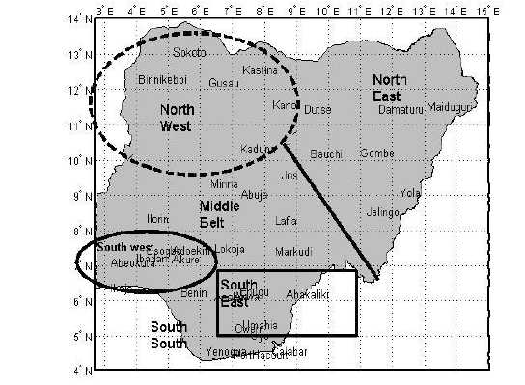
Figure 1.1: Map of Nigeria showing the 37 stations used in the study.

