Chapter Three

RESULTS AND DISCUSSIONS

3.0 Validation of TRMM Data with Measured Rainguage Data in Nigeria
Available rain gauge data from January 1991 to December 2000 were collected at 14-locations for the purpose of validating TRMM data which became available to the scientific community in January 1998. Ground data from January 1998 to December 2000 were selected to validate the closeness of the TRMM satellite data with the rain gauge data at 14-locations, which cover the entire six regions in Nigeria. Table 3.1 shows the Seasonal Variation of Mean Precipitation, Mean Bias Error and the overall correlation coefficients of TRMM 3B43V6 Data with the ground data collected at National Meteorological Centre Oshodi Lagos.
Table 3.1 shows the seasonal percentage mean bias error of TRMM 3B43V6 data with the ground data. In December, January, February (DJF) Mean bias error greater than ±50% occurred in ten locations, except Ado-Ekiti, Ibadan, Ikeja, and Calabar where the two data perfectly agree. While in March, April, May (MAM) bias error greater than ±50% occurred only at four locations, Minna, Kano, Jalingo and Maiduguri, there was perfect agreement between the two data in ten locations. In June, July, August (JJA) (the peak of rainy season) there was perfect agreement between the two data in thirteen locations, the seasonal mean bias error greater than ±50% occurred only in Kano. While in September, October, November (SON) the bias error greater than ±50% occurred only at four locations, Adoekiti, Yenagoa, Kaduna, and Jalingo. There was perfect agreement between the two data in ten locations.
The results suggest that in MAM, JJA and SON there was good agreement between the satellite data and the ground data, but in DJF (dry season) there was little agreement between the two data except for the South-West region. Adeyewa and Nakamura (2003) had observed similar seasonal percentage mean bias error of TRMM 3B43V6 data with ground data over the six major climatic zones in Africa:
1. Arid zone (Sahara Desert, 15⁰ -30⁰ N, 11.5⁰W-30⁰E)
2. Semiarid regions northern Africa (12⁰ –15⁰N, 11.5⁰W–30⁰E),
3. Semiarid Southern Africa (17⁰ –22⁰S, 17⁰W–30⁰E),
4. Savanna climate in western Africa (8⁰–12⁰N, 11.5⁰W–30⁰E),
5. Savanna climate in southern Africa (6.5⁰–17⁰S, 14⁰–40⁰E) and
6. Tropical-rain-forest (Tropical wet) climate (6.5⁰N–6.5⁰S, 11.5⁰W–30⁰E).
All the locations in Nigeria used in this study lie within latitude 4⁰–14⁰N, and Longitude 2.7⁰E–15⁰E, covering the following climatic zones: Semiarid, Savanna western Africa, and Tropical-rain-forest. The results of Adeyewa and Nakamura (2003) show similar seasonal percentages mean bias error for DJF, and JJA. For Semiarid region it was, 100%, and 5%, for Savanna Climate western Africa it was 54%, and 5%, while for Tropical-rain-forest it was 5%, and 2%, respectively. Their result also shows that in JJA (the peak of rainy season) there was perfect agreement between the ground and satellite data but in DJF (dry season) there is little agreement between the two data.
Column 4 of Table 3.1 shows the overall correlation coefficients between the two data. In JJA (peak of rainy season) there was strong correlation of 0.83 to 0.99, while in MAM and SON it was 0.77 to 0.99 and 0.73 to 0.99, respectively, but in DJF (dry season) the overall correlation was 0.56 to 1, in all the 14 locations. This suggests that there is good relationship between the ground and satellite data in MAM, JJA and SON while in DJF the relationship is not too good. The average mean seasonal rainfall (mm month⁻¹) of this present work was also compared with the work of Adeyewa and Nakamura (2003) for other climatic regions in Africa and the results are presented in Table 3.1b.
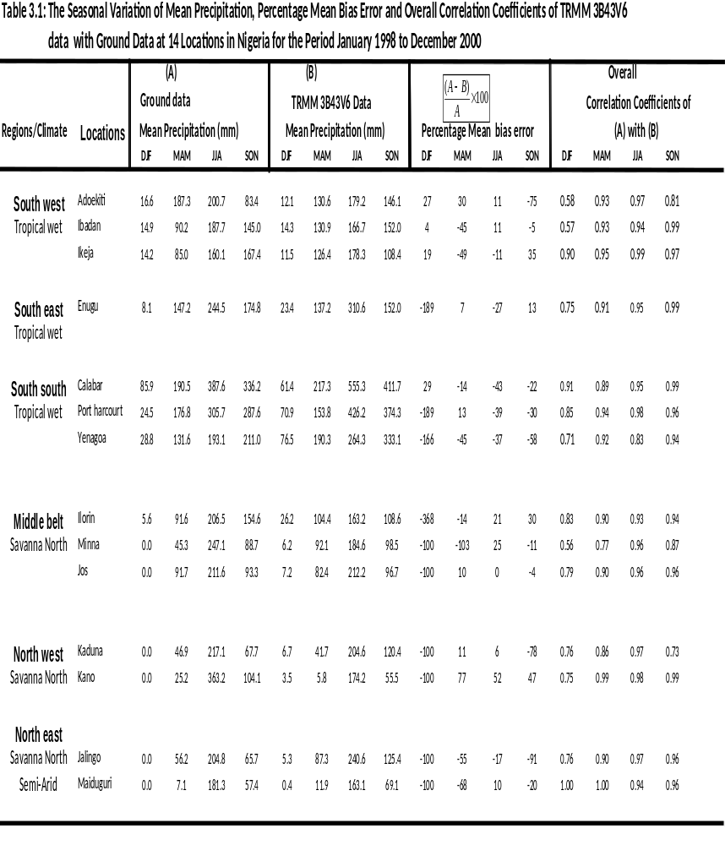
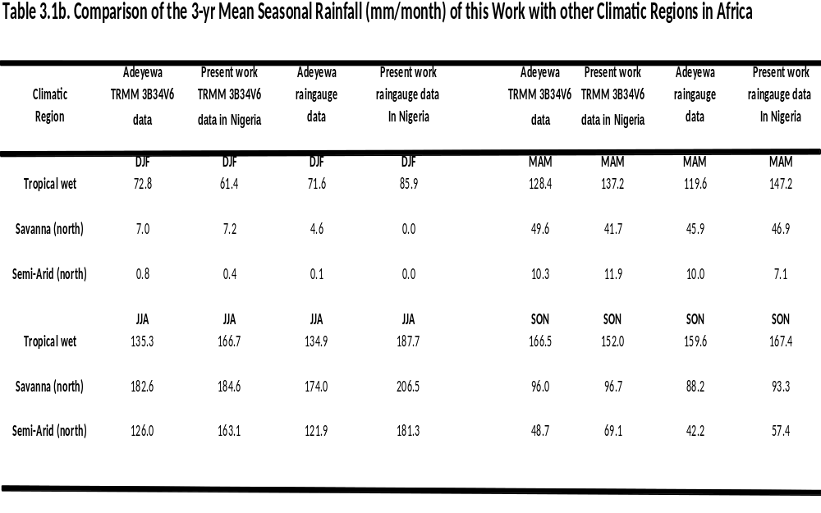
3.1 Nine-year Results of Rain Events as Recorded by TRMM Satellite at the 37 Locations in Nigeria.
Table 3.2 shows the numbers of rain events retrieved from the TRMM 3B43V6 data set. The highest numbers of rain events in nine years occurred at Ado-Ekiti, Akure, Calabar, Yola, Kano, Ilorin, Yenagoa, Jalingo, Port Harcourt, Owerri, Umuahia, Kaduna, and Jos. Though Jos and Kaduna recorded the highest average rain events of 355 per year, their annual rain accumulations (about 1184mm and 1112 mm, respectively) are small when compared with the other 11 locations. Sokoto (in the NW) recorded the lowest total number of rain events of 1771 in nine years and the lowest average rain events of 153 per year with an annual rain accumulation of 564 mm, as expected for a semi-arid region (Adejuwon et.al, 1990). Calabar (in the SS region) recorded the highest rain accumulation of 3748 mm per year, as expected for a tropical rain forest region (Adejuwon et.al, 2005). TRMM Satellite echo returns showed that the SS, SE and SW regions had the highest rain accumulations per year; with the SS between 1900 and 3748 mm, followed by the SE, 1899-2397 mm, and SW, 1100-1314 mm. The Satellite echo returns also revealed that the NW region had the lowest average rain total of 564-1112 mm, followed by NE, 649-1417 mm, and MB, 1049-1398 mm.
Retrieved echo returns also showed that the driest months in nine years common to all locations in SW and SE regions is December, while for the SS region it was December and January (except Port Harcourt which had January as its driest). For the MB, November was the driest month in nine years, a feature common to all locations in that region. For the North West the Satellite recorded that November, December, January, February, March and April are the driest months, as with all locations in that region except Kaduna which had November, and December as its driest months. For the NE region, the driest month common to all was November, except for Gombe and Maiduguri which had February, March and April respectively as their driest months. Damaturu was a totally different case. The satellite echo returns showed that November to April (about six-months) as the driest months. Furthermore the TRMM Satellite revealed that there is about eight months of rainfall in SW region (Mar-Oct), while in the SE and SS region it was about nine months (Feb-Oct). In the MB region it was about 7-months of rainfall (April-Oct), while in the NW and NE regions it was about 4-months (July-Oct) and 6-months (May-Oct) of rainfall, respectively.
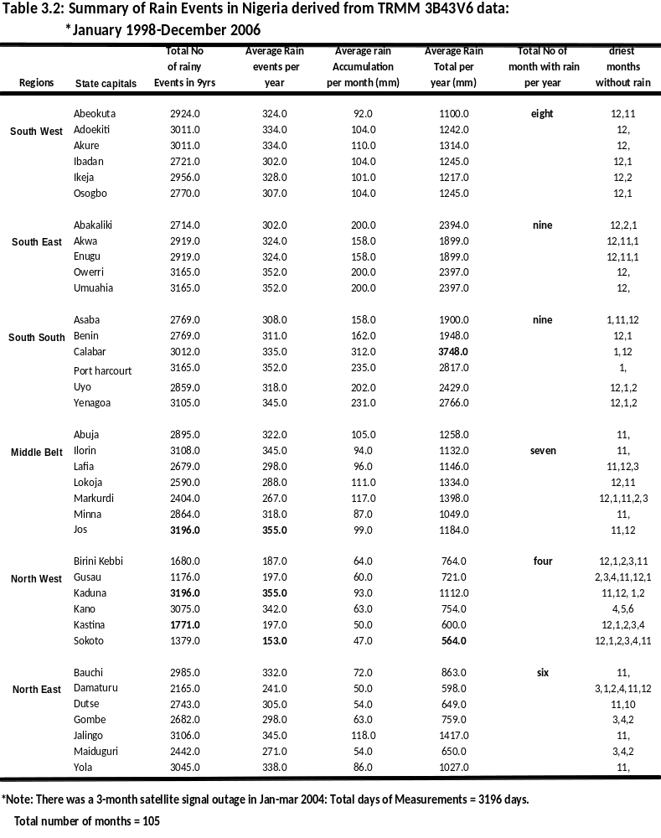
3.1.1 Year to Year Variation of the Derived One-Minute Rain rate from TRMM Data
Table 3.3 shows the results of the nine year mean annual rainfall rates exceeded for 0.01% of average year for the 37 locations. The results show that SE regions had the highest mean annual rainfall rates (111 to 125 mm/h) throughout the nine-years, followed by the SS (105 to 124 mm/h) and SW (79 to 94 mm/h). Abakaliki, Owerri, and Umahia (SE) had the highest mean annual rainfall rate of 125 mm/h, in nine-years. The lowest mean annual rainfall rate occurs in NW region (60 to 86 mm/hr), followed in increasing order by the NE (66 to 95 mm/hr) and the MB (84 to 94 mm/h). Sokoto in the NW recorded the lowest rain rate of 44 mm/h in 2001 and therefore it had the lowest mean annual rainfall rate of 60 mm/h in nine years. The four colour chart in Table 3.3 was adopted for the visualization of year to year variation of the derived one minute rainfall rate. The colour chart shows that the SW region is dominated by medium rainfall rates, while the SE and SS regions are dominated by very high rainfall rates. The MB is a mixture of high and medium rainfall rates. The NW region is dominated by low rainfall rates, while the NE region is a mixture of medium and low rainfall rates.

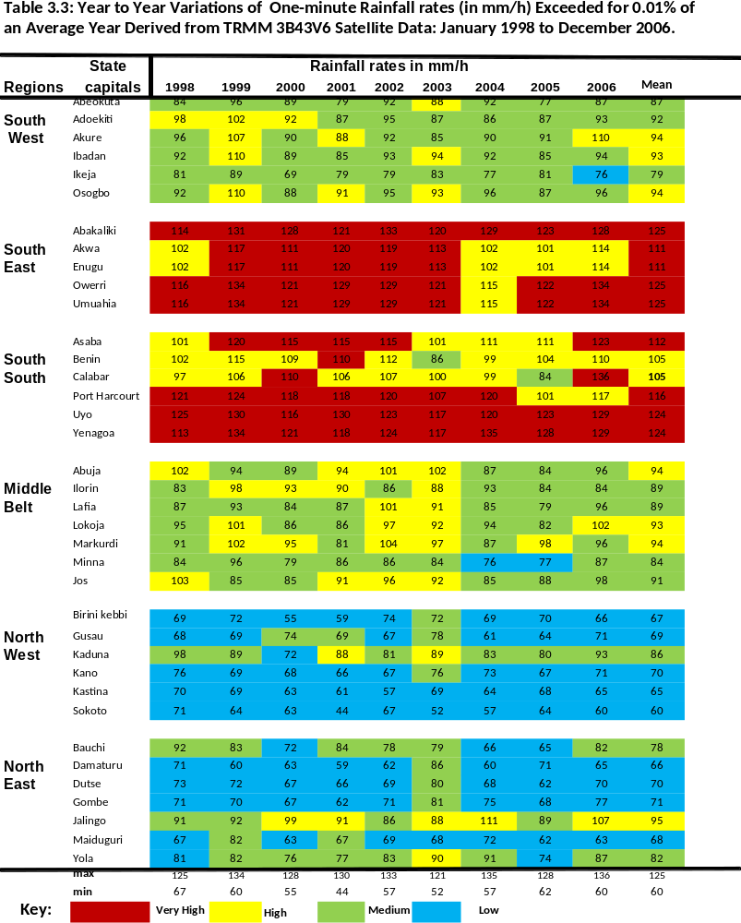
Table 3.4 shows the statistical summary of the derived one-minute rainfall rate. The results show that rainfall rate is highly variable in the SS region with standard deviation (σ) ranging from 5 to 14 mm/h, followed by the SW (σ = 5 to 9 mm/hr) region, the NE (σ = 6 to 9mm/hr) region, the SE (σ = 6 to 8 mm/hr) region, the NW (σ = 4 to 8 mm/hr) region, and the MB (σ = 5 to 7 mm/hr) region. Kano and Katsina in the NW region had the lowest standard deviation of 4 mm/h.
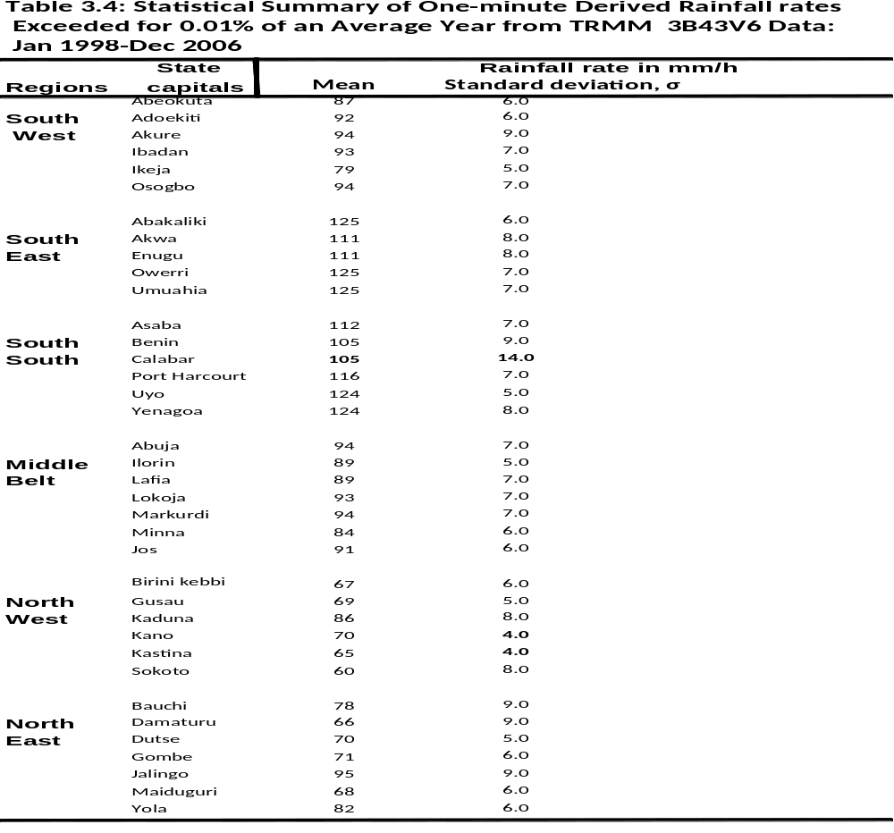
3.1.2 Cumulative Distribution of Rainfall rates in Six Regions
The inferred average cumulative distributions of rain rate over the nine-year period for the six regions are shown in Figure 3.1. The rain rates were plotted for other percentage of time 0.001% to 0.1%, of an average year. This corresponds to 5.26 minutes to 8.76 hours of exceedance of the indicated one-minute rainfall rates in an average year. It is seen that the SE (Abakaliki and Umahia) and SS (Uyo) regions had the highest cumulative distribution of 4 to 192mm/h and 4 to 191mm/h respectively, followed by the MB (Markudi, 2 to 164mm/h), and SW (Akure and Osogbo, 2 to 162mm/h) regions. The NW and NE regions had the lowest values of 1 to 153mm/h and 1 to 162mm/h respectively.
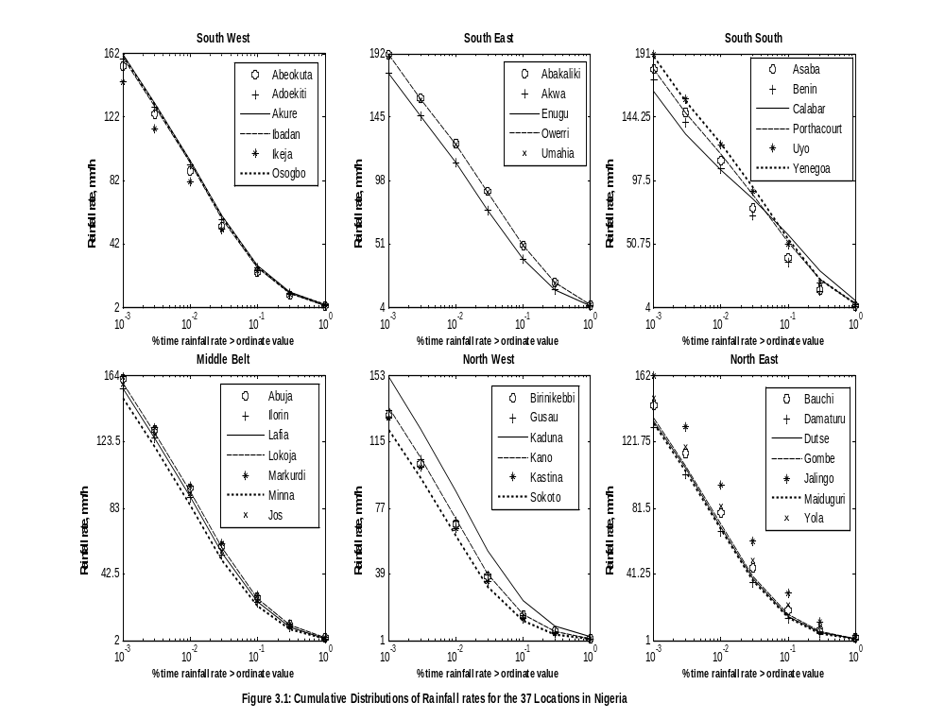
3.1.3 Comparison with Other Works
Table 3.5 shows the correlation coefficient of the derived rainfall rates with the International Telecommunication Union Radiowaves Propagation Study Group 3 digital maps (ITU_RP SG3) and with the work of Ajayi and Ezekpo (1988). Correlation coefficients between this present work and ITU-RP was positive in all regions except at the Middle Belt (with a correlation of -0.20). In Table 3.5 two outliers in the ITU RP rain rate data for Lokoja and Minna are the cause of the negative correlation. There is also a weak correlation (0.09) between this work and ITU-RP only in the South-South region, possibly as a result of the low values of rain rate data that ITU RP Digital map assumed for Uyo and Yenagoa.
The correlation coefficient between this work and that of Ajayi and Ezekpo (1988) was positive in all the six regions. Two weak correlation 0.17 and 0.41 occurred at the SW andand the MB regions respectively possibly as a result of the high rainfall rates values assumed by their contour lines across the two regions. This present work is based on 9-year data while Ajayi and Ezekpo (1988) work was based on thirty-year data. Long term data are expected to smoothen out large year to year variation. This may be one of the reasons why there was weak correlation between the two results for the two regions.

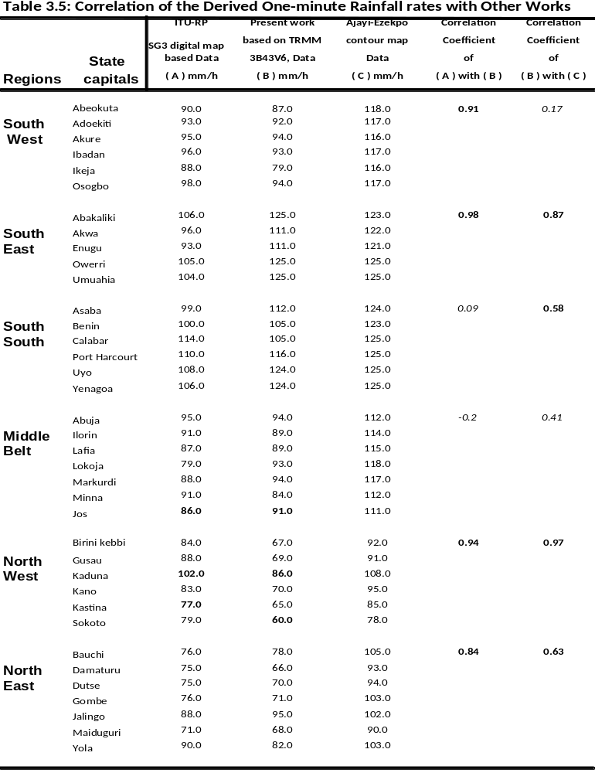
Measured one minute rainfall rates for other tropical and subtropical locations around the world such as Brazil (Migliora et al., 1990), Cameroon (Moupfouma, 1987 and Moupfouma et al.,1990), Congo-Brazzaville (Ajayi et al., 1996), Kenya (McCarthy et al, 1994b), Malaysia and Hong-Kong (Yusof et al., 1990), India (Sarkar, et al., 1992, and Sarkar,1995), USA Miami -Florida (Sim and Jones, 1973) and Indonesia (Brussard et al., 1993) were also compared with the results obtained for the 37-locatios in Nigeria and the results are presented in Table 3.5b. It is seen from the table that the measured rainfall rates obtained in tropical stations such as India (Shillong, Calcuta, and Bombay), Indonesia (Surabaya), Cameroon (Douala), Congo-Brazzaville and Vietnam (Ho-Chim), Australia (Darwin) are comparable with the values derived for tropical wet in the South-West, South-East and South-South part of Nigeria, while the results obtained for sub-tropical stations in Brazil (Alegre, Fortaleza, Rio de Janerio, Sao Paulo, and Brasilia) are comparable with those of the Middle-Belt region in Nigeria.
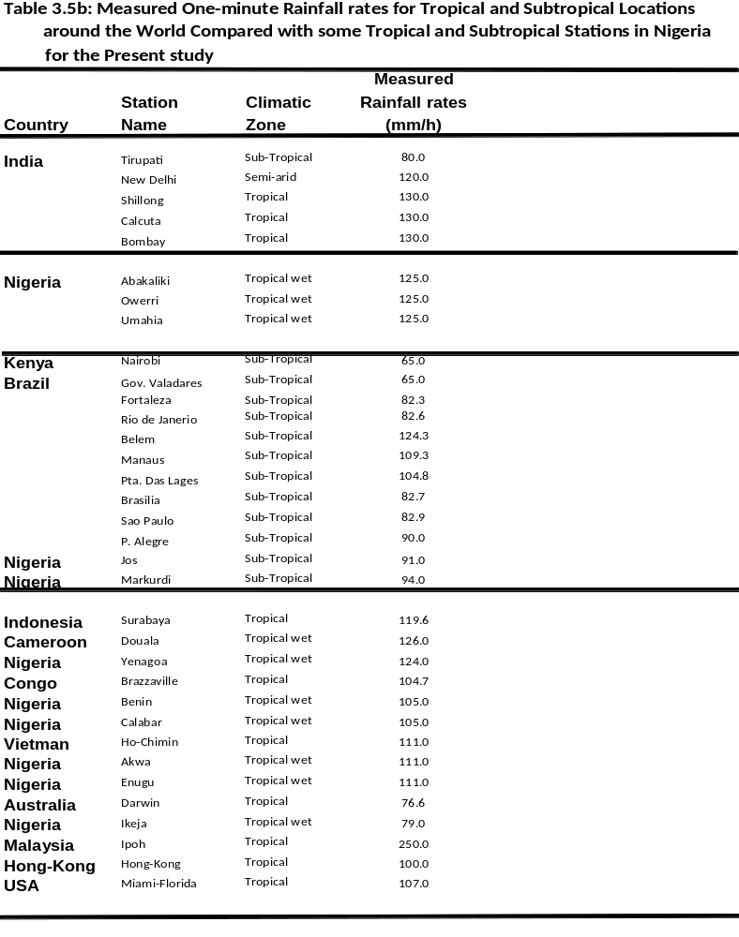
3.2 Results of Rain Attenuation
Rain attenuation on earth-space path has been calculated for frequencies 10-50 GHz for rain rates exceeded for 0.01% of time. Horizontally polarized signal was used for the 37 stations being investigated. Horizontal polarization was chosen because it was the worst case scenario on earth-space path. The results of this study show that the rain attenuations for vertically and circularly polarized signal are less than that of the horizontal polarization at all the frequencies and elevation angles investigated. Other results for vertical and circular polarizations are in the appendix. Mean annual rainfall rates shown in the last column of Table 3.3 (for the 9-year period) were used and spherical raindrops were assumed.
The frequency characteristics of the slant-path rain attenuation for horizontal polarization are presented in Figures 3.2 to 3.3, for the two elevation angles of 5⁰ and 55⁰ elevations. Generally, the slant-path rain attenuation increases with increasing frequency and rain rate and decreases with increasing elevation angle. Comparing the six graphs for the six regions, it appears that rain attenuation will be most severe in the SE and SS regions. Yenagoa and Abakaliki have the highest rain impairments in these two regions at all the frequencies and elevation angles investigated. The reason is not far fetched: looking at Table 2.8 and 3.3, Abakaliki and Yenagoa had the highest mean annual rainfall rates of 125 and 124 mm/h respectively in 9-years. Geometrical parameters in Table 2.8 also revealed that the SS and SE regions had the longest slant-path lengths and horizontal projection lengths to the rain-filled region above the ground at the two elevation angles.
The result shows further that rain attenuation will be less severe in the NW (Katsina and Sokoto) and NE (Damaturu) regions, probably due to their low mean annual rainfall rates (of 65, 60 and 66 mm/h respectively) and low slant-path lengths and horizontal projection lengths to the rain-filled region above the ground at the two elevation angles. Kaduna (NW) and Jalingo (NE) were exceptions in these two regions as their rain attenuations are comparable to those of the SW and MB regions. The two stations had the highest rain attenuation in the NW and NE at 5⁰ and 55⁰ elevations; the reason is obvious from Tables 3.1, 3.2 and 3.3 as the two stations had the highest number of rain events (3196 and 3106), rainfall accumulation (1417 and 1112 mm), and rainfall rates (86 and 98 mm/h), in 9-years for that region. Rain impairment for the six regions at 0.01% unavailability of an average year for 5⁰ and 55⁰ elevations, can therefore be summarized from Figures 3.2 and 3.3. It is observedthat rain attenuation is less severe in the Northern part but is more severe in the southern part of Nigeria, with SE region having the highest rain impairment. 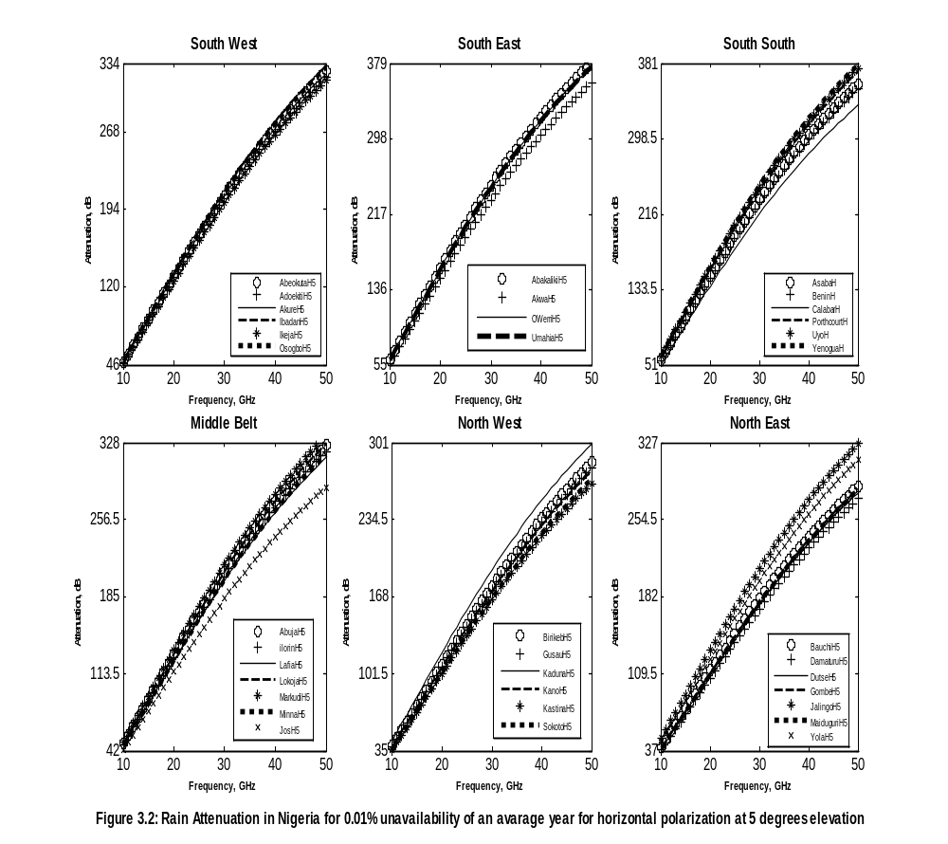
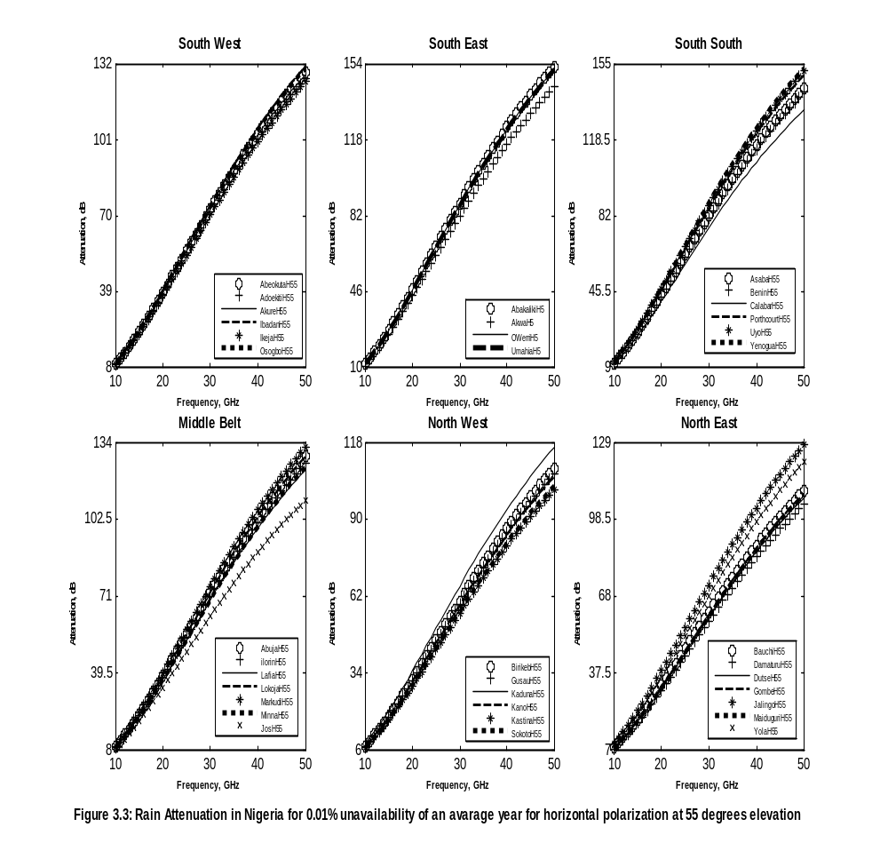

3.2.1 Rain Attenuation at Ku, Ka and V-Bands for Horizontally Polarized Wave for 0.01% Unavailability in an Average year at the 37stations in Nigeria.
In determining the link budget for a satellite-to-ground communications link, only two conditions need to be established:
- The “degraded sky” conditions: Attenuation due to rainfall, and
- the “clear sky” conditions: Attenuations due Cloud, gases and scintillations.
The former establishes the performance level of the system while the latter fixes the availability level. The difference between the two link budget levels is termed the link margin (Allnutt, 1989). Tables 3.6 and 3.7 summarize the results of rain attenuation for uplink and downlink frequencies at Ku, Ka, and V satellite bands at 5⁰ and 55⁰ elevations for 0.01% unavailability on earth-space path at the 37 stations in Nigeria with a colour chart. Four colours were chosen for easy visualization of the attenuation results across the six regions in Nigeria: Red indicates very high attenuation; yellow indicates high; green indicates medium and blue indicate very low attenuations. The colour charts are based on the maximum and minimum values calculated for all the 37 stations for each uplink and downlink frequencies.
The results at 5⁰ elevations show that rain attenuation will be most severe in SE and SS regions, followed by SW and MB, but will be less severe in the NW and NE. At 5⁰ elevation rain attenuation ranges from 42.1 dB (in Sokoto, at Ku-band) to 380 dB (in Abakaliki) at V-band. The results suggest that at Ku, Ka and V-bands (uplink and downlink frequencies) there will be total fade out of signals at 0.01% unavailability for very small elevation angles in all the 37-stations during rainfall. It means for 99.99% (about 53 minute outage in a year) availability of radio signal at 5⁰ elevation the transmitter power must be > 42.1 and 380 dB which is practically a waste. Most satellite system on earth-space path (at 10 GHz and above) are designed to withstand propagation losses that is ≤ 20 dB on its link (Ippolito, 1986) due to limited carrier power at the output of the transmission amplifier (about 150W) and limited battery power onboard the spacecraft.
Table 3.7 shows that at 55⁰ elevation, for Ku Uplink frequency (14 GHz) rain attenuation is between 14.7 and 24 dB, while at Ku downlink frequency (11 GHz) rain attenuation is between 8.6 to 14.3 dB in all the 37 stations. These results suggest that at Ku-uplink, 99.99% availability of signal is possible only at the NW, NE, MB and SW regions (except in Markudi whose attenuation > 20 dB, 99.99% availability is not possible). There will be total fade out of signal at Ku-uplink in the SE and SS regions, because rain attenuation at the two regions > 20 dB. While for Ku downlink frequency (11GHz) 99.99% availability of signal is possible in the entire six regions as rain attenuation at the 37 stations < 20 dB .
At Ka uplink and downlink frequencies (30 GHz and 20 GHz) rain attenuation was between 29.2 to 87.9 dB in all the 37stations. This implies that there will be total fade out of signal at 0.01% unavailability in all the locations during rainfall. The results suggest that 99.99% availability of signal (53 minutes outage in an average year) is not practicable as transmitter power to withstand rain loss must be > 29.2 or equal to 88 dB. Most satellite systems at Ku-band and above are designed to withstand propagation loss that is ≤ 20 dB (100W) on its link due to limited EIRP power and battery life onboard the satellite. At V-band uplink and downlink frequencies (50 GHz and 40 GHz) rain attenuation was between 80.4 and 153.1 dB in all the 37 station. This implies that 53 minutes outage of signal in an average year (99.99% availability) at V-band is not practicable, because the transmitter power has to be > 80.4 and 153.1 dB during rainfall to overcome rain loss. There will be total fade out of signal in all location at V-band for 99.99% availability.
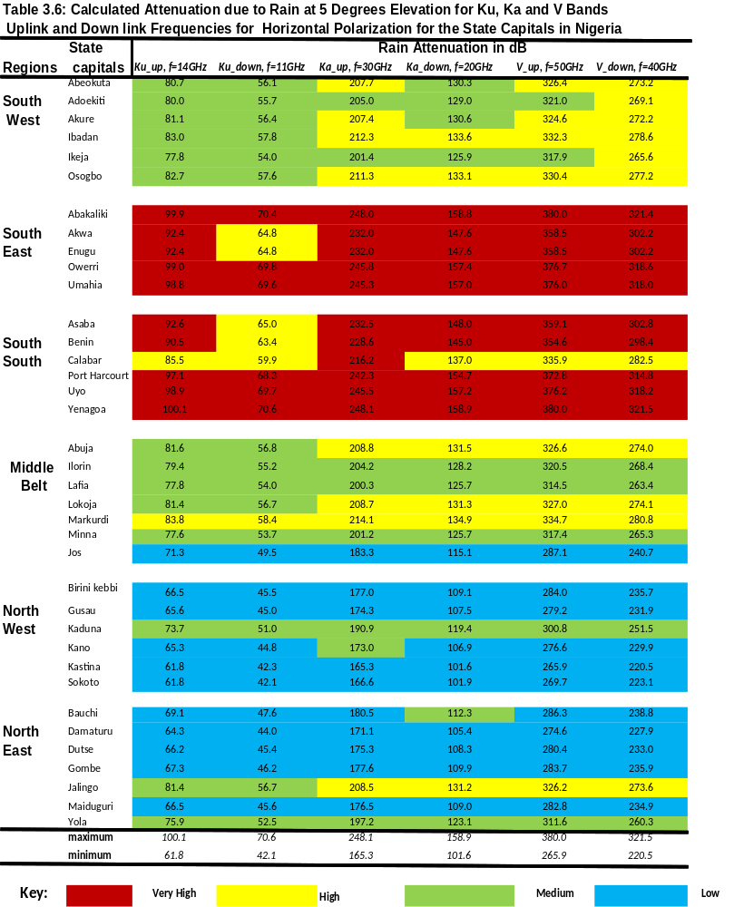

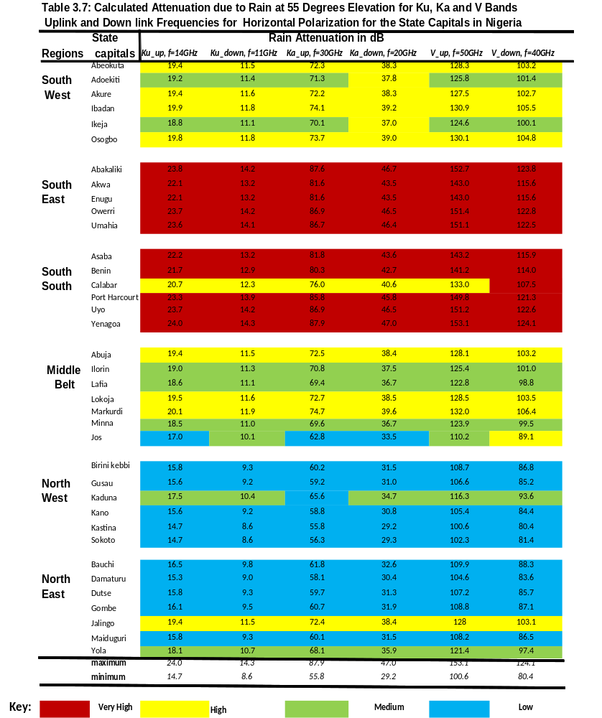

3.2.2 Application of Rain Attenuation to NigComSat-1 at Ku and Ka for 0.01-1% unavailability at the 37-locations in Nigeria.
Table 3.8 shows some geometrical parameters relevant to links to NigComSat-1 for downlink frequencies at Ku, Ka, and extended to V bands (for future Nigerian Communication Satellites operating in the V-band) at the 37 stations. The elevation and azimuthal angles to NigComSat-1 were calculated for each location. The effective path lengths through the rain filled region were also calculated for 0.01% unavailability. Table 3.8 shows that the slant path length L_{S} and the horizontal projection length L_{G} were longest in Ikeja, (SW) followed by Benin (SS), Akwa (SE), Ilorin (MB), Birinikebbi (NW) and Dutse (NE). Jos had the lowest L_{S} and L_{G} in all the 37 locations. The reason for Ikeja, L_{S} and L_{G} been the longest and Jos, L_{S} and L_{G} been the lowest was due to their geometrical height above the mean sea level. Table 3.8 also shows that the effective path lengths through rain increases with increasing frequency for all the locations and was highest at V-band.
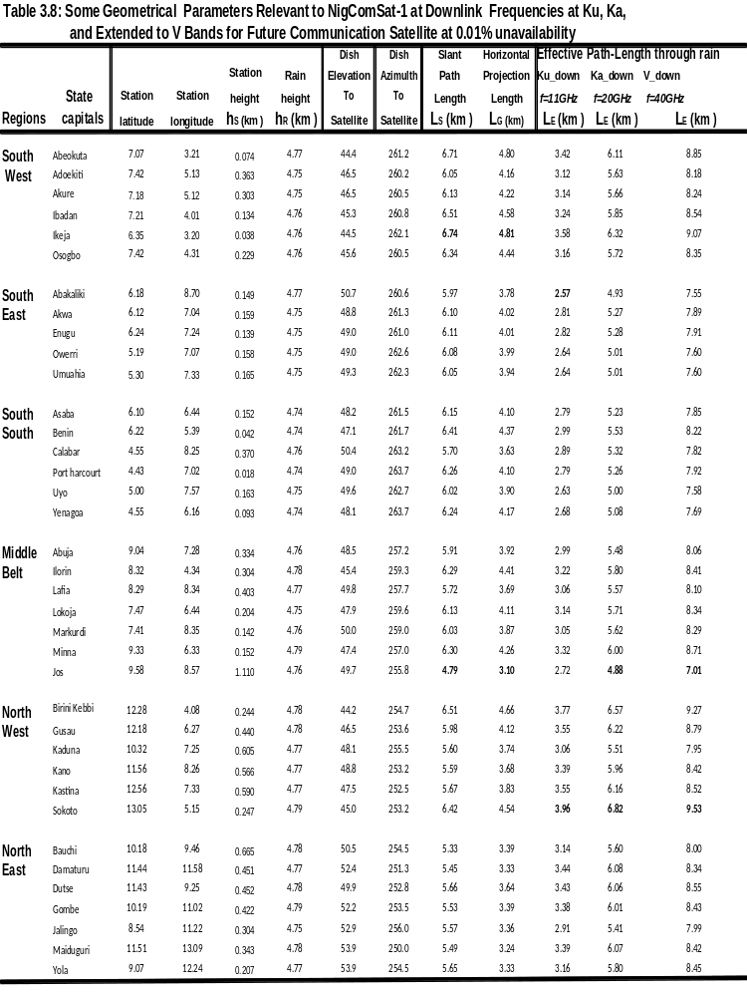
3.2.3 Rain Attenuation for Links to NigComSat-1 at Ku, Ka and V Bands Downlink Frequencies for a VSAT at 0.01 to 10% Unavailability in an Average for the 37-Stations in Nigeria.
Figures 3.4 to 3.6 show rain attenuation cumulative distribution for down links to NigComsat-1 for a very small aperture terminal (VSAT) at Ku (11 GHz), Ka (20 GHz), and V-band (40 GHz) for 0.01% to 10% unavailability. At Ku-band down link, Figure 3.4 shows that 99.99% availability (about 8.7 seconds outage per day) is practicable as rain attenuation for all the six regions ranges from 8.8 dB in (Damaturu) NE to 15 dB in (Yenagoa) SS. This is equivalent to a power loss of about 7.6 to 31.6 W in rainfall at all the 37 stations in Nigeria. NigComsat-1 carries three Ku antenna spot beam of EIRP between 48 to 52 dBW the antenna spot beam power (of 48 to 52 dBW) is enough to overcome rain loss at Ku-band. Measurements at Ku- band with INTELSAT VI at 11-GHz in Singapore a tropical location like Nigeria, showed several classes of rain fade level from 2 to 15 dB in an average year (Timothy et al., 2000). This shows that the results obtained at Ku band for Nigeria (8.8 to 15 dB) are comparable with that of Singapore (2 to 15 dB)
Figure 3.5 shows the cumulative distribution of rain attenuations at Ka-band downlink frequency (20 GHz). The results suggest that 99.99% availability of radio signal will not be possible in the SW, SE and SS regions in Nigeria, as rain attenuation at Ka-band in the SW, SE and SS regions ranges from about 40 to 47 dB, while for the NW, NE and MB regions it is between 28.9 to 40 dB. Katsina had the lowest rain attenuation of 28.9 dB at Ka-band while Yenagoa had the highest rain attenuation of 47 dB. NigComsat-1 carries a Ka-band antenna spot beam of EIRP between 52 to 55 dBW and allowances has to be made for other losses such as scintillation, gases, cloud, system loss, free space loss, and noise figure e.t.c. It is seen from Figure 3.5 that the only practicable availability is 99.9% (8.76 hours outage in a year or 1.44 minutes outage per day) as the losses at this availability for all locations is between 3.99 dB (in Kastina) to 13.47 dB (in Yenagoa). Studies on Ka band rain attenuation with ACTS Satellite (VSAT beacon receivers) for ten years in the United States of America (USA) showed that at 27.5 GHz under moderate elevation angles rain attenuation exceeds 20 dB for 0.1% unavailability of a typical year and that fading becomes worse for low-elevations and for higher rainfall climates in the US (Roberto, 1997).
At V-band downlink, Figure 3.6 shows that, 99.99% availability is not possible in all the 37 stations in Nigeria, as rain attenuation ranges from 79.2 - 121.7dB. Availability level of 99.9% is only practicable in the NW and NE regions because the attenuation for the two region at V-band is between 14 to 17.9 dB (excluding Kaduna, Jalingo and Yola with attenuation > 20 dB). There will be total fade out of signal during rainfall at V-band in the SS, SE, SW and MB regions at 99.9% availability as attenuation is between 20 and 41 dB. The only possible availability level for all regions at V-band is 99.8% (17.52 hours outage in a year or 2.88 minutes outage per day) as rain attenuation is between 6.3 dB (at Kastina and Sokoto) and 24.1 dB (in Calabar). Though V-band is still at an experimental stage and has not been fully commercialized, measurements with ITALSAT at beacon frequencies of 40 and 50 GHz show minimum rain fade level of 25 dB at 40 GHz for 99.8% availability in 10-year of measurements in Italy (van de Kamp and Castanet, 2002).

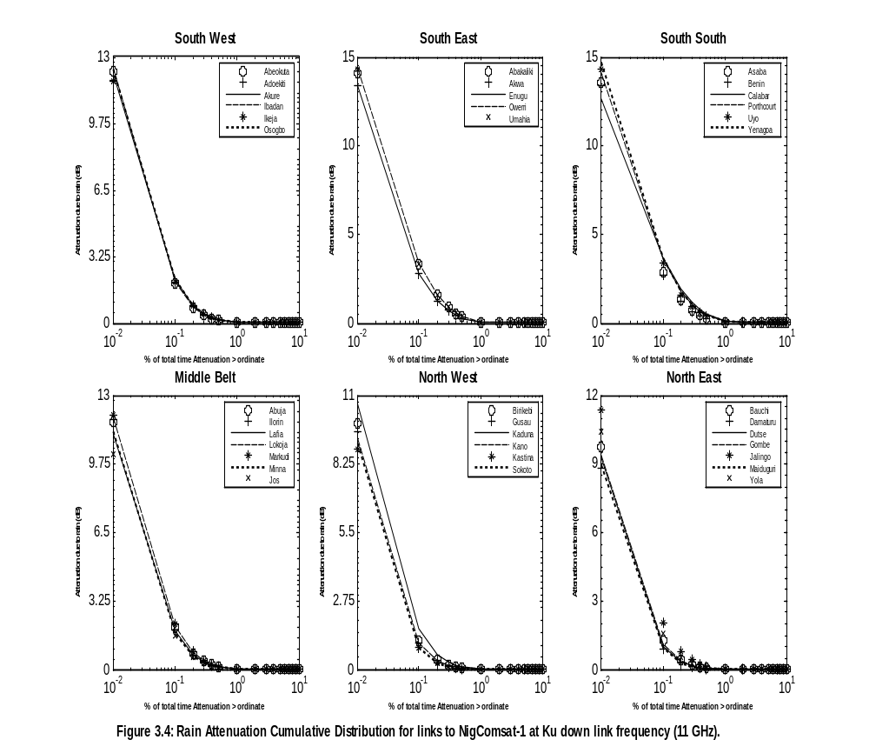

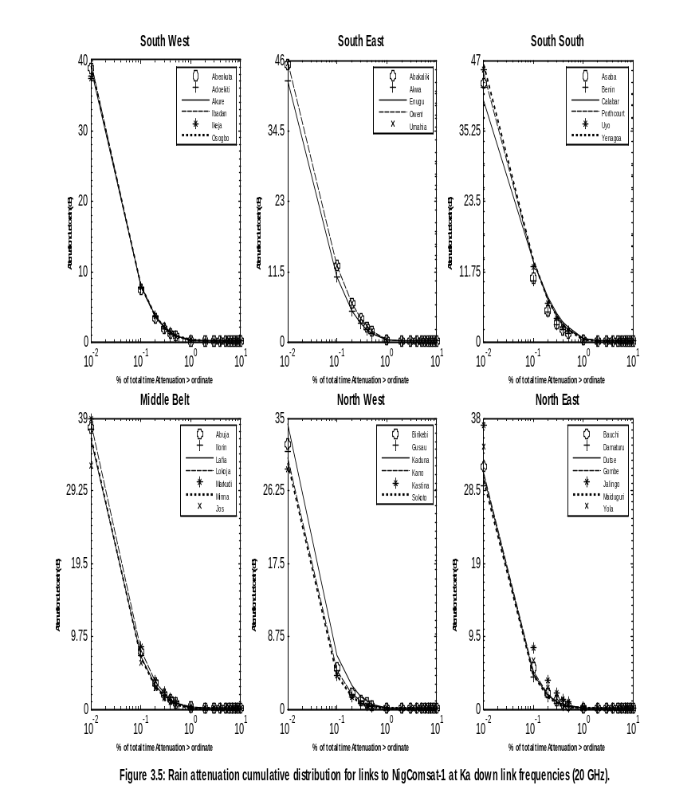
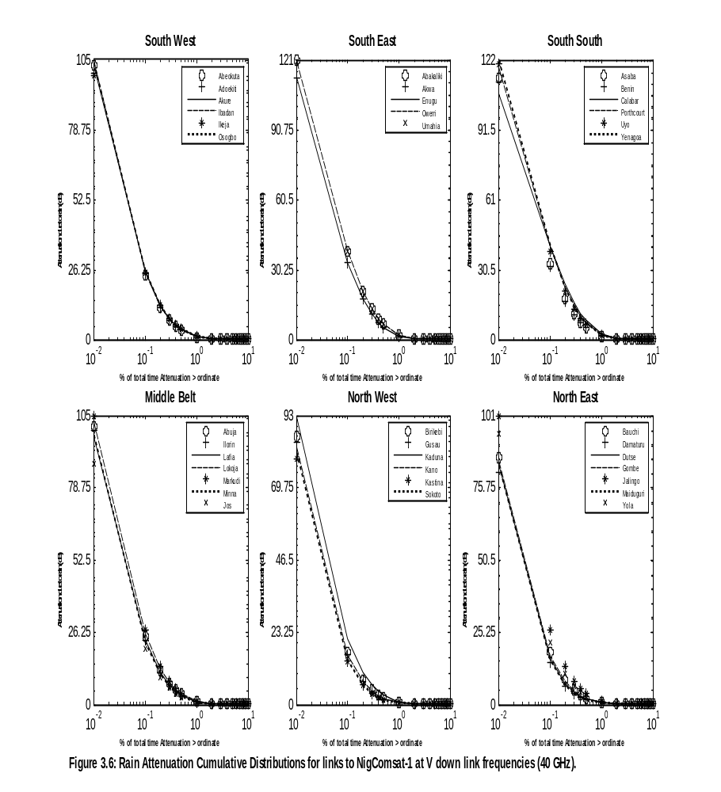

3.3 Results of Cloud Attenuations for 1% Unavailability of an Average Year
Figures 3.7 and 3.8 show the frequency characteristics of cloud attenuation for frequencies between 10-50 GHz at elevation angles of 5⁰ and 55⁰ degrees, respectively for 1% unavailability in an average year. The results show that cloud attenuation increases with increasing frequency and also increases with decreasing elevation angles and that at very low elevation angles on earth-space path, cloud attenuation was very high, as with rain attenuation.
At 5⁰ elevation angles, the results show the following distribution of cloud attenuation: SE region (1.56 - 33.19 dB), MB (1.57 - 33.06 dB), NE (1.58 - 32.95 dB), NW (1.58 - 32.87 dB), SW (1.55 - 32.41 dB) and SS (1.54 - 32.27 dB).
For 55⁰ elevation angles, the corresponding distribution is as follows: SE (0.16 – 3.54 dB), (0.16 – 3.52 dB), NE (0.16 – 3.51 dB), NW (0.16 - 3.5 dB), SW (0.16 - 3.45 dB) and SS (0.16 - 3.44 dB).
It can be seen from Figures 3.7 and 3.8 that cloud attenuation results for all the locations in each region are approximately the same at all the frequencies investigated. The reason is that the values of the Total Columnar Content of liquid water L (kg/m²) is nearly the same for all stations in each region and the specific attenuation coefficient K_{l}, is the same for all locations as assumed by the ITU-R 840 procedure ( a cloud temperature of 0° C) reported in Chapter 2.
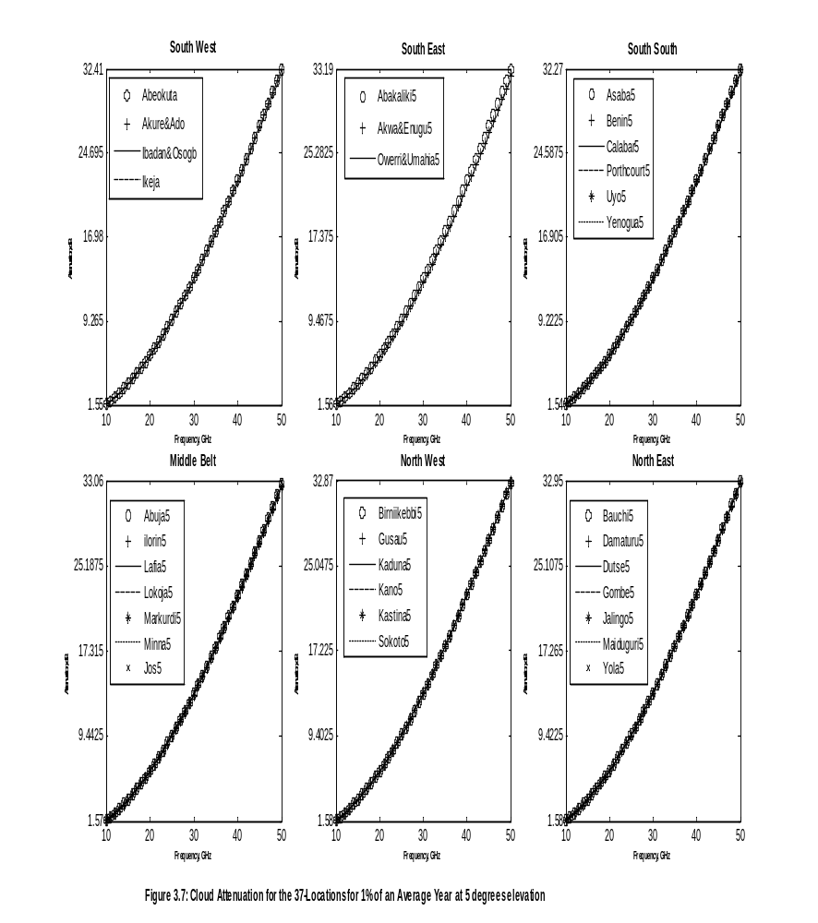
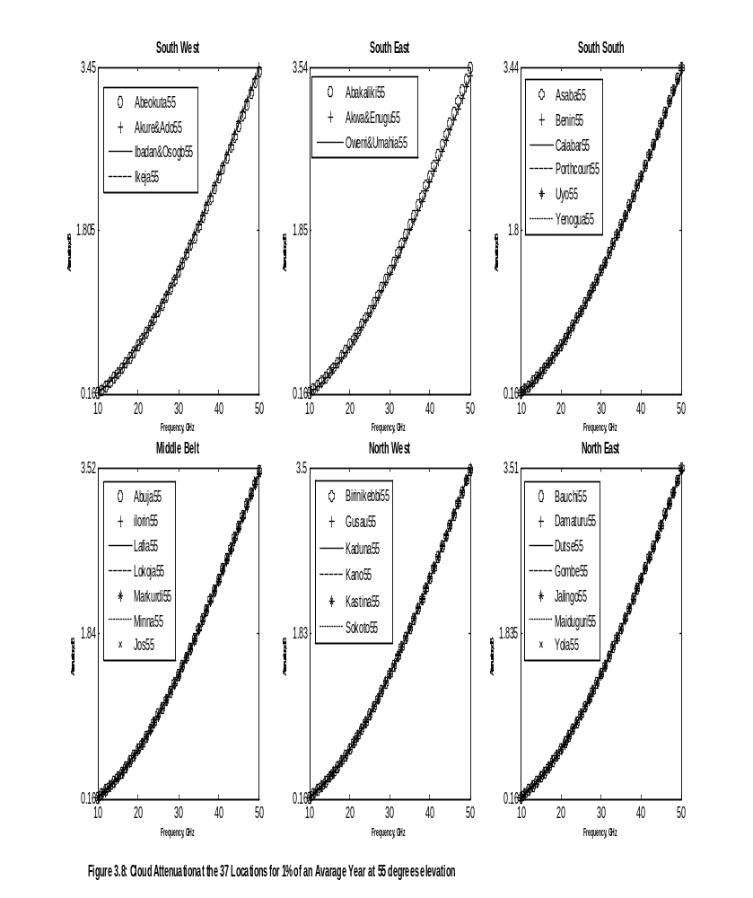

3.3.1 Cloud Attenuation Results at Ku, Ka and V bands for 1% Unavailability of an Average Year at 37 Stations in Nigeria.
Tables 3.9 and 3.9.1 show the results of cloud attenuations at Ku, Ka, and V bands for 1% unavailability of an average year at the 37 locations. At 5⁰ elevations angle, cloud attenuation is very low for Ku uplink and downlink being 1.9 to 3.1dB. At Ka down link cloud attenuation is between 6 to 6.3dB. But at Ka uplink for 5⁰ elevations, cloud attenuation will be a serious concern in satellite link budget. The loss is between 13 to 13.5dB in all the 37-locations. César Amaya, (2002) had observed a similar cloud attenuation of (6-12dB) radiowave signal at 20GHz for elevation angle of 5 degree. At V-band uplink and down link, cloud attenuations were very high in all the 37-locations and are between 21.8 to 33.2dB. Therefore, there will be total fade out of signal at V bands. Most clear sky conditions are designed with a fade margin of 6 to 7dB (Edward and Richard, 1989).
At 55⁰ elevations, cloud attenuation is very low at all the bands investigated for both uplink and down link frequencies. Losses due to cloud in all the 37 locations is between 0.1 to 3.5 dB, therefore, 99% availability of radio signal is possible at Ku, Ka, and V band for 55⁰ elevations.
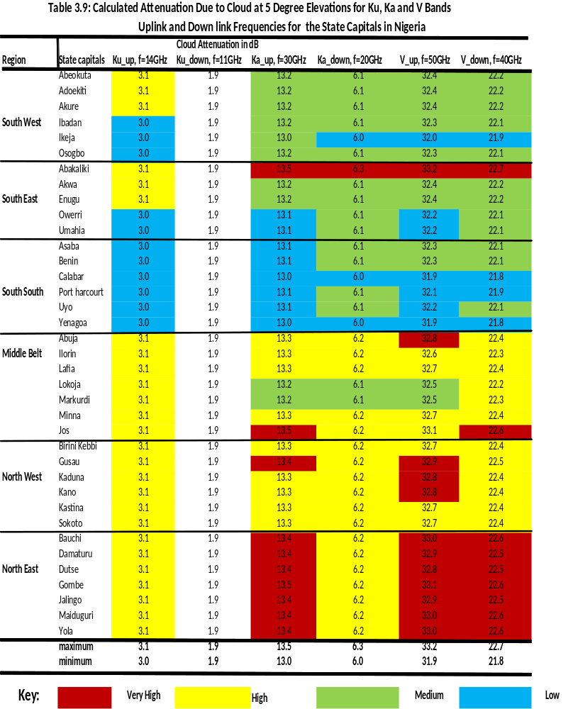
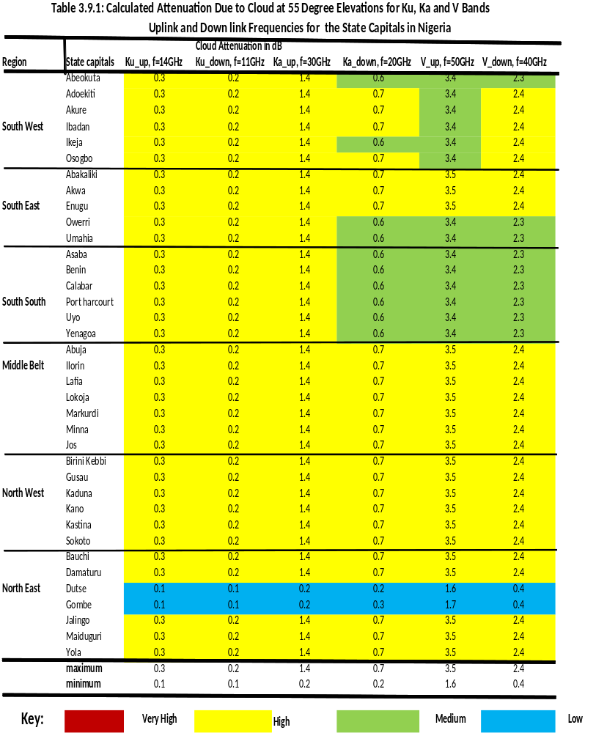

3.3.2 Cloud Attenuation for Links to NigComsat-1 at Ku, Ka and V-band for 0.01-10% Unavailability of an Average Year
As previously stated, elevation and azimuthal angles for links to NigComsat-1 for each of the 37 locations were calculated and used as one of the input parameters for the calculations of cumulative distributions of cloud attenuations from 0.01% to 10% unavailability. Figure 3.9 to 3.9.2 show the cloud attenuation cumulative distribution for links to NigComsat-1 down link frequencies at Ku (11GHz), Ka (20 GHz), and V (40 GHz) bands for 0.01% to 10% unavailability. At these three bands down link frequencies, it is seen that 99.99% availability is possible in all the 37 stations in Nigeria. Cloud attenuation is generally very low, at the three bands for all the six regions: At Ku downlink frequency it ranges from 0.01 dB (in NW) to 0.42 dB (in SW). For Ka it ranges from 0.05 (in NW) to 1.34 dB (in SW), while at V-band it ranges from 0.18 (in NW) to 4.9 dB (in SW). These results show consistently that cloud attenuation is generally higher in the SW region than in the NW region of Nigeria and that in the V-band, cloud attenuation could become a serious concern for earth-space satellite link in the SW region. At 0.01% unavailability these results suggests that in SW region if a satellite link is designed with small margin of 3 dB at V-band, the link will experience a total fade out of signal due to cloud attenuation even in clear sky conditions.
.
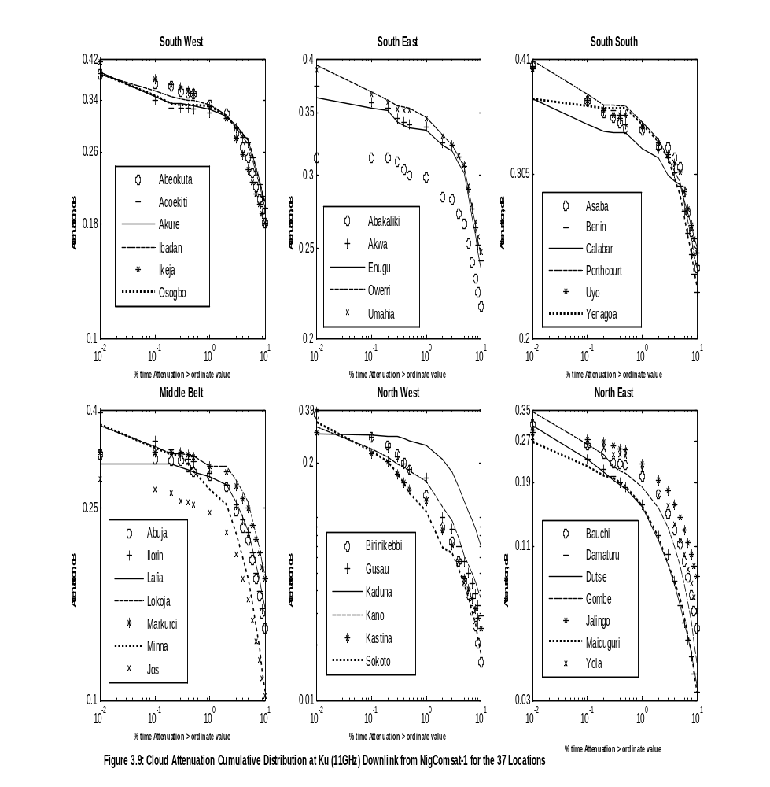

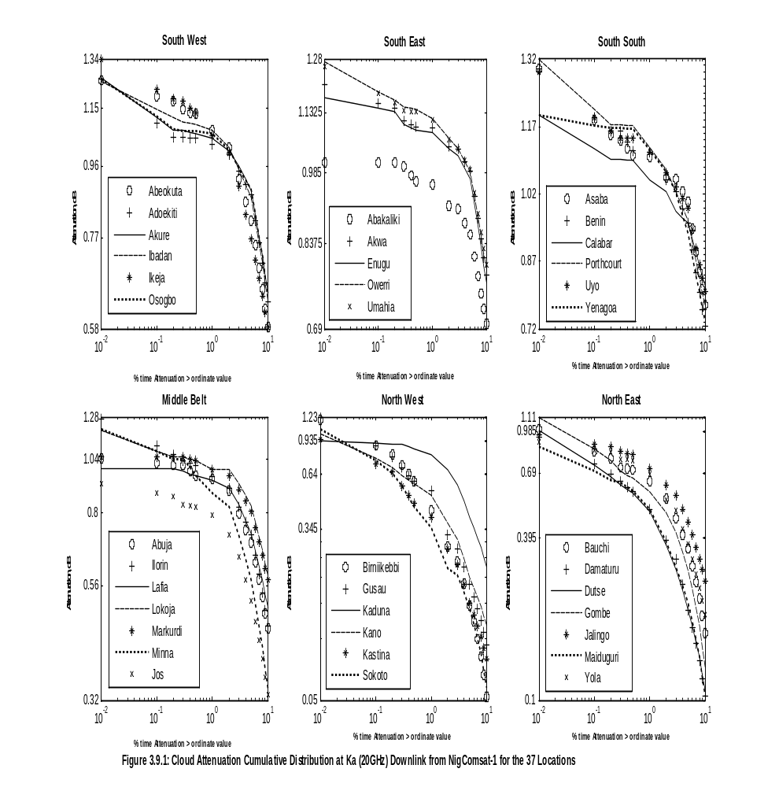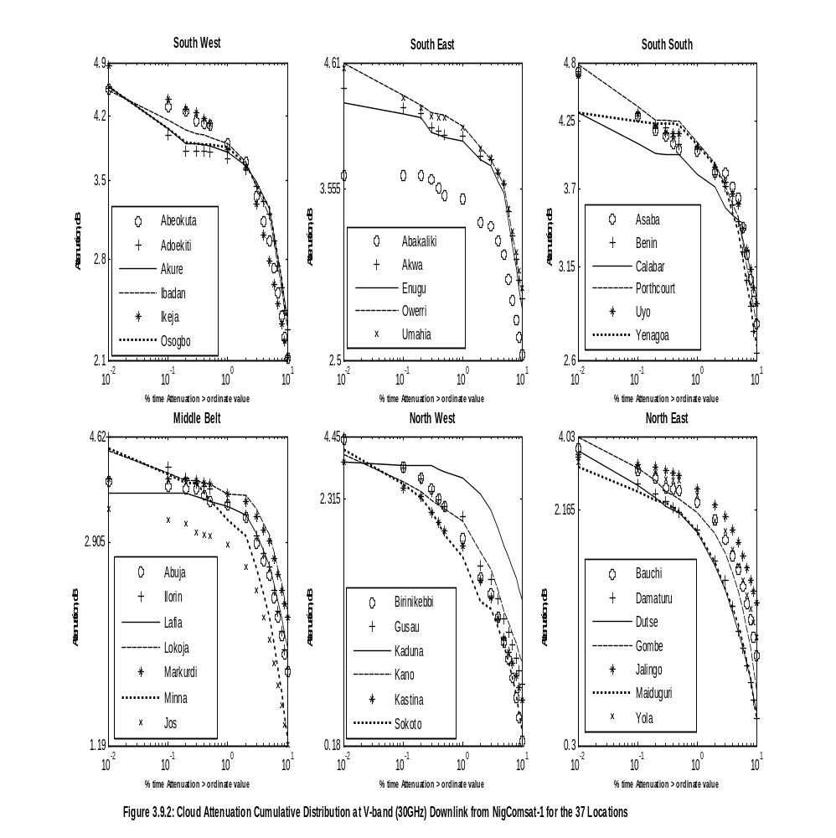

3.4 Gaseous Attenuation for 1% Unavailability of an Average Year at the 37 Locations in Nigeria
Figures 3.10 and 3.11 show the frequency characteristics of gaseous attenuation at the two elevation angles of 5⁰ and 55⁰, respectively, for 10-50 GHz at 1% unavailability in an average year. The results show that gaseous attenuation increases with increasing frequency up till 22.5 GHz, but reduces with increasing frequency between 22.5 to 30 GHz and increases with increasing frequency above 30 GHz. This behavior is due to water vapor as the main contributor to gaseous attenuation in the frequency range just below 30 GHz and its maximum occurring at 22.5 GHz. It is also observed that gaseous attenuation also increases with decreasing elevation angle but decreases with increasing elevation angle. This behavior is due to different effective slant path lengths using the cosecant law of equation (17) in Section 2.6.4 in Chapter 2.
For 5⁰ elevation, gaseous attenuation was highest in Calabar (the SS regions) with values between 0.55 to 17.27 dB followed by Ikeja (in the SW) with a value of 0.52 to 17.24 dB, and Abakaliki (the SE) with value between 0.54 to 17.16 dB. Gaseous attenuation was lowest in Katsina (the NW regions) with value between 0.46 to 16.06 dB followed by Dutse (NE) 0.64 to 16.5 dB, and Abuja (MB) 0.5 to 16.88 dB. The result suggests that at very low elevation angle even in clear sky condition gas attenuation on earth-space path was comparable with rain attenuation. The propagation loss in all the six regions is between 0.46 to 17.27 dB
At 55⁰ elevations, gaseous attenuation was also highest in Calabar (the SS region) with values between of 0.05 to 1.88 dB, followed by Ikeja (the SW), 0.05 to 1.84 dB, and Abakaliki (the SE region) with values between 0.55 to 1.83 dB and was lowest in Katsina (the NW region) with values between 0.04 to 1.71 dB, followed by Dutse (the NE) 0.04 to 1.76 dB, and Abuja (MB) with values between 0.05 to 1.8 dB. The propagation loss at 55⁰ elevations in all the six regions is very small and is between 0.04 to 1.88 dB. The reason for the higher gaseous attenuation in the Southern part was because of the high values of surface water vapour density (SVD) and integrated water vapour contents IWVC (as shown in Table 2.6) recorded for the southern regions as against the low value of SVD and IWVC which were responsible for the low gaseous attenuations in northern regions.
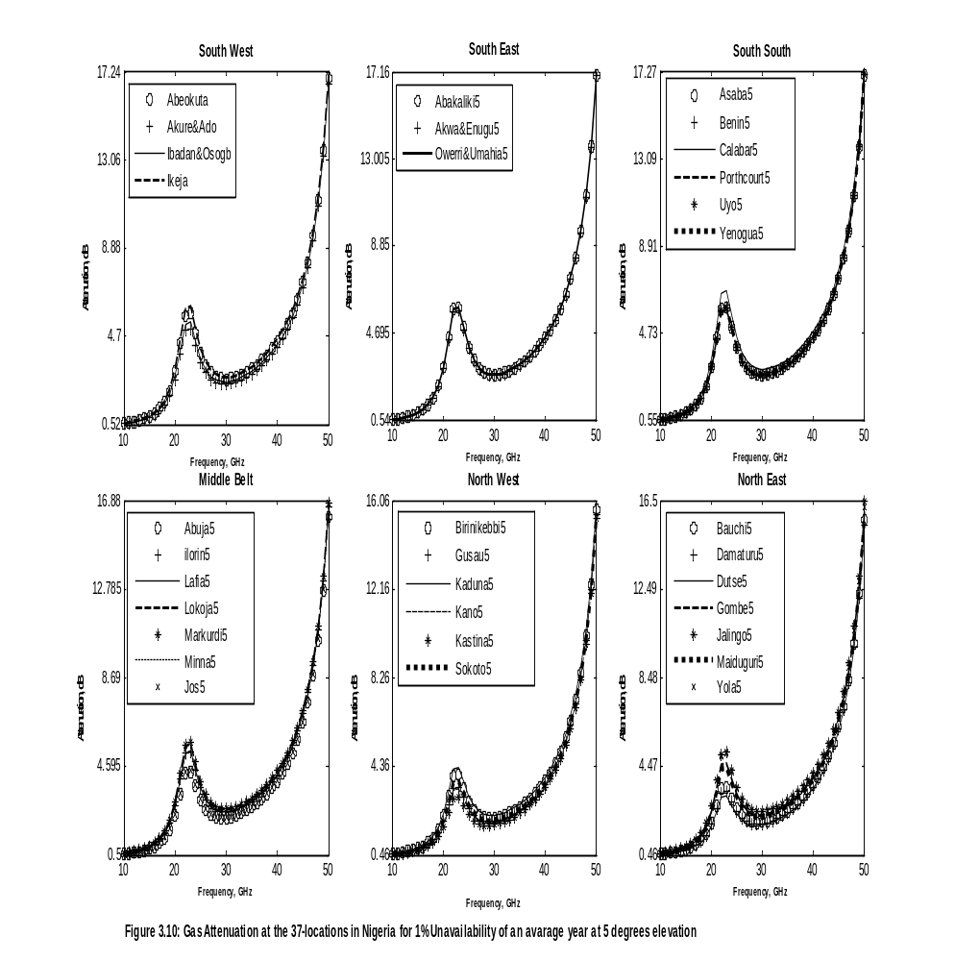
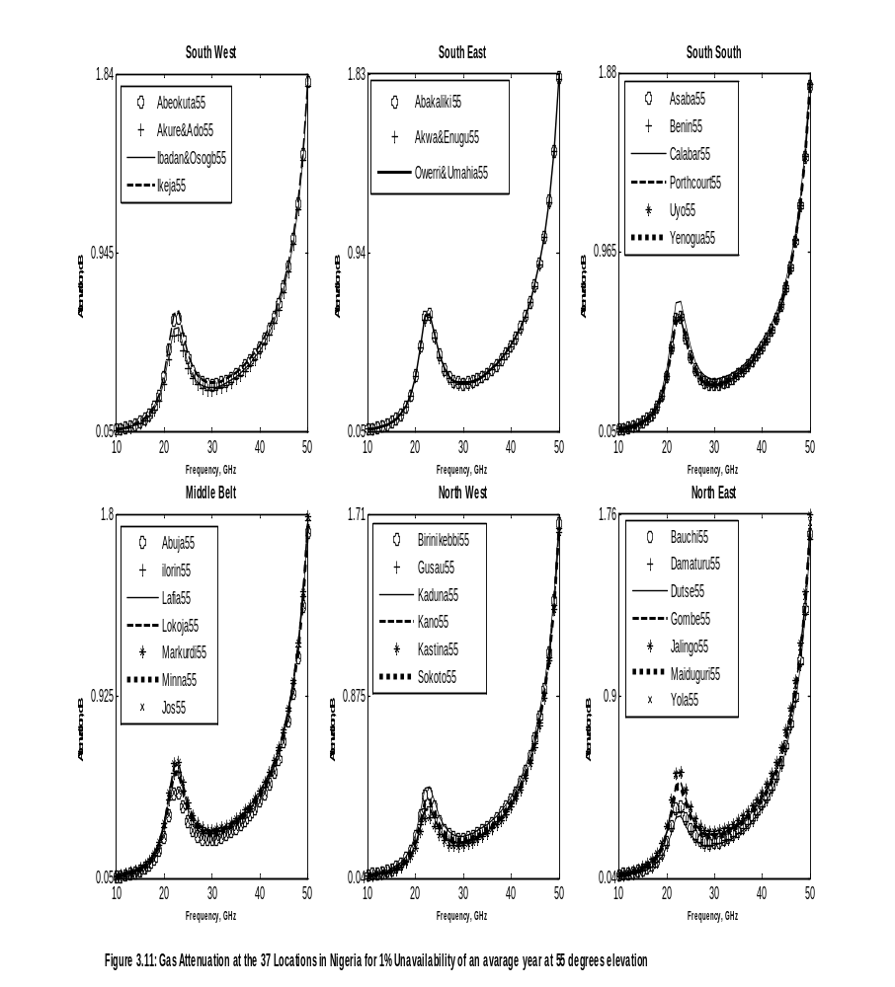

3.4.1 Gaseous Attenuations at Ku, Ka and V bands for 1% Unavailability of an Average Year at the 37 Stationss in Nigeria.
Tables 3.10 and 3.11 summarize the results of gas attenuation at Ku, Ka and V-bands for uplink and down link frequencies at the two elevation angles for the 37 stations. The colour chart was used for easy visualization. At 5⁰ and 55⁰ elevations the results showed that at Ku, Ka (uplink and downlink) and V-band downlink frequencies gaseous attenuations are low in all the 37 stations lying between 0.06 to 4.81 dB. Most clear sky conditions are designed with a loss margin of 6 to 7dB. But at V-band up links at both elevation angles, gaseous attenuation became very significant as attenuation was between 15.3 to 17.62 dB, in all the 37 stations. These suggest total outage of signals at V-band uplink for small elevations angles even in clear sky condition at all the 37 stations. This implies that 99% availability of radio signal is not possible at very low elevation angle for the V-band uplink. But at 55⁰ elevation, gaseous attenuation was low for the V band uplink, the attenuation being between 1.63 and 1.87 dB. At both elevation angles the Color charts show that gaseous attenuation (for all the three bands) is most severe in Calabar (the SS region) follow, in decreasing order, by Ikeja (SW), Owerri and Umahia (SE), Abuja (MB), Dutse (NE) and Kastina (NW) regions.

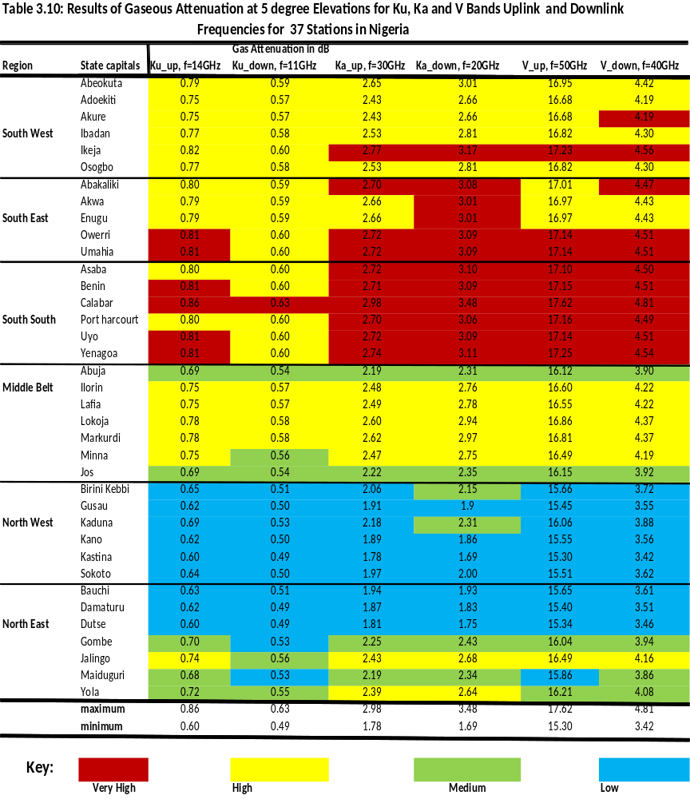
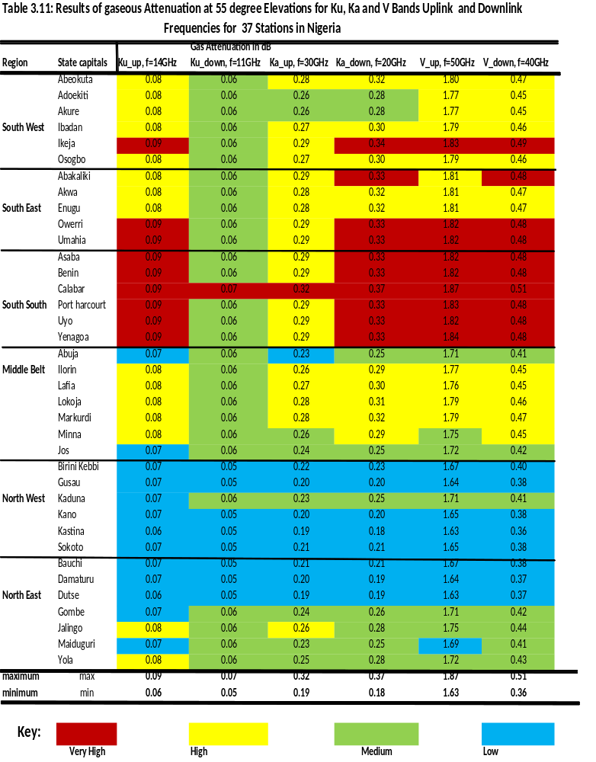

3.4.2 Gaseous Attenuation for Links to NigComSat-1 at Ku, Ka, and V-Bands for 1% Unavailability of an Average Year at 37 Stations in Nigeria.
Table 3.12 below summarizes the results of gaseous attenuation at Ku, Ka, and V bands
for links to NigComsat-1 for each of the 37 Stations under investigation. The result suggests that 99% availability is possible and that gaseous attenuation is negligible at Ku, Ka (uplink and downlink). But for the V band downlink, gaseous attenuation ranges between 0.05 to 0.39 dB, in all the 37 Stations. At V-band uplink, gaseous attenuation becomes very significant as gaseous attenuation ranges from 1.69 to 2.14 dB in all the 37 locations. The results for link to NigComSat-1 show that, gaseous attenuation is generally high in Ikeja (the SW region) follow, in descending order, by Calabar (SS), Enugu (SE), Ilorin (MB), Kano (NW) and Damaturu (NE) regions.

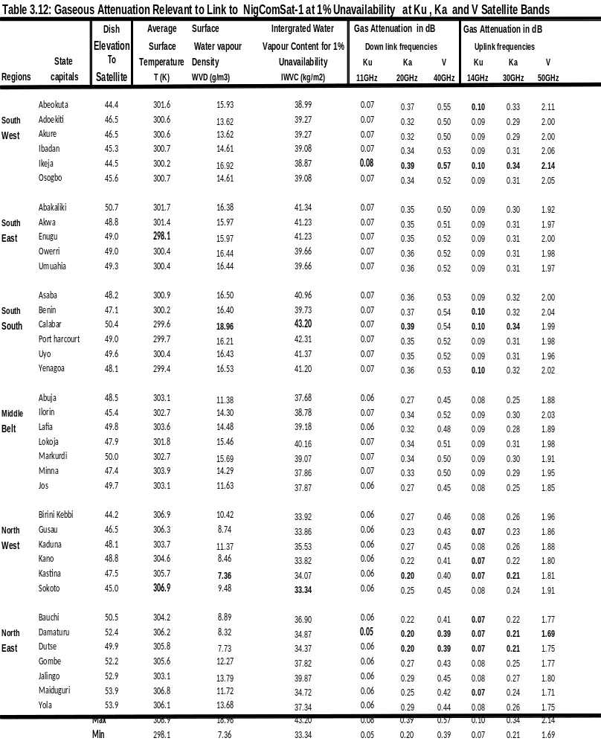

3.5 Scintillation Fade Depth for 0.01% Unavailability at 5⁰ and 55⁰ for 37 Stations in Nigeria.
Figures 3.12 and 3.13 show the frequency characteristics of tropospheric scintillation fade depth along earth-space paths at the two elevation angles of 5⁰ and 55⁰ for 10 to 50 GHz at the 37 stations for 0.01% unavailability. The results show that scintillation fade depth increases with increasing frequency and increases with decreasing elevation angle. At 5⁰ elevations, scintillation fade depth ranges between 4.04 dB in the NW to 19.08 dB in the SS regions. The results suggest that tropospheric scintillation is very high at low elevation angles and is comparable to rain attenuation. But at 55⁰ elevation angle, scintillation fade depth is very low and ranges between 0.27 dB in the NW to 1.29 dB in the SS regions. At both elevation angles, the results show that scintillation fade depth is most severe in Calabar (the SS region) followed, in descending order, by Ikeja (SW), Abakaliki (SE), Abuja (MB), Dutse (NE) and Kastina (NW) regions.

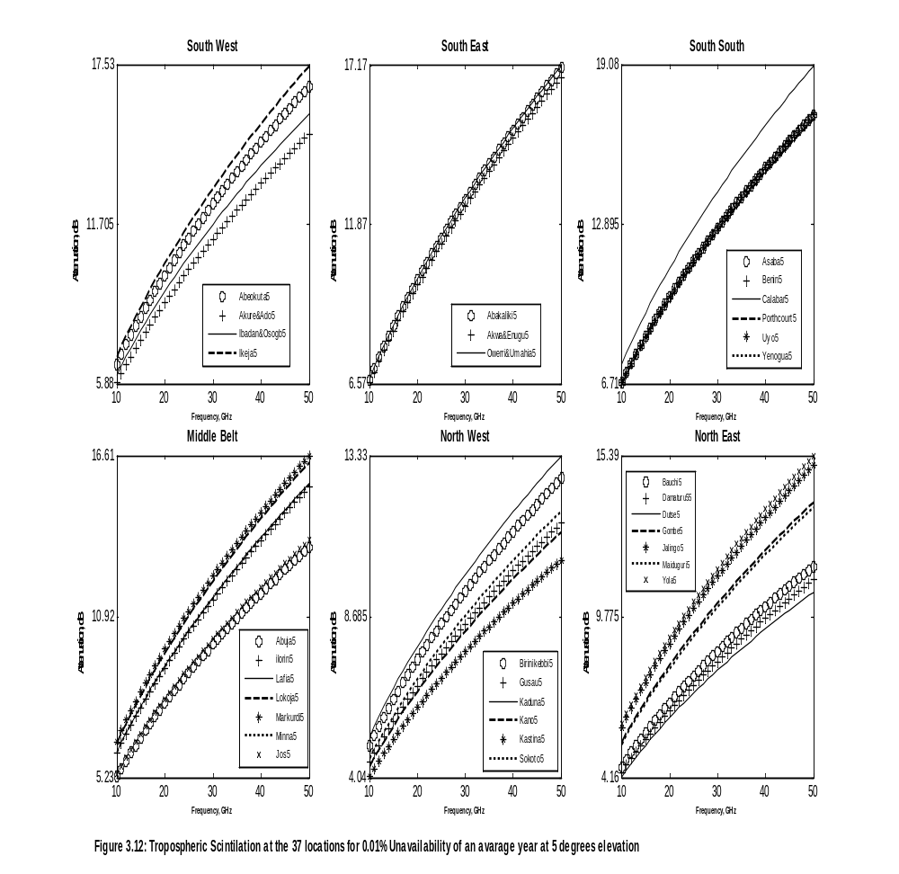

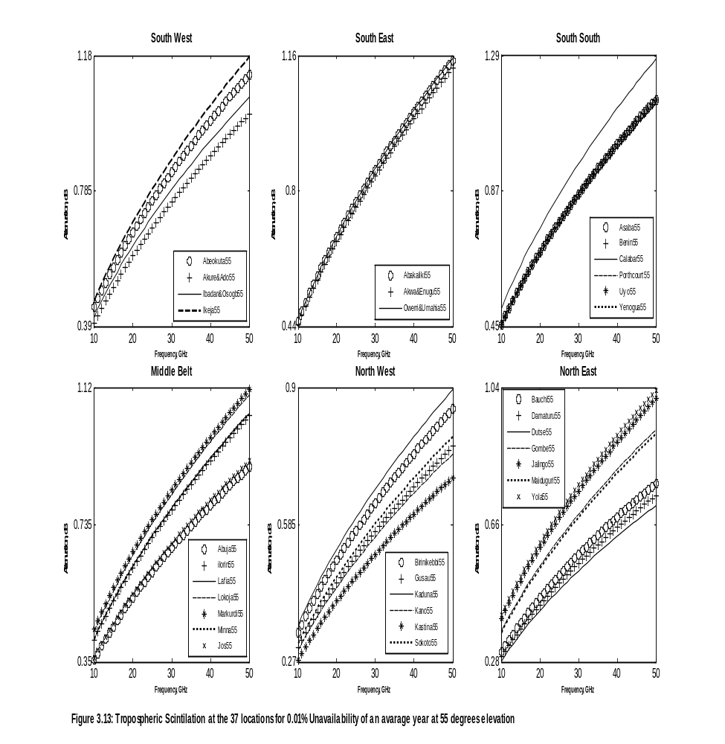

3.5.1 Scintillation Fade Depth for the 0.01% Unavailability at Ku, Ka and V-Bands at 37 Stations in Nigeria.
Tables 3.13 and 3.14 show the results of scintillation fade depth at elevation angles of 5 and 55⁰, respectively. Scintillation fade depth at 5⁰ elevations for Ku-band is between 4.27 to 9.09 dB, at Ka-band is between 6.05 to 14.17 dB, at V-band is between 9.06 to 16.75 dB for uplink and downlink frequencies at all the 37 stations. At 55⁰ elevation scintillation fade depth at Ku-band, is between 0.29 to 0.62 dB, at Ka-band it is between 0.41 to 0.96 dB, at V-band it is between 0.61 to 1.28 dB for uplink and downlink frequencies at all the 37 stations. These results suggest that at very low elevation angles for V-band uplink, 99.99% availability may not be practicable at all the 37 stations, because scintillation fade depth is between 10.32 to 19.07 dB. Most clear sky conditions are designed with a fade margin of 6 to 7 dB. But at 55⁰ elevations 99.99% availability is possible at all the 37 stations in all the bands considered.
The color charts summarize scintillation fade depth at all the 37 stations based on minimum and maximum values of attenuation occurring at all locations. At both elevation angles, of 5 and 55⁰ the chart shows that scintillation fade depth might be more severe in (Calabar) the SS region followed, in descending order, by (Abakaliki) SE, (Ikeja) SW, (Abuja) MB, (Dutse) the NE and (Kastina) NW regions.
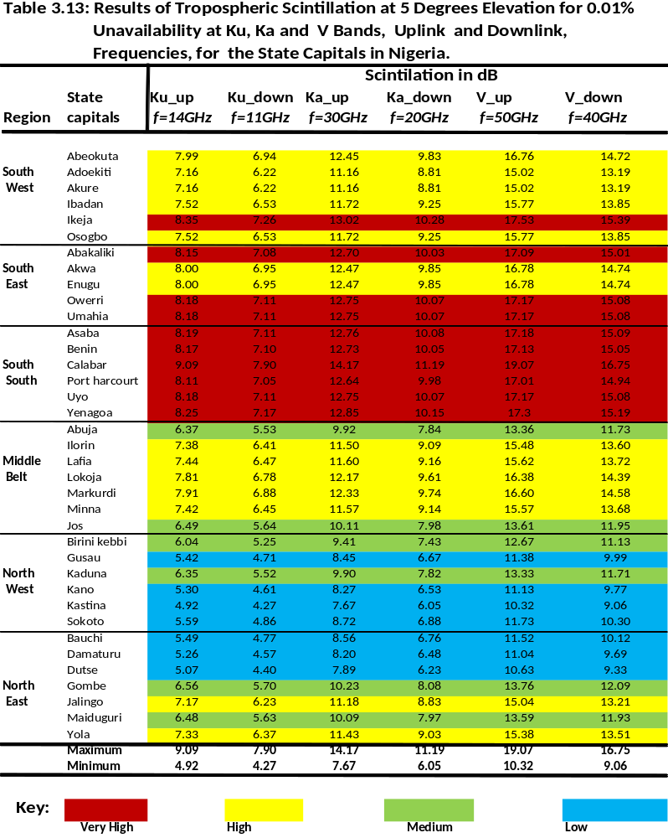
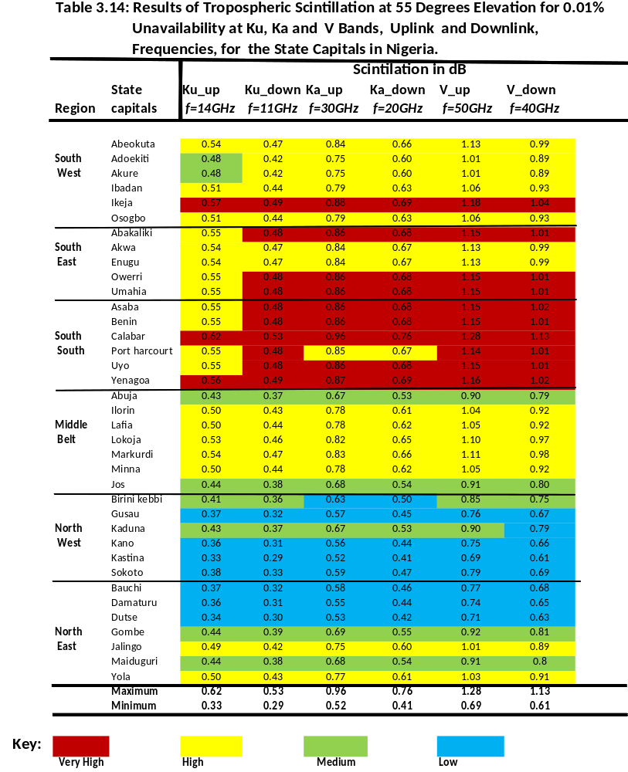

3.5.2 Scintillation Fade Depth for Links to NigComSat-1 at Ku and Ka for 0.01 - 10% Unavailability of an Average at 37 Stations in Nigeria.
Tables 2.7 in Chapter 2 shows the geometrical parameters relevant to scintillation fade depth for downlink from NigComsat-1 in the 37 stations. Figures 3.14 to 3.16 show cumulative scintillation distribution for down links to NigComsat-1 at Ku (11 GHz), Ka (20 GHz) and V-band (40 GHz) for 0.01% to 10% unavailability, respectively. At the Ku-band downlink, Figure 3.14 shows that scintillation fade depth is between 0.05 to 0.6 dB for all the locations. At the Ka-band downlink, Figure 3.15 shows that scintillation fade depth is between 0.08 to 0.84 dB, for all the 37 stations. At V-band downlink, (Figure 3.16) is between 0.12 to 1.26 dB for all the locations. NigComsat-1 carries an antenna power is 50, 70 Watts at Ku, Ka bands, respectively. These results imply that tropospheric scintillation will not be a serious concern and that 99.99% availability of signal is possible at all the 37 stations.
The summary of results for links to NigComsat-1 at all the downlink frequencies considered is that scintillation fade depth is highest in (Ikeja) the SW region, followed in descending order, by Calabar (SS), Enugu (SE), Jos and Abuja (MB), Damaturu and Bauchi (NE) and Sokoto (NW) regions.

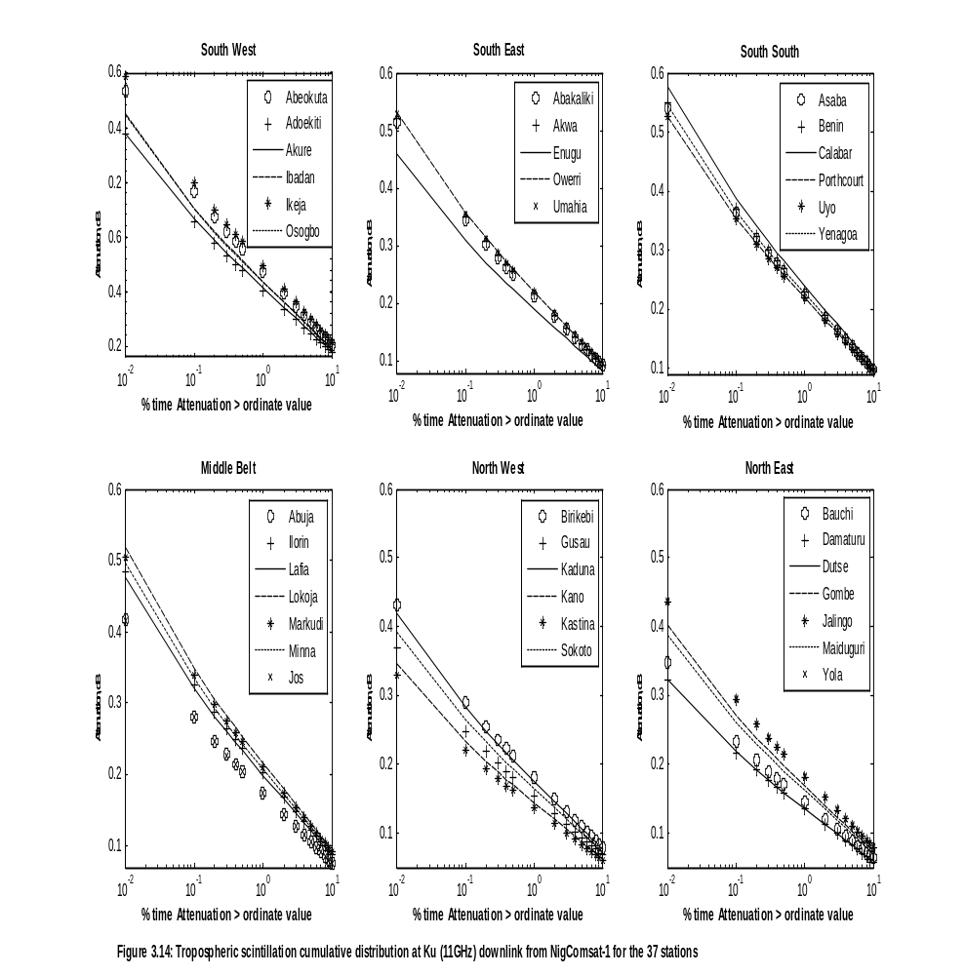
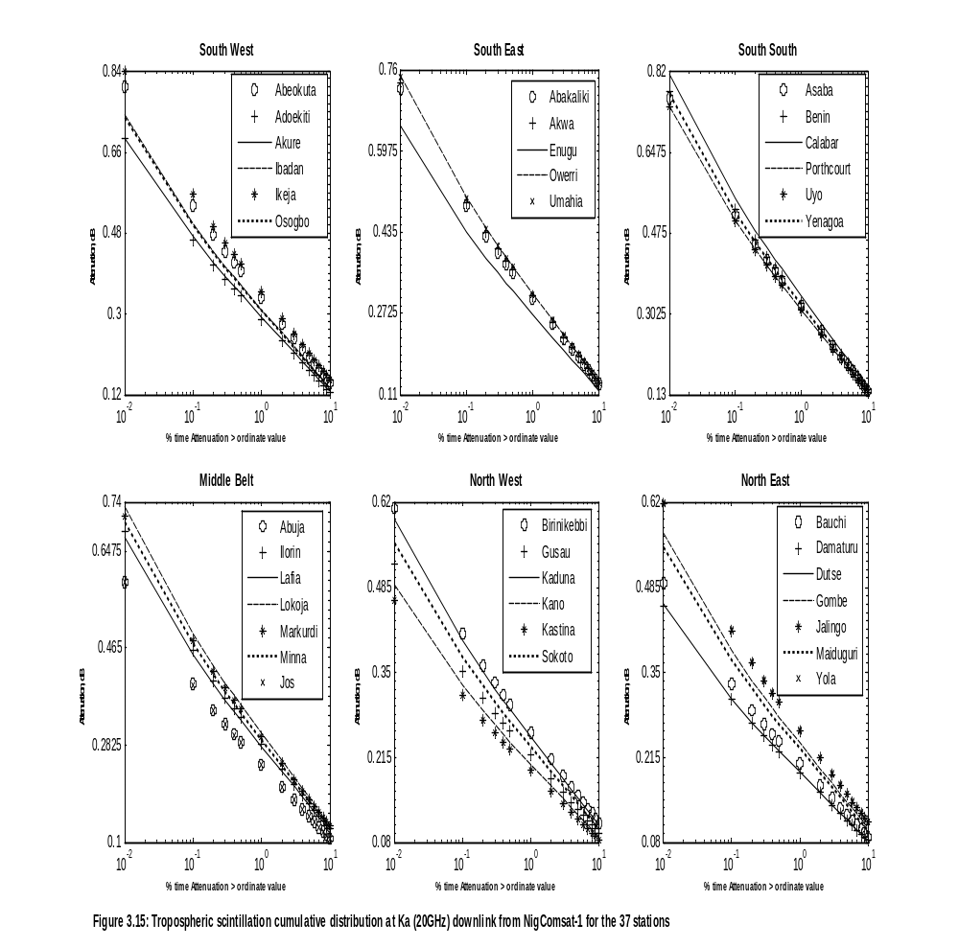
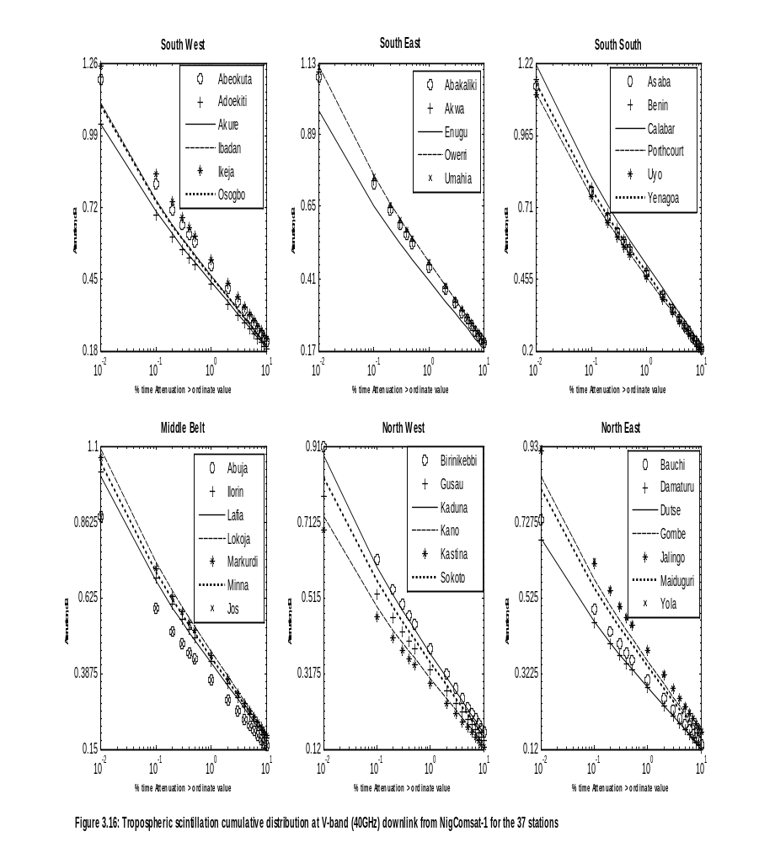

3.6 Combined Attenuation for 0.01% Unavailability in an Average Year for Frequencies 10 to 50 GHz at the 37 Stations in Nigeria
Figures 3.17 and 3.18 show the frequency characteristics of the combined attenuation, due to multiple sources of simultaneously occurring atmospheric attenuations at elevation angles of 5⁰ and 55⁰ for 0.01% unavailability of an average year, respectively. The results indicate that combined attenuation reduces with increasing elevation angle while it increases with increasing transmitting frequency. Combined attenuation at 5⁰ elevation is between 37 dB (in the NW) to 431 dB (in the SE). These results suggest that 99.99% availability may not be practicable, there will be a total fade out of signal at very low elevation on earth-space link due to multiple sources of simultaneously occurring atmospheric attenuation in all the 37 stations. But at 55⁰ elevation, combined attenuation was very low in the NW (7 dB) region and very high in the SE (159 dB) region. The results suggest that at 55 degrees elevation and for frequencies between 10-14 GHz, 99.99% availability of radiowave signal is possible in all the 37 stations.
At both elevation angles considered the results suggest that combined propagation
impairment on earth-space path was highest in (Abakaliki) the SE region followed, in descending order, by Uyo (SS), Ikeja (SW), Markudi (MB), Maiduguri (NE) and Kastina (NW) regions.
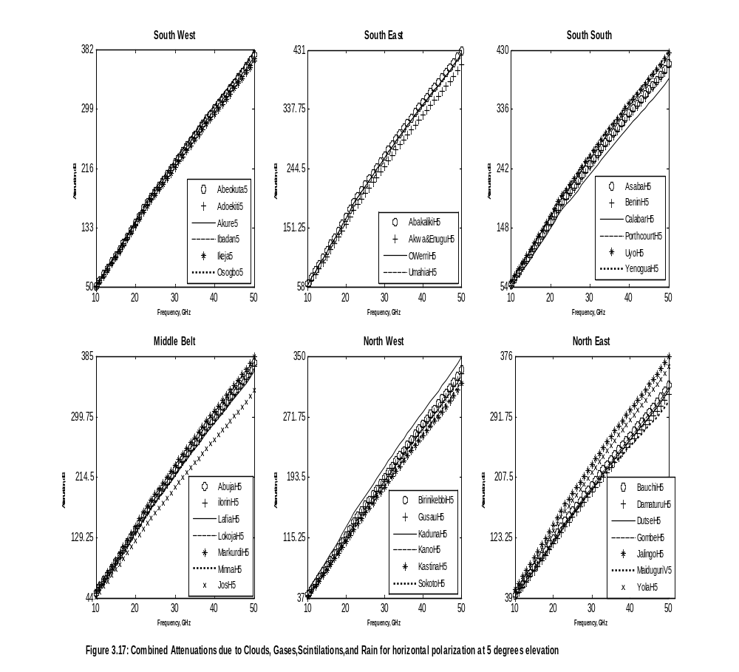
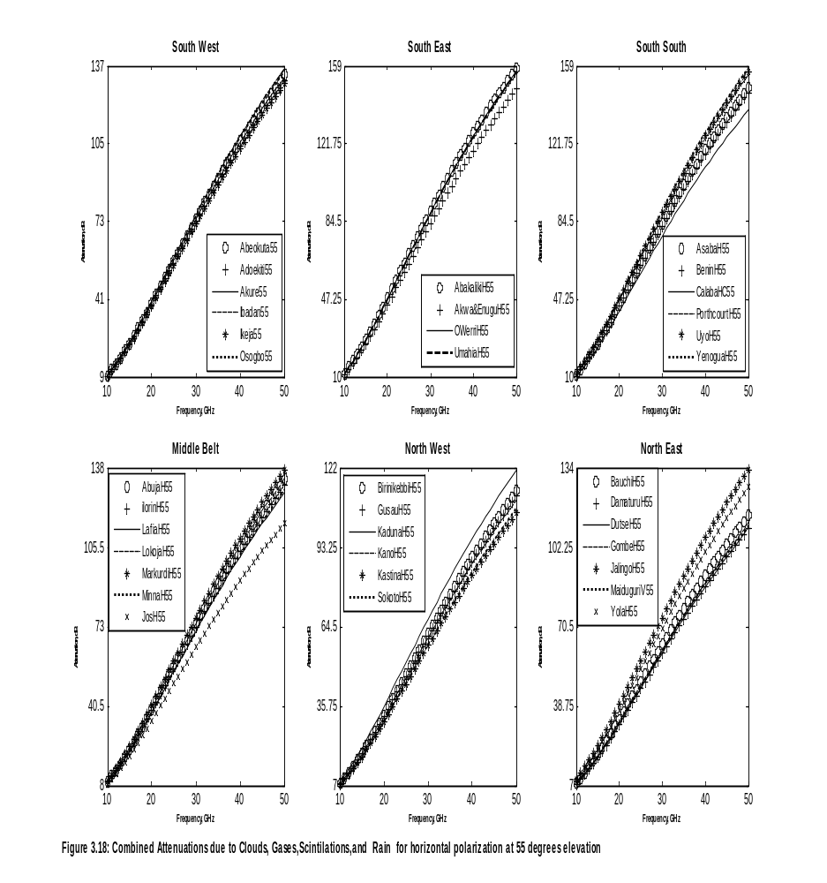

3.6.1 Combined Attenuation at Ku, Ka and V Bands for 0.01% Unavailability in an Average Year at the 37-locations in Nigeria
Tables 3.15 and 3.16 show the results of combined attenuation at Ku, Ka and V bands due to
multiple sources of simultaneously occurring atmospheric attenuation on satellite links for elevation angles of 5⁰ and 55⁰, respectively. At 5⁰ elevation the results suggest that there will be total fade out of signal at Ku, Ka and V-bands uplink and downlink frequencies. The propagation loss at this very low elevation angle for all locations is between 44.8 dB in Sokoto the NW region at Ku band, and 348.9 dB in Abakaliki at V-bands in the SE region.
For 55⁰ elevation, the results indicate that for Ku-band uplink combined attenuation is between 15.1 dB in Sokoto and Katsina, (the NW region) to 24.4 dB in Yenagoa the SS region. For Ku downlink it is between 8.9 dB in Sokoto and Katsina, (the NW region) to 14.6 dB in Yenagoa the SS region. The result reveals that 99.99% availability of signal is possible at Ku band uplink and downlink with EIRP power > 15.1 dB. Most recent travelling wave tube amplifier (TWTA) on board most satellite in space cannot provide power beyond 1KW due to battery life of the transponders, but most earth transmitting stations for uplink can achieve more than 10KW of transmitter power. At Ka uplink for 0.01% unavailability there will be total outage (for any transmitter power less than 1KW) as the combined propagation loss in all of the 37 stations is between 30 to 48 dB, while at Ka downlink with a fixed margin of 30 dB outage level, there will be total outage of signal in all regions except Sokoto. At V-band for 0.01% unavailability there will be total loss of signal as combined attenuation in all locations is between 83.1 to 158 dB for both uplink and downlink.
In summary, at Ku, Ka and V bands the colour charts of Table 3.15 and 3.16 indicate that combined propagation loss due to multiple sources of simultaneously occurring atmospheric attenuation for elevation angles of 5⁰ and 55⁰ are more severe in Abakaliki (the SE region) followed, in decreasing order, by Yenagoa (SS), Osogbo (SW), Jos (MB), Damaturu (NE) and Sokoto (NW) regions.

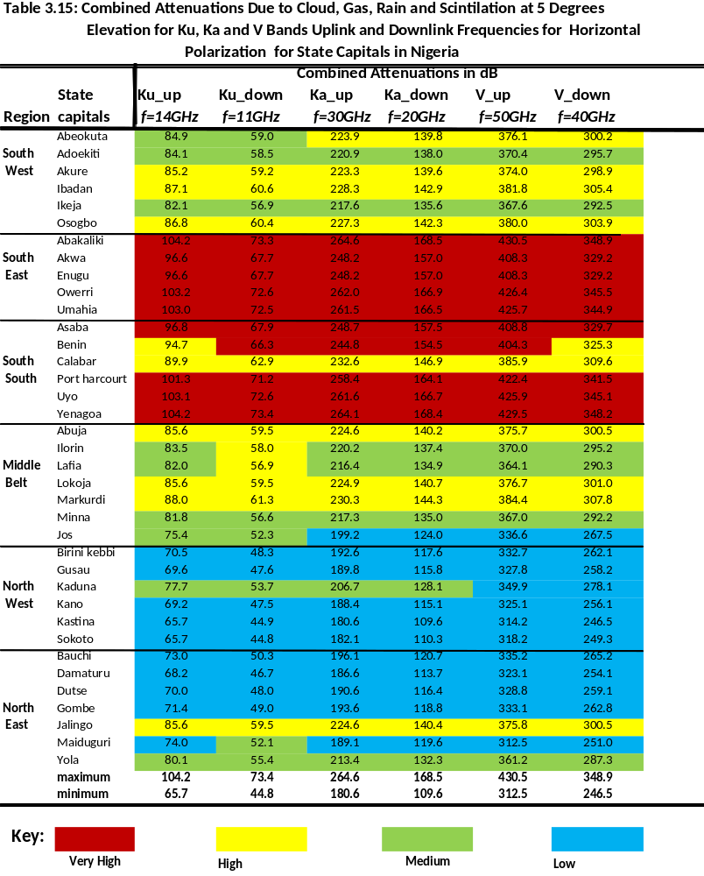
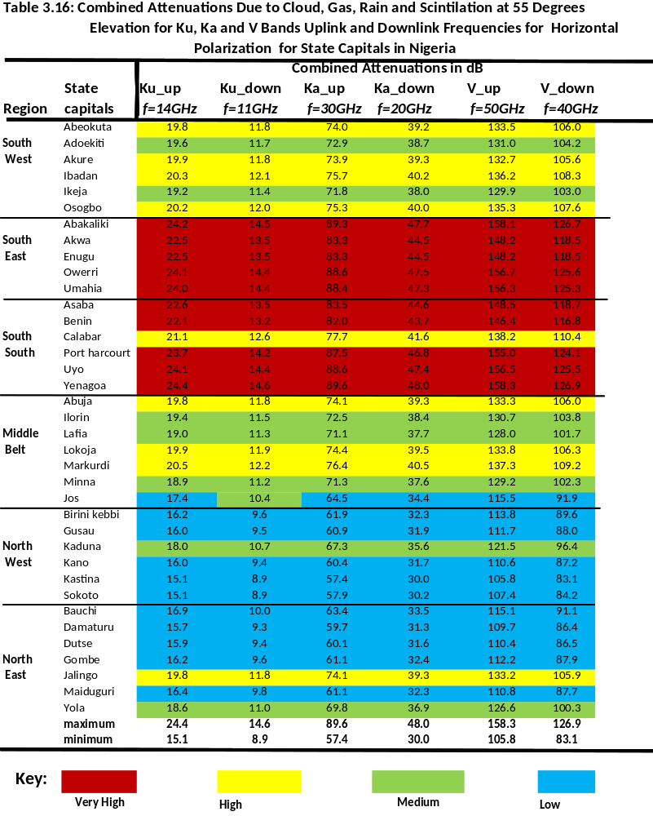

3.6.2 Combined Attenuation at Ku, Ka and V-bands for Downlinks from NigComsat-1 at 37 stations in Nigeria from 0.01 to 10% Unavailability in an Average Year.
The following results are for horizontal polarization (downlink frequencies) for all
stations, based on their true elevation and azimuth angles, for links to NigComsat-1. Figures
3.19, 3.20 and 3.21 show the combined cumulative distribution of attenuation due to rain,
cloud, scintillation and atmospheric gases at Ku (11GHz), Ka (20GHz) and V (40GHz) bands,
respectively from 99.99 to 90% availability of satellite signals in an average year for all of the
37 stations in Nigeria. The three graphs show that combined attenuation is highly severe
in Yenagoa the SS region followed, in decreasing order, by Owerri (SE), Ibadan (SW), Jos
(MB), Damaturu (NE) and Katsina (NW) regions.
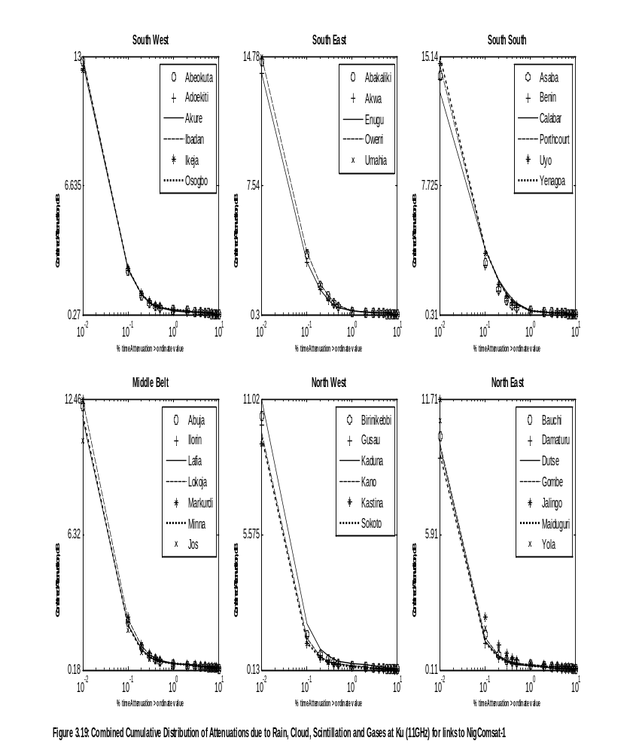
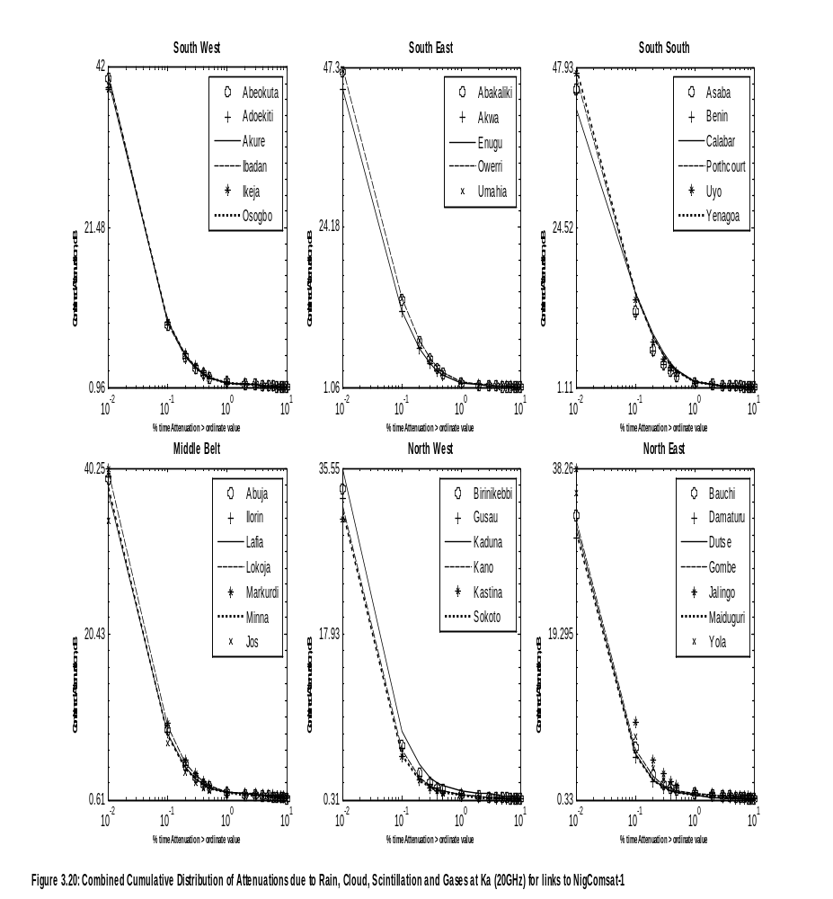
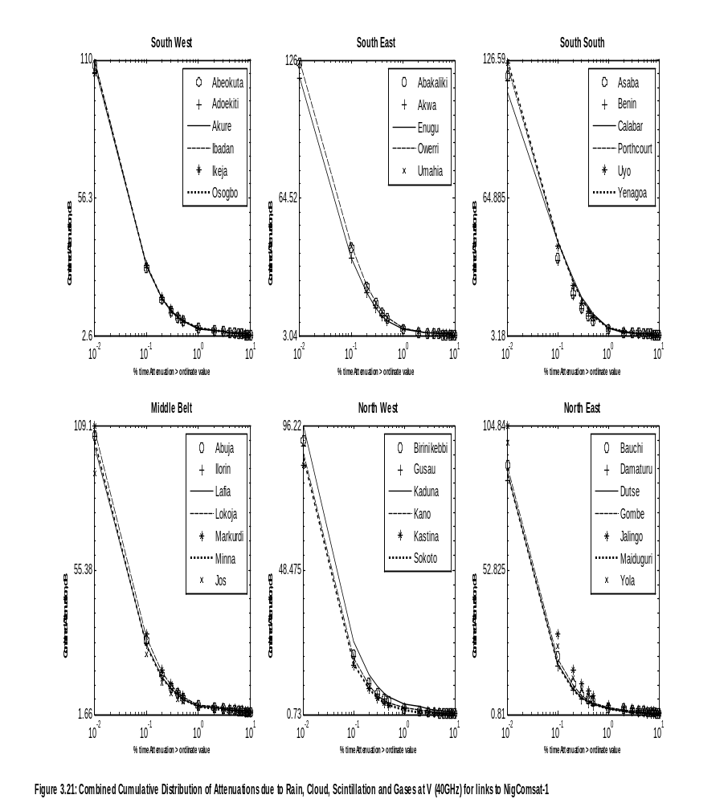

The percentage of time unavailabilities that are most important in propagation studies are from 0.01% to 1%. Table 3.17 to 3.19 summarize the results for the 37 stations in Nigeria. Table 3.17 shows that at Ku downlink from NigComsat-1 99.99% availability is possible as propagation loss was between 9.2 dB in (Katsina) the NW region to 15.1 dB in (Yenagoa) the SS region in all the 37 stations. NigComsat-1 carries a Ku-band antenna with maximum transmitting power of 150 W (21.76 dB), therefore signal availability at 99.99% of time is possible even in the presence of multiple sources of simultaneously occurring atmospheric attenuation.
With respect to the Ka band downlink from NigComsat-1 the results suggest that 99.99% availability is not possible in all locations. It can be seen from Table 3.18 that the loss at 0.01% unavailability is minimum in Katsina (NW region) with a value of 30.1 dB and maximum in Yenagoa (SS region) with a value of 47.9 dB. Since NigComsat-1 carries a Ka-band antenna with transmitting power between 17 dB and 18 dB, there will be total fade out of signal due to multiple sources of simultaneously occurring atmospheric attenuation in all the 37 stations. Table 3.18 suggests that the possible availability for all location will be 99.9% of an average year, as attenuation at this percentage is between 4.9 dB in Katsina (the NE region) to 15 dB in Yenagoa the SS region.
At the V-band for future Nigeria geostationary satellite with a V-band antenna, Table 3.19 suggests that 99.99% availability is not possible at V-band as the losses are between 83 to 126.6dB. The table shows that 99.9% availability is possible only in two locations Katsina and Sokoto (NW region) as the losses at the two locations is about 17dB. In the SW, MB, NW and NE regions availability of 99.8% is possible with a V-band antenna transmitting at about 80W as the loss for these four regions is between 9.1 dB and 18 dB. But the most reliable availability for all the 37 stations will be 99.6% of an average year, as Table 3.14 show that the loss at 0.4% unavailability is between 4.4 dB in Katsina (NW) to 16 dB in Calabar (SS). The colours used in Tables 3.17 to 3.19 are for easy visualization of the combined propagation impairments on earth-space path for the 37 stations for downlink from NigComsat-1. It is seen from the Tables that combined attenuation is highly severe in Yenagoa (the SS regions) followed, in descending order, by Owerri (SE), Ibadan (SW), Jos (MB), Damaturu (NE) and Katsina (NW) regions.


