CONCEPTUAL MODELLING OF FACILITIES MANAGEMENT DRIVEN HOTELS IN SOUTH-WESTERN NIGERIA
¹Olufemi Daniel Durodola, daniel.durodola@yahoo.com and
²Olawande Ayotunde Oni, wandeoni@yahoo.com
³Abiodun Caleb Ayedun, caayedun@yahoo.com
^{1,2,3}Department of Estate Management, Covenant University, Nigeria

ABSTRACT
Models in whatever form on Facilities Management (FM) driven business organizations are scanty in literature, and the available models are developed to depict the workings of few sections of facilities management, covering just few sectors of the Nigerian economy. Consequently, the researcher attempted to develop a conceptual model based on what is reasonably expected of the impact of facilities management principles on hotel organizations adopting FM holistically in South-Western Nigeria. The Conceptual model is validated based on the results emanating from a survey of fifty-seven hotels. Out of the fifty-seven questionnaires administered on hotel management, twenty-eight (49%) were retrieved while in respect of customers, six hundred and seventy-one questionnaires were administered from which three hundred and sixty (54%) were retrieved. Stratified sampling technique was adopted to select the samples while appropriate sample size was determined following the formula given by Kothari (1978). Data analysis was executed using descriptive statistics and Chi-Square (χ²). The validated heuristic model was derived and recommended as a template for hotel management operation where facilities management principles are employed.

Keywords: Facilities Management, Heuristic Model, Hotel Operation, Model Validation

1.0 INTRODUCTION
Literature is replete with the huge benefits derivable from holistic application of Facilities Management (FM) principles to business organizations (Owen, 1995; Spedding and Holmes, 1999; Meyer, 2003; Adewumi and Ogunba, 2006; and Durodola, Ayedun and Akinjare, 2012). The general presumption is that organizations imbibing the tenet of FM invariably remain effective. For instance, Hamer (1988) insisted that by implementing a facility management program, the manager should be able to develop more meaningful and accurate forecasts of future space requirements; reduce expenditure of resources, prepare more accurate future capital budgets; provide a framework within which to meet established budgets more effectively; improve employee morale; and improve organizational performance. Others are encouragement of employees to become more anticipatory and less reactionary in their facility management decisions; manage information proactively; carry out inventory of space and control of equipment and furnishings; control effectively capital resources required to support operations; and achieve improvement in overall work environment.
Researchers (notably, Amaratunga, 2000; Bracketz and Kenley, 2002; Kotze and Nkado, 2003; Okoro, Jones and Ilozor, 2003; Wai, 2003 and Durodola, 2009) probed into the efficacy of FM in solving organizational problems wherever it is holistically adopted as instrument of strategic change. Amaratunga (2000) in examining building performance evaluation in higher education properties in Britain from facilities management perspective developed a strategic framework which indicates elements of major importance for achieving overall corporate goals. Brackertz and Kenley (2002) examined facilities management in Australia from the perspective of facilities performance in local government and found that the use of balanced score card in facility-related decision-making improve support from those it is intended to serve while Kotze and Nkado (2003) investigated the use of facilities management in institutions of higher learning in South Africa concluding that there is need to adopt scenario planning as a tool in FM practice. Okoroh, Jones and Ilozor (2003) studied FM in hotel organizations in Great Britain and established that given the nature of hotels, there are tremendous benefits to be derived from the application of FM values in running hotels. Wai (2004) investigated the extent of and barriers to the application of facilities management to hotel renovations in Hong Kong and concluded that Facilities Management is a relatively new topic in Hong Kong and that research studies in FM in relation to hotel renovations were unpopular. Durodola (2009) studied the use of FM in hotel organizations in South-Western Nigeria and concluded that hotels that adopt FM principles in running the hotels are more effective than others using other assets management methods. Undoubtedly, traces of effectiveness of FM are being established within the business organizations that were studied. However, the researchers did not model the impact of FM on the organizations studied to give potential users, reasonable platform on which to test-run the potential strategic change before wholly adopting FM for implementation. Udo (2003) averred that one of the basic reasons for developing models is to discover which variables are the important or pertinent ones. The discovery of the pertinent variables is closely associated with the investigation of the relationships that exist among the variables. A model is therefore essentially a device that reflects the workings of the real world and in order to gain insight into the workings of the real world it is usually better to use models. This paper therefore attempts to present a potential heuristic graphical model of facilities management driven hotel organizations based on empirical study of hotels in South-Western Nigeria. The work is divided into seven sections namely introduction, literature review and the conceptual framework. Others are the a priori expectations of the impact of FM, the research method, working the variables, validating the conceptual model, conclusion and recommendation.
The research focused on hotel organizations simply because the industry is crucial to the growth and development of tourism as a foreign exchange spinner for many countries of the world, Nigeria inclusive. Just like any going concern, hotel organizational structures are not immune to the influences of the economy and business cycles, so the difficulties that befall business in general during economic down-turns also affect hotel organizations. Downsizing, reengineering, facilities management and strategic estate management are some of the strategic tools being used to describe the changes hotel companies have undergone or are undergoing Rutherford (2002).

2.0 LITERATURE REVIEW
Hamer (1988) developed a conceptual model of Facilities Management System as shown in Figure 1. The model tried to show the relevance of Information and Communication Technology in FM implementation. This emphasized the usefulness of central Data Based Management System (DBMS) in implementing FM in organizations and clearly showed the links with other independent variables. The model posited a scholastic outlook; however, it is heuristically driven and conceptual in nature without any validation.
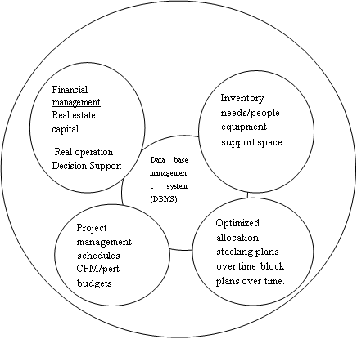

Fig 1 : - A Conceptual Model of Facilities Management System
Source: - Hamer (1988)

The centrality of database management system (DBMS) as a dependent variable in achieving success in facilities management operation is emphasized while the operators and the beneficiaries of the services being rendered are relegated to the background. Besides, the model might have been heuristically developed without validation limiting its acceptance.
Torkildsen (1992) in a study of successful facility managers in the public and private sectors of the United Kingdom’s economy, established a conceptual model suggesting that effective operational management of leisure facilities generally is a function of leadership, objectivity, staff motivation and care of customers. The four variables were found to be almost universal. Torkildsen’s model as depicted in Figure 2 appears confusing as leadership and objectivity assumed the central focus as against operational excellence that is declared to be the dependent variable.

Leadership
and
Objectivity

Care of customers Motivating staff

Operational excellence

Fig 2: - A Model for the Effective Operational Management of Leisure Facility
Source: - Torkildsen (1992)

Nonetheless, this model is classic in outlook as it explores the interface between management, staff, customers and strategic initiative of the organization. The model is heuristically developed without validation and its effectiveness in reality has not been established.
In Amaratunga’s (2000) building performance evaluation in higher education properties in Britain from facilities management perspective, the use of FM in promoting organizational performance and competitive advantage using the balance scorecard approach was explored. In the study, three Universities were selected and a conceptual model was developed as shown in Figures 3.
The conceptual model provides a strategic framework for evaluating operational performance and indicates the elements of major importance for achieving overall corporate goals. It focused on performance measurement and has therefore become a relevant model employable when trying to measure the impact of FM on corporate organizations especially where benchmarking is involved.
Financial perspective
How do we look at our stakeholders?

Customer perspective
How do our customers see us?
The balanced
Scorecard
Internal business
Processes perspective
What must we excel at?

Learning and growth
Perspective
How can we continue to Improve?

Fig. 3: - The Balanced Scorecard (BSC)
Source: Amaratunga (2000)

However, the model is extremely narrow in outlook and operation and not validated.
Furthermore, Hassanain, Froese and Vanier (2003) developed a conceptual model for Asset Maintenance Management aimed at developing IT solutions for the Asset maintenance industry which includes facilities management as shown in Figure 4.

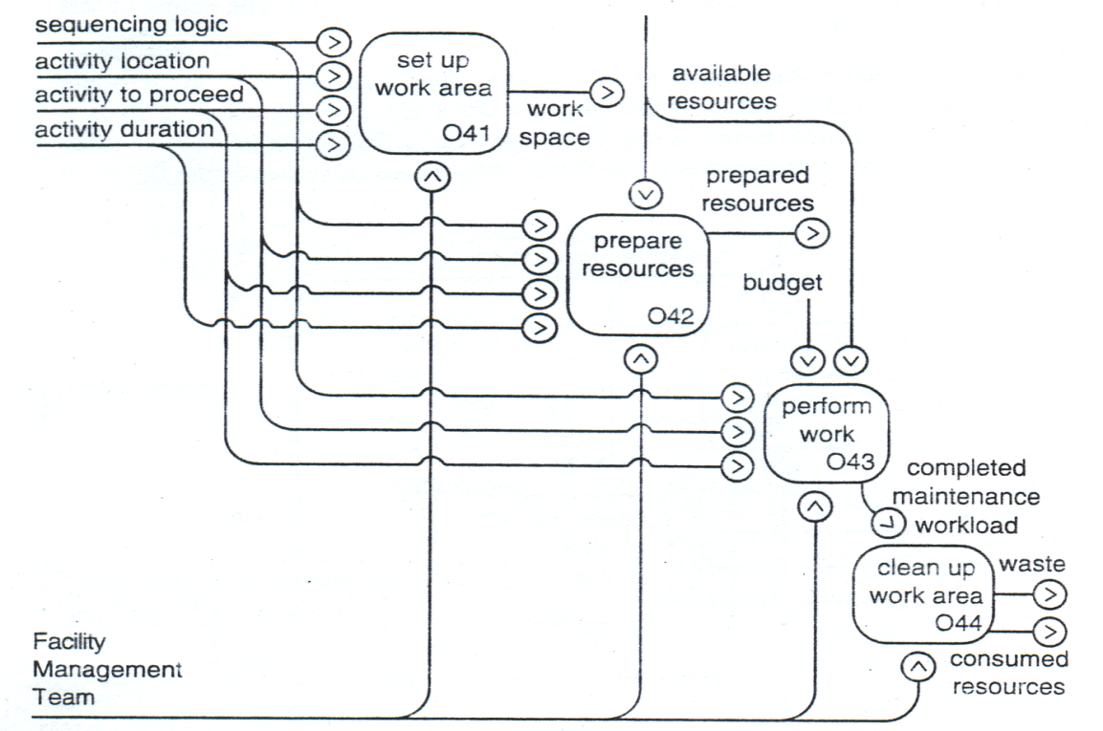
Fig. 4: A model Node for Accomplished Maintenance Workload
Source: Hassanain, Froese and Vanier (2003)

The work describes a collection of knowledge areas within the domain of asset maintenance management. Although, the areas have previously existed in practice and are documented in literature, they have not been introduced to the asset management (AM) domain in a formalized and standardized form as presented through the development of a process model. This model is a strategic tool that can be used in maintenance activities under facilities management. This model offers innovative and logical step towards the achievement of specific tasks in maintenance activity; however, its practical application has not been established through empirical analysis. Furthermore, the model is sectional and not really targeted at a particular industry to be able to test its veracity and the fact that it was not validated by any empirical study makes it difficult to accept out rightly.
Okoroh, Jones and Ilozor (2003) in a study on facilities management and hotel organizations in Great Britain dwelt on adding value to constructed facilities with emphasis on the hospitality industry. The study examined the impact of service contact on perceived quality and nature of the accommodation package. It was averred that a number of trends have become evident as influencing the rapid growth of facilities management. On the supply side, there has been a rapid increase in the number of contractors offering the services, partly through “pull factors” or demand led elements of cost reduction, flexibility, specialists in so many fields; and partly through “push factors” or increased supply; stimulated by competitive tendering, PRIVATE FINANCE INITIATIVE (PFI), PUBLIC PRIVATE PARTNERSHIP (PPP), and technological advances. More importantly, are the contributions of globalization, information and communication technology, competition, strategic management and shareholders’ pressure. These factors were conceptually modeled as shown in Fig. 5.
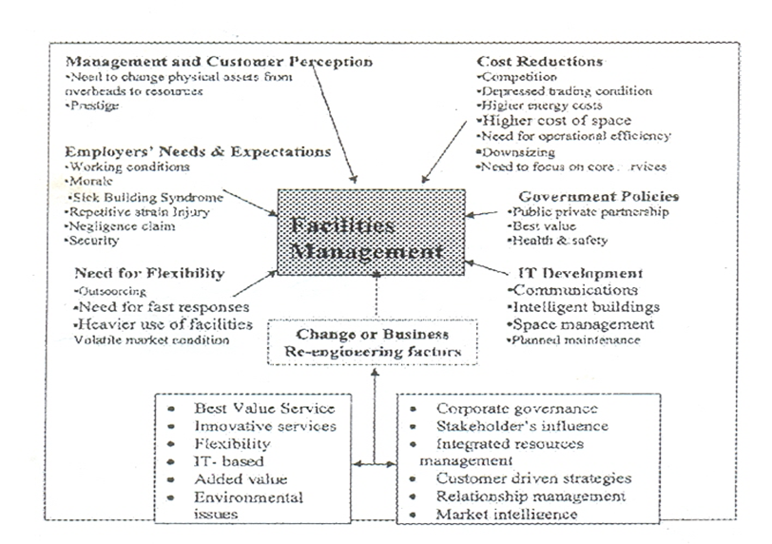

Fig. 5: - Conceptual Model of Recent Pressures influencing FM Development
Source: - Okoroh, Jones and Ilozor (2003)

This work even though instructive as regards variables impacting on the development of FM, it is just a conceptual model and a prognosis not validated. However, it shows the attempts by the authors to come up with models reflecting the workings of FM, with several others that have same pattern of palpable defect and non-validation.
From the foregoing, the importance of model development reflecting the procedure of implementing FM applying established principles in FM operation, and reflecting the impact of FM on organizations have been identified. It could be deduced that developing models in FM is not new; however, most of the models are sectional in nature, graphical and conceptual without validation. In particular, there is no conceptually or specifically developed model depicting the workings of FM on hotels apart from Torkildsen’s (1992) model for the effective operational management of leisure facility, which may be generically applicable to all going-concern and business organizations. With the identified anomalies, the researcher attempts to develop and validate a model for facilities management driven hotel organizations.

- THE CONCEPTUAL FRAMEWORK
First, the quantities and qualities of facilities provided by a hotel dictate its rating on the international platform and with the establishment of Nigeria Tourism Development Corporation (NTDC), appropriate rating and grading system has been institutionalized. Most of the hotels in Nigeria were built prior to NTDC grading coming into being, and it is expected that those established after the advent of the NTDC would comply with international standards. The NTDC grading was drawn from the international grading and comprehensiveness; and hotels that comply with the grading are usually used for assessment.
Second, it is expected that organizations that adopt FM would have dispensed with property and maintenance management principles, which would have been absorbed by FM. In that case, there is a probability that the Engineering Department would be renamed FM Department and the functions of FM would be predominant in the set up. In essence, a drastic transformation is expected and organizational set up would be transformed physically and logistically to comply with facilities management principles.
Third, a full-fledged Facilities Management Department, even if not so named, must be established around Hamer (1988)’s model, if not more and deploying all the tools as enunciated in Mbamali and Adebayo (2006) as depicted in Table 1.
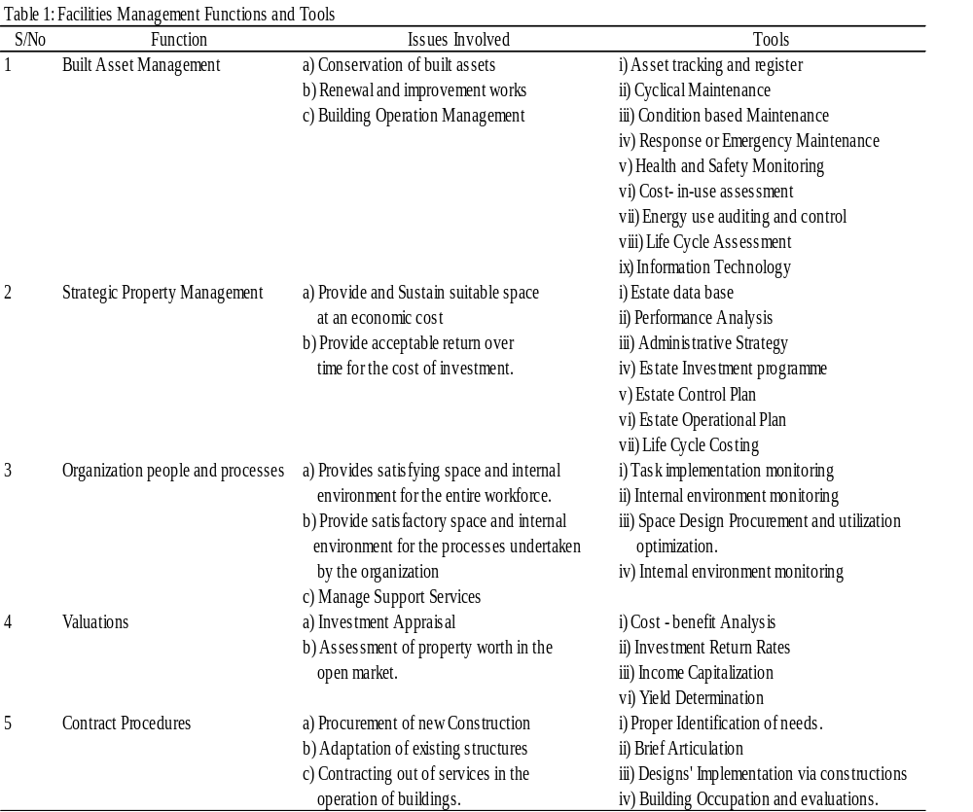
Source: Mbamali and Adebayo (2006)
From Table 1, major functions and associated activities of FM are identified along with required tools to achieve the aim of FM. Essentially; these are activities that are required to be seen as being executed by the FM Department. The Head and the subordinate staff must think and practice facilities management while its structure must reflect facilities management. Above all, the activities of the department must be backed up sufficiently with human and material resources, chief of which is information and telecommunication technology.
The importance of the contributions that the General Manager (GM), the Facilities Manager, the Line Managers, the Management and the Customers make to the propagation and sustenance of facilities management have been brought to the limelight. The GM is the arrowhead of the establishment and occupies the driver’s seat; seeing the horizon. Apart from enviable training, experience and exposure, such a person must be proactive, begin with the end in mind, put first things first, “think win-win” always, seek first to understand than to be understood, synergize and sharpen the saw in that order. The Facilities Manager and Line managers must have the same peculiar characteristics with the GM to be able to drive the vision and the mission of the former to a laudable conclusion (Conklin, 2002; Nebel and Ghei, 2002; and Covey, 2000).
From the foregoing, the variables that impact facilities management driven hotel organizations include the organization itself, the Hotel General Manager (GM), the Business Development Unit (BDU), the Line Staff (LS), the Customers, the Hotel Features, the Facilities Manager, and the Facilities Management Department. The presumption is that if all the variables identified are in place and effectively operated, the impact on hotel organization would result into a vibrant hotel organization measurable in terms of comparable reasonable charges, high quality of facilities and services, high speed of service delivery, high room occupancy rate which translates to effective hotel. These variables are said to be cogent and compelling in FM operations in hotel organizations [Durodola (2009)]. All the variables must feature in any meaningful model for facilities management driven hotel organization. The purpose of the conceptual model is to assist in identifying the features of a performing hotel and depict the likely impact which FM may have in the running of any hotel organization driven by facilities management principles as depicted in Figure 6.
4.0 A Priori Expectations of the Impact of Facilities Management
The expected outcomes of the impact of the identified variables driven by FM principles are summarized as a priori expectations and expressed in hedonic models; these are as follows:
A Priori 1
Hotels that are fully equipped with facilities in accordance with national standard are better-off in terms of effectiveness than under-equipped hotels. In this case, effectiveness which could be designated (Є) is a function of facilities; which is a dependent variable while facilities’ which could be designated (F_{c}) constitutes an independent variable. Thus, mathematically,
Є =ƒ (F_{c})…………………………………………………………………………..(i) Effectiveness in hotel organizations is influenced by Hotel traits or features; while the Management is symbolized by the General Manager; the Facilities Manager and the Staff; which are be designated as: h_{t}, g_{m}, f_{m} and s_{f}.
A Priori 2
Hotel organizations that implement proactive management style differ significantly in terms of effectiveness from those whose management style is reactive. In this case effectiveness is a function of management style. Effectiveness is a dependent variable while management style is an independent variable; thus, mathematically:
Є =ƒ (M_{s})…………………………………………………………………….(ii)

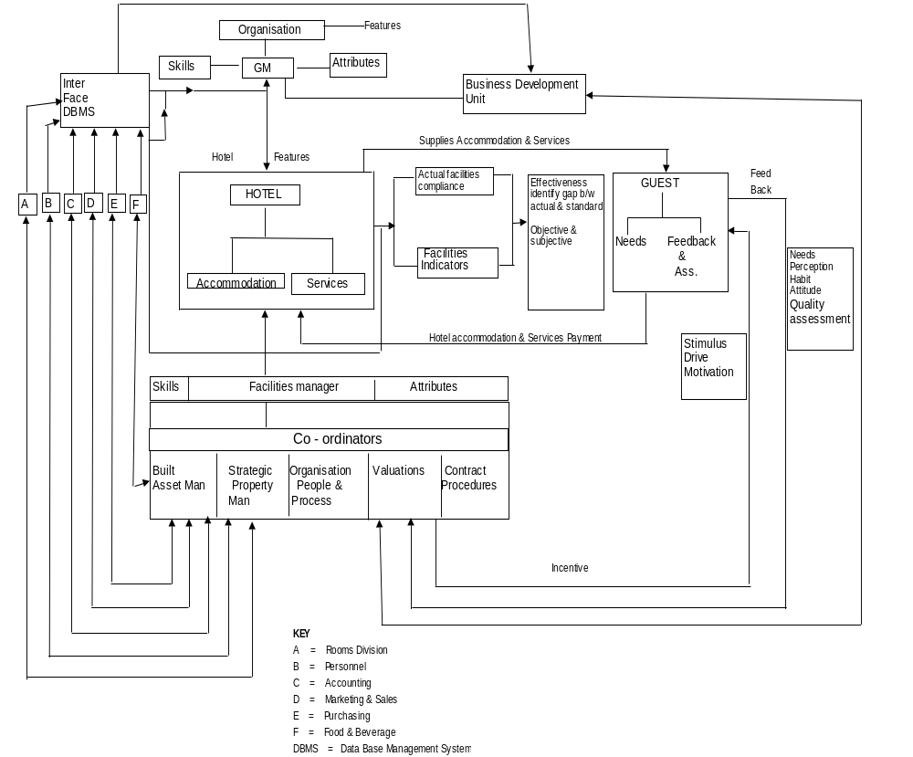
Fig. 6: Conceptual Model of Facilities Management Driven Hotel Organizations
Management style in this case is the style employed in managing the facilities to realize the objectives of the organization. This may be maintenance management, property management, or facilities management. The management style is assigned the following symbol: m_{m}, p_{m}, and f_{m}; where m_{m} = Maintenance Management; p_{m} = Property Management and f_{m} = Facilities Management. However, f_{m} is a function of proactive management, management of support services and commitment to information and telecommunication technology.
Thus, f_{m} = ƒ(m_{p}, s_{s}, I_{ct})……………………………… …………………. (iii)
A Priori 3
(iii) Hotels having quality and quantity accommodations to sell tend to be more effective than hotels with poor and paucity accommodations; thus,
Є =ƒ (A_{c})………………………………………………………………… (iv)
A Priori 4
(iv) Hotels having a large flock of inquisitive, selective and high quality conscious customers tend to be more effective than hotels with little flock of docile and tasteless customers. Thus,
Є =ƒ (C_{s})…………………………………………………………………….(v)
Thus, overall, Є =ƒ (F_{c,} A_{c,} C_{s,} M_{s} )………………………………………..(vi)
Since M_{s} can either be m_{m}, p_{m} or F_{m} then F_{m} as a management tool is picked…………...(vii)
Substituting (iii) and (vii) in (vi), then
Є =ƒ (F_{c,} A_{c,} C_{s,} m_{p}, s_{s},I_{ct})……………………………………...(viii)
5.0 RESEARCH METHOD
This is a survey research covering South-Western States of Nigeria namely Lagos, Ogun, Oyo, Ondo, Ekiti and Osun States with particular focus on the state capitals. Two to five ‘star’ hotels and conforming to NTDC grading were considered. Stratified sampling technique was adopted to select the samples while appropriate sample size was determined following the formula given by Kothari (1978). In order to secure representative responses, the size of the sample of hotels for the study should not fall below the representative size determined from statistical estimation theory, which is based on the degree of confidence that the researcher wishes to employ (Kothari, 1978). For this study, the researcher defines how large a sample of hotels should be in order to be 95% confident that the probable error of using a sample rather than surveying the whole population will not exceed 0.02%. The following formula is given:
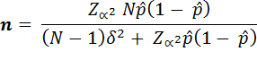
Where:
n = Sample Size
Zα = A value such that the probability of a normal variable exceeding it is (1 – α )/2 and obtainable from Z Table. In this case 1.96
= Unknown value we are trying to estimate and taken to be 0.5 conservatively in which case N will be maximum and the sample will yield at least the desired precision.
δ is the true value of β which in this case is 0.02 or 2%
In this case, the formula yields 57. Thus, a sample size of 57 was obtained and this figure was split among the States based on the number of hotels within each State. Out of the fifty-seven questionnaires administered on hotel organizations, twenty-eight (49%) were retrieved while in respect of customers, six hundred and seventy-one questionnaires were administered from which three hundred and sixty (54%) were retrieved. Data analysis was carried out using descriptive statistics and Chi-Square (χ²).

6.0 WORKING THE VARIABLES AND VALIDATING THE CONCEPTUAL MODEL
There is the need to explore the relationships between the identified variables (if any) through cross tabulations using Chi- square (χ²) and in the process validate, reject or amend equation (viii). In order to achieve this, level of hotel effectiveness, level of facilities; quality of hotel accommodation, customer structure, prevailing property assets management style and staff quality among others were determined. For instance Table 2 shows the degree of assessed hotel effectiveness and level of available facilities in studied hotels. Table 2 gave birth to Appendix 1 which shows the cross tabulation between hotel effectiveness and facilities intensity in investigated hotels as observed scenario. From Appendix 1 is derived Appendix 2 which shows the cross tabulation between hotel effectiveness and facilities intensity in investigated hotels as expected scenario.

Table 2: Degree of Assessed Hotel Effectiveness and Level of Available Facilities
 |  |  | Effectiveness | Assigned |  | Level of | Assigned
S/No | Hotel |  | Level | Value(X) | Ranking | Facilities | Value(Y) | Ranking
1 | Mainland |  | Effective | 3 | 2 | Intensive | 4 | 2
2 | Federal Palace |  | In-effective | 2 | 3 | Highly Intensive | 5 | 1
3 | Sheraton |  | Higly Effective | 4 | 1 | Highly Intensive | 5 | 1
4 | West End |  | Ineffective | 2 | 3 | Somewhat Intensive | 3 | 3
5 | Olujoda |  | In-effective | 2 | 3 | Somewhat Intensive | 3 | 3
6 | Owena |  | Higly Effective | 4 | 1 | Somewhat Intensive | 3 | 3
7 | Niger Palace |  | Poor | 1 | 4 | Sparse | 2 | 4
8 | Gateway |  | Effective | 3 | 2 | Highly Intensive | 5 | 1
9 | Hotel Plaza |  | In-effective | 2 | 3 | Sparse | 2 | 4
10 | L'eko Meridien |  | Higly Effective | 4 | 1 | Highly Intensive | 5 | 1
11 | Excellence |  | Effective | 3 | 2 | Intensive | 4 | 2
12 | Kilo |  | In-effective | 2 | 2 | Intensive | 4 | 2
13 | Oasis |  | Poor | 1 | 4 | Sparse | 2 | 4
14 | Newcastle |  | Poor | 1 | 4 | Somewhat Intensive | 3 | 3
15 | Bluenet |  | In-effective | 2 | 3 | Somewhat Intensive | 3 | 3
16 | Lagos Airport |  | Effective | 3 | 2 | Highly Intensive | 5 | 1
17 | Lafia |  | Effective | 3 | 2 | Intensive | 4 | 2
18 | Heritage |  | Poor | 1 | 4 | Poor | 1 | 5
19 | Premier |  | Higly Effective | 4 | 1 | Highly Intensive | 5 | 1
20 | Universal |  | Poor | 1 | 4 | Poor | 1 | 5
21 | Greenspring |  | In-effective | 2 | 3 | Sparse | 2 | 4
22 | MicCom Golf |  | Effective | 3 | 2 | Highly Intensive | 5 | 1
23 | D'Erovan |  | In-effective | 2 | 3 | Somewhat Intensive | 3 | 3
24 | Kankanfo |  | In-effective | 2 | 3 | Highly Intensive | 5 | 1
25 | Adesba |  | Poor | 1 | 4 | Sparse | 2 | 4
26 | K.S Motel |  | In-effective | 2 | 3 | Poor | 1 | 5
27 | Dusmar |  | In-effective | 2 | 3 | Poor | 1 | 5
28 | Leisure Spring |  | Effective | 3 | 2 | Poor | 1 | 5
Using the Chi squared (χ²) test for Tables 3 and 4 above, (χ²) calculated gives 25.94 as against (χ²) tabulated, which gives 21.03 at 12 degrees of freedom and 5% level of significance. There is thus no close association between degree of effectiveness and level of available facilities at the 5% of significance. Thus, increasing the level of facilities might not translate to high level of effectiveness in hotel management. In a similar manner, other relationships explored and tested are reflected in Table 3
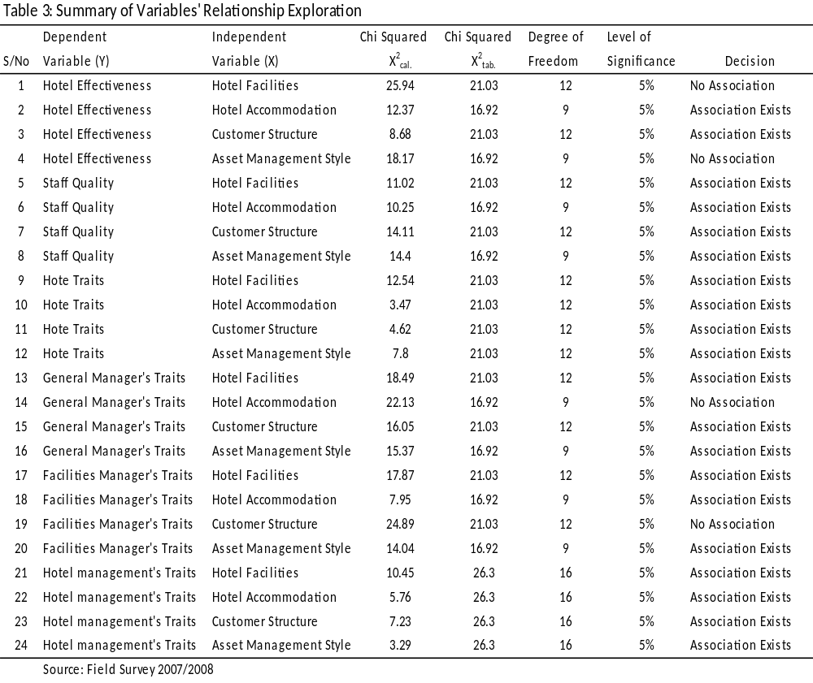
Based on the findings as reflected in Table 3, the conceptual model, as shown in Figure 6 is re-drawn as shown in Figure 7 to reflect changes where no relationship exists as shown in Table 3 and this model stays and shows that for effective hotel, there must be present, in organized relational form, an effective organization, a proactive general manager; effective data base management system (DBMS)), a management style (Maintenance management, Property management or Facilities management), quality accommodation and facilities. Others include quality staff and highly inquisitive and quality conscious customers. This is transformed mathematically as shown below:
Є =ƒ (F_{c,} A_{c,} C_{s,} M_{s} )…………………………(vi).
But since M_{s} = F_{m} …………………………(vii) and
F_{m} = ƒ(m_{p}, s_{s}, I_{ct})…………………….(iii)
Substituting (iii) and (vii) in (vi), then
Є =ƒ (F_{c,} A_{c,} C_{s,} F_{m})…………………………(viii)
Now, it could be proposed that
Є =F_{c} + A_{c} + C_{s} + M_{s}…………………………(ix)
From the findings, the following radical alterations are implemented. First, there is no linear association between hotel effectiveness and hotel facilities. That means facilities could be expunged as independent variable. This only proves the point made by Bevan (1991) that facilities are augmented assets put in place to sell accommodation, the primary products of hotel organizations. Thus, the fundamental alteration to the equation is that F_{c} goes or A_{c} is re-written as (A+F)_{c.} Since facilities are defined as inclusive of accommodation (A_{c}) and support services (S_{S}), F_{c} could also replace A_{c} or vice versa.
Second, there is a linear relationship between hotel effectiveness and hotel accommodation and so accommodation stays. There is also a linear relationship between hotel effectiveness and customer structure and so this also stays. There is no linear relationship between hotel effectiveness and management style which implies that either maintenance management or property management could replace facilities management. Since there is linear relationship between staff quality, the general managers (g_{t}) and facilities managers’ (f_{mt}) traits, it is the drive and commitment to these modes of management style and this point is buttressed by the fact that there is linear relationship between hotel management (h_{m}) and facilities, accommodation, management style and customer structure.. Besides, Staff qualities (s_{q}), hotel traits (h_{t}), general manager (g_{t}) traits and facilities manager (f_{mt}) traits which are all sub elements of hotel effectiveness (Є) have linear relationships with hotel facilities. Thus, F_{m} stays. It does imply that equation (ix) above could be re-written as follows:
Є =A_{c} + C_{s} + F_{m}…………………………(xi)
Substituting components of Є then (ix) becomes
S_{q} + h_{m} + h_{t} + g_{t} + f_{mt} = A_{c} + C_{s} + F_{m}…………………………(xii) so that
F_{m =} s_{q} + h_{m} + h_{t} + g_{t} + f_{mt} - (A_{c} + C_{s})………………………………….(xiii)
Since there is no linear relationship between facilities management traits and customer structure, Cs becomes zero and therefore (xiii) becomes
F_{m =} s_{s} + h_{m} + h_{t} + g_{t} + f_{mt} - A_{c} ………………………………….(xiv)

Since A_{c} A_{c} is what is being managed or sold, it remains a constant and could be assigned 1 (one) thus (xiv) becomes
F_{m =} s_{q} + h_{m} + h_{t} + g_{t} + f_{mt} - 1………………………………….(xv)

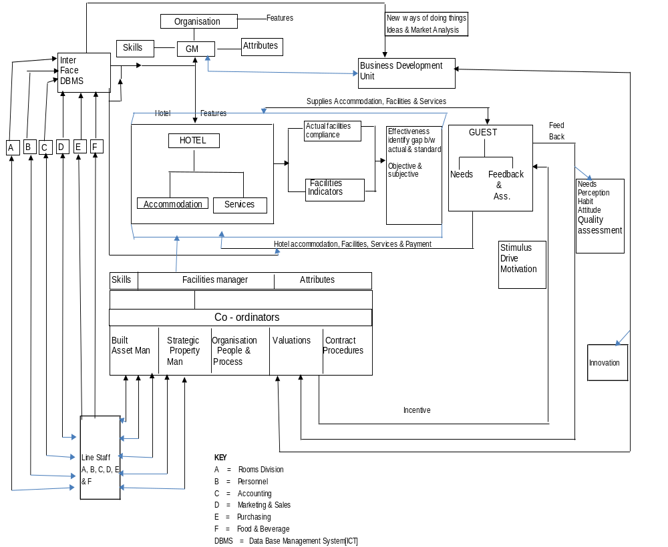
Figure 7: Validated Conceptual Model of Facilities Driven Hotel Organizations
This mathematical hedonic model (xv), as it is, stays. This translates the conceptual graphic model in Figure 7 to a mathematical hedonic model.
7.0 Conclusion and Recommendation
A validated heuristic graphic model, translated to a mathematical hedonic model for facilities management driven hotel has been generated incorporating all vital variables necessary and imperative for an effective hotel organization. This model is a useful tool for hotel operators embarking on strategic asset management in order to revitalize their set up. It is also useful for regulatory authorities and grading institutions as a template against which available facilities’ can be benchmarked. It is accepted that this model is not a cracker-barrel instrument and at infant stage, yet, a serendipity. Hence, praise, knock and constructive criticism are welcome.
REFERENCES
Adewunmi, Y & Ogunba, O (2006). Shaping a Sustainable Role for Estate Surveyors and Valuers in the
Evolution of Facilities Management in Nigeria. International Conference on the Built
Environment, Innovation Policy and Sustainable Development. Covenant University Ota,
Nigeria., 322 - 327

Amaratunga, D. (2000, December 16). Building Performance Evaluation in Higher
Education Properties: A Facilities Management Approach. RICS Foundation, 3
(14), 1-21

Bevan, O.A. (1991). Marketing and Property People. London: Macmillan Press Ltd.

Brackertz, N & Kenley, R (2002). A Service Delivery Approach to Measuring Facility
Performance in Local Government. Facilities, 20 ( ¾), 127 - 135

Conklin, M (2002). As I See It: Hotel Organization Structure. In D.G. Rutherford (Ed.), Hotel
Management and Operations 3rd Ed. (pp 53-54). New York, NY: John Wiley & Sons, Inc.

Covey, S. (2000). The 7 Habits of Highly Effective People. London: Simon and
Schuster Uk Ltd.

Durodola, O.D (2009). Management of Hotel Properties in South-Western Nigeria: Facilities
Management Perspective. Unpublished PhD Thesis of the Department of Estate
Management, Covenant University, Ota, Nigeria.

Durodola, O.D., Ayedun, C.A., & Akinjare, O.A. (2012). Beneficial Application of Facilities
Management in Hotel Organizations in South-Western Nigeria. Mediterranean Journal of
Social Sciences 3(1), 413-423

Hamer, J.M. (1988). Facility Management System. New York, NY: Van Nostrand Reinhold Inc.

Hassanain, M.A, Froese, T.M, Asce, M and Vanier, D.J (2003). Framework Model
for Asset Maintenance Management. Journal of Performance of
Constructed Facilities, February, (51 – 64)

Hassanien, A. & Losekoot, E. (2002). The Application of Facilities Management
Expertise to the Hotel Renovation Process. Facilities, 20(7/8) 230 – 238

Kothari, C.R. (1978). Quantitative Techniques 3rd Ed. New Delhi: Vikas Publishing
House PVT Ltd.

Kotze, M. and Nkado, R. (2003). An Investigation into the Use of Facilities Management in
Institutions of Higher Learning in South Africa. CIDB 1st Postgraduate Conference 2003,
Port Elizabeth, South Africa.

Nebel, E.C., & Ghei. A. (2002). A Conceptual Framework of the Hotel General Manager’s Job.
In D.G. Rutherford (Ed.), Hotel Management and Operations 3rd Ed. (pp 55-63). New
York, NY: John Wiley & Sons, Inc.

Nigerian Tourism Development Corporation. (NTDC) (2001). Standard for National
Classification and Grading of Hotels and Other Serviced Accommodations in Nigeria.
Abuja: Nigerian Tourism Development Corporation.

Mbamali, I and Adebayo, A (2006) “Potentials of Facilities Management as an
Instrument for Achieving a Sustainable Built Environment”
International Conference on the Built Environment, Innovation Policy
and Sustainable Development, Covenant University Ota, Nigeria.

Meyer, M. (2003). Translating Empty Space Into Dollars: How to Get a Handle on Space, Its
Use and Its Real Cost. Facility Management Journal (FMJ), March/April 29-30

Okoroh, M.I., Jones, C.M., & Ilozor, B.D. (2003). Adding Value to Constructed Facilities:
Facilities Management Hospitality Case Study. Journal of Performance of Constructed
Facilities, February 24-33

Owen, D. (1995.). FM is not Just a Radio Station . Chartered Surveyor Monthly. Supplement
June pp II - IV

Spedding, A., & Holmes, R. (1999). Facilities Management. In Spedding (Ed.), CIOB Handbook
of Facilities Management .(pp. 1-8). London: Longman Group Ltd.

Torkildsen, G. (1992). Leisure Recreation Management 3rd Ed. London: E & FN Spon.

Udo, G.O. (2003). Model Building in Property Valuation. Enugu: Institute Of Development
Studies

Wai, K.C. (2004). The Application of Facilities Management to Hotel Renovations in
Hong Kong. Retrieved from www.hub.hku.hk/handle/123456789/48845

APPENDICES
 | Appendix 1: Cross Tabulation of Effectiveness and Customer Structure(Observed Scenario)
 | 1 | 2 | 3 | 4 | 5
1 | 3 | 0 | 1 | 0 | 0 | 4
2 | 3 | 4 | 0 | 0 | 1 | 8
3 | 2 | 0 | 4 | 2 | 2 | 10
4 | 0 | 0 | 1 | 3 | 2 | 6
 | 8 | 4 | 6 | 5 | 5 | 28
 | Appendix 2: Cross Tabulation of Effectiveness and Customer Structure(Expected Scenario)
 | 1 | 2 | 3 | 4 | 5
1 | 1.142857143 | 0.571429 | 0.85714 | 0.714285714 | 0.714286 | 4
2 | 2.285714286 | 1.142857 | 1.71429 | 1.428571429 | 1.428571 | 8
3 | 2.857142857 | 1.428571 | 2.14286 | 1.785714286 | 1.785714 | 10
4 | 1.714285714 | 0.857143 | 1.28571 | 1.071428571 | 1.071429 | 6
 | 8 | 4 | 6 | 5 | 5 | 28

The Chi- Square calculation as generated is thus shown below.

 | Chi Squared Calculations
 | O-E | (O-E)² | (O-E)²/E
 | 1.857142857 | 3.449 | 3.0179
 | 0.714285714 | 0.5102 | 0.2232
 | -0.857142857 | 0.7347 | 0.2571
 | -1.714285714 | 2.9388 | 1.7143
 | -0.571428571 | 0.3265 | 0.5714
 | 2.857142857 | 8.1633 | 7.1429
 | -1.428571429 | 2.0408 | 1.4286
 | -0.857142857 | 0.7347 | 0.8571
 | 0.142857143 | 0.0204 | 0.0238
 | -1.714285714 | 2.9388 | 1.7143
 | 1.857142857 | 3.449 | 1.6095
 | -0.285714286 | 0.0816 | 0.0635
 | -0.714285714 | 0.5102 | 0.7143
 | -1.428571429 | 2.0408 | 1.4286
 | 0.214285714 | 0.0459 | 0.0257
 | 1.928571429 | 3.7194 | 3.4714
 | -0.714285714 | 0.5102 | 0.7143
 | -0.428571429 | 0.1837 | 0.1286
 | 0.214285714 | 0.0459 | 0.0257
 | 0.928571429 | 0.8622 | 0.8048
 |  |  | 25.937

FINAL RESPONSE TO REVIEWERS’ COMMENTS (CIB CONFERENCE)
Comment (PMB 1): Something is wrong here
Response: Yes, I agree – ‘in’ is missing, now injected
Comment (PMB 2): Kotharis has no formula. State the actual the actual name of this formula.
Response: Interestingly, Kothari (1978) pgs 25 – 27 did not give the name of the formula. Frank Harry & Althoen (1994) who gave similar formula did not state the name either; so I am at a cross road for now. So for ease of identification & confirmation by readers, the sentence was altered . . . while appropriate sample size was determined following the formula given by Kothari (1978) and adequately referenced.
Comment (PMB 3): What is this supposed to mean? What is this conclusion?
Response: Sorry that aspect was missed out. Now inserted as . . . concluded that Facilities Management is a relatively new topic in Hong Kong and that research studies in FM in relation to hotel renovations were unpopular.
Comment (PMB 4): Insert comma in between these words
Response : Done please
Comment (PMB 5): Check your reference list, this is omitted.
Response: Now inserted
Comment (PMB 6): Capitalize each word
Response: Done
Comment (PMB 7): Capitalize each word
Response: Done
Comment (PMB 8): Check your reference list, this is omitted.
Response: Now inserted
Comment (PMB 9): Check your reference list, this is omitted.
Response: Now inserted
Comment (PMB 10): It is important to write in full meaning of abbreviation appearing for the 1st time
Response: Done
Comment (PMB 11): Delete this word
Response: Done
Comment (PMB 12): Check your reference list, this is omitted.
Response: The correct Ref. is Nebel & Ghei (2002) which is already adequately referenced
Comment (PMB 13): Delete this word
Response: Done
Comment (PMB 14): Insert parenthesis
Response: Done
Comment (PMB 15): Define your variables
Response: Done
Comment (PMB 16): How are these related to the equation
Response: Facilities in hotel context hold the ace; the facilities, the structure & the management give the hotel its bearing heuristically. Hence, the relationships (see Rutherford, D.G (2002) and Hayes, D.K and Ninemeir, J.D (2007)
Comment (PMB 17): What are the meanings of these variables?
Response: They were all defined and explained briefly under A Priori 3 and 4. For clarity, M_{s} = Management Style; and management style could be maintenance management (m_{m}), property management (p_{m}) or facilities management (F_{m}). A_{c} represents accommodation package; C_{s} represents Customer structure. They are all defined; it just requires following and thinking along.
Comment (PMB 18): Too or tool/
Response: Tool please; change effected.
Comment (PMB 19): Insert comma between these names.
Response: Done
Comment (PMB 20): Kotharis has no formula. State the actual the actual name of this formula.
Response: Same as 2 above except that the formula is now given and how it was used expatiated.
Comment (PMB 21): Which factors?
Response: ‘These variables’ rather; changed
Comment (PMB 22): Why equation viii & not any of equations I – viii?
Response: That is the climax of the equation development which glaringly shows that hotel effectiveness is a function of facilities, accommodation package, customer structure, management of support services and information and communication technology.
Comment (PMB 23): No comment here ! ! !
Response: No response either
Comment (PMB 24): Delete this word
Response: Done
Comment (PMB 25): Take this Table to appendix
Response: Done
Comment (PMB 26): Take this Table to appendix
Response: Done
Comment (PMB 27): Take this Table to appendix
Response: Done
Comment (PMB 28): Which of the Table 3? See the previous page for another Table 3
Response: Mixed up. Rectified
Comment (PMB 29): Delete this word
Response: Done
Comment (PMB 30): Any difference between this & the earlier model? If any, indicate this graphically.
Response: Done

