CHAPTER ONE
  - Introduction.
A major factor affecting the construction industry in developing countries is the cost of building materials most of which have to be imported. As prices increase sharply, there is a growing awareness to relate research to local materials as alternatives for the construction of functional but low-cost dwellings both in the urban and rural areas of Nigeria. One such local material that is being researched is lateritic soils. Lateritic soil has been one of the major building materials in Nigeria for a long time. The main reason is because it is readily available and the cost of procuring it is very low.
Lateritic soil has other advantages which make it potentially a very good and appropriate material for construction, especially for the construction of rural structures in the developing countries. These advantages include no specialized skilled labour required for the production of laterized sandcrete blocks and for its use in the construction of structures; and laterized concrete structures have potentially sufficient strength compared with that of normal concrete.
This study is part of the continuing effort to investigate the properties of lateritic soils, stabilized or unstabilized, reinforced or unreinforced, with the view to improving such properties. Specifically, this study looks into the effect of replacement of the conventional fine aggregate, sand, with lateritic soils within Ota on the compressive strengths of laterized sandcrete blocks.
Lateritic soils are essentially the products of tropical weathering usually found in areas where natural drainage is impeded (Lasisi and Osunade, 1984). From an engineering point of view, laterite or lateritic soil is a product of tropical weathering with red, reddish brown and dark brown colour, with or without nodules or concretions and generally (but not exclusively) found below hardened ferruginous crusts or hard plan (Ola, 1983).
Generally, the degree of laterization is estimated by the silica sesquioxides (S-S) ratio (SiO₂/ (Fe₂O₃ + Al₂O₃)). Silica-Sesquioxide (S-S) ratio less than 1.33 are indicative of laterites, those between 1.33 and 2.00 are lateritic soils and those greater than 2.00 are non lateritic types (Lasisi, 1983).
In Nigeria, lateritic soil abounds locally and its use is mainly limited to Civil engineering works like road construction and land fill operations but it is less utilised in the building industry except in filling works.
Because of the abundance of lateritic soils and its ready availability, its optimum use in building production could positively affect the cost of buildings which can lead to the production of more affordable housing units.
But because laterites and lateritic soil have no sufficient technical data, it is not yet a generally accepted building constructional material and this contributes to its limited application in building block production.
Studies are currently going on in the use of lateritic soil in concrete production where laterite is made to partly or wholly replace conventional fine aggregate in the production of concrete known as laterized concrete; and in the production of brick units such as Compressed Laterized Brick (CLB) usually stabilised with cement. These applications are currently mostly limited to buildings in rural areas and low income housing projects which are mostly situated at satellite areas (outskirts) of Central Business Areas (CBA’s).
Its use in the building production is not yet formally generally accepted because there is no sufficient technical data and this has limited its wider application in building construction work (Udoeyo, 2006).
This study is aimed at partially and wholly replacing conventional fine aggregate, sand, with lateritic soil in the production of sandcrete blocks and comparing the various percentage replacements with the standard requirements of a sandcrete block as specified in standard codes and conclude at a maximum replacement that will satisfy the standard.
It is believed that this work will contribute to the few existing data available on the use of lateritic soil in Building production.

  - Aims and Objective.
The main aim of this study is to assess the effect when the readily available alternative local material within the locality of Ota, lateritic soils, is incorporated into the production of buildings. It is believed it will make housing more affordable and will start the development of a local technology since it is using material that is unique to its environment and this work is focussing its assessment in its use in the production of sandcrete blocks.
Specifically, this work is aimed at recommending a minimum percentage replacement of fine aggregate with the readily abundant lateritic soils within the boundaries of Ota, Ogun state to the block moulding industry operating within same location that can be incorporated into their sandcrete block production with the purpose of maximising the use of the alternative local material, lateritic soil, which is believed will bring housing more closer to the community and to some extent make housing more affordable within the Ota.
The objectives include the following:
- To establish a relationship between compressive strengths of various percentage replacement of the fine aggregate in sandcrete blocks with the lateritic soil and compare the strengths with the standard requirement of sandcrete blocks to determine the maximum permissible percentage replacement with lateritic soil that satisfies this standard requirement.
- To characterise the lateritic soil within Ota by carrying out physical tests on the lateritic soil samples, for example, compaction test to determine the bulk density, sieve analysis test, hydrometer test, specific gravity test and Atterberg’s limits test.

  - Research Methodology.
Hollow sandcrete blocks were moulded with fine aggregate and cement. Ten percent (10%) of the fine aggregate replaced with the lateritic soil and then 20%, 30% until the lateritic soil completely replaces the sand.
Four (4) blocks at each percentage replacement of the conventional fine aggregate with the lateritic soil content were be produced, cured weighed and tested for the twenty-eight (28) day compressive strength and the average values of the closest three (3) strength range values taken as actual parameters.
For control, four blocks were moulded without replacement, i.e., with 100% conventional sand. They were prepared to have water/cement ratio that will ease moulding and other preparation like curing methods the same. They were cured for 28 days and crushing test was performed on them to determine their compressive strengths.
These compressive strength values were compared with the 28 day strength requirement of a standard sandcrete block as specified in the National Building Code (2006) and the maximum lateritic soil replacement that still falls within the standard sandcrete block requirement be taken as the maximum permissible replacement that can be recommended for practice in the sandcrete block moulding production.
Compaction test to determine the bulk density, sieve analysis, hydrometer test, Atterberg’s limit test and specific gravity test were performed on the lateritic soil samples and their results were used to characterise the soil samples used in this work.
This whole process is repeated with lateritic soil sourced from two (2) other different location and the final average of the three (3) averages from the different lateritic soil sample sources be computed as actual values.
The lateritic soil samples that were used in this research work were obtained from three different locations within Ota, Ogun state. The first two samples were obtained from Canaanland, KM10 Idiroko road Ota, Ogun state with the first behind the Daniel Hall of Covenant University and the second in the Canaanland Camp grounds. The third and last sample was obtained from Chelsea, KM 14 Idiroko road Ota. Let the soil samples be tagged A, B and C respectively where
Sample A: lateritic soil sample from behind the Daniel hall,
Sample B: lateritic soil sample from the camp ground and
Sample C: lateritic soil sample from Chelsea.
The other materials used are the Dangote cement, bore-hole water fit for drinking sourced from Canaanland and the sharp sand obtained by water side beside the Lagos-Abeokuta express.
The fine aggregate samples (sharp sand and the lateritic soil) were sieved with a 5mm sieve size and spread indoors for about a week so as to maintain them as dry as possible since it was in the raining season.
The mix ratio of the laterised sandcrete block was 1:6 by volume, i.e., one part of cement to six parts of fine aggregate (combination of sand and lateritic soil) as recommended in the National Building Code (2006).
    - Block Production.
1.3.1.1 Materials.
The materials used in the laterised sandcrete block production include:-
- Lateritic soil from three (3) different locations as mentioned above
- Sharp sand (the conventional fine aggregate)
- Water sourced from borehole fit for drinking and
- Ordinary Portland Cement (Dangote cement).

1.3.1.2 Batching and Mixing.
The batching method employed in this work is the batching by volume and this is achieved as follows.
Two batching wooden boxes tagged B_{A} and B_{C} of dimensions (200mm x200mm x100mm depth) and (188mmx 188mm x188mm depth) respectively were constructed.
These batching boxes are dimensioned such that when 10xB_{A} volumes of aggregates is mixed with a volume of B_{C} of cement, the resulting mix ratio will be 1:6 (cement: fine aggregate), i.e. 10B_{A}=6B_{C}.
See calculations below:
B_{A}=200mm x 200mm x 100mm.
B_{C}=188mm x 188mm x 188mm.
Let VB_{A}= Volume of B_{A}= 4000000mm³ = 0.004m³.
VB_{c}=Volume of B_{C} =6644672mm³ =0.0066447m³.
In the mix ratio of 1:6 (cement: fine aggregate), if the volume of cement is VB_{c} = 0.0066447m³, then the volume of the fine aggregate will be 6 x VB_{c}.
Therefore, 6 x 0.0066447m³ = 0.0399 ~ 0.04m³. And 0.04m³ is the volume of ten times the volume of VB_{A} (volume of box A). This is so to ease the proportioning of the different fine aggregates to be used in this work.
A trial mix was first prepared with the only fine aggregates being the conventional sharp sand, i.e. without replacement with lateritic soil. The batching is such that ten (10) levelled volumes of B_{A} of the fine aggregate were mixed with a levelled volume of B_{C} of cement. Water was gradually added, mixed, vibrated and moulded into blocks till a perfect block was eventually moulded. This volume of water was then noted for guidance in further mix.
In the 10% replacement mix with the lateritic soils, nine (9) levelled volumes of B_{A} of the conventional sharp sand was measured and one (1) levelled volumes of B_{A} of lateritic soil was added. A levelled volume of B_{C} of the cement was added and mixed with the same quantity of water as derived in the trial mix. The batch is mixed and moulded into 225 X 225 X 450mm hollow sandcrete blocks with web thickness of 35mm and 30mm at one of the shorter dimension.
In the 20% replacement mix with the lateritic soils, eight (8) levelled volumes of B_{A} of the conventional sharp sand was measured and two (2) levelled volumes of B_{A} of lateritic soil was added. A levelled volume of B_{C} of the cement was added and mixed with the same quantity of water derived in the trial mix. The batch was mixed and moulded as in10% above.
This was continued till the lateritic soil replaces the conventional fine aggregate, the sharp sand, by 60% because at higher replacements, the mix didn’t come out of the mould.
This same process is repeated in all other lateritic soil samples sourced from the other locations.
The cement, sharp sand and the lateritic soil at all percentage replacement were thoroughly mixed before water was usually added.

1.3.1.3 Moulding of the Sandcrete Block.
The sandcrete blocks were moulded by vibrating its freshly mixed content in a block moulding machine-mould and vibrated with a 5.0KVA powered engine. Below is a pictorial view of the moulding machine used in this work and process.
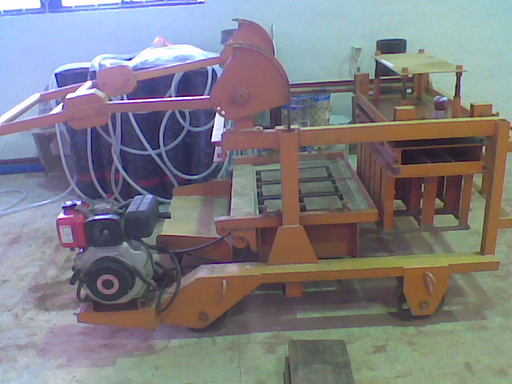
Plate 1.1: The vibrated block moulding machine used in this work.
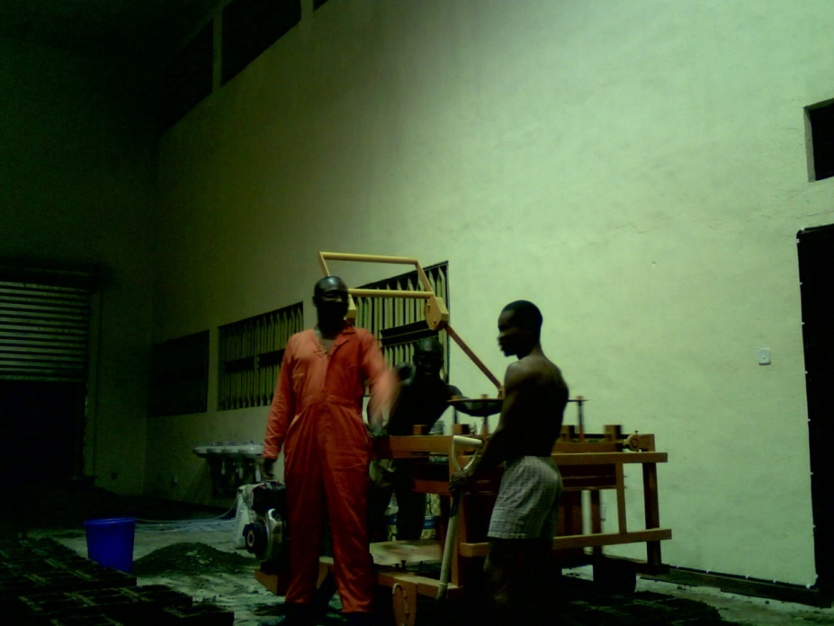
Plate 1.2: Block moulding in progress using the moulding machine Plate 1.1.

  - CURING.
The next morning of the block-moulding, the blocks were lifted to an erect position with the hollow sides facing the sides and water sprinkled on them till they were completely drenched. This water sprinkling process was repeated at 2:00pm of each day.
This process was repeated till the 27th day so when the crushing or compressive strength test was performed on the blocks.

  - Study Justification.
From findings, the closest construction element with laterite as part of its material in masonry is the compressed laterized earth brick stabilized usually with cement or lime. The use of this brick is either in the rural areas or in a low cost housing project. And unfortunately, despite the establishment of about twenty brick manufacturing plants in Nigeria since 1976 and the low-cost of locally produced bricks, their application in the Building construction industry has not gained much popularity except in very few occasion where the government took the initiative to deliberately utilise stabilized compressed lateritic and clay soil like the case of Aco Hi Tech in Lugbe, Abuja and few others. This is why this research is to find a way to incorporate the use of laterite in the production of sandcrete hollow block.
Sandcrete blocks are constructional masonry units that have been generally accepted to the extent that when an average individual thinks of building, the default mindset is the use of sandcrete hollow blocks and this is why this research seeks to find a way of incorporating the use of laterite in its production for cost reduction as a result of its ready availability.

CHAPTER TWO
2.0 Literature Review
2.1 Previous works on laterised blocks.
Past works according to Osunade (2002), the term “laterite” was used to describe a ferruginous, vesicular, unstratified and porous material with yellow ochre caused by its high iron content, occurring abundantly in Malabar in India. It was locally used in making bricks for buildings, and hence the name “laterite” from the Latin word “later” meaning “brick”.
Although laterite is a material that has been used in the building construction industry of Nigeria for a very long time, especially in the rural areas, there is lack of adequate data to fully understand the behavior of this abundant material. There is need to improve indigenous technology on the practical usefulness of lateritic soils in building and allied industries. A lot of research activities are now being carried out on lateritic soils. Earlier published works on laterized concrete appears to have been a study in which the strength properties of normal concrete were compared with those of laterized concrete (Adepegba, 1975). The conclusion of this study was that a concrete in which laterite fines are used instead of sand, can be used as a structural material in place of normal concrete.
According to Balogun and Adepegba (1982), when sand is mixed with laterite fines, the most suitable mix for structural applications is 1:1.5:3. (Cement: sand plus laterite fines:gravel) with a water-cement ratio of 0.65, provided that the laterite content is kept below fifty percent (50%).
It has also been established by Lasisi and Osunade (1984) that the finer the grain size of lateritic soils, the higher the compressive strength of the unstabilized cubes made from such soils. They have also reported that the possible formation processes form a factor in the strength determination and that the compressive strength of lateritic soils is dependent on the source from which they were collected.
In a study on the effect of mix proportion and reinforcement size on the anchorage bond stress of laterized concrete, it was established that both mix proportion and the size of reinforcement have a significant effect on the anchorage bond stress of laterized concrete specimens. The richer, in terms of cement content, the mix proportion, the higher the anchorage bond stress of laterized concrete (Osunade and Babalola, 1991). Also, the anchorage bond stress between plain round steel reinforcement and laterized concrete increases with increase in the size of reinforcement used.
According to Osunade (1994), it was found that increase in shear and tensile strengths of laterized concrete was obtained as grain size ranges and curing ages increased. Also, greater values of shear and tensile strengths were obtained for rectangular specimens than those obtained for cylinders. Studies have also been carried out on how the performance characteristic of laterite can be improved. Stabilized and unstabilized lateritic soils have been reinforced with different reinforcements (e.g. rope, grass, sawdust, etc.) and results have generally shown that performance characteristics of lateritic soils can greatly be improved using such reinforcements.

2.2 BLOCKS AND BLOCKWORK.
After the Second World War, other methods of building houses were abandoned for methods which favour the use of sandcrete blocks. The advantage of using sandcrete blocks is that they have better thermal insulators especially those made from light weight aggregate.
Another reason for preference of sandcrete blocks is availability compared to bricks for instance, the techniques for the production of sandcrete blocks appear simple thus favouring its preference.
Sandcrete blocks are made of dense or light weight aggregate and are formed either hollow or solid. The dense sandcrete has a mixture of cement and aggregates of sand while those of light weight are aggregate of clinker, expanded clay, foamed slag, sintered fly-ash, pumice, expanded vermiculite and aerated concrete as prescribed in BS 6073.
They are formed in moulds and compacted either by pressing, tamping or vibrating. After moulding, they are allowed to harden naturally. They are used in both external and internal load bearing, curtain, partition, panel walls and many other construction processes.
For the blocks to achieve its constructional purpose, it has to be made in a configuration or shape so as to support its imposed loads both life and dead loads. To achieve this according to Obande (1990), the blocks are laid in regular patterns such that it is resting at least partly on two blocks and this arrangements must present a pleasant surface appearance and avoid straight (vertical continuous) joints as much as possible when laying and this phenomenon is called bonding.

2.2.1 Sandcrete Blocks.
Sandcrete block is defined by the first edition of the National Building Code (2006), section 10.3.13 under the following headings:
2.2.1.1 Material and Dimension.
Sandcrete block is a homogeneous mixture of composite material made up of cement, sharp sand and water.
- Hollow or solid sandcrete blocks are molded for sandcrete using metal or wood moulds of external dimensions:
450mm x 225mm x 150mm
450mm x 225mm x 225mm
450mm x 225mm x 100mm

They are usually jointed by mortar which is a rich mix of sandcrete.

2.2.1.2 Pre-Cast Sandcrete Blocks.
The National Building Code (2006) specifies three types of Pre-cast solid or hollow sandcrete blocks (types A, B and C).
Type A – Dense aggregate concrete blocks.
Type B – Lightweight concrete blocks for load bearing walls.
Type C -- Lightweight concrete blocks for non-load bearing walls (partitions).

2.2.1.3 Mix Proportions.
Mix used for sandcrete blocks shall not be richer than one (1) part by volume of cement to six (6) parts of fine aggregate (sand) except that the proportion of cement to mixed-aggregate may be reduced to 1:4 or 1:2 (Where the thickness of the web of the block is 25mm or less).

2.2.1.4 Strength Requirements.
Sandcrete blocks shall possess resistance to crushing as stated below and the 28 day compressive strength for a load bearing wall of two or three storey building shall not be less than:-

Average strength of blocks. | Lowest strength of Individual block
2.00 N/mm2 (300 psi) | 1.75 N/mm2 (250 psi)
National Building Code, 2006

2.2.1.5 Moulding and Compaction.
Moulding in sandcrete block production is the casting of the sandcrete into shape with rigid moulds of different sizes (NIS 87:2000).
The initial set of Portland cement takes place from half to an hour after it is mixed with water. This implies that the already mixed sandcrete must be cast into moulds before the initial setting time takes elapses and should be disturbed no further for the production of more efficient blocks.
Once cast into moulds, sandcrete blocks should be thoroughly compacted which is achieved by a vibrator usually powered by a lister diesel engine which is the one used in most block moulding industry. Compaction generally causes entrapped bubbles of air to rise to the surface in order to produce dense, compacted and void free block of uniform strength.
Two methods of compaction are generally acceptable depending on the availability of materials (tools).
(1) By approved (standard) machine compaction usually by vibration and
(2) By metal mould (hand) compaction.

2.2.1.6 Production/Processing.
The sandcrete block shall be cast using an appropriate machine with cement/sand ratio of 1:6 measured by volume. Where hand mixing is carried out, the materials shall be mixed until an even colour and consistency throughout is attained. The measure shall be further mixed and water added through a fire hose in such sufficient quantity as to secure adhesion. It shall then be well rammed into moulds and smoothed off with a steel face tool.

2.2.1.7 Curing.
After removal from the machine, the blocks shall be left on pallets under cover in separate rows, one block high, with a space between each block for at least 24 hours and kept wet by weathering through a fire watering hose. The blocks may then be removed from the pallets and stacked during which time the blocks shall be kept wet. The blocks may be stacked not more than five blocks high under cover at least seven (7) days before use after the previous period.

2.3 Properties of Sandcrete Blocks.
2.3.1 Strength.
Provided the aggregate is unaltered (i.e. used of specified grade and type of aggregate), a definite relationship exists between strength and density (Neville, 1996). The strength of sandcrete blocks depends on the aggregate type, richness of mix and the degree of compaction (Orchard, 1979).
Cement and sandcrete block association (1970) shows that most sandcrete blocks are about 15% stronger when dry than when wet. BS 6073:(1981) specifies that sandcrete block of thickness 75mm or greater should have an average crushing strength for ten blocks not less than 2.8N/mm² and that the corresponding crushing strength of any individual block shall not be less than 80% of the minimum permissible average crushing strength i.e. not less than 2.10N/mm² (BS 6073: 1981) while Obande (1990) also states that it mustn’t be less than 80% at the average value. The National Building Code has specified the minimum strength requirements of 2.00N/mm² for sandcrete blocks.

2.3.2 Thermal Insulation.
The thermal insulation of buildings is necessary to achieve the desired degree of thermal comfort for the occupant at the minimum cost possible. This can be made through the selection of the right materials offering high degree of insulation with little or no extra cost. The insulating property of a building can be controlled from the sandcrete blocks to be used in the construction by instilling the insulating properties from the point of manufacture of the blocks.
The property of sandcrete block that can instill this thermal insulating property is by the production of less dense blocks by employing light weight aggregate. Light weight sandcrete blocks provide good thermal insulating property. The level of insulation is inversely proportional to the density of the material. In general, the lighter and more porous the block, the better will be its insulating value (Oberd, 1990).

2.3.3 Acoustic Property.
Sound is a form of energy that is detected by the human ear. Unwanted sounds could constitute disturbance. Sound is also defined as the hearing sensations that exist by the physical disturbance in a medium (Harris, 1979).
The sound reduction of a brick or block partitions of an external wall is in the range of 45dB to 50dB (Seeley, 1980). The effectiveness of transmitting sound is approximately proportional to the weight of the wall (Andrew and William, 1978).
Light weight aggregate blocks perform better than dense once in sound absorption. The sound absorption qualities of these blocks are said to be moderately high particularly at high frequency (Obande, 1990).
If the surface of light weight sandcrete blocks is seated, there is a considerable reduction in the sound transmission and the benefit obtained by sealing is greater (Orchard, 1979). Blochs with open texture according to Obande(1990) are unsuitable as barrier for sound transmission unless at least one side is properly painted to seal the cavities in the texture.
Sound absorption is different from sound insulation (Andrew and William, 1978) in that absorption reduces deflection from the surface while insulating reduces sound passing through it.
The sound absorption of a light weight aggregate concrete is rated as good because the air borne sound energy is converted into heat in the minute voids in the aggregate and this phenomenon is applicable to sandcrete blocks (Neville, 1996).

2.3.4 Fire Resistance and Durability.
Sandcrete blocks are excellent fire resistant material for walling construction. CP111 (1953) and the Building Regulation (1985) calls for an unplastered thickness of 100mm for 2hours fire resistance for sandcrete block walls.
The performance of sandcrete block under fire conditions depends largely on the aggregates used. Studies have shown that a loss of compressive strength begins at temperatures soon after 100ºC and blocks may loose as much as 80% of its strength at 450⁰C (Addleson, 1976).
The durability of sandcrete blocks refers to their ability to withstand alternate wetting and drying and their weather resistant properties.

2.3.5 Water Absorption and Effect of Admixture of Sand.
Light weight aggregates used in blocks are porous and have higher water absorption than dense blocks (Andrew and William, 1978). The more the water cement ratio, the more porous the sandcrete block will be.
The effect of the preference of the admixture of quartz-river sand over light weight sandcrete mixes is a common practice to increase the compressive strength and the bond of the resulting sandcrete blocks. This improves the durability, workability and reduces the cement requirements and the shrinkage of the block. The shrinkage of light weight sandcrete blocks is reduced by the addition of sand which acts as a stability element in the structure of the matrix (Andrew and William, 1978).

2.4 Introduction to lateritic soil.
According to Maignien (1966), Lateritic soils form the most common reddish, tropically weathered, pedogenic surface deposits that occur mostly in the continents of Australia, Africa and South America, but wide differences of opinion exist in regard to their origin, definition and classification than for other soil types.
Indeed, since lateritic soils constitute very important construction materials in the tropics, it is important not only to evaluate their engineering properties but also to understand the processes and factors which determine their formation as well as their genetic characteristics (Maignien, 1966).
According to Maignien (1966), studies have shown that the lateritic soils formation is a chemical weathering process which involves the profound transformation of primary rock forming materials into materials rich in the laterite constituents which include Iron (Fe), Aluminium (Al), Titanium (Ti) and Manganese (Mn). The main factors which influence the nature of the end product, laterite and lateritic soils, are the parent rock types, the weathering condition determined by climate, topography and drainage conditions. These factors and the pedogenic process determine the morphology, chemical and the mineralogical characteristics of the soils.
2.5 Review of Nomenclature on Lateritic Soils.
The term “Laterite” was apparently first proposed by Buchanan in the year 1807 to describe the reddish ferruginous, vesicular, unstratified and porous material with yellow orches occurring extensively in Malabar, India. The freshly dug material was soft enough to be cut in bricks with iron instruments but rapidly hardened on exposure to air and fairly resistant to the weathering effect of climate. This material was locally used as bricks for building and was hence called “laterite” from the Latin word “later” meaning brick.
Fermor (1911) developed a comprehensive system of nomenclature of lateritic soils on the basis of the relative content of the (Fe, Al, Ti and Mn). Similar chemical nomenclature was proposed by Locroix (1913), who divided laterites into true laterites, silicate laterites and lateritic clays, depending on the relative content of the hydroxides. Martin (1927) and Doyne (1930) defined three grades of laterite materials on the basis of silica-alumina ratio (SiO₂/Al₂O₃). Ratios less than 1.33 have been considered indicative of true laterite, ratios between 1.33 and 2.00 are lateritic soils and those greater than 2.00 of non-lateritic red soils. This definition appears to ignore the special importance attached to the iron oxide (FeO₂) content in laterite soils. Moreover, the hardening process in some grades of lateritic soils consists mainly of the crystallisation of the amorphous iron oxide (FeO₂) and dehydration, (Alexander and cady, 1962). The use of the silica-sesquioxide ratio was subsequently proposed instead by Jaochin and Kandiah (1941) with the same limiting values as those suggested by Martin (1927) and Doyne (1930).
Pendelton and Sharasuvana (1946) consequently defined “laterite” as soils in which a laterite horizon is found and “lateritic soil” as those in which there is an immature laterite horizon from which a true laterite will develop if appropriate conditions prevail long enough.
A criterion combining both the chemical and physical concepts was proposed by Kellog (1949) who classified laterites into four (4) principal forms of sesquioxide-rich minerals that are either hard in-situ or capable of hardening on exposure to air. The morphological, physical and chemical concepts proposed by various researchers have been summarised by Alexander and Cady (1962) as follows: “Laterite is a highly weathered material rich in secondary oxides of iron, aluminium or both. It is nearly void of bases and primary silicates, but may contain large amount of quartz and kaolinite. It is either hard or capable of hardening on exposure to wetting and drying”.
In terms of textural characteristics, some authors confined the term “laterite” to one textural group of these materials, for instance, Nixon and Skip (1957) suggested that only the concretionary coarse materials should be referred to as laterites, while the fine grained be refered to as red clays or latosols. Ninda and Krishnamachari (1959) on the other hand have restricted the term “lateritic” to only the massive concretionary rock-like materials also known as cuirasses (Remillon, 1967).
To overcome the discrepancy of classification by texture, Nascimento (1959) suggested the use of the term “lateritic” in conjunction with the standard grain size groups, for example, lateritic sand, lateritic clay, lateritic gravel, boulder, etc.
These different classifications and propositions made the definition and identification between laterite and non-laterite and the recognition of the different laterite-types a complex one and generated a lot of controversies.
Most of these existing controversies are apparently insignificant from the engineering point of view since this just have to do with the naming, Peck (1971) proposed the term “reddish tropically weathered materials” irrespective of the details of the degree of their weathering, and irrespective of the presence or absence of concretionary crust but for the purpose of this work, the term “lateritic soil” is used to describe all the reddish residual and non residual tropically weathered soils which genetically form a chain of materials ranging from decomposed rocks through clays to the sesquioxide rich concretionary rocks. Such a definition would include four of the great soil groups defined by Thorp and Smith (1949) as follows:
- The reddish brown lateritic soils.
- Yellowish brown lateritic soils.
- Lateritic soils and
- Ground water lateritic soils.
With the first three being the zonal soils of forested warm and tropical regions with well-developed profiles in which the dominating influences of climate and vegetation are expressed. The ground water lateritic soils are an intra-zonal soil and the profile shows the influences of imperfection to poor drainage and great age in the process of soil development.
Genetically, two (2) groups of lateritic materials have been identified in terms of chemical characteristics which include the continuous wet zone aluminous (bauxitic) laterite materials and the dry or alternate dry and wet zone iron rich (ferruginous) ones. The significant morphological difference between the two groups of lateritic materials is identified in the Table 2.1.
TABLE 2. 1: SUMMARY OF CHARACTERISTICS OF ALUMINOUS AND FERRUGINOUS LATERITIC SOILS
(MAIGNIEN, 1966)
CHARACTERISTIC | ALUMINOUS LATERITES | FERRUGINOUS LATERITES
Site | Old forms | Principally deep-seated forms
Indurations | Slight to moderate | Moderate to heavy and even very heavy
Colour | Whitish-rose to red | Rust to dark brown
Density | low | high
Structure | Basically scoriaceous | Extremely varied: pisolitic, alveolar, lamellar, etc.
Chemical composition | Strongly hydrated > 20% little insoluble material | Slightly hydrated (10%), plenty of insoluble material.
Mineralogical constitution | Principally gibbsite, boehmite, goethite, little insoluble material  Quartz absent, or if present elastic and not abundant. | Kaoline and goethite; principally variable amount of haematite; variable amount of gibbsite (often absent)  Quartz often an important constituent, residual or elastic; varying amount of phyllite minerals

Each of the two groups exist in a large succession of reddish materials of weathering starting with fresh rock and ending with sesquioxide rich pedogenic material which may be idealised as shown in figure 2.1 below.
Figure2.1 Structural Development of Lateritic Soils (Lohnes et al, 1973).
Changes in the physico-chemical weathering processes are accompanied by chemical mineralogical and physical changes all of which are determined by the weathering system.
Note that the term “laterite” or “lateritic” in this literature means the same thing but the suffix like coarse, sand or soil will be added to these terms to distinguish their sizes.

2.6 Genesis and Evolution of Laterites/ Lateritic Soils.
The weathering of laterites essentially involves the chemical and physico-chemical alteration and/or transformation of primary rock-forming materials into material rich mainly in 1:1 latice clay minerals and the lateritic constituents (iron, aluminium, manganese and titanium). There are three main identified stages of the formation of laterites and they include:
- The first stage involves the physical and chemical breakdown of primary minerals and release of the basic constituents (SiO₂, Al₂O₃, Fe₂O₃, CaO, MgO, K₂O, Na₂O and other metallic ions) which appear in ionic forms.
- The second stage involves the leaching under appropriate drainage conditions of the combined silica and bases and relative accumulation or enrichment from outside sources of oxides and hydroxides of sesquioxides (mainly, Al₂O₃, Fe₂O₃ and TiO₂).
- The third stage involves partial or complete dehydration of the sesquioxide rich minerals and secondary minerals.
The level to which each of these stages are carried depends upon the nature and the extent of the physico-chemical weathering, the primary rock forming mineral and the nature of the weathering system determined by the soil forming factors (i.e. parent material, climatic-vegetation conditions, topography and drainage conditions and time during which the weathering process have operated).

2.6.1 Physical Weathering of Rocks.
Physical weathering involves the fragmentation of parent rocks into end products consisting of angular blocks, cobbles, gravels, sand, silt and even clay-sized rock flour with chemical and mineralogical composition essentially the same as in the original rock.
The main factors which operate in physical weathering are: the periodical temperature changes; erosion forces and the disintegrating action of plants and animal. Thermal destruction of rocks is accomplished by alternate heating and cooling due to daily or seasonal changes. The rock fails by fatigue because of the continuous reversal of compression and tensile stresses produced in it by the temperature changes resulting in the scaling off (exfoliation) of rock fragments and pebbles may be split into numerous thin, wedge shaped pieces by this action. The abrasive action of rock pieces and sand carried by water and wind causes disintegration of rocks in the channels of swift-running rivers or in deserts. Finally, organic agents often have marked mechanical effects upon rocks. The roots of plants piece open the fissures in rocks in their search for moisture and nourishment; burrowing animals turn over the soils and subsoil; the action of man which include deforestation, tunnelling, quarrying, mining; and other numerous ways that help disintegrate the rocks.
2.6.2 Chemical Weathering of Primary Minerals.
Chemical weathering results in the decomposition of the rock and the formation of the new minerals. The near surface agents of weathering which enters into chemical reactions with the primary minerals of the rock include water, oxygen, carbon dioxide and organic acids derived from vegetation decay.
During chemical weathering, the structure of mineral crystals appear to be very important since cleavage planes and micro-fractures may permit the entry into the mineral of such agent as water, acids, air and other gasses which facilitate the weathering and deterioration of the solid mineral matter.
Therefore, the resistance of rocks to chemical decay depends firstly on their composition; other factors such as jointing and porosity and the prevailing climatic conditions (especially rainfall) are also important.
The various chemical processes involved include solution ion-exchange, hydration, hydrolysis, carbonation, oxidation and reduction. All of these may operate simultaneously, some more rapidly than others and some more effectively in the alteration of one mineral than another.
Since most chemical reaction are speeded up by higher temperature and wetter conditions, both the chemical alteration of the original rock and the subsequent evolution and modification of the soil material in the profile are more rapid in the wet tropics than in the drier and cooler areas of the world, and the processes involved may not be the same.
The rate of chemical weathering depends mainly on the amount of rainfall and temperature. The rate of chemical weathering is proportional to the wetness and temperature it is subjected to.
The ease of weathering of the different minerals is not the same; some minerals are rapidly destroyed in a given weathering system, whereas others are less affected and are transported by running water to be deposited as detritus grains.
It has been possible to arrange the common rock forming minerals in order of stability (i.e. their ability to withstand chemical alteration). The most stable are quartz; muscovite (mica) and orthoclase feldspar and the least stable are olivine, augite and plagioclase feldspar.

2.6.3 Accumulation of Sesquioxides in Laterite/Lateritic Soils.
Two theories have been proposed to explain the processes leading to the accumulation of sesquioxides in lateritic soils (Maignien, 1966).
The first was proposed by Ganse (1957) which suggests the “relative accumulation” of sesquioxides as a result of progressive loss of bases and soluble silica in alkaline water leaving insoluble kaolinite, quartz and oxides of iron and aluminium. This hypothesis is illustrated in figure 2.2.
Figure 2.2 Chemical and mineralogical characteristics of laterite weathering (Hamilton, 1964).
The crystallised silica (quartz) and kaolinite are also considered. The percolating alkaline water leaves a skeleton consisting predominantly of oxides of iron and aluminium as well as quartz and kaolinite and sometimes titanium and manganese. The relative accumulation of sesquioxides is therefore accompanied by the reduction in soil volume.
The second theory “absolute accumulation” attributes the formation of these soils to the precipitation in the soil of hydroxide of iron through action of acidic water in which they are soluble (Hamilton, 1964) and (Pickering, 1962). Longman (1969) discussed the solubility and mobility of the principal components involved in the lateritic weathering of silicate minerals in relation to the pH of the medium. The relation between the solubility of hydrated hydroxides and silica in relation to the pH of the weathering system is shown in Figure 2.3 below.
Fig 2.3 Solubility of hydrated hydroxides and silica in relation to PH (Pickering, 1962).
Mobilised sesquioxides migrate vertically in the same profile or down to lower soils thus giving an absolute accumulation since there are then more sesquioxides than formerly. Manganese and iron hydroxides appear to be capable of being moved more easily under certain conditions and thus often results in their concentration in certain areas or in well marked horizons in the soils.
On the profile scale, it is possible to explain the formation of horizons enriched in iron and/or manganese solely by vertical movements either descending. When iron is leached from the higher horizons and accumulates at depth (wetting phase) in the wet season or ascending due to capillary rise of iron-rich solutions in the laterization zones (drying phase) in the dry seasons while the insitu segregation and redistribution within the horizons may be explained by action of seasonal fluctuating water table.
Lateral and cross movements affect principally iron and manganese. Aluminium is much less mobilisable and migrates much more slowly. The concentration of lateritic constituents at different levels in a terrain and at different depths in the soils therefore appears to be a function of their rate of mobilisation and migration (Maigien, 1966). Manganese, an element which mobilises with extreme facility, is for the most part carried out of the profile. The iron mobilised has a short life and is therefore readily deposited. Aluminium behaves like a residual product with the result that aluminous laterites are almost invariably of the “relative accumulation” type whereas ferruginous and manganiferous laterites are mainly of the “absolute accumulation” type (Hamilton, 1964).
Appropriate topographical conditions favour the lateral transportation of sesquioxides especially iron, manganese and to some degree, aluminium, to enrich lateritic zones. The sesquioxides bearing water moves laterally and downward in relation to topography contributing to enrichment in the low lying positions. Gentle slopes at the bases of higher lying land, low-lying plains that receive water from other areas near so far and similar topographic positions are frequently sites of enrichment from outside sources (D’Hoore, 1954).
2.6.4 Evolution of Lateritic Soils.
Aeration including oxidation and consequently immobilisation of iron and/or manganese can be due to the accelerated loss of water of percolation or to lowering of the ground water level; this occurs as a fringe effect in drainage axes or transverse faults and also in alluvial deposits (Maignien, 1966).
A reduction of the organic matter content and the biological activity in the soil may also promote immobilisation; these processes are frequent when savannah vegetation replaces forest. A sudden onset of the dry season and consequent water deficit can restrict biological activity and promote immobilisation; this accounts for the more frequent occurrence of indurate materials in tropical climates with well-defined seasons than in the almost continuously humid equatorial climate (Ahn, 1970).
If the sesquioxide-rich horizon remains covered by several feet of soil, it may remain covered by several feet of soil; it may remain relatively soft or only slightly hardened so that it can still be penetrated by the plant roots. Such material can be dug out with a pick and though moderately firm or hard when undisturbed, may be brittle and break into angular fragments when dropped or struck. If the horizon is exposed at or near the surface, however, as by the removal of soil from above (or from the side, as in a road cutting), a hardening process may set in. This hardening or indurations appears to be partly a further oxidation and partly a re-organisation and crystallisation of the iron constituent compounds under the influence of alternate wetting and drying (Ahn, 1970; Alexander and Cady, 1962). According to Alexander and Cady (1962), microscopic examinations of thin sections of hardened crust have indicated that it is the formation of interlocking goethite crystals and of a more or less continuous crystalline phase of the iron oxide that causes indurations. There may be a little or no difference in the total iron content between the soft and the very hard rock-like forms. It is shown by Alexander and Cady (1962) that mere concentrations of sesquioxides do not necessarily ensure the hardening process in lateritic materials. Even though hard aluminous lateritic crusts do exist, and although alumina is known to crystallise and harden, many authors believe that iron plays a key role in the hardening process (Alexander and Cady, 1962). In addition to the availability of iron, it is believed that periods of drying do favour the crystallisation of geothite which is associated with hardening.
Cases of softening of lateritic rocks have been found to occur. According to Rosevear (1942), an appropriate softening of lateritic rock under tea wood plantation in Nigeria within a period of 16 years was reported. According to Maignien (1958) and D’Hoore (1954), the decomposition of lateritic rocks is a normal process in the cycle of transfer of lateritic constituents from high to low landscape. Studies in West Africa of hard crust and softened boulder reveal increase of silica and iron and decrease of aluminium and combined water (Alexander and Cady, 1962). Thin sections studies and mineralogical analysis also reveals that an increase in porosity, removal of gibbsite near large pores and cavities, appearance of traces of kaolin and conspicuous rearrangements of constituents in the softer specimens (Alexander and Cady, 1962). Some parts were highly depleted of iron while others were very densely impregnated, suggesting that the softening was associated with a decrease in continuity of the impregnating material. Lateritic rock softens when processes comparable to reversal of the hardening mechanism destroy the continuity of crystallinity.
From above discussions, one can say that the processes of laterite weathering involves a profound chemical, mineralogical and morphological transformation of primary rock forming minerals into reddish residual and non-residual soils with chemical, mineralogical and morphological characteristics sometimes entirely different from those of the original parent rock. The cycle of lateritic weathering is shown the Figure 2.4. Each stage of the process presents a stage of equilibrium of the compositional elements with the weathering environment.
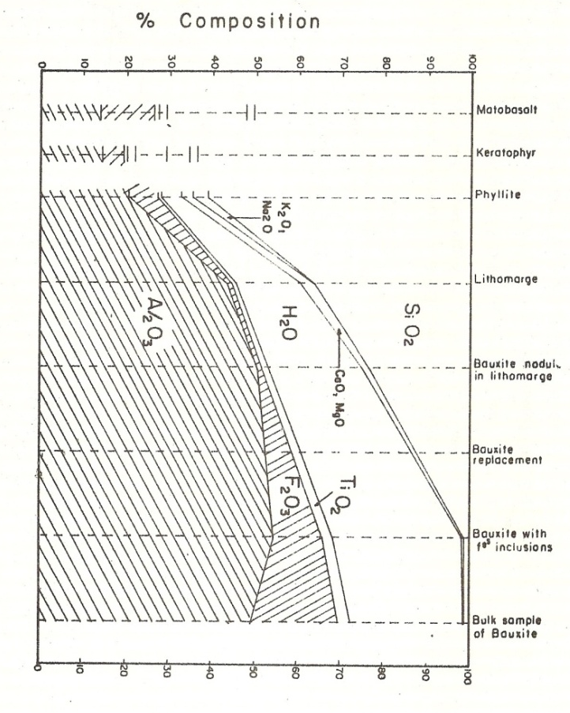
Figure 2.4 Cycle of weathering and laterization process (Maignien, 1966).

2.7.0 The Structural Development of Laterite Soils.
Tropical laterite weathering essentially involves the transformation of massive rock systems of primary feldspar, quartz, and ferromagnesian minerals to apparently porous clayey systems containing kaolinite, Sesquioxides and some residual quartz. It appears that “the ‘Ageing’ proceeds by producing first diffuse goethite, followed by well crystallized goethite and finally goethite and hematite (Hamilton, 1964). The crystallization manifests itself first as iron-oxide concretions followed by coalescence of concretions and their cementation by iron colloids, until the entire system is a continuous iron-oxide cemented crust.”

2.7.1 Morphological Change.
A typical laterite weathering is started by the development of cracks and open joints near the surface acting as collecting channels for run-off water. The fracture planes initially become stained with secondary minerals formed from the breakdown of the least stable parent minerals. Weathering slowly attacks the rock contained by the joints to isolate them into blocks with kernels of fresh materials within a cover of decomposed rock. As further attack continues the block themselves lose their corners to become spheroid boulders surrounded by debris until total decomposition results in the formation of reddish residual materials in which the original texture of the rock is still preserved.
According to Maignien (1966), generally, alteration is greatest at the surface and decreases in intensity downwards towards unaltered parent rock. This is attributed to the degree of saturation of the percolating water, which on entering the surface contain little of the potentially soluble constituents of the rock or soil, but with its passage downward, saturation with respect to these constituents increases and consequently, their rate of solution decreases. Small concentrations and enlargement of ferruginisation round patches appear, followed by the meeting of the round patches and their cementation together by iron colloids, which fill angular cavities. When the cavities are fully filled, the colloids start to overgrow the concretions forming concretionary particles. Dehydration and dessication may lead to the formation of hard pans or cuirasses. Whether the concretionary hardpan is formed as the end produce or not depends especially upon the weather condition and the nature of available Sesquioxides (Maignien, 1966).
In certain localities hardpan may never form at all while in others they may be found even in young profiles. For example, the deeply weathered laterite profiles in the continuously wet dense forest zones may never develop hardpans in the profile while profiles in the alternate wet and dry savannah zones hardpans are found.
2.7.2 Chemical and Mineralogical changes.
A prominent feature of all lateritic materials is the high content of either iron, aluminium or titanium oxides in relation to other constituents. Apparently, an essential chemical property of lateritic weathering is a chain of chemical and leaching processes which lead to partial or complete removal of combined silica, alkaline earths (calcium and magnesium oxides) and alkalis (potassium and sodium oxides) and relative or absolute accumulation of the so-called lateritic constituents (Al, Fe, Ti and Mn) either within the profile or from outside sources.
On the basis of laboratory and field studies, Cooper (1936) constructed a diagram as shown in Figure 2.5 showing the chemical composition at various stages in the formation of aluminous (bauxitic) lateritic soils from metabasalt, Karatophyr or phyllite under the wet forest zone weathering conditions of West Africa.
Figure 2.5 Change in chemical composition at various stages in the formation of aluminous lateritic rock (Cooper, 1963).
Mineralogically, the primary minerals are converted initially to clay minerals and then, with the ultimate loss of all potentially mobile constituents, the residue of oxides and hydroxides crystallize out.
The intensity of the chemical weathering appears to be controlled mainly by the amount, intensity and distribution of the annual rainfall and by the length of time that primary minerals have been exposed to weathering (Sherman, 1949, 1950). Thus, the chemical weathering of soil forming minerals under widely varying degrees of intensity will produce large members of clays and secondary minerals varying greatly in their physical and chemical properties. The very variable environmental conditions found in the tropics would be expected to produce weathered materials that reflect the influence of the intensity and age of the weathering factors. The materials developed under various conditions range from those made up of primary materials to those which are almost wholly made up of the free oxides of iron, aluminum and titanium (Sherman, 1952).
Sequence of types of secondary minerals produced either by the varying degree of intensity factors or by time of exposure of weathering processes, has been found to be as follows: primary minerals-secondary alumino-silicate clay minerals-free oxides. According to Hamilton (1964), the mineralogical sequence of lateritic soils genesis in West Africa has been broken down to its specific types of products. See diagram in Figure 2.2.
Each type of secondary minerals shown will impart its physical and chemical properties to the soil in relation to the degree of lateritic weathering.
2.7.3 Leaching of Dissolved Substances.
Leaching of dissolved primary materials in the alteration zone is an important laterite soil forming process (Sherman 1952; Loughnan, 1969). If the released primary chemical constituents are not removed through leaching the lateritic soils would not form (Mohr and van Baren, 1954). Removal of bases and especially combined silica causes further decomposition which finally leads to the breakdown of the alumino-silicate clay minerals and the formation of hydroxides of Sesquioxides (Longhnan, 1969). The geotechnical significance of the degree of leaching in tropically weathered residual soils appears to have been over-looked by engineers. However, studies by Nye (1955), Florentin et al, (1957), Lumb (1962) and Gidigasu (1971) have thrown considerable light on the physico-chemical and geotechnical implications of the pedogenic process. For example, Nye (1955) has shown that leaching causes wide reduction in density of decomposed rocks. Florentin et al, (1957) also reported considerable loss in dry density through leaching of decomposed rocks in West Africa. Consequently, vertical movement of dissolved bases, combined silica and of Sesquioxides may underlie the vertical of morphological characteristics of materials in various horizons of laterite profiles (Baldovin, 1969; Gidigasu and Bhatia, 1971). Vargas (1953) noted considerable influence of leaching on vertical variation of geotechnical properties of residual soil profiles in Brazil. Leaching was found to cause considerable increase in porosity which leads in many cases to voids of about 60% of the total volume. As water content in these upper layers is low, there is insufficient water to saturate the voids, and this produces material layers of high compressibility. As a result of the leaching, air easily reaches the top soil causing oxidation of the upper soil layers to form reddish materials. Materials below the porous surface layer is often hard layer as leached elements of the superior horizons precipitate with water moving down; this leads to an increase in the soil density and unusual compactness or hardness. High void ratio due to high degree of leaching in some residual lateritic soil profiles causes some high degree of disturbance during soil sampling for triaxial and consolidation tests in the laboratory.
Serious soil sampling and laboratory testing problems may arise through failure to recognize the implications of high void ratio and/or unstable in some highly leached residual lateritic soil.
2.7.4 Sesquioxide Coatings of Fine Particles.
The processes of laterisation appear to have serious physico-chemical consequences on the fine particles. For example, many investigators (e.g. Townsend et al., 1971) have found that the Sesquioxides are absorbed on the surface of the clay minerals in laterite soils; this absorption occurs through the interaction of the positively charged Sesquioxides and the negatively charged clay particles. The mechanism governing the absorption appears to be quite complex and dependent upon the surface characteristics of the iron and aluminium compounds, the charge characteristics of the clay minerals, and the pH of the medium (Greenland and Qades 1968). Greenland and Qades (1968) using electron microscope observed that at low pH values irons precipitates as surface coatings on kaolinite and that some of these surfaces are bound together by the iron hydroxide. The geotechnical significance of the iron coatings of clayey constituents has been investigated and reported (Terzaghi et al, 1969; 1971). For example, Townsend et al, (1971) have shown that the Sesquioxides iron and aluminium which coat the clayey constituents and bind them together into coarser aggregation impart a granular structure to the soil. For example, the x-ray diffraction patterns of a coarse clay fraction of sesquioxide free and remolded soil sample is shown in Figure 2.6 (Townsend et al, 1971). The existence of iron coatings on the soil particles is indicated in Figure 2.6 by the occurrence of a previously absent quartz peak (3.35ºA) after the removal of the Sesquioxides.The increased sharpness of the kaolin peaks (7.31 ⁰ A) and (3.57⁰A) upon treatment of the soil for Sesquioxide removal also substantiates the presence of coating.
Figure 2.6 X-Ray diffraction patterns of the coarse clay fraction of lateritic soil (Townsend et al, 1971).
However, it is still a challenge quantifying in engineering term the degree of sequioxide coating of clayey constituents. X-ray diffraction and electron microscope techniques used for evaluating the degree of coating may not be routinely employed; thus Sesquioxide coating though considered a vital factor in the understanding of physico-chemical and engineering behaviour of lateritic soils, cannot be quantitatively evaluated by current testing procedures.
2.7.5 Formation of the Concretionary Structure
According to Wallace (1973), the fabric or macro-structure of volcanic lateritic soils as identified in Papual, New Guinea, consists of a coarse open skeleton of rock forming mineral (hornblende, plagioclase and quartz) surrounded by a viscous residual gel of highly hydrated clay partly of rock forming minerals and partly of aggregated weathering products. He proposed an idealized structure of fine-grained residual soils as shown in Figure 2.7.
Figure 2.7 The influence of Iron oxide content on the strength of concretory aggregate (Millard, 1962).

Petro-graphic studies have revealed that some lateritics soils also possess porous granular structure consisting of iron impregnated clayey material in minute spherical aggregations resembling popcorn balls (Alexander et al., 1962; Hamilton, 1964). The strength of these aggregations is derived from the thin ferruginous film found within the micro-joints of the elementary clay particles and as coating over particles. The role of the Sesquioxides in the formation of these micro-aggregates is generally ascribed to one or all of the following (Townsend et al, 1971):
- Cementation due to precipitation of hydrated iron or aluminium gels and subsequent irreversible dehydration of these materials;
- The presence of iron in solution, which prevents deflocculation;
- The formation of organic mineral compounds of humic acids with free Sesquioxides (Mcintyre, 1956).
It has been noted that the immobilized iron on the clay particles facilitate the formation of “pseudo silt” and “pseudo sand” (D’Hoore et al, 1954) in which coated clay particles are bound by alumino-ferruginous binding agents and/or organic complexes to form particles of sand size.

2.7.6 Dehydration of Sequioxides and Secondary Minerals
Dehydration (desiccation) is a process which involves loss of water from hydrated Sesquioxides and/or minerals and transformation of amorphous gelatinous Sesquioxides from the mobile state to the immobile crystalline state (Machenzie, 1959; Sherman et al., 1953). The physico-chemical implication of this process especially its contribution to increase in lateritic soil density, specific gravity with simultaneous decrease in plasticity, loss on ignition and base exchange capacity have been discussed elsewhere (Sherman et al 1953; Moh et al, 1969). The degree to which lateritic soils has been desiccated in-situ is of major significance in the evaluation of these materials for construction. For example, difference in degree of desiccation of shallow and deep lateritic materials has been found to influence plasticity and compaction test results (Gidigasu and Yeboa, 1972). In-situ highly hydrated materials are less sensitive to drying than the deep hydrated materials. This is to be expected since shallow materials which have access to oxygen and natural heating by the sun may be highly dehydrated in-situ so that much of the ferrous iron oxide could be transformed to the ferric state to make the soil less sensitive to drying. Deep materials which have no access to air and natural heating may be poorly dehydrated in-situ and may tend to be more sensitive to drying.
Such is the case if the troublesome clay mineral in lateritic soil is the halloysite which exists in two forms depending upon the relative humidity and moisture condition of the environment. Hydrated halloysite (A1₂O₃.2SiO₂.4H₂O) may be converted to metahalloysite (A1₂O₃.2SiO₂.2H₂O) in which form the tubes may be split or partially unrolled (Terzaghi, 1958). The irreversible change from hydrated halloysite to metahalloysite involves loss of monomolecular layer of water from between the kaoline sheets of which halloysite is formed. Dehydration of hydrated halloysite occurs when the moisture content is reduced to below 10% or when the relative humidity is below 40%. If the soils are dried to below this moisture content during the preparation of a sample for test, then the test results apply to a material containing metahalloysite and not dehydrated halloysite (Newill, 1961).
The problem of degree of in-situ desiccation has emphasised the danger of applying standard laboratory index tests to all lateritic material without due consideration for their different genetic and mineralogical characteristics.
2.7.7 Sesquioxides in the Induration of Laterite Materials
The first reference to the influence of iron on the indurations of lateritic soils was made by Buchanan in 1807 who identified the property of in-situ hardening or the tendency to harden an exposure to air of some iron rich lateritic soils of Malabar, India. According to Auber (1950), the hardening of soft lateritic materials in Dahomey is as a result of exposure due to deforestation. Alexander and Cady (1962) have discussed the conditions of alternate softening and hardening of some lateritic materials in reducing or oxidizing environments respectively and emphasized the importance of the state of free iron oxide in the process of hardening of laterite materials.
According to Alexander and Cady (1962), the microscopic studies on slides revealed that the chemical and mineralogical composition together though contributory may not alone explain the hardness of laterite rocks and aggregates and it was postulated that the hardness or ability to harden is also a matter of the arrangement of components as of the kind of components. However, Maignien (1966) believes that iron oxide fully underlies the hardening process in laterite materials. For example, studies have shown that the higher the sesquioxide content, the greater the indurations (strength) hardness being a function of the iron content. The older and more dehydrated occurrences of the same lateritic rocks are frequently harder than the recent ones. According to Nanda and Krishnamachari (1958), studies in India emphasized that the hardening of lateritic materials may be due to:
- Dehydration of hydroxides of iron and aluminum present in the material
- Further oxidation of the high iron content of the material.
- The precipitation of these oxides as cementing material.

Experimented data collected on samples from different parts on India, however, yielded no significant correlation between the mechanical properties; this being attributed to the heterogeneous nature of the lateritic rocks and aggregates studied and their variation in porosity from sample to sample.
  - LOCATION OF LATERITIC SOILS
Lateritic soils are known to occur in humid tropical areas, however, the precise combination of environments under which they are formed have not been fully defined. It was suggested (e.g. Harrison, 1933) that they are formed only over igneous rocks under wet tropical rain forests. However, later studies (e.g. Maignien, 1966) have shown that lateritic soils, may in fact be formed under very wide range of conditions
    - Parents Materials
Lateritic soils have been found over different types of parent rocks including granites, gneisses, schists, phyllites and volcanic ash (Sherman, 1952; Mohr and Van Baren, 1954; Maignien, 1966) and according to Stephen (1966), lateritic soils is also located over shale, sandstone and limestone.
Apparently, lateritic weathering is more intense and more widespread on basic rocks than on quartz rich acid rocks, under the same weathering conditions. For example, because of the ease of alteration of such basic rocks as basalt, narite and amphibole schist, it was believed that these were the only rocks that could give rise to lateritic soils.
Lateritic soils could develop also on a variety of parent materials including even alluvia, colluvia and other sedimentary deposits, provided of course there is the source of sesquioxide in the system to be mobilized, transported and redeposited either on a profile scale or on geomorphological scale.
The relationship for West Africa between the simplified geological map (Fig. 2.8) and the distribution of lateritic soils (Fig.9) illustrates the wide range of parent material on which lateritic soils could be formed. Note that lateritic soils are found all over the pre-cambrian formations consisting partly of metamorphic rocks formed from sediments and partly from later volcanic intrusions. They are also found over later formations including conglomerates, limestones, sandstones and shales as well as on loose coastal sands derived from the weathering of sandstone formations.
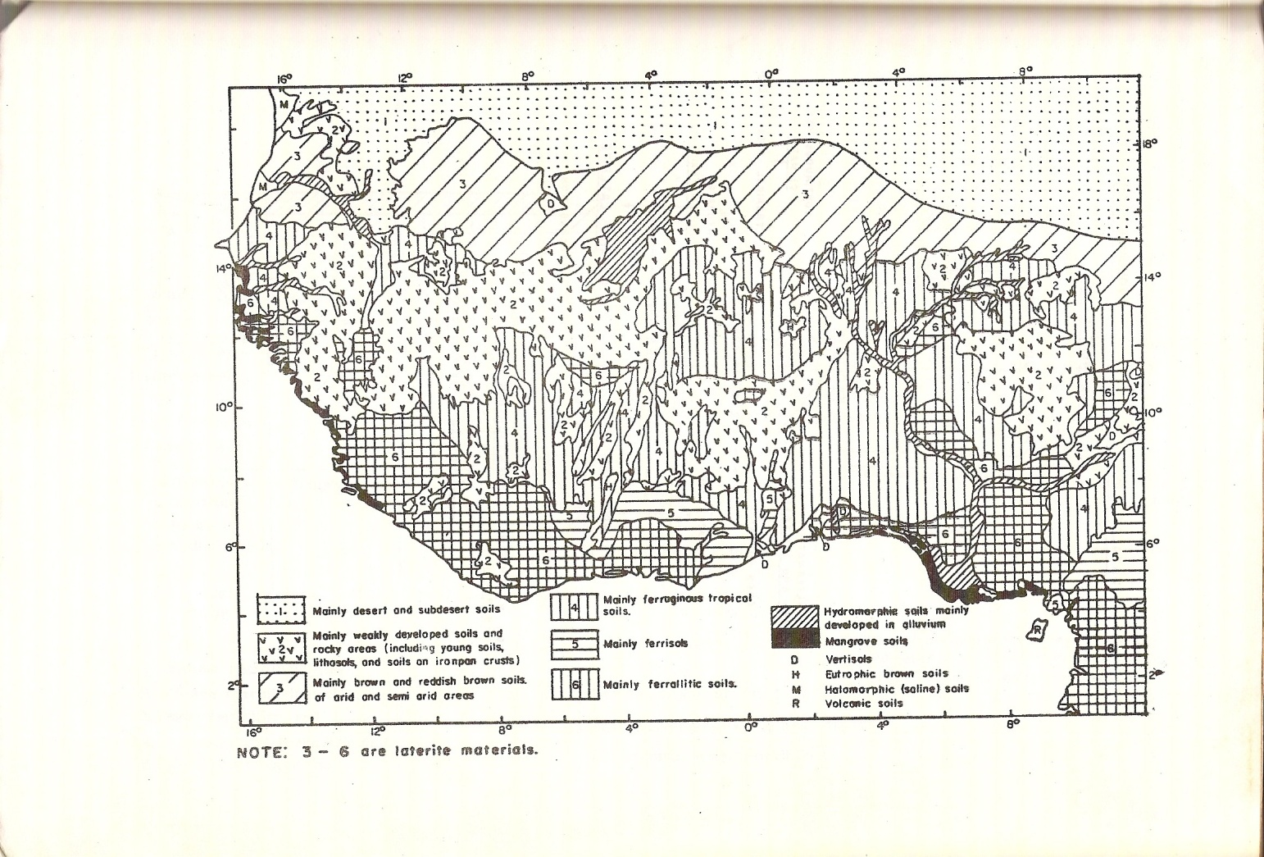
Fig 2.8 Pedological soil map of West Africa(D’Hoore, 1964).
Fig 2.9 Weathering Sequence of Basaltic lavas in relation to weathering conditions (Sherman, 1952).
2.8.2 Climate.
The two main climatic factors which appear to influence the distribution of laterite soils immensely are temperature and rainfall. Few studies concerning thermal conditions of laterite formation have been reported although this information appears to be essential. According to Crowther (1930), the SiO₂/A1₂O₃ (sesquioxide) ratio increases as temperature rises when humidity is constant. According to Maignien (1966), most contemporary lateritic soils develop at mean annual temperatures of about 25⁰C. However, mean annual temperature is 18-20⁰C on the high plateau of Madagascar, where laterite profiles are extremely deep.
Most studies on the effect of precipitation on laterite soils formation was based on the relation between precipitation and the SiO₂/A1₂O₃ ratio (e.g. Segalen, 1957). Mohr and Baren (1954) criticized this approach and noted that although there is some reason to believe this ratio represents a trend in lateritic soils formation as related to climate which should not be completely overlooked; three contradictory conclusions have been reported as follows:
  - A Negative correlation between precipitation and SiO₂/A1₂O₃ ratio (Martin and Doyne, 1927)
  - No correlation between precipitation and SiO₂/A1₂O₃ (Vine, 1949).
  - A positive correlation between precipitation and SiO₂/A1₂O₃ ratio (Glangeaud, 1941).

However, it is now known that where a definite dry period exists, the end products of laterite weathering are considerably enriched in ferric oxide and dominant constituent of the surface horizon. In a continuously wet climate stabilisation of the iron by oxidation or the titanium by desiccation of Ti (0H)₄ does not occur and appreciable quantities of both are lost through leaching. Apparently, in wet distinct and dry climate the development of lateritic soils rich in iron and titaniferous minerals occurs whereas in continuously wet areas the end product is dominated by aluminous minerals (see Fig.2.10). A major contribution has been made in attempting to define limits of laterisation in relation to the minimum precipitation. For example, observations in Africa (Maignien, 1966) indicate that the limit lies approximately towards the 1200mm isohyets, and may possibly be reduced to around 950 to 1000mm. Lateritic soils appear always to correspond to climates in which the rainy period is a warm season; this applies to semi-humid tropical climate as well as to equatorial climates. There does not appear to be upper limit to precipitation.
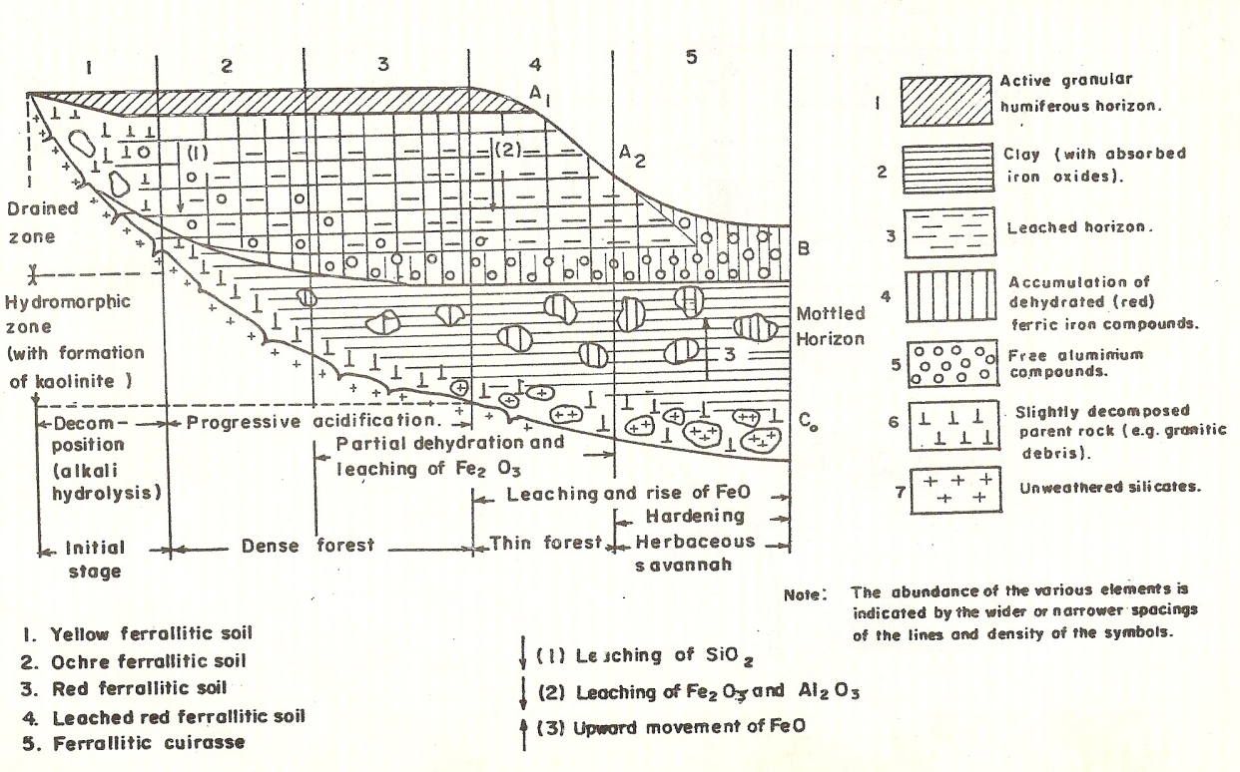
Fig 2.10 Morphological characteristics of laterite profile in relation to vegetation cover (Magnien, 1966).
2.8.3 Vegetation.
According to Maignien (1966), while lateritic soils occur in regions with rain forest vegetation, well developed lateritic rocks are most commonly found under a low forest and hard surface lateritic soils is are very common feature of the open Sudan-Guinea savannah vegetation adjacent to the forest. D’Hoore (1954) found iron mobilized to a greater degree and to a greater depth under tropical grasses than under forest. Humbert (1948) also observed lateritic soils in open savannah that was gradually replacing forest, a common condition where a soft lateritic soil that change to hard from within a few years was found to be due to change from forest to savannah (Aubert, 1950) . Humid forest vegetation favours the Buchanan’s type of soft lateritic soil while the hardened soils are found in the dry savannah regions where the conditions most favour oxidation and dehydration of the hydrated lateritic soils. The relationship between vegetation type and the nature of lateritic soils is shown in Figure 2.11. Apparently, lateritic soils are formed in areas covered by vegetation ranging from rain forest through woodland savannah to the dry grassland savannah (Brammer, 1962).
2.8.4 Topography and Drainage Conditions.
In order to understand the formation and distribution of some lateritic soils, it is often helpful to take into account the history of the landscape, and its geomorphology. A strong correlation has been reported between the nature of laterite soils and the local topography. Brammer (1962) and Ahin (1970) noted that upland well drained lateritic soils are frequently reddish to reddish-brown or brownish-red and occasionally very bright red or purplish red. These red colours denote the presence of a non-hydrated iron oxide, hematite (Fe₂O₃), in the soil.
In the middle and lower slope soils, drainage is poorer than in the upper slope and summit soils partly because they receive soil moisture seeping down slope from the upper soils. The fact that these soils remain moist longer and perhaps dry out less frequently and thoroughly is reflected in an increasing degree of hydration of the iron in the soil and is in a brown or yellow colour rather than a red one. The hydrated iron oxide in these soils are mainly goethite ( Fe₂O_{3.}H₂O) and limonite( Fe₂O₃.1.5H₃O), and their presence is responsible for the fact that going down the slope, the colour of the subsoil change first from reddish brown to warm brown or orange brown and then to yellow brown or even brownish yellow. Lower slope colluviums is typically brownish yellow in colour, as are the better drained soils developed in alluvium. Where drainage is very poor, as in the valley bottom itself where water table fluctuates and all or part of the soil profile is waterlogged, then another factor becomes prominent the reduction of iron and other compounds in the soil, as opposed to their hydration in the upland soils subject to moist conditions. The colours typical of reducing conditions in soils are the bluish greys, greenish greys, and neutral greys of valley bottom soils. These colours suggest prolonged water logging. Where the water logging is intermittent or seasonal, as in that part of the profile where the water table fluctuates, then instead of uniform grey colours, mottles are likely to be produced. Maignien (1966) has observed the occurrence of lateritic crusts at the borders of natural drainage areas, such as piedmonts, river banks, dissection forms, and other abrupt breaks in slopes where the profile of a saturated zone approaches the surface.
Lateritic crust on high-level peneplain remnants may be residuum of rocks weathered in place or may be transported material deposited prior to peneplain dissection. Its present position may be a consequence of landscape inversion (Clare, 1960). With uplift or with lowering of base level, areas protected by lateritic crust remain as erosion lower the surrounding areas. Such areas now occupy the highest positions and are being reduced slowly by lateral retreat of slopes. At the base of the penepalin remnant, detritus from above including fragments of the crust, accumulate and is re-cemented to younger lateritic crust on the colluvial foot slope (Maignien, 1966; D’Hoore, 1954). A typical example of the relation between the topography and morphological characteristics of laterite soil deposits is illustrated in Figure 2.11 below.
Fig 2.11 soil and slope relationship in south west Nigeria (Moss, 1965)
2.8.5 Geological Time Factor.
Deposits of lateritic crusts are associated with Pliocene, Pleistocene or middle to later Tertiary periods (Whitehouse, 1940; Fernando, 1948; Ruhe, 1954). Though some lateritic soils may be forming currently on some ancient peneplian remnants, it is believed that many high level crusts are “dead” products of the age of peneplain development. Lateritic soils with indurate, slag-like, concretionary layers in the profile appear to have developed on pre-tertiary, or least, on tertiary geological formulation.
The hard layer of concretionary ironstone, which caps low hills and plateau, was undoubtedly formed at some time in the past and appear to mark the remains of a late tertiary or early Quaternary peneplain, which stretched across many parts of West Africa.
Though it is believed that the formulation of lateritic crusts of “absolute accumulation” may occur rapidly, the formulation of lateritic soils from solid unweathered rock may be no more rapid than the time required to attaining a high degree of weathering. In unconsolidated material deposits subject to enrichment in iron from outside sources, the rate of development may be relatively rapid. Hardening of the soft preconditioned material may also take place in few years upon exposure (Alexander and Candy, 1962).
2.9 MORPHOLOGY AND COMPOSITION OF LATERITE SOILS.
Geotechnical studies on lateritic soils (USAID, 1971; Gidigasu, 1972) have revealed that similar combinations of soil forming processes do lead to soils of similar index properties. In the overall planning and material survey for highway and airfields and finding sources of satisfactory fill-material for embankment construction, the identification of localities in which weathering conditions are similar has been found useful (Clare and Beaven, 1965). Since most tropically weathered soils, and in particular, lateritic soils have developed under the influence of such factors as climate, vegetation, type of underlying parent material, topography and drainage conditions, etc, all these factors are useful indices for regional identification and grouping of lateritic soils for engineering purpose (Gidigasu, 1972). Indeed, Clare (1957) and USAID (1971) have shown that no system of classification nor any attempt to group most typically weathered soils can succeed if it is not based on an appreciation of tropical weathering processes.
2.9.1 Characteristics of Lateritic Soil Profile.
Laterite profiles have been defined as profiles in which laterite horizons are found or capable of developing if favourable conditions for laterisation persist for appropriate length of time (Penedelton and Sharasuvans, 1946).
Four typical soil horizons have been identified in lateritic profiles as follows:
A - Top soil (generally dark humus stained horizon)
B2 – Lateritic horizon of iron or alumina crusts
B1 – Zone of mottling with evidence of enrichment of sesquioxides.
C - Pallid or leached zone (rock suffering chemical change, but retaining physical appearance).
In certain cases the top soil is eroded away and the lateritic zone is an exposed desiccated and/or hardened cap generally on peneplain remnants (Ahn, 1970). Materials in each horizon may differ morphologically, chemically and mineralogically not only vertically but also from site to site because of the complexity of the inter-relationships among the controlling soil forming factors.
Morphologically, three main soil layers have however been identified in lateritic profiles.
2.9.1.1 Soil Layer Overlying Lateritic Bed.
Lateritic layer may be fairly shallow at places and fairly deep in other places. The soil overlying the layer appears to range from about 600mm (Sivarajasinghan, et al, 1962) to about 3900mm (Alexander and Candy, 1962)
The top layer may be genetically related or unrelated to the lateritic horizon. Stone-lines marking erosion surfaces which are very common in the tropics may mark discontinuities of materials vertically (Ruhe, 1959). A great variety of soils may overlie the lateritic horizon. Where such soil horizons are residual, they are composed of highly weathered material rich in sesquioxides with or without kaolin and with some component of whatever highly resistant minerals may have been present in the parent rock. They may be uniform in character with depth or may have genetic A-B horizon sequences.
2.9.1.2 Lateritic Horizon.
The lateritic horizon may be genetically related or unrelated to the lower soil horizons. This layer may be red clays, detrital nodules or fragments from adjacent high-lying landscape containing relics of disintegrating lateritic crust in which fresh soil are forming or units developing concurrently with new soil or may even be lateritic rock or cuirasses (Ahn, 1970; Dowling, 1966). Red clays are found in wet forest zone or in areas of high water table in which neither nodules nor lateritic crust may ever form.
In the case of lateritic nodule, this is formed in soils that have no obvious water table (Raychaudhuri, 1941), such nodules commonly increase progressively down-slope on a given land form.
In the case of concretions they could be two:
- Concretions formed by the successive deposition of sesquioxide films, usually ferruginous, around a nucleus, which is generally a quartz grain.
- Concretions consisting of altered rock debris impregnated by ferruginous solution.
The former develops in the near surface horizons, and the later at greater depth (Sivarajasighan et al., 1962).
2.9.1.3 Soil Layers below Lateritic Horizon.
Detrital lateritic fragments and nodules are deposited on whatever material may be present on foot-slopes of dissection forms in which the detrital lateritic crust and the underlying material may be unrelated. Where the lateritic horizon is residual, however, there is some measure of consistency of the kinds of underlying layers. Though it may be possible to meet a lateritic rock on unaltered rock, most descriptions show highly weathered, commonly thick, earthy layers between the lateritic zone and the bedrock (Loughnan, 1969). In dry areas or where conditions contribute to good aeration, as in some high-level positions, the underlying material may be bright in colour. In the low-level positions, the lateritic horizons is underlain by either a mottled zone, a light-coloured layer or both, suggestive of poor aeration, reduction of iron, and possible laterial leaching of sesquioxides. Walther (1915) and later Whitehouse (1940) suggested the terms “mottled zone” and “pallid zone” for the two distinct horizons between the laterite layer and the unweathered parent rock.
The entire layers may be present, and one or all apparently may be related genetically to the laterite. None except the lateritic horizon itself appears to be essential to the development of lateritic profiles in all environments.
2.9.2 Morphological characteristics.
Genetically, two major groups of lateritic soils have been identified. They are the aluminous (bauxites) and ferruginous lateritic soils. The significant genetic characteristics of the two groups of lateritic soils are summarized in the Table 2.2.
TABLE 2.2: Generalized Morphological Characteristics of Materials from Lateritic Profile.
Grade of literite materials | Genetic textural Groups | Origin and state of excavation | Colour and structure | Nature of coarse particles | Relationship to parent materials
I | Decomposed Rock | Residual materials exist from material that break under finger pressure to solid fresh rock | Discoloured parent rock; generally grey to yellowish red. Structure of parent rock is preserved. | Angular, sub-angular to cubical, Range in size from coarse sand to boulders in relation to degree of decomposition | In undisturbed state structure of parent rock is preserved
II | IIa Laterite fine grained soil | May be residual or non-residual, unconsolidated to compact in relation to genetic origin and environmental conditions including geological history and degree of dehydration and dessication | Variable red shades from yellowish red, through reddish brown to pinkish brown, structure depends on type of parent rock, degree of weathering and state of compaction | Isolated quartz and concretionary particles in fine grained (sand-silt-clay mixtures) soil matrix. | Particle size distribution is a function of parent rock type and degree of weathering.
 | IIb Laterite gravity soils | May be residual or non-residual, unconsolidated to compact in relation to genetic origin and environmental conditions including geological history and degree of dehydration and dessication | Yellowish-red to pink, structure depends on degree of weathering and laterisation. Generally free concretionary and quartz particles inearhty matrix, compacted to various degrees | Irregular, angular, cubical to rounded quartz particles and dark brown to pink hardiskinned concretionary modular particles of differrnt sizes and shapes. May be detrital, laterite rock pieces | Variable, quarz rich parent rocks give rise to high percentage of quarz particles in relation to concretionay ones. The relationship to parent rock may not be reflected in particle size distribution.
III | Laterite rocks (including cobbled and boulders) | May be residual or non-residual. Range from soft material breakable under finger pressure to very hard rock-like red concretionary masses. | Reddish-brown, dark brown, pinkish-brown to pink. In residual material, indurated elements form a continuous, coherent skeleton. In non-residual materials, the indurated elements cement pre-existing materials | Irregular quartz and concretionary particles of different sizes distinguishable in otherwise fussed mass of different sizes. | In the ferruginised rocks, texture and structure may be preserved; otherwise no relation with parent rock types is discernible, especially in non-residual types.
As most of these differences are qualitative and not easily identified under field conditions and are not of any major geotechnical significance, the significant differences should be based upon the physical and geotechnical characteristics determined in the laboratory. The result of geological sampling of materials in a typical West African lateritic soils deposit based upon a consideration of geological origin, state at excavation, colour and structure, and textural characteristics are summarized in table 2.3.
Table 2.3:The Chemical composition of laterite materials from various parts of the world.
Type | Ferruginous bauxite laterite | Detrital laterite | Laterite | Laterite | Laterite | Concretionary ironstone | Laterite on gneiss | Laterite  Over  Trachy  andesite | Ferrugi  nous laterite | Aluminous laterite | bauxite laterit
locality | Satara  India | Madras | Nigeria | Coll  gardic  Australia | Coll  Banda  Australia | British  Guiana | Sudan | Jaws | Lawra  Ghana | Goaso  Ghana | Yinahini  (kumasi)  Ghana
Reference | W.&W. | W.&W. | J.M.C. | E.S.S. | E.S.S. | J.B.H | M.B. | M.B | J.& J. | J.& J. | J.& J.
Total  Sio₂ | 0.9 | 34.8 | 26.5 | 2.6 | 3.5 | 5.7 | 34.92 | 37.00 | 23.96 | 21.09 | 0.71
Al₂0₃ | 26.3 | 6.7 | 19.9 | 4.2 | 16.4 | 7.1 | 30.73 | 28.84 | 16.69 | 15.75 | 59.71
Fe₂0₃ | 56.0 | 47.4 | 36.7 | 80.0 | 60.6 | 76.3 | 12.52 | 8.95 | 43.58 | 45.13 | 8.46
Fe0 | - | - | - | - | - | - | - | ND | 0.32 | - | -
Mg0 | - | - | - | - | - | - | 1.25 | 0.73 | 0.21 | 0.28 | -
Ca0 | - | - | - | - | - | - | 0.76 | 0.40 | - | - | -
Na₂0 | - | - | - | - | - | - | 0.90 | 2.98 | - | - | -
K₂0 | - | - | - | - | - | - | 0.6 | - | - | - | -
Ti0₂ | 1.6 | tr. | 1.1 | 6.1 | 1.3 | 0.3 | 1.02 | 1.02 | 1,1 | 2.17 | 3.25
H₂0 | 14.4 | 10.7 | - | - | 10 | 8.02 | 1 | 13.39 | 13.60 | 13.60 | 27.95

W. &W. – Wath and Wath (1903). J.B.H – Harrison (1933).
J.M.C- Campbell (1917). M. &B. - Mohr and Baren (1954).
E.S.S – Simpson (1912, 1916). J. & J- Junner and James (1974).
2.9.2.1 Genetic-textural characteristics.
Texturally, lateritic materials cover a large succession of materials from earthy to rocky materials which genetically form a chain of materials starting with fresh rock and ending with concretionary sesquioxide rich rock. During lateritic soils sampling and identification, records must be made of the absence or presence and if present, the quantity and distribution of the unweathered or partially weathered or pedogenic material greater than 2mm. These materials may have the form of one of the following:
- Residual parent material which is capable of further weathering to produce fine fractions. Such materials may produce both chemical and physical effects upon the soil forming processes and is a characteristic of immature soils. Stones of this nature usually consist of carbonates of lime and magnesia or the more complex silicates and alumino-silicates.
- Residual materials incapable of further chemical decomposition so long as present condition prevail. They may, however, be subject to further commution but their only direct effect upon the soil mean is a physical one. Such materials as quartzite pebbles and flints may be included in this category.
- Concretionary materials which, through chemical or physico-chemical reactions, have accumulated in the soil mass, though not usually referred to as stones; do in fact frequently behave as such. The recognition of the constituents of either of the above categories is merely a matter of examination of hand specimen and possibly of its fracture after a blow with a hammer.

2.9.2.2 Colour.
Lateritic materials have characteristic reddish shades which appear to be due to the various degrees of hydration of iron, titanium and manganese. The shades also reflect the degree of maturity; for example, with age ferruginous lateritic materials seem to change from red to brown to black wile aluminous materials become brighter in colour (Malgnein, 1996).
2.9.2.3 Macro-structure.
Structure in the undisturbed decomposed rock may be similar to that of the parent rock. The structure of fine-grained lateritic soils is very variable and appears to be a function of the nature of the parent rock, genesis and the degree of weathering and sesquioxide enrichment (Alexander and Candy, 1962; Maignein, 1966). The structure of the gravels/gravelly materials may have to be reduced to one form; the coarse fractions of concretions and/or quartz particles in red loamy matrix.
Two typical macro-structural patterns of lateritic rocks have been identified (Malgnien, 1966).
(a) The indurate elements form continuous coherent skeleton.
(b) The indurate elements cement pre-existing residual or transported materials.

2.9.2.4 Origin and state at excavation
Each of the genetic-textural groups of lateritic soils may be residual or non-residual. Depending upon the degree of decomposition, laterised (sesquioxide enrichment) or dehydrated (desiccation and/or hardening) lateritic soils range from decomposed rocks through unconsolidated, friable or granular materials to rock-like masses of considerable hardness.
2.9.2.5 Relation to parent rock.
Depending upon the genesis (i.e. the degree of decomposition, laterisation or dehydration) the materials may be related or unrelated to the parent rock types. For example, decomposed rocks and poorly leached fine grained soils are morphologically related to the parent rock type while the highly laterised and dehydrated material may show no trace of the characteristics of the parent rock.
However, quartz rich parent rocks tend to produce gravelly materials that are very rich in quartz particles in relation to concretionary particles. In lateritic rocks formed by the ferruginisation of the instant parent rocks, the texture and structure are related to those of the parent rock, while lateritic rocks that are formed through the cementation of pre-existing materials are generally unrelated to the parent rock.

2.9.3 Chemical characteristics
The high proportion of sesquioxides of iron (Fe₂O₃) and aluminium (Al₂O₃) relative to other chemical components is a feature characteristic of all grades of lateritic soils. According to Sherman (1952) and Maignien (1966), chemically, two groups of lateritic materials are identifiable. Those in which the iron oxide predominates (ferruginous lateritic soils) and those in which alumina predominate (Aluminous lateritic soils).
The chemical characterisations of typical lateritic soils from different tropical areas are given in Figure 2.12. Note in Table 2.3 above that bases are generally believed to be low, but some may have significant amounts. This is probably in the form of kaolin which appears to be the commonest silicate clay mineral in lateritic soils. Other common chemical constituents or lateritic soils are oxides of manganese (Mn) Titanium (Ti), Chromium (Cr) and Vanadium (V).
Figure 2.12 A typical lateritic profile (Grant and Aitchison).
Titanium oxides are not common in significant amounts in most varieties but may sometimes be a major constituent in some lateritic soils (Sherman, 1952). Quartz may be absent or present in only limited amounts, but on rocks rich in quartz it is a significant or major component, as on granite. It is considered an important factor in differentiating aluminous lateritic from ferruginous ones. The base (Ca0, Mg0, K₂0, Na₂0) are almost absent in most lateritic soils except in some ferruginous crusts developed in alluvium and concretionary horizons in some ferruginous type of tropical soils. The combined water determined by loss on ignition is always present in appreciable amount depending upon the degree of hydration of the soil and appears to range between 10 and 30 per cent and is more in aluminous than in ferruginous lateritic soils (Maignien, 1966). Chemical definitions of lateritic soils have not however found useful application in lateritic soil engineering for two reasons. The first reason is that generally identification of lateritic soils based upon chemical characteristics is imprecise for engineering purpose; soils in the same chemical group may have a wide range of engineering properties. Secondly, in spite of some engineering values derived from chemical data on lateritic soils, the determination of even the relatively simple silica-alumina or silica-sesquioxide ratio requires a chemical analysis not likely to be available to the geotechnical engineer. The mineralogical studies on lateritic soils have generally supplemented chemical data as the latter is too crude to reveal origin, nature and composition of most lateritic soil (Campbell, 1917).
2.9.4 Mineralogical Characteristics.
Experience with tropical soils has shown that climate, topography and vegetation through their control of the character and movement of water through the alteration zone, determine whether the weathering system and drainage conditions favour the development of kaolinites, halloysite, illite, montnorillonite type minerals or some less known secondary minerals (Mohr and van Baren, 1954; Dumbleton, 1963; Dumbleton et al., 1966). For example, the influence of the nature of the weathering condition on nature of the clay mineral developed is shown in Figure 2.13 and Table 2.4 below.
Fig 2.13 Chemical composition of laterite material (Lukens, 1964).
Table 2.4: influence of weathering condition on the mineralogy of typical tropical soil
Location | Parent Rock | Predominant Clay  Minerals | Accessory  Clay  Minerals | Mean  Annual  Rainfall | Rainy  Seasons | Drainage | Range In Mean Temp.
Ghana  Kumasi  Bompata,  Nkawkaw,  Kumasi | Granite  amphibolite  metamorphosed volcanic  phyllite | kaolinites  kaolinites  kaolinites  kaolinites | -  -  -  montmorillonite | 55”  65”  70”  55” | 2  2  2  2 | Good  Fair-good  Fair-good  Fair-good | 66.6-100  similar to kumasi  similar to kumasi  66.6-100
Ethiopia  Injabara,  Bahar Dar,  Soddu,  Lekempti  Addis Ababa | Basalt  Basalt  Trachyte  Basalt  basalt | -  halloysite  kaolinites  kaolinites  kaolinites | -  -  montmorillonite  montmorillonite  montmorillonite | -  60”  (1966)  -  90”  (1966)  49”  (1966) | 2  2  2  2  2 | Fair-good  Fair-good  Good  Good  Fair-good | -  36-87  (1966)  51-81  48-  40-81
Kenya  Sasumua  Nairobi,  Kabete | Welded  Tuffs  Trachyte  Tuff or  trachyte | halloysite  halloysite  Meta- halloysite | goethite  gibbsite  kaolinites  -  - | 53”  40”  40” | 2  2  2 | Good  Fair-good  - | 58⁰ – 88⁰  67⁰ annual  mean  67⁰ annual  mean
Other  Guma, Sierra  Leone  Fernando Po | gabbro  Basic extrusive | halloysite  halloysite | gibbsite  goethite  kaolinites  - | 100”  120” | 1  most of year | -  - | 70-95  -
Morin and Parry, 1969
Clay minerals as a rule are very sensitive to small changes in the composition, temperature and pH of the environment (Sherman, 1952; Loughnan, 1969). Kaolinite characteristically develops in an acid environment often produced by organic acids or the oxidation of sulphide minerals. In places where strong leaching processes under neutral conditions have affected the rocks, kaolinite also tends to develop under any condition that effectively remove the bases from the weathering system.
The montmorillonite minerals develop under a wide range of conditions in the presence of magnesium and to a lesser extent, in the presence of other alkalis and alkaline earths. The iron in these minerals is usually in the ferric state.
The illites are the dominant clay minerals in marine sediments but they also occur in certain soils, especially those derived from shales, and are thought to constitute 20% of mica content of the sediments of the earth. The environments of iron oxides and hydroxide minerals occurrence have been discussed by many investigators (e.g. Loughnan, 1969). These minerals occur in wide variety of rocks and their presence may serve as useful guide to environmental conditions under which certain soils, laterite and even ore deposits have developed (Frederickson, 1952). Dumbleton (1993) on the basis of studies in Borneo found that iron oxide tends to accumulate in well- drained soils with good oxidation under climate having hot, wet period. Under these conditions organic matter is rapidly broken-down so that the leached water is near neutral, and iron is oxidized and immobilized. The iron oxide and hydroxide minerals are particularly sensitive to changes in the redox potential of the environment. In the presence of organic matter or below water table, ferric minerals tend to be destroyed whereas, in the oxidized parts of the environment, ferrous compound are particularly unstable (Loughnan, 1969).
2.10 Soil Classification System.
The earliest soil classification system is the “Texture System.” This system is based on soil grain size alone. It is still used in the agricultural field, though geotechnical engineers have long abandoned the system. The FAA system initiated by the Federal
Aviation Administration was the first to be developed by the engineers. The only systems in use by the geotechnical engineers at present are the AASHTO System and the Unified Soil Classification system. The latter has gradually replaced all others.
2.10.1 Unified Soil Classification System (USCS).
According to Chen (1999), the Unified Soil Classification System was adopted in 1952 by the Bureau of Reclamation and the Corps of Engineers, with Professor A. Casagrande as consultant. Soils are categorized in groups, each of which has distinct engineering properties. The criteria for classification are:
- Percentage of gravel, sand, and fines in accordance with grain size.
- Shape of grain size curve for coarse grain soils and
- Plasticity and compressibility characteristics for fine grained soils and organic soils.
The letter symbols are as follows:
G Gravel and gravelly soils
S Sand and sandy soils
M Silt
C Clay
O Organic soils
Pt Peat
W Well graded
P Poorly graded
H High Plasticity
L Low Plasticity

2.10.2 Soil Classification Tools.
In classifying, sieve analysis is first conducted determined if the total percentage soil that passed the No. 200 (75 micron) sieve size is greater than fifty percent (50%) or not. Other results from the sieve analysis are checked with Auxiliary Identification Procedure chat as shown in Figure 2.15. The Atterberg’s limits (liquid and plastic limits) of the soils are then determined from the Atterberg’s limit tests and hence the plasticity index. The values of the liquid limit and plasticity index are used to determine the soil type from the Casagrande’s Plasticity chart as shown in Figure 2.14.These Atterberg’s Limit values together with the sieve analysis results are then checked with the chart in Figure 2.15 to classify the soil.
Fid 2.14 Casagrande’s plasticity chart showing several representative soil types developed from (Casagrande, 1948) by Holtz and William (1981).

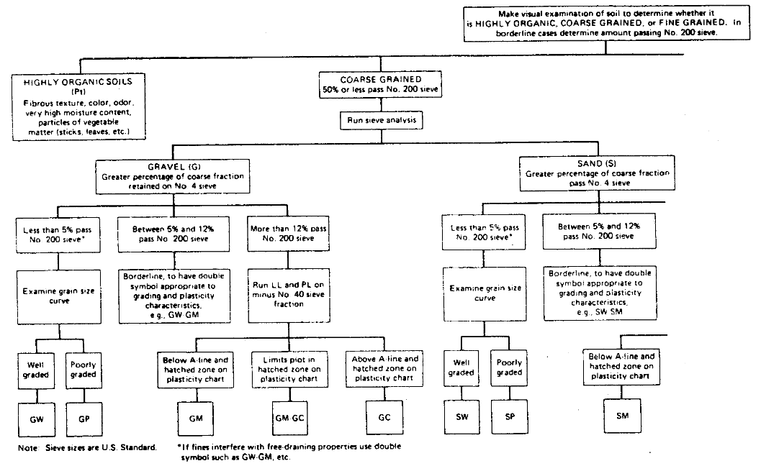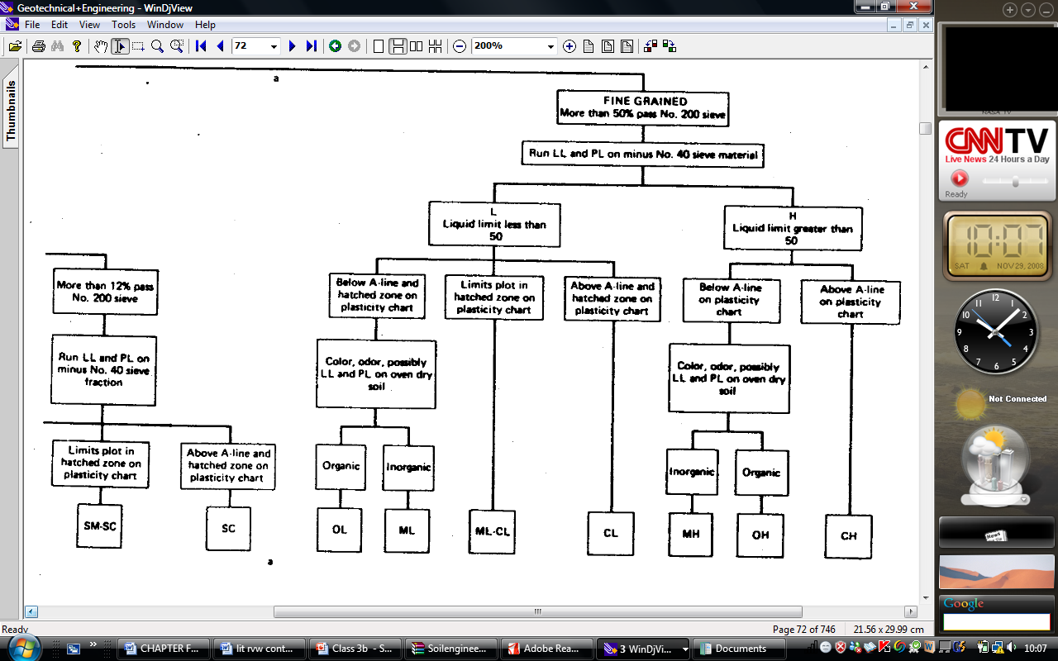

Fig 2.15 Auxiliary Laboratory Identification Procedure (Holtz and William, 1981)
2.10.3 Properties of a Well Graded Soil.
According to Holtz and William (1981), soil is said to be well graded if it has a good representation of particle size over a wide range and its gradation curve is usually smooth and generally concave upward. The Figure 2.16 show different curves and the gradation they represent.
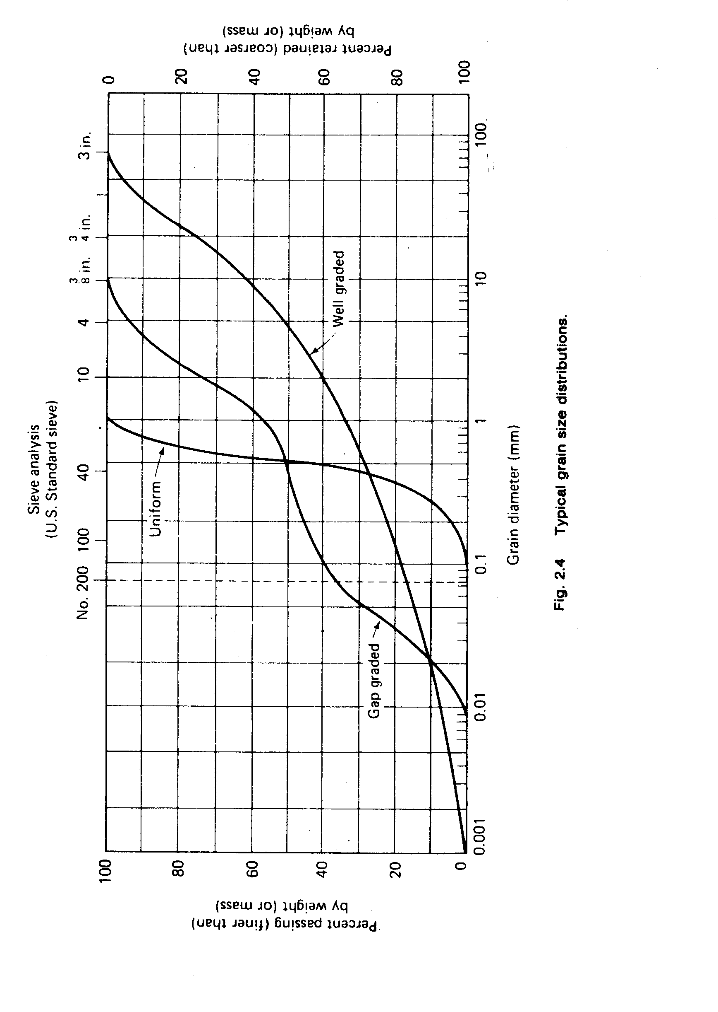
Figure 2.16 Typical grain size distribution curves. (Holtz and William, 1981)
The curves like the gap graded and the uniform curves are all termed poorly graded soils. The coefficient of uniformity (C_{u}) is a crude shape factor and is defined as.
And the coefficient of curvature which is another shape parameter is defined as.
Where D₆₀, D₃₀ and D₁₀ are grain diameter corresponding to 60%, 30% and 10% passing respectively.
According to Holtz and William (1981), soil is said to be well graded if the coefficient of curvatures is between one and three (1 & 3) and the coefficient of uniformity greater than four and six (4 and 6) for gravel and sand respectively.

CHAPTER THREE.
3.0 RESEARCH METHODOLOGY.
(MATERIALS, SPECIMENS, PREPARATION AND EXPERIMENTAL DETAILS).
3.1 Block Moulding and Curing.
The block moulding is as described in chapter 1.3 to 1.3.13.

  - PREPARATION OF DISTURBED SAMPLES FOR TESTING.
See appendix A for procedure to BS 1377: 1975.

  - DETERMINATION OF MOISTURE CONTENT (OVEN DRYING METHOD).
See appendix B for procedure to BS 1377: 1975.

  - ATTERBERGS LIMITS TEST.
See appendix C for procedure to BS 1377: 1975 and results in section 4.2.1 and 4.2.2; Tables 4.1 and 4.2; and Figure 4.1.

  - GRAINS-SIZE ANALYSIS.
See appendix D for procedure to BS 1377: 1975 and results in section 4.3.1 and 4.3.2; Tables 4.3, 4.4 and 4.5; and Figure 4.2.
  - SPECIFIC GRAVITY TEST.
See appendix E for procedure to BS 1377: 1975 and results in section 4.4 and Table 4.6.
  - SOIL COMPACTION TEST.
See appendix F for procedure to BS 1377: 1975 and results in section 4.5; Table 4.7 and Figure 4.3.
All tests on the lateritic soils to determine its characteristics and readings (section 3.2 to 3.7) were conducted in the Nigerian Building and Road Research Institute (NBRRI) in Ota. Ogun state.

3.8 COMPRESSIVE STRENGTH TEST.

Aim: To determine the compressive strength of the sandcrete blocks.

Apparatus: Compression machine, two steel plates, weighing balance and the block samples.

Procedure: The compression machine is connected to the main and the pointer on the reading calibration scale is adjusted to the zero mark.

The metal sheet placed on top of the block (to spread the load) is weighed so as to add it to the compressive strength value read from the machine and this sum is taken as the compressive strength value of the block sample.

The sandcrete block is weighed and recorded and then placed between the metal plates that completely cover the area of the block and fed into the compression zone and locked with the block centralized within the compression zone.

The start button is depressed to initiate the electronic compression and as the compressive force is applied to the block, the pointer reading the compressive strength value in kilo-Newton (KN) gradually rises till it reached its peak and then begins to drop back.

The maximum value just before the pointer begins to drop or the pointer reading when visible cracks is evident on the block is taken as the compressive strength of the block which is indicated by another pointer in the former case.

The compression is then powered off by depressing the red button and the block released and the crushed blocks poured out for disposal.
Result: The result is as shown in section 4.6, Table 4.8 and Figure 4.4 of the next chapter.

CHAPTER FOUR.
4.0 PRESENTATION AND DISCUSSION OF RESULTS.
4.1 Block Moulding Observations.
After the trial mix as described in section 1.3.1.2 to determine the quantity of water needed to mix a batch, it was observed that the quantity of water with same volume as the trial mix was only possible to produce the control mix and the ten percent (10%) lateritic soil replacement and more volume of water was needed to produce higher replacements of lateritic soil. If the water was not increased, the fresh sandcrete will not come out of the mould and if forced out by vibrating while removing from the mould, the fresh sandcrete will shatter out of the mould thereby not maintaining the mould-shape.
The higher the lateritic soil replacements, more water content were needed to effectively mould them to a perfect sandcrete block shape. But despite the increase in water content for effective moulding, perfect blocks could not be moulded beyond sixty percent (60%) replacement with the lateritic soil and the sixty percent (60%) replacement has to be done several times before finally getting a perfect mould after the mould was heavily lubricated with diesel.
  - Atterberg Limits’ Test Result.
4.2.1 Liquid limits test results.
Table 4.1: Liquid Limit Results.
 | Sample A |  |  |  | Sample B |  |  |  | Sample C
Test No. | 1 | 2 | 3 | 4 | 1 | 2 | 3 | 4 | 1 | 2 | 3 | 4
No. Of blows (liquid limit) | 48 | 33 | 25 | 19 | 47 | 38 | 24 | 19 | 47 | 36 | 24 | 19
Container No. | 1711 | 113 | 110 | 1224 | 115 | 120 | o26 | O19 | 115 | 120 | o26 | o19
Mass of wet soil + container (g) | 44 | 49 | 54 | 60 | 44 | 49 | 54 | 60 | 46 | 50 | 55 | 60
Mass of dry soil + container (g) | 36 | 38.5 | 41.5 | 45.5 | 37 | 40 | 42.5 | 43 | 37 | 39.5 | 42.5 | 43
Mass of container (g) | 18 | 18 | 18 | 18 | 18 | 18 | 18 | 18 | 18 | 18 | 18 | 18
Mass of moisture (g) | 8 | 10.5 | 12.5 | 14.5 | 7 | 9 | 11.5 | 17 | 9 | 10.5 | 12.5 | 17
Mass of dry soil (g) | 18 | 20.5 | 23.5 | 27.5 | 19 | 22 | 24.5 | 25 | 19 | 21.5 | 24.5 | 25
Moisture content (%) | 44.4 | 51.2 | 53.19 | 52.73 | 36.8 | 40.91 | 46.94 | 68 | 47.37 | 48.8 | 51 | 68
Liquid limit (LL) from Fig 4.1. | 53.2% |  |  |  | 46.7% |  |  |  | 51%
The values of the liquid limit are the moisture contents corresponding to 25 blows from Fig 4.1.

Figure 4.1 Number of blows/ moisture content graph.
4.2.2 Plastic Limit Test Results.
Table 4.2: Plastic Limits Results.
 | Sample A |  |  |  | Sample B |  |  |  | Sample C
Sample No. | 1 | 2 | 3 | 4 | 1 | 2 | 3 | 4 | 1 | 2 | 3 | 4
Container No. | 100 | 1703 | 1715 | 114 | 103 | O2 | 1716 | 1701 | 2a | 3a | 4a | 5a
Mass of wet soil + container (M2) | 47 | 47 | 47 | 47 | 52.5 | 52.5 | 52.5 | 52.5 | 49 | 49 | 49 | 49
Mass of dry soil + container (M3) | 40.5 | 40.5 | 40.5 | 40.5 | 45 | 45 | 45 | 45 | 42 | 42 | 42 | 42
mass of container (M1) | 18 | 18 | 18 | 18 | 18 | 18 | 18 | 18 | 18 | 18 | 18 | 18
Mass of moisture (M2 - M3) | 6.5 | 6.5 | 6.5 | 6.5 | 7.5 | 7.5 | 7.5 | 7.5 | 7 | 7 | 7 | 7
Mass of dry soil (M3 - M1) | 22.5 | 22.5 | 22.5 | 22.5 | 27 | 27 | 27 | 27 | 24 | 24 | 24 | 24
Moisture content w = ((M2 - M3)/(M3 - M1))*100 | 28.9 | 28.9 | 28.9 | 28.9 | 27.8 | 27.8 | 27.8 | 27.8 | 29 | 29 | 29.2 | 29
Plastic Limit (PL) | 28.9 |  |  |  | 27.8 |  |  |  | 29.2
Taking LL from 4.3,Plasticity Index, PL=LL-PL | 23.6 |  |  |  | 18.2 |  |  |  | 21.8

To further classify the lateritic soil samples, the Casagrande Plasticity chart Fig 2.14 and 2.15 were used. The lateritic soil samples fall within the MH zone and since greater than 12% pass the #200 sieve and their positions on the Fig 2.14 chart are below the A-line means the samples are sandy silt of high plasticity.

4.3 Grain Size Analysis Result (Gradation).
4.3.1 Sieve Analysis Test Results.
Table 4.3: Sieve Analysis Results.
 | Sample A |  |  | Sample B |  |  | Sample C |  |  | BS grading requirement for fine aggregate(fine grading)
Sieve size | Mass retained | % retained | % passing | Mass retained | % retained | % passing | Mass retained | % retained | % passing
5mm | 0 | 0 | 100 |  | 0 | 100 |  | 0 | 100 | 100
3.35mm | 0 | 0 | 100 |  | 0 | 100 |  | 0 | 100 | 100
2.36mm | 0.5 | 0.125 | 99.875 | 0.5 | 0.125 | 99.875 | 1 | 0.25 | 99.75 | 80-100
1.18mm | 13 | 3.25 | 96.625 | 11.5 | 2.875 | 97 | 14.5 | 3.625 | 96.125 | 70-100
600µm | 51 | 12.75 | 83.875 | 47.5 | 11.875 | 85.125 | 54.5 | 13.625 | 82.5 | 55-100
425µm | 34 | 8.5 | 75.375 | 34 | 8.5 | 76.625 | 35.5 | 8.875 | 73.625 | -
300µm | 38.5 | 9.625 | 65.75 | 39.5 | 9.875 | 66.75 | 38 | 9.5 | 64.125 | 5-70
212µm | 36.5 | 9.125 | 56.625 | 35 | 8.75 | 58 | 30.5 | 7.625 | 56.5
150µm | 23 | 5.75 | 50.875 | 25 | 6.25 | 51.75 | 21 | 5.25 | 51.25
75µm | 21.5 | 5.375 | 45.5 | 25.5 | 6.375 | 45.375 | 19.5 | 4.875 | 46.375
receiver | 182 | 45.5 | 0 | 181.5 | 45.375 | 0 | 185.5 | 46.375 | 0
 |  | 100 |  |  | 0

4.3.2 Hydrometer Test Results.
Table 4.4: Hydrometer Results
C | Time (sec) | R'H | RH=R'H+Cm | HR | D | RH+MT-CD | WT%
 | 60 | 11.25 | 11.65 | 3.99 | 0.051511 | 12.15 | 25.12
 | 120 | 9.5 | 9.9 | 4.04 | 0.03688 | 10.4 | 21.49
 | 240 | 7.25 | 7.65 | 4.16 | 0.026853 | 8.15 | 16.84
 | 480 | 6.25 | 6.65 | 4.21 | 0.019216 | 7.15 | 14.78
 | 900 | 4.75 | 5.15 | 4.28 | 0.014267 | 5.65 | 11.68
 | 1800 | 3.5 | 3.9 | 4.33 | 0.010206 | 4.4 | 9.09
 | 3600 | 2.5 | 2.9 | 4.38 | 0.0073 | 3.4 | 7.026
 | 7200 | 1.75 | 2.15 | 4.41 | 0.005197 | 2.65 | 5.48
 | 1440 | 1.5 | 1.9 | 4.43 | 0.0041674 | 2.4 | 4.96
 | 21600 | 1 | 1.4 | 4.44 | 0.003021 | 1.9 | 3.93
 | 86400 | 0.75 | 1.15 | 4.45 | 0.001514 | 1.65 | 3.41
A | 60 | 10 | 10.4 | 4.01 | 0.05 | 10.5 | 21.95
 | 120 | 8 | 8.4 | 4.12 | 0.037 | 8.5 | 17.77
 | 240 | 6 | 6.4 | 4.22 | 0.027 | 6.5 | 13.26
 | 480 | 4.75 | 5.15 | 4.27 | 0.02 | 5.25 | 10.97
 | 900 | 3.25 | 3.65 | 4.34 | 0.015 | 3.75 | 7.84
 | 1800 | 2 | 2.4 | 4.39 | 0.01 | 2.5 | 5.23
 | 3600 | 1.5 | 1.9 | 4.42 | 0.007 | 2 | 4.18
 | 7200 | 1 | 1.4 | 4.44 | 0.005 | 1.5 | 3.14
 | 1440 | 1 | 1.4 | 4.44
 | 21600 | 0.75 | 1.15 | 4.45 | 0.003 | 1.25 | 2.6
 | 86400 | 0.5 | 0.9 | 4.46 | 0.0015 | 1 | 2.09
B | 60 | 12.75 | 13.15 | 3.88 | 0.05 | 13.25 | 27.03
 | 120 | 11 | 11.4 | 3.96 | 0.036 | 11.5 | 23.46
 | 240 | 8.5 | 8.9 | 4.1 | 0.027 | 9 | 18.36
 | 480 | 7.5 | 7.9 | 4.15 | 0.02 | 8 | 16.32
 | 900 | 6 | 6.4 | 4.22 | 0.014 | 6.5 | 13.26
 | 1800 | 5 | 5.4 | 4.26 | 0.01 | 5.5 | 11.22
 | 3600 | 3.5 | 3.9 | 4.33 | 0.007 | 4 | 8.16
 | 7200 | 2.5 | 2.9 | 4.37 | 0.005 | 2 | 6.12
 | 1440 | 1.75 | 2.15 | 4.41 | 0.004 | 2.25 | 5
 | 21600 | 1.5 | 1.9 | 4.42 | 0.003 | 2 | 4.08
 | 86400 | 1.25 | 1.65 | 4.43 | 0.015 | 1.75 | 3.57

Figure 4.2 Grain size Distribution Curve.
From the curves in Fig 4.2, amounts greater than 50% of all the soil samples are retained within the number 4 and 200 BS sieves and hence it is classified as a sandy soil by virtue of their particle size.
and

Table 4.5: Coefficient of Curvature/ Uniformity readings
 | D10 | D30 | D60 | Cu | Cc
Sample A | 0.009 | 0.055 | 0.225 | 25 | 1.493827
Sample B | 0.01021 | 0.064 | 0.215 | 21.05779 | 1.865932
Sample C | 0.010206 | 0.064 | 0.225 | 22.04586 | 1.7837
Since C_{u} is greater than 6 and C_{c} between 1 and 3 for all samples, the samples are well graded soils.

4.4 SPECIFIC GRAVITY TEST RESULT.
Table 4.6: Specific Gravity Result.
Soil Sample. | Sample A |  | Sample B |  | Sample C
Mass of Density bottle (M1) | 39 | 39 | 39 | 39 | 39 | 39
Mass of Density bottle + Soil (M2) | 63 | 62 | 62 | 63 | 63 | 63
Mass of Density bottle + Soil + water (M3) | 155 | 154.5 | 154.5 | 154.5 | 155 | 155
Mass of Density bottle + water filled to brim (M4) | 140 | 140 | 140 | 140 | 140 | 140
Specific Gravity, Gs = (M2 -M1)/((M4-M1)-(M3-M2)) | 2.666667 | 2.705882 | 2.705882 | 2.526316 | 2.666667 | 2.666667
 | 2.69 |  | 2.62 |  | 2.67

Their specific gravity is within the range of 2.6 - 2.7which falls within the specified value by Neville and Brooks (1987) for natural aggregates.

4.5 Bulk/Dry Density Test Result.
The results of the compaction test according to BS 1377: 1975 for the three soils are as shown in Figure 4.3. The Maximum dry densities and the optimum moisture contents are as follows:

 | Sample A |  |  |  |  |  | Sample B |  |  |  |  |  | Sample C
Mass of wet soil + container (M2) | 80 | 81.5 | 82.5 | 84 | 85.5 | 86.5 | 90 | 90.5 | 92.5 | 93 | 93.5 | 94 | 85 | 86 | 87.5 | 88.5 | 89.5 | 90.3
Mass of dry soil + container (M3) | 77 | 78.5 | 77 | 79.5 | 78.5 | 79 | 88 | 87 | 89 | 89.5 | 86.5 | 89.5 | 82.5 | 82.8 | 83 | 84.5 | 82.5 | 84.3
mass of container (M1) | 18 | 18 | 18 | 18 | 18 | 18 | 25 | 25 | 25 | 25 | 25 | 43 | 22 | 22 | 22 | 22 | 22 | 22
Mass of moisture (M2 - M3) | 3 | 3 | 5.5 | 4.5 | 7 | 7.5 | 2 | 3.5 | 3.5 | 3.5 | 7 | 4.5 | 2.5 | 3.25 | 4.5 | 4 | 7 | 6
Mass of dry soil (M3 - M1) | 59 | 60.5 | 59 | 61.5 | 60.5 | 61 | 63 | 62 | 64 | 64.5 | 61.5 | 46.5 | 60.5 | 60.8 | 61 | 62.5 | 60.5 | 62.3
Moisture content w = ((M2 - M3)/(M3 - M1))*100 | 5.08 | 4.96 | 9.322 | 7.3171 | 11.6 | 12.3 | 3.17 | 5.645 | 5.469 | 5.426 | 11.38 | 9.677 | 4.132 | 5.35 | 7.377 | 6.4 | 11.6 | 9.64
 |  | 5.02 |  | 8.3196 |  | 11.9 |  | 4.41 |  | 5.448 |  | 10.53 |  | 4.74 |  | 6.89 |  | 10.6
Mass of wet soil + container (M2) | 87 | 88 | 88 | 88.5 | 89 | 89.5 | 94.5 | 95 | 96 | 96.5 | 97.5 | 98.5 | 90.75 | 91.5 | 92 | 92.5 | 93.3 | 94
Mass of dry soil + container (M3) | 78 | 78.5 | 76.5 | 77 | 76.5 | 76 | 88 | 88.5 | 88 | 88.5 | 87 | 88.5 | 83 | 83.5 | 82.25 | 82.8 | 81.8 | 82.3
mass of container (M1) | 18 | 18 | 18 | 18 | 18 | 18 | 43 | 43 | 43 | 43 | 43 | 43 | 22 | 22 | 22 | 22 | 22 | 22
Mass of moisture (M2 - M3) | 9 | 9.5 | 11.5 | 11.5 | 12.5 | 13.5 | 6.5 | 6.5 | 8 | 8 | 10.5 | 10 | 7.75 | 8 | 9.75 | 9.75 | 11.5 | 11.8
Mass of dry soil (M3 - M1) | 60 | 60.5 | 58.5 | 59 | 58.5 | 58 | 45 | 45.5 | 45 | 45.5 | 44 | 45.5 | 61 | 61.5 | 60.25 | 60.8 | 59.8 | 60.3
Moisture content w = ((M2 - M3)/(M3 - M1))*100 | 15 | 15.7 | 19.66 | 19.492 | 21.4 | 23.3 | 14.4 | 14.29 | 17.78 | 17.58 | 23.86 | 21.98 | 12.7 | 13 | 16.18 | 16 | 19.2 | 19.5
 |  | 15.4 |  | 19.575 |  | 22.3 |  | 14.37 |  | 17.68 |  | 22.92 |  | 12.9 |  | 16.1 |  | 19.4
Total Mass of Sample = 3000g
Mass of mould+base+Compacted soil(W2) | 5005 | 5074 | 5165 | 5415 | 5400 | 5326 | 5002 | 5028 | 5110 | 5395 | 5390 | 5335 | 5038 | 5097 | 5263 | 5398 | 5331 | 5330
Mass of mould+base (W1). | 3455 | 3455 | 3455 | 3455 | 3455 | 3455 | 3455 | 3455 | 3455 | 3455 | 3455 | 3455 | 3455 | 3455 | 3455 | 3455 | 3455 | 3455
Mass of compacted soil (W2 - W1). | 1550 | 1619 | 1710 | 1960 | 1945 | 1871 | 1547 | 1573 | 1655 | 1940 | 1935 | 1880 | 1583 | 1642 | 1808 | 1943 | 1876 | 1875
Bulk density ρ = (W2-W1)/903.2 | 1.72 | 1.79 | 1.893 | 2.1701 | 2.15 | 2.07 | 1.71 | 1.742 | 1.832 | 2.148 | 2.142 | 2.081 | 1.753 | 1.82 | 2.002 | 2.15 | 2.08 | 2.08
Moisture content (ω%) | 5.02 | 8.32 | 11.94 | 15.4 | 19.6 | 22.3 | 4.41 | 5.45 | 10.5 | 14.37 | 17.7 | 22.9 | 4.74 | 6.89 | 10.6 | 12.9 | 16.1 | 19.4
Dry Density ρd = (100ρ)/(100+ω) | 1.63 | 1.65 | 1.691 | 1.8805 | 1.8 | 1.69 | 1.64 | 1.652 | 1.658 | 1.878 | 1.82 | 1.694 | 1.673 | 1.7 | 1.81 | 1.91 | 1.79 | 1.74

Table 4.7: Soil Compaction Results
Figure 4.3 Dry density/ moisture content curve.

Sample A and B share the same maximum points as observed from the Fig 4.3 above.

From Fig 4.3, maximum dry density for samples A, B and C are 1.86, 1.86 and 1.875 respectively and optimum moisture content 17.5% for samples A and B, and 13% for sample C.
By interpolating values on Table 4.7 in section 4.5, bulk density for A, B and C corresponding to the maximum dry densities are 2.16Mg/m³, 2.14Mg/m³ and 2.10 Mg/m³ respectively.
Interpolations calculations.
Sample A.
From Fig 4.3, maximum dry density = 1.86.
The bulk density = x_{A}
Sample B.
Maximum dry density = 1.86
The bulk density = x_{B}
Sample C.
Maximum dry density = 1.875
The bulk density = x_{C}

4.6 Compressive Strength Test Results.
The results of the compressive tests are shown in Table 4.8 below and in Figure 4.4.
Table 4.8: Compressive Strength Results
Sample A
lat replmt % | Mass of blocks (Kg). |  |  |  |  | Compressive forces (KN). |  |  |  |  | Cmp Strth of Blk N/mm²
 | 1st | 2nd | 3rd | 4th | Average | 1st | 2nd | 3rd | 4th | Average
10 | 22 | 22 | 22 | 21.5 | 21.875 | 115 | 100 | 115 | 100 | 107.5 | 2.29
20 | 21.5 | 21.5 | 21.5 | 21 | 21.375 | 95 | 95 | 95 | 93 | 94.5 | 2.01
30 | 21.5 | 21 | 21 | 20.5 | 21 | 75 | 73 | 68 | 68 | 71 | 1.51
40 | 19 | 19.5 | 19.5 | 19.5 | 19.375 | 43 | 45 | 48 | 45 | 45.25 | 0.96
50 | 18.5 | 19 | 19 | 19 | 18.875 | 40 | 33 | 40 | 35 | 37 | 0.79
60 | 18 | 18.5 | 18.5 | 18 | 18.25 | 30 | 33 | 30 | 28 | 30.25 | 0.64
Sample B
lat replmt % | Mass of blocks (Kg). |  |  |  |  | Compressive forces (KN). |  |  |  |  | Cmp Strth of Blk N/mm²
 | 1st | 2nd | 3rd | 4th | Average | 1st | 2nd | 3rd | 4th | Average
10 | 22.5 | 22 | 22.5 | 22.3 | 22.325 | 110 | 115 | 115 | 110 | 112.5 | 2.39
20 | 21.5 | 21.8 | 21 | 21.5 | 21.45 | 98 | 95 | 95 | 93 | 95.25 | 2.02
30 | 21 | 21.5 | 20.5 | 21.5 | 21.125 | 75 | 75 | 70 | 70 | 72.5 | 1.54
40 | 20 | 20 | 19.5 | 19.5 | 19.75 | 48 | 48 | 43 | 45 | 46 | 0.98
50 | 19.3 | 19 | 19 | 19 | 19.075 | 35 | 38 | 40 | 38 | 37.75 | 0.80
60 | 18.5 | 18.3 | 18 | 18.5 | 18.325 | 30 | 30 | 33 | 30 | 30.75 | 0.65
Sample C
lat replmt % | Mass of blocks (Kg). |  |  |  |  | Compressive forces (KN). |  |  |  |  | Cmp Strth of Blk N/mm²
 | 1st | 2nd | 3rd | 4th | Average | 1st | 2nd | 3rd | 4th | Average
10 | 22 | 22 | 21.5 | 21 | 21.625 | 100 | 100 | 113 | 100 | 103.25 | 2.20
20 | 21 | 21 | 21.5 | 21 | 21.125 | 93 | 93 | 95 | 93 | 93.5 | 2.00
30 | 20.5 | 20.5 | 20.5 | 21 | 20.625 | 70 | 68 | 73 | 70 | 70.25 | 1.49
40 | 18.5 | 19 | 19 | 19.5 | 19 | 38 | 43 | 40 | 43 | 41 | 0.87
50 | 18 | 18.5 | 18.5 | 18.5 | 18.375 | 35 | 33 | 38 | 35 | 35.25 | 0.75
60 | 18 | 18 | 17.5 | 18.3 | 17.95 | 30 | 28 | 30 | 30 | 29.5 | 0.63
Control sample
lat replmt % | Mass of blocks (Kg). |  |  |  |  | Compressive forces (KN). |  |  |  |  | Cmp Strth of Blk N/mm²
 | 1st | 2nd | 3rd | 4th | Average | 1st | 2nd | 3rd | 4th | Average
0 | 23 | 23.5 | 24 | 23.5 | 23.5 | 115 | 130 | 125 | 130 | 125 | 2.66

Fig 4.4 Comparison of Compressive Strength for samples A, B and C.

CHAPTER 5
- CONCLUSIONS, LIMITATIONS AND RECOMMENDATION.
5.1 Conclusion.
Tests have been conducted to evaluate the suitability of lateritic soils within the boundaries of Ota and its effect on the strength of sandcrete blocks when used to replace the conventional fine aggregate, the following conclusions can be drawn from the analysis of the results:

- The sieve analysis on the three lateritic soil samples meets the British Standard requirements for fine aggregate under the fine grading zone as specified in BS882:1992 and therefore suitable for use in the production of sandcrete block.

- The lateritic soil samples A, B and C have a specific gravity of 2.69, 2.62 and 2.67 respectively which classifies them as normal aggregates since it falls within the range of 2.6 - 2.7 for normal aggregate as specified by Neville and Brooks (1987).

- The lateritic soil samples are sandy silt of high plasticity.

- The silt content present in the lateritic soil samples are greater than 8% specified by BS882:1992. This can be attributed to be one of the reasons for the reduction in strength of the sandcrete blocks with increased replacement of the mix with the lateritic soils. See the Gradation curve, Fig 4.2.

- It was observed that the higher the density of the blocks, the greater their compressive strengths. See Table 4.8.

- There was a reduction in the compressive strength of the sandcrete blocks produced with increased percentage replacement of the conventional fine aggregate with the lateritic soils. See Table 4.8.

- To produce a standard block to the requirement of National Building Code (2006) of minimum compressive strength 2.00N/mm², the average tolerable replacement of fine aggregate with the lateritic soil within the boundaries of Ota in Ogun state is 20% since beyond this percentage replacement, the strength of the sandcrete block produced falls below the standard recommended strength. See Table 4.8.

- This percentage replacement can be recommended to the block moulding Industries within Ota that strictly adhere to standard practice to incorporate lateritic soil not greater than 20% of the aggregate used into their sandcrete block production as this will reduce the production cost which will eventually reduce the cost of building production within the location.

  - Limitations.
The following poses limitations to this study and limitations to application of the findings:
- The lateritic soils sourced from other sources outside the once used in this study could have different properties which could in turn impact different properties on sandcrete blocks.

- Most block moulding Industries do not adhere strictly to standards and recommendations to incorporate lateritic soils in their production may further reduce the quality of their sandcrete blocks.

  - Recommendations for further studies.
- The effect of the different degrees of laterization on the strength of sandcrete blocks or concrete.

- Prepare cost analysis to assess the percentage savings when laterite is incorporated in the production of sandcrete blocks.

BIBLIOGRAPHY.
- Adepegba D. A., (1975) Comparative study of normal concrete which contains laterite fines instead of sand. Building Science; 10:135–41.

- Balogun .L.A, Adepegba D., (1982) Effect of varying sand content in laterized concrete. International Journal of Cement Composites and Lightweight Concrete; 4(4):235–41.

- Lasisi F, Osunade J. A., (1984) Effect of grain size on the strength of cubes made lateritic soils. Building and Environment; 19:55–8.

- Osunade J.A, Babalola J.I., (1991) Effect of mix proportion and reinforcement size on the anchorage bond stress of laterized concrete. Building and Environment; 26(4):447–52.

- Osunade J.A., (1994) Effect of grain size ranges of laterite fine aggregate on the shear and tensile strengths of laterite concrete. International Journal for Housing Science and Its Applications; 4:8–15.

- Lasisi F, Ogunjimi B., (1984) Source and mix proportions as factors in the characteristics strength of laterized concrete. International Journal for Development Technology;2(3):8–13.

- Jackson N. (1984) Civil Engineering Materials, 3rd edition. New York: ELBS— Macmillan.

- Neville A.M. (1981) Properties of concrete. 3rd edition. London: Pitman Publishing Limited, p. 208–10, p. 545–49.

- Addleson, L (1976) Heat and fire and their effects. Materials for Building Vol. 4 Butterworths and Company Limited. London.
- Ahn, P.M (1960) West African Soils, 3rd Edition, Oxford University Press. London.
- Alexander, L.T; Cady, F.G (1962) Genesis and hardening of Laterite in Soils. United States Department of Agricultural Technology Bulletin. Washington, D. C. Pg 90.
- Andrew, S; Williams, K (1978). Light weight concrete (Applied Science) 3rd Edition. London.
- Aubert, G. (1950) Observations on the degradation of soils and laterite crust formation in the north-east of Dahomey. 4th Trans-International Congress of Soil Science, Amsterdam. Pg 127 -128.
- Baldovin, G (1969) The shear strength of lateritic soils (Special Property of Lateritic soil). Proceedings of 7th International Conference of Soil Mechanics and Foundation Engineering. Mexico, 1, Pg 129 – 142.
- Brammer, H (1962) Ghana Soils. Agriculture and Land Use in Ghana. Oxford University press, London. Pg 88 – 126.
- Campbell, J. M (1917). Laterite: Origin, structure and minerals. Mineral Management. 17, 67 – 77; 120 – 128; 171 – 179 and 220 -229.
- Cement and Concrete Association. 1970. An Introduction to light weight concrete, London. Brochure No. B6 14.
- Chen, F.H (1988) Foundation on expansive soils. Development in Geotechnical Engineering. Vol. 54 (2). Elsevier. Amsterdam.
- Clare, K.E (1957) Airfield construction on overseas soils (the formation, classification and characteristics of tropical soils) Proceedings British Institute of Civil Engineers, 8, Pg 211 – 231.
- Clare, K.E (1960) Road making gravels and soils in Central Africa. British Road Research Laboratory Bulletin. 12, Pg 43.
- Clare, K.E; Breaven, P.J (1962). Soils and other road making materials in Nigeria. British Road Researsh Laboratory-Technical Paper, 57, Pg48.
- Clare, K.E; Breaven, P.J (1965) Road making materials in Northern Borneo. British Road Research Laboratory Technical- Paper, 68, Pg78.
- Cooper, G.G (1936) The bauxites of the Gold Coast. Ghana Geological Survey Bulletin 7, Pg 33.
- D’Hoore, J.L (1954) Studies in the accumulation of sesquioxides in tropical soils. Science Series, National Institute of Agronomy. Belgore. Congo, 62, Pg 132.
- D’Hoore, F.L., and Fridiat, F.F (1934) Tropical Clays and their iron oxides coverings. Proceedings of 2nd International African Soils Conference. Leopoldvilles, Pg 256 – 266.
- Dowling, J.W.F (1966) The occurrence of laterites in Northern Nigeria and their appearance in serial photography. Engineering Geology. 1(3) Pg 221 -233.
- Dumbleton, M.J., 1963. Clay mineralogy of Borneo soils in relation to their origin and their properties as road making materials. Proceedings of Asian regional Conference of Soil Mechanics and Foundation Engineering. Tokyo, 2, Pg 63-69
- Dumbleton, M.J; West, G (1966) Some factors affecting the relation between the clay minerals in soils and their plasticity. Clay minerals Bulletin, 6, Pg 179-193.
- Fernando, L.J.D (1948) The geology and mineral resources of Ceylon. Bulletin of Information Institute, London. 66, Pg 303-325.
- Fermor. L. L (1911) What is laterite? Geological Magazine, Pg. 453-462; 507-517 and 559-556.
- Fredrickson, A.F (1952) The genetic significance of mineralogy. Institute of Mineral and Metallogical Engineers. New York, Pg 1-11.
- Florentin, J. L; Heriteau, G; Farhi, .H (1957) Studies of some physico-mechanical properties of alluvial laterite soil samples. Proceedings of 4th International Conference of soil Mechanics and Foundation Engineering. London, 1, Pg 29-31.
- Ganse, R. Van (1957) Properties and Application of Laterite in Congo belgore. Royal Academy of science. Coloniales Memoires, 6, Pg 46.
- Gididasu, M. D (1971) The importance of soil genesis in the engineering classification of Ghana soil. Engineering Geology. Amsterdam, 5, Pg 117-161
- Gididasu, M. D (1972) Mode of information and geotechnical characteristics of laterite materials of Ghana in relation to soil forming factors. Engineering Geology. Amsterdam, 6, Pg79-150.
- Gididasu, M. D; Bhatia, H.S (1971) Importance of soil profile in the engineering studies of laterite soils. Proceedings of 5th African Regional Conference of soil Mechanic and Foundation Engineering. Luanda, Angola. 1, Pg 255- 260.
- Gididasu, M. D; Yeboa, S.L (1972) The significance of pretesting preparations in the evaluation of some index properties of laterite materials. High Research Records. 405, Pg 105-166.
- Greenland, D.J; Oades, J.M (1968) Iron hydroxides and clay surfaces. Proceeding of 9th International Conference of Soil Science. 1, p.657.
- Glangeaud, L., (1941) Statistical study of the effect of bio-climate on the chemical and mineralogical composition of Ivory Coast soils. Compte Rendues Academy of Science. Paris, Pg 360-362.
- Hamilton, R., (1964) Microscopic studies of laterite formation. Soil Micromorphology. Elsevier, Amsterdam, Pg 269-278.
- Harris, D. J. (1979) Noise buildings and people. 1st edition Elmsford, New York Pergamon Press.
- Harrison, J.B., (1933) The katamorphim of igneous rocks under humid tropical Conditions. Soil science. Harpenden, Pg 79.
- Holland, T.H (1903) On the constitution, origin and dehydration of laterite. Geological Magazine. 4(10), 59-69.
- Humbert, R.P (1948) The genesis of laterite. Soil Science, 65, Pg 281-290.
- Joachin. A.W.R; Kandiachi, S (1941) The composition of some local soil composition of some local soil concretions and clays. Tropical Agriculturist, 96 Pg 67 -75.
- Loughnan, F.C (1969) Chemical weathering of the silicate minerals. 1st edition Elsevier publishing Company, New York Pg 154.
- Lumb, P (1962) The properties of decomposed granite. Geo-technique 12 (3), Pg 226-243.
- Mackenzie, R.C., (1959) The ageing of Sesquioxide gel( Iron oxide gel). Mineral Magazine, London, 32, Pg131 – 165.
- Maignien, R., (1966) Review of Research on laterites. Natural Resources Research IV, UNESCO, Paris, Pg 148.
- Martin, F.J; Doyne, H.C (1927) Laterite and lateritic soils of Sierra Leone, International Journal of. Agricultural Science, 17, 530 – 546.
- Martin, F.J; Doyne, H .C (1930) Laterite and lateritic soils of Sierra Leone, Agricultural Science, 20(2) Pg 135-143.
- Mcintyre, D.S (1956) Effect of free ferric oxide on soil structure. Soil Science, 7, Pg 302.
- Moh, Z.C; Mazhar, F.M (1969) The effect of method of preparation on index properties of lateritic soils. Proceeding of 7th International Conference of Soil Mechanics and Foundation Engineering. Mexico, 1, Pg 53-63.
- Mohr, E.C.J; Van Baren, F.A (1954) Tropical Soils. Interscience, London, Pg 498.
- Nanda, R.L; Krishnamachari, R (1958) Study of soft aggregates form different parts of India with a view to their use in road construction. Central Road Research Institute. India, 2, Pg 3pp.
- Nascimento, U., (1959) Laterites of Portuguese overseas territories. Nat. Civ. Eng.Lab., Mem., 141. (unpublished).
- Neville, A. M. (1996) Properties of Concrete, 4th edition. London. Pitman Publishing Ltd.
- Newill, D., (1961) A laboratory investigation of two red clays from Kenya. Geotechnique, 11: 303-318.
- Nigerian Industrial Standard Code. 2000 (NIS 87:2000). Specification for standard Sandcrete Blocks. Nigeria Industrial Standard.
- Nixon, I.K., and Skipp, B.O., (1957) Airfield construction on overseas soils. (5 Laterites) Proceedings of British Institute of Civil Engineers. London, 8, Pg 253-292.
- Obande, M. O. (1990) Block laying and concreting, 2nd edition. Longman group, U.K Limited.
- Orchard, D. F., (1979.) Concrete Technology (Properties of Materials) 14th edition. Applied Science Publishers, London.
- Peck, R.B., (1971) Engineering implications of tropical weathering and laterisation. Seminar on Laterite and other problem soils of Africa. University of Science and Technology, Kumasi Ghana.
- Pendelton, R.L., (1936) On the use of the term laterite. American Soil Survey Bulletin, 17, Pg 102-108.
- Pendelton, R.L; Sharasuvana, S (1946) Analyses of some Siamese Laterites. Soil Science, 62, Pg 423-440.
- Pickering, R. L (1962) Some leaching experiments on three quartz free silicate rocks and their contribution to an understanding of laterisation. Economic Geology 57, Pg 1185-1206.
- Raychandhuri, S.P., (1941) Studies on Indian red soils. General morphological characteristics of some profiles. Indian Journal of Agricultural Science 11, Pg 220-235.
- Remillon, A (1967) Road research in French speaking African countries. Anne Institute of Technology. Paris, Pg 231-232 and 366-388.
- Rosevear, R.D (1942) Soil changes in Enugu plantations. Farm and forest, 5(1)
- Ruhe, R.V., (1954) Erosion surfaces of Central African Interior high Plateau. . Science Series. Institute of National Economics and Agriculture, 59, Pg 38.
- Ruhe, R.V (1959) Stone line insoils. Soil Science, 87(4) Pg 223-231.
- Sherman, G.D., (1949) Factors influencing the development of lateritic and laterite soils in the Hawaiian Islands. Pacific Science, 3, 307-314.
- Sherman, C.D., (1952) The genesis and morphology of aluminous rich laterite clays. problem of clay and laterite genesis. American Institute of Mining & Metalurgical Enggineers. New York, Pg 154-161.
- Sherman, G.D; Kanehiro, S; Matsu, Y (1953) Role of dehydration in the development of the laterite crust. Pacific Science, 7, Pg 438-446.
- Sivarajasingham, S; Alexander, L.T; Cady, J.G; Cline, M.G (1974) laterite. Advances in Agronomy, 14, Pg 1-60.
- Terzaghi, K (1958) Design and performance of the Sasumua dam. Journal of British Institute of Civil Engineers. London, 9, Pg 369-394.
- Townsend, F.C; Manke, G.P; Parcher, J. V., (1971) The influence of Sesquioxides on laterite soils properties. Highway Research Board Record 374, Pg 80-92.
- Townsend, F.C; Manke, G.P; Parcher, J. V (1976) Effect of remoulding on the properties of a laterite soil. Highway Research Record 284, Pg 76-84.
- Thop, J; Smith, G. D (1949) Higher categories of soil classification: order, sub-order, and great soil groups. Soil science, 67, 118-126.
- United States Agency for International Development (USAID), (1971) Laterite and lateritic soils and other problem soils of Africa. Report AID/csd-2164, Pg 290.
- Vine, H (1949) Nigeria soils in relation to parent materials. Commonwealth Soil Science, 46, Pg 22-29.
- Wallace, K.B. (1973) Structural behaviour of residual soils of continually wet highlands of Papua, New Guinea. Geo-technique, 23(2), Pg 203-218.
- Walther, J., (1915) Laterite in West Australien. Zeits. Deutz Geology. Gasellsch. 67B: 110-140.
- Whitehouse, F.W., (1940) The lateritic soils of Western Queensland. University of Queensland Department of Geology 2(1).
- Vargas, M., (1953) Some engineering properties of residual clay soils occurring in southern Brazil. Proceeding of 3rd International Conference of Soil Mechanic Foundation Engineers, Zuric 1, Pg 67-71.
- Vallerga, B.A; Schuster, J.A; Love, A.L; Vantil, C.J (1969) Engineering study of laterite and lateritic soils in connection with connection of roads, highways and airfields. Report AID/csd 1810: 165pp. and appendices.

APPENDICES.
APPENDIX A.
PREPARATION OF DISTURBED SAMPLES FOR TESTING TO BS 1377: 1975
Apparatus: Two weighing balances readable and accurate to 0.1g and 1.0g respectively; a means of breaking up aggregations of soils without reducing the sizes of the individual particles; British standard test sieves of sizes 425µm, 2mm, 5mm, 20mm, and 37.5mm; a thermostatically controlled drying oven capable of maintaining temperatures of 45ºC to 110ºC.
Procedures: An assessment is made of whether the soil is to be classified as a fine-grained, medium-grained, or coarse-grained soil (fine-grained soil containing not less than 90% passing a 2mm BS test sieves; medium-grained not less than 90% passing a 2mm BS test sieves and coarse-grained not less than 90% passing a 37,5mm BS test sieves).
The total mass of samples required depends on the soil group and the test to be carried out but in general should not be less than the following minimum cases. 500g for fine-grained soils, 5kg for medium and 30kg for fine grained soils.
The soil sample is then brought to a state in which it may be crumbled, if necessary by drying in air or in the oven at a temperature not exceeding 50ºC or 110ºC respectively provided this will not affect the results of the tests to be carried out subsequently.
In this work, the sample falls within the range of a fine-grained soil and sample was air-dried for a period of two (2) weeks before the samples were taken to the soil laboratory for tests.

APPENDIX B.
DETERMINATION OF MOISTURE CONTENT (OVEN DRYING METHOD) TO BS 1377: 1975.
Apparatus: A thermostatically controlled drying oven capable of maintaining a temperature of 105-110ºC; a glass weighing bottle fitted with a ground glass stopper or an airtight non-corrodible metal container; a balance readable and accurate to 0.01g; and a desiccator containing anhydrous silica gel.
Procedure: The weighing bottle or container shall be cleaned, dried and weighed to the nearest 0.01g, (m₁). The sample of at least 30g is crumbled and placed loosely in the container or the weighing bottle and the stopper replaced and weighed to the nearest 0.01g, (m₂).
The stopper is then removed and the bottle and its content are placed in the oven maintained at 110ºC for a period of not less than 16hours.
The bottle or container and contents shall be removed from the oven and the whole placed in the desiccator to cool. The stopper is then placed and weighed to the nearest 0.01g, (m₃).
Calculations: The moisture content of the soil, w, is the percentage of the dry mass from the equation:

Appendix C.
Atterbergs Limits Test.
Aim: To determine the liquid and plastic limits and hence the liquidity and the plasticity indices of the lateritic soil sample.
Apparatus: A flat glass plate (10mm thick and 500mm square); two (2) palette knives (200mm long and 30mm wide); Casagrande liquid limit apparatus; a grooving tool and gauge; an evaporating dish or a damp cloth; a beaker containing distilled water; and a non-corrodible air tight container large enough to take about 250g of wet soil and the material soil sample.
Procedure: Adjustment of apparatus.
The liquid limit device shall be inspected to be sure is clean, dry and in good working condition so that the cup falls freely and does not have too much side play at its hinges. The grooving tool is ensured clean, dry and in the best of conditions.
Liquid limits.
- The lateritic soil sample weighing at least 200g shall be taken from the material passing the 425µm BS test sieve which has been obtained in accordance with the procedure in 3.1. The proportion passing the 425µm sieve is recorded. This sample is placed on the flat glass plate and thoroughly mixed with distilled water using the palette knives until the mass becomes a thick homogenous paste. This paste is then allowed to stand in the air tight container for about a day to allow the water permeates through the soil mass.
- The sample is then removed from the container and remixed for at least 10min. A portion of the remixed soil is then placed in the cup resting on the base of the casagrande apparatus, levelled off to the base and divided by drawing the grooving tool along the diameter through the centre of the hinge and at the same time holding it normal to the surface of the cup with the chamfered edge facing the direction of movement. By turning the crank at the rate of two revolutions per second, the cup shall be lifted and dropped until the two parts of the soil come in contact at the bottom of the groove along a distance of 13mm and the number of blows at which this occurs shall be recorded.
- A little extra of the soil mixture shall be added to the cup and mixed with the soil in the cup.
- The operations in 2 and 3 will be repeated until two consecutive runs give the same number of blows for closure.
- A quantity of soil about 10g is taken from the portion of the sample that have just flowed together with a spatula and place in a suitable container and the moisture content determined by 3.2.
- Operations 2 to 5 shall be carried out at least using the same sample to which further increments of distilled water have been added. The moisture contents chosen or the amount of water added shall be such that when the moisture contents are plotted, they are evenly distributed over a range of 50 to 100 blows. The test shall always proceed from the drier to the wetter condition of each soil. Each time the soil is removed from the cup for the addition of more water, the cup and the grooving tool shall be washed and dried.
- If at any time during the test the soil has to be left for a while on the glass plate, it shall be covered with the evaporating dish or damp cloth to prevent it from drying.
Calculations: The relationship between the moisture content corresponding to the number of blows shall be plotted on a semi-logarithm chart with the percentage moisture content as ordinates on the linear scale and the number of blows as abscissa on the logarithmic scale.

Plastic limit.
- The lateritic soil sample weighing about 20g will be taken from the material passing the 425µm BS sieve which has been obtained according to section 3.1. The air dried soil will be thoroughly mixed with distilled water on the glass plates till it becomes homogeneous and plastic enough to be shaped into a ball.
- The ball of soil shall be moulded between the fingers and rolled between the palms of the hands until the heat of the hands has dried the soil sufficiently for slight cracks to appear on its surface. From this sample, two subsamples of about 10g each shall be weighed and a separate determination carried out on each. Each of these shall be divided into four approximately equal parts and each part treated as specified in 3 below.
- The soil shall be formed into a thread, about 6mm in diameter, between the first finger and the thumb of each hand. The thread is then rolled between the tip of the finger of one hand and the surface of the glass plate. The pressure shall sufficient to reduce the diameter of the thread to about 3mm in five to ten complete forward and backward movement of the hand. It is important to maintain a uniform rolling pressure throughout the test for its not correct to reduce the pressure as the diameter of the thread approaches 3mm. The soil shall be picked up and moulded between the fingers to dry the soil further. The soil shall be formed into a thread and rolled out again. This procedure shall be repeated until the thread shears both longitudinally and transversely when it has been rolled to about 3mm diameter.
- The portion of the crumbled soil thread shall be gathered together and transferred immediately to the container. The container shall only remain open while the crumbled soil is being placed in it. The moisture content of the soil shall be determined as described in section 3.2.
- The other duplicate sample shall be treated similarly so that two completely separate determinations are made.
Results.
The average of the moisture contents determined shall be taken as the plastic limit of the soil and be expressed to the nearest whole number.

APPENDIX D.
GRAINS-SIZE ANALYSIS TO BS 1377: 1975.
The grain size analysis is usually divided into two (2) parts, the sieve analysis and the hydrometer test. The latter test is performed on the soil samples that pass the 75 or 63 micron sieve size.
Sieve Analysis.
Aim: To determine the grading and particle size distribution of the lateritic soil samples A, B and C.
Apparatus: Orderly arranged British Standard Sieves to BS410 (1976); 4.36mm, 2.36mm, 1.18mm, 600m, 425m, 300m, 212m, 150m, 75m; Lid and receiver; Balance readable and accurate to 0.1gm, drying oven, sieve brush and the mechanical shaker.
Procedure: Weigh one kilogram (1kg) of the oven dried lateritic soil sample to the nearest gram. Arrange the sieves with the larger size (4.36mm) at the top and decreasing order of the sieve sizes with the receiver placed beneath the bottom sieve (75m)
Transfer the weighed sample into the topmost sieve and place the lid on the nest and agitate the nest of sieves with the aid of the mechanical sieve shaker for a period of about 15minutes.
Each sieve is then shaken separately over a clean tray until no more material passes and the tray content is returned to the next smaller sieve which is in turn shaken till the last sieve is shaken over the receiver.
The material retained on each sieve is weighed and recorded as shown in the tabulation below.
Tabulation.

BS sieve sizes. | Weight retained (gm) | % Retained | % passing

This is performed on lateritic soil sample A, B and C.
The results is as shown in table 4.?.

Hydrometer Method
Apparatus: Hydrometer with specifications to BS 718; two 1000ml graduated glass measuring cylinders with parallel sides or two parallel sided glass cylinders to glass stoppers about 70mm diameter at 330mm high at 1000ml volume; a thermometer (ranges between 0-50ºC with accuracy of 0.5ºC); a mechanical shaker; BS test sieves 2mm, 600µm, 212 µm , 63µm and a receiver; a balance readable an accurate to 0.01g, drying oven up to 105-115ºC; a stopwatch; a desiccator containing anhydrous silica gel, a millimetres scale, four porcelain evaporating dishes; a wide mounted conical flask or conical beaker of 1000ml capacity; a centrifuge capable of holding 250ml capacity bottles; 250ml capacity polypropylene centrifuge bottles; 100ml measuring cylinder; a wash bottle preferably plastics containing distilled water; a length of glass rod about 150mm to 200mm long and 5mm in diameter; a constant temperature bath or cabinet large enough to take the apparatus used in this test.
Reagents:
Hydrogen peroxide (20 volume solution); Sodium hexametaphospate solution (dissolve 33g of sodium hexametaphosphate and 7g of sodium carbonated in distilled water o make one litre of solution and should be prepared at most an hour before use).
Procedure: Calibration of hydrometer.
Volume.
The volume of the hydrometer bulb, V_{h}, shall be determined and in this work, by a method of water displacement.
Approximately 800ml of water shall be poured into the 1000ml measuring cylinder. The reading of the water level shall be observed and recorded and the hydrometer shall be immersed in the water and the level again observed and recorded. The difference between the two readings shall again be recorded as the volume of the hydrometer bulb in millilitres plus the volume of that part of the stem that is submerged.
Calibration.
- The sectional area of a 1000ml measuring cylinder in which the hydrometer is to be used shall be determined by measuring the distance between two graduations. The sectional area, A, is equal to the volume included between the two graduations divided by the measuring distance in millimetres between them. The sectional area shall be constant throughout the length of the cylinder.
- The distance from the lowest calibration mark on the stem of the hydrometer to each of the other major calibration marks , R_{h}, shall be measured and recorded.
- The distance from the neck of the bulb to the nearest calibration mark shall be measured and recorded.
- The distance, H, corresponding to each to the reading, R_{h}, is equal to the sum of the distances measured in steps 2 and 3 above.
- The distance, h, from the neck to the bottom of the bulb shall be measured and recorded as the height of the bulb.
- The effective depth ,H_{R}, corresponding to each of the major calibration marks, R_{h}, shall be calculated from the formula:
Where
H₁ = the length from neck of bulb to graduation R_{h}(mm)
h = twice the length from neck of bulb to its centre of volume (mm)
V_{h} = is the volume of hydrometer bulb (ml)
A = the area of measuring cylinder
- The relationship between H_{R} and R_{h} shall be plotted as a smooth curve; using the smooth curve so obtained, a scale of R_{h} values shall be constructed to the right of the H_{R} scale on the nomographic chart for the application of stokes’ law.
Meniscus correction.
- The hydrometer shall be inserted into a 1000ml measuring cylinder containing about 700ml water.
- By placing the eye slightly below the plane of the surface of the liquid, and then raising it slowly until the surface seen as an ellipse becomes a straight line, the point where the plane intersect the hydrometer scale shall be determined.
- By placing the eye slightly above the plane of the surface of the liquid, the point where the upper limit of the meniscus intersects the hydrometer scale shall be determined.
- The difference between the two readings taken in steps 2 and 3 above will be recorded as the meniscus correction, C_{m}.
Pre-treatment of soil.
- A sample of air dried soil weighing approximately 75g shall be obtained by riffling from the air dried bulk sample obtained as described in section 3.2. The soil, the mass of which need not be known accurately at this stage shall be place in the white mouthed conical flask. 150ml of hydrogen peroxide shall then be added and the mixture stirred gentle with a glass rod for a few minutes, after which it shall be covered with a cover glass and left to stand overnight. The mixture in the conical flask shall be heated gently. Care shall be taken to avoid frothing over and the contents of the dish shall be stirred periodically. As soon as vigorous frothing has subsided, the volume shall be reduced to about 50ml by boiling.
- The centrifuge bottle with its stopper shall be weighed accurately to the nearest 0.001g and the content of the beaker shall then be transferred to the centrifuge bottle taking care not to lose any soil in the transfer. The volume of the water in the bottle shall be adjusted to about 200ml, the bottle stoppered and centrifuged for 15min at about 2000 revolution per minute. The clear supernatant liquid shall be decanted and the bottle and its content placed in the oven and allowed to dry overnight. The bottle shall be restoppered and allowed to cool in a desiccator. When cool, the bottle shall be reweighed and the mass of oven dry pre-treated soil calculated (m).
Dispersion of soil.
- 100ml of the sodium hexametaphosphate solution shall be added from the pipette to the soil in the centrifuge bottle and the mixture shall then be shaken thoroughly until the soil is in suspension. The centrifuge tube shall then be shaken in the mechanical shaking device for at least 4 h. When convenient the soil should be left shaken overnight.
- The suspension shall be transferred from the centrifuge bottle to the 63 µm BS test sieve placed on the receiver, and the soil shall be washed in the sieve using a jet of distilled water from the wash bottle. The amount of water used during this operation must not exceed 500 ml. The suspension that has passed through the sieve shall be transferred to the 1000 ml measuring cylinder and made up to exactly 1000 ml with distilled water. This suspension shall then be used for the sedimentation analysis as described in the procedure for sedimentation later.
- The material retained on the 63 µm BS test sieve shall be transferred to an evaporating dish and dried in the oven maintained at about 110ºC. After drying, this material shall be sieved on the 2mm, 600µm, 212 µm and 63µm BS test sieves. The material retained on these sieves after the second sieving shall be weighed and the masses recorded as the mass of the fine sand in the sample (m_{fs}).
Sedimentation.
- A rubber bung shall be inserted in the mouth of the measuring cylinder. The measuring cylinder shall then be shaken vigorously until a uniform suspension is formed and finally shall be inverted end-over-end. Immediately the shaking has ceased, the measuring cylinder shall be allowed to stand and the stop watch started. The hydrometer readings shall be taken after the periods of ½min, 1 min, 2min and 4min. The hydrometer shall then be removed slowly, rinsed in distilled water and kept in a cylinder of distilled water at the same temperature as the soil suspension.
- The hydrometer shall then be re-inserted into the suspension and readings taken after periods of 8min, 15min, 30min, 60min, 120min, and 240min after the shaking. The hydrometer shall be removed, rinsed and placed in the water after each reading. After four (4) hours, sedimentation reading shall then be taken at intervals of further eight hours per day, the exact period of sedimentation being noted. In taking all readings, insertion and withdrawal of the hydrometer before and after taking a reading must be done carefully to avoid disturbing the suspension unnecessarily. Ten seconds shall be allowed for each operation. Vibration of the sample shall be avoided.
- The temperature of the suspension shall be observed and recorded once during the first 15min and then after every subsequent reading. The temperature shall be read with an accuracy of at least ±0.5ºC.
The correction, x, to be applied to the dispersing agent shall be ascertained by placing exactly 50ml of the dispersing agent solution in a weighted glass weighing bottle. After evaporating the water by drying at 105ºC to 110ºC in the oven, the mass of the dispersing agent, m_{d}, shall be calculated. The dispersing agent correction, x, shall then be calculated from the equation:
This correction is independent of the temperature and should be approximately four (4) if the sodium metaphosphate is as recommended.
Calculations.
- Fine Sieving
The mass of the pre-treated soil, m in grams, shall be used to calculate the percentages which follow.
- The percentage of gravel in the original sample shall be calculated from the following equation: percentage gravel (2mm)
- The percentage of coarse sand in the original sample shall be calculated from the following equation: percentage coarse sand (2mm to 0.6mm)
- The percentage of medium sand in the original sample shall be calculated from the following equation: percentage medium sand (0.6mm to 0.2mm)
- The percentage of fine sand in the original sample shall be calculated from the following equation: percentage fine sand (0.2mm to 0.06)
- Sedimentation.
The calculations are as follows.
- The observed data and the computed quantities shall be recorded in the table containing the following columns:
Date | Time | Temperature | Elapsed time |  | R_{h}=+C_{m} | D | R_{h}+m_{t}-x | K%
Where,
is the hydrometer reading at the upper rim of the meniscus. This shall be made by reading the decimals only and placing a decimal point between the third and fourth decimal places. For example, the density 1.032 would read 32.5
C_{m}= is the meniscus correction.
m_{t} = is the temperature correction.
X= is the dispersing agent correction.
- The equivalent particle diameter, D, shall be determined by means of the nomographic chart for the application of Stokes’ law. To do this, a value of the constant, B, shall be obtained by placing a straight edge across the relative density, G_{s,} and temperature, T, scales at the appropriate values. The value of B so obtained shall be noted.
- A value of velocity, v, shall be obtained by placing a straight edge across the hydrometer reading, R_{h}, and time, t, scales at the appropriate values.
- A value for the equivalent particle diameter, D, shall be obtained by placing a straight edge across the velocity and B scales at points corresponding to the values of and B found in steps (b) and (c). The values of the equivalent particle diameter so obtained shall be entered in column 7 of the table.
- The temperature correction, M_{t}, shall be obtained from the temperature correction chart and shall be added to the quantity (R_{h}-x) and recorded in column 8 of the table.
- The percentage by mass, K, of particles smaller than the corresponding equivalent particle diameters shall be calculated from the equation:
Where,
m is the total dry mass of the soil after pre-treatment;
G_{s} is the relative density of soil particle.
- The values of K shall be calculated for all the values of D. These percentages shall then be expressed as cumulative percentages of the pre-treated samples.
Reporting of results:
The results of the fine analysis shall be reported on a semi logarithym chart.
Alternatively, the results in terms of various size fractions shall be reported in the form of a table showing to the nearest 1% the percentage of each of the fractions defined in the glossary and also be reported that the hydrometer method was used.
Below are the charts referred to in the above procedure in the hydrometer test.
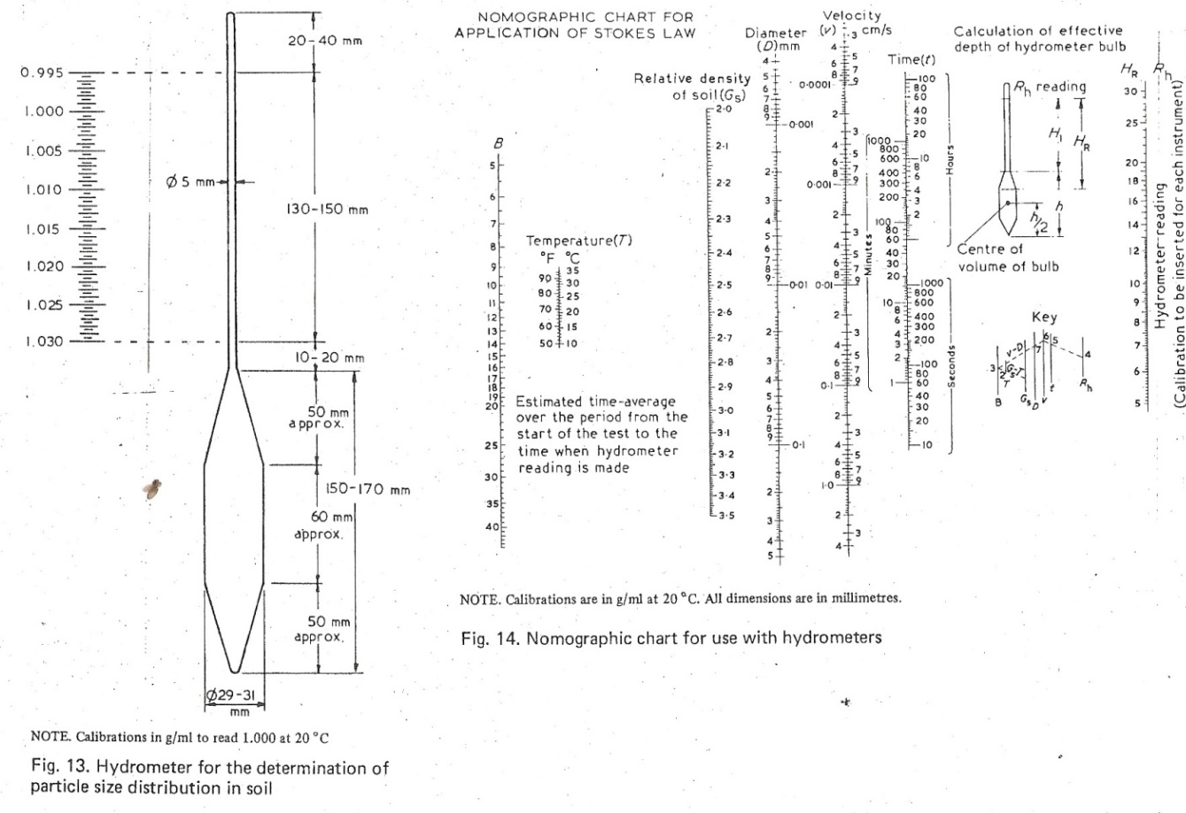

APPENDIX E.
SPECIFIC GRAVITY TEST TO BS 1377: 1975.
Aim: To determine the specific gravity of the lateritic soil samples A, B, and C.
Apparatus: Two density bottles (pycnometers) of approximately 50ml capacity with stoppers; water bath maintained at constant temperature of 20ºC within +0.2ºC; vacuum desiccators; thermostatically controlled drying oven (105-110ºC); balance readable and accurate 0.001g; a vacuum pump; Chattaway spatula (150mm long, 3mm wide); plastic wash bottle containing air-free distilled water; sample divider of the multiple slot type (riffle box) with 7mm width of opening; and a length of rubber tubing to fit the vacuum pump and the desiccators.

Procedure: The steps are as follows.
- Complete density bottle with stopper, shall be dried at 105ºC to 110ºC, cooled in the desiccators and weighed to the nearest 0.001g (m₁).
- The 50g sample obtained as described in section 3.1 shall if necessary be ground to pass a 2mm BS test sieve. A 5g to 10g subsample shall be obtained by riffling and then oven dried at 105ºC to 110ºC. This sample shall be transferred to the density bottle direct from the desiccator in which it has been cooled. The bottle and contents together with the stopper shall be weighed to the nearest 0.001g, (m₂).
- Sufficient air-free distilled water shall be added so that the soil in the bottle is just covered. The bottle containing the soil and liquid, but without the stopper, shall be placed in the vacuum desiccators, which shall then be evacuated gradually. The pressure shall be reduced to about 2mm of mercury. When using a water pump, because of variation in mains pressure, care shall be taken to ensure that the required vacuum is maintained. Care shall be taken during this operation to see that the air trapped in the soil does not bubble too violently so as to prevent small drops of the suspension being lost through the mouth of the bottle. The bottle shall be allowed to remain in the desiccators for an hour until no further loss of air is apparent.
- The vacuum shall be released and the lid of the desiccators removed. The soil in the bottle shall be stirred carefully with the Chattaway spatula, or the bottle vibrated. Before removing the spatula from the bottle, the particles of soil adhering to the blade shall be washed off with a few drops of air-free liquid. The lid of the desiccators shall then be replaced and the desiccator evacuated again.
- The procedure outlined in (3) and (4) shall be repeated until no more air is evolved from the soil.
- The bottle and contents shall then be removed from the desiccators and further air-free liquid added until the bottle is full. The stopper shall then be inserted. The stoppered bottle shall be immersed up to the neck in the constant temperature bath for an hour, or until it has attained the constant temperature of the bath. If there is an apparent decrease in volume of the liquid the stopper shall be removed and further liquid added to fill the bottle and the stopper replaced. The bottle shall then be returned to the bath and sufficient time shall be allowed to elapse after this operation to ensure that the bottle and its content again attain the constant temperature of the bath. If the bottle is still not completely full, this process shall be repeated.
- The stoppered bottle shall then be taken out of the bath, wiped dry and the whole weighed to the nearest 0.001g (m₃).
- The bottle shall then be cleaned out and filled completely with air-free liquid, the stopper inserted and then the whole immersed in a constant temperature bath for an hour or until it has attained a constant temperature of the bath. If there is an apparent decrease in the volume of the liquid, the stopper shall be removed and further liquid added to fill the bottle and the stopper replaced. The stoppered bottle shall then be returned to the bath and sufficient time shall be allowed to elapse after this operation to ensure that the bottle and its content again attain the constant temperature. If the bottle is still not completely full this process shall be repeated. The bottle shall then be taken out of the bath, wiped dry and the whole weighed to the nearest 0.001g (m₄).
- Two determinations of the specific gravity of the same soil sample shall be made.
Calculations.
The specific gravity of the soil particles, G_{S}, shall be calculated. If water has been used as the air-free liquid, then the following equation shall be used.
Where
m₁ is the mass of density bottle.
m₂ is the mass of the bottle and the dry soil.
m₃ is the mass bottle, soil and water.
m₄ is the mass of bottle when filled with water only.
Result:
The average of the values obtained shall be taken as the specific gravity of the soil particles and shall be reported to the nearest 0.01. If the two results differ by more than 0.03 the test shall be repeated.

APPENDIX F.

SOIL COMPACTION TEST TO BS 1377: 1975.

Aim: To determine the bulk density and dry density/moisture content relationship (2.5Kg rammer method).

Apparatus: A cylindrical metal mould having an internal diameter of 105mm, internal effective height of 115.5mm and a volume of 1000cm³ (the mould shall be fitted with a detachable base plate and a removable extension 50mm high); a metal rammer having a 50mm diameter circular face and weighing 2.5Kg (THE HAMMER SHALL BE EQUIPED with a suitable arrangement for controlling the height of drop to 300mm); a balance readable and accurate to 1g; a palette knife (100mm long and 20mm wide); a straight edge steel strip 300mm long, 25mm wide and 3mm thick with one beveled edge; 20mm BS test sieve and a receiver; large metal tray (600mmx500mm with sides 80mm deep); apparatus for moisture content determination.

Procedure:
- A 5Kg sample of air dried soil passing the 20mm BS test sieve obtained as described in section 3.2, shall be taken. The sample shall be mixed thoroughly with a suitable amount of water depending on the soil type.
- The mould, with the base plate attached, shall be weighed to the nearest 1g (M₁). The mould shall be placed on a solid base and the moist soil shall be compacted into the mould, with the extension attached, in three layers of approximately equal mass, each layer being given 27 blows from the rammer dropped from a height of 300mm above the soil surface. The blows shall be distributed uniformly over the surface of each layer. The operator shall ensure that the tube of the rammer is kept clear of soil so that the rammer always fall freely. The amount of soil used shall be sufficient to fill the mould, leaving not more than about 6mm to be struck off when the extension is removed. The extension shall be removed and the compacted soil shall be leveled off carefully to the top of the mould by means of the straightedge. The mould and the soil shall then be weighed to the nearest 1g (M₂).
- The compacted soil specimen shall be removed from the mould and placed on the large metal tray. A representative sample of the specimen shall be taken and its moisture content, w, shall be determined as described in section 3.3.
- The remainder of the soil specimen shall be broken up, rubbed through the 20mm test sieve, and then mixed with the remainder of the original sample. Suitable increments of water shall be added successively and mixed into the sample and the above procedure from step 2 to 4 shall be repeated for each increment of water added. The total number of determinations made shall be at least five (5) and the range of moisture content shall be such that the optimum moisture contents should be such that the optimum moisture content, at which the dry density occurs, is within that range.

Calculations: The calculations are as follows.
- The bulk density, ρ, in Mg/m³ of each compacted specimen shall be calculated from the equation
Where
is the mass of mould and base (g).
is the mass of mould, base and soil (g).
- The dry density ρ_{d} in Mg/m³ shall be calculated from the equation
Where, w, is the moisture content (%).
- The dry density, ρ_{d}, obtained in a series of determination shall be plotted against the corresponding moisture contents, w. A smooth curve shall be drawn through the resulting points and the position of the maximum on this curve shall be determined, and the zero, 5% to 10% air voids lines shall be plottedfor comparison.

