Solar Powered Buildings in Nigeria: challenges and opportunities for the future
By
Dare-Abel, O.A.,
Department of Architecture, covenant University, Ota.
E-mail: ladidabel@yahoo.com

ABSTRACT
In our quest for sustainable development and the achievement of a safe environment, numerous alternatives to power supply have been exploited. The challenge of erratic and insufficient power has for decades bedevilled our dear nation resulting in the proliferation of the use of generators in multiple locations within the built environment. This solution apparently is the people’s response to the nations decaying infrastructure but invariably produces an environment which is unsafe to its inhabitants. In recent times, reports have shown that the emissions arising from this practice have caused the death of occupants.
It is common knowledge that the use of solar energy as an alternative power source is not yet ubiquitous in this country. In recent times, innovation in the area of thermal solar and photovoltaics provide possibilities of its introduction in the building fenestration and facade. This study however examines some existing solar powered facilities in Abeokuta Nigeria. The Challenges and benefits of this scheme will be investigated while deriving essential design information for architects and allied professions. The future is bright but there is a great need to prepare for it.
Keywords: Solar energy, Alternative power, environmentally friendly
1.0 Introduction
The price of crude oil has quadrupled in the international market since the mid 1990s till date. This has had impact on the automotive, manufacturing, building industries creating a shift of focus to renewable energy sources. The global concern on Climate Change also poses a challenge on the design, sustenance of safer and cleaner environment. The creation of a future devoid of uncomfortable condition, pollution, and poor living standards has arisen from this concern.
Professionals in the fields of environmental design, technology, engineering and management should be seriously bothered about this development. The design, construction and maintenance of energy efficient buildings for the Nigerian environment will mark a stride towards proactively meeting global expectations.
This paper attempts to understand the level of integration of solar systems in community projects in some selected parts of Abeokuta while seeking to unearth the challenges militating against its widespread adoption.
2.0 Solar Energy Options
The Nation is blessed with an annual average daily sunshine of 6.25 hours and an annual average daily solar radiation of about 5.25 KW/m² per day. This translates to about 4.851 x 10¹² KWh of energy per day from the sun as stated by Okafor and Joe-Uzuegbu (2010). Furthermore the power generation capacity of Nigeria and the corresponding per-capita consumption of 0.03KW when compared to that of Egypt, South Africa and the United States (0.27, 1.02 and 3.2KW respectively) show gross inadequacy of the present capacity. It is therefore pertinent to note that all alternative systems of power supply that complements the current supply capacity provided within a properly regulated environment should be welcomed.
Table 1. Country Statistics of Electricity Generation and Per Capita Consumption
Continent | Country | Population  (Million) | Generation  Capacity (MW) | Per-Capita  Consumption (KW)
North America | U.S.A | 250 | 813000 | 3.2
South America | Cuba | 10.54 | 4000 | 0.38
Europe Central | United Kingdom | 57.5 | 76000 | 1.1
Europe Eastern | Ukraine | 49 | 54000 | 1.33
Middle East  Far East | Iraq  South Korea | 23.6  47 | 10000  52000 | 0.42  1.10
Africa | Nigeria  Egypt  South Africa | 140  67.9  44.3 | <4000  18000  45000 | 0.03  0.27  1.02
Source: Okafor and Joe-Uzuegbu (2010)
Ramjohn (2008) emphasized that solar energy can be utilized in either passive or active systems. The passive systems are characterized by the absence of internal energy sources. These include systems utilized for direct heating, water heaters, solar dryers and daytime lighting. The Active systems which this paper dwells upon are based on semiconductor technology which includes the various Photovoltaic (PV) devices and systems that are available.
Simba Solar (2010) ascerts that thin film framed solar panels that are manufactured to high specifications are available in Nigeria. However for efficient energy delivery other system components such as Light Emitting Diodes (LED), dry cell Maintenance free batteries and charge controllers have been developed.
3.0 Methodology
The paper arises from a cross-sectional study approach which ensures the cases are observed and analysed around the same time. The Case Study approach was employed for the study. An investigation of contemporary phenomenon within the real life contexts according to Amole (2005) is essentially the focus of this kind of approach. This approach is a data collection method that involves in-depth studies of specific cases or projects within a program.
The various locations were visited and the users of the facilities were interviewed. Technical personnel such as maintenance officers were also interviewed to ascertain the technical information needed as regards the reliability and efficiency of the installed systems. Finally observations and photographs of locations and facilities were taken to reinforce the data collected.
4.0 Cost of installation of Photovoltaic Systems
The solar module price represents about 50-60% of the cost of an installed solar system, its price therefore determines the cost of the system. In a survey of 1,250 prices within the United States and Europe (Germany) carried out by Solarbuzz (2010) it was revealed that a solar module costs less than $4.00 or £3.12 per watt as at September 2010. Over a period of about ten years there has been an unsteady reduction in prices from $5.40 to $4.00 per watt.
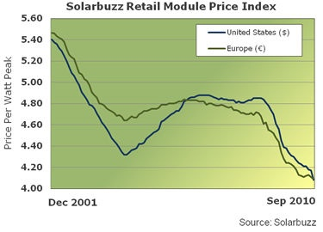
However in Nigeria, a typical 80watt PV panel costs about N68, 500 which puts solar module cost at N856.25 per watt an equivalent of $5.71. Other available specifications include the 54, 85 and 110 watt solar modules. The Batteries for storing power generated and the Wave Inverter that converts direct current DC to alternating current AC are essential components in a system.
A high quality 1200watt wave inverter costs about N120, 000 while a 200Ah dry cell maintenance free battery costs N35, 000 - N40, 000. The charge controller is crucial in completing the system ensuring that batteries do not become overcharged. Therefore considering the foregoing, it will cost between N2.5 – N4.0 million to install a 2.5Kw system with a life span of thirty five years. Madamombe (2006) puts the cost of a typical home system in sub-saharan Africa between $500 - $1000. This home systems have capacity to power lighting fittings for three to six rooms and also a black-and-white TV each night.
5.0 Case studies
The following projects within Abeokuta-South were studied: Ilogbo/Iberekodo, Ake-Wasimi area, Itoko Road lighting and the Abeokuta General Hospital Complex.

5.1 Case One: Ilogbo/Iberekodo Street Lighting
Ilogbo/Iberekodo community is located in Abeokuta south. The street lighting project is part of constituency projects executed in the area. Reports confirmed that this street lights have been commissioned for about twelve (12) months.
Most of the persons interviewed asserted that the street lights were very effective during the first few months after the commissioning but that currently the lights only come on for between one or two hours and the go off. This is seen to contradict the performance at the early stages when lights were solar powered from evening till dawn.
Several reasons were attributed to the perceived failure of this scheme. Notable amongst the reasons given by some interviewed experts include:
- The quality and condition of components installed e.g. the PV panels, expired batteries, the light bulbs used e.t.c.
- The period of the year could also affect the efficiency of the systems. Solar energy stored on cloudy days is usually lower on bright and sunny days.
5.2 Case Two: Ake/Wasimi Street Lighting
This is a very important area of the city as it is the community that houses the palace of the Alake of Egbaland. The project was commissioned around April 2010. Though one may consider it too early to evaluate the success of the street lighting scheme, it is evident that the people in the community are pleased to have their environment brightly illuminated for the entire night till dawn. This project has affected the social life of the people in many ways. Men gather under one of the lights to play the local game ‘Ayo’ and others also do their GSM phone business within the illuminated areas. Light Emitting Diodes LED bulbs which are very low energy consuming components (14W) were adopted in this scheme.
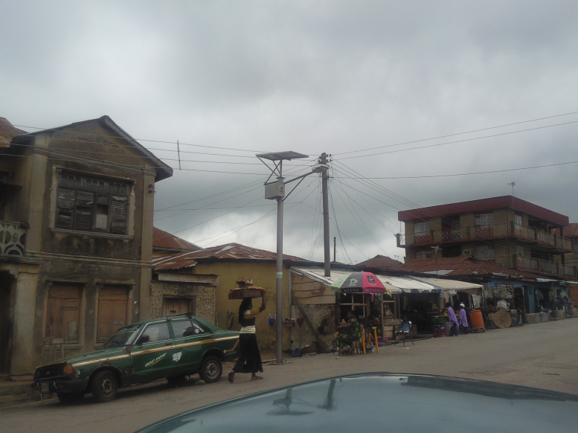
Plate 1: solar street lighting in Abeokuta South
Source: Author’s field study (2010)
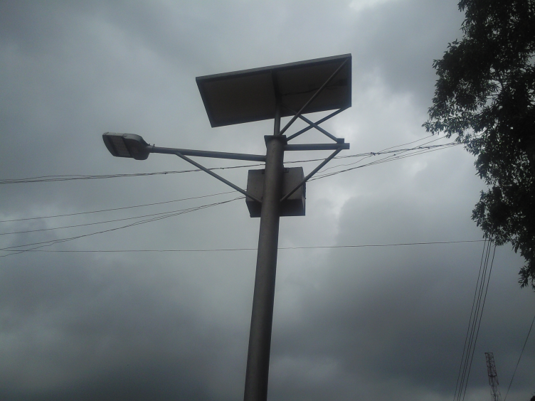
Plate 2: LED solar street lighting along Ake-Wasimi, Abeokuta South
Source: Author’s field study (2010)
5.3 Case Three: Itoko Road Lighting
Itoko road is located in Abeokuta south. The street lighting project is also part of constituency projects executed in the area. Reports confirmed that this street lights have been commissioned for more than twelve (12) months.
Most of the persons interviewed affirmed that the street lights were very effective during the first few months after the commissioning but that currently the lights do not work. It was obvious from the field visit that the systems were not complete. Some of the PV panels were missing from the assembly as seen in plate 3. Some respondents suspect that it was as a result of the activity of vandals but further investigations revealed that they were removed by the contractors following observed defects and deficiencies. 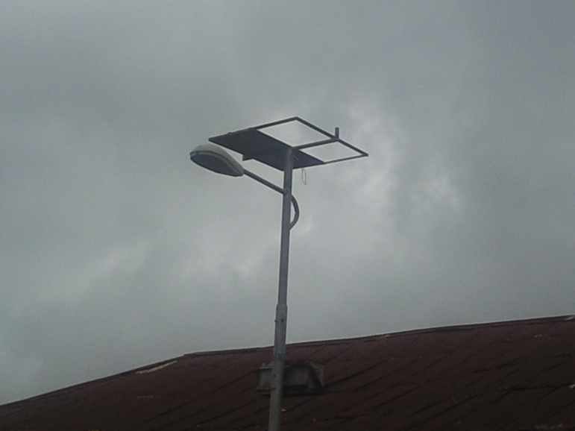
Plate 3: Incomplete solar street lighting assembly along Itoko Road, Abeokuta South
Source: Author’s field study (2010)
5.4 Case Four: General Hospital Complex, Abeokuta
The general hospital complex Abeokuta is located on a large expanse of land within Abeokuta South. The Alternative power Supply project in this complex had been commissioned for over three (3) years. The Solar PV panels were installed in two locations on the site to provide alternative power for the Out Patient Department (OPD)/ Emergency Wards and secondly the Children/Maternity Wards.
The installations were located in proximity to the buildings to be supplied. Each section is supplied by 24 units of 110w Solar panels receiving solar energy to be stored in 12 number 200Ah batteries. The PV panels were installed on steel framed platforms raised about a meter above the ground at the appropriate slope since the rooftop location will not effectively capture the optimal intake of solar energy of the assembly. The locations were deliberately obscured from passersby for security reasons.
The OPD, pharmacy, consulting rooms and the theatre have a total of Twenty-Three (23) fluorescent lights, fans, monitors and theatre LED lamps powered for between six to twelve hours of the night by the PV systems. On the other hand the Children Ward, Maternity Wards and the Intensive Care Unit (ICU) also have all lighting points, Fans, sucker machines and the Incubator powered by the second PV system.
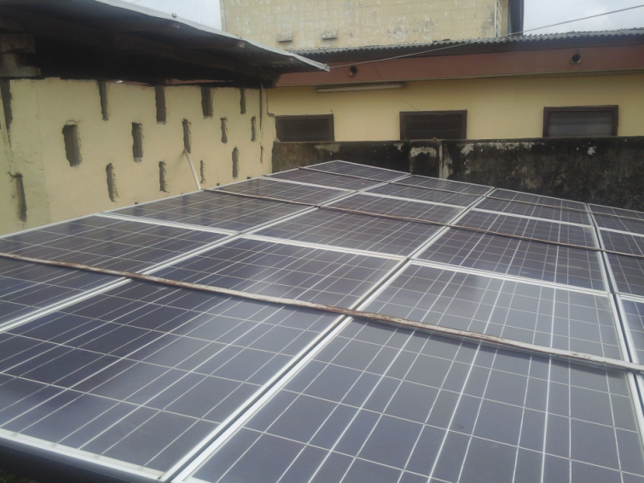
Plate 4: Solar PV array for OPD, Emmegency Unit and Theatre, General Hospital Abeokuta
Source: Author’s field study (2010)

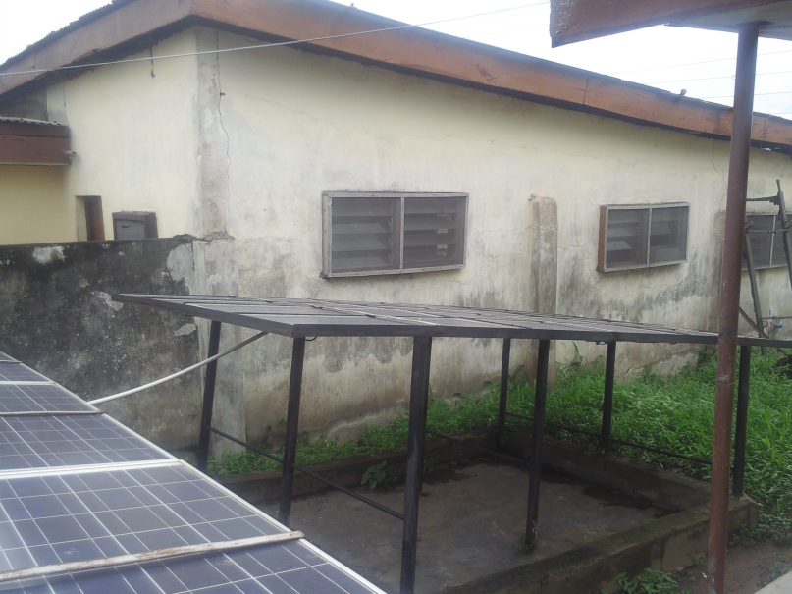
Plate 5: Solar PV array for OPD, Emmegency Unit and Theatre showing steel stand
Source: Author’s field study (2010)

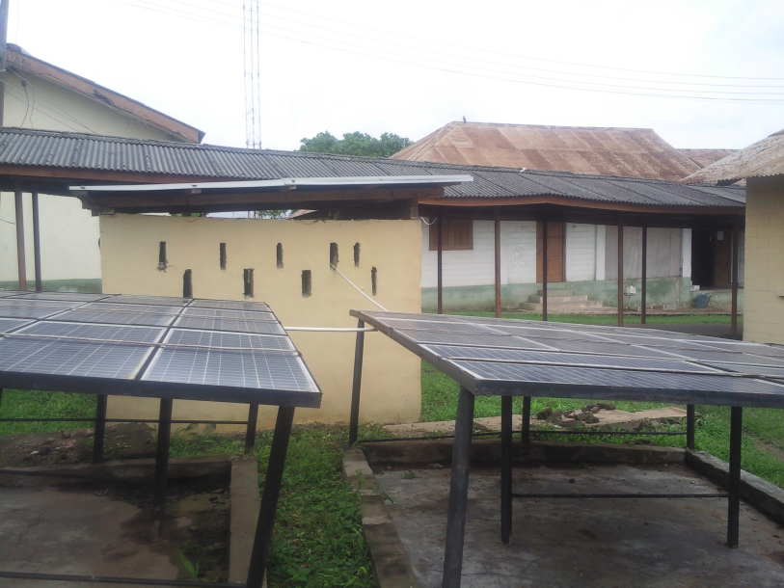
Plate 6: Solar PV array for Children’s, Maternity and ICU, General Hospital Abeokuta
Source: Author’s field study (2010)

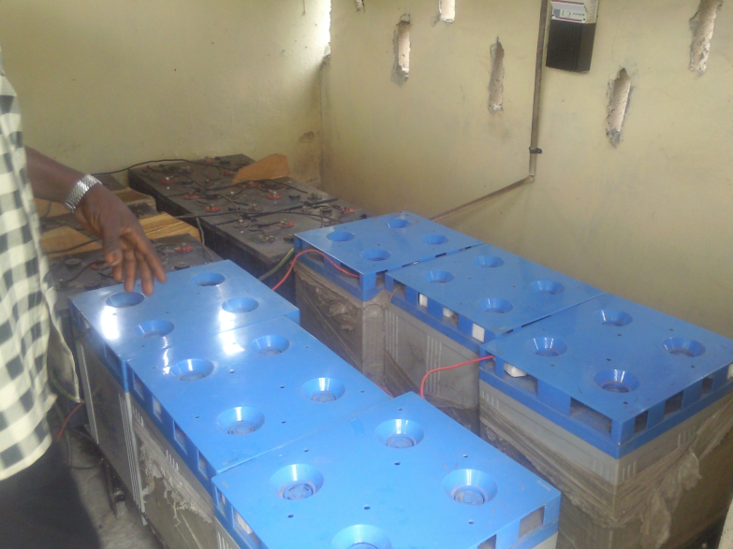
Plate 7: Energy storage batteries, Inverter and Charge control Room
Source: Author’s field study (2010)
It is important to note that the alternative power supply is reported to be effective and dependable within the hospital for the past three years. This is not unconnected with the fact that a vibrant maintenance unit takes care of these installations. An interview with the head of the unit revealed that only minor maintenance works such as cleaning the panels and replacement of damaged cables are being done as occasion demands.

6.0 Discussion and Conclusions
The initial capital investment for alternative power supply using solar systems is observed to be enormous but on the long run it offers such advantages as quiet operations, environmental friendliness, maintenance free operations and high reduction in cabling for external lighting.
However this study revealed that a number of challenges are militating against the success of the solar alternative power supply. The challenges include the following:
- The quality and conditions of components if not properly ascertained before installation may affect operations adversely.
- Lack of a well structured maintenance programme for the installations. Technical officers who understand the operations of the systems know the critical areas that should be monitored.
- Proper installation of the PV panels determines the amount of power collected. Many believe that the roof top is the best position for installation irrespective of the designed slope of the roof.
- Most installations are not considered at the design stages of buildings therefore resulting in land wastage and low efficiency of the systems.
Therefore it is important for the relevant regulatory institutions to monitor the quality and conditions of components sold within or imported into the country considering the high financial implications involved. In addition, design professionals should take up the challenge to propose alternative energy sources to their clients so as to achieve complete integration of the systems within the design. Architect and Engineers in Nigeria really need to work together more than ever to be able to deliver the quality of services expected. Training of technician to be able to maintain smooth running of systems should be embarked upon to concretize the efforts of the design professionals.
Lighting is considered a major factor that promotes community security and more attention should be given to exterior lighting to improve the quality of life of residents.
In the event that the above suggestions are implemented we shall soon see wide acceptance of solar and other forms of renewable energy options being widely accepted in Nigeria.
References
Aina A.G. (2010), Energy Efficient Buildings Using Solar Energy as an Alternative Energy Source. Unpublished B.Sc Dissertation submitted to the Department of Architecture, Covenant University Ota.
Amole B. (2005), “Logical Argumentation and the Case-study Method”. Architectural Research Techniques and Analysis by Amole B., Amole D., Arayela T. and W. Fadare. A monograph of the Association of Architectural Educators in Nigeria (AARCHES) No. 3.
Madamombe I. (2006), “Solar Power: Cheap Energy Source for Africa – NEPAD seeks to boost electricity supply in remote rural areas”. Africa Renewal, Vol. 20 number 3 October 2006. Pp10
Okafor E.N.C and Joe-Uzuegbu C.K.A. (2010), ‘Chalenges to development of renewable energy for electric power sector in nigeria’. International Journal of Academic Research, Vol.2. No.2 March 2010.
Ramjohn K. (2008), “Spatial Footprints” Challenges of Solar Energy Use. Geoenergy Network, July 15, 2008.

Simba Solar (2010), “Solar Lighting Solutions: Solar Street Light Solutions”. Simba Solar Website. http://www.solar.com.ng/lighting_solutions.html
Solarbuzz (2010), Solar Module Price Highlights: September 2010. http://www.solarbuzz.com/Moduleprices.htm

Solyndra (2008), “Cylindrical Solar Panels Are Cheaper, More Efficient, And Easier To Maintain”. Device Daily of October 8, 2008. http://www.devicedaily.com/misc/cylindrical-solar-panels-are-cheaper-more-efficient-and-easier-to-maintain.html 24 Mar. 10
Tournemille H. (2010), “The Positive Effects of Solar Energy on Rural Africa”. EnergyBoom. http://www.energyboom.com/
Woolsey M. (2007), “Stunning Solar-Powered Homes”. http://www.forbes.com/2007/08/16/solar-energy-homes-forbeslife-cx_mw_0816solarrealestate.html

