CHAPTER ONE
1.0 INTRODUCTION
1.1 Introduction to pesticides
Persistent organic pollutants (POPs) are toxic chemicals that persist in the environment and biomagnify in the food chain. Organochlorines such as chlorinated pesticides and polychlorinated biphenyls (PCBs) represent important groups of POPs, which have caused worldwide concern as toxic environmental contaminants (Covacia et al., 2005). Organochlorine pesticides (OCPs) are synthetic organochlorines which are lipophilic and hydrophobic. Their lipophilicity, hydrophobicity, stability to photo-oxidation, and low vapour pressure, and low chemical and biological degradation rates have led to their accumulation in biological tissues and the subsequent magniﬁcation of concentrations in organisms, progressing through to the food chain (Helberg et al., 2005). They can be recycled through food chains and produce a significant magnification of the original concentration at the end of the chain (Doong et al., 2002). They are resistant to natural breakdown processes and are extremely stable and persistent, highly toxic and bioaccumulate in the fatty tissues of animals and humans (Forget et al., 2001). Bioaccumulation is the ability of a pollutant to accumulate in living tissues at levels higher than those in the surrounding environment. It is a process in which a chemical pollutant enters into the body of an organism and is not excreted but rather collected in the organism’s tissues (Zweig et al., 1999).
Persistent organic pollutants are ubiquitous contaminants and have been detected far from their sources of origin because of long-range transport stemming from atmospheric exchange, water currents, animal migration and other pathways (Zhang et al., 2007). Efforts at minimizing and eventually phasing out POPs globally gave rise to the Stockholm Convention in 2001. Organochlorine pesticides (OCPs), namely aldrin, dieldrin, endrin, chlordane, dichlorodiphenyltrichloroethane (DDT), heptachlor, mirex, toxaphene, hexachlorobenzene (HCB) and industrial chemicals and byproducts, including PCBs, dioxins and furans, constitute the twelve chemical substances called the "dirty dozen" and defined under the Convention. However, at its fourth meeting held in 2009, the Conference of the Parties (COP) adopted the amendments to annexes A (elimination), B (restriction) and C (unintentional production) of the Stockholm Convention to list nine additional chemicals as persistent organic pollutants, resulting in the “dirty twenty one”. The nine additional chemicals include chlordecone, alpha hexachlorocyclohexane, beta hexachlorocyclohexane, lindane, pentachlorobenzene, octabromodiphenyl ether, pentabromodiphenyl ether, perfluorooctane sulfonic acid and perfluorooctane sulfonyl fluoride. Residues and metabolites of many POPs are very stable, with long half-lives in the environment (UNEP, 2002). The manufacture and use of chlorinated pesticides have been banned or restricted in developed countries. Although these bans and restrictions were enacted during the 1970s and 1980s, some developing countries are still using OCPs for agricultural and public health purposes because of their low cost and versatility in controlling various pests (Xue et al., 2006). Again, they are being used in most developing countries, including Nigeria, due to a lack of appropriate regulatory control and management of the production, trade and use of these chemicals (Darko and Acquaah, 2007). There is also a paucity of data on the use of pesticides in the country, a reflection of the lack of a mechanism and planning programme in place for chemicals management as well as a low level of understanding of the environmental and public health hazards of pesticide use (Osibanjo et al., 2002).
Pesticides are chemicals used to kill or control pests. They are classified according to their chemical class or intended use. Pesticides could be used as insecticides, rodenticides, fungicides, herbicides and fumigants. OCPs are basically insecticides composed primarily of carbon, hydrogen and chlorine and are found in the environment as a result of human activities. Insecticides act by poisoning the nervous system of target harmful insects. The use of OCPs takes many forms, ranging from pellet application in field crops to sprays for seed coating and grain storage. OCP residues enter aquatic environments through efﬂuent release, discharges of domestic sewage and industrial wastewater, atmospheric deposition, runoff from agricultural fields, leaching, equipment washing, disposal of empty containers and direct dumping of wastes into the water systems (Yang et al., 2005). Lagoons, seas, rivers and lakes are depositories of most effluent discharges, leachates and run-offs from activities on land. The distribution of various chlorinated contaminants in the marine and estuarine environment depends on the physicochemical properties of the ecosystem as well as the partition coefficients of individual chlorinated hydrocarbons (Sarkar et al., 1997). OCPs could distribute among the components of the ecosystem, such as water and sediment, and accumulate in the biota. As a result of their persistence, OCPs in water can be transferred into the food chain and accumulate in aquatic organisms like plankton. Different pesticides pose varying degrees and types of risk to water quality. It is reported that approximately three million people are poisoned and 200,000 die each year around the world from pesticide poisoning, the majority of them from the developing countries (FAO, 2000). It is also believed that the incidence of pesticide poisoning in developing countries may be greater than reported due to under-reporting, lack of data and misdiagnosis. Some of the symptoms of pesticides poisoning include irritation, dizziness, tremour, tonic and chronic convulsion (Winter, 1992). OCPs have been linked to human breast and liver cancers, testicular tumours and lower sperm counts in humans (Davies and Bradlow, 1995; Cocco et al., 1997). Studies have also suggested that OCPs may affect the normal function of the endocrine system of humans and wildlife (Xue et al., 2006).
OCPs are among the most commonly detected pesticides around the world. Although most of them were banned in the 1970s and 1980s, they can still be found in the environment in several matrices such as water, soil and marine sediments (Sarkar et al., 2008; Guan et al., 2009; Essumang et al., 2009). Pesticides can be bioconcentrated through biogeochemical processes and can be scavenged from the water through sorption onto suspended material before they get deposited to the bottom substrate. The sediment component of aquatic ecosystems deposits pesticides. Sediment is one of the principal reservoirs of environmental pesticides, representing a source from which residues can be released to the atmosphere, groundwater and living organisms (Xue et al., 2006). Persistence of these organic pollutants in sediment is possible due to their low solubilities and tendency to associate with suspended particulate matter. As a result of their low water solubility, OCPs have a strong afﬁnity for particulate matter. They are hydrophobic compounds that tend to adsorb to suspended particulate matter and benthic sediments in aquatic ecosystems. Sediments serve as ultimate sinks for them. Indirect exposure to contaminated sediments takes place when fishes feed on benthic invertebrates that are ingesting particulate matter. Direct exposure through the sediment takes place by release of contaminated particulate matter into the water column by both natural and anthropogenic processes.

1.2 Introduction to fishery resources in Lagos Lagoon
Nigeria is a rich fishery resource and fishes are major sources of proteins in the country. Foods derived from the aquatic environment vary in shape, size, colour and taste and can be broadly grouped into two: finfishes and shellfishes. Nutritionally, they are not significantly different. The two groups of shellfishes that are of importance in human food are the molluscs and the anthropods. While the molluscs consist of bivalves with two-piece shells, the anthropods comprise biota such as lobsters, prawns, shrimps, crayfishes and crabs (Ogunlade et al., 2005). The literature on shellfishes in Lagos Lagoon is scanty; however, reports have revealed the existence of diverse species of shellfishes. The decline in the hitherto viable commercial artisanal shellfishery, points to environmental degradation and possible changes in water quality with biological consequences for biota (Oribhabor and Ezenwa, 2005). Finfishes constitute the major components of most aquatic habitats and are important biomarkers of residue levels in aquatic ecosystems. Ingestion is the main source of human exposure to chlorinated pollutants, especially the consumption of seafood from contaminated areas (Schlummer et al., 1998). The age of an organism, and its position in the food chain, lipid content in the tissues and means of feeding are the factors affecting the potential pollution level in an organism. The discharge of rivers into lagoons is the main transport pathway of pesticide residues. The Nigerian coastal belt has estuaries and lagoons as a transition zone between it and the numerous rivers and creeks flowing southwards into the Atlantic Ocean. Nigeria has a variety of industrial establishments producing different industrial wastes and effluents. Industrial establishments in Lagos account for over 40% of all industries in Nigeria. The proliferation of urban settlements and slums in Lagos has also led to increased human pressure and the generation of domestic effluents, which eventually find their way into the Lagos Lagoon. The lagoon therefore receives a complex mixture of domestic and industrial wastes and has served as the ultimate sink for the disposal of sewage.

1.3 Background of the study
The contamination of the environment and food by chlorinated organic pesticides has become a topical issue of considerable concern in many parts of the world, and has led many researchers to investigate their occurrence, distribution and concentrations in several ecosystems (Sankar et al., 2006; Yang et al., 2007; Poolpak et al., 2008). The toxicity of pesticides varies greatly with their intrinsic properties, the species being studied and factors in the environment. Important factors that influence the impact of a pesticide on the aquatic environment are its persistence, the partitioning of the pesticide between the particulate and aqueous phases, toxicity to aquatic organisms and the tendency to bioaccumulate. All pesticides are toxic to some forms of life. Many modern pesticides are developed to be as selective against target organisms as possible, but it is rarely possible to achieve perfect control of one organism without the wider environment being exposed and susceptible non-target species being affected. Anthropogenic activities provide the primary point source of chlorinated hydrocarbon input into the aquatic environment (Malik et al., 2008). OCPs enter the aquatic environment by deliberate application or by accident. These substances are sometimes applied directly to water bodies to control aquatic pests. OCPs have been extensively used for agriculture and vector control purposes in Nigeria. The pesticides applied on land eventually find their way to the aquatic environment, thus contaminating it. The misuse of these chemicals for killing fishes is also practised. Being lipophilic, OCPs can be concentrated to harmful levels in the aquatic environment through bioaccumulation and biomagnification (Toft et al., 2003). Consequently, aquatic organisms that are commercially exploited for human food may pose a risk to man. It has also been recognized that the persistence and bioaccumulative tendency of these substances, their metabolites and residues in the environment make them not to remain where they are applied but to be partitioned between the major environmental compartments in accordance with their physicochemical properties. Such environmental distributions may lead to the exposure of living organisms, including man, that are far removed from intended targets.
OCPs are among the first set of pesticides to be used in Nigeria. They are still in use in Nigeria. Despite the difficulties associated with the analysis of organochlorine compounds, especially at the low levels normally found in marine samples, there is evidence that they are major long-term contaminants of the environment (Yang et al., 2005; Malik et al., 2008). Concern about exposure to organochlorines among humans has arisen mainly because of the proven carcinogenicity of these chemicals in experiments with animals and their ubiquity, bioconcentration and persistence in human tissues (Skaare et al., 2000). Many POPs, which pollute the environment, become incorporated into food webs. Humans, being the final links in the food chain, are the most affected. Consequently, the general public has become increasingly concerned about the potential risk to human health from the consumption of such polluted biota. The ill effects of pesticides may arise from short- or long-term and low- or high-level exposure through dermal absorption, inhalation and oral ingestion. Chemical pollutants can be accommodated in three basic reservoirs in the aquatic environment, namely water, sediment and biota. Several aquatic organisms such as shellfishes and finfishes have been recognized as excellent bioaccumulators of organic and inorganic pollutants (Osibanjo and Bamgbose, 1990; King and Jonathan, 2003). Bivalves, crabs and shrimps have been identified as standard bioindicators of aquatic pollution owing to their capability to bioaccumulate and bioconcentrate organic pollutants and trace metals in their target organs at levels higher than background concentrations (Osibanjo et al., 1994; Etuk et al., 2000). The sediment reservoir is important because it serves as a sink from which water and biota are continuously polluted. Thus, the quality of sediment is essential in assessing the pollution status of the ecosystem (Doong et al., 2002). The principal contaminants of water include suspended solids, organics, pathogenic organisms, dissolved inorganic substances and trace metals.
The toxicity of pesticides could be acute and chronic. There is growing evidence of cancer, neurological damage, endocrine disruption and birth defects arising from exposure (IARC, 2001). In view of the negative health effects of OCPs on humans and the nonexistence of a government policy on the regulation and monitoring of OCP levels in fishes in Nigeria, it is very important to evaluate the levels of chlorinated pollutants in commercially available fishes. Persistent organic pollutant levels are usually monitored in inorganic ecosystem compartments such as water, air and sediment or in biota. Monitoring in inorganic compartments has the advantage of producing an immediate, geographically localized measure of contamination, while biological monitoring provides information on the extent of biotransformation and bioaccumulation processes that the contaminants have undergone during their passage through biological systems. Biological monitoring, therefore, provides a more realistic view of the contaminant distribution in the environment site (Rissato et al., 2006). Lagos Lagoon is a depository of last resort for a large number of surface runoffs, drainage channels and important rivers flowing from the interior of Southwestern Nigeria to the Atlantic Ocean. The surrounding landmass to the lagoon is also among the most densely populated areas in the country. The introduction of deleterious materials into the lagoon is thus expected. Lagoons in Nigeria are generally subjected to both domestic and industrial pollution because of the poor enforcement of water pollution control laws and regulations. The monitoring of these water bodies becomes an issue of great concern to people who wish to maintain the environmental integrity and health of the ecosystems. Given the potential for contamination by these POPs and the importance of fishes as food and biomonitors of contamination, this study was undertaken to determine the levels of OCPs in selected shellfishes and finfishes, water and sediments from Lagos Lagoon.

1.4 Statement of the problem
The occurrence of organochlorine pesticides in biological species and in different compartments of the aquatic ecosystem, even at trace levels, is not desirable as they have toxic effects. Fishes are at the top of the aquatic food chain and do bioaccumulate these OCP residues, leading to many diseases in man.

1.5 Justification for the study
Pesticides are known to be toxic to man (Ademoroti, 1996). The use of pesticides introduces some risks to the environment, the degree of risk depending upon the pesticide persistence, mobility, non-target toxicity and volume of use. The toxicity level of a pesticide also depends on the deadliness of the chemical, the length of exposure, the health status of the recipient and the route of entry into the body. OCPs contribute to many acute and chronic health effects, including cancer, neurological damage, birth defects, tremors, headache, dermal irritation, respiratory problems and dizziness. Animal studies have also shown the potential for reproductive and developmental effects and disruption of normal hormone function. Long-term exposure to sub-lethal levels of OCPs and their metabolites through various pathways in the aquatic environment may cause far reaching ecological damage and health problems to man. Residues of these toxic chemicals found in water, sediments and aquatic biota pose a risk to aquatic organisms, predators and humans. OCPs act as central nervous system stimulants in aquatic fishes. In order to minimize the health risks from the ingestion of food contaminated with these chemicals, environmental protection agencies and public health authorities, including the World Health Organization (WHO), have set maximum residue levels (MRL) for OCPs in water, fishes and shellfishes (UNEP/FAO/WHO, 1988).
Fishes are suitable indicators for environmental pollution monitoring because they concentrate pollutants in their tissues directly from water and also through their diet, thus enabling the assessment and transfer of pollutants through the trophic web (Fisk et al., 2001; Lanfranchi et al., 2006). The low activity of the mono-oxygenase enzymes in ﬁshes limits their ability to metabolize organochlorines (Dearth and Hites, 1991). Hence, fishes generally reﬂect the levels of organochlorine pollution in the aquatic environment (Muir et al., 1990). This offers the opportunity to study the inﬂuence of environmental and biological factors on the bioaccumulation of pollutants (Porte and Albaiges, 1993; Sarkar et al., 2008). Besides analyzing OCPs in the muscle tissues of fishes, it is vital to investigate their distribution in organs which could provide more information about the pathways along which bioaccumulation occurs, and thus reflect the environmental conditions. Shellﬁshes are used in many pollution monitoring and assessment studies because they have world-wide geographical distribution and are relatively stationary. They reﬂect traces of contamination better than the finfishes. They are also sediment-dwelling and have a pronounced ability to concentrate persistent organic pollutants from sediments and water (Yang et al., 2006; Zhou et al., 2008). Organisms that live in aquatic environments are suitable representatives for assessing pollution. Crabs, shrimps and crayfish have been shown as appropriate indicator organisms because they are the most abundant group of aquatic sediment macro-fauna within tropical areas (Smith et al., 1991).
Pollution by persistent chemicals is potentially harmful to the organisms at higher trophic levels in the food chain. The aquatic organisms like fish are able to accumulate several fold higher concentration of pesticide residues than the surrounding water (Siddiqui et al., 2005). Research efforts indicate that more than 80% of the total intake of pesticide residues in human beings is through the food chain (Trotter and Dickerson, 1993; Martinez et al., 1997). It has been reported that the consumption of contaminated ﬁshes is one of the important pathways of human exposure to OCPs (Mwevura et al., 2002; Zhou et al., 2007; Muralidharan et al., 2008). Indeed, studies have related the presence of organochlorine residues in breast milk to the consumption of contaminated fishes (Fitzgerald et al., 2001). Data on the presence and distribution of OCPs in edible ﬁshes are, therefore, important from the ecological and human health perspectives. The transport, dispersion and the ultimate effects of pesticides in marine systems depend upon their persistence, bioaccumulation and biodegradation. OCPs could be associated with organic components of soils, sediments, biological tissues and dissolved organic carbon in aquatic systems (Xue et al., 2006; Vagi et al., 2007; Imo et al., 2007; Zhou et al., 2007). The indiscriminate use of pesticides in Nigeria has resulted in the occurrence of the residues in biota and other abiotic compartments (Osibanjo and Bamgbose, 1990; Ize-Iyamu et al., 2007; Adeyemi et al., 2008). It is necessary to ascertain the distribution, behaviour and fate of these compounds in various environmental compartments. The determination of POPs existing in water, sediment and biota could indicate the extent of aquatic contamination and the accumulation characteristics.
Literature data on the concentrations of OCP residues in the Nigerian environment are inadequate. There is need for continuous monitoring to identify the occurrence and the levels of OCPs in fishes, water and sediment of aquatic ecosystems in Nigeria. Most institutions and researchers in Nigeria lack the analytical facilities/equipment for the detection and quantitative analysis of OCPs in environmental samples. Lack of adequately trained experts in trace organic analysis, as well as funds for the purchase of chemicals, are some of the main limiting factors for conducting research and monitoring OCP residues in biota and other media in the environment. Data gaps have thus been identified. There are gaps in evaluating the accumulation of OCPs in the organs of fishes and the daily intake of pesticide residues which the present study aims to bridge. This research serves to provide data on the prevailing levels of these persistent pollutants in biotic and abiotic media in the Lagos Lagoon. The monitoring of ﬁshes serves as an important indicator of the water ecosystem where there is a vertical transport of OCPs leading to accumulation in the benthic organisms. Shellfishes and finfishes were collected for this study because they are important commercially available foods commonly consumed by a cross section of Nigerians. Multi-compartment monitoring is essential to ascertain the behaviour and fate of organochlorine pesticides and to assess the current status of these priority organic pollutants. The continuous monitoring of the pollution status of Lagos Lagoon is imperative as it is a major pelagic column in Nigeria.

1.6 Aim of the study
This research is a pollution monitoring study aimed at investigating the occurrence, concentration and distribution of organochlorine pesticides in shellfishes, finfishes, sediments and water of Lagos Lagoon with a view to assessing the current state of contamination of the study area and exposure to these toxicants and priority pollutants.

1.7 Objectives of the study
The research was designed to achieve the following objectives:
- Determination of organochlorine pesticide residues in the muscle tissues and organs of
the fishes, microlayer and mixed layer water, epipellic and benthic sediments.
- Comparison of bioaccumulation levels of organochlorine pesticide residues in the male
and female fishes.
- Evaluation of the daily intake of OCP residues through the fishes to human beings.
- Validation of the methodology used for the determination of organochlorine pesticide
residues in the selected samples.
- Assessment of the effects of seasonal variation on the levels of organochlorine pesticide
residues in the fishes, water and sediments.
- Determination of the physicochemical properties of water and sediments and their
influence on OCP distribution in fishes.

1.8 Limitations of the study
i. Some of the organs of the finfishes have not been analysed due to their very small sizes.
ii. There are other fish species in Agboyi Creek and Lagos Lagoon that have not been
analysed in the present study.
iii. No particular fish has been reported as a bioindicator.
iv. The ages of the fishes and their effects on accumulation of pesticide residues have not
been reported in this study.
v. No standard reference material was used to further validate the methodology used in the
extraction and clean-up procedure.
vi. The population used in estimating the dietary intake of the OCPs from fish consumption
is limited.

CHAPTER TWO

2.0 LITERATURE REVIEW
2.1 Review of previous studies on OCPs in water, sediment and fishes
The dearth of experts, nonavailability of materials, apparatus and functional modern equipment have affected the choice of analytical methods used for trace POPs determination in environmental samples in Nigeria. Organochlorine pesticides have been detected and determined in different compartments (water, sediments, biota) in the country using a gas chromatograph coupled with an electron capture detector (Nwakwoala and Osibanjo, 1990; Ize-Iyamu et al., 2007). Nigerian fishes have been reported to contain all the commonly encountered OCPs (Osibanjo and Bamgbose, 1990; Osibanjo et al., 2002; Unyimadu and Udochu, 2002; Adeyemi et al., 2008). From these studies, coastal waters are as contaminated as freshwaters. Most freshwater sediments in Africa are contaminated with OCPs (Calamari and Naeve, 1994). Based on the reported levels of dieldrin, lindane, endosulfan and total DDT, the water and sediments of the North African lakes in Egypt are more polluted, followed by those of West African rivers particularly in Nigeria. The East and Southern African waters are the least polluted by these organic pollutants. However, the trend for fish contamination is reversed. Fishes from East Africa are the most contaminated, followed by fishes from North Africa, while fishes from West Africa are the least contaminated (Calamari and Naeve, 1994). This disparity may be linked to a number of factors, including the relative fat contents in fishes, fish size and feeding habits, as well as biogeochemical transformations in different aquatic ecosystems.
Amakwe (1984) detected 10 organochlorine pesticides and HCB in 40 freshwater fish samples collected from various locations in Oyo and Ogun States. The relative occurrences of some of the residues identified were: lindane 100%, endosulfan 97%, DDT and metabolites 75%. The concentration ranges in ng/g fresh weight were: lindane 7.0-106.0; p,p'-DDE 2.0-30.0; p,p'-DDD 2.0-60.0; p,p'-DDT 3.0-18.0; total DDT 3.3-161.0; heptachlor 1.0-300.0; endosulfan 3.0-904.0; HCB 9.0-130.0 and α-HCH 0.2-5.0. Fish samples from freshwater were found to contain higher concentrations of these residues than sediments and water. Agunloye (1984) and Tongo (1985) studied the occurrences and levels of OCPs in water from 17 rivers, 2 lakes and one dam in Southern Nigeria. The overall range of values (ng/L) of the major OCPs found were: lindane ND-167.0, aldrin ND-190.0, endosulfan ND-750.0, HCB ND-9.2 and heptachlor ND-96.0. DDT and metabolites were not detected. In the report, the OCP levels (ng/L) in River Ogun, which traverses three states and discharges into Lagos Lagoon, were: lindane 1.4-41.9, aldrin 5.1-49.0, endosulfan ND-260.0 and heptachlor ND-0.8. Okonna (1985) confirmed the presence of pesticide residues in Lagos Lagoon water with concentrations in ng/L as: lindane 85.3, aldrin 19.3, DDE 12.0, HCB 1.9, endrin 12.5 and dieldrin 28.0. Fayomi (1987) also detected and quantified 9 OCPs in South Eastern Nigeria. The relative occurrences of some of these compounds were aldrin, lindane, α-HCH (100%), endosulfan (44.4%), δ-HCH (16.7%), ρ,ρ'-DDD (33.3%), ρ,ρ'-DDE (61.1%) and heptachlor (72.2%). The concentration ranges in ng/g fresh weight were: α-HCH 0.2-7.4, lindane 0.6-13.0, heptachlor ND-1.0, aldrin ND-14.9, endosulfan ND-89.6, ρ,ρ'-DDE ND-4.2 and DDD ND-8.0.
Osibanjo and Bamgbose (1990) have reported the contamination of Nigerian marine fishes and shellfishes by OCPs, based on their analyses of 94 samples of 25 marine fish species between 1983 and 1985 and of 14 samples of 7 shellfish species from Lagos Lagoon. The concentration ranges in ng/g fresh weight were found to be as follows: HCB 0.04-9.48, lindane ND-5.30, endosulfan ND-4.95, DDT 0.15-18.6 and aldrin ND-54.60. Fishes contained higher concentrations of aldrin, heptachlor, HCB and lindane than shellfishes while the reverse was observed for DDT and PCB. The levels of residues obtained were found to be lower than those reported in the literature for industrialized countries. There was a positive and significant correlation coefficient between fish weight, fish length, fish fat and residue levels. Predator fish species were found to concentrate more residues in muscle tissue than plankton feeders. The DDT/PCB ratios were less than 1, indicating a predominance of industrial activities over agricultural activities as the source of contamination of the marine environment. The fish Galeoides decadactylus was proposed as a potential bio-indicator organism for OCP pollution monitoring in the study area. Sunday (1990) also analyzed 20 sediment samples from streams and rivers in lbadan, Oyo State. The concentration ranges in ng/g dry weight were: dieldrin ND-6.0, α-HCH ND-1.6, γ-HCH ND-2.0, aldrin ND-0.04, DDE ND-50.0 and PCB ND-14.0. Heptachlor, endosulfan and endrin were not detected. Ojo (1991) investigated the occurrence and levels of OCPs in 23 bottom sediment samples from Lekki Lagoon in Lagos State. Eleven organochlorine pesticides and HCB were detected. The ranges of concentration, reported in ng/g dry weight were: lindane 0.11-4.9, aldrin ND-347.0, ρ,ρ'-DDE 11.0-555.0, o,p'-DDD ND-348.0, endosulfan 7.0-1,155.0, heptachlor ND-1845.0, β-HCH ND-260.0, α-HCH ND-116.0, HCB ND-3.3, endrin ND-129.0, dieldrin 190.0-8,460.0. Compared with other parts of the world, the sediments were considered to be fairly contaminated with organochlorine pesticides. Nwankwoala and Osibanjo (1992) reported the detection of 10 OCP residues, including PCBs, in surface waters in Ibadan. The concentration ranges in ng/L of some of the residues quantified were α- and β-HCH 1.0-302.0, lindane 7.0-297.0, aldrin ND-40.0, dieldrin 17.8-657.0, endrin ND-19.0, heptachlor 4.0-202.0, endosulfan ND-430.0, HCB ND-92.0 and total DDT ND-1,266.0. The study showed that organochlorine pesticide residues were widely distributed in the surface waters, even at sites remote from point sources. The problem of ground water contamination by OCPs has also been identified in Nigeria (Osibanjo and Ayejuyo, 1994; Ayejuyo et al., 2008).
Fisheries research in Lagos Lagoon has revealed four species of decapod shellfishes in three families (Oribhabor and Ezenwa, 2005). The lagoon is reported to contain about one hundred and fifteen (115) species of finfishes in seventy-nine (79) genera, forty-nine (49) families, seventeen (17) orders, two (2) classes and one (1) super-class (Gnathostomata). Recently, levels of organochlorine pesticide residues in water and fishes from some rivers in Edo State have been determined (Ize-Iyamu et al., 2007). In all the water samples analysed from Ovia, Ogba and Ikoro Rivers, lindane, aldrin, ρ,ρ'-DDE, o,p'-DDD, p,p'-DDD, o,p'-DDT, and p,p'-DDT were present, except in Ikoro River where the water samples exhibited non-detectable levels for p,p'-DDE and p,p'-DDT. The level of p,p'-DDT, 0.74 ppb, was the highest in Ogba River, followed by lindane, 0.71 ppb, and aldrin, 0.60 ppb. Lindane, 0.79 and 0.59 ppb was found to be the highest in Ovia and Ikoro Rivers respectively followed by aldrin, 0.77 and 0.49 ppb. The other organochlorine pesticides were present at various levels: 0.31-0.49 ppb in Ogba River; ND-0.31 ppb in Ikoro River; and 0.30-0.56 ppb in Ovia River. The OCP residues detected in water were also detected in fishes at higher concentrations. The concentrations of these OCP residues in the feeders increased in the following order: bottom > middle > top. These findings agree with the earlier report by Tongo (1985). Lindane levels of 0.06 ng/g, 0.05 ng/g and 0.04 ng/g were detected in fishes from Ovia, Ogba and Ikoro Rivers while aldrin levels were 0.06 ng/g and 0.03 ng/g in the bottom and top feeders from Ovia River. These levels are high compared with the allowable limits of the Federal Environmental Protection Agency (FEPA), now the Federal Ministry of Environment.
Studies have also been carried out in other parts of Africa and the world. Water, sediment, red swamp crayfish (Procambarus clarkii) and blackbass (Micropterus salmoides) from Lake Naivasha, Kenya were analysed for selected organochlorine pesticide residues (Gitahi, 1999). The mean p,p'-DDT, p,p'-DDE and o,p'-DDT residue levels (ppb) recorded in blackbass and crayfish were 28.3, 34.2, 16.1 and 4.6, 3.2, 1.4 respectively. The mean lindane, dieldrin, endosulfan and aldrin concentrations in blackbass were 100.5, 34.6, 21.6 and 16.7 ppb while lower concentrations of 2.0, 2.0, 2.0 and 1.9 ppb were detected in crayfish. The higher fat content of 3.7 g in blackbass compared to 0.6 g in crayfish accounted for the significantly higher residue concentration in blackbass. There is also increasing interest in South America on organic pollutants from the coastal marine environment. Menone et al. (2001) studied the occurrence and distribution of persistent organochlorine compounds in the Mar Chiquita, Argentina coastal lagoon watershed. The levels were measured in sediments and associated crabs. Pesticide concentrations were higher than PCBs as a result of agricultural activities in the area. Heptachlor epoxide, DDT and its metabolites, and % HCH were the predominant OCPs in sediments as well as in crabs. OCPs in sediment, water and biota from the coastal marine environment of Mumbai, India have been analysed to assess their distribution in various environmental compartments (Pandit et al., 2002). HCH isomers, DDT and its metabolites were the predominantly identified compounds in all the samples. High ratios of DDT to DDE were found in seawater samples, indicating the presence of a significant source of DDT. The levels of organochlorines in fishes obtained from the investigation were found to be lower than the levels of organochlorines in fishes in temperate regions. Coat et al. (2006) measured the levels of chlordecone in various freshwater and marine species. The results showed a heavy contamination of many carnivorous and detritivorous species of fishes and prawns.
The levels of OCPs in edible biota from the coastal area of Dar es Salaam city, Tanzania, have been reported (Mwevura, 2002). Samples were collected from the Msimbazi and Kizinga Rivers and from the coastal marine environment receiving waters from these rivers. The samples were analysed for various OCPs using GC-ECD and the results were confirmed with GC-MS. Dieldrin, p,p'-DDT, p,p'-DDE, p,p'-DDD, o,p'-DDT and α-HCH were the only organochlorines detected at concentrations above the method detection limits. The samples showed significant differences in levels of residues, depending on location, mode of feeding and age/size of analysed biota. The biota from mangrove areas showed the highest level of residues, followed by those from fresh water. The lowest concentrations were detected in biota from marine coastal water. In Uganda, Nile tilapia and Nile perch samples from Lake Victoria have been analysed for lindane, aldrin, endosulfan, dieldrin, DDT and DDE (Kasozi et al., 2006). No significant difference in the residue levels between fish types was observed for lindane, endosulfan, p,p'-DDT, p,p'-DDE and dieldrin. The aldrin levels in Nile perch (Lates niloticus) were significantly higher than the levels in Nile tilapia (Oreochromis niloticus). No difference was observed in the distribution of residues in the different organs of Nile tilapia, although a difference for p,p'-DDE was observed in the Nile perch. No significant difference was also observed in the average fat content of the tissues of Nile perch and Nile tilapia. However, the distribution of fat was significantly different in the different organs of the fishes, with the abdominal portion having the highest amount of fat. There was no correlation observed between fat contents and organochlorine concentrations.

2.2 Lagoon ecosystem
A lagoon is a body of comparatively shallow salt or brackish water separated from the deeper sea by a shallow or exposed sandbank, coral reef (Wikipedia Encyclopedia). Lagoons retain a proportion of their seawater at low tide and may develop as brackish, fully saline or hyper-saline water bodies. The arrangement of the deposits of various lagoons can be recognized from the difference in the vegetation. The lagoon area has a sandy ridge interspersed with muddy hollows. There are different types of lagoons: those separated from the adjacent sea by a barrier of sand or shingle; those arising as ponded waters in depressions on soft sedimentary shores; and those separated by a rocky sill or artificial construction such as a sea wall. Sea water exchange in lagoons occurs through a natural or man-modified channel or by percolation through the barrier. The salinity of the systems is determined by various levels of freshwater input from ground or surface waters. The degree of separation and the nature of the material separating the lagoon from the sea are the bases for distinguishing the different physiographic types of lagoon.
Lagoons can contain a variety of substrata, often soft sediments, which in turn may support tasselweeds and stoneworts as well as filamentous green and brown algae. In addition, lagoons contain invertebrates rarely found elsewhere. They also provide important habitats for waterfowl, marshland birds and seabirds. The flora and invertebrate fauna present can be divided into three main components: those that are essentially freshwater in origin, those that are marine/brackish species and those that are more specialist lagoonal species. A lagoon may or may not be subject to tidal mixing from the sea, and salinity may vary from that of a coastal fresh water lake to a hypersaline lagoon, depending on the hydrologic balance of the area (Suzuki et al., 2002). Lagoons are normally aligned with their largest diameters parallel to the seashore. They vary in size and shape in relation to geomorphology and are known to experience forcing from river input, tides, precipitation, wind stress, evaporation and surface heat balance (Kirk and Lauder, 2000). They are often highly productive habitats for a variety of plants and animals. They serve as nurseries for prawns and shrimps and also sites for harbours, wharfs, aquaculture, industries and recreation (Akpata et al., 1993). Lagoons are fragile ecosystems susceptible to pollution effects from municipal, industrial and agricultural run-offs (Odiete, 1999). The discharge of sewage into lagoons, trace metal loads coupled with contaminants from domestic and industrial solid wastes, lead to increases in environmental pollution (Isebor et al., 2006). Lagoons are important in water transportation, energy generation, exploitation and exploration of some mineral resources, including sand. They provide natural food resources rich in protein, (fishes) as well as unethical sites for the disposal of domestic and industrial wastes (Onyema et al., 2007).
Lagoons can be classified as open, closed and semi-closed, depending on whether they retain a permanent connection to the sea, an annual or less frequent connection, or a restricted and hence closed connection to the sea (Lawson and John, 1982). Adjeroud (1997) reported that there are essentially two types of lagoons based on their communication with the sea, namely closed and open lagoons. Three interlinked properties greatly influence the physical, chemical and biological diversity of lagoons. These are: salinity, amount of ocean flushing, and the degree of enclosure (Kirk and Lauder, 2000). Lagoons are common features on the coast of West Africa. According to Dublin-Green and Tobor (1992) there are four main lagoon systems on the Guinea coast. The fourth and the largest of these systems stretches for 256 km from Cotonou in the Republic of Benin to the western edge of the Niger Delta in Nigeria. Ten lagoons are known in South-western Nigeria namely Lagos, Yewa, Badagry, Ologe, Iyagbe, Kuramo, Epe, Lekki, Mahin (Onyema and Emmanuel, 2009) and Apẹsẹ Lagoons (Onyema, 2009). Two factors, namely fresh water discharge from rivers and tidal seawater incursion, influence the biological, physical and chemical characteristics of the Lagos Lagoon. There is the existence of an environmental gradient linked with the rainfall pattern in the Lagos Lagoon. Furthermore, the gradient of environmental factors in the coastal lagoons has been shown to be more discernable in the dry season than in the wet season. The dry season is usually associated with higher light penetration in these lagoons, transparency, conductivity, salinity, pH and sodium values (Nwankwo et al., 2003). Over the years these lagoons have been increasingly exposed to land based anthropogenic stressors leading to their use as sinks, and to their resultant deterioration (Chukwu, 2002). There are two main types of lagoon, namely coastal lagoons and estuaries.

2.2.1 Types of lagoon
2.2.1.1 Coastal lagoons
Coastal lagoons are formed by the build-up of sandbanks or reefs along shallow coastal waters, and the lagoon in atolls, formed by a growth of coral reefs on slowly sinking central islands. According to Kjerfve (1994), a coastal lagoon is an inland body of water, usually oriented parallel to the coast, separated from the ocean by a barrier, connected to the ocean by one or more restricted inlets, and having depths which seldom exceed a couple of meters. Coastal lagoons are found mostly on coasts with low to moderate tidal ranges and have been estimated to constitute 13 percent of the total world coastline. They are usually elongated parallel to the general trend of the coastline and are separated from the open sea by barrier islands. They can be sub-divided into leaky, choked and restricted lagoons. Leaky lagoons have wide tidal channels, fast currents and unimpaired exchange of water with the ocean. Choked lagoons occur along high-energy coastlines and have one or more long narrow channels, which restrict water exchange with the ocean. Circulation within this coastal lagoon is dominated by wind patterns. Restricted lagoons have multiple channels, a well-defined exchange with the ocean and tend to show a net seaward transport of water. Wind patterns in restricted lagoons can also cause surface currents to develop, thus helping to transport large volumes of water downwind.

2.2.1.2 Estuaries

Lagoons that are fed by freshwater streams are also called estuaries (Wikipedia Encyclopaedia). An estuary is a semi-enclosed coastal body of water with one or more rivers or streams flowing into it, and with a free connection to the open sea. Estuaries are often associated with high rates of biological productivity. They are often characterized by sedimentation or silt carried in from terrestrial runoff and, frequently, from offshore. They are made up of brackish water and are more likely to occur on submerged coasts where the sea level has risen in relation to the land. These can become estuaries if there is a stream or river flowing into them. The estuary serves a banquet of decaying plants, tiny floating plants and animals called plankton, and little fishes. Millions of sea animals get their start in life feeding in the quiet waters of the estuary. They can find shelter in salt marshes, beds of slender eelgrass, or wide mudflats. Estuaries could be classified based on their circulation and structure. Classes of estuaries with respect to circulation include salt wedge, highly stratified, slightly stratified, vertical mixed, inverse and intermittent estuaries. Estuaries that are classified by structure are bar-built, tectonic, coastal plain estuaries and fjords. In salt wedge estuary, the river output greatly exceeds marine input. There is little mixing, and thus a sharp contrast between fresh surface water and saline bottom water. In the highly stratified estuary, the river output and marine input are more even, with river flow still dominant; turbulence induces more mixing of salt water upward than the reverse. In the slightly stratified estuary, the river output is less than the marine input. Here, turbulence causes mixing of the whole water column, such that salinity varies more longitudinally rather than vertically. In the vertically mixed estuary, the river output is much less than marine input such that the freshwater contribution is negligible. There is only longitudinal salinity variation. Inverse estuary is located in regions with high evaporation. There is no freshwater input and salinity increases inland. Overall flow is inward at the surface, downward at the inland terminus and flows outward the subsurface. Intermittent estuary varies dramatically depending on freshwater input, and is capable of changing from a wholly marine embayment to any of the other estuary types. Bar-built estuary is synonymous with barrier island lagoon. Tectonic estuary forms when the sea floods a geologically subsidence region. Coastal plain estuary is a flooded river valley. Fjords are submerged glacier-eroded valleys.

2.3 Finfishes
Finfishes are non-tetrapods chordates, animals with backbones that have gills and limbs in the shape of fins (Nelson, 2006). They are cold blooded with streamline bodies that allow them to swim rapidly. Although most fishes are exclusively aquatic and ectothermic, there are exceptions to both cases. Finfishes from a number of different groups have evolved the capacity to live out of water for extended periods of time. Also, certain species of fish maintain elevated body temperatures to varying degrees. There is a close relationship between the evolution of fishes, morphology, physiology, behaviour and various parameters of the environment in which they live. The phylogenic and evolutionary patterns of fishes trace the adaptation of these organisms to the changing environment. Fishes are an important part of a healthy diet. They contain high-quality proteins and other essential nutrients. They are low in saturated fat, and contain omega-3 fatty acids. A well-balanced diet that includes fishes can contribute to heart health and children’s proper growth and development.

2.3.1 Classification of finfishes
Living things are classified into kingdom, phylum, class, order, family, genus and species. The term 'fish' is used to describe any animal that is part of the subphylum vertebrata but is not a member of the amphibia, reptilia, aves and mammalia classes. The subphylum vertebrata consists of two superclasses: agnatha and gnathostomata. The superclass agnatha has two classes of animals, both of which are fishes. The superclass gnathostomata is made up of six classes of animals, two of which are also fishes. There are about 28,100 species of fishes known. They are divided into 4 classes, 59 orders, 490 families and 4,300 genera. The various fish groups account for more than half of the known vertebrates. 27, 000 of the known species of fishes are bony fishes, with the remainder being 970 sharks, rays and chimeras and about 108 hagfishes and lampreys (Nelson, 2006). The classification is divided into phylum as shown in Table 2.1.

Table 2.1: Classification of the phylum chordata
Phylum Subphylum Superclass Class Common Name
Chordata Vertebrata Agnatha Myxini Hagfish
Chordata Vertebrata Agnatha Cephalspidomorphi Lampreys
Chordata Vertebrata Gnathostomata Chondrichthyes Sharks and Rays
Chordata Vertebrata Gnathostomata Osteichthyes Trout and Salmon
Source: Wikipedia, the Free Encyclopaedia

Finfishes are classified into the following major groups: jawless fishes (Agnatha) and jawed fishes. The families of distantly related eel fishes and hagfishes represent jawless fishes. They have tongues equipped with numerous small teeth and lack paired fins and body skeletons. Hagfishes are the vultures of the abyss, feeding on carcasses of dead fishes. Jawed fishes may be sub-divided into cartilaginous and bony fishes. Cartilaginous fishes (Chondrichthyes) have skeletons made of elastic cartilages. Chondrichthyes consist primarily of marine species. There are nearly over 1000 species of cartilaginous fishes including sharks, rays and ratfishes. Bony fishes (Osteichthyes) have skeletons made of rigid bones, encompassed by far largest diversity of fishes, with about 24,000 species inhabiting nearly every body of water on the earth. They are further divided into lobe-finned fishes and ray-finned fishes. Lobe-finned fishes include the lungfishes. In ray-finned fishes, the skeleton is made up of true bones. The fins consist of a set of bony spines that are covered with a thin layer of skin (Wikipedia Encyclopaedia).

2.3.2. Tilapia
Tilapia fish originated from the Nile valley and spread to Central and West Africa. Tilapias are paraphyletic and belong to a group of fishes called cichlids. They can be identified by an interrupted lateral line, which is a characteristic of the cichlid family of fishes. They are laterally compressed and deep-bodied with long dorsal fins. The front portion of the dorsal fin is spiny and the rear is soft rayed. Spines are also found in the pelvic and anal fins. The tilapia group consists of three important genera, Oreochromis, Sarotherodon and Tilapia. Several characteristics distinguish these three genera, but the most important one relates to their reproductive behaviour. Tilapia build nests and the fertilized eggs are guarded in the nest by a brood parent. Species of both Oreochromis and Sarotherodon are mouth brooders: eggs are fertilized in the nest but the parents immediately pick up the eggs in their mouths and hold them during egg incubation. They continue to hold the fry in their mouths for several days after hatching. In Oreochromis species, only the females practise mouth brooding, while in Sarotherodon species either the male or both male and female are mouth brooders. Species of tilapia include Tilapia guineensis, Sarothorodon melanotheron, Tilapia zillii, Oreochromis niloticus and Oreochromis aureus. Male tilapias are usually larger than females of the same age. The male has two body openings situated just in front of the anal fins, of which one is the anus. The other is the opening of the urethra, at the end of the genital papilla, from which milt and urine are discharged. The female has three body openings, of which one is the anus. The genital papilla of the female has two openings. They are the urethra, which is hardly visible to the naked eye, and the opening of the oviduct, from which eggs are released. These features are more visible and identifiable when the fish have grown to 10 - 20 cm in length and 100 - 150 g in weight. Tilapia feeds on a wide variety of food such as insect larvae, crustaceans, juvenile fish, worms, various plants and detritus. They are majorly carnivorous fishes.
Tilapia guineensis is a euryhaline species found along the West Coast of Africa and usually has a shiny, dark greenish-yellow back and flanks that are lighter in shade near the abdomen. Its ventral part is usually white although in some specimens, black and red colour appears. The scales on the flanks have dark spots at the base. The anal fin is grey and the ventral fins are also grey or black and marked by a white line in the anterior edge. The dorsal fin is grey or transparent with the “black” tilapia mark very prominent. The tail is bluish grey and banded with lighter colour spots and a distinctly shaded upper and lower portion. The adults of the species consume and digest a variety of natural and artificial feeds. The fish is considered a benthic grazer. Tilapia guineensis having between 2 and 13 cm standard length has the tendency to show a bicolour caudal fin, which is clear yellowish dorsally and dark yellowish ventrally. Specimens above 13 cm standard length have bicolour caudal fins but without dots. Sarothorodon melanotheron also called Blackchin tilapia is similar in appearance to other tilapine fish species and to many cichlids. It is a demersal species inhabiting fresh to brackish water where it occurs. It is a tropical West African specie that is commonly found in muddy backwater habitats where aquatic vegetation is abundant. It is broadly euryhaline, primarily inhabiting estuarine habitats such as mangrove marshes, and travel freely between fresh and saltwater environments. It frequents the saline lower reaches of streams and is tolerant of hypersaline conditions that may arise in enclosed lagoons and impounded marshes. Sarothorodon melanotheron exhibits an ontogenic dietary shift, switching from a more carnivorous habit as juveniles to an adult diet that focuses mainly on detritus, algae, periphyton and the organisms and material inhabiting or fouling submerged hard surfaces. The many small teeth, with their spoon-shaped crowns, are well-suited to such a diet (Wikipedia Encyclopaedia).

2.3.3 Mullet (Liza grandisquamis)
Mullets inhabit shallow coastal waters, estuaries and brackish lagoons, including freshwater rivers and mangroves. They constitute a very important estuarine fish species in Nigerian coastal waters, contributing over 17% of the estuarine fish catch. They can live in all tropical and temperate seas and are mainly marine and brackish water fishes. They have spinous and soft dorsal fins widely separated, and their pelvic fins are sub-abdominal. Their lateral lines are hardly visible and they have mouths of moderate sizes. Mullets are either toothless or with small teeth. They have long gill rakers and muscular stomachs with extremely long intestines. Their maximum length is about 90 cm. They travel in schools and feed on fine algae, diatoms and detritus of bottom sediments (Wikipedia Encyclopaedia).

2.3.4 Cat fish (Chrysichthys nigrodigitatus)
The silver cat has grey/silver body coloration and a white underside. It has a large dorsal fin and a deeply forked caudal fin. It is an omnivore. It can grow to excess of 50 cm. The fully grown males usually have a broader head which they use to dig out their breeding nests in their habitat. Their adipose fin is round and without rays. The head is oval and the eye is very large and easily visible. Chrysichthys nigrodigitatus excavates caves in the riverbank. The eggs are laid in the caves and guarded by the parents until they hatch. The fry are then guarded until they become free-swimming.
2.3.5 Bonga fish (Ethmalosa fimbriata)
Ethmalosa fimbriata belongs to the family clupeidae and order clupiformes. It is a coastal and estuarine clupeid found on the West African coast. It feeds by filtering phytoplankton, chiefly diatoms and breeds throughout the year in waters of salinities 3.5-38 ppt. It has a maximum length of 40 cm. Spawning of the Bonga takes place in waters of salinity greater than 5 percent. The young stay in the hatching area for 4 months to attain a length of 6 cm before moving into the estuaries or lagoons. It is a very valuable commercial specie for the fisheries of West Africa.

2.3.6 African Moony (Psettias sebae)
The African Moony has a deep body that is highly compressed. Pelvic fins are present in their juveniles. They are lacking or vestigial in adults African moony. It has dorsal fins with the base long and has a maximum length of about 25 cm. It can be found in freshwater, brackish and marine environment. It also inhabits estuaries and mangroves. It feeds on fish, shrimps and zooplankton. Neither anterolateral glandular groove nor venom gland is present in it.

2.4 Shellfishes
Shellfishes are classified under the phylum Arthropoda, superclass crustacean. They consist of various terrestrial and aquatic animals including lobsters, oysters, crabs, shrimps, prawns, crayfish, barnacles etc. The aquatic crustaceans are the majority and live in either freshwater or marine habitat while terrestrial crustaceans live in holes made on waterlogged land. These groups of animals have distinct body structures that have cephalothorax and the abdomen. They also possess two antennae on the head, a compound eye as well as a mouthpart for eating. They respire through their body surface and have the thorax and abdomen bear a number of lateral appendages, with gills and telson at the tail end (Vannier et al., 1997). Six classes of crustaceans are generally recognised namely Branchiopoda, Remipedia, Cephalocarida, Maxillopoda, Ostracoda and Malacostraca. Branchiopoda includes brine shrimp (Artemia) and triops (Notostraca). Remipedia is a small class restricted to deep caves connected to salt water, called anchialine caves. Cephalocarida involves the horseshoe shrimp. Maxillopoda includes barnacles and copepods and also contains Mystacocarida and Branchiura. Ostracoda are small animals with bivalve shells while Malacostraca is the largest class, with the largest and most familiar animals such as crab, lobster, shrimp, krill and woodlice.

2.4.1 Crabs
Crabs are decapod shellfishes of the order Brachyura where the reduced pleon (abdomen) is entirely hidden under the thorax. They are generally covered with a thick exoskeleton and armed with a single pair of chelae. They are found in oceans while many of them live in lagoons, freshwater and on land. They vary in size from the pea crab, a few millimetres wide, to the Japanese spider crab, with a leg span of up to 4 metres. Crabs show marked sexual dimorphism. Males often have larger claws. In most males, the abdomen is narrow and triangular while the females have a broader, rounded abdomen. This is due to the fact that females brood fertilized eggs on their pleopods. Crabs typically walk sideways due to the articulation of their legs which makes a sidelong gait more efficient. However, some crabs prefer to walk forwards or backwards while others are capable of swimming. Crabs are mostly active animals with complex behavioural patterns. They can communicate by drumming or waving their pincers. They tend to be aggressive towards one another and males often fight to gain access to females. They are omnivores, feeding on algae, molluscs, worms, other crustaceans, fungi, bacteria and detritus, depending on their availability and the crab species. Crabs make up 20% of all marine crustaceans caught, farmed and consumed worldwide. Some crab species are eaten whole, with the shell while other people prefer to eat the claws and legs. Some of the species of crab include Portunus trituberculatus, Callinectes sapidus, Metacarcinus magister and Ocypoda africanus.

2.4.2 Shrimps
Shrimps are small marine decapod shellfishes with 10 jointed legs on the thorax, well-developed swimmerets on the abdominal segments and a body that is compressed laterally. Shrimps differ from lobsters and crabs as they are primarily swimmers rather than crawlers. As with other crustaceans, the body is covered with a smooth exoskeleton that must be periodically shed and re-formed as the animal grows. However, the shrimp's exoskeleton tends to be thinner than that of most other crustaceans; it is greyish and transparent. Shrimps are widely distributed in temperate and tropical marine waters and freshwaters. They may grow as long as 23 cm but most of them are smaller. They swim forward by paddling their abdominal swimmerets and can move backward with swift strokes of their fanlike tails. Shrimps are omnivores and true shrimps are classified in the phylum Arthropoda, subphylum Crustacea, class Malacostraca, order Decapoda (Wikipedia, Encyclopaedia). They normally inhabit muddy or sandy bottoms near river mouths and lagoon outlets. The littoral distribution exposes them to important environmental factors originating from land. They are useful as indicators of pollution arising from man’s activities. Penaeus notialis is an example of a shrimp.

2.4.3 Prawns
Prawns are shellfishes belonging to the sub-order dendrobranchiata. They are similar in appearance to shrimps, but can be distinguished by the gill structure which is branching in them. They are found in calmer waters where they can nest in the water plants to lay their eggs. Like the shrimps, they prefer the warmer waters in the tropics although some species are found in the temperate Northern Hemisphere. They feed by filtering nutritious particles out of the water and are often found on rocks or close to the sea floor. Prawns are a common source of food for humans. The common prawn is pinkish-brown in colour and features reddish spots and lines. Its head and thorax are protected by a relatively thin carapace which is drawn out into a projection between the eyes known as a ‘rostrum’. The distinctive rostrum can be used to distinguish the common prawn from other species. The common prawn is omnivorous. The sexes are separate and breeding occurs between November and June. Fertilization is external, and occurs as the eggs leave the female’s body. The female then carries the eggs around attached to hairs on her pleopods, up to 4000 eggs are carried for about 4 months. The planktoniclarvae settle in July (Wikipedia Encyclopaedia).

2.4.4 Crayfishes
Crayfishes are members of the superfamilies Astacoidea and Parastacoidea. They are shellfishes characterized by a joined head and thorax, or midsection and a segmented body, which is sandy yellow, green or dark brown in colour. The head has a sharp snout, and the eyes are on movable stalks. Crayfish are usually about 7.5 cm long. They breathe through feather-like gills and are found in bodies of water that do not freeze to the bottom. They can move their eyes without actually having to move their bodies. When walking, they move in a forward motion, but when swimming they move in a backward motion. Most crayfish cannot tolerate polluted water, although some species such as Procambarus clarkii are hardy. Crayfish feed on living and dead animals and plants. They are usually smoked and are important food item in the diet of many Nigerians. The male crayfish often fights in order to breed with a female leading to the loss of a claw or a leg which are recoverable (Wikipedia Encyclopaedia).

2.5 Persistent organic pollutants (POPs)
Persistent organic pollutants are organic compounds that are often halogenated and characterized by low water solubility and high lipid solubility. They are present at parts per trillion levels in water samples and at parts per billion or million levels in sediments and biota, thereby requiring highly specific, sensitive and reliable analytical methods for carrying out such trace and ultra-trace measurements (Osibanjo and Ayejuyo, 1994). POPs include organochlorine pesticides, polychlorinated biphenyls, dibenzo-p-dioxins (dioxins) and dibenzo-p-furans (furans).

2.5.1 Classification of persistent organic pollutants
Persistent organic pollutants can be broadly classified into two groups: polycyclic aromatic hydrocarbons and halogenated hydrocarbons.

2.5.1.1 Polycyclic aromatic hydrocarbons (PAHs)
Polycyclic aromatic hydrocarbons have two or more fused aromatic rings. They are formed as incomplete combustion products of fossil fuels and other organic substances (Nadal et al., 2004). Another anthropogenic source is the accidental spillage of fossil fuels, including crude oil and refined oil products. PAHs may be derived from petrogenic and pyrogenic sources (Dahle et al., 2003). They are highly lipophilic and may induce adverse effects, such as immunotoxicity, genotoxicity, carcinogenicity and reproductive toxicity (Sverdrup et al., 2002).

2.5.1.2 Halogenated hydrocarbons
2.5.1.2.1 Organochlorine pesticides (OCPs)
Pesticides are chemicals – liquids, granules or gases – used to kill or control pests such as insects, weeds, bacteria, fungi, rodents and worms. They are usually chemical substances, although they can sometimes be biological agents such as viruses or bacteria. The active ingredient of a pesticide is generally formulated as an emulsifiable concentrate or in solid particles such as dust, granules and soluble powder. Many commercial formulations have to be diluted with water before use and contain adjuvants to improve pesticide retention and absorption by leaves or shoots. Pesticides play significant roles in increasing food production and eliminating diseases. Although some progress is achieved in the biological control and in the development of resistance of plants to pests, pesticides are still indispensable for feeding and protecting the world population from diseases. However, only a few environmental issues have aroused the concern of the public as much as pesticides, since exposure to them can be harmful to humans.
Pesticides can be classified according to chemical class such as organochlorine, carbamate, organophosphorus, chlorophenoxy compounds or according to their intended use, for example, as insecticides, herbicides, rodenticides, fungicides, molluscicides, nematicides, pheromones, plant growth regulators, repellents, fumigants and acaricides. Insecticides act by poisoning the nervous system of target harmful insects. They include organochlorines, organophosphates, carbamate esters, pyrethroids and botanical insecticides. The chlorinated derivatives are the most persistent of all the halogenated hydrocarbons. Organochlorine pesticides are insecticides composed primarily of carbon, hydrogen and chlorine. These chlorine-containing compounds are found in the environment as a result of human activities. Their carbon-chlorine bond is very stable towards hydrolysis and, the greater the number of chlorine substitutions, the greater the resistance to biological and photolytic degradation. Chlorine attached to an aromatic ring is more stable to hydrolysis than chlorine in aliphatic structures. OCPs are typically ring structures with a chain or a branched chain framework. By virtue of their high degree of halogenation, they have very low water solubility and high lipid solubility, leading to their propensity to pass readily through the phospholipid structure of biological membranes and accumulate in fat deposits. Chlorinated pesticides, with molecular weights greater than 236 g/mol, have the ability to accumulate in biological tissues and to concentrate in organisms that occupy positions in the upper trophic levels. Organochlorine pesticides generally have low volatility, high chemical stability, high lipid solubility and slow biotransformation and degradation. They are persistent, bioconcentrate and biomagnify. These qualities are not environmentally desirable.
The large scale manufacture and distribution of OCPs did not take place until after Muller in 1946 accidentally discovered that dichlorodiphenyltrichloroethane (DDT) is an insecticide. The uses of OCPs take a wide range of forms, ranging from pellet application in field crops to sprays for seed coating and grain storage. Some organochlorines are applied to surfaces to kill insects. They were heavily used from the mid-1940s to the mid-1980s. The persistence of OCPs, their bioaccumulation tendency and global contamination resulted in their ban and restriction in most countries. Banned OCPs include DDT, aldrin, dieldrin, toxaphene, chlordane and heptachlor. Despite their restriction, these compounds are still detected in the environment and in tissue samples. Biomonitoring studies continue to find them in the food supply, blood, adipose tissue and breast milk of humans. Body burdens have declined since these organochlorines were banned, yet virtually the entire population still carries detectable levels of the toxic chemicals. Chronic exposure to low levels of OCPs can cause a wide range of serious harmful effects in animals and humans. Those that are still being used include lindane, endosulfan, dicofol, methoxychlor and pentachlorophenol. They are known animal carcinogens and potential human carcinogens. The structural classification of organochlorine insecticides is presented in Table 2.2.
Examples of organochlorine pesticides are dichlorodiphenyltrichloroethane (DDT), hexachlorocyclo hexane (HCH), hexachloro benzene (HCB), chlordane, aldrin, dieldrin, endrin, heptachlor, heptachlor epoxide, endosulfan, methoxychlor, mirex and trans-nonachlor.

Table 2.2: Structural classification of organochlorine insecticides
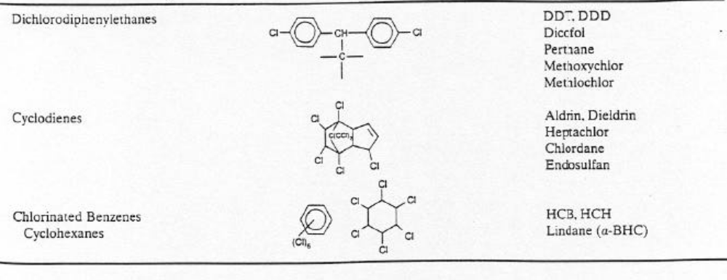
Source: Applied Toxicology by Kathrine Squibb

2.5.1.2.1.1 Dichlorodiphenyltrichloroethane (DDT)
Dichlorodiphenyltrichloroethane (DDT) is one of the best known synthetic pesticides. It was first synthesized by a German chemist named Othmar Zeidler in 1874. However, it remained a laboratory curiosity until Paul Hermann Müller discovered its insecticidal properties. DDT was adopted for widespread use in public health programmes. It was the most effective agent known for eradicating diseases that are transmitted by insects and was the first synthetic organic substance used in large quantities for insect control. Consequently, the undesirable side effects of chlorinated hydrocarbons were first discovered with it. During World War II, it was used by the military and civilians to control the spread of malaria and typhus by mosquitoes and lice respectively. As a result of his discovery of DDT's insecticidal properties, the Swiss chemist Paul Hermann Müller of Geigy Pharmaceutical was awarded the 1948 Nobel Prize in Physiology and Medicine. After the war, DDT was used as an agricultural insecticide. As a result of its potential for human toxicity and severe ecological effects, it was banned in Hungary in 1968, Norway and Sweden in 1970, the United States in 1972 and the United Kingdom in 1984. It was subsequently banned for agricultural use worldwide under the Stockholm Convention, though it is still being used in some underdeveloped countries for disease vector control.
The large scale manufacture and distribution of organochlorines took place after the accidental discovery of DDT. Although DDT has been banned in most nations, it is still found as a contaminant because of its extreme persistence and high mobility in the environment. DDT has the molecular formula C₁₄H₉C_{l5} and a molar mass of 354.49 g/mol. Its density is 0.99 g/cm³ while its boiling point is 109°C. Its structure is similar to the pesticides dicofol and methoxychlor. It is a highly hydrophobic, colourless, crystalline solid with a weak odour. It is soluble in most organic solvents, fats and oils and is produced by the reaction of chloral (CCl₃CHO) with chlorobenzene (C₆H₅Cl) in the presence of sulphuric acid, which acts as a catalyst. Commercial DDT is a mixture of some related compounds. The components include the p,p'-DDT isomer (77%), o,p'-DDT (15%), dichlorodiphenylethane (DDE) and dichlorodiphenyldichloroethane (DDD). In the environment and in the body, dichlorodiphenyltrichloroethane (DDT) breaks down into dichlorodiphenylethane (DDE) and dichlorodiphenyldichloroethane (DDD) over time. DDE and DDD are the major metabolites of DDT. The total DDT in a sample refers to the sum of all DDT congeners (p,p'-DDT, p,p'-DDE, p,p'-DDD, o,p'-DDT, o,p'-DDE and o,p'-DDD).
The most common route of DDT exposure is through the diet, particularly fatty foods such as fish, meat and dairy products. The continued use of DDT in some countries further contributes to worldwide environmental contamination. DDT can accumulate to high levels in the soil, sediments, plants, animals, fishes and humans. Analyses of blood and urine are the most common methods for detecting DDT exposure. It can also be measured in fatty tissues and breast milk. DDE has the shortest biological half-life, followed by DDT and then DDD. It is the persistence of DDT and its breakdown products that leads to its bioaccumulation and bio-concentration in the food chain. The fat solubility of DDT results in its being concentrated throughout the food chain. The result is that organisms at the top of the food chain have excessively high DDT levels in their body fat, levels that are much higher than those of soil or water. DDT has been associated with many health problems in humans, including cancer. It is a persistent organic pollutant that is extremely hydrophobic and is strongly absorbed by soils. Its soil half life ranges from 22 days to 30 years. Its breakdown metabolites, DDE and DDD, are also highly persistent and have similar chemical and physical properties.

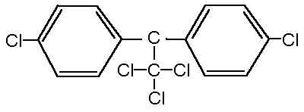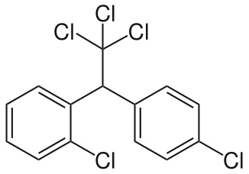
p, p'- dichlorodiphenyltrichloroethane o, p'- dichlorodiphenyltrichloroethane

2.5.1.2.1.2 Benzene hexachloride (BHC)
Benzene hexachloride (BHC), now called hexachlorocyclohexane (HCH), exists in eight isomeric forms. The isomers are named according to the position of the hydrogen atoms in the chemical structure. α-, β-, γ-, and δ- BHC are common isomers found in use in developing countries. Lindane, γ- BHC, is produced and used commercially as an insecticide on fruits, vegetables, forest crops, and animals (ATSDR, 2005a). Lindane is one of the restricted pesticides used to treat seeds (barley, corn, oats, rye, sorghum and wheat) prior to planting and as a pharmaceutical agent for the control of head lice and scabies. Because of its persistence and widespread use in the past, it still contaminates the environment, including the human food supply. It is highly persistent in the environment and can remain in soil and sediment for extended periods, accumulating in plants, fish and animals consumed by humans. Dietary exposure is the most common route for lindane exposure. Exposure to it can cause a wide range of adverse health effects in humans, including neurological effects, liver toxicity, reproductive and developmental effects. Exposure to high doses can cause symptoms such as vomiting, nausea, diarrhea, muscle weakness, seizures, blood disorders and immune deficiencies. Studies have also shown possible associations between lindane exposure in pregnant women and increased risk of spontaneous abortion and premature delivery. Fortunately, it is rapidly broken down and excreted from the body. Lindane and its metabolites can be measured in serum, urine and tissues. The International Agency for Research on Cancer (IARC) has classified BHC isomers as possibly carcinogenic to humans. Long-term exposure to α- BHC, β- BHC, γ- BHC, or technical-grade BHC has been reported to result in liver cancer. It can also result in blood disorders, dizziness, headaches, and possible changes in the levels of sex hormones in the blood (ATSDR, 2005a).
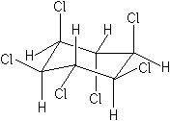
Lindane

2.5.1.2.1.3 Hexachloro benzene (HCB)
Hexachloro benzene is a by-product in the manufacture of tetrachloroethylene, trichloroethylene, carbon tetrachloride, chlorine, dimethyl tetrachloroterephthalate, vinyl chloride, atrazine, propazine, simazine, pentachloronitrobenzene and mirex. It is a contaminant in several pesticides, including dimethyl tetrachlorophthalate and pentachloronitrobenzene. HCB is a persistent organic pollutant that is still detectable in marine environments and organisms. It is used as a wood preservative and as a fungicide on grains, especially wheat. It could cause skin lesions, nerve and liver damage from acute exposures, while long-term exposures can result in damage to liver and kidney tissues, and reproductive organs and cause benign tumors in the endocrine glands. There is evidence that HCB may have the potential to cause cancer as a result of lifetime exposure. Major environmental releases of HCB are due to its air and water discharges as a by-product of chemical manufacture, or from pesticide applications. Exposure to hexachloro benzene can occur through eating and drinking foods and liquids such as milk, other dairy products, meat and poultry. It can also occur through contact with soil, dust particles, or industrial releases contaminated with hexachloro benzene (ATSDR, 2002a). Because of its low water solubility, hexachloro benzene is usually not present in drinking water.
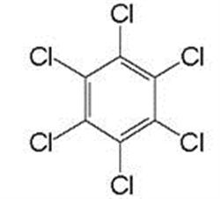
Hexachloro benzene

2.5.1.2.1.4 Chlordane
Chlordane is a cyclodiene that was used extensively in home and agricultural applications. It was commonly used in the past to kill insects on crops and for termite control. It does not readily breakdown in the environment and bioaccumulates in the fatty tissues of animals and fishes. The most common route of exposure to chlordane is consumption of contaminated foods. Chlordane exposure has been linked to toxic effects on the nervous system, digestive system and liver. It has been classified as a probable human carcinogen (ATSDR, 1994). It is a highly persistent compound and can travel long distances in the atmosphere. These characteristics, combined with the widespread past use of chlordane in some countries and current use in other countries have resulted in people’s continued exposure to it worldwide. It is extremely persistent in soil and aquatic systems and accumulates in edible crops, fish and animals. Chlordane compounds, cis-chlordane and trans-chlordane are very persistent in the environment, resistant to metabolism, have a strong affinity for lipid and biomagnify in aquatic food webs. They can migrate into surrounding water, air and soil if not properly disposed at waste sites. Chlordane and its metabolites can be measured in blood, serum, breast milk, adipose tissue and body tissues.
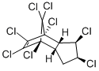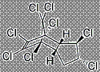
Cis-chlordane Trans-chlordane

2.5.1.2.1.5 Aldrin
Aldrin is an organochlorine insecticide that was widely used to treat seeds and soil until the 1970s when it was banned in most countries. It is produced by combining hexachlorocyclopentadiene with norbornadiene in a Diels-Alder reaction. It is highly lipophilic and its solubility in water is only 0.027 mg/L, which exacerbates its persistence in the environment. Exposure to it is mostly from eating contaminated foods. Aldrin quickly breaks down to dieldrin in the body and the environment. Exposure to it leads to headaches, dizziness, irritability, vomiting and uncontrolled muscle movements. There is no conclusive evidence that it causes cancer in human. It could be measured in the blood, urine and body tissues. Aldrin changes to dieldrin quickly in the body hence test should be carried out immediately after exposure to aldrin. The United States Environmental Protection Agency (USEPA) limits the amount of aldrin that may be present in drinking water to 0.001 mg/L of water.
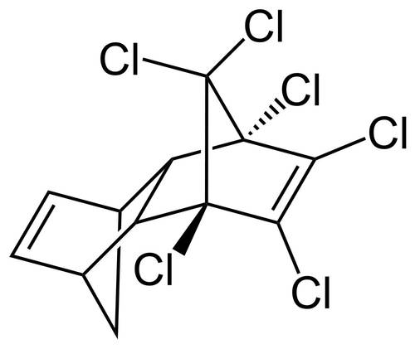
Aldrin

2.5.1.2.1.6 Dieldrin
Dieldrin is a chlorinated hydrocarbon which has a ring structure based on naphthalene. It is an extremely persistent organic pollutant that tends to biomagnify as it is passed along the food chain. Aldrin and dieldrin are insecticides with similar chemical structures. Sunlight and bacteria rapidly change aldrin to dieldrin in plants, animals and the environment. Long-term exposure to dieldrin is toxic to a wide range of animals including humans. It has been linked to health problems such as Parkinson's, breast cancer, immune, reproductive and nervous system damage. It also adversly affects testicular descent in the foetus if a pregnant woman is exposed to it.
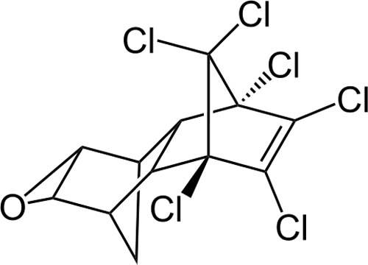
Dieldrin

2.5.1.2.1.7 Endrin
Endrin is a colourless, odourless solid that could also be used as a rodenticide. It is a stereoisomer of dieldrin and is produced through a multistep route from hexachlorocyclopentadiene. The metabolites of endrin include endrin ketone and endrine aldehyde. It is not known what happens to endrin aldehyde or endrin ketone once they are released to the environment. However, the amount of endrin broken down to its metabolites is very small. The use of endrin is banned in many countries. Like related organochlorine pesticides, it is lipophilic. Thus, it tends to accumulate in fatty tissues of organisms living in water. Some estimates indicate that its half-life in soil is over 10 years. In comparison with dieldrin, endrin is less persistent in the environment. It is toxic and its acute poisoning in humans affects primarily the nervous system. Symptoms that may result from endrin poisoning are headaches, dizziness, nervousness, confusion, nausea, vomiting and convulsions. It is very toxic to aquatic organisms, namely fish, aquatic invertebrates and phytoplankton. USEPA’s maximum contaminant level for endrin in drinking water is 0.0002 mg/L.
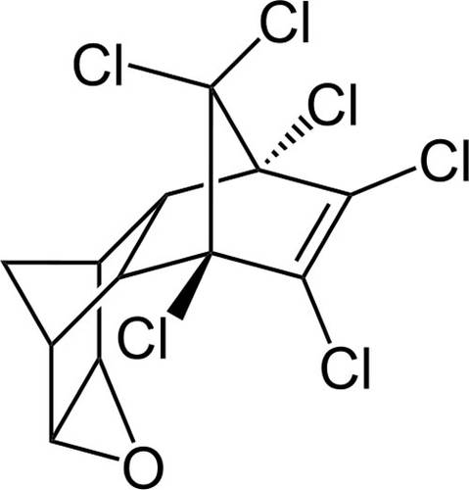
Endrin

2.5.1.2.1.8 Heptachlor
Apart from its use in killing soil insects and termites, heptachlor has also been used more widely to kill cotton insects, grasshoppers, other crop pests and malaria-carrying mosquitoes. Heptachlor is one of the cyclodiene insecticides. As a result of its highly stable structure, it can persist in the environment for decades. USEPA has limited the sale of the products to fire ant control in underground transformers. The amount that can be present in different foods is regulated. Analogous to the synthesis of other cyclodienes, heptachlor is produced via the Diels-Alder reaction of hexachlorocyclopentadiene and cyclopentadiene. Soil microorganisms transform heptachlor by hydrolysis, epoxidation and reduction. Metabolites of heptachlor include 1-hydroxychlordene, 1-hydroxy-2, 3-epoxychlordene and heptachlor epoxide. Heptachlor epoxide is more persistent and dissolves more easily in water than its parent compound. Animals exposed to heptachlor epoxide during gestation and infancy are found to have changes in their nervous system and immune function. Humans are exposed to heptachlor through drinking water and foods, including breast milk. IARC and USEPA have classified the compound as a possible human carcinogen. Higher doses of Heptachlor when exposed to newborn animals result in decrease in body weight and death.
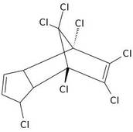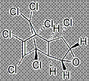
Heptachlor Heptachlor epoxide

2.5.1.2.1.9 Endosulfan
Endosulfan is an organochlorine insecticide of the cyclodiene group. It is a derivative of hexachlorocyclopentadiene and is chemically similar to aldrin, chlordane and heptachlor. Specifically, it is produced by the Diels-Alder reaction of hexachlorocyclopentadiene with cis-butene-1, 4-diol and subsequent reaction of adduct with thionyl chloride. Technical endosulfan is a 7:3 mixture of stereoisomers, designated endosulfan 1 (α) and endosulfan 11 (β). Endosulfan 1 and 11 are conformational isomers arising from the pyramidal stereochemistry of sulphur. Endosulfan 1 is the more thermodynamically stable of the two; endosulfan 11 irreversibly converts to endosulfan 1, although the conversion is slow. Endosulfan 1 is about 3 times more toxic than endosulfan 11 (ATSDR, 2000b). Endosulfan is both an insecticide and acaricide and is used to control pests in vegetables, fruits, cereal grains, cotton, ornamental shrubs, trees, vines and plants. It is highly toxic to the nervous system and can cause circulatory problems, headache, vomiting and diarrhea. This colourless solid has emerged as a highly controversial organochlorine due to its acute toxicity, potential for bioaccumulation and role as an endocrine disruptor. Endosulfan is banned or restricted in many countries because of its human health and environmental impacts. The principal metabolite of endosulfan is endosulfan sulphate. The sulphate is regarded as being equally toxic and of increased persistence in comparison with the parent isomers (USEPA, 2007a). Endosulfan sulphate is usually included with the isomers of endosulfan as ‘total endosulfan’ in measurement of residues. Other metabolites include endosulfan diol, endosulfan ether, endosulfan hydroxy carboxylic acid, endosulfan hydroxyether and endosulfan lactone.
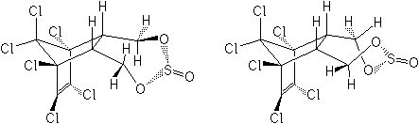
Endosulfan 1(α) Endosulfan 11(β)

2.5.1.2.1.10 Methoxychlor
Methoxychlor is a synthetic organochlorine used as an insecticide. Pure methoxychlor is a pale-yellow powder with a slight fruity or musty odour. It is used to protect crops, ornamentals, livestock and pets against fleas, mosquitoes, cockroaches and other insects. It has been used to some degree as a replacement for DDT as it is metabolized faster and does not lead to bioaccumulation. Methoxychlor is ingested and absorbed by living organisms but it is readily released and does not accumulate in the food chain. This is due to its relatively low toxicity and short persistence in biological systems. Sprayed methoxychlor settles on the ground or in aquatic ecosystems, where it can be found in sediments. Human exposure to methoxychlor occurs via air, soil and water, primarily in people who work with the chemical or who are exposed to media that have been contaminated by it. Methoxychlor breaks down slowly in air, water and soil by sunlight and microscopic organisms (ATSDR, 2002b). Fishes do metabolize methoxychlor fairly rapidly and thus tend not to accumulate it appreciably. Methoxychlor is very persistent in soil and its half-life is greater than six months. It degrades much more rapidly in aerobic soil than in anaerobic soil.
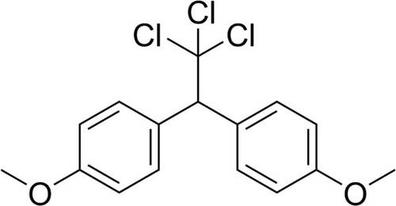
Methoxychlor
2.5.1.2.1.11 Mirex
Mirex is a chlorinated hydrocarbon that was commercialized as an insecticide and later banned because of its impact on the environment. It was used to control fire ants and termites but by virtue of its chemical robustness and lipophilicity it is recognized as a bioaccumulative pollutant. It has also been used as a fire retardant in plastics, rubber and electrical goods. This white crystalline odourless solid is a derivative of cyclopentadiene. It is one of the "dirty dozen". Its slow oxidation produces chlordecone, a related insecticide that is also banned in most of the western world. Sunlight degrades mirex to photomirex. Mirex is highly resistant to microbiological degradation. It only slowly dechlorinates to a monohydro derivative by anaerobic microbial action in sewage sludge and by enteric bacteria. Mirex is highly cumulative and amount depends upon the concentration and duration of exposure. There is evidence of its accumulation in aquatic and terrestrial food chains to harmful levels. Being lipophilic, mirex is strongly adsorbed on sediments. It can enter the body through inhalation, ingestion and the skin. The most sensitive effects of repeated exposure in animals are principally associated with the liver. At higher dose levels, it is fetotoxic (25 mg/kg in diet) and teratogenic (6.0 mg/kg per day). Mirex is toxic for a range of aquatic organisms, with crustaceans being particularly sensitive. It induces pervasive chronic physiological and biochemical disorders in various vertebrates. No acceptable daily intake (ADI) for Mirex has been advised by FAO/WHO.
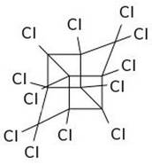

Mirex

2.5.1.2.1.12 Dioxins
Dioxin is commonly used to refer to a family of toxic chemicals that share a similar chemical structure and a common mechanism of toxic action. This family includes polychlorinated dibenzo dioxins (PCDDs). They are not commercial chemical products but are trace level unintentional byproducts of most forms of combustion and several industrial chemical processes. Certain kinds of metal recycling, pulp and paper bleaching can release dioxins. They have also been found in automobile exhaust, tobacco smoke, wood and coal smoke. Most dioxins are introduced to the environment through the air. Ninety per cent of people's overall exposure to them is from diet. Meat, milk products and fish have higher levels of dioxins than fruit, vegetables and grains. Health effects associated with human exposure to dioxins include skin disorders, liver problems, impairment of the immune system, the endocrine system and reproductive functions. Because they are widely distributed throughout the environment in low concentrations and do bioaccumulate, most people have detectable levels of dioxins in their tissues. Dioxins can be commonly detected in air, soil, sediments and food.
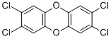
2, 3, 7, 8-tetrachlorodibenzo-p-dioxin (TCDD)

2.5.1.2.1.13 Furans
Furan is a heterocyclic organic compound, consisting of a five-membered aromatic ring with four carbon atoms and one oxygen atom. It is a colourless, flammable, highly volatile liquid with a boiling point close to room temperature. It is toxic and may be carcinogenic. Furans are produced unintentionally from the same processes that release dioxins, and they are also found in commercial mixtures of PCBs. Exposure to furans has been associated with a wide range of adverse health effects in animals and humans. The type and occurrence of these effects depend on the level and duration of exposure. Since they are stored in body fat, people take more furans into their bodies through food than through air, water or soil. On exposure to air, furan decomposes very slowly by autoxidation. Substituted furans, particularly negatively substituted furans, are much less sensitive.
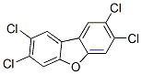
2, 3, 7, 8-tetrachloro-dibenzofuran (TCDF)

2.5.1.2.1.14 Toxaphene
Toxaphene, also called camphechlor, is a mixture of many organic compounds, formed by the chlorination of camphene. It is a yellow to amber waxy solid that smells like turpentine. It is applied to cotton, cereal grains, fruits, nuts and vegetables. It has also been used to control ticks and mites in livestock. It is volatile enough to be transported unchanged in the air for long distances from release sites. When inhaled or ingested, sufficient quantities of toxaphene can damage the lungs, nervous system, kidneys and may cause death. Toxaphene is found in the environment, mainly as a result of past releases to air, water and soil through its use as a pesticide. It enters the body faster if it is taken in after a meal heavy in oil because oil helps it to move from the stomach into the blood. Once toxaphene has entered the human body, it is rapidly broken down and removed. It does not appear to accumulate in the body to any appreciable degree. Almost all of the toxaphene taken into the body leaves quickly in the urine and faeces within a few weeks. Toxaphene breaks down very slowly in the environment. It accumulates in fish and mammals.
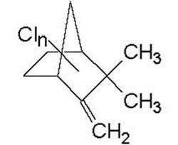
Toxaphene

2.5.1.2.2 Polychlorinated biphenyls (PCBs)
Polychlorinated biphenyls are a group of halogenated aromatic compounds that consists of 209 congeners differing either in physicochemical properties or in toxicological response. These anthropogenic chemicals could be manufactured by direct chlorination of biphenyl in the presence of iron, forming a mixture of isomeric products, the structures of which depend on the reaction temperature and the ratio of Cl₂ to the biphenyl. They are a class of organic compounds with 1 to 10 chlorine atoms attached to a biphenyl. The chemical formula for PCBs is C₁₂H_{10-x}Cl_{x}, where x = 1-10 (Wikipedia Encyclopaedia). The commercial production of PCBs started in 1929 but their use has been banned or severely restricted in many countries since the 1970s and 80s because of the risks to human health and the environment. They are among the industrial chemicals banned, and they are included in the list of priority contaminants to be monitored regularly. PCB congeners are odourless, tasteless, clear or pale-yellow viscous liquids. Only about 130 of the theoretically possible congeners are found in commercial mixtures (UNEP Chemicals, 1999). As the number of chlorines in a PCB mixture increases the flash point rises and the substance becomes less combustible. Also, PCBs with large numbers of chlorines are more stable and thus resistant to biodegradation. The most highly favoured PCBs are those with large numbers of chlorines even though they pose the greatest environmental and health risks. PCBs have a low degree of reactivity. They are not flammable, have high electrical resistance and good insulating properties and are very stable even when exposed to heat and pressure. They are used as coolants and lubricants in transformers, capacitors and other electrical equipment because they do not burn easily. PCBs are used in hydraulic fluids, casting wax, carbon paper, compressors, heat transfer systems, plasticizers, pigments, adhesives, liquid cooled electric motors and fluorescent light ballasts. However, the high thermal and chemical resistance of PCBs is hazardous to the environment. Since they persist in the environment they continue to build up as more are introduced into the environment leading to their bioaccumulation in the tissues of animals up to the top of the food chain.
The most toxic PCBs are the “coplanars”. Studies on their structure-activity relationship (Kannan et al., 1995) suggest that the “dioxin-like” non-ortho chlorine substituted PCBs, especially 3, 3′, 4, 4′-tetrachlorobiphenyl, 3, 3′, 4, 4′, 5-pentachlorobiphenyl and 3, 3′, 4, 4′, 5, 5′-hexachlorobiphenyl, are able to adopt a planar configuration which makes them behave in a similar fashion as the highly toxic 2, 3, 7, 8-tetrachlorodibenzo-p-dioxin (TCDD). Thus, the non-ortho congeners exhibit the highest toxicity, followed by the moderately toxic mono-ortho, while the di-ortho- substituted PCBs reveal a lower toxicity. These compounds exhibit a broad range of toxicological responses, including immunotoxicity, reproductive deficits, teratogenicity, endocrine toxicity, carcinogenity and tumor promotion. Several studies have shown that these compounds exhibit a great variety of sex-, strain-, and species-specific toxic effects, including immuno, hepato and neurotoxicity, as well as reproductive alterations (Ahlborg et al., 1994). PCBs could be exposed to humans through old fluorescent lighting fixtures, electrical devices and appliances, such as television sets and refrigerators. Repair and maintenance of PCB transformers, accidents, fires and spills involving transformers are also sources of exposure. They could be released into the environment from hazardous waste sites, illegal or improper disposal of industrial wastes and consumer products and burning of some wastes in incinerators. They can travel long distances in the air and can be deposited in areas far away from where they are released. In water, a small amount of PCBs may remain dissolved, but most stick to organic particles, bottom sediments and soil. They are taken up by small organisms, fish and marine mammals. They accumulate in them, reaching levels that are many times higher than in water.
Human beings may be exposed to PCBs by ingesting contaminated food and water or inhaling contaminated air. Their main dietary sources are fish, meat and dairy products. Once absorbed, PCBs move into cell membranes, blood vessels and the lymphatic system. In the human body, they can remain in fatty tissues and in the liver and may be transferred from mother to child through the placenta or breast milk. The highest concentrations of PCBs are usually found in the liver, fatty tissue, brain, skin and the blood. The speed at which they are transformed in the body and the extent to which they are either stored or excreted depend on the type of PCB. Health effects that have been associated with exposure to PCBs include acne-like skin conditions in adults and neurobehavioural and immunological changes in children. Neurobehavioural deficits observed include depressed responsiveness, impaired visual recognition and poor short-term memory. PCBs have been demonstrated to exert effects on thyroid hormone levels in animals and humans. USEPA and IARC have noted that PCBs are probably carcinogenic to humans. Studies have shown endocrine disruption in animals that eat food containing large amounts of it for short periods of time. Other effects of PCBs in animals include changes in the immune system, liver cancer, behavioural alterations and impaired reproduction. They have been reported to cause a variety of effects including immunologic, teratogenic, carcinogenic, reproductive and neurological problems in organisms (Nakata et al., 2002).
Once released into aquatic environment these hydrophobic substances can either be absorbed by organisms or adsorb onto suspended particles. After deposition with settling particles on bottom sediments, they are accumulated by benthic organisms and re-enter the food chain (Nhan et al. 2001). PCBs in the environment associate with the organic components of soils, sediments and biological tissues or with dissolved organic carbon in aquatic systems. They can be resuspended by physical mixing or by the activity of bottom-dwelling organisms and bioaccumulate the food chain. Consequently, fish living on or near the floor of water bodies are highly prone to accumulation. PCBs volatilize from water surfaces in spite of their low vapour pressure. This is partly due to their hydrophobicity. Atmospheric transport may therefore be a significant pathway for their distribution in the environment. The toxicity of a PCB is dependent not only upon the number of chlorines present on the biphenyl structures, but also on the positions of the chlorines. Biodegradability is related to the amount of chlorination of a specific PCB. The higher the chlorine contents of a PCB, the lesser its biodegradability and the consequent bioaccumulation in the environment. The stability of PCBs, which makes them useful commercially, also results in their persistence in the environment. They are resistant to both hydrolysis and oxidation and undergo slow microbial degradation. Highly chlorinated PCBs are photo degraded with the long-wavelength UV light (> 290 nm), which is not absorbed by the ozone layer.

Top of Form
Top of Form
Top of Form
Top of Form
Bottom of Form
Bottom of Form
2.5.2 Environmental behaviour and fate of persistent organic pollutants
The behaviour and fate of chemicals in the environment are determined by their chemical and physical properties and the nature of the environment. The POPs are persistent, mobile, toxic and lipophilic. High lipophilicity results in these substances bioconcentrating from the surrounding medium into the organisms. Lipophilicity also results in biomagnification through the food chain. Biomagnification results in much greater exposures in organisms at the top of the food chain. Environmental behaviour and exposure are strongly related.

2.5.2.1 Fate processes of pesticides
When a pesticide is introduced into the environment by application, a disposal or a spill, it is influenced by many processes. These processes determine a pesticide’s persistence, movement and ultimate fate. The fate processes can have both positive and negative influences on a pesticide’s effectiveness or its impact on the environment. They can move a pesticide to the target area or destroy its potentially harmful residues. Sometimes they can be detrimental, leading to reduced control of a target pest, injury of non target plants and animals and environmental damage. Different soil and climatic factors and different handling practices can promote or prevent each process. An understanding of the fate processes ensures that applications are not only effective but are also environmentally safe. Fate processes could be grouped into four major types: degradation, transfer, adsorption and bioaccumulation/biomagnification. These physical and chemical properties of pesticides determine their environmental risk. Pesticide degradation refers to the breakdown of pesticides in the environment. The rate at which the degradation occurs is measured by the pesticide’s half-life. A pesticide with a long half-life is described as persistent. Persistence is good for long term pest control but it is also undesirable because the pesticide can cause environmental damage over a long period of time. Pesticide degradation is usually beneficial as pesticide-destroying reactions change most pesticide residues in the environment to non toxic or harmless compounds. However, degradation is detrimental when a pesticide is destroyed before the target pest has been controlled. The rate of pesticide degradation is affected by many environmental factors including temperature, moisture and pH. The three types of pesticide degradation are microbial, chemical and photodegradation.
Microbial degradation is the breakdown of pesticides by fungi, bacteria and other microorganisms that use pesticides as a food source. It is the most common type of pesticide breakdown. Pesticides are broken down into basic compounds such as water and carbon (IV) oxide. Most microbial degradation of pesticides occurs in the soil. Soil conditions such as moisture, temperature, aeration, pH and the amount of organic matter affect the rate of microbial degradation because of their direct influence on microbial growth and activity. The frequency of pesticide application is also a factor that can influence microbial degradation. Rapid microbial degradation is more likely when the same pesticide is used repeatedly in a field as repeated applications can stimulate the buildup of organisms that are effective in degrading the chemical. As the population of these organisms increases, degradation accelerates and the amount of pesticide available to control the pest is reduced. Microorganisms greatly reduce the effectiveness of these chemicals soon after application. The possibility of very rapid pesticide breakdown is reduced by using pesticides only when necessary and by avoiding repeated applications of the same chemical. Alternating between different classes, groups or formulations of pesticides can minimize the potential for microbial degradation problems as well as pest resistance.
Chemical degradation is the breakdown of pesticides by processes that do not involve living organisms. It is the chemical reaction that occurs between the pesticide and other chemicals in the environment resulting in the splitting of pesticides into less hazardous compounds. The adsorptive capacity, pH, temperature, moisture, mineralogy of the soil, physical and chemical properties of the pesticide determine the rate and type of chemical reactions that occur. One of the most common pesticide degradation reactions is hydrolysis, a breakdown process in which the pesticide reacts with water. Photodegradation is the breakdown of pesticides by ultraviolet or visible light, particularly sunlight. It can destroy pesticides on foliage, surface of the soil and in the air. Pesticides, once applied, vary considerably in their stability under natural light. Factors that influence this kind of degradation include intensity of the sunlight, characteristics of the application site such as soil type and vegetation; application method, physical and chemical properties of the formulated pesticide. Pesticide losses from photodegradation can be reduced by incorporating the pesticide into the soil during or immediately after application and by using adjuvants in the pesticide formulation to protect the active ingredient.
Pesticide transfer is sometimes essential for pest control as some pesticides need to circulate for effective utilization. Too much movement, however, can move a pesticide away from the target pest, leading to reduced pest control, contamination of surface water and groundwater and injury to non target species, including humans. Pesticides can be transferred through natural processes such as volatilization, runoff, leaching, absorption and crop removal. Volatilization is the conversion of a solid or liquid into a gas. Once volatilized, a pesticide can move in air currents away from the treated surface. Vapour pressure is an important factor in determining pesticide volatility. The higher the vapour pressure, the more volatile the pesticide is. Environmental factors such as high temperature, low relative humidity and air movement tend to increase volatilization. A pesticide tightly adsorbed to soil particles is less likely to volatilize. Soil conditions such as texture, organic matter content and moisture can thus influence pesticide volatilization. Volatilization can result in reduced control of the target pest because less pesticide remains at the target site. Vapour drift, the movement of pesticide vapours or gases in the atmosphere, can lead to injury of non target species. To avoid pesticide volatilization, application of volatile pesticides when conditions are unfavourable should be avoided. Low-volatile formulations should also be employed.
Run-off refers to the movement of water over the land surface or a sloping surface. It occurs when water accumulates on the land surface faster than it can infiltrate the soil. Pesticides can be carried in the water itself or bound to eroding soil particles. The amount of pesticides in runoff water is a function of site-related factors such as the slope of the land and moisture content of the soil. Climatic factors such as temperature, the amount and timing of rainfall relative to the pesticide application are also of influence. Climatic factors affect the persistence of pesticides in the environment thus influencing the availability of pesticides for transport by runoff. Other factors of note are the pesticide-water-soil interactions such as the solubility and adsorptivity of the pesticide, the erodibility and texture of the soil. In general, pesticide losses in runoff are most likely to occur when a heavy rainfall or excessive irrigation takes place shortly after a pesticide is applied to the soil surface. Steep slopes, wet soils and poor vegetative cover all contribute to high levels of run-off. Each pesticide’s preference for the dissolved or adsorbed state controls the amount of chemical that is released into the runoff solution. Some pesticides are so tightly adsorbed that they will remain attached to particles of soil and organic matter even when these solids are suspended in run-off water. Pesticide run-off is usually greatest after an application. Over-irrigation can lead to excess surface water and pesticide run-off, especially when an irrigation system is used to apply a pesticide. Vegetation or crop residue tends to slow the movement of run-off water. The rate of pesticide absorption by plants and nature of adsorption to plant tissue or soil are also important. Pesticide run-off can also lead to groundwater contamination and can cause injury to crops, livestock or humans if the contaminated water is used downstream. Practices to reduce pesticide run-off include monitoring of weather conditions, careful application of irrigation water, using a spray mix additive to enhance pesticide retention on foliage and incorporating the pesticide into the soil. Reduced tillage cropping systems and surface grading, in addition to contour planting and strip cropping of untreated vegetation, can slow the movement of run-off water and help keep it out of wells, sinkholes, water bodies and other sensitive areas.
Leaching is the movement of pesticides through the soil rather than over the surface. Pesticides can leach downward, upward or side to side. Leaching depends on the pesticide’s chemical and physical properties such as adsorption, solubility and persistence. A pesticide held strongly to soil particles by adsorption is less likely to leach. A pesticide that dissolves in water can move with water in the soil. A pesticide that is rapidly broken down by a degradation process is less likely to leach because it may remain in the soil only for a short time. Soil factors that influence leaching include permeability, texture and organic matter. The more permeable a soil is the greater is its potential for pesticide leaching. A sandy soil, for example, is much more permeable than clay. Texture and organic matter affect pesticide adsorption. The method and rate of application, the use of tillage systems that modify soil conditions and the amount and timing of water a treated area receives after application can also influence pesticide leaching. Pesticides can leach through the soil to groundwater from storage, mixing, equipment cleaning and disposal areas. A certain amount of pesticide leaching may be essential for control of a target pest. Too much leaching, however, can lead to reduced pest control, injury of non target species and ground water contamination. Monitoring weather conditions and the amount and timing of irrigation can help minimize pesticide leaching.
Absorption is the movement of pesticides into plants and animals or structures such as soil and wood. Absorption of pesticides by target and non target organisms is influenced by environmental conditions, physical and chemical properties of the pesticide and the soil. Once absorbed by plants, pesticides may be broken down or they may remain in the plant until tissue decay or harvest. Similarly, desorption is the release of pesticides from soil, wood or other substances. Crop removal transfers pesticides and their breakdown products from the treatment site. Most harvested food commodities are subjected to washing and processing procedures that remove or degrade much of the remaining pesticide residue. Pesticides can be transferred during such operations as tree and shrub pruning and turf grass mowing. Pesticide adsorption is the binding of pesticides to soil particles and organic matter. Positively charged pesticide molecules, for example, are attracted and bound to negatively charged clay particles. The amount of adsorption in the soil depends on the type of soil, the soil conditions (temperature, pH, moisture content etc) and the characteristics of the pesticides.
Soils high in organic matter or clay are more adsorptive than coarse, sandy soils, in part because a clay or organic soil has more particle surface area onto which pesticides can bind. Moisture affects adsorption. Wet soils tend to adsorb less pesticide than dry soils because water molecules compete with the pesticide for the binding sites. Pesticides vary in their adsorption to soil particles. Some pesticides such as paraquat and glyphosate bind very tightly while others bind only weakly and are readily desorbed or released back into the soil solution. Pesticide adsorption leads to reduced pest control hence higher application rates are recommended when the chemical is applied to adsorptive soils. Plant injury can also result from adsorption of pesticides to soil particles. Injury occurs when a pesticide used for one crop is later released from the soil particles in amounts great enough to cause injury to a sensitive rotational crop. This can also lead to the presence of illegal residues on rotational food or feed crops. Adsorption is particularly important as it influences the effects of other processes on the pesticides. For most pesticides, the degree of adsorption is described by an adsorption distribution coefficient (K_{D}) which is mathematically defined as the amount of pesticide in soil solution divided by the amount adsorped to the soil.
Bioaccumulation is the ability of some pesticides to build up in the body tissue of animals. Pesticide build-up can cause long-term damage or death. It can also build up in the food chain – a process called biomagnification. Biomagnification results in much greater exposures in organisms at the top of the food chain. Biomagnification of persistent pesticides in food chains was one of the reasons for banning organochlorine pesticides such as DDT. Bioaccumulation and biomagnification also occur in aquatic systems. Fishes, for example, are affected when their water habitats or food sources are contaminated. The extent of damage to the fish depends not only on the properties of the pesticide but also on the species of fish, its age, size and its position in the food chain.
The use of pesticides introduces some risk to the environment. The degree of risk depends upon four factors, namely persistence, mobility, non-target toxicity and volume of use. The toxicity level of a pesticide depends on the deadliness of the chemical, the dose, the length of exposure, the health status of a recipient and the route of entry or absorption into the body. Pesticide degradation generally results in a reduction in toxicity. However, some pesticides have metabolites that are more toxic than the parent compounds. Pesticides could be classified according to their potential toxicity to humans and animals. Chemical structures differ within categories as well as between categories. Thus, toxicity to humans can vary widely within each group. Pesticides are inherently toxic. OCPs contribute to many acute and chronic health effects including cancer, neurological damage, birth defects, tremors, headache, dermal irritation, respiratory problems and dizziness. They are also suspected endocrine disruptors and are highly toxic to the nervous system, particularly during early stages of development. Prenatal exposure to OCPs has been associated with neurological effects such as learning deficits and behavioural changes in infants. They have been linked with many forms of cancer. Animal studies have shown the potential for reproductive and developmental effects and disruption of normal hormone function. Children may be especially vulnerable to OCPs exposure because they consume larger amounts of food and water relative to their body weight than adults. Children’s developing organ systems are more sensitive and their bodies have thus limited ability to detoxify OCPs. There are many different pesticides in use with very different modes of action and levels of toxicity. WHO/UNEP (1990) estimated 3 million cases of acute, severe poisonings annually, with 220,000 deaths. Organochlorine pesticide should be chosen such that it gives the needed pest control with the least risk of harm to non-target species and the environment. The adverse environmental effects of pesticides used in public health can often be mitigated through proper selection and application procedures. A minimum amount of pesticide should be applied by the most efficient method at the most suitable time to achieve the required goal.

2.5.3 Chemistry and toxicology of persistent organic pollutants
2.5.3.1 Chemistry of persistent organic pollutants
Persistent organic pollutants are highly resistant to degradation by biological, photolytic or chemical means. They are often halogenated and most often chlorinated. The carbon-chlorine bond is very stable towards hydrolysis and, the greater the number of chlorine substitutions, the greater the resistance to biological and photolytic degradation. Chlorine attached to an aromatic ring is more stable to hydrolysis than chlorine in aliphatic structures. Chlorinated POPs are typically ring structures with a chain or branched chain framework. Although some natural sources of organochlorines are known to exist, most POPs originate from anthropogenic sources associated largely with the manufacture, use and disposition of certain organic chemicals. In contrast, HCB, dioxins and furans are formed unintentionally in a wide range of manufacturing and combustion processes.
POPs are semi-volatile compounds, a characteristic that favours their long-range transport. In the environment, organochlorines can be transformed by a variety of microbial, chemical and photochemical processes. The efficiency of these environmental processes is largely dependent on the physicochemical properties of the specific compound and characteristics of the receiving environment. Cyclic, aromatic and cyclodiene-type chlorinated hydrocarbon compounds, such as some chlorinated pesticides with molecular weights greater than 236 g/mol have been noted for their ability to accumulate in biological tissues, particularly concentrating in organisms that occupy positions in the upper trophic levels. Conversely, the lower molecular weight chlorinated hydrocarbons (less than 236 g/mol) may include a number of alkanes and alkenes and are often associated with little acute toxicity, reversible toxicological effects and relatively short environmental and biological half-lives. Bioavailability is controlled by a combination of chemical properties of the compound including the ambient environment and the morphological, biochemical and physiological attributes of the organism itself.

2.5.3.2 Toxicology of persistent organic pollutants
It is difficult to establish causality of illness or disease that is directly attributable to exposure to a specific persistent organic pollutant or group of pollutants. This is because POPs rarely occur as single compounds. Besides, individual field studies are insufficient to provide compelling evidence of cause and effect. Again, the significant lipophilicity of these compounds means that POPs are likely to accumulate, persist and bioconcentrate and could achieve toxicologically relevant concentrations even though discrete exposure may appear limited. Experimentally, POPs have been associated with significant environmental impact in a wide range of species and at virtually all trophic levels. While acute effects of POP intoxication have been well documented, adverse effects associated with chronic low level exposure in the environment is of particular concern. Noteworthy in this context is their long half life in biological organisms. This facilitates the accumulation of seemingly small unit concentrations over extended periods of time.
For some POPs, there is some experimental evidence that such cumulative low level exposures may be associated with chronic non-lethal effects, including potential immunotoxicity, dermal effects, impairment of reproductive performance and carcinogenicity. Much work remains to be done on the study of the human health impact of exposure to POPs, particularly in view of the broad range of concomitant exposure experienced by humans. For some POPs, occupational and accidental high-level exposures are of concern for both acute and chronic worker exposures. The risk is greatest in developing countries where the use of POPs in tropical agriculture has resulted in a large number of deaths and injuries. In addition to other exposure routes, workers exposures to these pollutants during waste management is a significant source of occupational risk in many countries. Short-term exposure to high concentrations of certain POPs could result in illness and death. Occupational, bystander and near-field exposure to toxic chemicals is often difficult to minimize in developing countries. Obstacles in managing occupational exposure are in part due to poor or non-existent training, lack of safety equipment and substandard working conditions. Concerns resulting from bystander and near-field exposure are difficult to identify due to inadequacies in monitoring the ambient environment and inconsistencies in medical monitoring, diagnosis, reporting and treatment. These factors contribute to a lack of epidemiological data. The scientific evidence demonstrating a link between chronic exposure to sublethal concentrations of POPs and human health impacts is more difficult to establish, but gives cause for serious concern.

2.6 Analytical methods of OCP determination
Analytical methods for the identification and determination of organochlorine pesticides are widely available and are the result of an extensive environmental analytical method development and research on persistent organic pollutants over the past 30 - 40 years. Given the broad range of technical expertise for analysis of OCPs, the UNEP POPs workshop on global monitoring (UNEP, 2003) noted that no single, detailed, step-by-step analytical method can be specifically recommended. Laboratories are thus encouraged to use methods best-suited to their situation and take part in international interlaboratory comparisons to verify their work. This performance-based approach has also been adopted by the US EPA in an effort to introduce flexibility in conducting environmental monitoring.

2.6.1 Gas chromatograph coupled with electron capture detector (GC-ECD)
Since the 1960s, OCPs have been determined by gas chromatography coupled with electron capture detector (GC-ECD), initially using packed columns. Capillary GC-ECD began to be routinely applied by the early 1980s. It is capable of determining pesticide residues at very low levels in environmental matrices. Although at a time tritium-based ECDs were available, the ⁶³Ni detector is now universally used. This detector is operated at high temperatures, 300-350⁰C, which makes it relatively unaffected by column bleed. Electron capture detector suffers from the potential for false positives due to interferences from sulphur, phthalate esters and negative peaks generated by hydrocarbons. ECDs are normally operated with N₂ or argon/methane gas, which combines with the flow from the GC column (He or H₂ carrier gas). Gases used for GC–ECD must be ultrapure to protect both the GC column (which can be oxidized by trace oxygen or siloxanes hydrolyzed by trace water) and the ECD itself.

2.6.2 Gas chromatograph coupled with mass spectrometer (GC-MS)
GC-MS is one of the analytical methods used for the identification and determination of organochlorine pesticide residues in samples. The use of a mass spectrometer as the detector in gas chromatography was developed during the 1950s by Roland Gohlke and Fred McLafferty (Muir and Sverko, 2006). The gas chromatograph utilizes a capillary column which depends on the column's dimensions and phase properties. The difference in the chemical properties between different molecules in a mixture separates the molecules as the sample travels the length of the column. The molecules take different retention time to elute from the gas chromatograph, and this allows the mass spectrometer downstream to capture, ionize, accelerate, deflect, and detect the ionized molecules separately. The mass spectrometer does this by breaking each molecule into ionized fragments and detecting these fragments using their mass to charge ratio. Combining these two processes reduces the possibility of an analytical error, as it is extremely unlikely that two different molecules will behave in the same way in both a gas chromatograph and a mass spectrometer. The most common GC-MS instruments for environmental analysis are those with electron impact ion sources and quadrupole mass analyzers. In the electron impact mass spectrometer, analyte molecules bombarded in the ion source with a flow of electrons, produce charged fragments. The negatively charged ions are deflected and removed from the system, whereas the positively charged fragments are accelerated into the quadrupole mass analyzer. The fragments are separated by mass and velocity under the effects of a direct electrical current and a radio frequency applied to the quadrupoles. Only the ions with a single charge are retained in the mass analyzer. Each group of ions with the same m/z value has its own trajectory as it reaches the detector. As ion beams of different m/z values enter the electron multiplier of the detector, they are recorded as a change in the electrical signal. Every organic chemical has a mass spectrum, which is a combination of ions with different masses and different intensities. To identify a compound, its mass spectrum is compared to the mass spectra of standards, analyzed under the same instrument settings and to the mass spectra library. Compound identification in GS/MS is based on the retention time and the mass spectra interpretation while the quantitation is based on the abundance of a primary ion. For a compound to be positively identified, all of the ions in the spectrum must be detected at one and the same retention time, which corresponds to the retention time of the compound in the calibration standard (Popek, 2003).

2.6.3 Enzyme-linked immunoabsorbent assays (ELISAs)
ELISAs have been used to determine most DDT/DDE, HCH isomers, toxaphene and cyclodiene OCPs in environmental samples. ELISAs are based on competitive binding in which the binder molecule, an excess amount of labelled analyte or coating antigen and the target analyte are allowed to approach equilibrium. The sample antigen competes with the coated antigen for binding sites on the labelled antibody; after a wash step, detection is performed by adding substrate and chromophore. Determination is generally performed via spectrophotometric measurements and the amount of analyte in the sample is interpolated from a calibration curve. Although widely used to screen for herbicides and insecticides as well as their polar metabolites, the development of competitive immunoassays for neutral hydrophobic OCPs has lagged. This is in part due to the need for low detection limits. Also, ELISA analysis for some OCPs such as HCH and lindane has been challenging due to the small size of the HCH molecule, its structural symmetry, and its lack of aromatic structures or other atomic groups capable of supporting delocalized electron networks (Muir and Sverko, 2006).
2.7 Chromatography
Historically, chromatography was used to describe the separation of plant pigments by percolating a petroleum-ether extract through a glass column packed with powdered calcium carbonate. Coloured zones were produced by the various pigments migrating through the column at different rates, the components being isolated by extrusion and sectioning of the calcium carbonate packing. Modern chromatographic techniques are more complex and are used for a wide variety of separations frequently involving colourless substances. However, all the techniques depend upon the same basic principle: variations in the rate at which different components of a mixture migrate through a stationary phase under the influence of a mobile phase. Rates of migration vary because of differences in distribution ratios. Chromatography is the method of separation in which components are distributed between two phases, the stationary phase and the mobile phase. In practice, the liquid stationary phase is coated onto an inert, granular or powdered solid support which is either packed into a column or spread on a supporting sheet in the form of a thin layer. The solid stationary phases used in some chromatographic techniques have no need of a support if packed into a column but still require a supporting sheet for thin-layer operation. As the distributing components of a mixture are moved down a column or across a surface by the mobile phase, they assume a Gaussian concentration profile. Since both phases are continuous, diffusion and other kinetic effects play a significant role in determining the width of the profile.

2.7.1 Chromatographic mechanisms
During a chromatographic separation solute molecules are continually moving back and forth between the stationary and mobile phases. When they are in the mobile phase, they are carried forward with it but remain virtually stationary during the time they spend in the stationary phase. The rate of migration of each solute is therefore determined by the proportion of time it spends in the mobile phase, otherwise referred to as its distribution ratio. The process whereby a solute is transferred from a mobile phase to a stationary phase is called sorption. Chromatographic techniques are based on four different sorption mechanisms, namely surface adsorption, partition, ion exchange and exclusion. The historical method involved surface adsorption where the relative polarities of solute and solid stationary phase determine the rate of movement of the solute through a column or across a surface. When a liquid is coated onto the surface of an inert solid support, the sorption process is that of partition, and movement of the solute is determined solely by its relative solubility in the two phases or by its volatility if the mobile phase is a gas.
Both adsorption and partition sorption may occur simultaneously but the contribution of each is determined by the system parameters, such as the nature of the mobile and stationary phases, solid support and solute. In ion-exchange sorption, the stationary phase is a permeable polymeric solid containing fixed charged groups and mobile counter-ions which can exchange with the ions of a solute as the mobile phase carries them through the structure. The exclusion mechanism is not a true sorption process as the separating solutes remain in the mobile phase throughout. Separations occur because of variations in the extent to which the solute molecules can diffuse through an inert but porous stationary phase. This is normally a gel structure which has a small pore size into which small molecules up to a certain critical size can diffuse. Molecules larger than the critical size are excluded from the gel and move unhindered through the column while smaller ones are retarded to an extent dependent on molecular size. In each chromatographic technique, one of the four mechanisms predominates, but it should be noted that two or more may be involved simultaneously. Partition and adsorption frequently occur together while ion-exchange and exclusion are involved in paper chromatography.

2.7.2 Forms of chromatography
Chromatographic separation has different forms, depending on the type of mobile and stationary phase, the type of equilibrium involved and the physical means by which these two phases are brought into contact. However, all chromatographic separations are based on the establishment of equilibrium between a stationary phase and a mobile phase. Components are separated according to their different affinities for the stationary phase, which is sometimes a solid but most commonly a liquid. The sample, often vapourized or dissolved in a solvent, is moved through the stationary phase by the mobile phase which could be a liquid or a gas. In the process, the sample components undergo a series of partitions between the two phases and the differences in their chemical and physical properties are exploited. These differences govern the rate of migration of the individual components. Eluted components emerge from the chromatograph as gaussian-shaped peaks and in the order of increasing interaction with the stationary phase. Separation is obtained when one component is retarded sufficiently to prevent overlap with the peak of an adjacent neighbour.
When the stationary phase is contained in a column, the term column chromatography applies. The stationary phase can also occupy a plane surface. This is called planar chromatography and includes thin-layer and paper chromatography and electrophoresis. Column chromatography can be subdivided into gas chromatography (GC) and liquid chromatography (LC) to reflect the physical state of the mobile phase. Gas chromatography comprises gas-liquid chromatography (GLC) and gas-solid chromatography (GSC), depicting the nature of the stationary phase. GLC is correlated to the volatilities of the compounds to be separated. A more volatile compound with a lower boiling point will be eluted first. Liquid-column chromatography embraces several distinct types of interaction between the liquid mobile phase and the various stationary phases. Separation is often achieved on the basis of molecular polarity via partitioning between a liquid mobile phase and a liquid film adsorbed on a solid support material and in some cases through adsorption on a solid stationary phase. When the separation involves a simple partition between two immiscible stationary and mobile liquid phases, the process is called liquid–liquid chromatography (LLC). In liquid–solid chromatography (LSC) physical surface forces are mainly involved in the retentive ability of the stationary phase. Ionic species are separated in ion chromatography by selective exchange with counter ions of the stationary phase. This may be by ion-exchange chromatography, ion-pair chromatography or ion exclusion chromatography. In columns filled with porous polymers, components may be separated by exclusion chromatography, also called gel-permeation chromatography.

2.7.2.1 Gas chromatography
Gas chromatography involves the separation of mixtures by passage of the vapourized sample in a gas stream through a column containing a stationary phase (Mendham et al., 2000). Components migrate at different rates due to differences in boiling point, solubility or adsorption. In gas chromatography the mobile phase is a gas. It comprises gas-liquid chromatography (GLC) and gas-solid chromatography (GSC). In GLC, the stationary phase is a high boiling liquid and the sorption process is principally that of partition. In GSC, the stationary phase is a solid and adsorption plays the major role. Samples, which must be volatile and thermally stable at the operating temperature, are introduced into the gas flow via an injection port located at the top of the column. A continuous flow of gas elutes the components from the column in order of increasing distribution ratio from where they pass through a detector.

2.7.2.1.1 Gas chromatographic components
Gas chromatographs span a wide range of complexity, capability and options. A schematic diagram of a typical gas chromatograph is shown in Figure 2.1. The basic components of a gas chromatograph are as follows: a regulated carrier gas supply, an injection port, a separation column, a thermostatically controlled oven, a detector and a recorder.

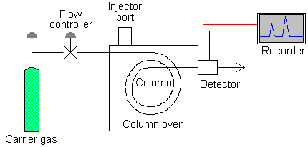
Figure 2.1: Schematic diagram of a typical gas chromatograph
Source: http://teaching.shu.ac.uk/hwb/chemistry/tutorials/chrom/gaschrm.htm.

2.7.2.1.1.1 Carrier gas
The analytes are carried by an inert carrier gas through the injection port, the column and the detector. The carrier gas is the mobile phase and is chosen for its inertness. Its purpose is to transport the analyte vapours through the chromatographic system without interaction with the sample components. The carrier gas is obtained from a high-pressure gas cylinder and should be high in purity as impurities such as oxygen and moisture affect column performance and detector response and may chemically attack the liquid stationary phase (Mendham et al., 2000). Problems encountered by oxygen entering the system include excessive column bleed caused by oxidation of the liquid phase, short column life, loss of sensitivity in electron-capture operation and loss of column retention from phase breakdown. Impurities are removed using gas purification traps placed between the gas cylinder and the instrument. The choice of a carrier gas depends on the type of column, cost and the detector type. Helium and nitrogen are the most common carrier gases but other auxiliary gases, such as air and hydrogen may be used in certain detectors.

2.7.2.1.1.2 Sample-injection system
The injection port provides an entry for the syringe and the sample into the carrier gas stream and also provides sufficient heat to vapourize the sample instantly without decomposition or fractionation. Samples can be introduced either by manual injection or by an auto sampler. Sample injection is most often accomplished with a micro syringe through a self-sealing silicon elastomer septum. For optimum performance the sample must be deposited on the column in the narrowest band width possible. The flash-vapourization chamber of the injection port should be as small as possible to preserve efficiency. Sufficient volume is required to accommodate the sudden vapourization and expansion of the sample after injection. For packed columns, a sample is introduced directly into the column or introduced into the heated region where it is vapourized by heating the column at a programmed rate. Capillary columns have a much lower sample capacity than packed columns. Several techniques, namely split, splitless, on-column and programmed-temperature vapourization are available for introducing samples into capillary columns. Split injection involves an inlet stream splitter incorporating a needle valve that enables most of the injected sample to be vented to the atmosphere whilst allowing only a small fraction to pass into the column. A disadvantage of split injection is that samples with components that vary widely in their boiling points tend to be split in differing proportions; relatively more of the lower boiling components entering the column than the high boiling ones. Split injection is not suitable when the highest sensitivity is required as most of the sample is vented to the atmosphere. Splitless injection avoids the problems and several variations of this technique are used. On-column injection allows very small liquid samples to be placed directly into the cooled top of the column which is then heated to volatilize the components. Automatic injectors, which eliminate variations due to the analyst and improving reproducibility are of value where large numbers of samples are to be analysed or unattended operation is required. Solid samples can be introduced as a solution or in a sealed glass ampoule which is crushed in the gas stream by means of a gas-tight plunger. Only solids which have appreciable vapour pressures at the operating temperature of the column can be successfully chromatographed. For the injection port, a general rule is to have the temperature at 50ºC higher than the boiling point of the sample. This temperature should be hot enough to vapourize the sample rapidly, but low enough not to thermally decompose the analytes. The control of column temperature within 0.5ºC is essential. Raising the column temperature speeds both the elution and the rate of approach to equilibrium between the mobile and stationary phases. Higher column temperature should be avoided since it causes column bleeding where the stationary phase itself can be vapourized and decomposed and the material is then passed along the column and eluted. The detector temperature depends on the type of detector used but the temperature from the column exit must be hot enough to prevent condensation of the sample and liquid phase (Zhang, 2007).

2.7.2.1.1.3 Gas-chromatographic columns
The column is the heart of the gas chromatograph. It consists of a coil of stainless steel, glass or fused silica tubing which may be 1 m to 100 m long and have an internal diameter of between 0.1 mm and 5 mm. To ensure operation under reproducible conditions, the column is enclosed in a thermostatically controlled oven whose temperature can be held constant to within ±0.1°C. Operating temperatures range from ambient to over 400°C and may remain constant during a separation or automatically increased at a predetermined rate to speed the elution process. The separation of the sample components takes place in packed or capillary columns through which the carrier gas flows continuously. The separation column, which contains the stationary phase, is placed immediately after the injection port and any attendant sample splitter. A packed column is typically a glass or stainless steel coil that is filled with the stationary phase, or a packing coated with the stationary phase. Packed columns do not have the very high resolving power of capillary columns but are cheaper, robust and have high sample capacities which allow the use of simpler injection systems (Mendham et al., 2000).
A capillary column is a thin fused-silica tube which has an open tubular structure without packing materials. They are coated by these three ways. The first type of capillary column, named ‘‘wall-coated open-tubular’’ (WCOT column), has a thin liquid film stationary phase coated on the walls of the capillary. The second type, ‘‘support coated open-tubular’’ (SCOT column), has micro particles attached to the wall of the capillary, which is in turn coated with the liquid stationary phase. The third type, ‘‘porous layer open-tubular’’ (PLOT column), has solid-phase micro particles attached to the capillary walls. Unlike WCOT or SCOT columns, the PLOT columns are used in adsorption-based gas–solid chromatography rather than partition-based gas–liquid chromatography. Because the open tubular structure has very low resistance to the gas flow, capillary columns can be made much longer, up to 100 m, than packed columns. Such long lengths permit very efficient separations of samples with a complex mixture. Therefore, capillary columns have become predominately used in most trace environmental analysis requiring gas chromatograph (Mendham et al., 2000).
The flexible, mechanically durable and chemically inert fused-silica capillaries offer many advantages over packed columns and are becoming the dominant type of column design. A highly efficient capillary column does not require as much selectivity toward sample components as a less efficient packed column to achieve the same resolution. Peaks are sharper. Sharper peaks provide better separation and also deliver the solutes to the detector at higher concentrations per unit time, thus enhancing sensitivity. Capillary column offers an increased speed of analysis. When packed-columns flow rates are used, the capillary column produces separation efficiencies that are equal to those of packed column but at about three times the speed. When the flow rate is optimized for the tubing diameter, the capillary column produces far superior efficiencies with analysis times approximately equal to those for packed columns. Although efficiency (plates per meter) is the same for both packed and capillary columns, capillary columns are open tubes. Therefore, they are more permeable and can be made much longer before the inlet pressure requirement becomes too large. Capillary columns with more than 100 000 plates are relatively common. Better peak shape and increased column stability are other advantages. Although capillary columns are much more expensive than packed columns, they are most widely used columns because of their superior resolving power for complex mixtures compared to that of packed columns.

2.7.2.1.1.4 Stationary phase
For any resolution to be achieved, the components of the sample must be retained by the stationary phase. The longer and more selective the retention, the better will be the resolution. In gas chromatography, the inert carrier gas plays no active role in solute selectivity, although it does affect resolution. Selectivity can be varied only by changing the polarity of the stationary phase or by changing the column temperature. The higher efficiency of capillary columns has reduced the necessity for a large number of selective liquids. A polar solid can be used as a stationary phase, the most common choices being silica gel and alumina. Activity is determined by the overall polarity and by the number of adsorption sites. The choice of stationary phase and its degree of activity is determined by the nature of the sample. If sample components are adsorbed too strongly, they may be difficult to elute or chemical changes may occur. Weakly polar solutes should be separated on highly active adsorbents otherwise they may elute rapidly with little or no resolution. Strongly polar solutes are better separated on adsorbents of low activity. A liquid stationary phase should be non-volatile and thermally stable at the operating temperature of the column otherwise it will bleed during operation and cause a drifting baseline on the recorder. In addition, it should be chemically stable and inert towards samples to ensure reliable results.
Stationary phases are described as non-polar or polar according to their structure and separating abilities. Non-polar types include hydrocarbon and silicone oils and greases. Polar types cover a wide range of polarity and include high molecular weight polyesters, ethers and amines. In general, the most suitable stationary phase for a given sample is that which is chemically similar to it. Since it is the stationary phase that has the greatest influence on the separations obtained and the key to good separation, choosing a good column with the right stationary phase becomes a critical step in developing a chromatographic method. In selecting a column from various stationary phases, a nonpolar column should be chosen for a nonpolar mixture and a polar column for a polar mixture. Using a less polar column will provide the best resolution for the most difficult separation, whereas a more polar column will be of benefit when difficult isomer separations are required (McNair and Miller, 1998).

2.7.2.1.1.5 Liquid phase
Bonded liquid phases are much superior to stationary phases. They can be cleaned by rinsing with strong solvents and baking at high temperatures. Column life can be extended, dirtier samples can be tolerated and sample cleanup can be reduced. Most analyses can be accomplished using columns with standard film thickness of 0.25 mm for 0.25 and 0.32 mm i.d. columns. For wide-bore columns the standard film thicknesses are 1 or 1.5 mm depending on the phase. Thin-film columns are used for high boiling solutes (petroleum waxes, glycerides and steroids) while thick-film columns are used for very volatile solutes (gases, light solvents and purgables). A persistent problem with liquid phases is their upper temperature limits. The maximum temperature is that above which the bleed rate will be excessive as a result of solvent vapourization. For the separation of high-boiling-point compounds, a polar phase should be used so that they can be eluted at a lower temperature. The eluting power of a solvent is determined by its overall polarity, the polarity of the stationary phase and the nature of the sample components. In practice, better separations are achieved with the least polar solvent possible and mixtures of solvents are often used to achieve optimum separation conditions. It is important that a given solvent should not contain impurities of a more polar nature, e.g. water or acids, alcohol in chloroform, aromatics in saturated hydrocarbons, as resolution may be impaired. Certain solvent-adsorbent combinations can be chemically unstable (McNair and Miller, 1998).

2.7.2.1.1.6 Temperature control
The column is either kept at a constant temperature or programmed during the run. The temperature should be monitored, adjusted and regulated at the injection port, in the oven surrounding the column and at the detector. The temperature of the injection port must be sufficiently high to vapourize the sample, yet not so high that thermal decomposition or molecular rearrangements occur. The column temperature need not exceed the boiling point of the sample in order to keep the analytes in their vapour phases. The column produces better separations if the temperature is below the sample’s boiling point but above its condensation point in order to increase the interaction with the stationary phase. The smaller the amount of the stationary phase, the lower the temperature at which the column can operate. Capillary columns are usually run at lower temperatures than packed columns. Selecting the column temperature for isothermal operation is a complex problem, and a compromise is usually the answer. A sample whose components have a wide range of boiling points cannot be satisfactorily chromatographed in a single isothermal run. A scouting run at a moderate column temperature may provide good resolution of the lower-boiling-point compounds but requires a lengthy period for the elution of high-boiling-point material. One solution is to raise the column temperature to a higher value at some point during the chromatogram so that the higher-boiling-point components will be eluted more rapidly and with narrower peaks. The better solution is to change the band migration rates during the course of separation by using temperature programming.
In temperature programming, the sample is injected into the chromatographic system when the column temperature is below that of the lowest-boiling-point component of the sample, preferably 90°C below. Then the column temperature is raised at some preselected heating rate. As a general rule, the retention time is halved for a 20 to 30°C increase in temperature. The final column temperature should be near the boiling point of the final solute but should not exceed the upper temperature limit of the stationary phase. Heating rates of 3 to 5°C per min should be tried initially and then fine-tuned to achieve optimum separation. The effect of column temperature on chromatographic retention is pronounced because there is an inverse exponential relation with the distribution coefficient, K_{D}. This results in a shortening of retention times as the temperature is increased.
Temperature programming, which is a form of gradient elution, exploits this relation. In practice, the oven temperature is progressively raised during a chromatographic run to improve the resolution of mixtures where the components have a wide range of boiling points and to shorten the overall analysis time by speeding up the elution of the higher boiling compounds. It is particularly useful for the separation of multi component mixtures on capillary columns. In such cases, it is very likely that no isothermal conditions will be entirely satisfactory for separating and detecting all components. If the isothermal temperature is too high, early eluting peaks may not be fully resolved as these solutes will elute quickly. If the isothermal temperature is too low, later eluting peaks may have unacceptably long retention times, and detection limits will be poor because of excessive peak-broadening. Peak shape may also be adversely affected. Intermediate isothermal temperatures may result in part of the chromatogram having acceptable resolution and detection limits while other parts do not. For mixtures where the individual components are not members of a homologous series, temperature programmes are often more complex. They may involve initial, intermediate and final isothermal periods separated by temperature ramps of varying rates, usually between 2 and 30°C per minute. The optimum conditions for a particular sample are generally established by trial and error. Two potential disadvantages of temperature programming are the inevitable delay between consecutive chromatographic runs while the oven is cooled down and a stable starting temperature re-established, and the possible decomposition of thermally-labile compounds at the higher temperatures (Mendham et al., 2000).

2.7.2.1.1.7 Detectors
A chromatographic detector is a device that is able to recover chemical information from the column effluent and convert it to a measurable form of signal. Coupled with a data-acquisition system, such a signal may need further amplification before a chromatogram can be generated. The process of converting chemical signals to electrical signals and then generating a chromatogram is much more complicated than the separation process. It is estimated that more than 60 types of GC detectors have been developed. For most environmental applications, only a few are commonly used, including thermal conductivity detector (TCD), flame ionization detector (FID), and electron capture detector (ECD) (Mendham et al., 2000). After separation in the column, the sample components enter a detector. The detector measures the quantity of the analytes and generates an electrical signal in the form of a chromatogram (signal vs. run time).
The purpose of a detector is to monitor the carrier gas as it emerges from the column and respond to changes in its composition as solutes are eluted. The response of most detectors is proportional to the concentration or mass flow rate of the eluted component (Popek, 2003). They depend on changes in some physical property of the gas stream such as thermal conductivity, density, flame ionization, electrolytic conductivity, x-ray ionization, in the presence of a sample component. The signal from the detector is fed to a chart recorder or computing integrator via suitable electronic amplifying circuitry where the data are presented in the form of an elution profile. A detector should have the following characteristics: high sensitivity, low noise level, linear response over a wide dynamic range, good response for all organic component classes, insensitivity to flow variations and temperature changes, stability of operations and ruggedness, simplicity of operation and positive compound identification.

2.7.2.1.1.7.1 Electron capture detector (ECD)
The electron-capture detector (ECD) responds only to electrophilic species such as halogenated, nitrogenated and oxygenated compounds. The ECD is a selective electrode that is capable of providing extremely sensitive responses to specific sought-for substances that might be present in a sample. It consists of two electrodes. On the surface of one electrode is a radioisotope (usually nickel-63) that emits high-energy electrons as it decays. The high-energy electrons bombard the carrier gas to produce a plasma of positive ions, radicals and thermal electrons. A potential difference applied between the two electrodes allows the collection of the thermal electrons. The baseline signal results when only the carrier gas is flowing through the detector. When an electron-absorbing compound is swept through the detector, there is a decrease in the detector current, that is, a negative excursion of the current relative to the baseline as the effluent peak is traced. The potential is applied as a sequence of narrow pulses with a duration and amplitude sufficient to collect the very mobile electrons but not the heavier, slower negative ions. The ⁶³Ni sources can be safely heated up to 400°C with no loss of activity (Popek, 2003).
Residual oxygen and water must be rigorously removed from the carrier gas and makeup gases. ECD has detectability of the order of 1 × 10⁻¹³ g and good specificity. Trace residues of chlorinated pesticides, herbicides and polychlorinated hydrocarbons can be measured by ECD with very high sensitivity. The detector is very sensitive to compounds containing halogens and sulphur, anhydrides, peroxides, conjugated carbonyls, nitrites, nitrates and organometallics but is insensitive to hydrocarbons, alcohols, ketones and amines. Steroids, biological amines, amino acids, and various drug metabolites can be converted to perfluoro derivatives, which could give a signal with this detector. ECD is sensitive to temperature changes. The carrier gas must be exceptionally pure because oxygen, air and water at levels exceeding 10 ppm affect performance. Halogenated solvents should be avoided in sample preparation as residual traces can deactivate the detector. Linearity varies with conditions and analytes, and quite often the ECD has a limited dynamic range because the response is nonlinear unless the potential across the detector is pulsed (Mendham et al., 2000; Popek, 2003).

2.7.2.1.1.7.2 Flame-ionization detector (FID)
The flame-ionization detector (FID) is the most popular detector because of its high sensitivity, wide linear dynamic range, low dead volume and responsiveness to trace levels of most organic compounds. Ionization detectors depend on the principle that the electrical conductivity of a gas is directly proportional to the concentration of charged particles within it. Effluent gas from the column passes between two electrodes across which a direct current is applied. An ionizing source partially ionizes the carrier gas allowing a steady current to flow between the electrodes and through a resistor where a corresponding voltage drop is amplified and fed to a recorder. When a sample component is eluted from the column, it is also ionized in the electrode gap thereby increasing the conductivity and producing a response in the recorder circuit. The detector’s insensitivity to moisture and to most of the gases is advantageous in the analysis of moist organic samples and in air-pollution studies. In FID, three gases are needed: H₂ and air as the auxiliary gases for the flame and He used as a carrier gas (Popek, 2003). The H₂-air flame is used to burn organic compounds that undergo a series of ionization reactions such as thermal fragmentation, chemi-ionization, ion molecule and free radical reactions. Because the flame ionization detector responds to the number of carbon atoms entering the detector per unit of time, it is a mass-sensitive, rather than a concentration-sensitive device. As a consequence, this detector has the advantage that changes in flow rate of the mobile phase have little effects on detector response. The FID is a universal detector and can be used for most organics with good sensitivity and linearity (Mendham et al., 2000).

2.7.2.1.1.7.3 Thermal conductivity detector (TCD)
The thermal conductivity detector (TCD) is the most common universal detector used in gas chromatography. It is versatile but less sensitive than most GC detectors. Its response has a limited linear range and is sensitive to changes in temperature and flow rate; hence it is not particularly suitable for quantitative work. This detector is based on the principle that a hot body loses heat at a rate which depends on the thermal conductivity and therefore the composition of the surrounding gas. It measures the difference in the thermal conductivity between the pure carrier gas and the carrier gas plus components in the gas stream from the separation column. It uses a heated filament (rhenium–tungsten) placed in the emerging gas stream. The amount of heat lost from the filament by conduction to the detector walls depends on the thermal conductivity of the gas. When substances are mixed with the carrier gas, its thermal conductivity goes down thus the filament retains more heat, its temperature rises and its electrical resistance goes up. Monitoring the resistance of the filament with a Wheatstone bridge circuit provides a means of detecting the presence of the sample components. The signals, which are fed to a chart recorder, appear as peaks on the chart, which provides a visual representation of the process. Of all the detectors, only the thermal conductivity detector responds to anything mixed with the carrier gas. Being nondestructive, the effluent may be passed through a thermal conductivity detector and then into a second detector or a fraction collector in preparative gas chromatography. The linearity of the detector is good at the lower concentration range but not in the high percent range. Oxygen is the most detrimental carrier-gas impurity. Also, oxide formation on the hot-wire surface minimizes the detector’s ability to sense changes in thermal conductivity and thus decrease its sensitivity (Mendham et al., 2000).

2.7.2.1.1.7.4 Thermionic ionization detector (TID)
The thermionic ionization detector (TID), also called nitrogen-phosphorous detector (NPD), responds only to compounds that contain nitrogen or phosphorus. Its fabrication is similar to flame-ionization detector hence it is usually designed to mount on an existing FID-type detector base. The thermionic source has the shape of a bead or cylinder centered above the flame tip. This bead is composed of an alkali-metal compound impregnated in a glass or ceramic matrix. The body of the source is molded over an electrical heating wire. A typical operating temperature is between 600 and 800°C. A fuel-poor hydrogen flame is used to suppress the normal flame-ionization response of compounds that do not contain nitrogen or phosphorus. With a very small hydrogen flow, the detector responds to both nitrogen and phosphorus compounds. Enlarging the flame size and changing the polarity between the jet and collector limit the response to only phosphorus compounds. Located in proximity to the ionization source is an ion-collector electrode that is usually cylindrical. The thermionic source is also polarized at a voltage that causes ions formed at the source to move toward the ion collector. Compared with the flame-ionization detector, the thermionic emission detector is about 50 times more sensitive for nitrogen and about 500 times more sensitive for phosphorus (Mendham et al., 2000).

2.7.2.1.1.7.5 Flame photometric detector (FPD)
In the flame photometric detector (FPD), the column effluent passes into a hydrogen-enriched, low-temperature flame contained within a shield. Both air and hydrogen are supplied as makeup gases to the carrier gas. Two flames are used to separate the region of sample decomposition from the region of emission. Flame blowout is not a problem because the lower flame quickly reignites the upper flame. Phosphorus compounds emit green band emissions at 510 and 526 nm. Sulphur compounds emit a series of bands from excited diatomic sulphur. Phosphorus and sulphur can be detected simultaneously by attaching a photomultiplier tube and an interference filter for sulphur on one side of the flame and a photomultiplier tube with an interference filter for phosphorus on the opposite side of the flame (Popek, 2003). The detector response to phosphorus is linear whereas the response to sulphur depends on the square of its concentration. Carbon (IV) oxide and organic impurities in the makeup and carrier gases must be less than 10 ppm. The quenching effect of carbon (IV) oxide is very significant. The FPD has found application for the determination of pesticide residues containing sulphur and phosphorus.

2.7.2.1.1.7.6 Photo ionization detector (PID)
The photo ionization detector (PID) is a concentration sensitive detector with a response that varies inversely with the flow rate of the carrier gas. A typical PID has two functional parts: an excitation source and an ionization chamber. The excitation source may be a discharge lamp excited by a direct current (1 to 2 kV), a radio frequency (75 to 125 kHz), a microwave (2450 MHz), or a laser. A discharge lamp passes ultraviolet radiation through the column effluent from one of several lamps with energies ranging from 8.3 to 11.7 eV. Photons in this energy range are energetic enough to ionize most organic species but not the permanent gases. A potential of 100 to 200 V is applied to the accelerating electrode to push the ions formed by UV ionization to the collection electrode at which the current is measured. PID is similar to FID, as both results in the ionization of the analyte. However, PID uses UV light as the energy source to ionize. It does not require support gases hence it is ideal for portable instruments. For detection of purgeable aromatics, PID is about 35 times more sensitive than FID. It is also non-destructive hence it can be used in series with other detectors (Mendham et al., 2000).

2.7.2.1.1.7.7 Electrolytic conductivity detector (EICD)
In the electrolytic conductivity detector, also called the Hall conductivity detector, organic compounds in the effluent are first converted to carbon (IV) oxide by passing the column eluate through a high-temperature reactor in which the hetero atoms of interest (sulphur and nitrogen-containing compounds) are converted to small inorganic molecules. The reaction-product stream is then directed into a flow-through electrolytic conductivity cell. Changes in electrolytic conductivity are measured. Ionic material is removed from the system by water that is continuously circulated through an ion-exchange column. The combustion products may be mixed with hydrogen gas and hydrogenated over a nickel catalyst in a quartz-tube furnace. Ammonia is formed from organic nitrogen, HCl from organic chlorides, and H₂S from sulphur compounds (Popek, 2003). For detecting halogen compounds, a nickel reaction tube, hydrogen reaction gas, a reactor temperature of 850 to 1000°C and 1-propanol are used. Under these conditions, compounds containing chlorine are converted to HCl, methane and water. The HCl dissolves in 1-propanol and change its electrolytic conductivity whereas the non halogen products do not dissolve in the alcohol and do not change their conductivity to any significant degree. In the detection of sulphur compounds, the compound must be converted to SO₂, which is usually accomplished in the reaction tube heated between 950 and 1000°C. Collection of SO₂ in methanol containing a small amount of water converts the SO₂ into ionic species. Although water is a satisfactory solvent for the sulphur or halogen modes, water containing 10% to 20% organic solvent (tertbutyl alcohol) is preferred for the nitrogen mode. The ElCD detector finds use in analysis of pesticides, herbicides, alkaloids and pharmaceuticals. When compared to other selective detectors electrolytic conductivity detector chromatograms are much cleaner.

2.7.2.1.1.7.8 Chemiluminescence–redox detector
This detector is based on specific redox reactions coupled with chemiluminescence measurement. An attractive feature of this detector is that it responds to compounds such as ammonia, hydrogen sulphide, carbon disulphide, sulphur dioxide, hydrogen peroxide, hydrogen, carbon monoxide, sulpides and thiols that are not sensitively detected by flame-ionization detector. Moreover, compounds that typically constitute a large portion of the matrix of many environmental and industrial samples are not detected, thus simplifying matrix effects and sample cleanup procedures for some applications (Popek, 2003).

2.7.2.1.1.8 Use of chromatogram for gas chromatographic analyses
A chromatogram is the instrumental output of all chromatographic analyses. It is a plot of detector signal vs. time after sample introduction, that is, the time from sample injection to the time when the detector responds to the compound. Chromatograms are the same regardless of the chromatographic method employed. They vary only with the types of signals. The mobile-phase holdup time is the time required for an average molecule of the mobile phase to pass through the column. The time required by the mobile phase to convey a solute from the point of injection onto the stationary phase to the detector is defined as the retention time. The retention volume is the retention time multiplied by the volumetric flowrate. The peak of an unretained compound may be due to the response to air or methanol. In a chromatogram the peaks broaden as the time increases. This is due to the random diffusion processes in the column. Various molecules of the same compound elute from the column at slightly varied times. Another feature of a typical chromatogram is the symmetrical nature of all eluting peaks. The symmetry can be mathematically described by the normal (Gaussian) distribution. All peaks in an ideal chromatogram should be narrow, symmetrical, well-spaced (one compound per peak) but not too far apart from one another for a short run time (Mendham et al., 2000; Popek, 2003).

2.7.2.1.1.8.1 Qualitative analysis
Qualitative information on all chromatographic techniques can be obtained by comparing the retention time of an analyte to that of a pure standard. Further confirmative identification of the compounds can be obtained by other techniques such as GC-MS and nuclear magnetic resonance (NMR). Although chromatograms may not lead to positive identifications of chemical species, they can provide evidence of the absence of certain compounds. That is, if the sample does not produce the peak with the same retention time as the standard, then it can be assumed that the chemical species in question is not present at the given detection limit.

2.7.2.1.1.8.2 Quantitative analysis
Gas chromatography has become one of the most useful separation techniques because quantitative information can be readily obtained from it. Standardization of operating conditions is of prime importance and detector response factors must be known for each compound to be determined. Quantitative chromatographic analyses are achieved by determining instrumental signals from the chromatograms. Signals are normally measured by peak area or by peak height, either one of which should be in direct proportion with the change in analyte concentrations. Peak areas are better because areas are independent of broadening effects. Peak heights could be affected by variations in column temperature, flow rate and sample injection rate. Peak heights are sensitive to small changes in operating conditions and sample injection. Measurement of peak area is accomplished by one of the following methods (Mendham et al., 2000).

2.7.2.1.1.8.2.1 Geometric methods
Since normal peaks have a Gaussian profile, which approximates to an isosceles triangle, their area can be estimated by multiplying the height by the width at half height or by calculating the area of a triangle formed by the baseline and the sides of the peak produced to intersect above the maximum, that is base x height. The methods are simple and rapid but are unreliable if peaks are narrow or asymmetrical. Precision is only moderate (Mendham et al., 2000).

2.7.2.1.1.8.2.2 Automatic integration
Electronic integrators are the most rapid and precise means of determining peak areas. They have a digital output derived by feeding the detector signal into a voltage-to-frequency converter which produces a pulse rate proportional to the input signal. The total number of pulses is a measure of the peak area and this can be printed out directly or stored until required. Electronic integrators have a wide linear range, a high count rate and may automatically correct for baseline drift. In addition, the more expensive versions print retention data alongside peak areas. Computing integrators, based on a microcomputer, are now widely available. Chromatographic detectors that respond to the concentration of the solute yield a signal that is proportional to the solute concentration that passes through the detector. For these detectors the peak area is proportional to the mass of the component and inversely proportional to the flowrate of the mobile phase. Thus, the flowrate must be kept constant if quantitation is to be performed (Mendham et al., 2000).

2.7.2.1.1.8.2.3 Evaluation methods
Once the peak areas or peak heights have been measured, there are four principal evaluation methods that can be used to translate these measurements to concentrations of solute.

2.7.2.1.1.8.2.3.1 Calibration by standards
Calibration curves for each component are prepared from pure standards, using identical injection volumes and operating conditions for standards and samples. The concentration of the solute is read from its calibration curve. In this evaluation method only the area of the peaks of interest need be measured. However, the method is very operator-dependent and requires good laboratory technique. Relative response factors must be considered when converting area to volume and when the response of a given detector differs for each molecular type of compound (Mendham et al., 2000).

2.7.2.1.1.8.2.3.2 Area normalization
For this method to be applicable, the entire sample must have eluted, all components must be separated and each peak must be completely resolved. The area under each peak is measured and corrected by a response factor. All the peak areas are added together. The percentage of individual component is obtained by multiplying each individual calculated area by 100 and then dividing by the total calculated area. Results would be invalidated if a sample component were not chromatographed on the column or failed to give a signal with the detector.

2.7.2.1.1.8.2.3.3 Internal standard
In this technique a known quantity of the internal standard is chromatographed and area versus concentration is ascertained. Then a known quantity of the internal standard is added to the raw sample prior to any sample pretreatment. The peak area of the standard in the sample run is compared with the peak area when the standard is run separately. This ratio serves as a correction factor for variation in sample size, for losses in any preliminary pretreatment operations or for incomplete elution of the sample. The material selected as the internal standard must be completely resolved from adjacent sample components, must not interfere with the sample components and must never be present in samples. The advantages of internal standardization are that the quantities of sample injected need not be measured accurately and the detector response need not be known, as neither affects the area ratios (Mendham et al., 2000).

2.7.2.1.1.8.2.3.4 Standard addition
If only a few samples are to be chromatographed, it is possible to employ the method of standard addition. The chromatogram of the unknown is recorded. Then a known amount of the analyte is added and the chromatogram is repeated using the same reagents, instrument parameters and procedures. From the increase in the peak area or peak height, the original concentration can be computed by interpolation. The detector response must be a linear function of analyte concentration and yield no signal (other than background) at zero concentration of the analyte. Sufficient time must elapse between addition of the standard and actual analysis to allow equilibrium of added standard with any matrix interferant. A correction for dilution must be made if the amount of standard added changes the total sample volume significantly. It is always advisable to check the result by adding at least one other standard. Additions of analyte equal to twice and to one-half the amount of analyte present in the original sample are optimum statistically. Standard addition is particularly useful in the analysis of complex mixtures where it may be difficult to find a suitable internal standard which can be adequately resolved from the sample components (Mendham et al., 2000).

2.7.3 Applications of chromatography
Since the first gas chromatography instrument became commercially available in 1955, chromatographic techniques have evolved to become the premier technique for the separation and analysis of complicated organic mixtures. In many laboratories performing petroleum analyses, clinical analyses, forensic testing and environmental monitoring, chromatographic instruments are used. Chromatographic techniques are used by many environmental professionals who are involved in research as well as monitoring for regulatory compliance. The GC gives fast analysis, ease of operation, sensitivity and higher resolution, a variety of columns and detectors, providing analytical flexibility and readily interfaced to a mass spectrometer for structural confirmation. The GC technique is rapid, simple and can cope with very complex mixtures and very small samples. It is useful for qualitative and quantitative analysis (Mendham et al., 2000).

CHAPTER THREE
3.0 MATERIALS AND METHODS
3.1 Study area
The study area for this investigation is the Lagos Lagoon, which lies between latitude 6º 26' - 6º 37' N and longitude 3º 23' - 4º 20' E in the western part of Nigeria. The map of the lagoon is shown in Fig 3.1. The lagoon consists of three main segments namely Lagos Harbour, Metropolitan End and Epe Division. It empties into the Atlantic Ocean via Lagos Harbour and is drained by Ogun, Agboyi, Majidun and Aye Rivers. The lagoon is shallow, with an average depth of about 1.5 m. Its brackish nature is a consequence of the influence of tidal sea water incursion and freshwater discharge from the adjoining rivers and creeks. Lagos Lagoon impacts the lives of many people and provides accommodation for the Ilajes and Ijaws. It is a recreational outlet, a means of livelihood and transport, a dumpsite for residential and industrial discharges and a natural shock absorber to balance forces within the natural ecological system. Other human activities associated with the lagoon are fishing, aquaculture and sand mining. The fauna is composed of fresh, marine and brackish water species, depending on the season. Among the fauna exploited for commercial purposes are shrimps, crabs, crayfishes and finfishes.

3.2 Sampling strategy
Sampling was conducted between December 2008 and September 2009 during the dry and wet seasons to study the effects of seasonal variations on the samples. Field investigations were carried out four (4) times at the designated sites during the dry season months of December 2008 and February 2009 and the wet season months of May and September 2009. The five sampling sites were Agboyi Creek (AGR), Oworonshoki (OWS), Ajara (AJR), Ogogoro (OGG) and Tarkwa Bay (TBY). The Agboyi Creek is one of the water bodies that drain the Lagos Lagoon and was used as the control site in this study. The other sampling sites are locations within the lagoon and were chosen because major fishing activities are carried out there. At Agboyi Creek, samples were collected at the zone where it empties into the lagoon while at Tarkwa Bay sampling was carried out where the lagoon discharges into the Atlantic Ocean. Sampling locations were identified with a hand-held Garmin-GPSMAP 76S-type global positioning system.
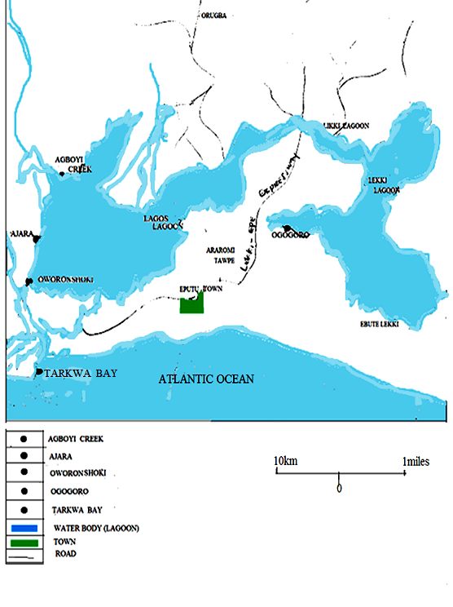
Figure 3.1: Map of Lagos Lagoon and surrounding areas showing the sampling points
Source: Author’s field survey (http://maps.google.ca/maps)

3.2.1 Pretreatment of sampling and storage vessels
Prior to sampling, sample bottles and glasswares were washed with detergent, rinsed with distilled water and pure acetone (99.9%) and then dried in an oven overnight at 100⁰C. Glass containers were used in collecting water samples for organochlorine pesticide determination while polythene bottles were used in sampling water for physicochemical analyses. Analar grade chemical reagents and materials were used in the study.

3.2.2 Collection of water samples
The microlayer water was collected with clean glass and polythene bottles from a depth of 1 cm while the mixed layer water was sampled with a 5 L Goflon water sampler with the aid of a boat. The containers were rinsed three times with the site water prior to collection. Water samples were collected in three labelled amber glass bottles to form composite samples at each of the five sites with the following coordinates: Agboyi Creek (31 N 0545254, UTM 0726974), Oworonshoki (31 N 05450361, UTM 0725474), Ajara (31 N 0545098, UTM 0727826), Ogogoro (31 N 0543330, UTM 0710845) and Tarkwa Bay (31 N 0543889, UTM 0707582). Filled sample bottles were sealed free of air bubbles with glass stoppers. Water samples were similarly collected in three labelled white polythene bottles to form composite samples at each of the sites for in situ determination of physicochemical parameters. A total of twenty microlayer and twenty mixed layer composite water samples were collected for OCP determination and twenty microlayer and twenty mixed layer composite water samples were similarly collected for physicochemical analysis. After collection, samples were properly covered and stored in ice-packed coolers. The water samples were refrigerated in the laboratory at 4ºC to inactivate microbes and thus preserve the integrity of the samples (Radojevic and Bashkin, 1999).

3.2.3 Collection of sediment samples
Epipellic (intertidal) sediments were obtained by using a short core sampler to scoop the top 1 to 5 cm of the sediments at five sites with the following coordinates: Agboyi Creek (31 N 0545069, UTM 0727598), Oworonshoki (31 N 0545159, UTM 0725638), Ajara (31 N 0545136, UTM 0727884), Ogogoro (31 N 0543288, UTM 0710820) and Tarkwa Bay (31 N 0543893, UTM 0707630). Benthic (subtidal) sediment samples were obtained at Agboyi Creek (31 N 0545254, UTM 0726974), Oworonshoki (31 N 05450361, UTM 0725474), Ajara (31 N 0545098, UTM 0727826), Ogogoro (31 N 0543330, UTM 0710845) and Tarkwa Bay (31 N 0543889, UTM 0707582) with the aid of a Shipek grab sampler. Benthic sediments were collected by lowering the grab sampler into the water bed and raising it aboard after a few minutes. Three grap sediment samples were collected at each site and mixed together to form composite samples and subsequently wrapped in labelled aluminium foil. A total of twenty epipellic and twenty benthic composite sediments were collected for OCP determination. After collection, the sediment samples were stored in ice-packed coolers to preserve the integrity of the samples. Sediment samples were refrigerated in the laboratory at 4ºC to inactivate microbes. Pebbles, shells and vegetable matter were manually removed.

3.2.4 Collection of fish samples
Shellfishes and finfishes were harvested with the assistance of fishermen at the Lagos Harbour and Agboyi Creek in order to analyse them for OCP residues. Freshly harvested shellfishes - crab (Ocypoda africanus), shrimp (Penaeus notialis) and crayfish (Procambarus clarkii) - were collected from each harvesting area using nets. Male and female finfishes at different trophic levels were harvested with the aid of fishing nets. The carnivorous fishes sampled were tilapia (Tilapia guineensis) and African Moony (Psettias sebae) while the herbivorous fishes were bonga fish (Ethmalosa fimbriata) and tilapia (Sarothorodon melanotheron). Omnivores that were sampled were catfish (Chrysichthys nigrodigitatus) and mullet (Liza grandisquamis). Other fish samples collected were grouper (Epinephelus aeneus), barracuda (Sphyraena guachancho), croaker (Pseudotolithus senegalensis), croaker (Pseudotolithus typus), tongue sole (Cynoglossus canariensis), snapper (Lutjanus goreensis), herring (Sardinella maderensis), Jack fish (Caranx hippos) and oarfish (Regalecus glesne). All the fish samples were properly labelled. The harvested fish samples were separately wrapped in aluminium foil, stored in ice-packed coolers and transferred to the laboratory where they were frozen, thawed, cleaned in distilled water and the scales of the finfishes sloughed off. The fishes were identified and collected with the assistance of staff of the Department of Marine Sciences, University of Lagos and the Nigerian Institute for Oceanography and Marine Research (NIOMR), Lagos. Tables 3.1 and 3.2 show the number of finfishes and shellfishes sampled.
Table 3.1: Sampled finfishes for the determination of OCP residues
Common Name Biological Name Local Name Feeding No Collected No of No of
(Yoruba) Mode AGR LAG Males Females
1. Tilapia Tilapia guineensis Epiya Carnivorous 12 12 12 12
2. Tilapia Sarothorodon melanotheron Epiya Herbivorous 12 12 12 12
3. African Moony Psettias sebae Owere Carnivorous - 12 6 6
4. Bonga fish Ethmalosa fimbriata Agbodo Herbivorous - 12 6 6
5. Catfish Chrysichthys nigrodigitatus Obokun Omnivorous 12 12 12 12
6. Mullet Liza grandisquamis Atoko Omnivorous 12 12 12 12
7. Grouper Epinephelus aeneus Oko Carnivorous - 6 - 6
8. Barracuda Sphyraena guachancho Kuta Carnivorous 6 6 - 12
9. Croaker Pseudotolithus senegalensis Apo Carnivorous - 12 6 6
10. Croaker Pseudotolithus typus Apo Carnivorous - 12 6 6
11. Tongue sole Cynoglossus canariensis Abo Carnivorous - 6 6 -
12. Snapper Lutjanus goreensis Igbakere Herbivorous - 6 - 6
13. Herring Sardinella maderensis Efolo/Sawa Carnivorous - 12 6 6
14. Jack fish Caranx hippos Agasa Carnivorous 6 6 6 6
15. Oarfish Regalecus glesne Ojei Carnivorous - 6 - 6
Total 60 144 90 114

Table 3.2: Sampled shellfishes for the determination of OCP residues
Common Name Biological Name Local Name Feeding No Collected No of No of
(Yoruba) Mode AGR LAG Males Females
1. Crab Ocypoda africanus Akan Omnivorous 12 12 12 12
2. Shrimp Penaeus notialis Ede Omnivorous - 12 6 6
3. Crayfish Procambarus clarkii Ede Omnivorous 12 12 12 12

Total 24 36 30 30
AGR = Agboyi Creek; LAG = Lagos Lagoon
3.3 Determination of physicochemical properties of water
Temperature, pH, conductivity, salinity and turbidity were measured in situ using appropriate portable equipment.

3.3.1 Colour
The colour of the water samples was noted by physical observation.

3.3.2 Odour
The odours were subjectively perceived.

3.3.3 Temperature
A HANNA HI 145 thermometer was used to determine the temperature of the water samples.

3.3.4 pH
A Jenway 350 portable pH meter was used to determine the pH of the water. Buffer capsules of pH 4 and 9 manufactured by Fluka were used for the calibration. The pH meter was standardized with the diluted buffer capsules before use. The probe of the pH meter was dipped into the sample containers and allowed to steady before readings were taken.

3.3.5 Conductivity
A HANNA HI 9835 conductivity meter was used to determine the conductivity of the water samples. The conductivity meter was calibrated with KCl solution. Selectable calibration points used to calibrate the equipment were 0.0, 0.084 mS/cm, 1.413 mS/cm, 5.00 mS/cm 12.88 mS/cm, 80.0 mS/cm, 111.8 mS/cm in the conductivity calibration range.

3.3.6 Total dissolved solids (TDS)
The HANNA HI 9835 conductivity meter, which also has a compartment for the determination of dissolved solids, was used to determine the total dissolved solids in the water samples. TDS reading is automatically derived from the conductivity reading and no specific calibration was needed for TDS.
3.3.7 Salinity
The HANNA HI 9835 conductivity meter, which also has a compartment for the determination of salinity, was used to determine the salinity (% NaCl) of the water samples.

3.3.8 Turbidity
The HANNA HI 98703 turbidimeter was used to determine the turbidity of the water samples. The equipment was calibrated with four commercially prepared turbidity standards at 0, 15, 100 and 750 NTU while silicon oil was used to clean the cuvette before use.

3.4 Evaluation of sediment particle sizes
The hydrometer method was used to evaluate the particle sizes of the sediments. 50 g of the air dried sediment was ground and introduced into a plastic beaker. 400 cm³ deionized water and 100 cm³ sodium hexametaphosphate solution were added to the beaker. The mixture was agitated with a stir-rod and emptied into a blender where it was blended for about 30 seconds until the sediment could not be physically broken apart any further. The contents of the blender were poured into a 1000 cm³ graduated cylinder and deionized water was added to the graduated cylinder up to the 1000 cm³ mark. The opening of the graduated cylinder was completely covered and inverted a few times to fully suspend the sediment particles. A bouyoucos hydrometer was gently added to the sediment suspension and reading taken 40 seconds after the cylinder inversions ended. The hydrometer was removed and cleaned. The temperature of the suspension was recorded and the hydrometer reading was corrected. The introduction of the bouyoucos hydrometer was repeated two hours later. The proportion of sand, silt and clay was determined by simple proportion from the hydrometer readings and the original mass of the sediments. The sediments were separated into the following sizes: % sand (0.20 -2.00 mm), % silt (0.02-0.20 mm) and % clay (<0.02 mm) (Brady and Weil, 2007).

3.5 Characterization of fishes
3.5.1 Determination of sex
The fish samples were separated into males and females by examining their gonads.

3.5.2 Measurement of length
The carapace lengths (cm) of the shellfishes were measured using a ruler. The total and standard lengths of the finfishes were also measured.

3.5.3 Evaluation of percentage (%) dry matter
The frozen fish samples were thawed and cleaned in distilled water before the evaluation of percentage dry matter. 1.0 - 2.0 g of muscle tissue of each of the fresh fish samples was weighed and dried in an oven maintained at 105⁰C for 8 hours. The dried fish samples were cooled in a desiccator and weighed in an analytical balance to constant weight. The percentage dry matter was calculated as follows:
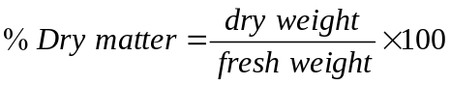

3.5.4 Calculation of condition factor (CF)
The condition factor (CF) which describes the physiological condition of the fishes (Voight, 2003) was calculated according to the equation (Busacker et al., 1990):
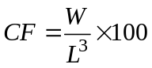
where,  = the fish wet weight (g)
= the fish total length (cm)

3.5.5 Determination of fat content
10 g of fish muscle tissue was homogenized with 10 g of anhydrous Na₂SO₄ using a mortar and pestle. Cold solvent extraction was carried out using 50 cm³ petroleum ether/acetone (1:1 v/v) mixture in a reagent bottle. The mixture was well shaken and the stopper removed continuously to release the gas built up in the bottle. The mixture was allowed to stand for 30 minutes and then filtered. After evaporating the solvent extracts with the aid of a rotary evaporator, the fat content of the muscle tissue was determined gravimetrically:
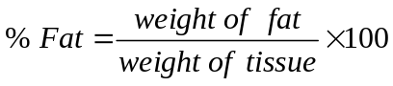
3.6 Treatment of samples for determination of OCP
3.6.1 Extraction of water samples for determination of OCP
Water samples were subjected to liquid-liquid extraction. 200 cm³ aliquot of water sample was introduced into a 300 cm³ capacity separating funnel and 30 cm³ of HPLC grade of dichloromethane was added. The mixture was well shaken and the stopper removed continuously to release the gas built up in the bottle. The solvent extract was carefully drained into a glass container. The extraction process was repeated with 20 cm³ dichloromethane and the solvent extract was again drained out and combined with the first portion (US EPA Method 3510C, 2007).

3.6.2 Extraction of sediment samples for determination of OCP
5 g of wet sediment was homogenized with 5 g of anhydrous granulated Na₂SO₄ using a mortar and a pestle. Cold solvent extraction (Steinwandter, 1992) was carried out using 50 cm³ HPLC grade petroleum ether/acetone (1:1 v/v) mixture in a 250 cm³ reagent bottle containing the homogenized sediment sample. The mixture was well shaken and the stopper removed continuously to release the gas built up in the reagent bottle. The mixture was allowed to stand for 30 minutes and then filtered with a filter paper into a glass container (US EPA Method 3570C, 2002).

3.6.3 Extraction of fish samples for determination of OCP
Muscle tissue was dissected with a dissecting set between the pectoral fin and vent of each fish. The muscle tissues of the finfishes and shellfishes were extracted. The separated organs of the finfishes such as livers, gills, kidneys and intestines were also extracted. 10 g of fish sample was homogenized with 10 g of anhydrous granulated Na₂SO₄ using a mortar and a pestle. Cold solvent extraction was performed. 50 cm³ of the petroleum ether/acetone (1:1 v/v) mixture was introduced into a 250 cm³ reagent bottle containing the homogenized fish sample. The mixture was shaken and the stopper removed intermittently to release the gas built up in the bottle. The mixture was allowed to stand for 30 minutes and then filtered into a glass container using a filter paper (US EPA Method 3570C, 2002).

3.6.4 Pre-concentration of extracts
The solvent extracts were concentrated to 1 cm³ using a rotary evaporator and kept for clean-up procedure.

3.6.5 Clean-up of extracts
Column chromatography was employed to clean-up the extracts (US EPA method 3630B, 1996). The glass separating column (20 cm) was packed with activated silica gel (90% < 45 µm) and washed down with n-hexane to remove any dirt. The extracts were demoisturized over 1 g of anhydrous granulated Na₂SO₄ and separated into two eluted fractions using mixtures of dichloromethane, hexane and acetonitrile as eluting solvents. For the first fraction, 30 cm³ of a dichloromethane/hexane (20/80) mixture was used, while 30 cm³ of a dichloromethane/hexane/acetonitrile (50/49.5/0.5) mixture was used for the second fraction in order to ensure that the polar acetonitrile eluted any remaining residue. The fractions were combined, concentrated to 1 cm³ using a rotary evaporator and subsequently analysed.

3.7 Identification and determination of OCP residues by gas chromatography
A gas chromatograph equipped with an electron capture detector (GC-ECD) was used for the analysis of the OCP residues. The cleaned-up extracts were dried and re-dissolved in 1.0 cm³ of analar grade isooctane for injection into the gas chromatograph (Pandit et al., 2002). Blank runs were made for background correction and performance of the system. Organochlorine Pesticides II EPA Method 8081A {Mix AB # 3, cat. #32415 (ea.)} was employed for the analyses. The detection and determination of the residues were performed by injecting 1 µL of the 1.0 cm³ purified extract into the injection port of a gas chromatograph with a ⁶³Ni electron capture detector (GC-µECD Agilent Technology 7890A) equipped with the ChemStation software. The column consisted of a DB-5 fused silica capillary column (30 m length × 0.32 mm i.d. × 0.25 µm ﬁlm thickness). The column temperature was programmed from 50⁰C at a rate of 25⁰C/min to 100⁰C, held for 1 min, and then at a rate of 5⁰C/min to 300⁰C, held for 5 mins. The temperatures of the injector and detector were 250⁰C and 300⁰C, respectively. The injection was carried out on a splitless injector at 250⁰C and the purge activation time was 30 s. The carrier gas was helium while nitrogen gas was used for the makeup flow. The run time was 17 mins. The chromatographic conditions are given in Table 3.3. Identification of pesticide residues was accomplished using reference standards and relative retention time techniques, while the concentration of the residues was determined by comparing the peak heights of the samples with the corresponding peak heights of the reference standards of known concentrations. The stock solution of the OCP standards was purchased from Restek Corporation, USA. It contained 1000 ppm in n-hexane and was serially diluted to obtain the desired concentrations of 10, 20 and 40 ng/mL. All the extracts from water, sediment and fish samples were analysed for aldrin, dieldrin; endrin, DDT, heptachlor and their metabolites; HCH and endosulfan isomers; α, γ-chlordane and methoxychlor. The concentrations (ww) of the OCP residues were calculated directly by the gas chromatograph after inputing the weight of the samples. Blank corrections were effected.

Table 3.3: Operating conditions of the gas chromatograph
Detector Electron capture
Column DB-5 fused silica capillary column (30 m length
× 0.32 mm i.d. × 0.25 µm ﬁlm thickness).
HP – 5 5% Phenyl methyl siloxan
Carrier gas Helium (99.9992) flowing at 20 mL/min
Carrier gas pressure 10.744 psi
Make-up gas Nitrogen (99.9995%)
Injector temperature 250⁰C
Injection 1 µL Splitless
Detector temperature 300⁰C
Temperature programme Initial temp 50⁰C at a rate of 25⁰C/min to
100⁰C (held for 1 min), then at a rate of
5⁰C/min to 300⁰C

3.8 Quality assurance
Before analysis was performed, standards were run to check for the column performance, peak height, resolution and the detection limit. The correlation coefficients of calibration curves of OCPs were all higher than 0.998. The quality assurance measures included strict cleaning procedures, procedural blank, recovery of spiked standards and monitoring of detector response. The OCP standard was purchased from Restek Corporation, USA.

3.8.1 Recovery study
Recovery studies were undertaken to evaluate the efficiency of the extraction procedure used. The recovery of organochlorine pesticides was done in replicate and was determined by spiking the previously analysed samples with the pesticide standard at concentrations similar to those expected in the samples. The recovery values expressed in percentages were calculated from the chromatograms.
% Recovery = CS₂ - CS₁ x 100
CS
where, CS₁ = concentration of pesticide residues in the sample
CS₂ = concentration of pesticide residues in the spiked sample
CS = concentration of added pesticide

3.8.2 Determination of method detection limits (MDLs)
The method detection limit (MDL) of OCPs is defined as the minimum concentration of a substance that can be measured and reported with 99% confidence that the analyte concentration is greater than zero. A solution of the analyte that is 3 times the estimated detection was prepared. The method detection limit was determined according to the formula:
MDL = Student’s t value x the standard deviation of replicate measurements.

3.9 Determination of limit of detection (LOD)
The limit of detection (LOD) is the lowest quantity of a substance that can be distinguished from the absence of that substance (blank value) within a stated confidence limit. It is taken as the concentration of an analyte in a sample that gives rise to a peak with a signal-to-noise ratio (S/N) of 3. The limits of detection of the organochlorine pesticide residues were determined by replicate chromatographic runs (6 times) of the least concentration of the OCP standards (10 ng/mL) and then multiplying the standard deviation obtained by 3.

3.10 Determination of limit of quantification (LOQ)
The limit of quantification (LOQ) is the level above which quantitative results may be obtained with a specified degree of confidence. It is mathematically defined as being equal to 10 times the standard deviation of the results for a series of replicates used to determine the limit of detection. The limits of quantitation of the organochlorine pesticide residues were determined by replicate chromatographic runs (6 times) of the least concentration of the OCP standards (10 ng/mL) and then multiplying the standard deviation by 10.

3.11 Determination of bioconcentration factor (BCF) and biota-sediment accumulation

factor (BSAF)
BCF 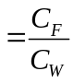
where, BCF = bioconcentration factor
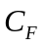 = the mean concentration of OCP residue in fish
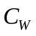 = the mean concentration of OCP residue in the water.
Biota-sediment accumulation factor (BSAF) = 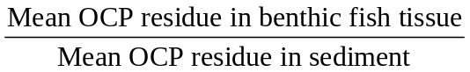

3.12 Estimation of daily intakes (EDI) of organochlorine pesticide residues by humans
The daily intake of OCP residues by humans was estimated based on questionnaires and interviews conducted in 100 families. The respondents were persons who eat the types of fishes harvested and were categorized into males and females. Information on preference of the fish species, age and weight of the respondents and frequency of consumption was collated in order to estimate the daily dietary intake of the fishes. The respondents were mainly adults and a few children who reside in Lagos. Their economic activities cut across fishing, farming, teaching, public service and business. The average per capita consumption was estimated and compared with the acceptable daily intake. The dietary intake of organochlorine pesticides was calculated by multiplying concentrations measured in the muscle tissues of each fish by the per capita consumption. The estimated daily intake of OCPs was calculated using the equation:
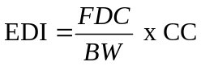 (IPCS, 2006)
where, 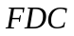 = fish daily consumption (g)
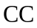 = contaminant concentration (ng/g)
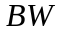 = body weight (kg)
EDI = Estimated daily intake of OCPs (ng/kg body weight/day).
US EPA recommends standard values for daily intake calculations. 70 kg is taken as average body weight, 6.5 g as daily fish consumption and 70 years as exposure for a lifetime.

3.13 Analyses of data
A total of 23 OCPs were detected and determined in the three matrices at various sample locations for both dry and wet seasons. Concentrations of OCP residues were calculated individually and as the sum of their isomeric forms. Description of data was performed using a Statgraphics Centurion XV statistical software, with the level of significance maintained at 95% for each test. The mean and standard deviation were calculated from the detectable values, and values below the detectable limit were considered not detected (ND). The mean was calculated from triplicate determinations. There were values that were “0” (i.e., non-detects). The results obtained were compared with FAO/WHO and USEPA standards.

Table 4.3: Comparative statistics of physicochemical properties of microlayer water in
Agboyi, Oworonshoki, Ajara, Ogogoro and Tarkwa Bay during the dry season
Parameter | Temperature  (⁰C) | pH | Conductivity (mS) | TDS  (mg/L) | Salinity  (%) | Turbidity  (NTU)
Average | 29.78 | 7.23 | 25.05 | 12236.00 | 48.24 | 7.56
Standard deviation | 1.60 | 0.46 | 27.17 | 13348.40 | 52.54 | 2.39
Coeff. of variation (%) | 5.39 | 6.38 | 108.46 | 109.09 | 108.92 | 31.67
Minimum | 28.00 | 6.82 | 4.03 | 1780.00 | 7.40 | 4.23
Maximum | 31.80 | 7.94 | 59.80 | 29300.00 | 115.20 | 10.20
Range | 3.80 | 1.12 | 55.77 | 27520.00 | 107.80 | 5.97
Stnd. skewness | 0.35 | 1.05 | 0.63 | 0.62 | 0.62 | -0.39
Stnd. kurtosis | -0.99 | 0.12 | -1.29 | -1.29 | -1.30 | -0.44

Table 4.4: Correlations among physicochemical properties of microlayer water in Agboyi
Oworonshoki, Ajara, Ogogoro and Tarkwa Bay during the dry season
 | Conductivity | pH | Salinity | TDS | Temperature | Turbidity
Conductivity |  | 0.9521 | 1.0000 | 1.0000 | 0.9614 | -0.2337
pH | 0.9521 |  | 0.9511 | 0.9511 | 0.9633 | -0.4302
 | 0.0125 |  | 0.0129 | 0.0129 | 0.0084 | 0.4697
Salinity | 1.0000 | 0.9511 |  | 1.0000 | 0.9613 | -0.2291
 | 0.0000 | 0.0129 |  | 0.0000 | 0.0091 | 0.7109
TDS | 1.0000 | 0.9511 | 1.0000 |  | 0.9600 | -0.2331
 | 0.0000 | 0.0129 | 0.0000 |  | 0.0095 | 0.7059
Temperature | 0.9614 | 0.9633 | 0.9613 | 0.9600 |  | -0.1888
 | 0.0090 | 0.0084 | 0.0091 | 0.0095 |  | 0.7610
Turbidity | -0.2337 | -0.4302 | -0.2291 | -0.2331 | -0.1888
 | 0.7052 | 0.4697 | 0.7109 | 0.7059 | 0.7610
Correlation
P-Value

Table 4.5: Comparative statistics of physicochemical properties of microlayer water in
Agboyi, Oworonshoki, Ajara, Ogogoro and Tarkwa Bay during the wet season
Parameter | Temperature  (⁰C) | pH | Conductivity (mS) | TDS  (mg/L) | Salinity  (%) | Turbidity  (NTU)
Average | 27.86 | 6.81 | 9.56 | 38.32 | 18.58 | 39.02
Standard deviation | 0.68 | 0.45 | 15.86 | 25.09 | 30.86 | 20.88
Coeff. of variation (%) | 2.43 | 6.58 | 165.83 | 65.48 | 166.08 | 53.51
Minimum | 27.20 | 6.32 | 0.10 | 5.28 | 0.20 | 11.40
Maximum | 29.00 | 7.38 | 36.70 | 60.20 | 71.40 | 56.40
Range | 1.80 | 1.06 | 36.60 | 54.92 | 71.20 | 45.00
Stnd. skewness | 1.44 | 0.18 | 1.67 | -0.59 | 1.67 | -0.64
Stnd. kurtosis | 1.47 | -0.89 | 1.46 | -1.10 | 1.46 | -1.12

Table 4.6: Correlations among physicochemical properties of microlayer water in Agboyi
Oworonshoki, Ajara, Ogogoro and Tarkwa Bay during the wet season
 | Conductivity | pH | Salinity | TDS | Temperature | Turbidity
Conductivity |  | -0.4111 | 1.0000 | -0.6883 | -0.2370 | -0.9007
 |  | 0.4917 | 0.0000 | 0.1989 | 0.7011 | 0.0370
pH | -0.4111 |  | -0.4113 | -0.3000 | 0.5623 | 0.0072
 | 0.4917 |  | 0.4914 | 0.6238 | 0.3238 | 0.9909
Salinity | 1.0000 | -0.4113 |  | -0.6879 | -0.2365 | -0.9006
 | 0.0000 | 0.4914 |  | 0.1992 | 0.7017 | 0.0371
TDS | -0.6883 | -0.3000 | -0.6879 |  | 0.0487 | 0.9338
 | 0.1989 | 0.6238 | 0.1992 |  | 0.9381 | 0.0202
Temperature | -0.2370 | 0.5623 | -0.2365 | 0.0487 |  | 0.1243
 | 0.7011 | 0.3238 | 0.7017 | 0.9381 |  | 0.8422
Turbidity | -0.9007 | 0.0072 | -0.9006 | 0.9338 | 0.1243
 | 0.0370 | 0.9909 | 0.0371 | 0.0202 | 0.8422
Correlation
P-Value

Table 4.7: Comparative statistics of physicochemical properties of mixed layer water in
Agboyi, Oworonshoki, Ajara, Ogogoro and Tarkwa Bay during the dry season
Parameter | Temperature  (⁰C) | pH | Conductivity (mS) | TDS  (mg/L) | Salinity  (%) | Turbidity  (NTU)
Average | 29.80 | 7.05 | 23.83 | 11784.00 | 46.88 | 190.88
Standard deviation | 1.81 | 0.48 | 23.12 | 11467.00 | 45.88 | 253.51
Coeff. of variation (%) | 6.07 | 6.78 | 97.01 | 97.31 | 97.86 | 132.81
Minimum | 27.70 | 6.75 | 3.97 | 1940.00 | 7.30 | 10.20
Maximum | 31.80 | 7.90 | 50.20 | 24600.00 | 97.00 | 621.00
Range | 4.10 | 1.15 | 46.23 | 22660.00 | 89.70 | 610.80
Stnd. skewness | 0.21 | 1.98 | 0.53 | 0.53 | 0.52 | 1.59
Stnd. kurtosis | -1.15 | 2.18 | -1.48 | -1.50 | -1.50 | 1.33

Table 4.8: Correlations among physicochemical properties of mixed layer water in Agboyi
Oworonshoki, Ajara, Ogogoro and Tarkwa Bay during the dry season
 | Conductivity | pH | Salinity | TDS | Temperature | Turbidity
Conductivity |  | 0.4942 | 0.9994 | 0.9999 | 0.9782 | -0.5207
 |  | 0.3974 | 0.0000 | 0.0000 | 0.0039 | 0.3684
pH | 0.4942 |  | 0.5250 | 0.5086 | 0.4723 | -0.3568
 | 0.3974 |  | 0.3636 | 0.3815 | 0.4218 | 0.5556
Salinity | 0.9994 | 0.5250 |  | 0.9998 | 0.9778 | -0.5219
 | 0.0000 | 0.3636 |  | 0.0000 | 0.0040 | 0.3670
TDS | 0.9999 | 0.5086 | 0.9998 |  | 0.9778 | -0.5222
 | 0.0000 | 0.3815 | 0.0000 |  | 0.0039 | 0.3667
Temperature | 0.9782 | 0.4723 | 0.9778 | 0.9778 |  | -0.3544
 | 0.0039 | 0.4218 | 0.0040 | 0.0039 |  | 0.5584
Turbidity | -0.5207 | -0.3568 | -0.5219 | -0.5222 | -0.3544
 | 0.3684 | 0.5556 | 0.3670 | 0.3667 | 0.5584
Correlation
P-Value

Table 4.9: Comparative statistics of physicochemical properties of mixed layer water in
Agboyi, Oworonshoki, Ajara, Ogogoro and Tarkwa Bay during the wet season
Parameter | Temperature  (⁰C) | pH | Conductivity (mS) | TDS  (mg/L) | Salinity  (%) | Turbidity  (NTU)
Average | 27.8 | 7.15 | 11.38 | 72.22 | 22.06 | 412.42
Standard deviation | 0.85 | 0.32 | 16.46 | 54.96 | 31.99 | 341.58
Coeff. of variation (%) | 3.04 | 4.41 | 144.62 | 76.10 | 145.01 | 82.82
Minimum | 26.80 | 6.71 | 0.19 | 9.52 | 0.30 | 8.12
Maximum | 29.10 | 7.46 | 36.80 | 126.40 | 71.50 | 750.00
Range | 2.30 | 0.75 | 36.61 | 116.88 | 71.20 | 741.88
Stnd. skewness | 0.71 | -0.52 | 1.09 | -0.35 | 1.09 | -0.09
Stnd. kurtosis | 0.68 | -0.53 | -0.01 | -1.37 | -0.00 | -1.21

Table 4.10: Correlations among physicochemical properties of mixed layer water in Agboyi
Oworonshoki, Ajara, Ogogoro and Tarkwa Bay during the wet season
 | Conductivity | pH | Salinity | TDS | Temperature | Turbidity
Conductivity |  | 0.7939 | 1.0000 | -0.8791 | -0.2617 | -0.8917
 |  | 0.1088 | 0.0000 | 0.0496 | 0.6706 | 0.0421
pH | 0.7939 |  | 0.7936 | -0.7199 | 0.3288 | -0.9459
 | 0.1088 |  | 0.1090 | 0.1703 | 0.5891 | 0.0150
Salinity | 1.0000 | 0.7936 |  | -0.8783 | -0.2618 | -0.8913
 | 0.0000 | 0.1090 |  | 0.0500 | 0.6705 | 0.0423
TDS | -0.8791 | -0.7199 | -0.8783 |  | 0.3539 | 0.8497
 | 0.0496 | 0.1703 | 0.0500 |  | 0.5590 | 0.0684
Temperature | -0.2617 | 0.3288 | -0.2618 | 0.3539 |  | -0.1190
 | 0.6706 | 0.5891 | 0.6705 | 0.5590 |  | 0.8489
Turbidity | -0.8917 | -0.9459 | -0.8913 | 0.8497 | -0.1190
 | 0.0421 | 0.0150 | 0.0423 | 0.0684 | 0.8489
Correlation
P-Value

Table 4.13: Mean biometric data of finfishes in Agboyi Creek during the dry season
Fish Feeding Sex Wet weight % Dry % Fat TL SL CF
species mode (g) matter (cm) (cm)
T. guineensis Carnivorous Male 83.4±0.5 17.2±0.8 0.2±0.1 17.0±0.6 14.0±0.6 1.7±0.5
Female 55.0±0.7 10.3±0.1 0.2±0.1 14.0±0.7 12.0±0.7 2.0±0.6
S. melanotheron Herbivorous Male 58.7±0.2 19.8±0.4 0.4±0.1 17.0±0.2 13.5±0.2 1.2±0.2
Female 41.0±0.3 20.4±0.2 0.4±0.2 14.5±0.2 11.0±0.2 1.3±0.2
L. grandisquamis Omnivorous Male 48.0±0.1 19.4±0.6 0.2±0.1 20.0±0.1 15.0±0.1 0.6±0.1
Female 45.0±0.2 19.2±0.4 0.2±0.2 20.0±0.2 15.0±0.2 0.6±0.2
C. nigrodigitatus Omnivorous Male 75.3±0.4 23.2±0.3 0.8±0.1 23.0±0.4 17.0±0.4 0.6±0.3
Female 110.1±0.1 25.4±0.9 0.9±0.1 23.0±0.8 18.5±0.8 0.9±0.6
S. guachancho Carnivorous Female 100.0±0.8 11.0±0.6 0.2±0.2 31.0±0.7 26.0±0.7 0.3±0.6
C. hippos Carnivorous Male 18.3±0.5 8.5±0.2 0.1±0.1 11.0±0.5 9.0±0.5 1.4±0.5
TL = total length of wet fish; SL = standard length of wet fish; CF = condition factor of fish
The mean value was calculated from 3 fishes of each species

Table 4.14: Mean biometric data of finfishes in Agboyi Creek during the wet season
Fish Feeding Sex Wet weight % Dry % Fat TL SL CF
species mode (g) matter (g) (cm) (cm)
T. guineensis Carnivorous Male 85.4±0.3 17.6±0.3 0.2±0.1 17.0±0.3 14.0±0.3 1.7±0.3
Female 55.3±0.5 10.4±0.2 0.2±0.3 14.0±0.4 12.0±0.4 2.0±0.3
S. melanotheron Herbivorous Male 58.0 ±0.1 19.0±0.6 0.4±0.2 17.0±0.2 13.5±0.2 1.2±0.2
Female 41.5±0.2 20.4±0.1 0.4±0.1 14.5±0.2 11.0±0.2 1.4±0.2
L. grandisquamis Omnivorous Male 48.3±0.4 19.0±0.5 0.2±0.2 20.0±0.4 15.0±0.4 0.6±0.4
Female 45.4±0.6 18.9±0.6 0.2±0.3 20.0±0.5 15.0±0.5 0.6±0.4
C. nigrodigitatus Omnivorous Male 74.2±0.7 23.1±0.1 0.8±0.1 23.0±0.6 17.0±0.6 1.5±0.5
Female 90.1±0.1 24.6±0.8 0.8±0.1 23.0±0.1 18.5±0.9 1.4±0.8
S. guachancho Carnivorous Female 105.0±0.4 11.3±0.4 0.2±0.4 31.5±0.2 26.5±0.5 0.3±0.5
C. hippos Carnivorous Male 24.5±0.3 10.5±0.5 0.2±0.1 12.0±0.8 10.0±0.7 1.4±0.6
TL = total length of wet fish; SL = standard length of wet fish; CF = condition factor of fish

Table 4.15: Mean biometric data of finfishes in Lagos Lagoon during the dry season
Fish Feeding Sex Wet weight % Dry % Fat TL SL CF
species mode (g) matter (cm) (cm)
T. guineensis Carnivorous Male 32.3±0.6 17.3±0.5 0.2±0.1 13.0±0.5 10.5±0.5 1.5±0.4
Female 63.2±0.8 22.1±0.8 0.3±0.2 15.5±0.7 12.5±0.7 1.7±0.6
S. melanotheron Herbivorous Male 65.2±0.3 26.4±0.3 0.3±0.1 13.5±0.3 11.0±0.3 2.7±0.2
Female 72.8±0.2 29.9±0.2 0.3±0.2 16.0±0.3 13.0±0.2 1.8±0.2
L. grandisquamis Omnivorous Male 133.6±0.8 38.4±0.7 0.4±0.1 24.5±0.7 20.0±0.6 0.9±0.2
Female 108.2±0.1 35.4±0.8 0.3±0.2 25.0±0.7 20.0±0.8 0.7±0.1
C. nigrodigitatus Omnivorous Male 52.3±0.2 28.8±0.2 0.5±0.1 20.0±0.2 16.0±0.2 0.7±0.2
Female 55.2±0.4 29.3±0.4 0.6±0.1 20.5±0.4 16.5±0.3 0.6±0.3
P. sebae Carnivorous Male 25.4±0.6 20.6±0.5 0.8±0.2 13.0±0.5 10.0±0.5 1.2±0.4
Female 85.2±0.5 28.3±0.4 1.8±0.1 20.0±0.5 16.0±0.5 1.1±0.4
E. fimbriata Herbivorous Male 65.8±0.3 17.1±0.3 0.6±0.1 17.0±0.3 13.0±0.2 1.3±0.2
Female 69.9±0.6 18.9±0.6 4.0±0.2 18.5±0.5 14.0±0.6 1.1±0.5
S. maderensis Carnivorous Male 61.5±0.1 20.6±0.1 0.3±0.1 18.0±0.1 14.5±0.2 1.1±0.1
Female 90.9±0.2 19.9±0.2 0.3±0.1 20.5±0.2 16.5±0.2 1.1±0.2
R. glesne Carnivorous Female 68.9±0.8 25.3±0.7 0.3±0.1 50.0±0.7 46.0±0.7 0.1±0.6
E. aeneus Carnivorous Female 109.3±0.7 19.6±0.7 0.4±0.2 21.0±0.6 16.5±0.6 1.2±0.6
S. guachancho Carnivorous Female 42.3±0.4 19.7±0.3 0.7±0.2 21.0±0.4 18.0±0.3 0.5±0.3
P. typus Carnivorous Male 56.6±0.3 23.2±0.3 0.5±0.1 19.5±0.3 16.5±0.3 0.8±0.2
Female 100.7±0.9 22.0±0.8 2.0±0.2 22.0±0.8 19.5±0.8 0.9±0.7
P. senegalensis Carnivorous Male 45.6±0.4 21.5±0.4 1.0±0.1 15.5±0.3 13.0±0.3 1.2±0.4
Female 47.6±0.1 21.8±0.1 1.1±0.2 17.0±0.2 15.0±0.2 0.9±0.2
L. goreensis Herbivorous Female 33.6±0.4 20.7±0.4 0.2±0.1 13.5±0.4 11.0±0.4 1.4±0.3
C. hippos Carnivorous Male 48.5±0.3 26.8±0.3 0.3±0.1 17.0±0.3 14.0±0.3 0.9±0.2
C. canariensis Carnivorous Male 25.5±0.5 22.2±0.4 0.1±0.2 20.0±0.5 19.5±0.4 0.3±0.4
TL = total length of wet fish; SL = standard length of wet fish; CF = condition factor of fish
The mean value was calculated from 3 fishes of each species

Table 4.16: Mean biometric data of finfishes in Lagos Lagoon during the wet season
Fish Feeding Sex Wet weight % Dry % Fat TL SL CF
species mode (g) matter (cm) (cm)
T. guineensis Carnivorous Male 62.5±0.3 19.3±0.2 0.2±0.1 15.0±0.3 12.0±0.2 1.9±0.2
Female 64.9±0.2 20.7±0.3 0.3±0.1 16.8±0.2 12.5±0.2 1.4±0.3
S. melanotheron Herbivorous Male 63.2±0.5 26.1±0.4 0.3±0.2 13.4±0.5 11.0±0.5 2.6±0.4
Female 71.6±0.3 29.7±0.3 0.3±0.2 15.9±0.3 13.0±0.3 1.8±0.2
L. grandisquamis Omnivorous Male 167.8±0.8 18.9±0.6 0.4±0.1 24.5±0.7 20.0±0.7 1.1±0.4
Female 125.8±0.5 35.0±0.4 0.3±0.1 30.0±0.5 25.0±0.4 0.5±0.4
C. nigrodigitatus Omnivorous Male 50.3±0.3 28.5±0.3 0.5±0.2 20.0±0.3 16.0±0.3 0.6±0.3
Female 53.2±0.5 29.0±0.5 0.6±0.2 20.8±0.5 16.8±0.4 0.6±0.2
P. sebae Carnivorous Male 25.0±0.3 20.5±0.3 0.8±0.1 13.0±0.3 10.0±0.3 1.1±0.2
Female 75.2±0.7 27.2±0.7 1.8±0.2 19.0±0.6 16.0±0.6 1.1±0.3
E. fimbriata Herbivorous Male 65.6±0.4 17.1±0.3 0.6±0.1 17.0±0.3 13.0±0.3 1.3±0.3
Female 69.0±0.3 18.9±0.3 4.0±0.1 18.4±0.3 13.9±0.3 1.1±0.1
S. maderensis Carnivorous Male 60.4±0.8 20.3±0.7 0.3±0.1 17.9±0.7 14.4±0.6 1.1±0.2
Female 90.7±0.6 19.8±0.5 0.3±0.2 20.4±0.5 16.4±0.6 1.1±0.2
R. glesne Carnivorous Female 78.9±0.5 24.2±0.5 0.3±0.2 50.0±0.4 46.0±0.5 0.1±0.3
E. aeneus Carnivorous Female 110.3±0.8 19.5±0.7 0.4±0.1 21.2±0.7 16.6±0.6 1.2±0.1
S. guachancho Carnivorous Female 42.2±0.2 19.6±0.2 0.7±0.2 21.0±0.1 18.0±0.2 0.5±0.2
P. typus Carnivorous Male 57.0±0.3 23.3±0.3 0.5±0.1 19.6±0.2 16.5±0.3 1.0±0.1
Female 90.6±0.4 21.7±0.4 2.0±0.1 20.0±0.3 17.5±0.3 1.1±0.2
P. senegalensis Carnivorous Male 45.0±0.1 21.5±0.1 1.0±0.2 15.5±0.2 13.0±0.2 1.2±0.1
Female 47.2±0.2 21.8±0.2 1.0±0.1 17.0±0.2 15.0±0.2 0.9±0.2
L. goreensis Herbivorous Female 35.5±0.3 20.8±0.2 0.2±0.2 13.6±0.3 11.2±0.3 1.4±0.1
C. hippos Carnivorous Male 47.5±0.6 26.4±0.5 0.3±0.3 16.9±0.5 13.9±0.5 0.9±0.1
C. canariensis Carnivorous Male 25.0±0.1 22.2±0.2 0.1±0.2 20.0±0.2 19.5±0.2 0.3±0.2
TL = total length of wet fish; SL = standard length of wet fish; CF = condition factor of fish
The mean value was calculated from 3 fishes of each species

Table 4.17: Mean biometric data of shellfishes in Agboyi Creek during the dry season
Shellfish Feeding Sex Wet weight % Dry % Fat CL
species mode (g) matter (cm)
O. africanus Omnivorous Male 29.9±0.2 19.5±0.2 0.2±0.1 11.0±0.1
Female 128.4±0.6 19.9±0.5 0.2±0.2 13.0±0.2
P. clarkii Omnivorous Male 5.9±0.3 15.8±0.3 0.2±0.1 9.0±0.3
Female 6.0±0.2 16.0±0.4 0.2±0.2 9.0±0.2
CL = carapace length of wet shellfish; the mean value was calculated from 3 fishes of each species

Table 4.18: Mean biometric data of shellfishes in Agboyi Creek during the wet season
Shellfish Feeding Sex Wet weight % Dry % Fat CL
species mode (g) matter (cm)
O. africanus Omnivorous Male 63.6±0.7 20.4±0.5 0.2±0.2 11.0±0.1
Female 205.0±0.9 23.0±0.8 0.3±0.1 9.0±0.2
P. clarkii Omnivorous Male 5.9±0.2 16.0±0.2 0.2±0.3 9.0±0.1
Female 6.1±0.3 16.2±0.2 0.2±0.1 9.0±0.1
CL = carapace length of wet shellfish; the mean value was calculated from 3 fishes of each species

Table 4.19: Mean biometric data of shellfishes in Lagos Lagoon during the dry season
Shellfish Feeding Sex Wet weight % Dry % Fat CL
species mode (g) matter (cm)
O. africanus Omnivorous Male 29.9±0.4 19.5±0.3 0.2±0.1 11.0±0.2
Female 220.0±0.6 23.4±0.4 0.3±0.1 9.1±0.2
P. notialis Omnivorous Male 46.7±0.2 28.6±0.2 0.02±0.01 19.5±0.1
Female 49.6±0.2 28.9±0.3 0.02±0.01 19.6±0.2
P. clarkii Omnivorous Male 5.6±0.1 15.8±0.5 0.3±0.2 11.5±0.1
Female 6.5±0.2 16.1±0.2 0.3±0.1 11.6±0.2
CL = carapace length of wet shellfish; the mean value was calculated from 3 fishes of each species

Table 4.20: Mean biometric data of shellfishes in Lagos Lagoon during the wet season
Shellfish Feeding Sex Wet weight % Dry % Fat CL
species mode (g) matter (cm)
O. africanus Omnivorous Male 104.1±0.3 20.3±0.2 0.2±0.1 12.5±0.3
Female 81.1±0.5 19.9±0.1 0.2±0.2 12.0±0.2
P. notialis Omnivorous Male 45.3±0.8 28.5±0.3 0.02±0.01 19.4±0.2
Female 49.0±0.3 28.8±0.3 0.02±0.01 19.5±0.3
P. clarkii Omnivorous Male 5.5±0.2 15.7±0.2 0.3±0.2 11.4±0.1
Female 6.3±0.1 16.0±0.4 0.3±0.1 11.5±0.2
CL = carapace length of wet shellfish; the mean value was calculated from 3 fishes of each species

Table 4.21: Recoveries, method detection limits (MDLs) and the relative standard
deviation (RSD), limits of detection (LOD) and limits of quantification
(LOQ) of OCPs in water samples
OCPs % Recoveries MDLs RSD (%) Mean OCP LOD LOQ
Water (ng/mL) nª = 5 (ng/mL ± S.D) (ng/mL) (ng/mL)
Alpha-BHC 95.10 0.07 5 8.77 ± 0.61 1.82 6.06
Beta- Beta-BHC 96.14 0.18 7 9.17 ± 0.66 1.97 6.58
Lindane 98.65 0.08 6 8.73 ± 0.60 1.81 6.04
DeltDel Delta-BHC 97.19 0.10 8 8.95 ± 0.52 1.55 5.18
Hepta Heptachlor 96.87 0.20 8 8.60 ± 0.64 1.93 6.44
Aldrin Aldrin 96.05 0.20 6 8.68 ± 0.61 1.84 6.15
Hepta Heptachlor -epoxide (B) 94.15 0.25 7 8.67± 0.62 1.86 6.21
Cis-Chlordane 90.48 0.30 8 8.70 ± 0.64 1.93 6.45
Trans- Trans-Chlordane 93.67 0.28 9 8.78 ± 0.62 1.85 6.17
Endos Endosulfan 96.25 0.14 7 8.80 ± 0.58 1.75 5.84
Dieldri Dieldrin 93.35 0.22 5 8.70 ± 0.61 1.83 6.10
p,p´-D p,p´-DDE 95.58 0.09 8 8.79 ± 0.58 1.73 5.77
Endrin Endrin 92.95 0.15 5 9.48 ± 0.80 2.39 7.96
Endosu Endosulfan 11 94.14 0.10 6 9.14 ± 0.56 1.69 5.65
p,p´-D p,p´-DDD 96.45 0.08 7 9.00 ± 0.48 1.43 4.77
Endrin Endrin aldehyde 91.85 0.10 8 9.11 ± 0.63 1.90 6.34
Endos Endosulfan sulphate 96.10 0.16 8 9.99 ± 0.67 2.01 6.69
p,p´-D p,p´-DDT 95.74 0.20 10 8.43 ± 0.78 2.34 7.81
Metho Methoxychlor 92.08 0.26 9 10.34 ± 1.22 3.66 12.21
Endrin Endrin ketone 90.88 0.12 7 20.20 ± 3.43 10.28 34.29
ª measurements repeated five times
M. Araoud, W. Douki, A. Rhim, M.F. Najjar and N. Gazzah, Multiresidue analysis of pesticides in fruits and vegetables by gas chromatography–mass spectrometry, Journal of Environmental Science and Health B (2007), pp. 179–187. | | Cited By in Scopus (0)

Table 4.22: Recoveries, method detection limits (MDLs) and the relative standard deviation
(RSD) of OCPs in sediment samples
OCPs % Recoveries MDLs RSD (%)
Sediment (ng/g) nª = 5
Alpha-BHC 96.43 0.18 8
Beta- Beta-BHC 94.24 0.28 7
Lindane 97.04 0.35 8
DeltDel Delta-BHC 98.15 0.10 8
Hepta Heptachlor 94.80 0.20 9
Aldrin Aldrin 98.12 0.22 10
Hepta Heptachlor -epoxide (B) 96.30 0.36 12
Cis-Chlordane 92.38 0.25 9
Trans- Trans-Chlordane 92.18 0.32 10
Endos Endosulfan 94.43 0.30 5
Dieldri Dieldrin 94.05 0.18 11
p,p´-D p,p´-DDE 94.65 0.20 7
Endrin Endrin 90.14 0.45 9
Endosu Endosulfan 11 93.89 0.35 8
p,p´-D p,p´-DDD 94.32 0.18 7
Endrin Endrin aldehyde 93.80 0.40 6
Endos Endosulfan sulphate 95.25 0.38 8
p,p´-D p,p´-DDT 96.10 0.24 8
Metho Methoxychlor 90.36 0.30 5
Endrin Endrin ketone 92.26 0.25 6

Table 4.23: Recoveries, method detection limits (MDLs) and the relative standard deviation
(RSD) of OCPs in fish samples
OCPs % Recoveries MDLs RSD (%)
Fish (ng/g) nª = 5
Alpha-BHC 93.12 0.90 6
Beta- Beta-BHC 97.55 0.65 8
Lindane 97.10 2.80 12
DeltDel Delta-BHC 98.42 0.60 9
Hepta Heptachlor 95.70 1.75 11
Aldrin Aldrin 97.10 2.00 7
Hepta Heptachlor -epoxide (B) 95.05 1.80 10
Cis-Chlordane 92.21 1.58 13
Trans- Trans-Chlordane 92.75 1.52 9
Endos Endosulfan 95.16 0.50 6
Dieldri Dieldrin 90.37 0.90 6
p,p´-D p,p´-DDE 94.25 2.10 10
Endrin Endrin 88.45 2.25 9
Endosu Endosulfan 11 95.02 1.80 8
p,p´-D p,p´-DDD 96.31 0.70 7
Endrin Endrin aldehyde 90.85 1.00 11
Endos Endosulfan sulphate 94.34 0.84 7
p,p´-D p,p´-DDT 94.20 2.20 9
Metho Methoxychlor 90.38 1.60 8
Endrin Endrin ketone 89.13 1.25 10

M. Araoud, W. Douki, A. Rhim, M.F. Najjar and N. Gazzah, Multiresidue analysis of pesticides in fruits and vegetables by gas chromatography–mass spectrometry, Journal of Environmental Science and Health B (2007), pp. 179–187. | | Cited By in Scopus (0)Table 4.24: Mean concentrations (ng/mL) of organochlorine pesticide residues in
microlayer and mixed layer water during the dry season
OCPs Agboyi Creek Oworonshoki Ajara Ogogoro Tarkwa Bay
AGR-SW AGR-BW OWS-SW OWS-BW AJR-SW AJR-BW OGG-SW OGG-BW TBY-SW TBY-BW
Alpha-BHC 0.6±0.1 ND 0.7±0.2 0.6±0.2 2.0±0.3 2.0±0.3 8.0±3.2 0.6±0.2 5.0±2.1 0.7±0.2
Beta-BHC 0 2.0±0.2 0.1±0.3 2.0±1.3 2.0±0.1 0.1±0.3 44.0±8.4 0.6±0.1 0.4±0.3 3.0±1.3
Lindane 0.9±0.3 0.5±0.3 0.6±0.2 5.0±3.2 13.0±2.4 17.0±6.5 18.0±7.2 0.9±0.4 38.0±4.3 30.0±8.3
Delta-BHC 1.0±0.3 0.7±0.1 0.9±0.2 1.0±1.2 3.0±1.1 0.8±0.2 14.0±5.4 0.7±0.3 3.0±2.3 1.0±0.1
ΣBHC 2.5±0.7 3.2±0.6 2.3±0.9 8.6±5.9 20.0±3.9 19.9±7.3 84.0±24.2 2.8±1.0 46.4±9.0 34.7±9.9
Heptachlor 5.0±2.2 2.0±1.1 0.9±0.1 0.8±0.2 2.0±0.3 12.0±5.2 36.0±4.4 4.0±1.3 23.0±3.2 0.9±0.1
Heptachlor
-epoxide (B) 0.5±0.2 0.5±0.2 0.7±0.2 0.5±0.2 2.0±0.2 0.5±0.2 48.0±6.2 0.5±0.1 2.0±1.2 0.6±0.3
Aldrin 2.0±0.3 1.0±0.1 2.0±0.2 4.0±2.2 5.0±3.2 6.0±2.2 39.0±2.4 1.0±0.3 5.0±1.1 6.0±3.3
Dieldrin 0.6±0.1 ND 0.6±0.1 0.6±0.1 2.0±0.3 0.9±0.8 60.0±2.6 ND 0.8±0.2 0.7±0.2
Endrin 0.9±0.2 0.9±0.1 3.0±1.2 0.9±0.2 3.0±1.2 0.8±0.4 ND 0.7±0.1 0.7±0.2 1.0±0.1
Endrin aldehyde 0.9±0.2 ND ND 2.0±0.1 2.0±0.3 0.7±0.4 ND 2.0±0.1 1.0±0.2 0.4±0.2
Endrin ketone 0 ND ND 0 0 0 1127.0±8.1 0 0 0
Cis-Chlordane 1.0±0.1 ND 0.6±0.1 0.7±0.3 2.0±0.2 3.0±1.3 94.0±5.5 0.6±0.3 0.7±0.4 0.6±0.2
Trans-Chlordane 0.5±0.1 ND 0.7±0.2 0.7 ±0.1 2.0±0.2 4.0±1.3 67.0±4.5 0.6±0.2 0.7±0.6 0.8±0.1
Endosulfan 1 0.7±0.2 0.9±0.2 0.8±0.2 1.0±0.2 2.0±1.3 1.0±0.2 ND 0.8±0.7 0.8±0.1 0.8±0.1
Endosulfan 11 0.7±0.1 2.0±1.2 2.0±1.2 0.5±0.1 3.0±0.2 2.0±0.2 159.0±2.5 ND 0.5±0.8 0.7±0.6
Endosulfan sulphate1.0±0.2 ND 20.0±8.1 2.0±0.3 4.0±2.2 5.0±2.4 365.0±2.3 0.8±0.2 4.0±3.2 2.0±1.2
Methoxychlor 0 ND 4.0±1.2 0 0.4±0.1 0 119.0±0.5 0 0 0
p,p´-DDE 0.7±0.2 ND 1.0±0.2 0.8±0.2 2.0±0.3 0.9±0.3 ND 1.0±0.3 0.8±0.4 0.8±0.1
p,p´-DDD 2.0±0.2 ND 4.0±2.3 2.0±0.2 3.0±0.1 2.0±0.1 21.0±5.2 2.0±0.2 2.0±1.2 2.0±0.3
p,p´-DDT 0.7±0.3 14.0±9.5 9.0±1.3 0.6±0.2 2.0±0.1 1.0±0.2 99.0±0.3 0.7±0.1 1.0±0.4 0.5±0.2
ΣDDT 3.4±0.7 14.0±9.5 14.0±3.8 3.4±0.6 7.0±0.5 3.9±0.6 120.0±5.5 3.7±0.6 3.0±2.0 3.3±0.6
ΣOCPs 21.7±5.4 24.6±2.9 51.7±7.5 24.8±10.5 56.5±14.1 60.6±22.5 2320.0±48.7 18.0±4.9 90.0±22.2 52.5±16.9
AGR-SW = microlayer water at Agboyi; AGR-BW = mixed layer water at Agboyi; OWS-SW = microlayer water at Oworonshoki; OWS-BW = mixed layer water at Oworonshoki; AJR-SW = microlayer water at Ajara; AJR-BW = mixed layer water at Ajara; OGG-SW = microlayer water at Ogogoro; OGG-BW = mixed layer water at Ogogoro; TBY-SW = microlayer water at Tarkwa Bay; TBY-BW = mixed layer water at Tarkwa Bay.
The mean value was calculated from triplicate determinations.
Table 4.25: Mean concentrations (ng/mL) of organochlorine pesticide residues in
microlayer and mixed layer water during the wet season
OCPs Agboyi Creek Oworonshoki Ajara Ogogoro Tarkwa Bay
AGR-SW AGR-BW OWS-SW OWS-BW AJR-SW AJR-BW OGG-SW OGG-BW TBY-SW TBY-BW
Alpha-BHC 3.0±1.3 2.0±2.4 0.7±0.4 0.7±0.5 0.7±0.6 1.0±0.5 1.0±0.3 0.6±0.2 2.0±0.2 0.8±0.1
Beta-BHC 2.0±1.5 1.0±0.8 4.0±2.2 0.2±0.1 0.3±0.1 3.0±1.2 0.2±0.2 0.5±0.3 0.2±0.1 0.5±0.2
Lindane 3.0±1.6 13.0±3.3 3.0±0.3 0.6±0.2 1.0±0.2 120.0±9.5 0.6±0.3 1.0±0.2 0.9±0.2 0.9±0.3
Delta-BHC 0.9±0.4 0.9±0.2 0.8±0.2 0.9±0.3 1.0±0.3 1.0±0.2 0.8±0.1 0.8±0.3 0.9±0.3 0.8±0.1
ΣBHC 9.0±4.8 17.0±6.7 9.0±3.1 2.0±1.1 3.0±1.2 125.0±11.4 3.0±0.9 3.0±1.0 4.0±0.8 3.0±0.7
Heptachlor 0.8±0.3 0.9±0.3 26.0±5.4 1.0±0.3 0.9±0.4 13.0±6.5 13.0±1.5 17.0±6.1 0.9±0.3 21.0±0.4
Heptachlor
-epoxide (B) 0. 6±0.1 0.6±0.2 1.0±0.2 1.0±0.4 0.7±0.3 0 .5±0.4 0.7±0.2 0 .6±0.4 0.6±0.3 1.0±0.5
Aldrin 3.0±1.4 3.0±1.6 4.0±1.5 3.0±0.1 3.0±0.3 4.0±3.2 4.0±2.1 3.0±1.1 2.0±1.1 5.0±3.3
Dieldrin 0.6±0.3 0.6±0.3 0.8±0.2 2.0±0.2 2.0±0.3 0.6±0.2 0.6±0.2 3.0±0.5 0.8±0.3 0.7±0.3
Endrin 0.7±0.3 0.8±0.6 0.7±0.3 4.0±1.6 3.0±1.4 0.9±0.7 0.5±0.6 1.0±0.2 1.0±0.2 0.8±0.3
Endrin aldehyde 0. 6±0.3 0.7±0.4 0.8±0.4 22.0±2.6 3.0±0.4 1.0±0.6 2.0±0.5 0.4±0.2 0.6±0.3 0.8±0.4
Endrin ketone 0 0 0 143.0±9.2 1.0±0.3 0 0 0 0 0
Cis-Chlordane 0.7±0.5 0.5±0.5 0.7±0.4 4.0±2.1 1.0±0.2 0.8±0.3 0.6±0.3 0.6±0.5 0.6±0.4 0.6±0.5
Trans-Chlordane 0.5±0.2 0.8±0.3 0.7±0.4 1.0±0.7 0.5±0.4 0.5±0.2 0.5±0.3 0.5±0.3 0.5±0.2 1.0±0.4
Endosulfan 1 0.6±0.3 0.6±0.1 0.9±0.3 4.0±1.5 1.0±0.4 0.6±0.5 0.6±0.3 1.0±0.4 0.7±0.3 0.8±0.4
Endosulfan 11 0.5±0.4 0.6±0.3 0.8±0.5 6.0±2.7 3.0±1.5 0.9±0.2 0.5±0.3 0.7±0.2 1.0±0.4 0.7±0.4
Endosulfan sulphate 2.0±0.6 1.0±0.5 2.0±0.3 11.0±8.4 4.0±0.4 2.0±0.2 12.0±5.7 2.0±0.3 20.0±0.7 3.0±1.5
Methoxychlor 0 0 0 10.0±2.8 2.0±0.4 0 0 0 0 0
p,p´-DDE 0.7±0.4 0.9±0.3 0.8±0.6 3.0±0.7 1.0±0.5 0.7±0.4 1.0±0.6 0.7±0.6 0.8±0.3 0.7±0.5
p,p´-DDD 1.0±0.6 1.0±0.4 2.0±0.3 7.0±2.5 6.0±2.6 2.0±0.2 2.0±0.2 1.0±0.3 3.0±0.2 1.0±0.3
p,p´-DDT 0.7±0.5 0.6±0.2 1.0±0.5 18.0±7.8 4.0±2.5 0.7±0.3 1.0±0.2 1.0±0.2 1.0±0.3 0.7±0.3
ΣDDT 3.0±1.5 3.0±0.9 4.0±1.4 28.0±11.0 11.0±5.6 3.0±0.9 4.0±1.0 3.0±1.1 4.8±0.8 3.0±1.1
ΣOCPs 22.6±11.0 30.1±12.7 51.4±14.4 243.0±33.7 39.1±8.5 152.8±0.3 42.0±14.1 35.8±12.3 37.5±6.1 41.4±10.2

Table 4.26: Mean concentrations (ng/g) of organochlorine pesticide residues in epipellic
and benthic sediments during the dry season
OCPs Agboyi Creek Oworonshoki Ajara Ogogoro Tarkwa Bay
AGR-SS AGR-BS OWS-SS OWS-BS AJR-SS AJR-BS OGG-SS OGG-BS TBY-SS TBY-BS
Alpha-BHC 2.3±1.5 11.9±7.2 7.7±2.2 2.1±1.4 10.1±2.4 4.9±2.3 1.3±0.1 81.2±2.4 17.2±2.5 2.1±1.1
Beta-BHC 178.9±5.1 60.7±4.5 34.2±3.4 21.9±3.2 13.9±4.5 28.5±3.7 0.7±0.1 203.3±5.8 102.0±4.3 12.1±3.2
Lindane 8.2±1.6 24.7±2.3 28.4±1.8 15.6±6.8 10.1±2.1 11.6±2.2 3.6±1.6 56.1±8.3 45.7±8.2 4.9±2.2
Delta-BHC 9.1±3.2 111.2±4.1 37.5±8.6 9.5±2.3 16.1±3.3 20.3±9.4 0.7±0.2 1382.9±5.8 11.7±1.1 0.8±1.4
ΣBHC 198.5±11.4 208.5±18.1 107.8±16.0 49.1±13.7 50.2±12.3 65.3±17.6 5.3±2.0 1723.5±22.3 176.6±16.1 19.9±7.9
Heptachlor 5.6±2.4 44.9±5.6 33.1±5.1 22.8±8.2 9.8±4.2 24.9±3.3 92.5±5.9 278.3±9.9 119.3±5.4 91.8±7.2
Heptachlor
-epoxide (B) 11.6±2.8 403.6±9.3 40.4±3.7 38.4±3.1 24.2±5.2 37.4±2.1 2.6±0.2 13681.1±4.3 15.4±8.3 2.2±2.1
Aldrin 27.3±6.3 14.8±4.2 27.9±1.6 4.0±1.3 40.0±2.3 36.8±6.1 6.5±0.4 210.8±5.9 31.6±1.2 12.6±2.5
Dieldrin 17.5±7.6 37.2±7.5 22.2±6.4 3.6±4.2 22.7±3.4 13.9±1.8 0.9±0.1 74.1±3.3 27.4±2.3 2.8±1.2
Endrin 73.8±2.1 139.5±2.3 25.3±3.2 15.1±3.3 120.8±4.6 16.9±4.2 11.8±8.6 170.7±2.2 ND 10.7±3.3
Endrin aldehyde 135.2±6.5 536.2±7.4 202.6±9.6 27.5±4.1 140.3±9.4 113.8±7.3 1.4±1.5 225.8±8.3 143.5±2.4 6.1±2.1
Endrin ketone 442.4±8.2 ND 403.6±3.8 21.5±8.5 79.4±5.6 451.2±2.9 0 294.6±3.5 238.6±8.3 14.5±2.2
Cis-Chlordane 18.4±3.4 28.4±2.5 35.6±2.3 19.4±3.3 23.2±3.5 25.7±4.1 0.6±0.3 76.5±6.4 60.1±5.2 2.8±4.2
Trans-Chlordane 16.1±8.1 90.8±6.2 29.8±2.1 20.1±3.7 31.3±5.2 68.3±7.8 0.5±0.7 63.1±5.5 45.5±3.3 7.7±5.3
Endosulfan 1 30.2±2.0 37.7±3.6 26.9±5.3 14.3±1.2 13.3±9.1 26.7±2.7 0.6±0.3 71.8±9.2 62.9±4.5 2.0±5.2
Endosulfan 11 30.1±4.5 55.3±6.3 39.7±3.6 5.6±2.1 44.7±3.5 16.4±4.4 0.9±0.2 123.3±2.8 260.9±5.8 2.2±4.2
Endosulfan 71.5±9.1 53.6±4.2 40.5±5.4 8.1±1.9 77.2±5.4 48.2±7.2 2.4±1.1 305.9±8.3 252.6±9.7 10.7±7.4
sulphate
Methoxychlor ND 146.7±8.2 22.4±8.5 2.8±3.8 47.4±8.3 43.6±3.6 0 58.7±2.5 84.7±3.4 7.9±8.2
p,p´-DDE ND 43.1±5.6 44.2±2.5 5.2±5.4 20.9±2.6 39.4±8.2 1.2±0.3 ND 20.6±6.2 ND
p,p´-DDD 31.7±5.6 52.3±8.2 64.9±7.6 8.4±6.4 49.7±3.1 33.2±3.3 2.9±5.2 72.7±3.6 ND 4.6±3.1
p,p´-DDT 26.9±3.8 44.5±2.4 88.9±3.4 11.8±2.5 21.3±1.9 85.3±5.5 2.9±2.4 89.8±8.3 113.2±8.2 7.4±7.3
ΣDDT 58.6±9.4 139.9±16.2 198.0±13.5 25.4±14.3 91.9±7.6 157.9±17.0 7.0±7.9 162.5±11.9 133.8±14.4 12.0±10.4
ΣOCPs 1138.9±83.8 1939.1±101.6 1254.8±90.1 277.7.±76.7 811.6±89.6 1139.0±92.1 127.0±29.2 17521.6±64.3 1646.9±90.3 184.9±74.1
AGR-SS = epipellic sediment at Agboyi Creek; AGR-BS = benthic sediment at Agboyi Creek; OWS-SS = epipellic sediment at Oworonshoki; OWS-BS = benthic sediment at Oworonshoki; AJR-SS = epipellic sediment at Ajara; AJR-BS = benthic sediment at Ajara; OGG-SS = epipellic sediment at Ogogoro; OGG-BS = benthic sediment at Ogogoro; TBY-SS = epipellic sediment at Tarkwa Bay; TBY-BS = benthic sediment at Tarkwa Bay.
The mean value was calculated from triplicate determinations.
Table 4.27: Mean concentrations (ng/g) of organochlorine pesticide residues in epipellic
and benthic sediments during the wet season
OCPs Agboyi Creek Oworonshoki Ajara Ogogoro Tarkwa Bay
AGR-SS AGR-BS OWS-SS OWS-BS AJR-SS AJR-BS OGG-SS OGG-BS TBY-SS TBY-BS
Alpha-BHC 11.1±3.5 28.7±9.4 19.7±6.3 91.4±2.2 12.2±4.4 52.5±8.2 1.3±4.1 159.6±6.3 29.9±3.2 2.1±3.1
Beta-BHC 74.3±2.8 49.7±2.3 52.8±4.5 82.4±6.9 86.4±3.5 97.3±3.5 6.7±2.2 36.8±3.6 16.6±4.3 6.0±2.2
Lindane 25.4±8.3 83.3±4.4 51.4±2.4 13.2±8.5 26.9±8.6 83.1±4.4 3.5±8.5 32.3±2.5 26.9±2.4 0.5±0.8
Delta-BHC 96.3±5.2 20.9±2.3 56.5±5.2 11.2±2.2 21.1±2.3 44.1±6.2 2.2±3.2 9.2±7.3 19.4±2.2 0.6±0.2
ΣBHC 207.1±19.8 182.6±18.4 170.4±18.4 198.2±19.8 146.6±18.8 277.0±22.3 13.7±20.0 237.9±19.7 92.8±12.1 9.2±6.3
Heptachlor 49.5±4.2 125.6±8.5 99.7±9.4 70.3±4.3 60.2±5.3 194.6±4.5 580.9±9.2 45.1±3.2 556.5±5.5 13.2±5.2
Heptachlor
-epoxide (B) 440.3±8.5 19.0±1.4 97.9±2.2 10.4±2.2 49.3±4.6 13562.8±2.5 1.0±5.5 40.7±8.3 49.0±6.3 0.7±1.2
Aldrin 24.2±2.2 43.6±2.1 44.7±4.4 26.2±7.4 29.5±9.2 ND 3.3±6.2 29.4±5.2 80.4±3.8 2.2±1.3
Dieldrin 33.0±8.5 38.9±7.5 64.8±7.3 36.7±2.3 37.6±4.5 2.0±6.1 0.7±2.5 12.5±3.1 48.8±2.4 0.6±0.2
Endrin 103.0±9.9 137.8±2.4 55.6±8.8 132.8±9.8 24.1±3.3 1.0±4.6 0.9±0.8 ND 49.6±8.5 0.8±0.2
Endrin aldehyde 334.1±4.3 101.8±8.5 226.6±4.1 198.8±4.7 419.3±8.7 1.1±3.8 1.3±0.6 118.2±5.6 375.4±5.5 0.6±0.1
Endrin ketone 426.8±2.8 691.7±5.8 657.8±3.8 148.2±8.3 438.9±2.2 0 0 332.4±8.7 420.6±3.6 0
Cis-Chlordane 61.1±3.3 53.7±3.2 75.2±2.5 23.9±1.1 52.7±2.4 3.0±2.3 0.5±0.3 67.3±5.3 76.6±6.5 0.6±1.2
Trans-Chlordane 34.7±7.2 40.8±2.3 141.7±8.4 25.0±3.2 89.9±4.6 ND 0.5±0.4 50.3±9.4 80.5±2.4 1.2±2.1
Endosulfan 1 39.4±2.1 69.5±3.2 64.8±5.3 44.2±2.2 40.4±3.7 3.8±2.3 0.9±0.9 46.4±7.3 32.6±9.4 0.6±1.4
Endosulfan 11 76.9±8.5 139.7±8.7 30.4±9.2 87.6±6.4 22.2±8.4 1.1±1.4 0.9±0.4 282.9±6.6 102.9±6.5 0.8±3.6
Endosulfan 78.2±2.4 114.9±5.4 135.4±4.9 151.8±2.2 97.6±9.8 6.9±1.6 1.5±0.4 105.3±3.3 178.6±9.6 2.7±7.3
sulphate
Methoxychlor 20.1±5.3 74.2±4.2 84.9±7.5 170.2±6.6 61.9±2.5 0 0 61.3±3.2 141.6±5.4 0
p,p´-DDE 41.2±2.5 66.3±8.2 103.7±5.4 ND 49.5±5.4 1.0±1.4 0.7±0.2 54.7±9.4 32.2±3.6 0.8±3.4
p,p´-DDD 52.6±7.2 10.4±4.3 108.7±6.3 41.0±3.2 47.3±3.6 2.1±2.3 2.9±0.3 ND 93.1±2.3 2.9±4.1
p,p´-DDT 104.9±3.3 102.3±8.4 168.2±8.2 58.6±9.4 63.6±6.3 2.1±3.2 1.0±0.9 83.6±5.5 101.8±5.7 0.8±5.2
ΣDDT 198.7±13.0 279.0±20.9 380.6±19.9 99.6±12.6 160.4±15.3 5.2±6.9 4.6±1.4 138.3±14.9 227.1±11.6 4.5±12.7
ΣOCPs 2121.1±89.3 2102.8±102.5 2328.5±112.1 1418.9±93.1 1722.6±100.3 14054.4±38.3 608.0±48.6 1562.0±89.8 2503.0±111.1 36.0±42.8

Table 4.28: Mean concentrations (ng/g) of organochlorine pesticide residues in the muscle
tissues of male and female Tilapia guineensis during the dry and wet seasons
OCPs Agboyi Creek Lagos Lagoon
Dry season Wet season Dry season Wet season
Male Female Male Female Male Female Male Female
Alpha-BHC 3.9±3.2 ND 6.5±2.4 1.3±1.2 10.6±2.7 12.3±3.4 1.9±2.3 27.9±6.3
Beta-BHC 14.6±7.8 0.9±0.5 55.1±8.5 1.6±1.3 65.7±4.2 107.9±6.5 11.5 ±8.6 24.3±8.5
Lindane 4.7±2.3 0.9±0.2 18.1±4.6 1.4±1.2 39.8±5.4 11.1±2.7 2.8±3.2 81.6±9.3
Delta-BHC 11.2±4.7 0.6±0.6 10.2±2.2 ND 31.9±7.2 28.1±1.3 6.9±4.3 17.9±4.8
ΣBHC 34.4±18.0 2.4±1.3 88.9±17.7 4.3±3.7 148.0±19.5 159.4±13.9 23.1±18.4 151.7±28.9
Heptachlor 20.0±8.3 1.5±2.3 13.1±7.2 6.9±5.3 28.8±8.6 26.0±2.2 5.9±2.1 11.1±4.3
Heptachlor
-epoxide (B) 38.9±4.4 5.9±3.4 5.6±4.2 ND 57.9±4.2 100.1±5.4 5.7±7.3 26.2±5.5
Aldrin 14.6±1.2 2.9±3.6 11.4±3.2 9.1±3.1 18.9±6.2 19.2±2.2 7.6±5.6 67±4.2
Dieldrin ND ND 3.6±4.1 13.6±2.2 41.9±3.2 8.9±3.1 ND 64.8±3.4
Endrin 116.9±9.6 64.9±8.3 16.8±8.4 92.3±3.3 183.3±9.2 40.2±4.3 15.9±7.3 91.2±4.6
Endrin aldehyde ND ND ND ND 192.2±6.4 216.8±0.7 ND 433.9±6.5
Endrin ketone ND ND ND ND 554.9±9.5 230.9±6.4 415.6±3.3 161.9±9.3
Cis-Chlordane ND ND 7.3±5.5 ND 37.7±5.9 25.6±2.3 5.0±2.4 17.2±5.3
Trans-Chlordane ND ND 16.9±6.2 ND 117.6±7.8 92.1±3.2 12.7±5.3 55.9±3.4
Endosulfan 1 46.6±2.2 33.8±5.3 17.1±3.8 69.3±8.2 47.9±2.2 33.3±3.2 20.2±2.9 37.5±3.8
Endosulfan 11 ND ND 4.2±5.2 ND 26.8±1.3 11.5±5.3 ND 60.2±8.3
Endosulfan sulphate ND ND 7.2±3.3 ND 69.3±3.6 31.2±2.2 ND 48.3±4.2
Methoxychlor ND ND 15±8.4 ND 50.7±5.2 14.6±6.3 ND 25.7±2.4
p,p´-DDE ND ND 3.9±3.5 ND 27.4±2.4 29.6±2.2 8.4±5.4 19.1±7.1
p,p´-DDD ND ND 4.1±6.1 ND 67.5±8.2 35.9±4.3 ND 76.2±2.2
p,p´-DDT ND ND ND ND 122.9±3.6 30.4±6.3 ND 147.8±8.3
ΣDDT ND ND 8.0±9.6 ND 217.8±14.2 95.9±12.8 8.4±5.4 243.1±17.6
ΣOCPs 271.5±43.7 111.7±24.2 217.3±92.9 195.6±25.8 1793.8±107.0 1105.7±73.5 17.9±60.0 1495.6±111.7
The mean value was calculated from triplicate determinations.

Table 4.29: Mean concentrations (ng/g) of organochlorine pesticide residues in the musc le
tissues of male and female Tilapia (Sarothorodon melanotheron) during the dry
and wet seasons
OCPs Agboyi Creek Lagos Lagoon
Dry season Wet season Dry season Wet season
Male Female Male Female Male Female Male Female
Alpha-BHC 11.4±5.4 13.5±6.3 1.1±1.3 4.7±3.4 24.8±5.3 66.7±5.2 1.8±1.5 ND
Beta-BHC 25.9±3.3 108.1±5.6 1.6±1.2 6.5±5.1 98.9±8.2 31.5±6.5 1.8±1.6 0.4±0.7
Lindane 14.8±8.6 11.6±2.5 1.1±1.8 3.7±1.2 15.2±4.4 20.2±3.3 1.2±1.8 0.6±0.5
Delta-BHC 8.9±2.8 37.3±5.6 0.8±3.6 10.8±1.7 57.1±3.5 18.4±5.2 1.7±1.2 ND
ΣBHC 61.1±20.1 170.5±20.0 4.6±7.9 25.7±11.4 196.0±21.4 136.8±20.2 6.5±6.1 1.0±1.2
Heptachlor 31.2±8.3 31.1±6.8 0.9±0.6 17.0±5.3 44.1±8.2 200.5±6.6 2.4±1.1 0.9±0.4
Heptachlor
-epoxide (B) 79.4±3.3 61.5±4.6 0.6±0.2 10.4±4.3 17.5±3.8 20.6±4.6 0.7±0.2 0.6±1.4
Aldrin 11.6±5.2 17.5±6.4 1.5±1.9 12.1±2.6 20.5±8.2 48.1±3.1 0.7±0.4 1.5±2.1
Dieldrin ND 41.0±7.3 ND 10.0±1.2 42.8±3.4 18.5±6.3 0.7±0.6 ND
Endrin 97.9±7.5 152.6±6.5 0.4±0.2 43.6±4.2 74.1±6.1 77.8±5.2 0.5±0.2 0.4±2.2
Endrin aldehyde ND 211.1±8.6 ND 139.7±7.3 170.5±4.2 358.3±9.5 0.4±0.8 ND
Endrin ketone ND 370.9±8.3 69.4±8.6 289.1±24.2 296.5±8.7 175.9±6.9 0 ND
Cis-Chlordane 83.7±8.4 34.6±8.2 ND 12.0±3.3 30.6±3.2 37.5±3.5 0.6±0.7 ND
Trans-Chlordane 15.8±3.0 56.8±4.5 0.6±0.2 13.9±3.2 81.9±5.3 55.4±5.8 0.8±0.7 0.5±0.6
Endosulfan 1 31.7±2.2 46.2±3.8 1.4±1.1 10.6±2.4 44.6±6.2 40.1±2.3 1.3±0.2 0.8±0.6
Endosulfan 11 55.9±6.3 23.4±3.3 ND ND 20.8±2.1 100.4±9.3 0.5±0.4 ND
Endosulfan sulphate ND 56.8±7.2 ND 30.4±2.6 85.7±8.4 88.6±6.2 0.5±0.1 ND
Methoxychlor ND 51.9±8.1 ND 148.7±8.5 45.4±3.2 81.1±3.9 ND ND
p,p´-DDE 74.7±4.6 42.3±3.2 0.7±0.5 29.5±5.4 22.1±4.1 67.2±9.2 0.7±0.1 ND
p,p´-DDD 55.6±0.3 46.4±0.4 ND 65.1±0.3 43.2±0.2 64.5±7.2 1.7±0.1 1.5±0.3
p,p´-DDT ND 116.5±0.2 ND ND 42.1±0.3 118.7±5.5 ND ND
ΣDDT 130.3±4.9 205.2±3.8 0.7±0.5 94.6±5.7 107.4±4.6 250.4±21.9 2.4±0.2 1.5±0.3
ΣOCPs 598.6±69.2 1531.1±107.4 79.9±21.2 857.2±86.2 1278.2±142.0 1689.9±70.3 17.9±11.7 7.3±8.8

Table 4.30: Mean concentrations (ng/g) of organochlorine pesticide residues in the muscle
tissues of male and female Bonga fish (Ethmalosa fimbriata) during the dry and
wet seasons in Lagos Lagoon
OCPs Lagos Lagoon
Dry season Wet season
Male Female Male Female
Alpha-BHC 35.09±2.25 49.47±4.06 ND 0.63±0.15
Beta-BHC 179.07±9.16 199.56±9.10 0.61±0.30 0.27±0.26
Lindane 33.91±2.53 29.11±5.72 0.81±0.28 0.76±0.14
Delta-BHC 121.88±8.78 62.41±12.18 ND ND
Σ BHC 369.95±22.72 340.55±31.06 1.42±0.58 1.66±0.55
Heptachlor 74.29±7.43 56.25±6.91 1.08±1.11 1.08±1.26
Heptachlor-epoxide (B) 108.19±4.52 96.82±1.24 0.63±0.25 0.59±0.32
Aldrin 21.21±9.06 30.13±2.36 1.16±1.01 1.21±1.52
Dieldrin 40.74±2.15 69.45±3.45 0.70±0.28 ND
Endrin 154.62±6.86 131.69±4.84 0.45±0.30 0.48±0.29
Endrin aldehyde 665.60±16.27 315.83±3.13 ND ND
Endrin ketone 678.37±4.65 559.51±23.05 ND ND
Cis-Chlordane 66.01±5.23 45.00±7.23 0.58±0.18 ND
Trans-Chlordane 93.01±2.14 56.38±6.64 0.49±0.14 ND
Endosulfan 1 77.25±6.76 84.54±2.06 0.78±0.20 0.70±0.31
Endosulfan 11 34.92±9.92 39.85±5.73 ND ND
Endosulfan sulphate 83.93±2.54 70.05±4.46 ND ND
Methoxychlor 198.98±9.25 106.84±6.82 ND ND
p,p´-DDE 67.53±0.45 37.36±4.25 0.80±0.25 ND
p,p´-DDD 79.30±0.24 66.03±5.54 ND ND
p,p´-DDT 191.45±0.63 164.38±8.33 ND ND
ΣDDT 338.28±1.32 267.78±18.12 0.80±0.25 ND
ΣOCPs 3005.35±110.82 2270.67±127.10 8.08±5.66 5.72±4.2 5

Table 4.31: Mean concentrations (ng/g) of organochlorine pesticide residues in the muscle
tissues of male and female Catfish (Chrysichthys nigrodigitatus) during the dry
and wet seasons
OCPs Agboyi Creek Lagos Lagoon
Dry season Wet season Dry season Wet season
Male Female Male Female Male Female Male Female
Alpha-BHC 53.1±2.3 10.6±2.5 1.4±0.2 1.5±0.4 59.6±1.6 14.2±2.3 ND ND
Beta-BHC 54.9±3.2 67.1±2.2 2.1±0.3 2.2±1.7 16.9±2.1 54.1±3.0 0.3±0.4 0.2±0.8
Lindane 10.7±4.3 27.8±3.3 1.2±1.0 1.3±0.4 5.4±2.8 27.5±2.6 0.6±0.1 0.6±0.3
Delta-BHC 10.4±2.1 28.5±5.2 0.9±0.3 0.9±0.2 8.8±3.0 12.5±1.1 ND 0.7±0.2
ΣBHC 129.1±11.9 134.0±13.2 5.6±1.8 5.9±2.7 90.7±9.5 108.3±9.0 0.9±0.5 1.4±1.3
Heptachlor 64.0±5.1 7.7±1.2 1.0±0.4 1.0±1.1 254.2±9.4 14.3±2.0 0.8±0.2 0.9±0.2
Heptachlor
-epoxide (B) 5.1±2.5 10.8±3.3 0.5±0.5 0.6±0.2 11.9±3.5 38.3±2.1 ND ND
Aldrin 22.5±4.3 24.6±2.4 0.7±0.2 0.8±0.3 30.1±5.7 12.9±1.9 0.9±0.3 1.2±0.2
Dieldrin ND 3.8±1.5 ND ND 9.8±1.5 57.9±2.4 ND ND
Endrin 37.5±4.5 18.1±2.2 6.9±2.0 7.6±2.0 20.1±2.7 82.1±3.0 0.4±0.5 0.5±0.4
Endrin aldehyde 20.6±5.3 ND ND ND 38.9±5.9 279.3±6.0 ND ND
Endrin ketone ND 15.5±2.4 225.0±0.4 238.4±8.4 123.4±2.3 ND ND ND
Cis-Chlordane 21.3±1.5 13.3±3.6 0.6±0.3 0.6±1.1 23.5±3.6 4.1±2.0 ND ND
Trans-Chlordane 9.9±2.2 19.7±5.1 ND ND 20.2±4.3 27.3±7.0 ND ND
Endosulfan 1 5.6±2.3 19.6±4.1 0.9±0.4 0.9±0.5 10.6±2.5 20.4±4.1 0.6±0.6 0.7±0.3
Endosulfan 11 7.9±1.5 7.9±2.2 ND ND 7.4±1.6 54.0±3.0 ND ND
Endosulfan sulphate ND ND ND ND 26.4±3.4 227.1±6.0 ND ND
Methoxychlor ND 0 ND ND 9.2±6.8 313.7±3.0 ND ND
p,p´-DDE 26.8±2.3 3.9±1.3 ND ND 4.9±2.2 110.6±2.0 ND ND
p,p´-DDD 6.0±1.2 9.3±3.5 8.8±2.2 9.7±3.3 6.6±1.0 198.5±3.0 ND ND
p,p´-DDT 16.2±4.4 ND ND ND 22.3±2.0 471.9±5.1 ND ND
ΣDDT 49.0±7.9 13.2±4.8 8.8±2.2 9.7±3.3 33.8±5.2 781.0±10.1 ND ND
ΣOCPs 372.5±49.0 288.4±46.0 249.9±8.2 265.7±19.6 910.2±67.9 2040.8±61.6 3.8±2.1 4.6±2.4

Table 4.32: Mean concentrations (ng/g) of organochlorine pesticide residues in the muscle
tissues of male and female Mullet (Liza grandisquamis) during the dry and wet
seasons
OCPs Agboyi Creek Lagos Lagoon
Dry season Wet season Dry season Wet season
Male Female Male Female Male Female Male Female
Alpha-BHC 1.1±0.8 1.7±0.7 29.5±2.3 8.9±2.1 5.2±1.1 53.9±5.2 39.5±2.4 0.6±0.4
Beta-BHC 0.4±0.3 1.6±0.5 147.8±8.4 57.1±2.3 1.0±0.3 24.1±2.5 31.4±1.2 0.3±0.5
Lindane 0.6±0.4 1.7±1.2 63.4±2.2 26.4±1.5 14.0±2.4 10.7±1.2 71.4±3.8 0.6±0.1
Delta-BHC 0.7±0.8 0.9±0.8 23.9±1.3 10.5±3.2 3.7±2.2 13.5±2.1 21.4±2.5 ND
ΣBHC 2.8±2.3 5.9±3.2 264.6±14.2 102.8±9.1 23.9±6.0 102.2±11.0 163.7±9.9 1.5±1.0
Heptachlor 0.9±0.2 3.8±1.5 55.9±3.3 19.1±2.1 27.7±3.4 71.5±6.8 14.4±3.5 0.9±0.3
Heptachlor
-epoxide (B) 1.1±1.2 0.6±0.2 44.1±2.4 69.9±3.3 17.9±2.5 11.6±2.2 24.5±1.5 ND
Aldrin 1.2±1.3 1.2±0.6 21.7±1.3 12.0±2.1 5.4±1.2 26.1±1.4 70.3±2.3 1.2±0.2
Dieldrin 0.6±0.4 0.6±0.3 38.4±4.2 ND 3.4±1.3 22.7±2.2 54.9±2.5 ND
Endrin 1.3±0.5 0.5±0.9 146.0±7.2 ND 1.7±1.1 116.9±6.4 92.4±1.2 0.5±0.2
Endrin aldehyde 1.2±0.8 1.2±1.2 ND ND 2.3±1.3 ND 608.5±8.4 ND
Endrin ketone 2.3±1.3 0 457.7±8.5 ND 22.4±2.3 718.3±4.2 273.8±5.5 ND
Cis-Chlordane 0.9±0.2 0.8±0.2 48.2±3.2 94.1±3.3 13.4±3.2 77.6±2.5 109.3±2.4 ND
Trans-Chlordane 0.7±0.3 0.5±0.2 113.9±2.3 ND 5.1±1.2 19.3±1.3 39.5±3.4 0.5±0.5
Endosulfan 1 2.1±0.4 1.1±1.2 66.9±4.2 127.1±6.4 1.6±0.4 21.3±3.2 97.2±3.5 0.7±0.3
Endosulfan 11 1.2±0.1 0.7±0.1 88.3±3.4 ND 2.5±0.6 107.5±7.1 124.2±7.1 ND
Endosulfan sulphate 0.9±1.4 0.4±0.3 339.8±8.1 ND 12.4±2.2 ND 91.5±3.3 ND
Methoxychlor 0 0 61.1±2.1 ND 2.9±1.4 25.5±3.7 86.0±2.3 ND
p,p´-DDE 0.8±0.3 0.8±0.2 44.8±1.3 ND 1.9±0.2 26.8±2.4 37.7±3.2 ND
p,p´-DDD 1.7±1.1 2.1±1.2 56.2±0.2 ND 2.9±0.2 ND 52.7±1.2 ND
p,p´-DDT 0.9±0.3 0.7±1.1 195.0±3.1 ND 7.5±2.4 393.5±4.4 141.2±3.1 ND
ΣDDT 3.4±1.7 3.6±2.5 296.0±4.6 ND 12.3±2.8 420.3±6.8 231.6±7.5 ND
ΣOCPs 20.4±12.1 20.7±12.4 2042.7±69.0 424.9±26.3 155.1±30.9 1740.7±58.8 2081.8±64.3 5.2±2.5

Table 4.33: Mean concentrations (ng/g) of organochlorine pesticide residues in the muscle
tissues of male and female African Moony (Psettias sebae) during the dry and
wet seasons in Lagos Lagoon
OCPs Lagos Lagoon
Dry season Wet season
Male Female Male Female
Alpha-BHC 6.10±4.54 8.63±2.63 0.81±1.53 0.94±1.72
Beta-BHC 36.55±3.26 33.48±4.32 0.79±0.49 0.31±0.12
Lindane 11.02±8.62 9.63±6.56 1.36±1.85 0.56±0.10
Delta-BHC 18.06±5.21 2.07±1.81 1.40±1.41 1.81±2.32
ΣBHC 71.73±21.63 53.81±15.32 4.36±5.28 3.62±4.26
Heptachlor 37.52±4.65 106.35±8.34 1.17±1.25 1.63±1.93
Heptachlor-epoxide (B) 38.85±9.33 5.38±2.23 0.64±0.37 0.66±0.55
Aldrin 11.89±8.96 20.67±2.70 1.44±1.42 1.47±1.61
Dieldrin 14.41±7.32 7.74±1.83 ND ND
Endrin 16.59±3.41 20.47±1.21 0.54±0.19 0.49±0.30
Endrin aldehyde 111.99±8.04 24.56±2.28 ND ND
Endrin ketone 261.94±7.52 88.41±10.94 0 0
Cis-Chlordane 31.19±2.25 28.05±2.62 ND ND
Trans-Chlordane 78.71±2.13 12.39±2.19 ND ND
Endosulfan 1 28.93±1.72 6.55±1.24 0.82±0.58 0.73±0.45
Endosulfan 11 33.06±6.35 9.02±3.64 ND ND
Endosulfan sulphate 61.15±9.54 20.59±4.32 ND ND
Methoxychlor 35.66±5.16 10.54±3.71 0 0
p,p´-DDE 36.23±6.52 ND 0.68±0.30 0.66±1.32
p,p´-DDD 51.84±4.03 6.09±5.64 ND ND
p,p´-DDT 78.56±5.15 5.71±4.09 ND ND
ΣDDT 166.64±15.70 11.80±9.73 0.68±0.30 0.66±1.32
ΣOCPs 1000.27±92.08 426.32±56.98 9.65±9.39 9.28±10.42

Table 4.34: Mean concentrations (ng/g) of organochlorine pesticide residues in the muscle
tissues of male and female Grouper (Epinephelus aeneus) during the dry and
wet seasons in Lagos Lagoon
OCPs Lagos Lagoon
Dry season Wet season
Male Female Male Female
Alpha-BHC 14.41±3.84 1.05±1.73 5.32±3.52 1.46±1.75
Beta-BHC 46.50±8.33 1.21±1.42 18.51±12.03 2.98±2.93
Lindane 18.55±4.85 0.88±0.50 7.55±5.12 3.05±5.23
Delta-BHC 14.42±6.01 0.76±0.20 16.17±8.25 2.90±2.12
ΣBHC 93.88±23.03 3.90±3.85 47.55±28.92 10.38±12.03
Heptachlor 30.88±5.12 2.01±1.21 18.37±7.74 3.39±3.44
Heptachlor-epoxide (B) 26.36±3.19 0.69±0.10 20.61±8.53 6.31±5.62
Aldrin 10.95±7.24 2.13±1.04 7.16±5.82 2.86±2.43
Dieldrin 22.64±9.64 0.66±0.35 12.17±3.07 0.59±0.28
Endrin 105.97±13.18 0.64±0.27 43.25±5.34 0.72±0.20
Endrin aldehyde 258.20±24.65 0.46±0.56 34.56±6.65 1.31±1.25
Endrin ketone ND 25.79±6.46 99.35±7.12 0
Cis-Chlordane 18.94±7.34 0.81±0.30 9.62±3.54 0.84±0.38
Trans-Chlordane 71.46±3.26 0.71±0.15 22.75±6.45 0.84±0.70
Endosulfan 1 28.26±13.12 1.19±1.32 11.89±4.38 1.43±1.85
Endosulfan 11 45.25±6.25 0.56±0.34 21.33±5.27 ND
Endosulfan sulphate 42.46±4.53 0.40±0.46 45.81±3.10 0.39±0.67
Methoxychlor 26.71±8.42 0 17.71±9.03 0
p,p´-DDE 50.36±4.25 0.72±0.24 23.11±8.52 0.76±0.49
p,p´-DDD 43.41±5.72 1.75±1.34 18.67±6.96 2.01±1.43
p,p´-DDT 81.14±8.13 ND 15.83±6.23 ND
ΣDDT 174.91±18.10 2.47±1.58 57.60±21.71 2.77±1.92
ΣOCPs 956.87±147.07 42.41±17.99 469.73±126.67 26.16±30.77

Table 4.35: Mean concentrations (ng/g) of organochlorine pesticide residues in the muscle
tissues of male and female Barracuda (Sphyraena guachancho) during the dry
and wet seasons
OCPs Agboyi Creek Lagos Lagoon
Dry season Wet season Dry season Wet season
Male Female Male Female Male Female Male Female
Alpha-BHC 0.9±0.4 0.8±0.1 1.3±1.4 10.4±2.5 0.8±0.5 14.5±2.3 0.6±0.4 1.0±0.8
Beta-BHC 1.1±1.2 2.2±1.3 3.7±0.9 14.7±3.3 0.9±0.2 79.2±2.8 0.4±0.8 0.6±0.4
Lindane 0.9±0.6 0.9±0.6 1.3±0.8 13.9±2.4 0.7±0.8 28.3±5.2 0.6±0.4 0.7±0.3
Delta-BHC 0.8±0.3 0.8±0.2 1.5±1.4 39.7±2.2 ND 46.5±4.3 0.6±0.2 0.7±0.5
ΣBHC 3.9±2.5 4.8±2.2 7.9±4.5 78.7±10.4 2.5±1.5 168.5±14.6 2.2±1.8 3.0±2.0
Heptachlor 2.7±1.2 2.9±1.3 4.3±2.2 18.7±3.1 1.0±0.7 28.2±1.5 1.1±0.7 1.6±0.5
Heptachlor
-epoxide (B) 0.7±0.4 2.9±1.5 0.7±0.5 33.1±2.6 ND 65.9±3.8 0.5±0.3 0.5±0.3
Aldrin 0.8±0.5 1.2±1.2 0.9±0.8 5.9±2.2 1.2±1.5 30.1±2.6 0.7±0.8 0.7±0.4
Dieldrin 0.7±0.8 ND ND 20.7±6.5 ND 26.2±4.3 ND 0.8±0.7
Endrin 0.8±0.5 29.6±2.1 0.4±0.5 97.6±2.4 0.4±0.3 116.4±5.3 0.6±0.3 0.6±0.4
Endrin aldehyde ND ND ND 57.5±3.5 ND 182.3±6.8 ND ND
Endrin ketone 0 139.7±4.3 0 ND ND 554.3±3.6 ND 0
Cis-Chlordane 0.7±0.6 2.7±2.2 0.8±0.5 9.1±4.4 ND 61.3±2.7 ND 0.5±0.5
Trans-Chlordane 0.6±0.3 ND 0.5±0.6 30.5±4.7 0.5±1.5 77.5±3.2 0.6±0.6 0.9±1.3
Endosulfan 1 1.0±1.2 7.6±2.2 1.4±1.1 47.0±2.6 0.7±0.4 42.3±4.8 0.8±0.5 0.9±0.6
Endosulfan 11 0.5±0.3 ND 0.5±0.8 79.7±2.8 ND 52.9±3.5 ND ND
Endosulfan sulphate ND ND ND 201.4±23.9 ND 72.3±5.3 ND 0.7±0.6
Methoxychlor 0 92.4±5.7 0 19.5±2.6 ND 61.4±1.3 ND 0
p,p´-DDE ND ND 0.9±0.9 35.9±3.5 ND 69.2±5.3 ND 0.7±0.5
p,p´-DDD 1.6±0.4 ND 1.4±2.5 40.9±3.2 ND 54.8±2.4 1.6±0.8 1.7±1.6
p,p´-DDT ND ND ND 208.8±9.6 ND 127.8±4.2 ND ND
ΣDDT 1.6±0.4 ND 2.3±3.4 285.5±16.3 ND 251.7±11.9 1.6±0.8 2.4±2.1
ΣOCPs 13.8±8.7 283.9±22.7 19.6±14.9 984.9±88.0 6.3±7.6 1791.1±75.2 8.1±5.8 12.5±9.4

Table 4.36: Mean concentrations (ng/g) of organochlorine pesticide residues in the muscle
tissues of male and female Croaker (Pseudotolithus senegalensis) during the dry
and wet seasons in Lagos Lagoon
OCPs Lagos Lagoon
Dry season Wet season
Male Female Male Female
Alpha-BHC 18.63±10.45 14.04±0.23 1.70±0.02 1.46±1.17
Beta-BHC 32.88±8.19 103.69±0.84 1.83±0.93 2.40±1.14
Lindane 51.46±5.53 36.10±0.12 0.75±0.16 2.08±1.63
Delta-BHC 64.46±9.08 27.05±0.43 0.85±0.24 ND
ΣBHC 167.42±33.25 180.87±1.62 5.13±1.35 5.94±3.94
Heptachlor 63.25±12.23 42.07±2.84 2.27±2.63 1.43±1.03
Heptachlor-epoxide (B) 20.02±8.12 15.39±3.43 2.83±2.02 0.53±0.11
Aldrin 37.58±9.65 29.90±4.62 3.44±2.24 2.05±1.62
Dieldrin 73.93±6.14 39.42±6.29 ND ND
Endrin 150.75±34.74 88.64±6.37 22.21±9.32 0.42±0.19
Endrin aldehyde 298.74±34.43 96.66±8.73 104.94±10.43 0.53±0.26
Endrin ketone 891.95±56.46 337.89±23.16 10.54±8.54 0
Cis-Chlordane 73.56±7.24 47.41±6.30 3.39±2.14 0.57±0.35
Trans-Chlordane 110.47±9.94 61.49±5.12 7.03±4.81 ND
Endosulfan 1 100.89±8.12 56.92±5.42 6.66±2.20 0.79±0.40
Endosulfan 11 81.46±3.65 55.73±8.53 ND ND
Endosulfan sulphate 170.28±6.45 74.61±6.76 ND ND
Methoxychlor 90.86±4.24 23.75±4.34 77.24±9.39 0
p,p´-DDE 55.92±9.92 40.89±7.08 ND ND
p,p´-DDD 119.03±8.95 78.37±8.26 ND ND
p,p´-DDT 86.52±7.23 130.71±16.64 ND ND
ΣDDT 261.47±26.10 249.97±31.98 ND ND
ΣOCPs 2592.61±280.76 1400.73±125.51 245.67±53.07 12.26±7.90

Table 4.37: Mean concentrations (ng/g) of organochlorine pesticide residues in the muscle
tissues of male and female Croaker (Pseudotolithus typus) during the dry and
wet seasons in Lagos Lagoon
OCPs Lagos Lagoon
Dry season Wet season
Male Female Male Female
Alpha-BHC 12.59±5.63 30.07±9.95 1.11±1.03 1.19±1.62
Beta-BHC 23.82±8.92 60.79±5.32 0.60±0.62 0.61±0.10
Lindane 18.53±3.03 27.76±8.64 0.82±0.57 1.14±1.42
Delta-BHC 43.41±4.54 97.31±22.23 ND ND
ΣBHC 98.35±22.12 215.93±46.14 2.53±2.22 2.94±3.14
Heptachlor 37.41±9.26 69.83±6.52 1.42±1.62 1.80±1.83
Heptachlor-epoxide (B) 54.64±5.94 88.84±8.63 0.60±0.86 0.64±0.26
Aldrin 24.07±8.13 53.54±6.71 2.32±2.12 1.04±1.34
Dieldrin 12.99±5.28 95.05±5.29 0.68±0.18 0.69±0.28
Endrin 61.83±8.74 132.69±31.83 2.05±2.38 0.58±0.12
Endrin aldehyde 106.17±7.13 555.58±8.24 ND 0.35±0.32
Endrin ketone 145.52±9.44 641.25±9.49 16.52±8.25 0
Cis-Chlordane 34.72±5.04 56.97±4.22 0.58±0.10 0.54±0.48
Trans-Chlordane 106.99±8.96 79.29±8.43 0.81±0.29 0.82±0.02
Endosulfan 1 43.68±6.27 75.06 ±4.26 0.90±0.43 1.40±0.19
Endosulfan 11 15.41±8.16 40.38±5.92 ND ND
Endosulfan sulphate 38.94±4.63 135.55±6.13 ND 0.42±0.25
Methoxychlor 4.76±2.43 69.89±5.42 44.66±34.32 0
p,p´-DDE 46.28±2.14 26.31±6.13 0.70±0.17 0.79±0.13
p,p´-DDD 32.47±3.32 65.75±8.84 ND 2.01±1.27
p,p´-DDT 45.71±16.83 62.13±5.43 ND ND
ΣDDT 124.47±22.29 154.19±20.40 0.70±0.17 2.80±1.40
ΣOCPs 909.93±133.82 2464.06±177.63 73.78±52.94 14.03±9.63

Table 4.38: Mean concentrations (ng/g) of organochlorine pesticide residues in the muscle
tissues of male and female Tongue Sole (Cynoglossus canariensis) during the
dry and wet seasons in Lagos Lagoon
OCPs Lagos Lagoon
Dry season Wet season
Male Female Male Female
Alpha-BHC 63.23±8.28 1.42±1.71 0.97±0.20 0.93±0.32
Beta-BHC 63.25±6.34 5.11±3.63 1.46±1.02 0.36±0.23
Lindane 33.38±9.12 0.95±0.20 0.56±0.15 0.55±0.48
Delta-BHC 112.69±8.83 1.02±1.05 0.78±0.30 0.69±0.23
ΣBHC 272.55±32.57 8.50±6.59 3.77±1.67 2.53±1.26
Heptachlor 89.94±7.43 1.43±1.12 1.37±1.96 1.50±1.42
Heptachlor-epoxide (B) 28.22±8.25 1.49±1.35 0.51±0.25 1.45±1.23
Aldrin 38.90±9.54 0.78±0.20 0.66±0.10 2.91±2.92
Dieldrin 78.29±5.62 5.37±3.64 ND 1.98±1.71
Endrin 106.21±8.23 6.04±7.32 0.56±0.16 6.37±5.23
Endrin aldehyde 180.97±7.02 34.19±8.72 ND 20.23±7.52
Endrin ketone 591.71±6.63 ND ND 153.39±87.04
Cis-Chlordane 55.68±3.82 1.96±1.42 0.55±0.24 2.60±2.32
Trans-Chlordane 128.83±6.13 2.08±1.23 0.67±0.20 1.52±1.74
Endosulfan 1 71.98±2.65 2.55±1.83 0.83±0.39 3.34±2.54
Endosulfan 11 35.28±1.25 ND ND 4.38±3.81
Endosulfan sulphate 118.04±23.16 ND ND 12.01±7.28
Methoxychlor 63.87±7.23 ND ND 19.48±8.52
p,p´-DDE 34.75±6.54 5.40±4.53 ND 6.53±5.19
p,p´-DDD 67.88±9.62 7.90±6.12 ND 7.07±5.27
p,p´-DDT 60.48±8.13 ND ND 6.37±6.23
ΣDDT 163.10±24.29 13.30±10.65 ND 19.96±16.69
ΣOCPs 2023.58±153.82 77.71±44.07 8.91±4.97 253.66±151.23

Table 4.39: Mean concentrations (ng/g) of organochlorine pesticide residues in the muscle
tissues of male and female Snapper (Lutjanus goreensis) during the dry and wet
seasons in Lagos Lagoon
OCPs Lagos Lagoon
Dry season Wet season
Male Female Male Female
Alpha-BHC 11.14±7.28 ND ND ND
Beta-BHC 44.86±12.05 0.32±0.30 0.35±0.37 0.36±0.29
Lindane 23.22±12.62 ND 0.73±0.79 0.65±0.33
Delta-BHC 10.52±4.31 0.64±0.29 0.66±0.53 0.70±0.17
ΣBHC 89.74±36.26 0.96±0.59 1.74±1.69 1.72±0.79
Heptachlor 11.42±7.93 1.55±1.93 0.98±0.26 0.96±0.35
Heptachlor
-epoxide (B) 10.56±5.62 0.74±0.17 ND ND
Aldrin 15.88±8.11 1.31±1.56 0.99±0.34 0.87±0.28
Dieldrin 41.62±9.52 0.59±0.22 ND ND
Endrin 64.63±8.13 0.99±0.27 0.46±0.52 10.68±6.55
Endrin aldehyde 226.38±8.24 0.51±0.30 ND ND
Endrin ketone ND ND 169.39±8.15 ND
Cis-Chlordane 18.99±9.05 0.60±0.54 ND ND
Trans-Chlordane 22.46±12.84 1.16±1.04 ND ND
Endosulfan 1 14.91±8.03 1.06±0.37 0.64±0.72 2.09±1.06
Endosulfan 11 35.92±7.19 0.71±0.12 ND ND
Endosulfan sulphate 174.49±20.83 0.35±0.19 ND ND
Methoxychlor ND ND ND ND
p,p´-DDE 83.90±8.12 0.67±0.23 ND ND
p,p´-DDD 149.63±12.34 ND ND ND
p,p´-DDT 352.51±32.27 ND ND ND
ΣDDT 586.04±52.73 0.67±0.23 ND ND
ΣOCPs 1313.05±194.48 11.19±7.53 174.20±11.68 16.32±9.03

Table 4.40: Mean concentrations (ng/g) of organochlorine pesticide residues in the muscle
tissues of male and female Herring (Sardinella maderensis) during the dry and
wet seasons in Lagos Lagoon
OCPs Lagos Lagoon
Dry season Wet season
Male Female Male Female
Alpha-BHC 14.08±2.24 21.20±6.42 1.12±2.73 1.30±0.20
Beta-BHC 72.56±8.16 94.26±4.06 0.40±0.56 0.99±0.59
Lindane 46.17±4.12 20.04±8.35 0.97±0.20 0.52±0.38
Delta-BHC 55.25±9.08 59.24±6.31 0.65±0.52 0.66±0.19
ΣBHC 188.06±23.60 194.75±25.14 3.14±4.01 3.47±1.36
Heptachlor 36.36±6.24 47.31±5.38 2.46±1.23 1.40±1.74
Heptachlor-epoxide (B) 24.02±2.75 19.44±8.42 1.05±1.83 0.61±0.36
Aldrin 30.54±6.51 25.83±3.03 1.41±1.22 1.80±1.62
Dieldrin 51.22±2.42 52.02±5.14 1.77±0.38 ND
Endrin 87.10±6.64 114.71±12.12 6.11±2.24 0.70±0.20
Endrin aldehyde 422.96±8.31 263.09±7.92 9.21±5.32 ND
Endrin ketone 329.46±6.12 558.83±5.04 3.65±4.19 30.97±15.53
Cis-Chlordane 37.39±7.36 41.68±4.13 0.99±1.72 0.55±0.29
Trans-Chlordane 60.67±0.12 67.12±0.22 1.70±1.63 0.55±0.40
Endosulfan 1 55.24±0.39 55.40±0.15 3.55±2.24 0.87±0.25
Endosulfan 11 29.82±0.43 25.84±0.69 5.32±4.72 ND
Endosulfan sulphate 71.34±0.94 71.99±0.24 11.85±7.27 ND
Methoxychlor 66.63±0.32 64.08±0.25 5.02±6.12 ND
p,p´-DDE 55.89±0.91 31.64±0.63 2.98±1.84 0.67±0.30
p,p´-DDD 83.67±0.13 57.12±0.82 6.53±2.42 1.76±1.04
p,p´-DDT 148.24±0.23 138.33±0.16 20.63±5.83 ND
ΣDDT 287.80±1.27 227.09±1.61 30.14±10.09 2.42±1.34
ΣOCPs 1778.60±73.42 1829.18 ±70.48 87.37±54.21 43.36±23.09

Table 4.41: Mean concentrations (ng/g) of organochlorine pesticide residues in the muscle
tissues of male and female Jack fish (Caranx hippos) during the dry and wet
seasons
OCPs Agboyi Creek Lagos Lagoon
Dry season Wet season Dry season Wet season
Male Female Male Female Male Female Male Female
Alpha-BHC 0.7±0.4 6.3±4.3 1.3±1.5 4.8±2.5 3.9±2.6 4.8±1.5 2.6±1.0 4.5±2.0
Beta-BHC 0.3±0.6 13.4±2.5 1.8±2.4 13.0±3.9 17.1±3.4 19.1±3.3 9.1±2.3 18.6±3.7
Lindane 0.6±0.4 7.4±4.5 1.1±1.0 4.3±2.6 5.2±2.3 5.3±1.2 2.9±1.1 5.3±2.5
Delta-BHC 0.8±0.3 15.8±5.4 1.9±0.3 14.9±1.5 9.9±1.7 10.5±2.5 6.2±1.4 10.2±2.3
ΣBHC 2.4±1.7 42.9±16.7 6.1±5.2 37.0±10.5 36.2±10.0 39.6±8.5 20.8±5.8 38.6±10.5
Heptachlor 1.2±1.6 5.6±3.6 1.7±1.5 12.6±3.8 18.3±2.4 20.1±5.2 2.4±1.5 19.6±3.6
Heptachlor
-epoxide (B) 0.6±0.3 10.5±3.5 0.6±0.5 6.4±2.4 6.5±1.8 7.9±2.5 2.2±1.4 7.6±2.7
Aldrin 0.7±0.4 3.3±2.4 0.8±0.1 2.7±1.7 3.2±2.2 3.7±1.3 1.8±1.6 3.5±2.4
Dieldrin ND 8.4±4.7 ND 5.9±3.4 3.5±1.1 6.6±2.6 2.7±1.3 6.0±2.5
Endrin 1.9±1.3 26.3±8.3 1.1±1.6 17.3±6.4 17.4±2.9 20.7±3.3 8.1±2.5 19.5±3.4
Endrin aldehyde ND ND ND 29.2±3.3 28.8±4.5 33.0±1.4 14.7±1.2 31.3±3.5
Endrin ketone ND ND 58.7±2.8 21.2±2.5 51.2±1.4 54.9±2.5 5.1±1.2 17.9±2.4
Cis-Chlordane 0.5±0.6 14.4±6.5 0.5±1.4 9.8±3.2 5.7±2.5 13.0±2.6 1.7±0.5 12.0±3.8
Trans-Chlordane ND ND 0.5±0.5 6.9±2.5 3.4±1.3 6.9±2.4 2.5±1.3 6.6±2.7
Endosulfan 1 0.7±0.4 18.8±4.4 1.0±0.2 9.4±2.3 10.4±2.2 12.3±1.2 5.9±2.5 11.4±3.8
Endosulfan 11 ND 8.0±2.5 ND 6.9±1.7 9.9±3.1 9.9±2.3 5.4±1.5 5.8±1.3
Endosulfan sulphate ND 108.8±9.7 ND 21.7±3.8 12.3±1.3 14.9±2.4 15.8±2.7 14.8±2.2
Methoxychlor ND 106.5±6.4 21.3±3.5 29.9±2.3 25.2±3.5 30.9±2.6 3.9±1.2 32.9±2.8
p,p´-DDE ND 42.6±3.5 0.7±0.8 10.5±4.5 5.7±1.4 5.9±4.2 2.8±3.4 5.6±1.5
p,p´-DDD ND ND 5.8±1.7 17.3±2.4 12.2±2.3 19.1±2.4 6.7±1.6 18.5±2.3
p,p´-DDT ND ND ND 41.9±2.3 9.9±3.5 10.8±3.6 6.5±2.2 10.6±1.7
ΣDDT ND 42.6±3.5 6.5±2.5 69.7±9.2 27.8±7.2 35.7±10.2 15.9±7.2 34.6±5.5
ΣOCPs 8.1±6.4 396.1±72.2 98.8±19.8 286.5±57.0 259.7±47.4 310.2±51.0 109.1±33.4 262.3±53.1

Table 4.42: Mean concentrations (ng/g) of organochlorine pesticide residues in the muscle
tissues of male and female Oarfish (Regalecus glesne) during the dry and wet
seasons in Lagos Lagoon
OCPs Lagos Lagoon
Dry season Wet season
Male Female Male Female
Alpha-BHC 64.88±4.34 67.86±6.65 58.96±5.91 60.77±2.23
Beta-BHC 263.87±8.14 269.45±9.34 234.84±4.24 226.07±5.49
Lindane 25.99±5.37 29.95±5.62 20.56±8.20 23.44±8.02
Delta-BHC 38.75±7.12 41.11±7.51 32.09±5.30 35.41±6.17
ΣBHC 393.48±24.97 408.36±29.12 346.45±23.65 345.69±21.91
Heptachlor 81.18±9.66 86.50±4.13 67.01±9.78 73.46±4.64
Heptachlor-epoxide (B) 100.98±6.83 106.15±3.52 89.66±23.94 95.54±6.32
Aldrin 34.90±9.32 39.97±4.15 30.88±7.62 32.76±4.43
Dieldrin ND ND ND ND
Endrin 122.78±7.15 127.33±8.13 105.45±8.26 119.75±7.17
Endrin aldehyde ND ND ND ND
Endrin ketone 3974.07±10.52 4635.05±3.75 3500.19±76.24 3796.53±18.03
Cis-Chlordane 126.01±4.18 130.79±8.49 115.79±6.36 123.88±6.28
Trans-Chlordane 90.89±5.37 99.02±4.53 79.10±9.22 85.66±8.81
Endosulfan 1 87.77±3.43 99.13±5.16 85.15±4.50 86.66±4.62
Endosulfan 11 75.71±2.40 82.14±3.42 73.88±3.46 74.43±6.83
Endosulfan sulphate ND ND ND ND
Methoxychlor 71.76±6.63 73.95±6.25 66.78±8.13 69.88±4.29
p,p´-DDE 289.01±8.26 292.76±7.19 267.87±3.04 281.79±7.93
p,p´-DDD ND ND ND ND
p,p´-DDT ND ND ND ND
ΣDDT 289.01±8.26 292.76±7.19 267.87±3.04 281.79±7.93
ΣOCPs 5448. 53±98.72 6181.16±87.84 4828.22±184.20 5186.04±101.26

Table 4.43: Mean concentrations (ng/g) of organochlorine pesticide residues in the gills of
male and female Tilapia guineensis during the dry and wet seasons
OCPs Agboyi Creek Lagos Lagoon
Dry Season Wet Season Dry Season Wet Season
Male Female Male Female Male Female Male Female
Alpha-BHC 21.9±3.2 24.9±7.3 1.5±2.6 1.9±1.4 56.6±6.4 53.9±4.7 53.7±9.5 57.2±2.8
Beta-BHC 33.7±4.3 36.6±5.5 2.7±2.1 2.9±3.6 260.0±12.3 246.3±8.3 240.8±8.7 243.9±6.4
Lindane 10.7±5.4 11.1±8.3 1.3±1.2 1.6±3.5 58.2±7.4 53.1±6.2 49.0±3.6 53.0±3.5
Delta-BHC 12.9±3.5 14.8±7.4 0.8±0.3 0.9±0.3 51.2±2.5 43.8±4.4 43.6±2.5 46.9±6.6
ΣBHC 79.2±16.4 87.4±28.5 6.4±6.2 7.4±8.8 426.0±17.6 397.1±23.6 387.5±24.3 401.0±19.3
Heptachlor 31.9±8.6 34.5±5.6 1.0±1.5 1.4±2.1 405.4±9.9 408.6±3.6 398.5±4.4 400.4±7.5
Heptachlor
-epoxide (B) 52.0±7.3 49.7±8.3 3.9±1.6 3.9±5.3 154.1±3.6 148.5±5.5 134.7±2.3 146.1±4.5
Aldrin 16.8±5.6 18.0±1.6 1.7±2.2 1.9±2.2 130.5±5.4 122.7±6.6 102.6±3.4 120.6±5.7
Dieldrin 5.6±6.4 7.6±2.2 4.9±3.7 4.6±2.1 118.6±8.3 115.0±7.2 94.6±4.6 105.7±5.3
Endrin 198.9±16.5 178.2±4.5 46.2±2.4 52.8±5.2 199.3±5.2 195.6±8.2 148.9±8.3 167.7±6.4
Endrin aldehyde ND ND ND ND 1422.4±8.3 1366.2±25.6 1100.8±5.9 1313.9±8.2
Endrin ketone ND ND ND ND 615.4±4.5 598.6±8.3 423.8±4.3 590.4±6.4
Cis-Chlordane 9.8±2.4 11.9±1.2 8.8±5.5 9.1±0.4 86.2±8.5 83.9±5.6 49.0±7.2 53.4±3.3
Trans-Chlordane 14.9±4.5 16.9±3.3 12.9±2.4 13.9±6.3 ND ND ND ND
Endosulfan 1 58.0±3.4 69.3±6.3 4.5±3.5 8.9±5.6 423.2±6.7 412.7±42.8 386.4±8.4 415.9±3.8
Endosulfan 11 ND ND ND ND 161.9±8.3 157.5±5.5 126.4±7.6 135.0±6.4
Endosulfan sulphate 96.9±7.3 98.3±2.4 87.3±8.6 96.7±3.3 586.6±4.3 565.7±6.3 427.1±9.7 547.7±4.5
Methoxychlor 64.6±6.3 67.9±3.5 61.2±4.6 67.1±5.2 237.1±5.6 219.7±10.6 178.5±5.3 229.1±6.5
p,p´-DDE ND ND ND ND 138.1±12.2 123.1±8.3 90.9±6.2 8.8±3.6
p,p´-DDD ND ND ND ND ND ND ND ND
p,p´-DDT 45.5±2.5 47.1±7.6 30.9±2.3 35.8±4.6 375.6±7.5 423.7±13.5 286.5±8.5 345.6±4.4
ΣDDT 45.5±2.5 47.1±7.6 30.9±2.3 35.8±4.6 513.7±19.7 546.7±21.8 377.4±14.7 444.4±8.0
ΣOCPs 674.3±89.2 686.9±75.0 282.2±43.5 303.5±55.1 5480.5±115.9 5338.4±181.2 4335.9±110.4 5071.2±95.8
The mean value was calculated from triplicate determinations.

Table 4.44: Mean concentrations (ng/g) of organochlorine pesticide residues in organs of
male and female Tilapia (Sarothorodon melanotheron) during the dry and wet
seasons in Agboyi Creek
OCPs Agboyi Creek
Liver Gill
Dry Season Wet Season Dry Season Wet Season
Male Female Male Female Male Female Male Female
Alpha-BHC 89.1±1.3 9.4±6.4 70.5±4.6 50.4±7.3 85.5±8.5 1005.7±5.7 67.4±9.3 942.8±8.3
Beta-BHC 21.6±2.6 52.8±7.3 16.8±3.6 26.8±5.0 104.9±16.6 1579.6±8.2 87.4±4.7 1253.6±21.9
Lindane 71.9±5.4 18.5±6.2 80.4±2.6 46.7±9.1 103.0±8.8 1648.5±25.6 88.3±6.3 1428.8±8.3
Delta-BHC 25.7±2.3 14.1±4.5 23.7±2.3 13.9±6.2 34.8±3.4 1210.1±9.5 30.6±2.2 1054.2±7.4
ΣBHC 208.2±11.6 94.8±24.4 191.4±13.1 137. 8±27.6 328.2±37.3 5443.8±49.0 273.7±22.5 4679.4±45.9
Heptachlor 246.3±8.3 14.8±6.1 198.2±6.2 75.2±6.6 278.2±9.5 954.2±5.4 265.4±9.4 764.9±6.8
Heptachlor
-epoxide (B) 23.1±6.2 8.5±3.4 20.8±2.6 18.6±4.2 273.6±5.6 334.8±8.5 263.3±8.2 298.6±4.5
Aldrin 52.5±9.3 28.3±6.4 47.6±2.5 34.7±2.8 117.3±3.7 876.2±6.4 103.4±3.4 697.2±8.9
Dieldrin 50.8±2.1 7.7±8.1 39.5±8.3 26.6±4.5 ND 374.1±3.8 ND 295.8±3.6
Endrin 49.2±5.3 49.4±24.5 42.8±9.4 41.3±6.7 ND 606.2±4.5 ND 534.6±5.2
Endrin aldehyde 163.7±6.4 14.6±10.2 150.5±4.8 85.5±5.3 ND 1802.9±6.1 ND 1657.8±5.3
Endrin ketone 177.0±7.6 80.8±5.2 159.2±2.7 103.6±7.5 551.7±7.5 3544.4±68.6 442.1±8.5 2897.3±7.2
Cis-Chlordane 79.5±5.2 23.3±6.4 75.7±2.5 34.8±5.2 362.3±5.7 779.6±7.6 356.9±5.5 744.7±6.6
Trans-Chlordane 41.7±2.3 32.4±1.2 38.3±7.6 30.5±3.4 126.1±2.8 540.4±5.9 108.6±4.7 456.8±4.8
Endosulfan 1 27.9±1.1 18.9±4.2 28.1±6.3 19.2±2.6 ND 1002.4±7.3 ND 996.3±8.2
Endosulfan 11 45.6±3.7 10.2±3.2 42.4±8.1 28.7±1.2 606.0±3.8 539.2±5.5 547.2±8.3 530.6±6.8
Endosulfan sulphate108.0±2.2 25.6±8.1 101.8±3.3 38.3±6.5 ND 961.7±5.9 ND 876.3±8.7
Methoxychlor 134.3±7.6 8.4±7.2 122.6±6.3 76.2±8.2 2670.6±7.8 468.4±7.6 2398.4±7.3 397.5±4.4
p,p´-DDE 27.6±3.2 11.3±5.2 24.5±2.3 17.9±3.4 692.2±8.8 872.6±5.7 579.2±6.2 789.5±8.3
p,p´-DDD 42.7±2.1 16.9±7.5 34.6±1.7 28.1±2.3 ND 340.4±6.4 ND 290.3±6.2
p,p´-DDT 68.9±8.3 20.1±3.5 64.1±6.4 51.8±2.4 ND 901.6±8.3 ND 874.3±5.8
ΣDDT 139.2±13.6 48.4±16.2 123.2±10.4 97.8±8.1 692.2±8.8 2114.5±20.4 579.2±6.2 1954.1±20.3
ΣOCPs 1546.7±92.5 466.1±134.8 1382.1±94.1 848.8±100.4 6006.2±92.5 20342.8±212.5 5338.8±85.0 17782.9±148.2

Table 4.45: Mean concentrations (ng/g) of organochlorine pesticide residues in organs of
male and female Tilapia (Sarothorodon melanotheron) during the dry season
in Lagos Lagoon
OCPs Lagos Lagoon
Liver Kidney Gill Small intestine
Male Female Male Female Male Female Male Female
Alpha-BHC 4.5±3.2 31.3±8.4 4.9±5.3 7.5±1.4 502.7±3.8 1306.9±3.1 22.8±4.3 26.7±5.2
Beta-BHC 26.7±2.3 103.1±5.3 39.0±7.4 45.6±4.6 1413.4±25.6 2712.1±6.3 128.9±5.2 139.7±3.6
Lindane 12.1±4.2 17.9±3.2 13.8±6.5 16.9±6.3 513.9±7.5 1196.4±4.4 76.1±3.4 81.4±8.4
Delta-BHC 4.4±2.5 33.9±4.5 10.8±7.6 11.6±3.0 577.1±5.8 5953.5±6.7 60.5±6.7 63.6±6.5
ΣBHC 47.7±12.2 186.3±20.4 68.4±26.8 81.6±15.3 3007.1±42.7 11168.9±20.5 288.3±19.6 311.3±23.7
Heptachlor 6.1±4.6 70.5±2.5 71.4±4.6 75.6±3.5 484.5±2.6 2592.4±8.4 41.3±4.3 44.8±2.6
Heptachlor
-epoxide (B) 6.4±3.4 120.4±6.4 24.5±3.4 26.2±2.3 188.7±3.6 858.9±4.7 52.2±6.3 53.5±4.3
Aldrin 9.8±6.5 80.6±8.3 23.9±5.3 24.2±3.2 411.6±2.4 798.8±7.3 79.5±5.5 85.6±7.5
Dieldrin 12.1±8.2 ND 47.3±7.4 50.9±5.6 481.5±5.4 1468.3±42.8 88.5±3.6 92.9±4.7
Endrin 70.9±7.4 ND 128.7±5.3 139.9±4.7 1403.8±7.3 931.2±3.5 432.1±6.4 444.7±2.8
Endrin aldehyde 25.5±8.9 ND 155.7±2.5 158.9±6.5 1351.7±5.7 2446.9±8.5 378.8±3.6 393.3±3.4
Endrin ketone 259.7±6.8 5459.3±6.8 608.9±7.6 611.1±8.3 2215.7±24.9 2613.7±9.8 998.3±8.4 1014.1±6.5
Cis-Chlordane 24.2±9.4 242.1±5.3 45.7±6.4 47.7±6.4 242.3±6.5 2314.2±5.6 59.1±6.3 65.4±5.2
Trans-Chlordane 33.7±3.3 ND 17.3±5.2 20.6±3.2 318.9±5.4 ND 231.8±5.5 250.4±6.4
Endosulfan 1 32.3±5.7 122.8±4.6 12.4±3.1 15.9±6.5 456.7±3.3 3158.1±3.5 82.5±4.6 86.7±4.5
Endosulfan 11 12.0±8.6 689.7±5.9 25.5±7.3 28.8±7.4 323.6±6.3 1469.0±6.4 65.2±3.7 69.7±3.3
Endosulfan sulphate 45.2±2.5 ND ND ND 583.6±5.2 6558.2±41.1 98.8±6.6 117.9±5.3
Methoxychlor 20.6±4.6 166.9±9.5 64.7±8.3 69.1±6.4 996.7±2.5 2031.7±3.5 100.9±9.4 106.3±9.6
p,p´-DDE 22.7±3.1 ND ND ND ND 514.4±6.3 93.3±5.4 99.6±5.2
p,p´-DDD 19.7±8.6 233.1±8.6 42.4±7.5 47.6±8.7 ND 2577.3±8.9 87.7±6.8 90.2±6.4
p,p´-DDT 46.9±2.5 ND 180.7±5.3 192.1±4.3 588.7±8.3 4404.3±5.4 238.6±7.6 245.3±4.5
ΣDDT 89.2±14.2 233.1±8.6 223.1±12.8 239.7±13.0 588.7±8.3 7495.9±20.6 419.6±19.8 435.1±16.1
ΣOCPs 695.7±106.3 7372.0±78.3 1517.8±106.0 1590.2±92.3 13055.5±132.1 46716.4±186.2 3417.8±113.6 3572.0±105.9

Table 4.46: Mean concentrations (ng/g) of organochlorine pesticide residues in organs of
male and female Tilapia (Sarothorodon melanotheron) during the wet season
in Lagos Lagoon
OCPs Lagos Lagoon
Liver Kidney Gill Small intestine
Male Female Male Female Male Female Male Female
Alpha-BHC 3.2±2.7 26.1±4.3 5.9±3.5 7.2±1.5 495.2±24.5 1215.1±5.8 22.1±2.4 26.7±3.8
Beta-BHC 21.3±3.6 96.8±3.4 34.9±1.3 40.1±3.3 1213.0±6.6 2432.8±8.4 119.8±5.3 130.8±4.7
Lindane 9.1±4.2 13.8±8.2 12.1±3.4 14.5±2.2 476.0±4.3 1004.5±6.0 65.4±3.4 81.4±5.6
Delta-BHC 3.9±2.2 31.3±6.2 8.0±2.6 10.1±6.1 525.1±9.2 5300.4±4.9 57.5±2.3 61.3±3.8
ΣBHC 37.6±12.7 168.0±22.1 60.9±10.8 71.9±13.1 2709.3±44.6 9952.7±25.1 264.7±13.4 300.1±17.9
Heptachlor 4.0±1.5 52.1±2.4 53.7±8.4 72.5±5.4 430.6±3.3 2132.9±8.2 31.1±1.2 40.5±4.4
Heptachlor
-epoxide (B) 5.2±2.1 114.9±4.8 19.0±5.6 23.8±2.2 154.1±7.2 798.6±5.4 46.1±5.3 53.5±2.4
Aldrin 7.9±3.4 70.9±8.4 20.9±2.2 22.9±4.3 402.9±5.4 763.8±4.8 74.8±4.4 67.3±6.7
Dieldrin 10.5±4.2 ND 36.9±4.3 45.9±5.4 408.3±6.5 1236.1±4.9 71.1±3.6 87.1±5.1
Endrin 62.1±2.3 ND 119.9±5.6 120.1±6.5 116.2±5.8 897.9±8.4 374.1±4.3 403.8±9.4
Endrin aldehyde 23.9±4.5 ND 122.9±2.5 122.6±3.8 1124.9±8.5 2006.3±3.3 364.9±6.5 376.0±5.5
Endrin ketone 231.1±8.6 5005.2±8.2 523.0±4.4 562.2±5.3 2052.3±7.2 2310.8±4.7 964.8±8.7 984.1±8.9
Cis-Chlordane 19.6±2.5 196.9±5.1 224.8±6.7 31.8±2.6 218.8±4.3 2015.1±6.3 57.3±3.4 59.1±5.5
Trans-Chlordane 22.9±3.2 ND 17.9±4.5 12.0±4.3 254.1±3.6 ND 212.9±8.6 201.3±7.2
Endosulfan 1 27.4±5.4 103.9±8.5 13.5±5.3 11.0±6.6 357.6±3.2 2895.5±12.9 72.7±8.5 81.8±3.8
Endosulfan 11 12.9±7.2 664.6±6.8 19.9±2.7 24.9±3.3 311.9±2.6 1219.4±9.6 43.1±7.8 52.3±4.3
Endosulfan sulphate 41.5±8.8 ND ND ND 513.3±5.3 5642.4±4.4 98.3±6.9 87.5±2.4
Methoxychlor 15.8±4.3 134.7±7.5 38.9±6.5 54.9±4.7 996.7±3.6 1875.3±6.3 96.4±8.6 99.2±5.2
p,p´-DDE 18.5±2.2 ND ND ND ND 476.1±7.6 89.8±6.4 74.7±5.2
p,p´-DDD 16.7±5.1 217.9±5.6 32.8±2.6 42.4±3.5 ND 2129.9±6.4 60.7±5.3 75.8±6.3
p,p´-DDT 34.9±3.2 ND 162.9±6.8 190.6±5.8 500.2±8.8 4003.5±9.8 198.9±7.6 215.5±8.6
ΣDDT 69.9±10.5 217.9±5.6 195.8±9.4 232.9±9.3 500.2±8.8 6609.4±23.8 349.5±19.3 365.9±20.1
ΣOCPs 592.4±81.2 6729.3±79.4 1501.7±78.9 1409.6±83.5 10556.7±119.9 40356.2±128.1 3121.7±110.5 3259.8±110.8

Table 4.47: Mean concentrations (ng/g) of organochlorine pesticide residues in the organs
of male and female Bonga fish (Ethmalosa fimbriata) during the dry and wet
seasons in Lagos Lagoon
OCPs Lagos Lagoon
Liver Gill
Dry Season Wet Season
Male Female Male Female
Alpha-BHC 236.91±3.05 438.55±23.08 25.99±7.02 30.68±8.13
Beta-BHC 168.47±6.84 208.87±8.03 17.89±6.73 20.55±7.42
Lindane 75.44±9.92 85.66±7.02 19.73±9.12 27.85±6.81
Delta-BHC 134.87±7.23 157.08±9.04 15.73±8.51 17.70±8.35
ΣBHC 615.68±27.04 890.16±47.17 79.34±31.38 96.77±30.71
Heptachlor 86.73±4.72 98.85±7.53 42.98±9.75 47.44±9.21
Heptachlor-epoxide (B) 105.78±7.34 112.51±8.86 28.05±8.26 30.62±4.74
Aldrin 40.78±10.91 46.96±7.22 14.96±9.63 16.63±5.18
Dieldrin 36.80±8.25 50.22±9.93 22.56±6.24 24.93±6.39
Endrin 164.39±23.53 167.37±12.12 37.35±8.45 41.90±5.85
Endrin aldehyde 789.03±8.17 812.76±23.08 ND ND
Endrin ketone 824.99±9.92 890.68±9.26 ND ND
Cis-Chlordane 70.86±4.53 73.77±7.32 8.95±7.21 10.84±8.91
Trans-Chlordane 98.87±8.92 95.94±5.84 7.46±8.83 8.85±5.32
Endosulfan 1 87.66±4.23 90.12±6.23 11.06±7.24 13.12±6.52
Endosulfan 11 38.01±6.52 42.24±9.43 20.48±5.92 24.95±9.44
Endosulfan sulphate 87.55±2.25 78.82±8.82 34.87±8.21 38.35±7.17
Methoxychlor 200.22±8.18 197.84±4.13 ND ND
p,p´-DDE 69.58±6.63 76.44±8.52 9.53±7.43 10.05±4.03
p,p´-DDD 76.39±8.32 83.00±4.35 ND ND
p,p´-DDT 198.77±19.15 184.33±7.82 ND ND
ΣDDT 344.75±34.10 343.78±20.69 9.53±7.43 10.05±4.03
ΣOCPs 3592.10±168.61 3992.01±187.63 317.59±118.55 364.46±103.47

Table 4.48: Mean concentrations (ng/g) of organochlorine pesticide residues in organs of
male and female Catfish (Chrysichthys nigrodigitatus) during the dry season
in Agboyi Creek
OCPs Agboyi Creek
Liver Kidney Gill
Male Female Male Female Male Female
Alpha-BHC 57.56±8.65 62.54±5.23 36.77±8.73 38.55±7.85 15.15±8.15 18.52±6.26
Beta-BHC 75.28±6.53 87.46±7.94 65.29±5.24 68.87±8.74 80.23±9.62 92.87±9.03
Lindane 29.57±8.12 33.23±4.32 137.77±54.08 149.54±63.53 30.71±6.27 32.42±8.94
Delta-BHC 34.77±11.54 36.54±6.27 51.88±6.35 60.41±9.16 86.54±9.03 95.31±9.52
ΣBHC 197.18±34.84 219.77±23.76 291.71±74.40 317.38±32.28 212.63±33.07 239.12±33.75
Heptachlor 12.85±8.34 15.67±5.22 38.12±9.20 43.74±8.03 49.63±8.75 52.76±8.42
Heptachlor
-epoxide (B) 18.77±8.13 21.44±4.06 133.83±5.72 154.88±8.24 201.91±5.19 214.62±12.43
Aldrin 30.22±6.74 35.77±9.23 81.75±11.54 87.45±6.16 126.51±8.92 140.45±7.38
Dieldrin 8.12±3.52 14.76±12.06 97.38±8.35 98.12±6.24 120.37±7.65 135.67±9.25
Endrin 24.77±8.15 28.24±9.23 236.40±4.84 256.54±8.67 297.17±23.83 312.11±8.06
Endrin aldehyde 32.86±7.58 38.66±7.38 403.98±9.63 429.40±9.35 685.81±9.32 702.53±6.08
Endrin ketone 25.48±6.22 28.33±5.73 547.47±5.69 564.72±6.12 514.91±7.03 538.56±8.24
Cis-Chlordane 21.57±4.21 27.65±9.28 135.31±8.50 150.84±8.63 264.26±9.70 272.54±9.15
Trans-Chlordane 28.68±9.43 37.84±8.05 66.57±8.83 87.53±4.15 169.59±12.32 171.05±6.48
Endosulfan 1 35.19±4.17 39.04±7.83 106.94±5.26 123.36±4.34 143.16±8.84 150.23±5.33
Endosulfan 11 12.55±4.43 30.53±10.86 90.28±4.28 98.22±8.93 ND ND
Endosulfan sulphate ND ND 312.89±7.95 332.77±7.26 604.84±9.13 618.52±7.35
Methoxychlor 23.68±6.32 28.43±9.44 79.44±7.86 91.24±4.24 231.94±6.18 238.77±9.28
p,p´-DDE 9.65±8.83 12.33±7.13 197.14±5.64 205.65±6.92 167.21±7.23 182.89±8.84
p,p´-DDD 13.22±4.29 18.76±8.20 260.61±4.13 278.43±8.27 ND ND
p,p´-DDT 6.56±6.74 9.31±9.83 226.87±6.18 242.75±7.95 370.37±8.35 384.88±12.45
ΣDDT 29.43±19.86 40.40±25.16 684.62±15.95 726.82±23.14 537.59±15.58 567.77±21.29
ΣOCPs 501.31±131.94 606.54±147.29 3306.68±188.00 3563.01±145.78 4160.30±165.51 4354.70±152.49

Table 4.49: Mean concentrations (ng/g) of organochlorine pesticide residues in organs of
male and female Catfish (Chrysichthys nigrodigitatus) during the wet season
in Agboyi Creek
OCPs Agboyi Creek
Liver Kidney Gill
Male Female Male Female Male Female
Alpha-BHC 24.67±9.14 32.95±1.43 26.07±2.05 32.94±9.34 45.63±6.83 58.54±5.26
Beta-BHC 54.69±6.47 61.79±2.15 56.95±1.63 62.44±7.23 77.93±8.05 86.54±6.75
Lindane 20.57±4.13 38.29±1.67 74.28±6.24 98.64±4.65 39.42±5.26 38.13±7.23
Delta-BHC 37.64±6.32 39.68±9.34 45.06±5.95 66.51±7.42 76.76±8.23 89.63±6.72
ΣBHC 137.59±26.06 172.70±14.59 202.35±15.87 260.53±28.64 239.76±28.37 272.84±25.96
Heptachlor 10.54±7.78 13.80±8.19 38.01±7.26 39.11±7.75 36.22±2.16 40.18±6.67
Heptachlor
-epoxide (B) 13.83±7.83 16.90±6.25 104.97±5.33 114.04±4.82 186.56±1.73 193.45±5.06
Aldrin 20.77±9.16 25.78±5.28 51.85±3.12 54.34±9.05 96.34±8.82 105.57±8.43
Dieldrin 5.06±6.54 7.64±6.24 68.43±4.83 65.79±6.13 90.96±4.45 108.34±4.82
Endrin 12.01±7.13 19.72±9.19 205.86±2.68 219.07±7.26 232.41±7.53 267.32±6.75
Endrin aldehyde 21.96±8.42 31.90±5.12 365.04±7.63 387.85±4.24 615.20±4.25 654.92±7.93
Endrin ketone 18.87±3.24 19.38±8.57 520.65±3.45 518.06±8.65 476.55±8.98 510.05±3.28
Cis-Chlordane 13.60±2.92 18.71±6.32 105.40±8.28 110.06±9.18 209.20±3.47 225.03±2.85
Trans-Chlordane 18.95±6.01 23.21±8.52 42.63±2.55 56.16±8.83 127.42±9.24 145.11±7.34
Endosulfan 1 27.61±8.28 31.07±5.54 96.53±8.06 116.95±6.35 123.06±2.85 126.05±6.23
Endosulfan 11 10.20±2.12 24.18±9.63 60.65±4.37 82.56±9.43 ND ND
Endosulfan sulphate ND ND 250.78±5.94 280.89±8.32 564.44±5.47 575.39±8.16
Methoxychlor 20.88±1.23 22.76±8.66 52.07±3.18 76.21±6.53 211.06±3.26 225.21±5.67
p,p´-DDE 7.60±5.42 10.44±6.13 159.06±9.64 186.95±8.24 130.04±9.94 164.78±8.35
p,p´-DDD 11.06±5.15 13.94±5.63 220.92±4.83 218.71±6.42 ND ND
p,p´-DDT 4.85±7.02 6.43±8.32 202.49±8.29 217.86±9.35 320.67±6.93 313.92±12.24
ΣDDT 23.51±17.59 30.81±20.08 582.47±22.76 623.51±24.01 450.72±16.87 478.71±20.59
ΣOCPs 355.37±114.31 458.58±122.18 2747.69±107.99 3005.11±149.19 3659.87±107.45 3928.19±119.74

Table 4.50: Mean concentrations (ng/g) of organochlorine pesticide residues in organs of
male and female Catfish (Chrysichthys nigrodigitatus) during the dry season
in Lagos Lagoon
OCPs Lagos Lagoon
Liver Kidney Gill
Male Female Male Female Male Female
Alpha-BHC 54.29±8.24 58.54±4.15 33.35±3.93 38.96±7.45 278.18±8.26 292.97±5.16
Beta-BHC 15.08±1.13 20.96±2.64 2.92±3.22 4.56±5.03 634.09±7.13 685.98±8.34
Lindane 28.84±2.77 32.86±9.36 6.14±7.02 10.54±3.24 108.26±4.10 126.05±5.92
Delta-BHC 14.62±4.14 18.67±2.41 4.74±1.45 7.95±7.18 440.70±8.08 450.93±6.25
ΣBHC 112.84±16.28 131.02±18.56 47.15±15.62 62.01±22.90 1461.23±27.57 1555.93±25.67
Heptachlor 266.23±7.68 270.81±3.65 193.52±5.28 198.66±4.83 216.57±9.13 234.33±7.36
Heptachlor
-epoxide (B) 16.28±3.32 19.07±1.84 10.82±7.23 12.95±5.15 206.46±3.05 208.76±8.84
Aldrin 37.65±3.16 40.62±3.53 26.02±3.76 29.52±4.33 240.67±5.33 259.78±9.26
Dieldrin 16.12±8.95 19.94±2.37 3.05±4.25 4.83±2.42 250.13±3.04 276.97±6.45
Endrin 48.02±2.73 56.65±2.73 15.23±7.32 18.94±5.18 367.93±2.98 386.83±4.12
Endrin aldehyde 90.07±2.12 95.73±4.35 6.79±6.35 6.90±1.63 ND ND
Endrin ketone 244.53±5.65 248.62±9.83 57.80±8.23 68.45±2.84 ND ND
Cis-Chlordane 74.00±8.24 83.86±8.10 4.22±3.57 6.85±3.23 305.85±8.64 398.74±4.64
Trans-Chlordane 29.74±4.72 26.34±5.16 6.65±9.63 8.44±4.08 160.03±6.37 190.73±7.22
Endosulfan 1 31.32±3.83 37.87±4.34 7.71±7.65 8.02±6.43 184.16±8.52 193.55±5.16
Endosulfan 11 47.86±7.31 49.63±6.75 4.21±3.04 5.77±8.55 132.76±3.72 139.06±7.87
Endosulfan sulphate 133.93±2.28 138.93±10.13 15.70±2.12 17.93±4.92 ND ND
Methoxychlor 48.34±7.34 56.34±5.42 9.15±5.52 11.55±7.13 ND ND
p,p´-DDE 36.82±4.22 34.55±7.26 1.96±7.01 2.96±3.42 126.45±5.03 135.95±8.33
p,p´-DDD 63.98±3.75 68.52±6.83 4.61±3.82 5.01±4.17 ND ND
p,p´-DDT 69.10±7.54 76.43±5.24 7.15±7.26 6.78±7.23 2316.14±7.27 2110.87±12.14
ΣDDT 169.91±15.51 179.51±19.33 13.71±18.09 14.75±14.82 2442.58±12.30 2246.82±20.47
ΣOCPs 1366.84±99.12 1454.96±106.09 421.73±107.66 475.58±98.44 5968.37±90.65 6091.48±107.06

Table 4.51: Mean concentrations (ng/g) of organochlorine pesticide residues in organs of
male and female Catfish (Chrysichthys nigrodigitatus) during the wet season
in Lagos Lagoon
OCPs Lagos Lagoon
Liver Kidney Gill
Male Female Male Female Male Female
Alpha-BHC 45.85±7.35 54.62±7.03 24.90±4.24 26.38±3.76 260.40±32.16 282.34±19.53
Beta-BHC 12.86±5.13 13.41±3.25 4.29±3.32 4.74±2.24 627.03±52.68 639.22±82.36
Lindane 21.58±8.52 30.27±2.92 8.07±6.45 9.52±3.13 96.15±8.95 106.00±20.44
Delta-BHC 12.44±9.46 14.93±1.01 6.19±2.73 8.45±2.32 412.86±5.10 454.72±26.17
ΣBHC 92.73±30.46 113.23±14.21 43.45±16.74 49.09±11.45 1396.44±98.89 1482.28±148.50
Heptachlor 249.57±12.19 255.21±9.27 174.90±3.37 182.50±9.18 202.68±23.56 235.43±7.36
Heptachlor
-epoxide (B) 12.48±5.65 14.98±4.13 8.30±6.54 11.26±3.42 225.62±45.84 210.77±9.30
Aldrin 33.08±4.32 36.29±3.32 28.63±2.05 30.64±2.23 228.35±4.65 219.24±4.15
Dieldrin 13.55±3.48 17.69±2.83 3.90±1.23 4.84±1.15 239.66±5.83 234.86±29.27
Endrin 44.36±9.27 40.54±5.24 13.07±5.38 17.53±3.53 318.85±45.04 347.39±76.16
Endrin aldehyde 85.64±4.38 84.19±3.42 5.99±2.24 8.36±4.14 ND ND
Endrin ketone 228.59±6.08 246.05±9.14 52.57±2.76 60.54±2.63 ND ND
Cis-Chlordane 71.20±4.24 72.78±2.32 4.75±7.15 4.36±2.25 284.19±7.19 310.28±56.35
Trans-Chlordane 25.90±3.63 29.32±8.63 5.52±3.39 7.35±1.52 140.20±8.05 145.63±98.83
Endosulfan 1 28.40±2.12 32.82±12.61 8.17±2.14 9.30±4.42 165.00±9.93 216.98±8.50
Endosulfan 11 43.03±7.96 50.06±3.28 3.17±1.06 7.20±8.35 119.11±5.26 128.60±6.18
Endosulfansulphate 129.35±20.45 134.87±6.15 11.80±3.62 15.92±16.34 ND ND
Methoxychlor 43.08±2.36 50.83±3.53 9.64±2.31 10.58±9.47 ND ND
p,p´-DDE 32.08±5.14 36.53±6.12 1.66±1.82 1.82±2.26 115.80±54.03 105.35±5.95
p,p´-DDD 60.30±3.52 64.75±2.23 4.09±2.55 5.24±5.36 ND ND
p,p´-DDT 61.08±6.25 68.66±2.35 9.67±3.68 8.55±9.54 1865.50±45.75 1756.42±57.16
ΣDDT 153.46±14.91 169.94±10.70 15.42±8.05 15.61±17.16 1981.30±99.78 1861.77±93.11
ΣOCPs 1254.42±131.50 1348.80±98.78 389.28±80.48 435.08±97.24 5301.40±354.02 5393.23±537.71

Table 4.52: Mean concentrations (ng/g) of organochlorine pesticide residues in gills of male
and female Mullet (Liza grandisquamis) during the dry and wet seasons in
Agboyi Creek
OCPs Agboyi Creek
Dry Season Wet Season
Male Female Male Female
Alpha-BHC 2.57±2.54 5.08±4.36 0.73±0.36 4.80±4.02
Beta-BHC 1.39±2.23 16.50±9.42 0.64±0.01 12.28±5.73
Lindane 2.86±2.84 14.78±8.14 0.61±0.21 8.22±6.20
Delta-BHC 2.47±3.61 28.84±9.63 0.65±0.42 23.66±13.07
ΣBHC 9.28±11.22 65.21±31.55 2.63±1.00 48.95±29.02
Heptachlor 2.97±3.65 14.05±12.16 1.85±0.43 7.73±6.92
Heptachlor
-epoxide (B) 9.56±9.35 24.53±8.73 7.24±0.12 18.50±8.43
Aldrin 2.95±2.37 8.54±4.62 1.73±0.48 6.46±4.62
Dieldrin 7.96±5.29 14.93±9.24 4.94±0.57 12.23±15.30
Endrin 39.59±7.29 72.73±8.25 35.83±0.32 57.69±8.04
Endrin aldehyde ND ND ND 323.22±23.62
Endrin ketone ND ND ND ND
Cis-Chlordane 6.44±6.38 32.95±9.85 6.44±0.53 29.26±8.52
Trans-Chlordane ND 8.63±6.51 ND 6.79±6.18
Endosulfan 1 17.07±7.04 56.06±17.68 12.28±0.26 49.03±9.43
Endosulfan 11 24.13±9.05 37.75±20.43 12.81±0.45 38.11±4.09
Endosulfan sulphate ND ND ND ND
Methoxychlor ND ND ND ND
p,p´-DDE ND 38.75±8.62 ND 34.27±12.56
p,p´-DDD ND ND ND ND
p,p´-DDT ND ND ND ND
ΣDDT ND 38.75±8.62 ND 34.27±12.56
ΣOCPs 119.97±61.64 374.13±137.64 85.75±4.16 632.25±136.73

Table 4.53: Mean concentrations (ng/g) of organochlorine pesticide residues in organs of
male and female Mullet (Liza grandisquamis) during the dry season in Lagos
Lagoon
OCPs Lagos Lagoon
Liver Kidney Gill Large intestine Small intestine
Male Female Male Female Male Female Male Female Male Female
Alpha-BHC 33.4.±9.6 15.6±3.4 6.2±3.5 7.1±7.3 1626.8±6.1 836.2±6.2 48.3±3.6 60.8±4.4 18.2±6.3 25.2±2.5
Beta-BHC 77.4±6.8 54.6±1.8 50.3±2.6 37.6±3.5 878.6±5.9 1763.5±7.8 238.2±4.5 255.4±5.6 149.7±8.7 177.5±4.8
Lindane 15.4±7.4 12.5±2.8 15.3±4.4 26.4±6.3 1117.8±5.2 629.1±6.5 56.9±5.3 41.2±6.5 39.4±3.1 38.2±6.4
Delta-BHC 26.3±5.2 24.4±1.7 34.6±3.2 34.7±3.8 543.2±3.3 313.3±8.4 104.5±8.4 157.2±8.6 20.9±6.2 50.2±8.3
ΣBHC 152.7±29.0 107.1±9.7 106.5±3.7 104.3±20.9 4164.4±20.5 3540.9±28.9 447.9±21.8 514.3±25.1 228.2±24.3 290.8±22.0
Heptachlor 39.2±4.9 51.3±2.3 34.8±6.1 17.5±2.7 1089.5±7.8 661.2±6.4 91.3±2.2 109.2±7.2 34.5±2.3 79.8±3.5
Heptachlor
-epoxide (B) 68.7±7.2 80.8±3.4 45.2±3.3 35.2±3.9 342.2±5.8 588.8±2.1 61.2±3.7 127.9±6.6 42.3±6.3 65.2±6.2
Aldrin 36.3±4.4 22.4±3.5 20.5±6.3 15.5±2.5 599.6±2.9 520.4±5.3 101.5±7.2 164.4±8.6 91.8±5.3 23.2±5.6
Dieldrin 48.2±6.3 92.7±1.5 ND 25.2±3.3 293.3±7.4 638.2±6.7 84.2±8.5 132.6±5.1 134.3±8.4 81.2±6.1
Endrin 67.5±7.1 161.2±2.2 201.2±4.2 55.7±6.2 452.5±7.5 219.6±3.3 59.4±5.2 108.6±4.7 394.2±3.8 ND
Endrin aldehyde ND 105.6±2.4 ND ND 3571.4±5.8 2772.5±8.5 562.3±3.2 847.5±8.6 1322.6±5.3 ND
Endrin ketone 3762.9±4.6 989.2±8.5 657.9±5.2 464.3±8.4 ND 1909.3±4.2 864.2±5.3 1166.2±7.6 ND 1239.6±5.5
Cis-Chlordane 26.3±3.1 68.5±3.2 25.6±7.1 39.8±3.3 653.9±5.3 752.8±2.3 110.6±6.4 86.0±4.4 52.8±4.1 148.5±6.3
Trans-Chlordane 53.6±7.3 27.3±7.4 67.2±2.4 21.2±2.5 1084.2±3.5 301.2±7.6 22.3±4.3 77.1±3.4 130.8±6.3 28.2±8.1
Endosulfan 1 68.3±4.2 81.5±3.2 38.4±4.3 17.3±9.1 856.3±7.4 629.3±5.2 40.6±1.1 111.8±5.2 37.2±5.2 64.7±6.3
Endosulfan 11 174.2±9.5 65.4±2.1 68.4±7.4 27.2±5.3 256.3±3.4 588.6±8.3 100.2±9.4 40.9±6.5 ND 297.4±7.2
Endosulfan sulphate ND 244.6±6.4 ND ND 1038.9±2.3 421.9±7.5 ND ND ND ND
Methoxychlor 67.9±7.3 56.3±5.4 325.2±5.2 224.5±3.2 379.6±8.3 435.6±5.5 311.2±7.4 279.3±7.3 923.5±6.2 101.2±5.2
p,p´-DDE 34.5±4.4 81.8±6.3 ND 39.5±6.3 431.3±4.4 211.2±6.2 24.9±4.6 34.2±7.2 138.6±5.3 ND
p,p´-DDD ND 177.6±5.5 ND ND 1261.3±8.3 628.2±8.4 ND 78.7±6.5 ND ND
p,p´-DDT ND 119.7±2.2 ND ND 838.6±4.3 572.3±9.1 ND ND ND ND
ΣDDT 34.7±4.4 377.3±14.0 ND 39.5±6.3 2529.8±17.0 1411.7±23.7 24.9±4.6 112.9±13.7 138.6±5.3 ND
ΣOCPs 4592.2±99.3 2523.6±75.2 1584.9±55.2 1081.2±77.6 17304.7±104.9 15386.3±125.5 2877.1±90.3 3871.8±114.0 3522.3±82.8 415.4±82.0

Table 4.54: Mean concentrations (ng/g) of organochlorine pesticide residues in organs of
male and female Mullet (Liza grandisquamis) during the wet season in Lagos
Lagoon
OCPs Lagos Lagoon
Liver Kidney Gill Large intestine Small intestine
Male Female Male Female Male Female Male Female Male Female
Alpha-BHC 33.5±4.5 15.8±5.2 6.3±3.1 7.0±2.2 1626.4±5.3 836.4±8.8 48.2±5.2 59.5±2.1 18.7±2.4 25.0±3.2
Beta-BHC 77.8±6.2 53.2±6.3 50.4±5.2 37.3±8.4 877.9±3.6 1763.8±9.6 237.1±3.9 255.2±3.3 149.4±8.5 1770.1±4.2
Lindane 15.4±3.3 11.1±3.1 15.2±4.3 26.7±5.3 1117.4±4.3 629.2±7.2 57.0±2.5 41.3±7.2 39.5±6.3 38.2±2.4
Delta-BHC 26.7±2.4 24.3±3.8 34.6±2.6 34.3±2.1 543.2±3.2 313.1±2.3 105.4±4.3 157.8±9.6 20.6±1.1 50.5±3.3
ΣBHC 152.6±16.4 105.7±18.4 106.5±15.2 104.2±18.0 4164.5±16.4 3541.3±27.9 447.2±15.9 534.8±22.2 228.2±18.3 2083.8±13.1
Heptachlor 39.9±3.2 51.4±5.5 34.3±8.7 17.7±1.1 1088.3±4.2 661.6±6.4 91.3±8.4 109.5±4.6 34.2±5.2 79.5±8.4
Heptachlor
-epoxide (B) 67.6±5.6 80.2±8.3 44.2±7.6 35.2±3.5 342.8±3.1 588.2±2.5 61.1±2.5 128.4±3.4 42.1±2.1 65.4±5.2
Aldrin 36.5±2.3 22.5±3.4 19.8±3.3 15.5±3.6 599.2±7.3 519.7±3.2 101.8±7.4 163.2±8.3 91.6±8.5 23.7±4.5
Dieldrin 47.4±6.4 91.4±8.3 ND 25.2±8.5 293.5±5.6 638.5±4.3 84.6±8.3 132.3±2.6 134.9±9.3 80.3±2.1
Endrin 67.5±2.2 160.8±3.4 201.2±9.2 55.8±3.3 452.4±6.5 219.2±5.5 59.4±3.2 108.3±7.5 394.8±2.4 ND
Endrin aldehyde ND 104.6±7.8 ND ND 3570.3±8.4 2772.4±7.8 562.3±2.4 847.5±2.7 1322.6±3.6 ND
Endrin ketone 3761.8±4.5 989.3±8.3 657.3±5.4 463.4±2.8 ND 1909.2±8.4 864.2±2.3 1166.5±6.5 ND 1239.2±7.3
Cis-Chlordane 26.4±6.2 68.3±8.4 25.9±4.3 39.5±4.2 653.3±5.3 752.4±6.3 109.2±2.6 87.6±4.4 52.8±2.3 148.2±9.6
Trans-Chlordane 53.4±5.3 27.6±3.3 67.1±8.5 21.3±2.1 1084.6±7.8 301.2±8.5 22.8±6.2 77.5±2.3 129.3±4.4 28.7±3.2
Endosulfan 1 68.5±8.8 81.2±6.5 38.6±4.3 17.5±4.3 856.4±2.7 629.7±3.4 39.5±1.6 110.3±1.6 37.2±2.3 64.7±2.5
Endosulfan 11 174.3±9.6 65.5±5.7 68.2±4.9 27.5±2.6 256.4±4.3 588.7±5.2 100.6±6.4 39.3±3.4 ND 297.9±6.8
Endosulfan sulphate ND 244.2±7.4 ND ND 1038.6±7.6 422.2±5.8 ND ND ND ND
Methoxychlor 67.2±3.3 56.5±4.6 325.7±4.3 224.3±3.7 379.0±8.4 436.4±3.3 311.4±4.6 279.1±2.6 923.5±2.4 101.6±7.3
p,p´-DDE 34.6±2.2 81.9±9.4 ND 39.2±6.2 431.3±9.5 211.2±8.6 24.8±2.3 34.2±2.5 138.6±2.3 ND
p,p´-DDD ND 177.5±8.6 ND ND 1260.2±6.6 628.6±9.4 ND 78.2±2.3 ND ND
p,p´-DDT ND 119.4±6.5 ND ND 838.8±5.4 572.4±6.7 ND ND ND ND
ΣDDT 34.8±2.2 377.3±24.5 ND 39.2±6.2 2529.5±21.5 1411.2±24.7 24.8±2.3 112.4±4.8 138.6±2.3 ND
ΣOCPs 4592.6±76.0 2523.8±123.8 1584.3±75.7 1081.2±63.9 17304.5±109.1 15386.3±126.2 2877.9±74.2 3871.6±76.9 3522.1±63.1 2415.6±70.0

Table 4.55: Mean concentrations (ng/g) of organochlorine pesticide residues in the gills of
male and female African Moony (Psettias sebae) during the dry and wet seasons
in Lagos Lagoon
OCPs Lagos Lagoon
Dry Season Wet Season
Male Female Male Female
Alpha-BHC 3.01±6.43 3.12±4.81 2.87±1.13 3.12±5.03
Beta-BHC 30.19±2.25 32.21±6.02 28.46±2.45 32.21±6.34
Lindane 3.90±3.63 4.33±3.21 4.04±2.33 4.33±2.23
Delta-BHC 9.93±1.22 11.48±2.64 10.77±7.83 11.48±3.81
ΣBHC 47.03±13.53 51.15±16.68 46.13±13.74 51.15±17.41
Heptachlor 5.51±5.86 7.40±3.31 5.93±8.41 7.40±2.28
Heptachlor-epoxide (B) 9.78±2.03 12.25±2.12 10.17±3.92 12.25±2.05
Aldrin 4.26±3.14 4.06±1.71 3.86±1.43 4.06±1.12
Dieldrin ND ND ND ND
Endrin 1.16±6.63 1.01±0.08 0.99±0.36 1.01±0.82
Endrin aldehyde 1.53±2.52 1.64±1.52 1.44±0.17 1.64±1.62
Endrin ketone 20.99±6.65 22.81±6.44 20.78±2.06 22.81±2.23
Cis-Chlordane ND ND ND ND
Trans-Chlordane 15.66±3.24 19.16±12.35 16.06±7.32 19.16±2.54
Endosulfan 1 4.81±4.73 5.05±3.92 4.93±6.91 5.05±1.75
Endosulfan 11 3.31±2.01 3.17±2.41 3.35±3.72 3.17±1.23
Endosulfan sulphate 5.33±3.46 5.63±3.11 4.98±2.51 5.63±2.72
Methoxychlor 4.43±1.32 6.33±1.32 5.65±3.12 6.33±1.83
p,p´-DDE 3.98±2.54 5.85±2.62 5.37±5.23 5.85±2.35
p,p´-DDD 2.01±1.28 2.38±1.21 2.12±2.32 2.38±1.44
p,p´-DDT 3.24±1.15 3.93±2.42 3.66±1.42 3.93±1.13
ΣDDT 9.24±4.97 12.16±6.25 11.15±8.97 12.16±4.92
ΣOCPs 133.03±60.09 151.81±61.22 124.27±62.64 151.81±42.52

Table 4.56: Mean concentrations (ng/g) of organochlorine pesticide residues in muscle
tissues of male and female Crab (Ocypoda africanus) during the dry and wet
seasons
OCPs Agboyi Creek Lagos Lagoon
Dry season Wet season Dry season Wet season
Male Female Male Female Male Female Male Female
Alpha-BHC 34.5±9.3 17.9±9.4 13.0±3.2 2.7±1.6 4.8±2.5 1.9±1.4 3.5±2.3 1.3±5.6
Beta-BHC 43.9±4.4 18.8±3.3 80.0±8.4 3.0±2.5 20.6±3.3 8.5±8.5 4.1±1.3 6.5±4.2
Lindane 39.3±3.1 19.9±2.8 27.0±6.2 4.2±2.3 2.6±1.2 2.7±2.3 1.9±1.2 14.5±5.4
Delta-BHC 37.7±2.4 6.3±5.2 28.9±9.7 2.7±2.4 7.7±6.3 5.1±3.2 5.0±2.3 1.4±1.6
ΣBHC 155.4±19.2 62.9±20.7 149.4±27.5 12.6±8.8 35.6±13.3 18.1±15.4 14.5±7.1 23.7±16.8
Heptachlor 26.9±1.5 10.6±7.1 9.4±5.2 2.3±1.6 4.0±2.1 2.5±1.4 2.6±2.3 73.2±9.6
Heptachlor-epoxide (B) 40.4±6.3 4.1±4.3 8.8±7.1 0.8±0.9 1.9±1.2 0.9±0.3 1.3±1.5 3.3±2.4
Aldrin 37.2±7.2 19.3±8.5 21.7±5.2 4.8±1.2 2.6±2.3 2.0±0.2 1.7±1.3 13.2±4.2
Dieldrin 40.2±8.3 92.8±6.3 5.1±2.3 0.6±0.1 1.3±1.2 0.7±0.1 0.8±0.2 7.1±4.5
Endrin 158.7±9.4 23.0±5.4 16.3±5.5 0.9±0.2 2.2±1.8 0.4±0.2 1.6±0.3 5.3±2.2
Endrin aldehyde ND ND 38.2±2.3 1.1±1.3 3.5±2.3 0.4±0.3 0.8±0.4 14.3±3.5
Endrin ketone 1429.2±12.3 63.2±9.7 ND 0 0 0.8±0.6 0 5.6±2.2
Cis-Chlordane 48.2±4.6 20.5±8.5 16.4±8.3 1.2±2.1 6.4±3.4 0.7±0.5 3.0±0.3 3.3±2.4
Trans-Chlordane 22.0±6.3 7.4±2.3 22.7±5.5 1.2±1.2 3.5±2.5 0.9±0.3 1.7±0.4 5.0±1.3
Endosulfan 1 43.9±2.4 3.8±2.7 17.1±6.2 1.8±2.3 4.5±3.3 0.9±0.6 2.4±0.4 4.7±1.4
Endosulfan 11 81.8±7.5 ND 7.5±6.6 0.9±0.6 1.8±1.1 ND 1.2±0.3 8.7±4.3
Endosulfan sulphate 332.9±4.8 ND 17.5±9.2 2.1±2.3 1.8±1.3 1.7±1.4 0.8±0.2 4.6±1.6
Methoxychlor 105.2±3.4 70.3±9.5 8.1±6.3 0 0 0 0 0
p,p´-DDE 47.6±5.2 ND 6.2±5.8 2.9±1.5 1.6±2.2 0.8±0.5 1.0±0.4 ND
p,p´-DDD 88.9±3.3 43.6±7.0 5.4±5.3 1.8±1.2 1.6±1.3 1.6±1.6 1.9±0.7 3.9±2.2
p,p´-DDT 274.3±2.8 28.1±5.3 ND 1.0±1.3 1.4±1.5 2.4±1.3 0.7±0.2 2.5±1.4
ΣDDT 410.8±11.3 71.7±12.3 11.6±11.1 5.7±4.0 4.6±5.0 4.8±3.4 3.6±1.3 6.4±3.6
ΣOCPs 2932.8±104.5 449.3±97.3 349.7±88.3 36.3±26.6 73.8±28.8 34.8±24.7 35.9±16.0 178.5±60.0
The mean value was calculated from triplicate determinations.

Table 4.57: Mean concentrations (ng/g) of organochlorine pesticide residues in muscle
tissues of male and female Shrimp (Penaeus notialis) during the dry and
wet seasons
OCPs Agboyi Creek Lagos Lagoon
Dry season Wet season Dry season Wet season
Male Female Male Female Male Female Male Female
Alpha-BHC 7.3±1.3 5.7±2.4 6.9±1.5 4.5±2.3 9.4±2.1 2.7±1.4 2.9±1.6 2.3±1.2
Beta-BHC 4.0±1.2 2.7±1.3 5.4±2.3 3.9±1.2 32.7±4.2 2.2±1.5 2.7±1.5 2.2±1.1
Lindane 1.4±1.3 1.7±1.1 1.9±1.2 1.3±1.1 12.9±3.3 0.9±0.6 1.1±1.1 0.9±0.3
Delta-BHC 0.7±0.8 1.1±1.2 1.8±1.3 1.3±1.2 11.1±2.2 0.9±0.4 0.9±0.3 0.7±0.2
ΣBHC 13.5±4.6 11.2±6.0 16.1±6.3 11.2±5.8 66.2±11.8 6.8±3.9 7.6±4.5 6.2±2.8
Heptachlor 0.9±0.3 1.2±0.3 1.2±1.5 0.9±0.3 28.9±7.1 0.9±0.4 0.9±0.1 0.9±0.4
Heptachlor
-epoxide (B) ND 0.7±0.5 1.3±1.4 0.6±0.5 79.1±3.2 ND ND ND
Aldrin 1.8±0.2 2.3±2.4 0.7±0.2 1.5±1.3 37.5±8.3 1.4±0.5 1.6±0.3 1.2±0.6
Dieldrin 0.6±0.3 0.6±0.2 0.7±0.1 ND ND ND ND ND
Endrin 0.7±0.1 0.8±0.1 2.0±0.1 0.4±0.3 ND 0.7±0.6 0.6±0.4 0.5±0.1
Endrin aldehyde 1.9±0.1 1.9±1.3 1.8±1.2 0.7±0.4 ND ND ND ND
Endrin ketone 6.7±2.2 0 0 31.5±5.2 2694.1±8.4 0 0 0
Cis-Chlordane 0.7±0.1 0.5±0.1 0.9±0.2 0.5±0.4 80.6±7.6 ND ND ND
Trans-Chlordane 0.9±0.3 1.1±0.2 1.1±0.3 ND 18.5±4.2 0.5±0.4 0.5±0.5 0.5±0.3
Endosulfan 1 0.9±0.4 0.9±0.1 2.7±1.6 0.9±0.5 32.7±7.3 0.9±0.3 0.9±0.2 0.9±0.2
Endosulfan 11 0.7±0.2 0.9±0.3 1.6±1.4 ND 238.7±5.8 ND ND ND
Endosulfan sulphate 2.7±1.5 1.0±0.2 2.3±1.2 0.4±0.4 ND 0.3±0.2 ND 0.3±0.3
Methoxychlor 12.9±3.2 3.0±1.5 0 ND 77.5±6.5 ND 0 ND
p,p´-DDE 0.7±0.3 0.7±0.1 1.3±1.2 0.9±0.3 ND ND ND ND
p,p´-DDD ND 1.7±0.4 1.8±1.5 ND ND ND ND ND
p,p´-DDT ND 0.7±0.5 0.8±0.1 ND ND ND ND ND
ΣDDT 0.7±13.5 3.1±1.0 3.9±2.8 0.9±0.3 ND ND ND ND
ΣOCPs 45.7±5.2 29.7±14.2 36.2±18.3 49.6±15.4 3353.7±70.2 11.6±6.3 12.1±6.0 10.5±4.7

Table 4.58: Mean concentrations (ng/g) of organochlorine pesticide residues in muscle
tissues of male and female Crayfish (Procambarus clarkii) during the dry
and wet seasons
OCPs Agboyi Creek Lagos Lagoon
Dry season Wet season Dry season Wet season
Male Female Male Female Male Female Male Female
Alpha-BHC 1.1±0.4 0.9±0.2 2.6±1.1 0.6±3.4 54.6±4.3 ND 1.3±0.1 1.1±0.2
Beta-BHC 1.5±0.6 1.2±0.4 19.2±4.2 0.6±4.3 93.4±7.2 0.4±0.4 1.7±0.3 1.2±0.3
Lindane 0.8±0.2 0.8±0.3 6.7±2.4 0.7±3.2 58.3±3.3 0.6±0.2 0.9±0.2 0.8±0.4
Delta-BHC 0.8±0.3 0.7±0.2 5.1±1.2 0.7±2.3 76.8±5.2 0.8±0.2 2.3±0.4 0.7±0.3
ΣBHC 4.3±1.5 3.6±1.1 33.6±8.9 2.6±13.2 283.1±20.0 1.8±0.8 6.2±1.0 3.8±1.2
Heptachlor 0.9±0.3 0.9±0.1 4.8±2.3 1.7±3.2 132.4±2.3 0.8±0.3 0.9±0.4 0.9±0.1
Heptachlor
-epoxide (B) ND ND 7.7±2.4 ND 186.6±6.5 ND ND ND
Aldrin 0.9±0.1 1.1±0.2 3.8±2.2 0.9±2.3 70.9±4.4 1.3±1.4 1.1±0.3 1.0±0.1
Dieldrin ND ND 7.3±2.4 ND 181.6±5.6 ND ND ND
Endrin 0.6±0.2 0.6±0.1 43.9±5.3 0.5±3.4 405.2±12.7 0.5±0.3 0.6±0.6 0.5±0.2
Endrin aldehyde ND ND 86.1±2.1 ND 1103.5±7.3 ND 0.4±0.3 ND
Endrin ketone 0 2.3±0.2 ND 0 418.4±42.3 0 0 0
Cis-Chlordane ND ND 3.3±1.1 ND ND ND ND ND
Trans-Chlordane 0.5±0.3 ND 10.4±6.2 ND ND 0.5±0.5 0.5±0.4 ND
Endosulfan 1 0.8±0.4 0.8±0.3 9.6±3.1 0.8±2.5 647.9±6.6 0.8±0.4 0.9±0.3 0.8±0.3
Endosulfan 11 ND ND 14.0±2.0 ND ND ND ND ND
Endosulfan sulphate 0.4±0.3 2.4±0.2 ND ND ND ND 0.3±0.1 0.6±0.2
Methoxychlor 4.1±2.4 3.4±0.1 9.8±3.2 0 451.2±9.7 0 0 0
p,p´-DDE ND ND 13.5±2.1 ND 300.2±8.4 ND ND ND
p,p´-DDD ND ND 13.8±1.3 ND 335.8±7.3 ND ND ND
p,p´-DDT ND 2.6±0.2 ND ND ND 0.8±0.4 0.6±0.2 0.7±0.2
ΣDDT ND 2.6±0.2 27.3±3.4 ND 636.0±15.7 0.8±0.4 0.6±0.2 0.7±0.2
ΣOCPs 12.5±5.5 17.7±2.5 261.8±41.6 6.5±24.6 4516.7±133.3 6.5±4.1 11.4±3.6 8.4±2.3

See: contamination. See: contamination.
prep.
1. As stated or indicated by; on the authority of: 2. In keeping with: 3. branch of the governing body of the European Union (EU) invested with executive and some legislative powers. Located in Brussels, Belgium, it was founded in 1967 when the three treaty organizations comprising what was then the European Community (EPA), independent agency of the U.S. government, with headquarters in Washington, D.C. It was established in 1970 to reduce and control air and water pollution, noise pollution, and radiation and to ensure the safe handling and eicosapentaenoic acid.

abbr.eicosapentaenoic acid

n.pr See acid, eicosapentaenoic.

n. /der·mal/ () pertaining to the dermis or to the skin.

or der·micadj.Of or relating to the skin or dermis.
abbr.
American Society for Testing and Materials M. Araoud, W. Douki, A. Rhim, M.F. Najjar and N. Gazzah, Multiresidue analysis of pesticides in fruits and vegetables by gas chromatography–mass spectrometry, Journal of Environmental Science and Health B (2007), pp. 179–187. | | Cited By in Scopus (0)
Table 4.64: Acceptable daily intake (ng/kg body weight/day) of organochlorine
pesticide residues in fish
OCPs FAO/WHO Health Canada USEPA (R_{f}D) Current Study
BHC 42000 18000 18000 408.36
Heptachlor 5000 - - 254.16
Aldrin 7000 - - 70.31
Hepta Dieldrin - - - 95.05
Endrin 6000 - - 183.28
Chlordane - 3000 30000 130.79
Endosulfan - - - 100.89
Methoxychlor - - - 313.98
DDT 1200000 1200000 30000 781.08

Source: Oostdan et al., 1999; FAO/WHO, 2005; USEPA, 2006

The mean values of physicochemical properties of microlayer and mixed layer water in Agboyi Creek, Oworonshoki, Ajara, Ogogoro and Tarkwa Bay during the dry and wet seasons are presented in Tables 4.1 and 4.2. The comparative statistics of the physicochemical properties of microlayer and mixed layer water and their correlations in Agboyi, Oworonshoki, Ajara, Ogogoro and Tarkwa Bay during the dry and wet seasons are presented in Tables 4.3 to 4.10. The dry season recorded higher mean values for the following parameters: temperature, conductivity, total dissolved solids (TDS) and salinity. Turbidity values were higher during the wet season at all the sites investigated. The pH values were relatively neutral, having values between 6.32 and 7.94. There was a positive correlation between salinity and conductivity. The highest mean temperature (31.80⁰C) was recorded during the dry season at the mixed layer water in Ogogoro and the microlayer water in Tarkwa Bay while the mixed layer water in Ajara gave the lowest temperature (26.80⁰C) during the wet season. The highest mean salinity (115.20%), conductivity (59.80 mS/cm) and TDS (29300 mg/L) were observed at the microlayer water in Tarkwa Bay during the dry season while the lowest value for TDS (5.28 mg/L) was recorded at the microlayer water in Ogogoro during the wet season. Turbidity values of mixed layer water in Oworonshoki and Ajara during the wet season were greater than 750 NTU, the maximum detection limit of the HANNA HI 98703 turbidimeter used for the determination. The lowest conductivity value (0.10 mS/cm) was recorded during the wet season at the microlayer water in Agboyi Creek while the lowest turbidity (4.23 NTU) was observed during the dry season at the microlayer water in Tarkwa Bay. Oworonshoki and Ajara sites contained the lowest salinity value of 0.20%. Except for values obtained from Ajara and Tarkwa Bay sampling sites during the dry season, the mixed layer water at the locations showed higher levels for conductivity, TDS, salinity and turbidity. Temperature and pH values showed no particular trend between microlayer water and mixed layer water. As a result of dilution effect, there was a reduction in the values of the parameters during the wet season. The correlation Tables show Pearson product moment correlations between each pair of variables. These correlation coefficients range between -1 and +1 and measure the strength of the linear relationship between the variables. P-value tests the statistical significance of the estimated correlations. P-values below 0.05 indicate statistically significant non-zero correlations at the 95% confidence level. The mean physicochemical properties of epipellic and benthic sediments at the five sites during the dry and wet seasons are shown in Tables 4.11 and 4.12. The sediments were admixtures of sand, silt and clay. An increase in the % silt in the sediments largely resulted in increasing levels of total organochlorine pesticide residues in the sediments. The persistence of OCPs in sediment is due to their tendency to associate with particulate matter.
The mean biometric data of finfishes and shellfishes are presented in Tables 4.13 to 4.20. Psettias sebae, Ethmalosa fimbriata, Epinephelus aeneus, Pseudotolithus senegalensis, Pseudotolithus typus, Cynoglossus canariensis, Lutjanus goreensis, Sardinella maderensis and Regalecus glesne were harvested from the Lagos Lagoon. There was a positive correlation between the total lengths and standard lengths of the finfishes. The total length of a finfish is the distance from the pre-maxilla to the tip of the caudal fin while the standard length is the distance from the pre-maxilla to the caudal peduncle. The standard length is a reliable length measurement as the caudal fins of fishes which are included in the measurement of the total length could break off. The difference between the total length and the standard length of the finfishes ranged from 0.50 cm to 6.00 cm. Increasing fish lengths gave corresponding increases in fish weights in most of the finfishes. There was no particular correlation between the wet weights and the fat weights of the fish species.
During the dry and wet seasons at Agboyi Creek, the female of T. guineensis had the highest condition factor: 2.01. S. guachancho had the lowest condition factor: 0.34. The % dry matter was from 8.50 for male C. hippos to 25.35% for female C. nigrodigitatus while the % fat was from 0.10 to 0.90% in the same fishes. At Lagos Lagoon, the male of S. melanotheron recorded the highest condition factor of 2.65 and 2.63 during the dry and wet seasons respectively, indicating the good physiological state of the fish species. The lowest condition factor of 0.06 was observed in the female of R. glesne. All the herbivorous fishes had condition factors greater than 1 while most of the omnivorous finfishes had condition factors less than 1. The % dry matter was from 17.10 for male E. fimbriata to 38.37% for male L. grandisquamis while the % fat was between 0.10 for male C. canariensis and 4.00% for female E. fimbriata. The determination of fish fat is essential because the fat weight is an indicator of the level of bioaccumulation of organochlorine pesticide residues in the fish tissues. The condition factor describes the physiological condition of fishes (Voight, 2003) and usually increases when sexual maturation approaches. An undernourished or thin fish has a condition factor less than 1 while an adequately fed or fat fish has a condition factor greater than 1. The condition factor could be variable between samples due to anatomical differences. Some fish breeds are short and stout with small cranium/heads. These have appreciably higher condition factors than breeds of slender and more streamlined shape. During the dry season, shellfishes at Agboyi Creek recorded 0.20% fat. The % dry matter ranged from 16.00 to 19.95%. In the wet season, % fat was between 0.20 and 0.30% while the % dry matter was between 16.00 and 23.00%. At Lagos Lagoon, % fat was between 0.02 and 0.30% while the % dry matter ranged from 15.70 to 28.90%.
Tables 4.21 to 4.23 shows the percentage recoveries, method detection limits and the relative standard deviation, limits of detection and limits of quantification of OCPs in the samples. The mean recoveries of the residues in water ranged from 90.48 to 98.65%. The mean recoveries of the residues in sediment ranged from 90.14 to 98.15% while the mean recoveries of the residues in fish ranged from 88.45 to 98.42%. These recovery values indicate good accuracy of the methodology used in this study, thus validating it. The method detection limits ranged from 0.07 to 0.30 ng/mL, 0.10 to 0.45 ng/g and 0.50 to 2.80 ng/g in water, sediment and fish respectively. The relative standard deviation in water was in the range of 5 to 10%. The relative standard deviation in sediment ranged from 5 to 12% and 6 to 13% in fish samples. The limits of detection ranged from 1.43 ng/g to 10.29 ng/g, indicating the high sensitivity of the gas chromatograph at the operating conditions. The calibration curves of the analysed pesticides present a good regression line (r > 0.999) in the range of explored concentrations.
The mean organochlorine pesticide residues in microlayer and mixed layer water from Agboyi, Oworonshoki, Ajara, Ogogoro and Tarkwa Bay are shown in Tables 4.24 and 4.25. Compared to the sediment and fish samples analysed, the water samples contained the lowest amounts of residues. The distribution of chlorinated contaminants in the marine and riverine environment is a function of the physicochemical properties of the ecosystem as well as the partition coefficients of the OCPs (Sarkar et al., 1997). There was a correlation between the total dissolved solids and the total OCP residues in water. Higher total dissolved solids generally gave rise to higher total OCP residues. During the dry season, the most frequently occurring residues were β-BHC, lindane, δ-BHC, heptachlor, heptachlor epoxide (B), aldrin, endrin, endosulfan1 and p,p´-DDT. Dieldrin, α-BHC, endrin aldehyde, endrin ketone, cis-chlordane, trans-chlordane, endosulfan sulphate, methoxychlor, p,p´-DDE and p,p´-DDD were not detected in the mixed layer water of Agboyi Creek. Endrin aldehyde and endrin ketone were below the detection limits in the microlayer water at Oworonshoki. Dieldrin and endosulfan11 were not detected at the Ogogoro sampling site. The total BHC (ΣBHC) ranged from 2.38 ng/mL in Oworonshoki microlayer water to 45.49 ng/mL in microlayer water at Tarkwa Bay. Endrine ketone was not detected in all the samples investigated. Methoxychlor was only detected in microlayer water at Oworonshoki and Ajara sites. The total DDT (ΣDDT) ranged from 1.04 ng/mL in Ogogoro mixed layer water to 14.84 ng/mL in Oworonshoki microlayer water. p,p´-DDT was particularly high (14.43 ng/mL) in the mixed layer water at Agboyi. The total OCPs (ΣOCPs) ranged from 18.26 ng/mL in Ogogoro mixed layer water to 89.82 ng/mL in microlayer water from Tarkwa Bay. There was a high concentration of lindane in the microlayer water (37.77 ng/mL) and mixed layer water (29.67 ng/mL) at Tarkwa Bay. Heptachlor was significantly high (22.98 ng/mL) in the microlayer water at Tarkwa Bay while the level of endosulfan sulphate residue (20.24 ng/mL) was pronounced in the microlayer water sample from Oworonshoki.
The microlayer water at Agboyi Creek had a wider distribution of OCPs, though the total OCP residues were more in the mixed layer water (25.59 ng/mL) than in the microlayer water (19.87 ng/mL). There were more OCPs in the microlayer water at Oworonshoki (51.52 ng/mL) than in the mixed layer water (25.98 ng/mL). The mixed layer water at Ajara site contained higher levels (59.84 ng/mL) of OCPs than the microlayer water (55.51 ng/mL). Total OCP concentration recorded in the microlayer water at Tarkwa Bay was 89.82 ng/mL while 51.49 ng/mL was the concentration in the mixed layer water. At Tarkwa Bay, the majority of the residues were found at higher concentrations in the microlayer water than in the mixed layer water. Generally, Agboyi Creek had the lowest OCP residues in the water column, probably due to a dilution effect. The concentrations of residues did not follow any particular pattern during the dry and wet seasons. The concentrations of OCP residues obtained in this study were higher when compared to the residues obtained by Ize-Iyamu et al. (2007) in their studies of Ovia, Ogba and Ikoro Rivers in Edo State, Nigeria. The mean pesticide residues obtained were higher than those obtained by Tongo (1985) from studies carried out in some rivers in Nigeria. In similar investigations carried out on Gomti River, India (Malik et al., 2008) and Beijing Guanting reservoir, China (Xue et al., 2006), the total OCP concentration ranged from 2.16 to 567.49 ng/L and from 16.70 to 791.00 ng/L respectively. In all cases, though, the levels were within the permissible limits (FAO/WHO, 2005; USEPA, 2006). It was observed that the levels of OCPs in samples collected from the same site in different seasons varied. These differences in concentration could be attributed to tidal changes. Water turbulence might lead to a mixing tendency as earlier reported by Tongo (1985) and Ize-Iyamu et al. (2007).
The mean concentrations of OCP residues in epipellic and benthic sediments at the sites are presented in Tables 4.26 and 4.27. The sediment samples exhibited significantly higher residue levels than the water samples. Sediments with higher percentages of silt accumulated higher concentrations of OCP residues. Methoxychlor and p,p´-DDE were not detected in the epipellic sediment of Agboyi during the dry season while endrin ketone was not detected in its benthic sediment. p,p´-DDE was not detected at the benthic sediment of Ogogoro and Tarkwa Bay. Endrin and p,p´-DDD were not detected at epipellic sediment at Tarkwa Bay. During the wet season, p,p´-DDE, aldrin and trans-chlordane, endrin and p,p´-DDD were not detected at Oworonshoki, Ajara and Ogogoro respectively. OCP levels did not show any particular pattern between the epipellic and benthic sediment and during the dry and wet seasons. ΣBHC ranged from 5.27 ng/g in epipellic sediment of Ogogoro to 1723.56 ng/g in its benthic sediment during the dry season. ΣDDT ranged from 3.51 ng/g in benthic sediment of Tarkwa Bay to 378.62 ng/g in epipellic sediment of Oworonshoki during the wet season. Heptachlor-epoxide (B) gave striking levels of 13681.10 ng/g and 13561.80 ng/g at the benthic sediment of Ogogoro and Ajara sites respectively. Total OCPs ranged from 35.97 ng/g to 17513.80 ng/g in the benthic sediments of Tarkwa Bay and Ogogoro respectively. The OCP levels were within the permissible limits (FAO/WHO, 2005; USEPA, 2006).
The mean organochlorine pesticide residues levels in muscle tissues of male and female finfishes during the dry and wet seasons in Agboyi Creek and Lagos Lagoon are shown in Tables 4.28 to 4.42. Pesticide residues in the finfishes were higher than residues in water and comparable to residues in the sediments. The distribution patterns of the total OCP contaminants in the samples largely followed the order: sediment > fish > water. The level of pesticide residues in the fishes in Lagos Lagoon was more than the level at Agboyi Creek. A higher concentration of OCPs was observed during the dry season. There was no consistent pattern in the pesticide accumulation by male and female organs of the fish species studied. The dominant BHC was beta-BHC. BHCs followed the order beta-BHC > lindane > delta-BHC > alpha-BHC. In general, the total DDT concentration followed the order: p,p´-DDT > p,p´-DDD > p,p´-DDE. The high p,p´-DDT levels detected in this study was in contrast with previous studies by Naso et al. (2005) which showed that p,p′-DDE was the major DDT residue in aquatic species.
In many of the fishes, the female fish accumulated higher OCP levels than the male fish but there was no consistent pattern noted. The residue distribution pattern in muscle tissues of the fishes were as follows: Regalecus glesne > Ethmalosa fimbriata > Pseudotolithus senegalensis > Sardinella maderensis > Pseudotolithus typus > Liza grandisquamis > Sarothorodon melanotheron > Tilapia guineensis > Cynoglossus canariensis > Chrysichthys nigrodigitatus > Sphyraena guachancho > Lutjanus goreensis > Epinephelus aeneus > Psettias sebae > Caranx hippos. R. glesne recorded the highest OCP residue of 6181.16 ng/g. In previous studies, the mean concentration of OCPs in fish samples from rivers in Edo State, Nigeria ranged from 0.36 to 0.71 ng/g. In Ogun River, the residues ranged from 0.06 to 19 ng/g while a range of 0.01 to 8.92 mg/kg was obtained in the studies by Adeyemi et al. (2008). In this study, the total detectable concentration of OCP residues (wet weight) of the muscle tissues ranged from 3.78 ng/g in C. nigrodigitatus to 6181.16 ng/g in R. glesne and were of enhanced levels when compared to studies in Ogun and Edo Rivers (Unyimadu and Udochu, 2002; Ize-Iyamu et al., 2007) but with much reduced levels with respect to studies conducted by Adeyemi et al. (2008) in Lagos Lagoon. The levels of OCP were all within permissible limits (Oostdan et al., 1999; FAO/WHO, 2005; USEPA, 2006).
The bioconcentration factor (BCF) is presented in Tables 4.59 and 4.60. See: contamination. Bioconcentration factor characterizes the accumulation of pollutants through chemical partitioning between the aqueous phase and the organic phase and is correlated to the octanol-water partition coefficient. The bioconcentration factor is used to quantitatively describe bioaccumulation and is defined as the dimensionless ratio of wet-weight contaminant concentration in fish to the water concentration. It also describes the equilibrium reached between uptake and depuration of a contaminant by fish and is the ratio of the respective rate constants for those processes. ΣBHC, Σendrin, Σchlordane, Σheptachlor, Σendosulfan, ΣDDT, aldrin, dieldrin and methoxychlor were used in calculating BCF. See: contamination.
prep.
1. As stated or indicated by; on the authority of: 2. In keeping with: 3. branch of the governing body of the European Union (EU) invested with executive and some legislative powers. Located in Brussels, Belgium, it was founded in 1967 when the three treaty organizations comprising what was then the European Community (EPA), independent agency of the U.S. government, with headquarters in Washington, D.C. It was established in 1970 to reduce and control air and water pollution, noise pollution, and radiation and to ensure the safe handling and eicosapentaenoic acid.

abbr.eicosapentaenoic acid

n.pr See acid, eicosapentaenoic.

n. /der·mal/ () pertaining to the dermis or to the skin.

or der·micadj.Of or relating to the skin or dermis.
abbr.
American Society for Testing and Materials The highest BCF for the finfishes at Agboyi Creek (300.49) was observed in endrin in S. melanotheron while the highest BCF for the shellfishes (416) was recorded in endrin in O. africanus. Methoxychlor gave the lowest BCF for all the finfishes and shellfishes. The highest BCF at the lagoon (57.04) was observed in endrin in R. glesne. BCF at the Lagoon was relatively lower than that at Agboyi Creek, indicating that the mean residue concentration in the water at the lagoon was higher than that at Agboyi.
The biota-sediment accumulation factor (BSAF) is presented in Tables 4.61 and 4.62. Bioaccumulation is used in the assessment of the hazard and risk of chemical contamination See: contamination. in the environment and is a process by which chemicals are enriched in the organisms relative to the water in which they reside. In fishes, organic pollutants preferentially accumulate in lipids relative to other compartments. ΣBHC, Σendrin, Σchlordane, Σheptachlor, Σendosulfan, ΣDDT, aldrin, dieldrin and methoxychlor were used in calculating BSAF. See: contamination.
prep.
1. As stated or indicated by; on the authority of: 2. In keeping with: 3. branch of the governing body of the European Union (EU) invested with executive and some legislative powers. Located in Brussels, Belgium, it was founded in 1967 when the three treaty organizations comprising what was then the European Community (EPA), independent agency of the U.S. government, with headquarters in Washington, D.C. It was established in 1970 to reduce and control air and water pollution, noise pollution, and radiation and to ensure the safe handling and eicosapentaenoic acid.

abbr.eicosapentaenoic acid

n.pr See acid, eicosapentaenoic.

n. /der·mal/ () pertaining to the dermis or to the skin.

or der·micadj.Of or relating to the skin or dermis.
abbr.
American Society for Testing and Materials Biota-sediment accumulation factor was calculated as an index of the partitioning of mean residues between sediments and fish. It is a valuable parameter for predicting bioaccumulation of lipophilic compounds, a measure of the biotic fate of OCPs. In this study, BSAF indicated that there were higher mean residues in sediment than in water. At Agboyi Creek, the highest BSAF for the finfishes was observed in methoxychlor (1.78) in C. hippos while the highest for the shellfishes was noted in endrin (1.46) in O. africanus. The highest BSAF for the finfishes and shellfishes in the lagoon was observed in endrin (12.05) in R. glesne and methoxychlor (9.26) in P. clarkii respectively. The bioaccumulation of pesticide residues in the fishes is attributable to their lipophilic nature. Pesticides gain entrance into fishes by ingestion, dermal absorption and respiration. Accumulation of contaminants in fish lipids can occur by diffusion from the water across the gills and by transfer from the gut into the body after consumption of contaminated food. When these organic pollutants are taken in by the fish, they bioaccumulate, biomagnify and remain in the fish until they are eventually consumed by man. The processes of bioaccumulation and biomagnification of persistent contaminants may be affected by the fish’s physiology, age, trophic levels, habitat, structure of food web and contaminant physicochemical properties (McIntyre and Beauchamp, 2007). Middle to top feeders and the bottom feeders exhibited varying levels of residue but without a definite accumulation pattern.
The mean organochlorine pesticide residues in organs of male and female finfishes in Agboyi Creek and Lagos Lagoon are presented in Tables 4.43 to 4.55. The distribution profile of the OCPs in the muscles, gills, livers, kidneys, large and small intestines indicate that different tissues and organs of fishes have varied concentrations of pesticide residues. The order of accumulation in the fishes at the two locations was largely gills > livers > large intestines > small intestines > kidneys > muscles. Gills accumulated much OCPs than other organs in most of the fishes analysed. However, the organochlorine pesticide levels in the gills were reduced during the wet season, especially at Agboyi Creek. In fish, bioconcentration from water via the gills, skin and food is a possible route for persistent organic pollutants to accumulate in tissue, the route depending mainly on their feeding preference, general behaviour and trophic level (Fisher, 1995). In the present study, the levels of OCPs were higher in liver than in most muscle tissues, and this is consistent with a study carried out by Metcalfe et al. (1999). The difference in patterns of these contaminants in liver and muscle tissue may reflect differences in metabolism of contaminants, content and composition of lipids, or the degree of blood perfusion in the various tissues. Liver plays a major role in the distribution, detoxification or transformation of these xenobiotics and constitutes an important site of pathological effects induced by persistent organic pollutants (Evans et al., 1993). Moreover, contaminants tend to concentrate in the liver, reflecting a short-term exposure to pollutants (Albaiges et al., 1987).
The mean concentrations of organochlorine pesticide residues in muscle tissues of the male and female shellfishes during the dry and wet seasons in Agboyi Creek and Lagos Lagoon are presented in Tables 4.56 to 4.58. The OCP concentrations in the shellfishes were found higher than residues in water. They were comparable to pesticide residues in the sediments.

The residue distribution pattern in muscle tissues of the shellfishes were in the following order: Procambarus clarkii > Ocypoda africanus > Penaeus notialis. Procambarus clarkii recorded the highest OCP residue of 4516.71 ng/g in the lagoon during the dry season. The total detectable concentration of OCP residues (wet weight) of the muscle tissues ranged from 6.47 ng/g to 4516.71 ng/g in Procambarus clarkii. The levels of OCP were all within permissible limits (Oostdan et al., 1999; FAO/WHO, 2005; USEPA, 2006).
or der·micadj.Of or relating to the skin or dermis.
abbr.
American Society for Testing and Materials M. Araoud, W. Douki, A. Rhim, M.F. Najjar and N. Gazzah, Multiresidue analysis of pesticides in fruits and vegetables by gas chromatography–mass spectrometry, Journal of Environmental Science and Health B (2007), pp. 179–187. | | Cited By in Scopus (0)The dietary surveys indicated that the amount of finfishes consumed ranged from 20 to 200 g/day, with a mean value of 40 g/day while shellfishes consumption ranged from 10 to 50 g/day, with a mean value of 12 g/day. The mean consumption of fish in this study compared with the dietary surveys conducted in China where the consumption of fish increased from 27.5 g/day in 1989 to 30.5 g/day in 1997 (Yang et al., 2006). In a survey conducted in 325 families in Coimbatore city, India, Muralidharan et al. (2008) also reported a fish consumption of 47 g/day. In this study, respondents, including children, were asked to give information about the amount of species of fish they consume. Fish consumption represents an important pathway for exposure to OCPs and the assessments of risks to human health have been undertaken worldwide in various environmental media (Liu et al., 2010). However, some limitations associated with exposure analysis can lead to uncertainty in the total risk. Ages of consumers are important as childhood exposure may have a greater probability of producing more toxic effects than exposure in adulthood. In addition, human body weight and possible interactions among different toxic chemicals could lead to uncertainties. Although the vital organs of fish such as gills, livers and kidneys are sensitive to persistent organic pollutant accumulation, muscle forms the major edible portion in a fish. Therefore, muscle tissue alone was used in determining the dietary intakes to human body. The estimated daily intakes (EDI) of organochlorine pesticide residues by humans are shown in Table 4.63. ΣBHC, Σendrin, Σchlordane, Σheptachlor, Σendosulfan and ΣDDT were used in estimating the daily intakes. The highest EDI for the finfishes and shellfishes was observed in endrin for R. glesne (442.22 ng/kg body weight/day) and P. notialis (250.17 ng/kg body weight/day) respectively. The total EDI calculated was 4160.48 (ng/kg body weight/day). The appraisal of dietary intake was based on comparison of acceptable daily intakes established by the joint FAO/WHO expert committee, Health Canada and USEPA (Table 4.64) with the estimated daily intakes in this study. Acceptable daily intake represents the daily concentration below which there is a high probability of no adverse health effect. It is an estimate of the residue that can be ingested by a person daily over an extended period of time without suffering deleterious effects. ADI is expressed by body mass per kilogram per day. Levels of OCPs in the fish species analysed were within the permissible limits recommended by the international organisations, suggesting that the fishes are safe for consumption.

4.1 Conclusion
Results of the OCP analyses showed that a total of twenty three pesticide residues were detected in the samples. The organochlorine pesticide residues were detected in all the samples though the frequency of detection of a few of the residues was less than 100%. The concentrations of pesticide residues in the fishes were higher than in water and largely comparable to the concentrations in the sediments. The residue levels were higher in the Lagos Lagoon than in Agboyi Creek while a higher concentration of the residues was generally observed during the dry season. In many of the fishes, the female fishes accumulated higher OCP levels than the male fishes. The total detectable concentration of OCP residues (wet weight) of the muscle tissues of the finfishes ranged from 3.78 ng/g in C. nigrodigitatus to 6181.16 ng/g in R. glesne, while in the shellfishes the range was from 6.47 ng/g to 4516.71 ng/g in P. clarkii. Different fish organs had varied concentrations of residues; the order of accumulation of OCPs in the organs of the fishes was largely gills > livers > large intestines > small intestines > kidneys > muscles.

or der·micadj.Of or relating to the skin or dermis.
abbr.
American Society for Testing and Materials M. Araoud, W. Douki, A. Rhim, M.F. Najjar and N. Gazzah, Multiresidue analysis of pesticides in fruits and vegetables by gas chromatography–mass spectrometry, Journal of Environmental Science and Health B (2007), pp. 179–187. | | Cited By in Scopus (0)The estimated daily intakes of the pesticides were within the acceptable daily intakes recommended by various agencies. Levels of residues in the fishes were below the recommended maximum residues limits (MRLs), suggesting that the fishes are safe for human consumption. Despite the positive risk assessment results obtained in this study, the potential health risk associated with fish consumption cannot be neglected, hence the need for continuous monitoring to ensure the long-term safety of consumers.

4.2 Recommendations
Education, training and information on pesticide safety and management should be strengthened. Legislation to control the indiscriminate use of pesticides should be enforced. Pesticide residue determinations should be undertaken on other fish species and food items. Different age ranges of the fishes should be used to establish the effects on pesticide accumulation. Other toxicants (polychlorinated biphenyls, organophosphorous pesticides, polycyclic aromatic hydrocarbons etc) in fish samples should also be investigated, especially as some toxic wastes could be disposed into the Lagos Lagoon.

REFERENCES
Ademoroti, C. M. A. (1996). Environmental Chemistry and Toxicology. Foludex Press Ltd., Ibadan, 79 - 209.

Adeyemi, D., Ukpo, G., Anyakora, C and Unyimadu, J. P. (2008). Organochlorine Pesticide Residues in Fish Samples from Lagos Lagoon, Nigeria. American Journal of Environmental Sciences, 4 (6), 649-653.

Adjeroud, M. (1997). Long-term Changes of Epibenthic Macrofauna Communities in a Closed Lagoon (Tais Atoll, French Polymesia): 1972-1994. Hydrobiologia, 356, 11-13.

Agency for Toxic Substances and Disease Registry (ATSDR) (1994). Toxicological Profile for Chlordane. Atlanta, GA: U.S. Department of Health and Human Services, Public Health Service.

Agency for Toxic Substances and Disease Registry (ATSDR). (2000a). Toxicological Profile for DDT/DDE/DDD, Draft for Public Comment. U.S. Department of Health and Human Services.

Agency for Toxic Substances and Disease Registry (ATSDR) (2000b). Toxicological Profile for Endosulfan. Atlanta, GA: U.S. Department of Health and Human Services, Public Health Service.

Agency for Toxic Substances and Disease Registry (ATSDR) (2002a). Toxicological Profile for Hexachlorobenzene. Atlanta, GA: U.S. Department of Health and Human Services, Public Health Service.

Agency for Toxic Substances and Disease Registry (ATSDR) (2002b). Toxicological Profile for Methoxychlor. Atlanta, GA: U.S. Department of Health and Human Services, Public Health Service.

Agency for Toxic Substances and Disease Registry (ATSDR) (2005a). Toxicological Profile for Hexachlorocyclohexane. Atlanta, GA: U.S. Department of Health and Human Services, Public Health Service.

Agunloye, T. O. (1984). A Survey of Chlorinated Hydrocarbons in Rivers of Southern Nigeria. Unpublished M.Sc Thesis, Department of Chemistry, University of Ibadan, Nigeria.

Ahlborg, U.G., Becking, G.C., Birnbaum, L.S., Brouwer, A., Derks, H.J and Feeley, M. (1994). The Equivalency Factors for Dioxinlike PCBs. Chemosphere, 28, 1049-1067.

Akpata, T.V., Oyenekan, J.A and Nwankwo, D.I. (1993). Impact of Organic Pollution on the Bacterial Plankton and Benthic Population of Lagos Lagoon, Nigeria. International Journal of Ecology and Environmental Science, 19, 73-82.

Albaiges, J., Farran, A., Soler, M., Gallifa, A and Martin, P. (1987). Accumulation and Distribution of Biogenic and Pollutant Hydrocarbons, PCBs and DDT in Tissues of Western Mediterranean Fishes. Marine Environmental Research, 22, 1-18.

Amakwe, C. (1984). Organochlorine Pesticide Residues in Nigerian Freshwater Fish. Unpublised B.Sc Project, Department of Chemistry, University of Ibadan, Nigeria.

Ayejuyo, O.O., Williams, A.B and Igbasan, S.O. (2008). Assessment of Organochlorine Pesticide Residues in Irrigation Groundwater of Lagos. Journal of Chemical Society of Nigeria, 33 (1), 65-69.

Brady, N.C and Weil, R.R. (2007). The Nature and Properties of Soil. Pearson International Edition.

Busacker, G.P., Adelman, I.R and Goolish, E.M. (1990). Growth. In Methods for Fish Biology (Schreck, C.B and Moyle, P.B., eds). American Fisheries Society, Bethesda, Maryland, USA, pp 363-387.

Calamari, D and Naeve, H. (eds.) (1994). Review of Pollution in the African Aquatic Environment. Committee for Inland Fisheries of Africa (CIFA) Technical Paper. No. 25. Rome, FAO. 118p.

Chukwu, L. O. (2002). Ecological Effects of Human Induced Stressors on Coastal Ecosystems in Southwestern Nigeria. PIM 2002 Conference: the Ocean in the New Economy held in Capetown, South Africa between 8-14 December, 2002. 61-70.

Coat, S., Bocquené, G and Godard, E. (2006). Contamination of some Aquatic Species with the Organochlorine Pesticide Chlordecone in Martinique. Aquatic Living Resources, 19,181-187.
Cocco, P., Blair, A., Congia, P., Saba, G., Flore, C., Ecca, M.R and Palmas, C. (1997). Archives of Environmental Health, 52, 299.

Covacia, A., Gheorgheb, A., Voorspoelsa, S., Maervoeta, J., Redekere, E.S., Blustc, R and Schepensa, P. (2005). Polybrominated Diphenyl Ethers, Polychlorinated Biphenyls and Organochlorine Pesticides in Sediment Cores from the Western Scheldt River (Belgium): Analytical Aspects and Depth Profiles. Environment International, 31, 367-375.

Dahle, S., Savinov, V.M., Matishov, G.G., Evenset, A and Nacs, K. (2003). Polycyclic Aromatic Hydrocarbons (PAHs) in Bottom Sediments of the Kara Sea Shelf, Gulf of Ob and Yanisei Bay. Science of the Total Environment, 306, 57-71.

Darko, G and Acquaah, S.O. (2007). Levels of Organochlorine Pesticides Residues in Meat. International Journal of Environmental Science and Technology, 4, 521-524.

Davies, D.L and Bradlow, H.L. (1995). Can Environmental Estrogen Cause Breast Cancer? Scientific American, 273, 166-172.

Dearth, M.A and Hites, R.A. (1991). Chlordane Accumulation in People. Environmental Science and Technology, 25, 1279-1285.

Doong, R.A., Peng, C.K., Sun, Y.C and Liao, P.L. (2002). Composition and Distribution of Organochlorine Pesticide Residues in Surface Sediments from Wu-Shi River Estuary, Taiwan. Marine Pollution Bulletin, 45, 246-253.

Dublin-Green, C.O and Tobor, J.G. (1992). Marine Resources and Activities in Nigeria. NIOMR Tech Paper No 84, 25pp.
Essumang, D.K., Togoh, G.K and Chokky, L. (2009). Pesticide Residues in the Water and Fish (Tilapia) Samples from Lagoons in Ghana. Bulletin of the Chemical Society of Ethiopia, 23 (1), 19-27.

Etuk, E.U.I., King, R.P and Ina, M.K. (2000). Tissues Elemental Status of the Freshwater Clam, Galatea Paradoxa (Donacidae) from the Cross River, Nigeria. Ecology of Food and Nutrition, 39, 1-11.

Evans, D.W., Doodoo, D.K and Hanson, P.J. (1993). Trace Element Concentrations in Fish Livers: Implications of Variations with Fish Size in Pollution Monitoring. Marine Pollution Bulletin, 26, 329-334.

Fayomi, S.F. (1987). Determination of Organochlorine Pesticides and Polychlorinated Biphenyls (PCBs) in Nigerian Freshwater Fishes from Cross River State of Nigeria. B.Sc. Dissertation, Department of Chemistry, University of Ibadan, Nigeria.

FAO (2000). The State of World Fisheries and Aquaculture. FAO, Rome, Italy. FAO/WHO (2005). Residues in Food. Report of Joint FAO/WHO Food Standards Programme. Rome, Italy. Vol. 2B, 61-81.

Fisher, S.W. (1995). Mechanisms of Bioaccumulation in Aquatic Systems. In: G.W. Ware, ed. Reviews of Environmental Contamination and Toxicology, 142, 87-118.

Fisk, A.T., Hobson, K.A and Norstrom, R.J. (2001). Influence of Chemical and Biological Factors on Trophic Transfer of Persistent Organic Pollutants in the Northwater Polynya Food Web. Environmental Science and Technology, 19, 1508-1516.

Fitzgerald, E., Hwang, S.A., Deres, D.A., Bush, B., Cook, K and Worswick, P. (2001). The Association between Local Fish Consumption and DDE, Mirex, and HCB Concentrations in the Breast Milk of Mohawk Women at Akwesanse. Journal of Exposure Analysis and Environmental Epidemiology, 11, 381-388.

Forget, J., Solomon, K.R., Ritter, L. (2001). A Review of Selected Persistent Organic Pollutants: DDT, Aldrin, Dieldrin, Endrin, Chlordane, Heptachlor, Hexachloro-benzene, Mirex, Toxaphene, Polychloro Biphenyls, Dioxins and Furans; IPCS Report PCS/95.39.

Gitahi, S.M. (1999). Pesticide Contamination in Lake Naivasha (Kenya). In Oceans' 99 MTS/IEEE, Riding the Crest into the 21st Century, 1, 319-323.

Guan, Y., Wang, J., Ni, H and Zeng, E.Y. (2009). Organochlorine Pesticides and Polychlorinated Biphenyls in Riverine Runoff of the Pearl River Delta, China: Assessment of Mass Loading, Input Source and Environmental Fate. Environmental Pollution, 157, 618-624.

Helberg, M., Bustnes, J.O., Erikstad, K.E., Kristiansen, K.O and Skaare, J.U. (2005). Relationships between Reproductive Performance and Organochlorine Contaminants in Great Black-backed Gulls (Larus marinus). Environmental Pollution, 134, 475-483.

International Agency for Research on Cancer. (2001). In: IARC Monographs on the Evaluation
of Carcinogenic Risk to Humans. World Health Organisation, 79, 493-567.

International Programme on Chemical Safety (IPCS) (2006). Inventory of IPCS and other WHO Pesticide Evaluations and Summary of Toxicological Evaluations Performed by the Joint Meeting on Pesticide Residues (JMPR) through 2005.
Available at: http://www.who.int/ipcs/publications/jmpr/jmpr_pesticide/en/index.html.

Imo, S.T., Hirosawa, E., Sheikh, M.A., Tamaki, F and Oomori, T. (2007). Persistent Organochlorine Pesticides in River Waters of Southern Part of Okinawa Island, Japan. Asian Journal of Water, Environment and Pollution, 4 (2), 37-42.

Isebor, C.E., Awosika, L and Smith, S.V. (2006). Preliminary Water, Salt and Nutrient Budgets for Lagos Lagoon, Nigeria.
Available at http://data.ecology.su.se/MNODE/Africa/Lagos/lagosbud.htm.

Ize-Iyamu, O.K., Asia, I.O and Egwakhide, P.A. (2007). Concentrations of residues from Organochlorine Pesticide in Water and Fish from some Rivers in Edo State Nigeria. International Journal of Physical Sciences, 2 (9), 237-241.

Kannan, K., Battula, S., Loganathan, B.G., Hong, C.S., Lam. W.H., Villeneuve, D.L., Sajwan, K., Giesy, J.P and Aldons, K.M. (1995). Geographical Distribution and Accumulation Features of Organochlorine Residues in Fish in Tropical Asia and Oceania. Environmental Science and Technology, 29, 2673-2683.

Kasozi, G.N., Kiremire, B.T., Bugenyi, F.W., Kirsch, N.H and Nkedi-Kizza, P. (2006). Organochlorine Residues in Fish and Water Samples from Lake Victoria, Uganda. Journal of Environmental Quality, 35, 584-589.

King, R.P and Jonathan, G.E. (2003). Aquatic Environmental Perturbations and Monitoring:
African Experience, USA., pp. 166.

Kirk, R.M and Lauder, G.A. (2000). Significant Coastal Lagoon Systems in the South Island, New Zealand. Coastal Processes and Lagoon Mouth Closure. Science for Conservation,146, 47p.

Kjerfve, B. (ed.) (1994). Coastal Lagoon Processes. Elsevier Oceanography Series 60. Elsevier, Amsterdam, 577pp.

Lanfranchi, A.L., Menone, M.L., Miglioranza, K.S., Janiot, L.J., Aizpun, J.E., Moreno, V.J. (2006). Stripped Weakfish (Cynoscion guatu cupa): A Biomonitor of Organochlorine Pesticides in Estuarine and Near-Coastal Zones. Marine Pollution Bulletin, 52, 74-80.

Lawson, G.W and John, D.M. (1982). The Marine Algae and Coastal Environment of Tropical
West Africa. Bei hertazur Nor. Hedingia. Heft., 70. Jim Cramer Publishing Company.

Liu, Z., Zhang, H., Tao, M., Yang, S., Wang, L., Liu, Y., Ma, D and He, Z. (2010). Organochlorine Pesticides in Consumer Fish and Mollusks of Liaoning Province, China: Distribution and Human Exposure Implication. Archives of Environmental Contamination and Toxicology, 59 (3), 444-453.
Malik, A., Ojha, P and Singh, K. (2008). Levels and Distribution of Persistent Organochlorine Pesticide Residues in Water and Sediments of Gomti River (India) - A Tributary of the Ganges River. Environmental Monitoring and Assessment, 148 (1-4), 421-435.

Martinez, M.P., Angulo, R., Pozo, R and Jodral, M. (1997). Organochlorine Pesticides in Pasteurized Milk and Associated Health Risks. Food and Chemical Toxicology, 35, 621.

McIntyre, J.K and Beauchamp, D.A. (2007). Age and Trophic Position Dominate Bioaccumulation of Mercury and Organochlorines in the Food Web of Lake Washington. Science of the Total Environment, 372, 571-584.

McNair, H.M and Miller, J.M. (1998). Basic Chromatograph, Wiley, New York, 200p.

Mendham, J., Denney, R. C., Barnes, J. D and Thomas, M. J. K. (2000). Vogel’s Textbook of
Quantitative Chemical Analysis, Sixth Edition, 317-339.

Menone, M.L., Aizpún de Moreno, J.E., Moreno, V.J., Lanfranchi, A.L., Metcalfe, T.L and Metcalfe, C.D. (2001). Organochlorine Pesticides and PCBs in a Southern Atlantic Coastal Lagoon Watershed, Argentina. Archives of Environmental Contamination and Toxicology, 40 (3), 355-362.

Metcalfe, C., Metcalfe, T., Ray, S., Paterson, G and Koenig, B. (1999). Polychlorinated Biphenyls and Organochlorine Compounds in Brain, Liver and Muscle of Beluga Whales (Delphinapterus leucas) from the Arctic and St. Lawrence Estuary. Marine Environmental Research, 47, 1-15.

Muir, D. G., Norstom R. J and Simon, M. (1990). Organochlorine in Arctic marine Food Chains:
Accumulation of Speciﬁc Polychlorinated Biphenyls and Chlordane Related Compounds. Environmental Science and Technology, 22, 1071-1079.

Muir, D and Sverko, E. (2006). Analytical Methods for PCBs and Organochlorine Pesticides in
Environmental Monitoring and Surveillance: A Critical Appraisal. Analytical Bioanalytical Chemistry, 386 (4), 769-789.
Muralidharan, S., Dhananjayan, V and Jayanthi, P. (2008). Organochlorine Pesticide in Commercial Marine Fishes of Coimbatore, India and their Suitability for Human Consumption. Environmental Research, 109 (1): 15-21.

Mwevura, H., Othman, O.C and Mhehe, G.L. (2002). Organochlorine Pesticide Residues in Edible Biota from the Coastal Area of Dar es Salaam City. Western Indian Ocean Journal of Marine Science, 1 (1), 91-96.

Nadal, M., Schuhmacher, M and Domingo, J.L. (2004). Levels of PAHs in Soil and Vegetation Samples from Tarragora County, Spain. Environmental Pollution, 132, 1-11.

Nakata, H., Kawazoe, M., Arizono, K., Abe, S., Kitano, T and Shimada, H. (2002). Organochlorine Pesticides and Polychlorinated Biphenyl Residues in Foodstuffs and Human Tissues from China: Status of Contamination, Historical Trend and Human Dietary Exposure. Archives of Environmental Contamination and Toxicology, 43, 473-480.

Naso, B., Perrone, D., Ferrante, M.C., Bilancione, M and Lucisano, A. (2005). Persistent Organic Pollutants in Edible Marine Species from the Gulf of Naples, Southern Italy. Science of the Total Environment, 343, 83-95.

Nelson, J.S. (2006). Fishes of the World. John Wiley and Sons, Inc. ISBN 0471250317.

Nhan, D.D., Carvalho, F.P., Am, N.M., Tuan, N.Q., Yen, N.T., Villeneuve, J.P and Cattini, C. (2001). Environmental Pollution, 112 (3), 311-320.

Nwakwoala, A.U and Osibanjo, O. (1992). Baseline Levels of Selected Organochlorine Pesticides in Surface Waters in Ibadan (Nigeria) with Electron Capture Gas Chromatography. Science of the Total Environment, 119, 179-190.

Nwankwo, D.I., Onyema, I.C and Adesalu, T.A. (2003). A Survey of Harmful Algae in Coastal Waters of South-western Nigeria. Journal of Nigerian Environmental Society, 1 (2), 241-246.

Odietie, W.O. (1999). Environmental Physiology of Animals and Pollution. Diversified Resources Ltd., Lagos, 261pp.

Ogunlade, I., Olaofe, O and Fadare, T. (2005). Chemical Composition, Amino Acids and Functional Properties of Selected Seafoods. Journal of Food, Agriculture and Environment, 3 (2), 130-133.

Ojo, O.O. (1991). Bottom Sediments as Indicators of Chemical Pollution in Lekki Lagoon. Unpublished M.Sc. Thesis. Department of Chemistry, University of Ibadan, Nigeria.

Okonna, S.I. (1985). A Survey of Pesticide Residues in some Nigerian River Waters and Sediments. M.Sc. Thesis. Department of Chemistry, University of Ibadan, Nigeria.

Onyema, I.C. (2009). Notes on the Existence of an Additional Lagoon in South-Western Nigeria: Apẹsẹ Lagoon. Journal of American Science, 5 (4), 151-156.

Onyema, I.C and Emmanuel, B.E. (2009). Fishing Impairment and Spirogyra africanum (Fruda)
in a Freshwater Lagoon. Estonian Journal of Ecology, 58 (1), 1-7.

Onyema, I.C., Okpara, C.U., Ogbebor, C.I., Otudeko, O and Nwankwo, D.I. (2007). Comparative Studies of the Water Chemistry Characteristics and Temporal Plankton Variations at Two Polluted Sites along the Lagoon, Nigeria. Ecology, Environment and Conservation, 13,
1-12.

Oostdan, J.V., Gilman, A and Dewailly, E. (1999). Human Health Implication of Environmental Contaminants in Arctic Canada: A Review. Science of the Total Environment, 230, 1-82.

Oribhabor, B. and Ezenwa, B. (2005). Inventory of Fisheries and Fishes of the Lagos Lagoon, Lagos, Nigeria. Tropical Freshwater Biology, 14, 19-36.

Osibanjo, O and Ayejuyo, O. (1994). Organochlorine Pesticides in Ground Water in Nigeria. Nigeria Journal of Science, 5, 14-17.

Osibanjo, O and Bamgbose, O. (1990). Chlorinated Hydrocarbons in Marine Fish and Shellfishes of Nigeria. Marine Pollution Bulletin, 21, 581-586.

Osibanjo, O., Bashin, N., Onyoyo, H., Bouwman, H., Yive, R and Okond’Ohoka, J. (2002). UNEP/GEF Regionally based Assessment of Persistent Toxic Substances, Sub-Saharan Africa Regional Report.

Osibanjo, O., Biney, C., Calamari, D., Kaba, N., Mbome, I.L., Naeve, H., Ochumba, P.B.P and Sadd, M.A.H. (1994). Review of Chlorinated Hydrocarbon Substances in the Africa Aquatic Environment. In: Review of Pollution in the African Aquatic Environment. FAO Committee for Inland Fisheries of Africa (CIFA). Technical Papers, 25, 61-91.

Pandit, G.G., Sahu, S.K and Sadasivan, S. (2002). Distribution of HCH and DDT in the Coastal Marine Environment of Mumbai, India. Journal of Environmental Monitoring, 4, 431-434.

Poolpak, T., Pokethitiyook, P., Kruatrachue, M., Arjarasirikoon, U and Thanwaniwat, N. (2008). Residue Analysis of Organochlorine Pesticides in the Mae Klong River of Central Thailand. Journal of Hazardous Materials, 156, 230-239.

Popek, E. (2003). Sampling and Analysis of Environmental Chemical Pollutants, Academic Press, Elsevier Science, USA, pp. 211-223.

Porte, C and Albaiges, J. (1993). Bioaccumulation Pattern of Hydrocarbons and Polychlorinated biphenyls in Bivalves, Crustaceans and Fish. Archives of Environmental Contamination and Toxicology, 26, 273-281.

Radojevic, M and Bashkin, N. V. (1999). Practical Environmental Analysis. Royal Society of Chemistry, pp. 25-150.

Rissato, S.R., Galhiane, M.S., Ximenes, V.F., de Andrade, R.M.B., Talamoni, J.L.B., Libaˆnio, M., de Almeida, M.V., Apon, B.M and Cavalari, A.A. (2006). Organochlorine Pesticides and Polychlorinated Biphenyls in Soil and Water Samples in the Northeastern Part of Sa˜o Paulo State, Brazil. Chemosphere, 65, 1949-1958.

Sankar, T.V., Zynudheen, A.A., Anandan, R and Viswanathan Nair, P.G. (2006). Distribution of Organochlorine Pesticides and Heavy Metal Residues in Fish and Shellﬁsh from Calicut Region, Kerala, India. Chemosphere, 65, 583-590.

Sarkar, A., Nagarajan, R., Chaphadkar, S., Pal, S and Singbal, S.Y. (1997). Contamination of Organochlorine Pesticides in Sediments from the Arabian Sea along the West Coast of India. Water Research, 31(2), 195-200.

Sarkar, S. K., Bhattacharya, B. D., Chatterjee, M., Alam, A., Satpathy, K. K., Jonathan, M. P. (2008). Occurrence, Distribution and Possible Sources of Organochlorine Pesticide Residues in Tropical Coastal Environment of India: An Overview. Environment International, 34, 1062-1071.

Schlummer, M., Moser, G and McLahlan, M. (1998). Digestive Tract Absorption of PCDD/Fs, PCBs and HCB in Humans: Mass Balance and Mechanistic Considerations. Toxicology and Applied Pharmacology, 152, 128-137.

Siddiqui. M.K.J., Anand, M., Mehrotra, P.K., Sarangi, R and Mathur, N. (2005). Biomonitoring of Organochlorines in Women with Benign and Malignant Breast Disease. Environmental Research, 98, 250-257.

Skaare, J.U., Bernhoft, A., Derocher, A., Gabrielsen, G.W., Gokbyr, G.W and Henriksen, E. (2000). Organochlorines in Top Predators at Svalbard- Occurrence, Levels and Effects. Toxicology Letters, 112/ 113, 103-109.

Smith, T.J., Boto, K.G., Frusher, S.D and Giddins, R.L. (1991). Keystone Species and Mangrove Forest Dynamics: the Inﬂuence of Burrowing by Crabs on Soil Nutrient and Forest Productivity. Estuarine, Coastal and Shelf Science, 33, 419-432.

Steinwandter, H. (1992). Development of Microextraction Methods in Residue Analysis. Cairns, T and Sherma, J., eds. Emerging Strategies for Pesticide Analysis, 3-50. CRC. Boca Raton, FL.

Sunday, M. (1990). Determination of Chlorinated Pesticide Residues and Metals in Sediments from Rivers and Streams in Ibadan, Oyo State, Nigeria. Unpublished M.Sc. Thesis, Department of Chemistry, University of Ibadan, Nigeria.

Suzuki, M.S., Figueiredo, R.O., Castro, S.C., Silva, C.F., Pereira, E.A., Silva, J.A and Aragon, G.T. (2002). Sand bar Opening in a Coastal Lagoon (Iquipari) in the Northern Region of Rio De Janeiro State: Hydrological and Hydrochemical Changes. Brazilian Journal of Biology, 62 (1), 51-62.

Sverdrup, L.E., Nielsen, T and Krogh, P.H. (2002). Soil Ecotoxicity of Polycyclic Aromatic Hydrocarbons in Relation to Soil Sorption, Lipophilicity and Water Solubility. Environmental Science and Technology, 36, 2429-2435.

Toft, G., Edwards, T.M., Baatrup, E and Guillette, Jr L.J. (2003). Disturbed Sexual Characteristics in Male Mosquitofish (Gambusia holbrooki) from a Lake Contaminated with Endocrine Disruptors. Environmental Health Perspectives, 111, 695-701.

Tongo, A.A. (1985). Baseline Study of Levels of Organochlorine Pesticides in Nigerian Rivers and their Sediments. Unpublished M.Sc. Thesis, Department of Chemistry, University of Ibadan, Nigeria.

Trotter, W. J and Dickerson, R. (1993). Pesticide Residues in Composite Milk collected through the US Pasteurized Milk Network. Journal of Association of Official Analytical Chemists International, 76, 1220.

UNEP (2003). Proccedings of the UNEP Workshop to develop a Global POPs Monitoring Programme to support the Effectiveness Evaluation of the Stockholm Convention. UNEP Chemicals, Geneva, Switzerland, p. 260.

UNEP (2002). Sub-Saharan Africa, Regionally Based Assessment of Persistent Toxic Substances. United Nations Environment Programme, Chemicals (UNEP Chemicals), Geneva, Switzerland. Available at: http://www.chem.unep.ch/Pts/regreports/ssafrica.pdf.

UNEP Chemicals. (1999). Guidelines for the Identification of PCBs and Materials Containing PCBs.

UNEP/FAO/WHO (1988). Assessment of Chemical Contaminants in Food. Report on the Results of the UNEP/FAO/WHO Programme of Health-related Environmental Monitoring. Nairobi, UNEP/FAO/WHO, 110 p.

Unyimadu, J. P and Udochu, A. (2002). Comparative Studies of Organochlorine and PCBs in Fish from the Lagos Lagoon. River Elber Saar. Journal of Agricultural Biotechnology: Environmental, 4 (1-2), 14-17.

US Environmental Protection Agency (US EPA) (1996). Method 3630, Revision B. Silica gel Cleanup. SW-846 Manual. Washington, DC, USA.

US Environmental Protection Agency (US EPA) (2002). Method 3570, Revision C. Microscale
Solvent Extraction (MSE), Washington, DC, USA, 9p.

US Environmental Protection Agency (US EPA) (2006). Guidance for Assessing Chemical Contaminant Data for Use in Fish Advisories. Vol. 2: Risk Assessment and Fish Consumption Limits. Available at: http://www.epa.gov/ost/fishadvice/volum2/index.httml.

US Environmental Protection Agency (US EPA) (2007). Method 3510, Revision C. Washington, DC, USA.

US Environmental Protection Agency (US EPA) (2007a). Note to Reader. Endosulfan Readers Guide. EPA-HQ-OPP-2002-0262-0057. Available at: http://www.regulations.gov.

Vagi, M.C., Petsas, A.S., Kostopouloua, M.N., Karamanolia, M.K and Lekkasb, T.D. (2007). Determination of Organochlorine Pesticides in Marine Sediments Samples using Ultrasonic Solvent Extraction followed by GC/ECD. Desalination, 210, 146-156.

Vannier, J., Williams, M and Siveter, D.J. (1997). The Cambrian Origin of the Circulatory System of Crustaceans. Lethaia, 30 (3), 169-184.
Voight, R.H. (2003). Concentrations of Mercury and Cadmium in some Coastal Fishes from the Fumash and Estman Parts of the Gulf of Finland. Proceedings of the Estonian Academy of Sciences: Biology and Ecology, 52, 305-318.

WHO/UNEP (1990). Public Health Impact of Pesticides used in Agriculture. WHO, Geneva.

Wikipedia Encyclopedia, the Free Encyclopaedia.

Winter, C. (1992). Dietary Pesticide Risk Assessment. Reviews of Environmental Contamination and Toxicology, 127, 23-67.

Xue, N., Zhang, D and Xu, X. (2006). Organochlorinated Pesticide Multiresidues in Surface Sediments from Beijing, Guanting Reservoir. Water Research, 40, 183-194.

Yang, R., Ji, G., Zhoe, Q., Yaun, C and Shi, J. (2005). Occurrence and Distribution of Organochlorine Pesticides (HCH and DDT) in Sediments collected from East China Sea, Environment International, 31, 799-804.

Yang, Y., Liu, M., Xu, S., Hou, L., Ou, D., Liu, H., Cheng, S and Hofmann, T. (2006). HCHs and DDTs in Sediment-dwelling Animals from the Yangtze Estuary, China, Chemosphere, 62, 381-389.

Yang, N., Matsuda, M., Kawano, M and Wakimito, T. (2006). PCBs and Organochlorine Pesticides (OCPs) in Edible Fish and Shellfish from China. Chemosphere, 63 (8), 1342-1352.

Yang, R., Yao, T., Xu, B., Jiang, G and Xin, X. (2007). Accumulation Features of Organochlorine Pesticides and Heavy Metals in Fish from High Mountain Lakes and Lhasa River in the Tibetan Plateau. Environment International, 33, 151-156.

Zhang, C. (2007). Fundamentals of Environmental Sampling and Analysis. John Wiley and Sons, Inc. 436 p.

Zhang, G., Li, J., Cheng, H.R., Li, X.D., Xu, W.H and Jones, K.C. (2007). Distribution of Organochlorine Pesticides in the Northern South China Sea: Implications for Land Outflow and Air-Sea Exchange. Environmental Science and Technology, 41, 3884-3890.

Zhou, R., Zhu, L and Kong, Q. (2007). Persistent Chlorinated Pesticides in Fish Species from Qiantang River in East China. Chemosphere, 68, 838-847.

Zhou, R., Zhu, L and Kong, Q. (2008). Levels and Distribution of Organochlorine Pesticides in Shellﬁsh from Qiantang River, China. Journal of Hazardous Materials, 152, 1192-1200.

Zwieg, R.D., Morton, J.D and Stewart, M.M. (1999). Source Water Quality for Aquaculture: A Guide for Assessment. The World Bank, Washington, D.C.

APPENDICES
Appendix 1: Chromatograms

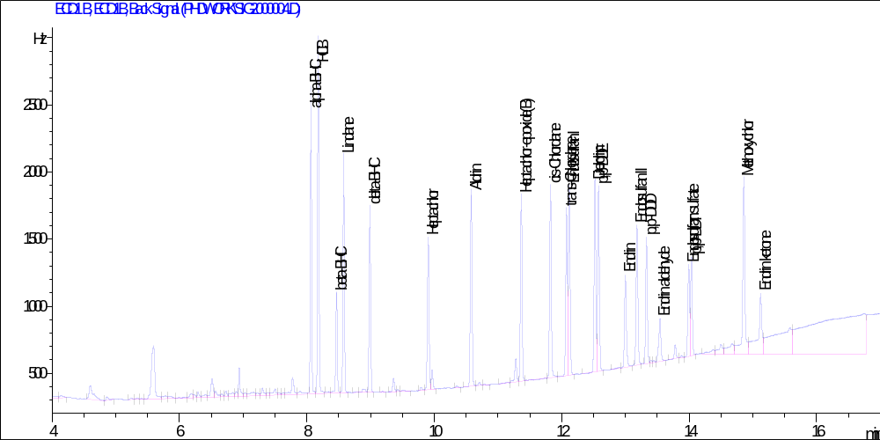
Chromatogram 1: Organochlorine pesticide standard (10 ng/mL) run

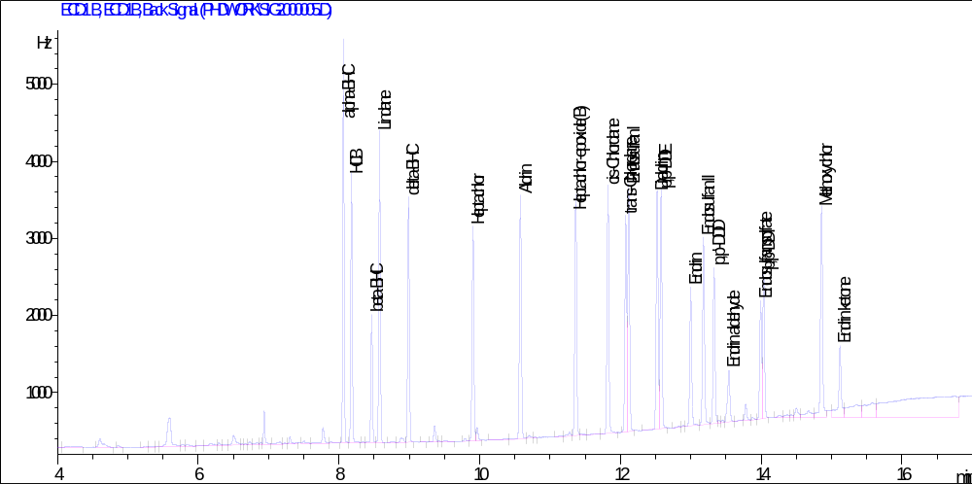
Chromatogram 2: Organochlorine pesticide standard (20 ng/mL) run
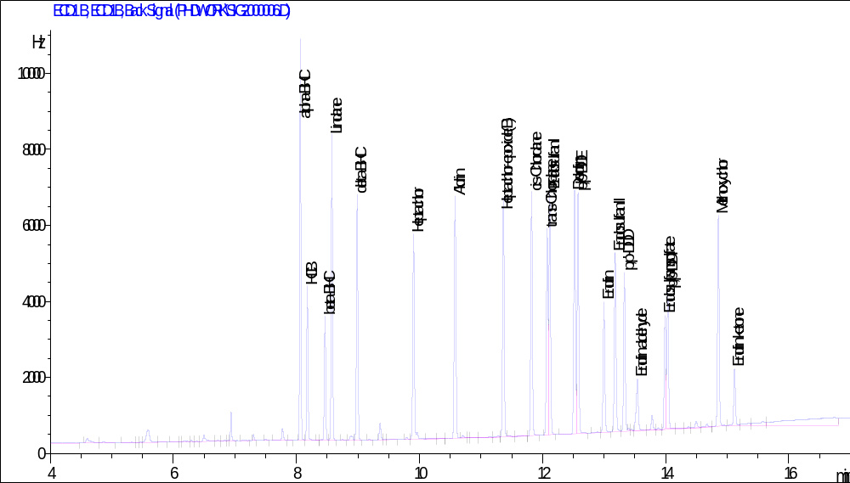Chromatogram 3: Organochlorine pesticide standard (40 ng/mL) run

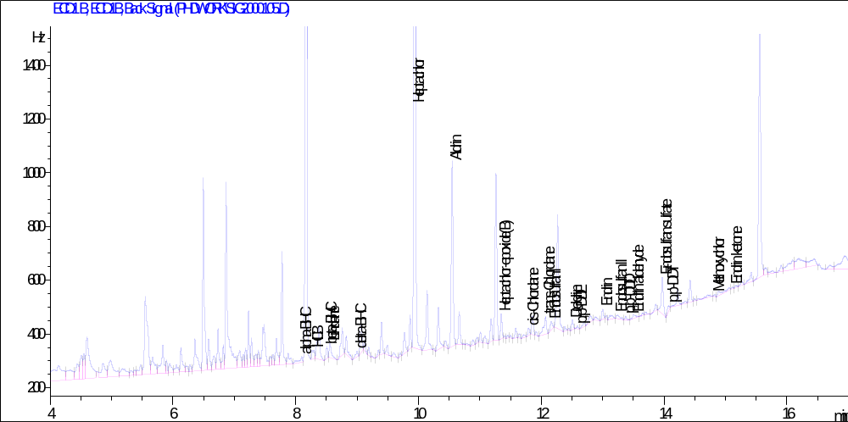Chromatogram 4: Concentration (ng/mL) of OCP residues in mixed layer water in Tarkwa Bay
during the wet season

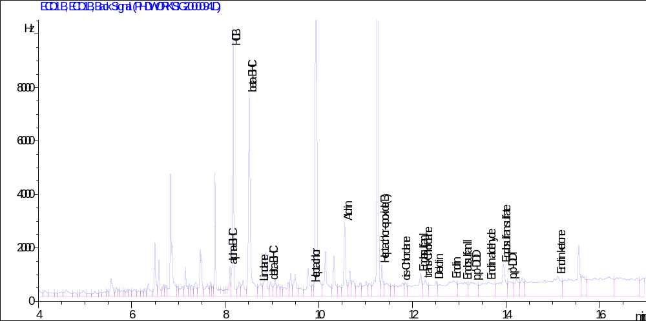
Chromatogram 5: Concentration (ng/g) of OCP residues in epipellic sediment in Agboyi Creek
during the dry season

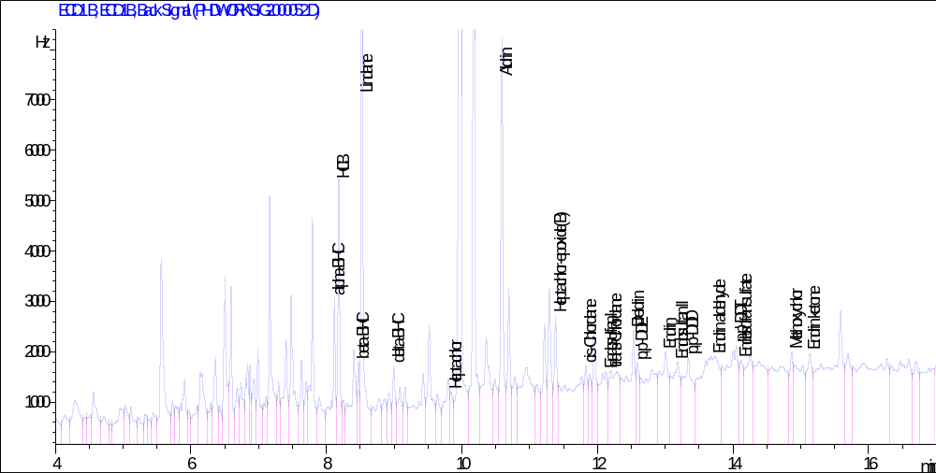
Chromatogram 6: Concentration (ng/g) of OCP residues in the muscle tissue of female Tilapia
guineensis in Lagos Lagoon during the wet season

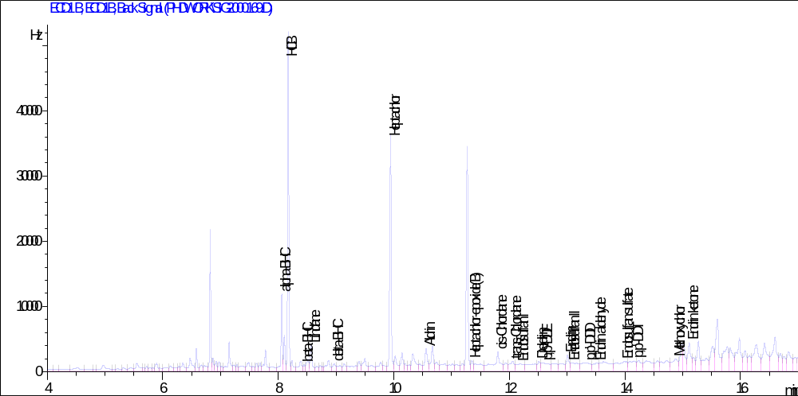
Chromatogram 7: Concentration (ng/g) of OCP residues in the liver of male Chrysichthys
nigrodigitatus in Lagos Lagoon during the dry season

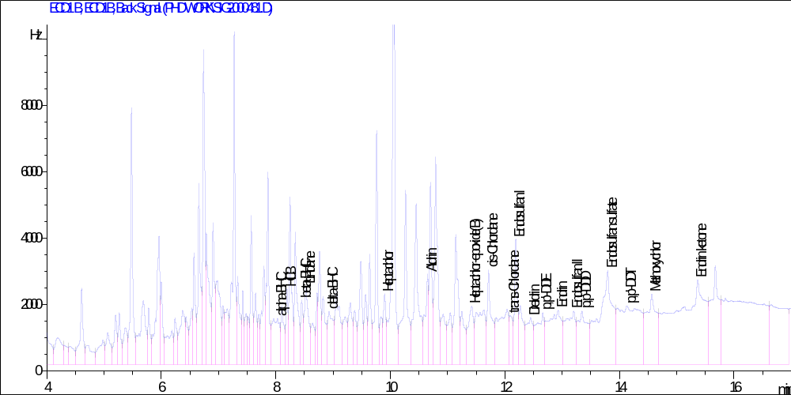
Chromatogram 8: Concentration (ng/g) of OCP residues in the muscle tissue of male Ocypoda
africanus in Agboyi Creek during the dry season
Appendix 2: Plates
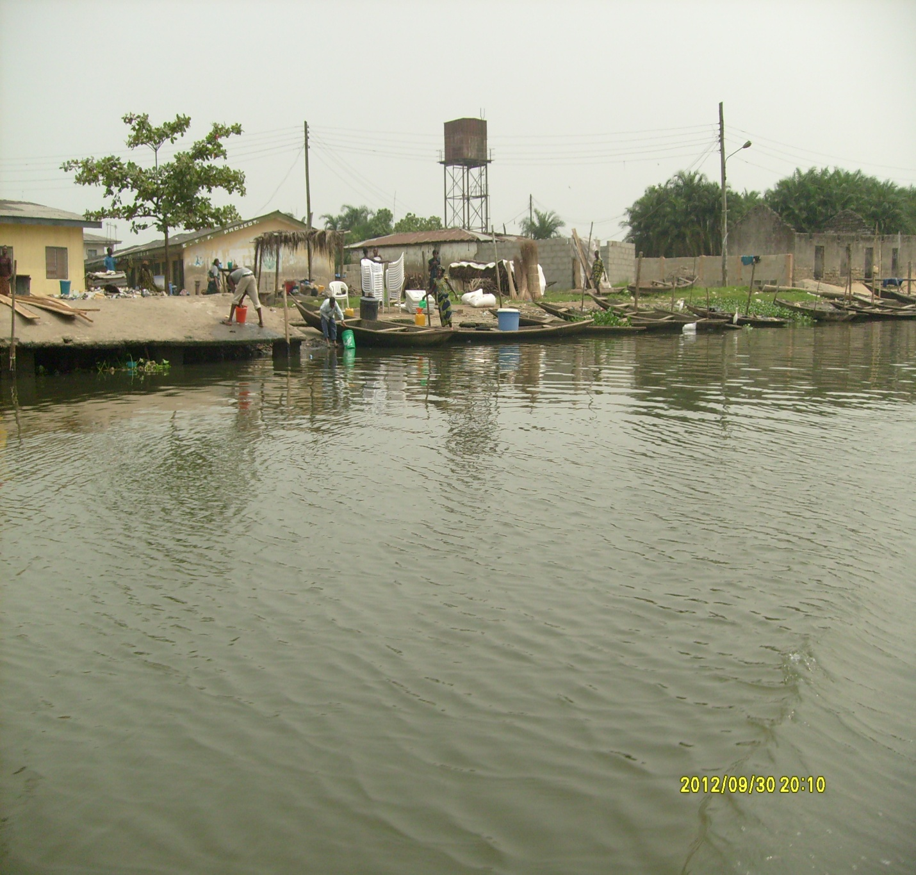Plate 1: Agboyi Creek terminus

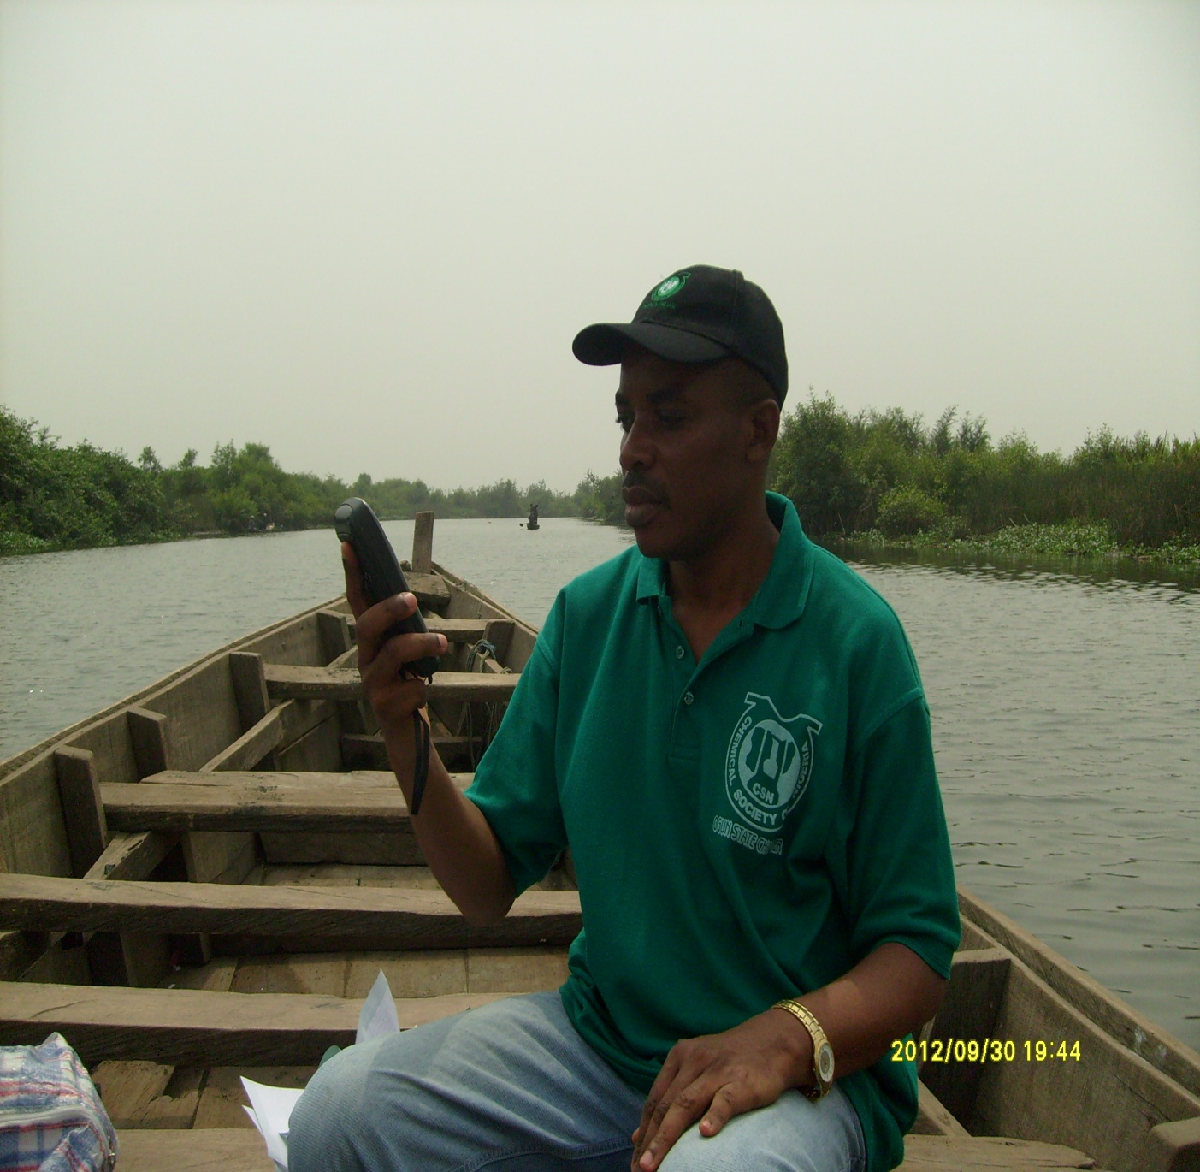 Plate 2: Investigator Williams identifying sampling locations with Garmin-GPSMAP 76S

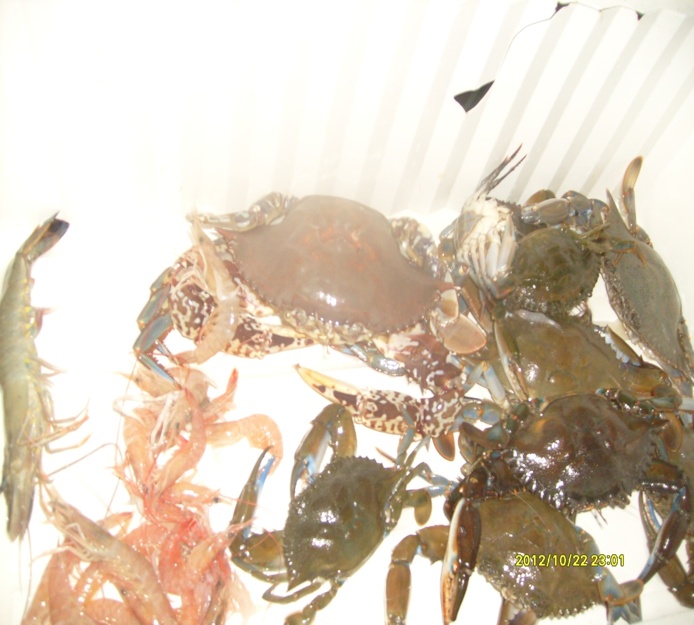Plate 3: Shellfishes sampled for organochlorine pesticide analysis

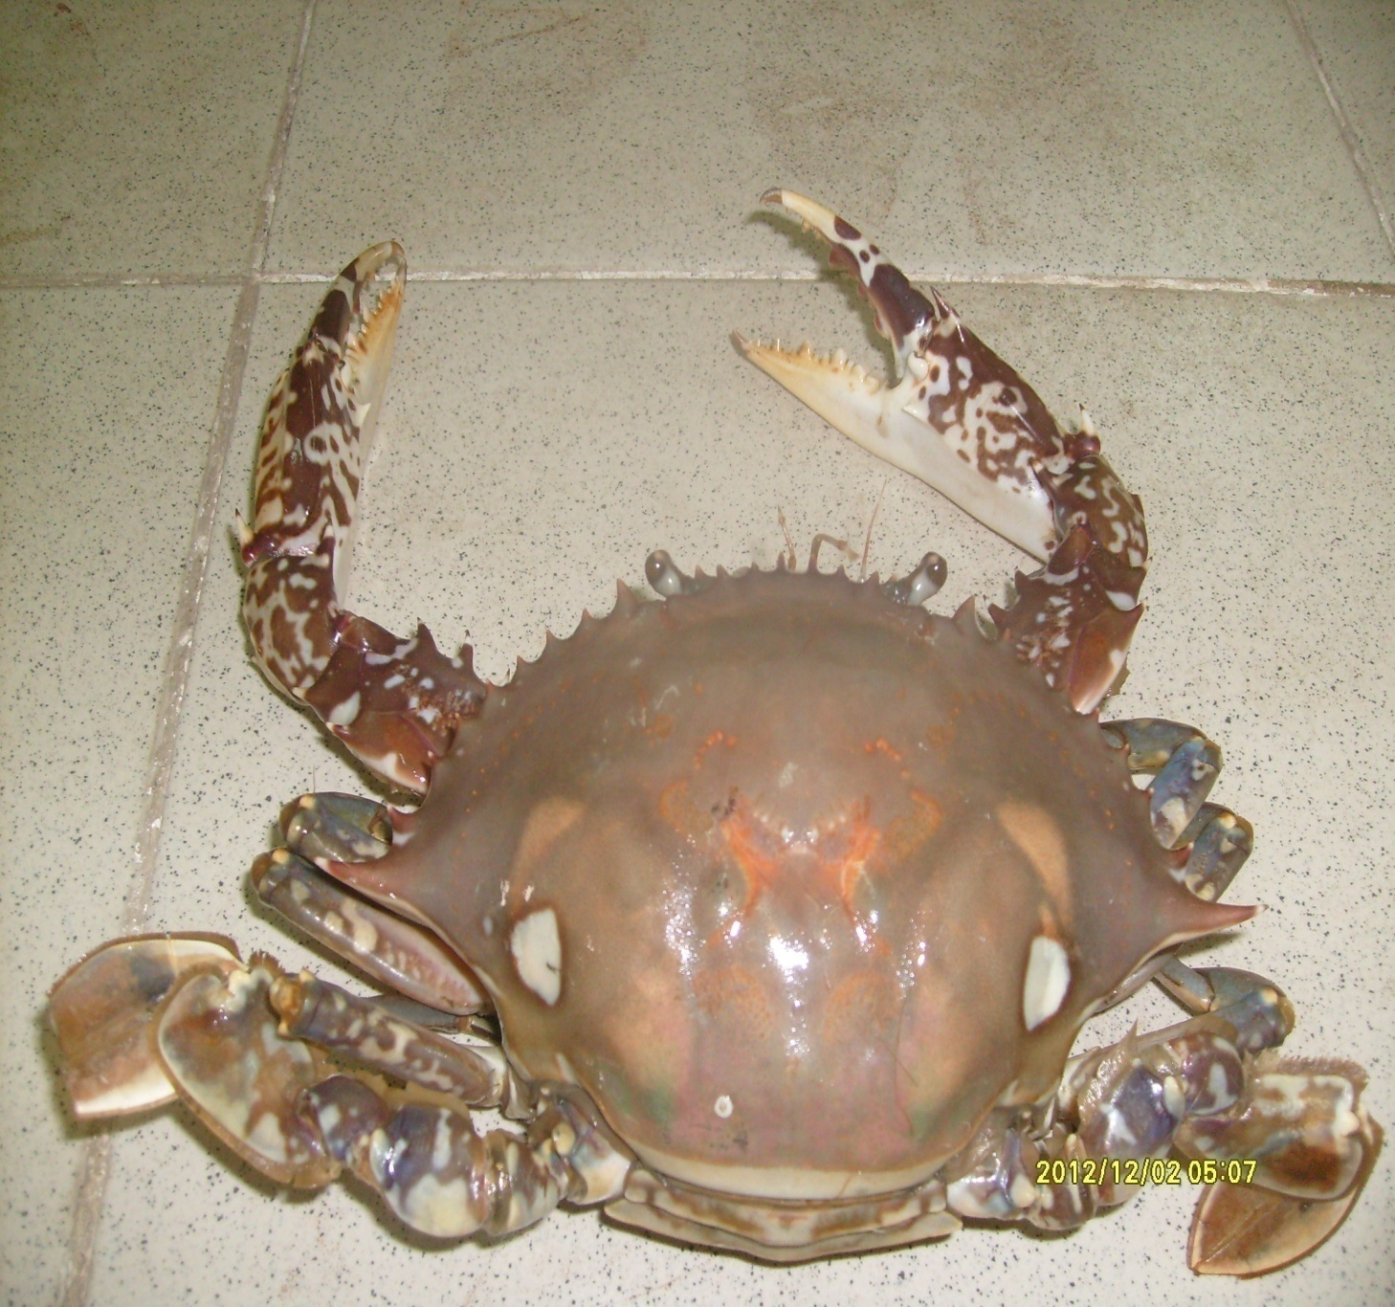Plate 4: Crab (Ocypoda africanus) sampled for organochlorine pesticide analysis
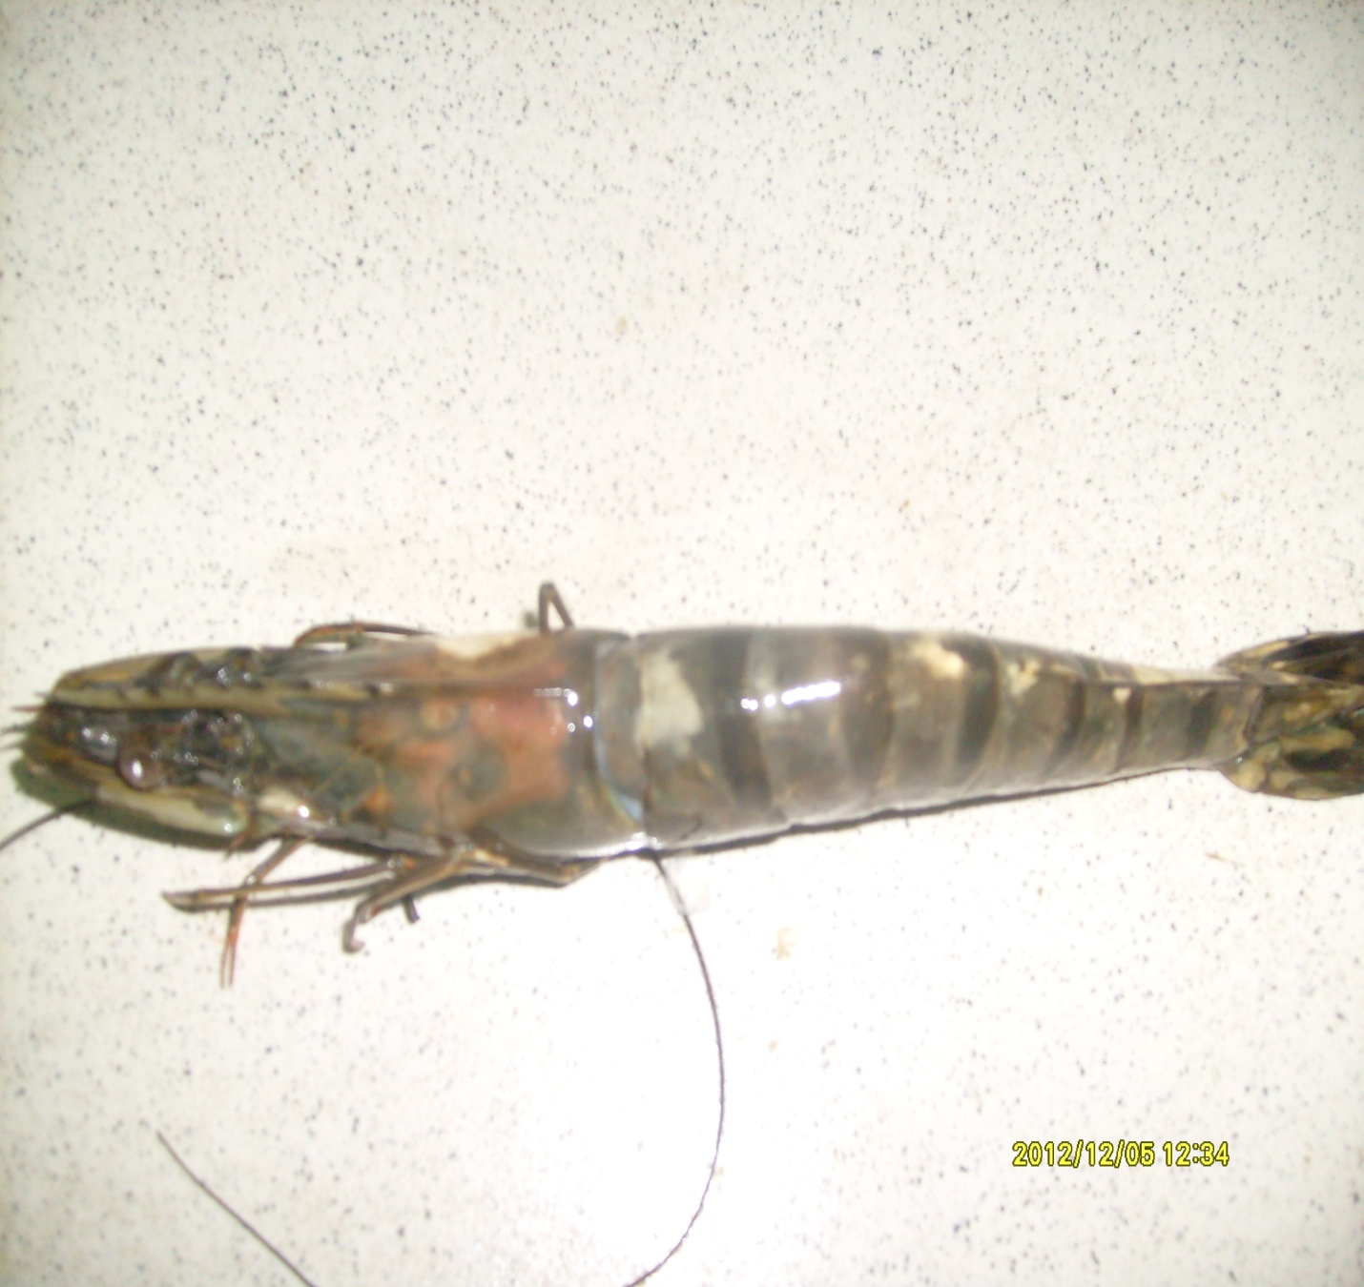Plate 5: Shrimp (Penaeus notialis) sampled for organochlorine pesticide analysis

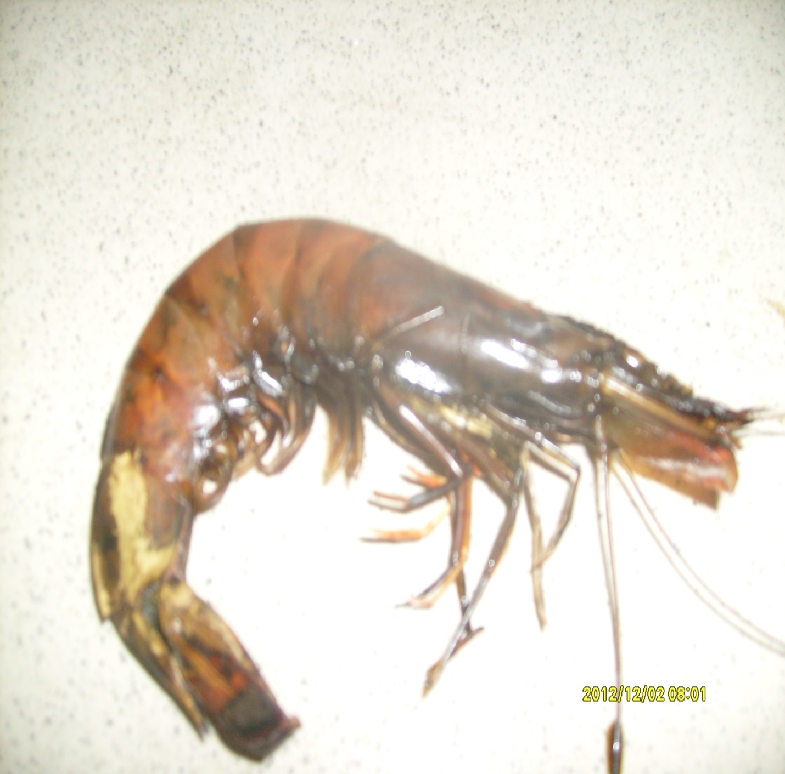Plate 6: Crayfish (Procambarus clarkii) sampled for organochlorine pesticide analysis
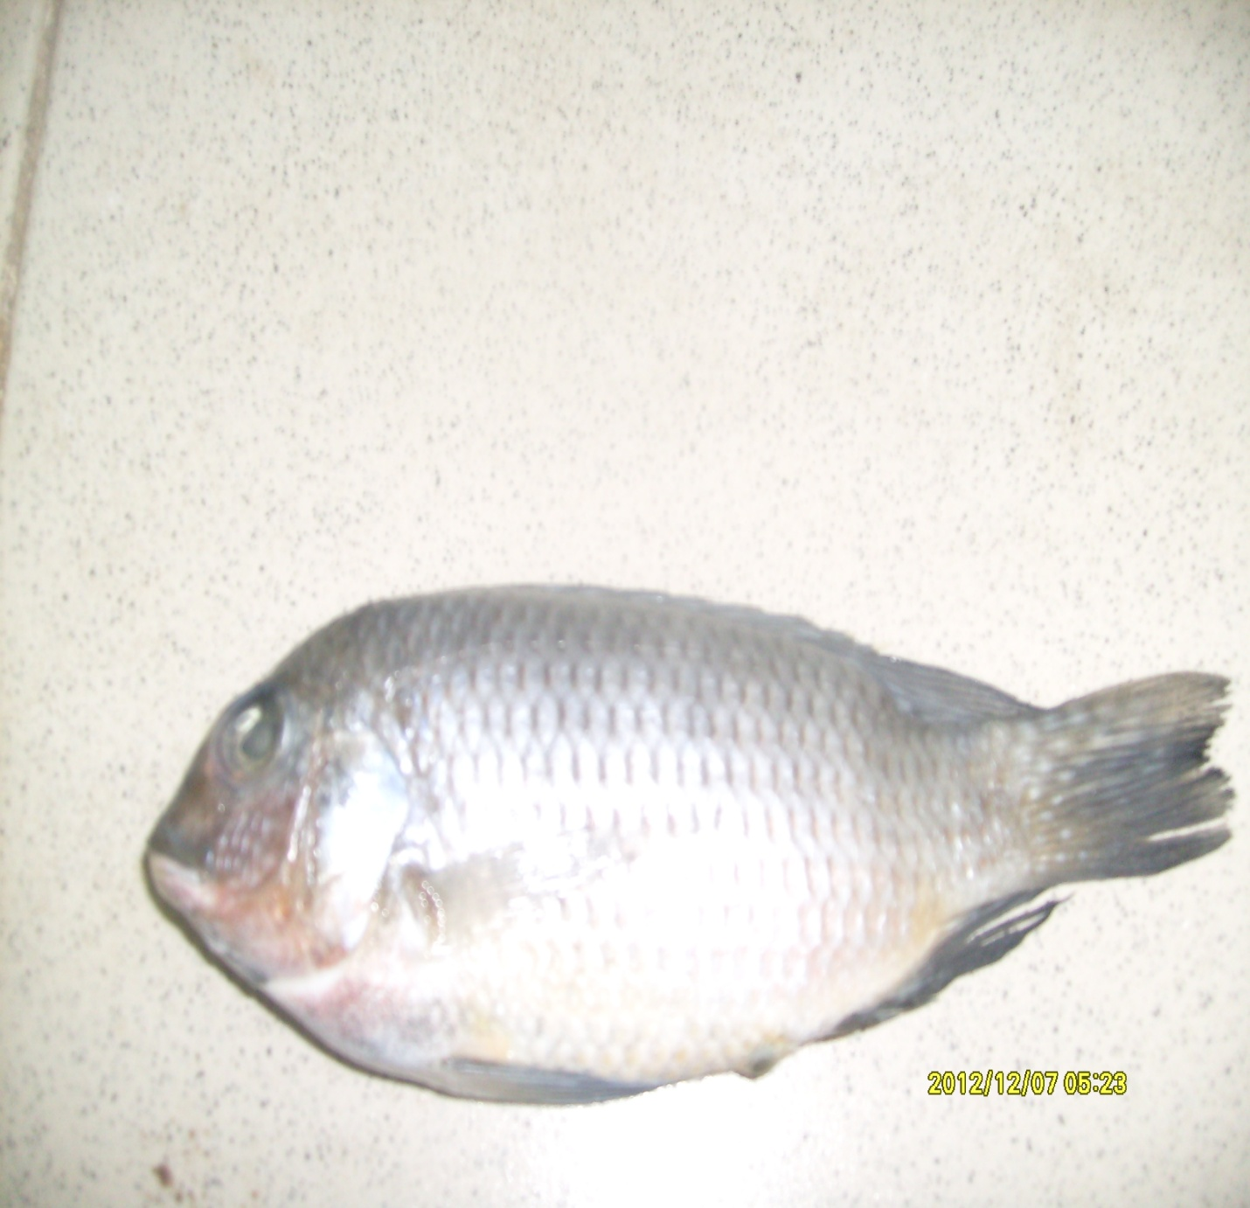Plate 7: Tilapia (Tilapia guineensis) sampled for organochlorine pesticide analysis

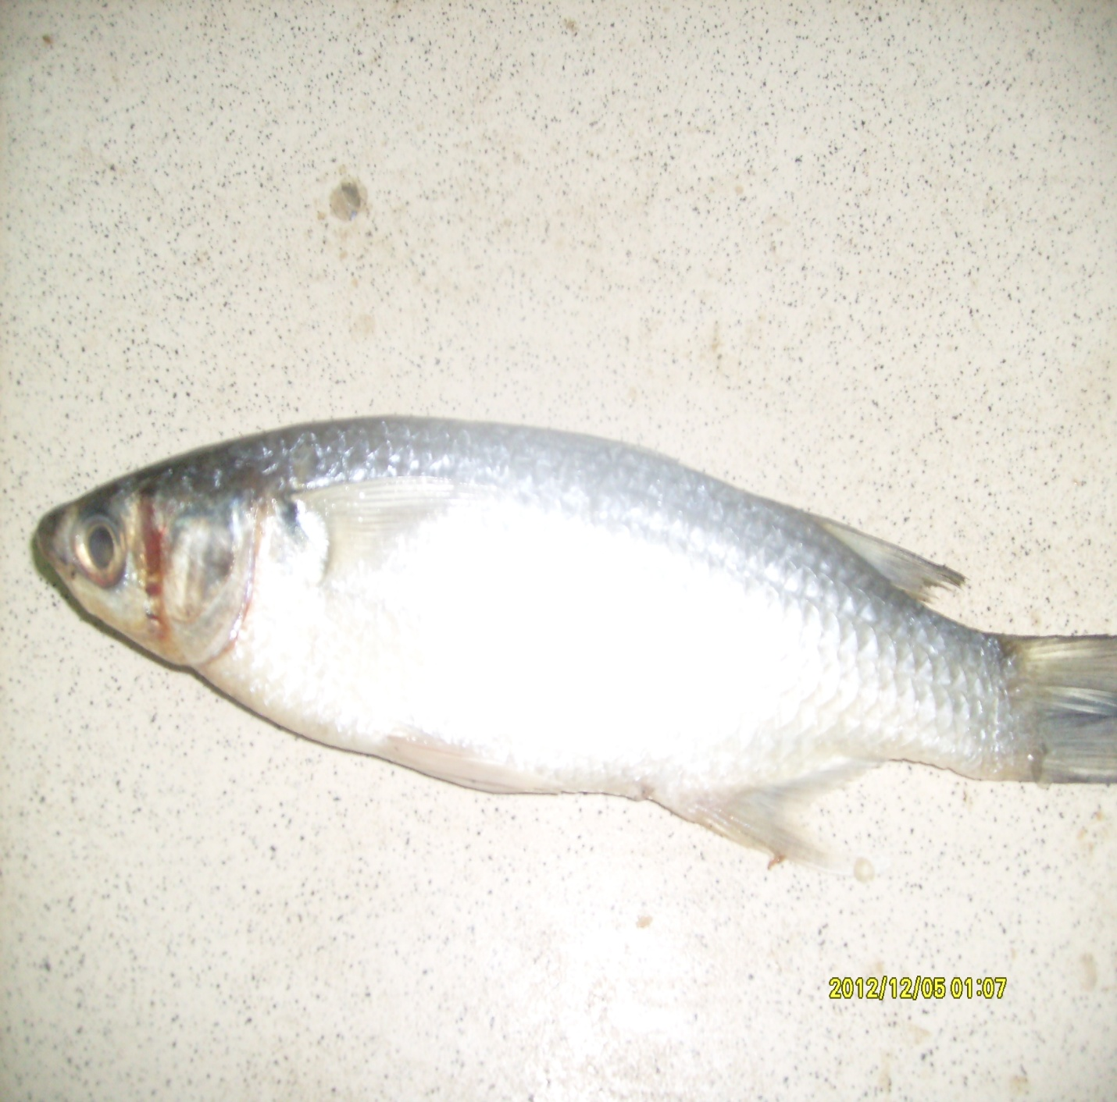Plate 8: Mullet (Liza grandisquamis) sampled for organochlorine pesticide analysis
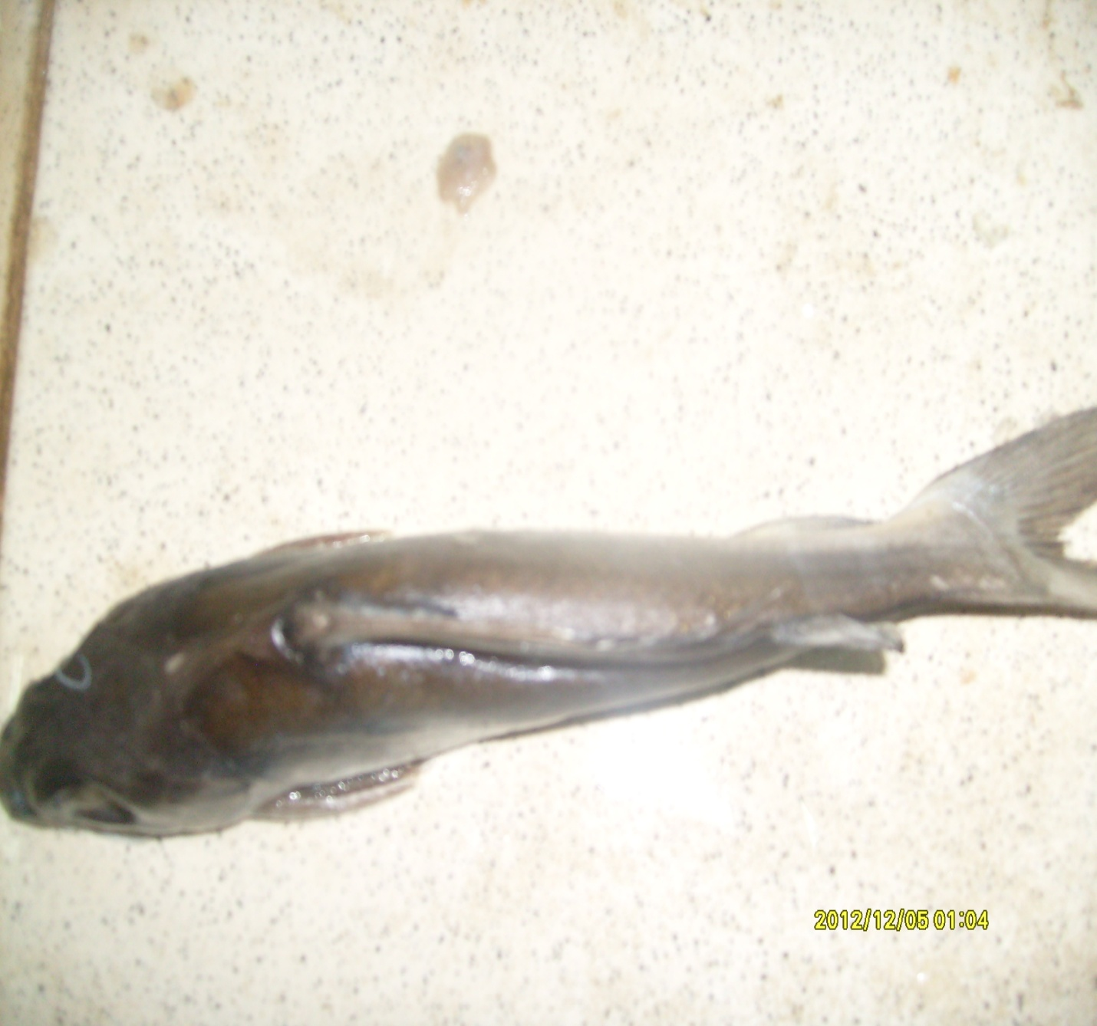Plate 9: Catfish (Chrysichthys nigrodigitatus) sampled for organochlorine pesticide analysis

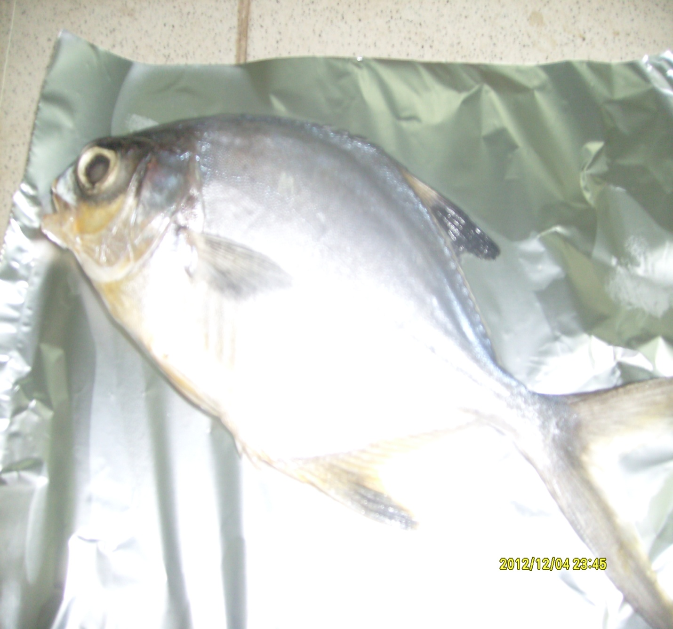Plate 10: African Moony (Psettias sebae) sampled for organochlorine pesticide analysis
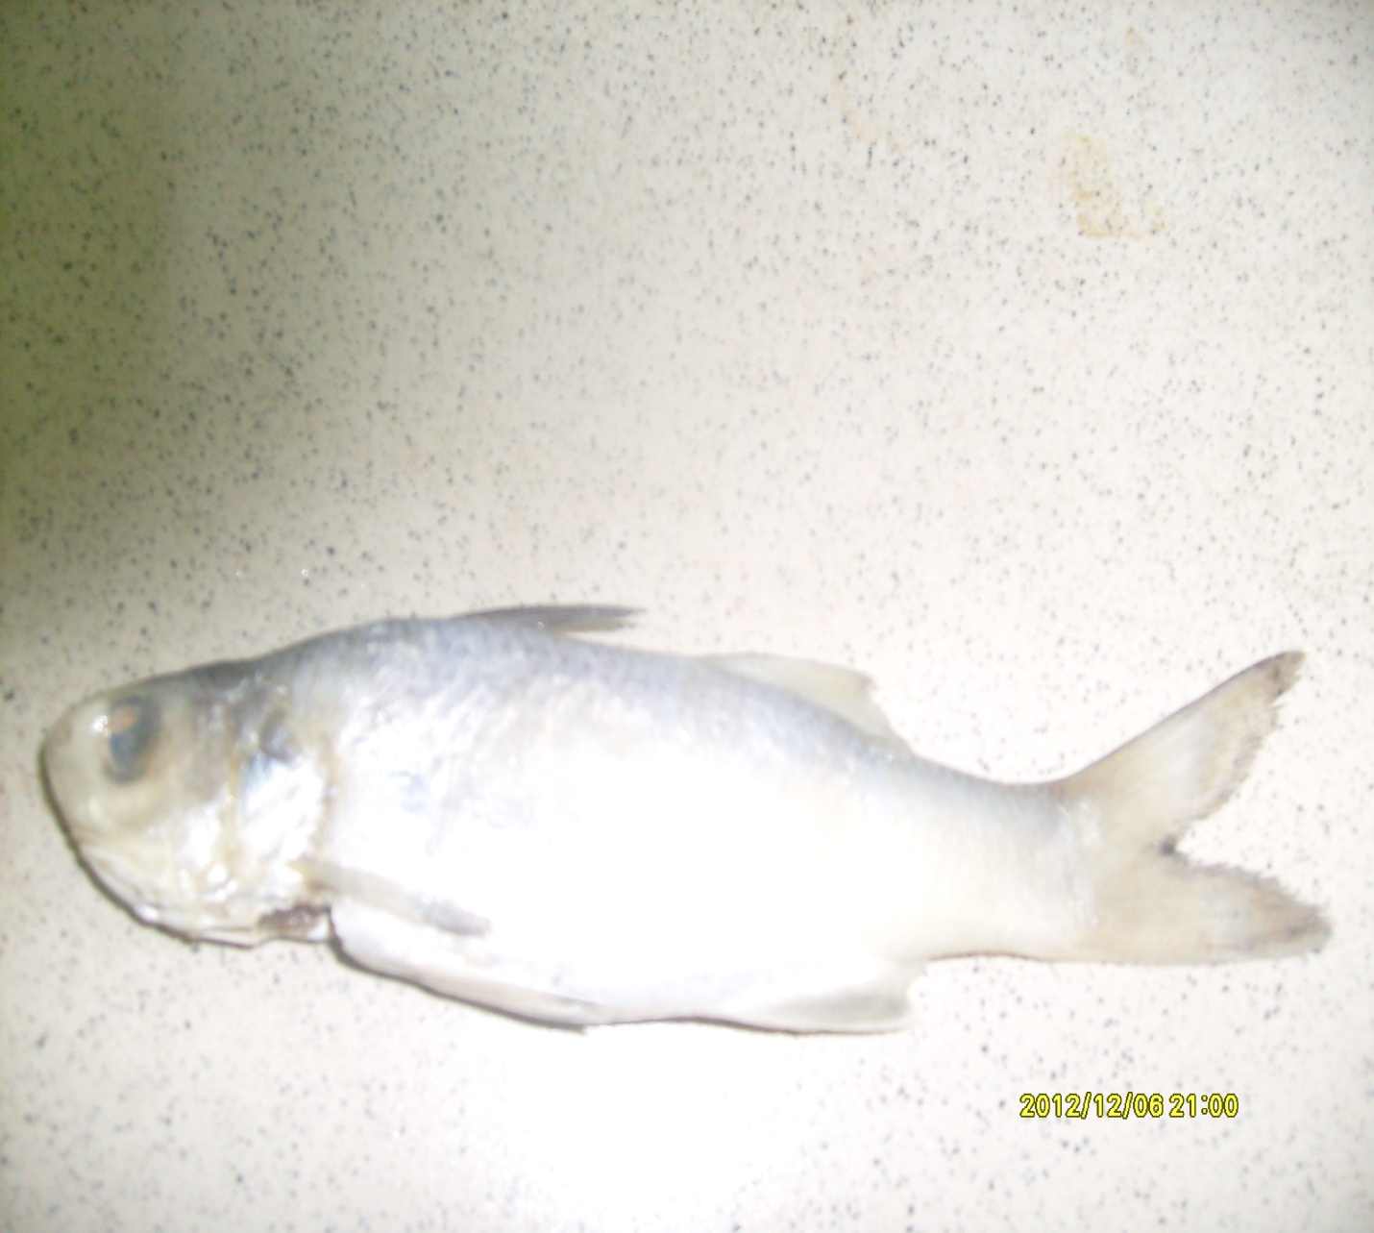Plate 11: Bonga fish (Ethmalosa fimbriata) sampled for organochlorine pesticide analysis

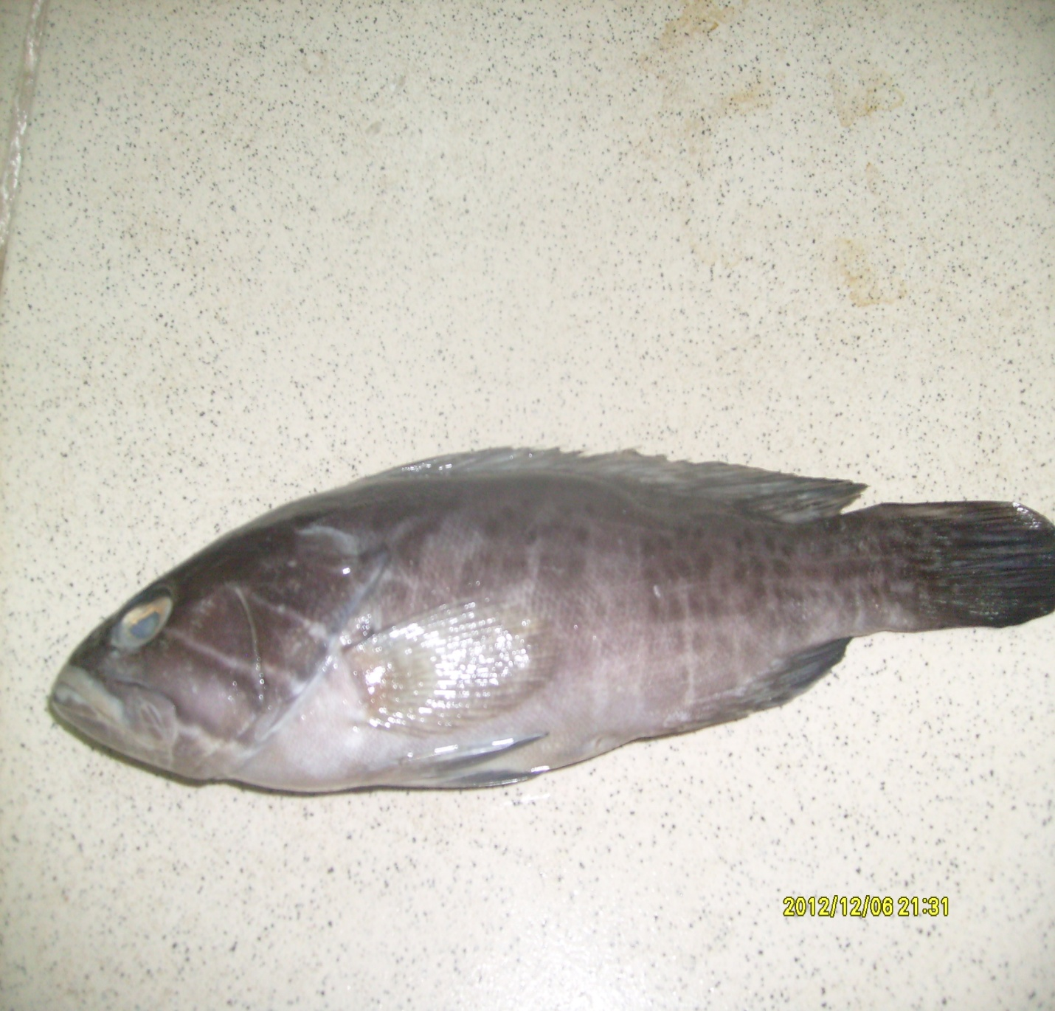Plate 12: Grouper (Epinephelus aeneus) sampled for organochlorine pesticide analysis
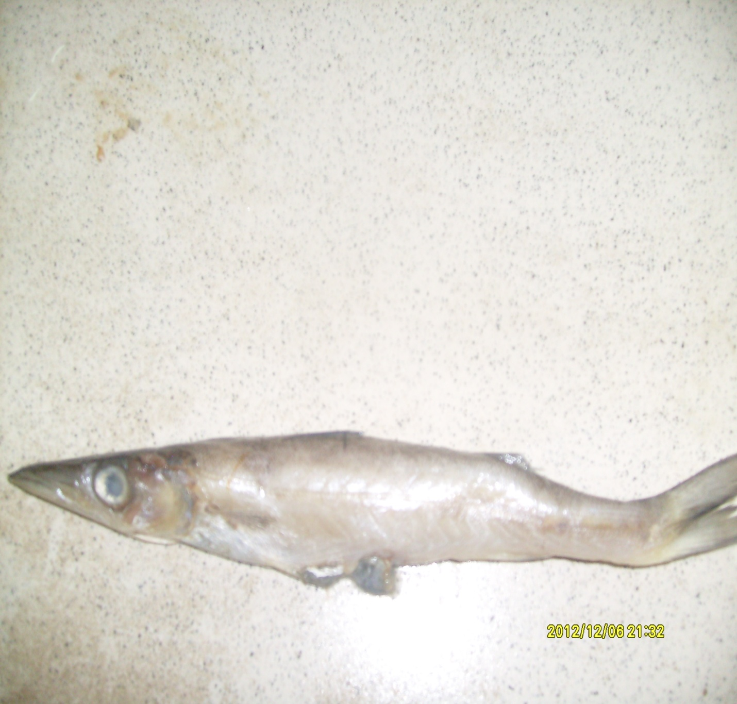Plate 13: Barracuda (Sphyraena guachancho) sampled for organochlorine pesticide analysis

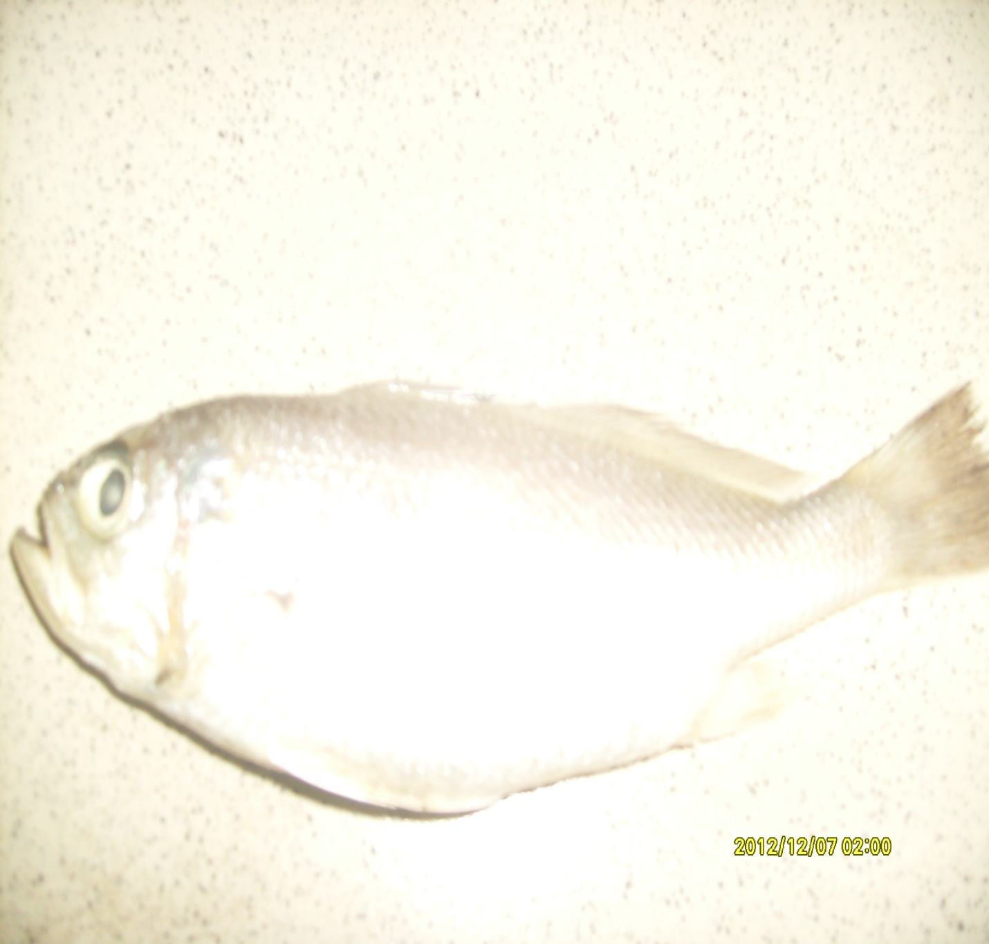Plate 14: Croaker (Pseudotolithus senegalensis) sampled for organochlorine pesticide analysis
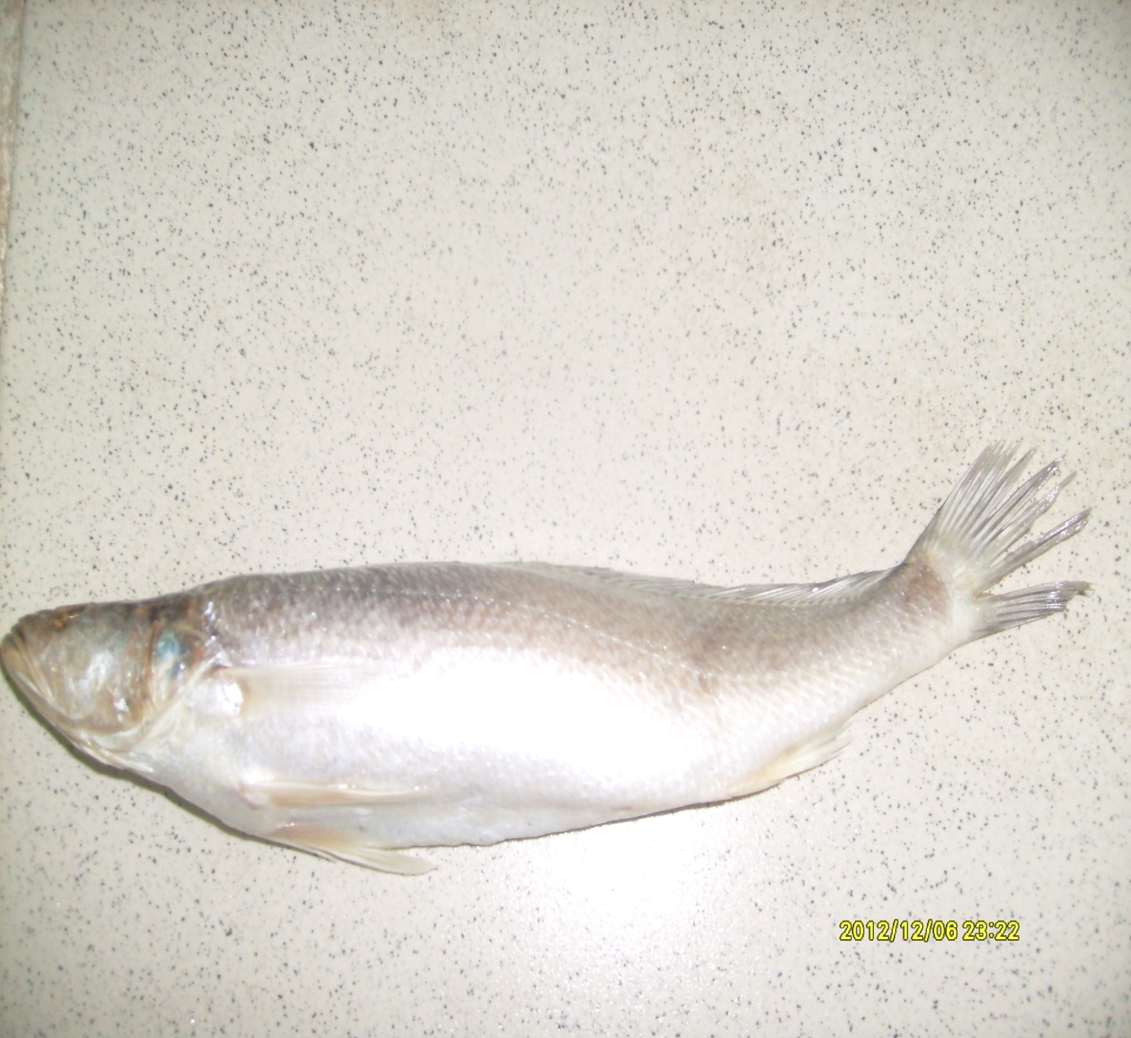Plate 15: Croaker (Pseudotolithus typus) sampled for organochlorine pesticide analysis

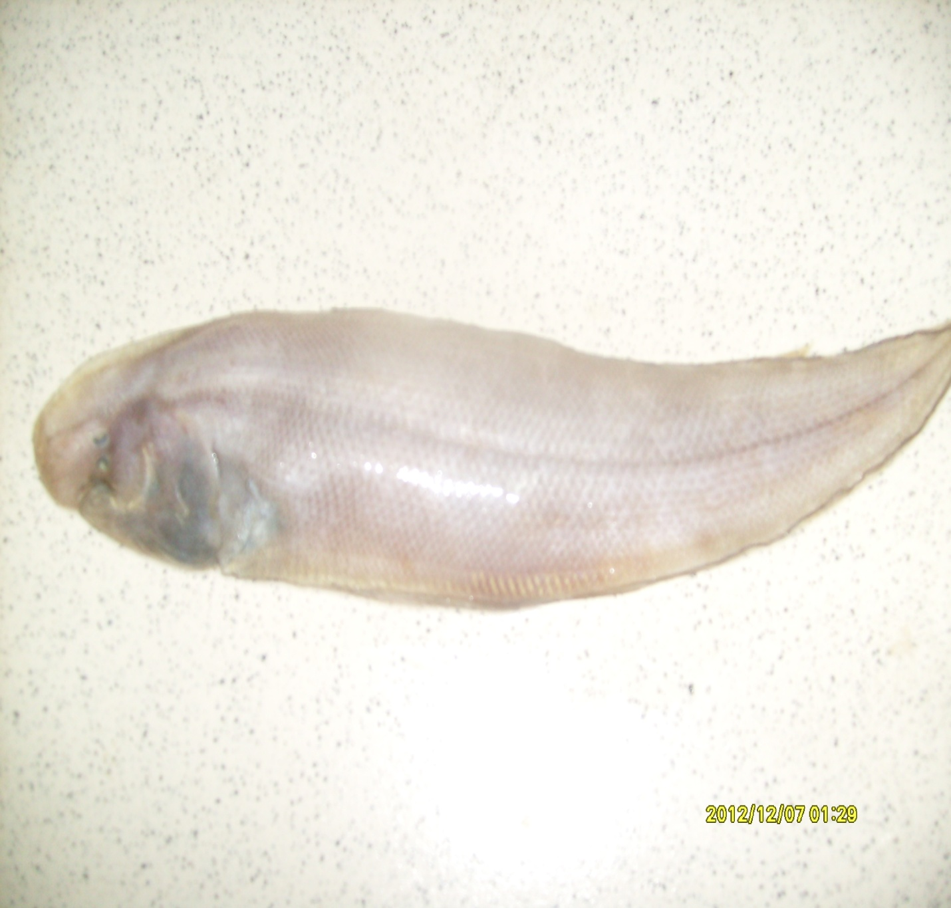Plate 16: Tongue Sole (Cynoglossus canariensis) sampled for organochlorine pesticide analysis
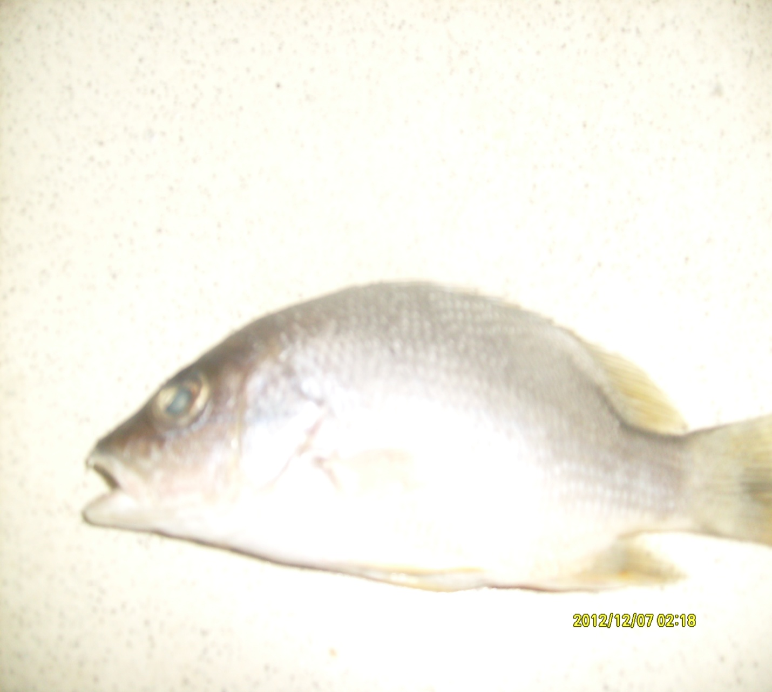Plate 17: Snapper (Lutjanus goreensis) sampled for organochlorine pesticide analysis

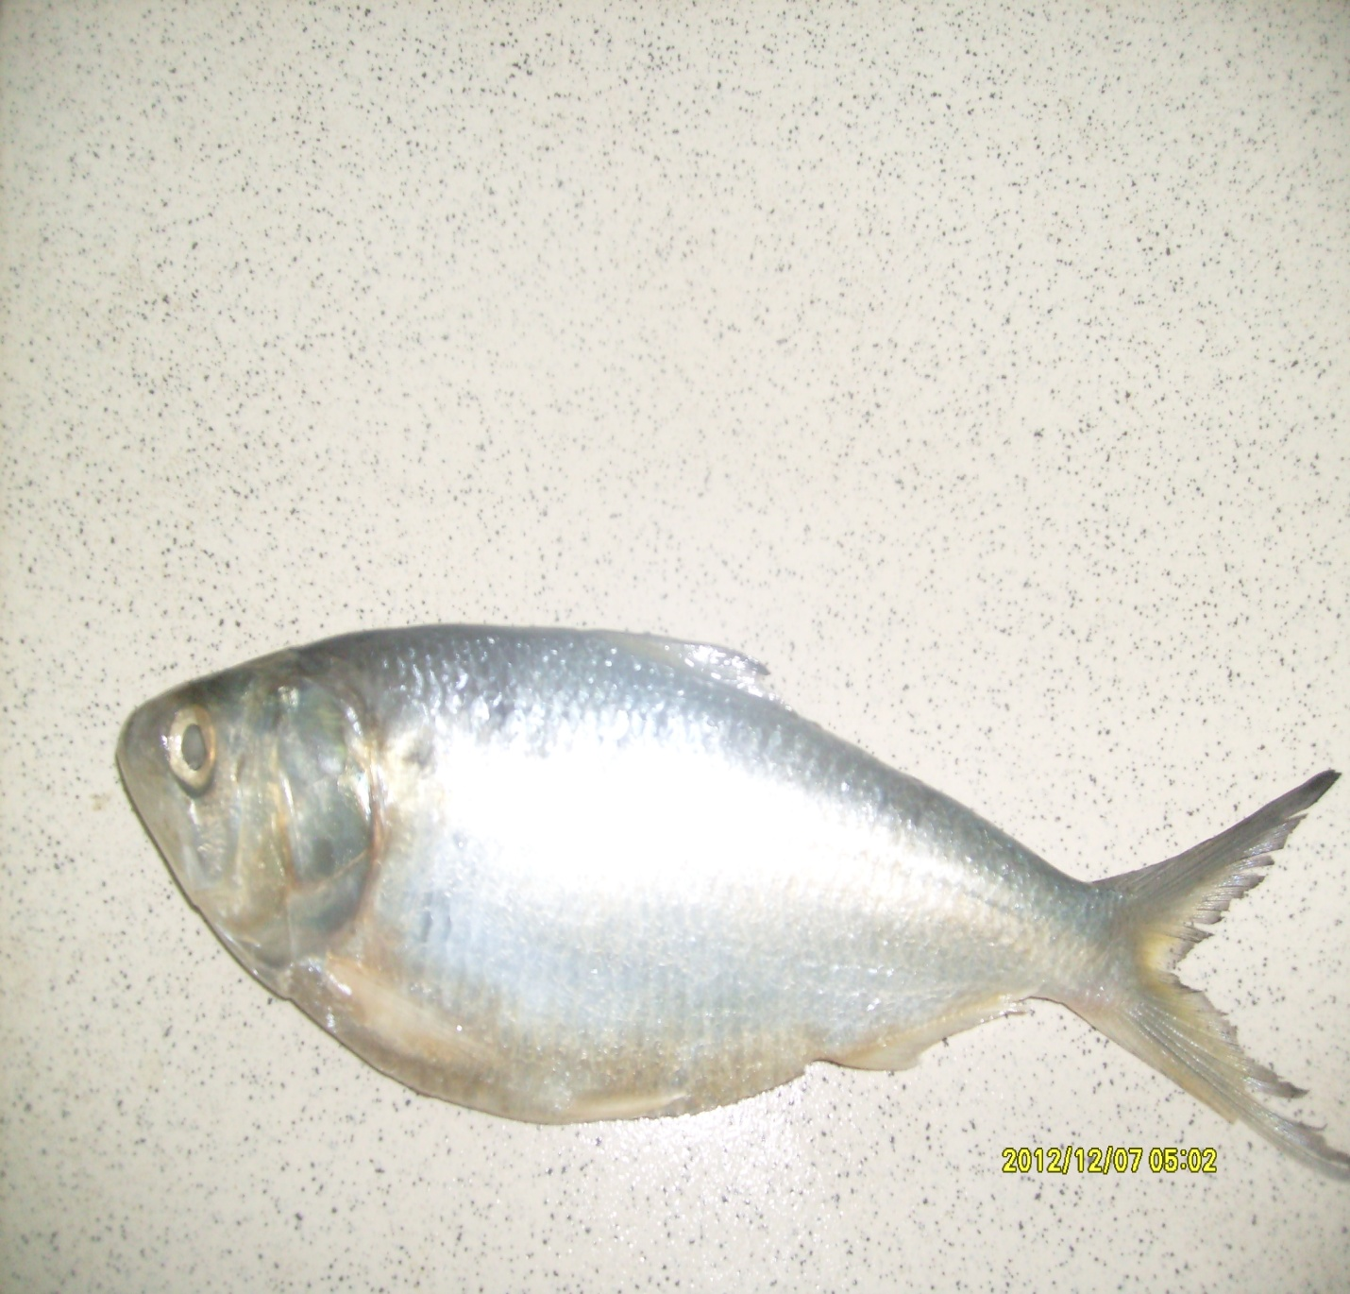Plate 18: Herring (Sardinella maderensis) sampled for organochlorine pesticide analysis
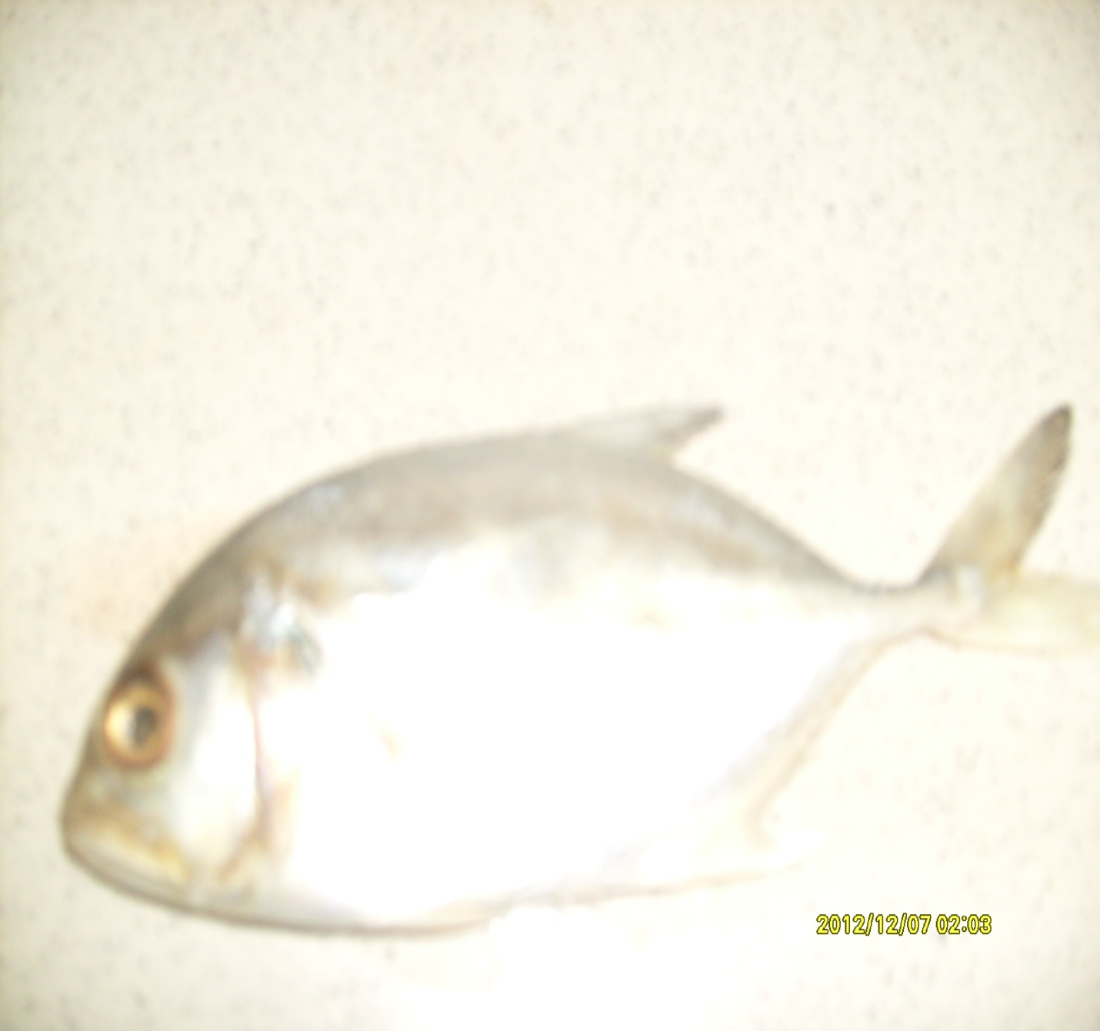Plate 19: Jack fish (Caranx hippos) sampled for organochlorine pesticide analysis

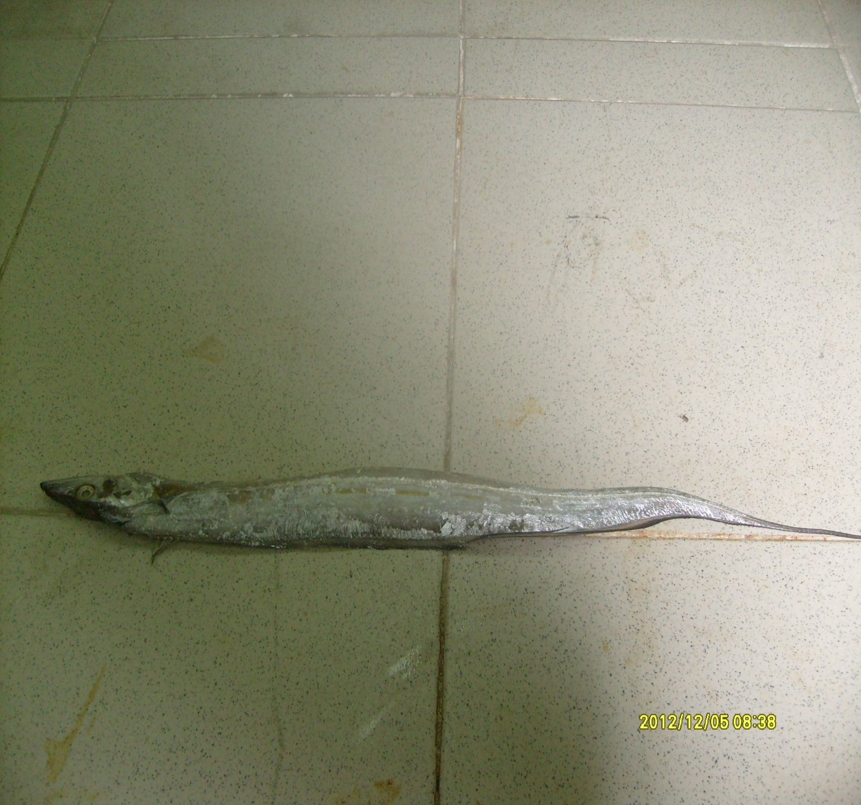Plate 20: Oarfish (Regalecus glesne) sampled for organochlorine pesticide analysis
Appendix 2 RESEARCH QUESTIONNAIRE

DEPARTMENT OF CHEMISTRY
SCHOOL OF NATURAL & APPLIED SCIENCES
COLLEGE OF SCIENCE & TECHNOLOGY
COVENANT UNIVERSITY

Dear Respondent,
This is a dietary survey aimed at obtaining information on the type and amount of fish consumed by you daily in order to obtain the mean consumption data for the consumers. This study is in partial fulfillment of the requirements for the award of a Ph.D degree in Environmental Chemistry.
Kindly complete this questionnaire honestly. I assure you that your answers will be treated with strict confidence and used mainly for the aforementioned academic purpose. Your anticipated cooperation is highly appreciated.

Yours sincerely,

Williams, Akan Bassey

Section A Personal Data
Please tick the appropriate response or fill the gap
1. Sex: Male □ Female □
2. Age: Below 20 years □ 21-40 years □ Above 40 years □
3. Residential Address: Within Lagos □ Outside Lagos □
4. Highest Academic Qualification
FSLC □ GCE □ OND □ HND □ B.A/B.Sc □ M.A/M.Sc □ Ph.D □
Others (Specify)……………………………………………………………
5. Occupation: Fishing □ Farming □ Business □ Public Servant □ Teaching □ Clergy □
Others (Specify)……………………………………………………………

Section B Dietary Survey
6. Do you eat finfishes Yes □ No □
7. What type of finfishes do you eat
8. Do you eat finfishes harvested from Lagos Lagoon Yes □ No □
9. Do you eat finfishes harvested from Agboyi Creek Yes □ No □
10. What is your daily consumption of the finfishes □
11. Do you eat shellfishes Yes □ No □
12. What type of shellfishes do you eat
13. Do you eat shellfishes harvested from Lagos Lagoon Yes □ No □
14. Do you eat shellfishes harvested from Agboyi Creek Yes □ No □
15. What is your daily consumption of the shellfishes □
Bottom of Form
Bottom of Form

