CHAPTER ONE
INTRODUCTION
1.1 Background of the Study
The organizations that care for persons who are ill and injured vary widely in scope and scale, from specialized outpatient clinics to large urban hospitals, teaching hospitals, to regional healthcare systems. Despite these differences, one can view the healthcare processes that these organizations generate within the context of queuing systems in which patients arrive, wait for service, obtain service, and then depart (Fomomundam and Herrmann, 2007). From birth to death, we are all part of the health care system. We rely on hospitals to provide preventive care and treat our illnesses, diseases and injuries. In fact, health care is perhaps the stage determinant of people’s quality of life and longevity (Hall, 2006). With rapid change and realignment of healthcare system, new lines of services and facilities to render the same, severe financial pressure on the healthcare organizations, and extensive use of expanded managerial skills in healthcare setting, the use of queuing model has become a prevalent analytical tool (Singh, 2007).

Health care systems have been challenged in recent years to deliver high quality services with limited resources (Hall, Benson, Mural and Dessouky, 2001). Health care resources are becoming increasingly limited and expensive, thereby placing greater emphasis on the efficient utilisation of the resources and the corresponding level of service provided to patients. Consequently, one of the most important operational issues in health care delivery involves capacity planning such that the goals of efficient resource utilization and providing high quality service are met (Pierskalla & Wilson, 1989; Smith-Daniels, 1988). In Nigeria, during the 2000’s some teaching hospitals experienced restructuring and renovation to meet international standards. In some regions of the country, the restructuring and renovation have produced serious overcrowding effect such that patients wait for hours to see doctors or before attention particularly in emergency departments (ED) and intensive care units (ICU). There may be growing recognition that mortality is increasing among patients to whom admission into crowded intensive care units is refused (Nelson, Waldrop, Jones and Randall, 1998) principally due to the rationalization programme of the EDs and ICUs. But there is an incomplete understanding amongst health policy makers of the limits of the downsizing process and no consensus as to the number of intensive care unit beds necessary to serve a given population (Meticafe, Slogget and Mcpherson, (1997)). Nevertheless, emergency departments and intensive care units are among the most complex and expensive of all medical resources, and hospital administrators are challenged to meet the demand for intensive care services with an appropriate capacity (Green, 2002).

Many hospitals are faced with the challenge of allocating the limited resources, such as beds and personnel available for arriving patients. Researches show that in the emergency department(ED) and intensive care units (ICU) of the teaching hospitals (Ridge, Jones, Nelson and Shahani, 1998; Kim, Horowitz and Buckly, 1999; Baqust, Place and Posnett, 1999; Derlet and Richards, 2000; Henry, 2001; Lewin Group, 2004; IOM, 2006; Av-yeung, Herrison and Knottenberg, 2006; Green, Soares, Giulio and Green, 2006; Delia 2007; Bruin, Rossum, Visser and Koole, 2007; Geranmayeh and Iyer, 2008, etc.), patients experience longer waiting times to be admitted to or diverted from a unit (as a bottleneck unit) as it reaches capacity thereby reducing healthcare access to the public, and increasing operational cost to hospitals because of the associated inefficiencies. The case hospitals are not exception. The number of refused admission at the ED and ICU is high and many patients are diverted or referred to mostly private hospitals. Also many of these private hospitals suffer from an acute shortage of the materials and human capacity required for the services needed. These major bottlenecks occur at emergency departments, intensive care units, and operating rooms and their related pre-care and post-care areas because they have non- interchangeable resources like other few hospital areas. Management of waits, delays and unclogging bottlenecks requires the assessment and improvement of flow between and among various departments in the entire hospital system.

Researchers around the world have become more focused on service industries in general and healthcare in particular (Takagi, 1991, Bretthauer, 2004; Zhu, Sivakumar and Parasuraman, 2004). In addition, patient flow times play an increasingly important role in today’s healthcare systems (Creemers and Lambrecht, 2007). Government regulations, public-private participation, competition amongst hospitals and patient satisfaction urge hospital administrators to find ways to manage congestion and decrease waiting times (both waiting time inside the hospital as well as the waiting lists that exist outside the hospital). Current healthcare literature and practice indicate that waiting lists and congested patient flows are indeed made up of one of the most important problems in care industries (Belson, 2006; Cerda, de Pablo, and Rodrigolz, 2006). In order to improve performance in an environment as complex as a hospital system, the dynamics at work need to be understood, of which queuing theory and simulation provide an ideal set of instruments for such understandings (Creemers and Lambrecht, 2007).

Queuing theory was developed to study the queuing phenomena in commerce, telephone traffic, transportation, business-industrial servicing systems, variable reservoirs, et cetera. (Cooper, 1981; Gross and Harris, 1985). Although there are completely different mechanisms operating in various systems, queuing theory studies their common properties in the queuing process, because the phenomenological laws governing the queuing processes are similar (Wu, 1998). Queuing theory is used widely in engineering, telecommunication and industry for analysis and modeling of processes that involve waiting lines (McManus, Long, Cooper and Lituak, 2004). In appropriate systems, it enables managers to determine the optimal supply of fixed resources necessary to meet a variable demand (Duckworth, 1962).

Queuing models have a long tradition and they are very useful tools for evaluating the performance of health care systems in which waiting lists occur, (Bailey, 1952). For instance Jackson, Welch and Fry (1964); Worthington (1991) and Goddard, Malek and Tauakolu (1995) modeled appointment systems and waiting list management in outpatient clinics. Milliken, Rosenberg and Milliken, (1972) predicted the delivery room utilization and emergency departments. Ridge, Jones, Nielsen and Shahani, (1998) focused was on planning the capacity of emergency services. Tucker, Barone, Cerere, Blabbey and Rha, (1999) use an M/M\1 model to assess operating room staffing needs for night shifts. Peinus, Enyan, Flanegen, Pim, Sallee and Segrist, (2000) used a non- preemptive priority model to assess the average waiting times of emergent and non-emergent patients for computed tomography scans. Gorunescu, Mcleen, Millard, (2002) used queuing model for designing, planning and staffing service units. Ivahs and Millard (2003) and Adele and Berry (2005) applied it in modeling health care. Queuing theory was also used to determine capacity requirements (Green, 2002; McManus et al, 2004). Vasanawala and Desser (2005) used Poisson probabilities to predict the required number of reserved slots (on weekly basis) for emergency radiology given that 95% of the requests are accommodated

More recently, operations researchers and health policy formulators have also sought to apply these techniques more widely across the health-care system. Results show that in contradiction with other conventional theories more often used in healthcare studies, such as internal analysis, external analysis, competitive analysis, etc., the application of operations research (queuing model in particular) brings greater versatility, variety and control to the management of healthcare organization (Ginter et al., 1998). However, in comparison to developed countries, the practice of using queuing network model on health issues in developing countries (especially in Nigeria) is still limited.

1.2 Statement of the Research Problem
It is a goal universally acknowledged that a healthcare system should treat its patients – and especially those in need of critical care – in a timely manner. However, this is often not achieved in practice, particularly in public healthcare systems that suffer from high patient demand and limited resources (Au-Yeung et al, 2006; Bruin et al, 2007). Today’s healthcare system operates under severe pressure and along with improved medical and healthcare science and possibly healthier lifestyles, the proportion of people needing medical attention in the population continues to increase. Additionally, the expectations on healthcare delivery are increasing with enhanced medical care, improved diagnostic techniques and efficiency of treatments. This evidently conveys a general increased demand for quality healthcare and tends to raise the costs of healthcare (Persson, 2007).

Furthermore, the long waiting lists have become symbols of the inefficiency of hospitals services all over the world, particularly in publicly funded hospitals (Gauld, 2000). Overcrowded emergency departments (EDs), intensive care units, prolonged waiting times, patient care delays and scare resources are common themes in large public hospitals (Ridge, Jones, Nelson and Shahani, 1998; Kim, Horowitz and Buckly, 1999; Baqust, Place and Posnett, 1999; Derlet and Richards, 2000; Henry, 2001; Schull et al, 2002; Lewin Group, 2004; IOM, 2006; Av-yeung, Herrison and Knottenberg, 2006; Green, Soares, Giulio and Green, 2006; Delia 2007; Bruin, Rossum, Visser and Koole, 2007; Geranmayeh and Iyer, 2008, etc.). Patient length of stay (LOS) is a key measure of ED throughput and an index of overcrowding (Yoon et al, 2003). Variability in length of stay (LOS) has a major impact on day-to-day hospital operation and capacity requirement (Bruin et al, 2007). Previous studies have shown that overcrowding, prolonged waiting times, and protracted lengths of stay increase the proportion of patients who leave without being seen by a physician (Stock et al, 1994; Fernandes et al, 1997).

It is important to stress that not all decisions affecting ICU patients are made within the unit itself. Demand for ICU beds comes from emergency, add-on and planned (i.e. elective) procedures and from wards. Emergency and add-on procedures are random and cannot be scheduled in advance. Although planned procedures are scheduled ahead of time, they are often scheduled for the daily block-time driven mostly by physicians’ priorities. Usually elective surgery scheduling does not take into account the competing demand for ICU beds from ED and add-on cases. This leads invariably to a typical example of a system bottleneck caused by the interdependency and competing demands between patient flows in a complex system: the upstream problem (ED closure, diversion or queuing) is created by the downstream problem (limited ICU beds) (Troy and Rosenberg, 2009). After decades of attempts, researchers still do not know what it would take to solve the problem, more importantly; the dynamics of waiting lists are not well understood. Buhang (2002) believes that most hospitals operate below their capacity given the way they are organized and given the present methods of coordination and control. Also, the potential productive capacity of the hospital is hard to estimate, as hospital production is very complex because of variety of treatments (Arnoud, 2004).

Although several measures have been adopted over the past years to increase quality, the issues of waiting lists, delays and cancellations with respect to both in-patient and outpatient flows are still a problem to be reckoned with (Arnoud, 2004). After attracting the public’s attention more than a decade ago, overcrowding in emergency departments and intensive care units in particular has resurfaced as a healthcare crisis in the past few years (Caglar, 2005). Unfortunately, long waiting, delays, waiting lists, admission diversion and turn-away cases are very common, and in Nigerian public hospitals, these are forcibly accepted as the standard of care. It was observed that long waiting lists, delays and admission diversion or turn away, could be attributed to several factors. For example, the American Hospital Association (AHA) ambulance diversion surveys showed the lack of critical care or intensive care units beds in the hospital as the major cause of long waiting lists, delays, admission diversions or turn- away (LewinGroup 2004). Also, some internal and external factors do contribute to patient care delays. These factors include patient characteristics, ED and ICU staff patterns, access to stretchers and health care providers, time of patient arrival, management practices, and diagnostic and treatment strategies chosen (Fernandes and Fernandes,1995; Christenson and Price, 1996). Understanding the factors that contribute to ED and ICU process times and patient care delays and division is a critical step in improving ED and ICU patient care efficiency (Philip et al, 2002).

Information has shown that hospital administrators have been under pressure to allocate/determine ED and ICU resources and bed capacity. Available evidence shows that capacity decisions in Nigerian hospitals are generally made by experience and rule of the thumb rather than with the help of operations research model-based analyses. For many years, average bed occupancy level has been the primary measure that has guided hospital bed capacity decisions at both policy and managerial levels (Green et al., 2006).This method has been questioned by some scholars. Variability in the length of stay can have a major impact in hospital operational efficiency, casualty level and capacity requirement (Bruin, 2004; Bruin et al, 2007). Also, Bruin, et al. (2009) is of the opinion that distribution of hospital beds over the different units is to a great extent based on historically obtained rights. A well-founded quantitative approach is often lacking when hospital management decides about the quality and quantity of resources. Capacity planning issues are primarily driven by available budgets and target occupancy levels instead of service level standards (e.g. length of stay, waiting time, percentage of refused admissions, etc.).

Queuing theory is used as a means of directing the allocation of increasingly scarce resources. Queuing has the advantage of producing simple models using less data while including randomness, and it also helps managers/administrators to determine the optimal supply of fixed resources necessary to meet a variable demand (McManus, et al, 2004). Recently, health policy formulators and hospital administrators have sought to apply this model in all facets of health-care systems (el-Darzi et al., 1998; Bagust et al., 1999). Unfortunately, most proposed queuing methods lack real world validation (Costa et al., 2003) and, perhaps for this reason, are yet to be embraced by most physicians and hospital administrators. Therefore, to explore the utility and implications of queuing theory (analytical and simulation) as it relates to patient flow modeling, allocation of ED and ICU resources, and improving the quality of health care delivery via reduction of waiting lists, waiting time, blocking, we sought to model the general health care system as a network of queuing stations and embed the queuing network in an optimization framework to guide the capacity planning decision. The use of queuing network techniques (Bitran & Tirupati, 1988; Koizumi, 2002; Koizumi, 2005; Osorio and Bielaire, 2007) allows us to capture the stochastic nature of arrivals and service times that is typical in health care systems.
The key parameters that affect the optimum size of the required bed capacity are: occupancy levels, service level expectations and incurred staff cost to service the demand (Tutuncu and Newlands, 2009), the number of admissions per day, the number of patient waiting, associated waiting time and length of staying (service). All these parameters except cost related issues are to be used in this steady-state analysis study. The results of the analysis could provide policy makers with the guidelines for the resource allocation (i.e. the number of beds) at emergency department and intensive care unit for any given acceptable level of patient flow.

1.3 Objectives of the Study
Considering the huge financial and budgetary expenditure in the national health care sector and the subsequent inefficiency of services that amount to poor medical services and overcrowding, it has become necessary to look into the nature of supply and demand of health care so as to determine the reasons for the permanency of long waiting lists, delays and admission diversion or turn-away at the emergency departments (EDs) and intensive care unit(ICUs) in Nigeria public hospitals. The overall goal objective of this study is to use queuing network model to analyse patient flow and resource allocation (optimal beds) in emergency departments and intensive care units in Nigerian public teaching hospitals.
Specifically, the objectives of this study are five which include the following:
1. To construct or draw a structural model (or flowchart) of patient flow within the emergency departments and intensive care units of the hospital system in Nigeria.
2. To determine the system performance parameters (such as patient average arrival rate, average length of stay (service time), number of patients in the queue and in system, system utilization, average waiting time in the system and queuing, occupancy level and bed utilization.
3. To analyse the impact of variation of in-patient flow on bed capacity requirement
4. To determine the optimal bed allocation in the intensive care unit (modeling the emergency department and intensive care unit).
5. To analyse the causes of admission delay, turn away, refused admission or patient diversion or bed blocking.

1.4 Research Questions
The framework in which healthcare and hospital care operate could be very difficult to understand. Several interdependencies between resources and patient flows constitute a complex network structure which needs to be modeled for comprehension and analysis. This study intends to answer the under-listed research questions to proffer solution to our research problem.
1. What are the structural relationships between different hospital units as well as the different patient flows in emergency department and intensive care unit?
2. What are the system performance parameters for modeling patient flow and analyzing resource allocation?
3. To what extent do fluctuations in arrivals and variations in length of stay on bed affect capacity requirement?
4. What is the optimal bed allocation in the intensive care unit?
5. What are the causes of admission delay or bed blocking, admission turn away or patient diversion?

1.5 Justification for the Study
Research conducted in Indonesia revealed that interventions to improve health care are important policy instrument in government’s overall strategy to alleviate poverty and improve the welfare of the population (The world bank, 1991). Three factors isolated justifying these policy options are: First, relief from the burden of illness and premature death satisfies directly a basic consumption need, which is an important social policy goal in itself. Second, improvements in health constitute an investment in human capital formation leading to future yields through increased productivity. Third, reduction in infant and child mortality also contributes indirectly to reducing poverty by helping to lower high fertility rates.

Globally, health care consumes an increasing percentage of our economic product; this rising cost can be attributed partly, to ageing population and partly, to the expense of new advanced treatment (Hall 1999). Health care service has therefore become a prominent need within our immediate environment, the ability of the healthcare system to serve patients quickly (minimizing waiting time) and appropriately considering the time factor as they move from one stage of care to another.

1.6 Significance of Study
This research will contribute to both hospital practice and academic knowledge. In practical terms, this research would be useful for understanding the inefficiencies and finding improvement opportunity for the emergency departments, intensive care units in particular and the hospitals at large which are crucial for making health care policy and budgeting decisions. Also, the predictable variables of the EDs and ICUs performance will be established, thus helping managers to better allocate resources (beds) for the units and entire hospitals. Put differently, analyzing the number of admissions and length of stay distribution provide an insight to understanding the key characteristics of in-patient flow. Also, using standard queuing model (Erlang loss model) to analyse in-patient flow within ED and ICU helps in supporting strategic and tactical managerial decisions considering the complexity of the units.

Cochan (2006) asserts that higher operational efficiency of the hospital is likely to help to control the cost of medical services and consequently to provide more affordable care and improved access to the public. Since, the focus of this study is capacity management (i.e. efficient resource allocation), it will provide idea on what resources (beds) are needed at the units at a particular time. Lastly, queuing model is implemented as a decision support system. This provides hospital management a powerful instrument to evaluate the current capacity and to quantify the impact of bed reallocations.

1.7 Scope of the Study
Based on in-depth review of literature on how queuing theory can accurately model the need for critical care resources, the research identifies certain performance variables which are going to be used as the basis of this research. This study covers emergency departments and intensive care units of University of Lagos Teaching Hospital (LUTH) and Olabisi Onabanjo University Teaching (OOUTH). The choice of the two public Hospitals (emergency department and intensive care unit) is as result of patient patronage, cost and modern facilities. A federally-owned teaching hospital and state-owned teaching hospital were selected to maintain. Also, Lagos and its environment were chosen being the most populous area in Nigeria. This is responsible for high patronage experience at the two hospitals, while the choice of the emergency departments and intensive care units is as a result of the complexity and variability of the system. Patients requiring different services and condition severities create a mixed arrival stream. Variability in the length of stay (service time) makes the system more complex, as does the set of various resources. The problem that this study focuses on shall require interactions between the hospital, emergency department (ED) and intensive care unit (ICU) to be analysed. The entire hospital is a very large and complex one for queuing theory to be applied thoroughly. This justified the decomposition of the entire hospital system into different multi-channel subsystems which represent various units/ departments of the hospital and in which one of the departments (intensive care unit within the Emergency Department) is chosen as a case study.

1.8 Limitation of Study
The study was confined to emergency departments and intensive care units of Lagos University Teaching Hospital (LUTH) and Olabisi Onabanjo University Teaching Hospital (OOUTH). This implies that the results may be peculiar to the chosen case studies and may be of limited generalization except for those health care institutions with similar characteristics in terms of patient flow and resources. Furthermore, the study covered a period of 18 months only (January, 2008 to July, 2009).

1.9 Structure of the Work
The thesis consists of five chapters in which chapter one presents a progression of the study from background, logical explanations of the research problem, objectives of the study, justification and significance of the study. Chapter Two is a discourse of theoretical framework on queuing system, types of queuing models, queuing network model and queuing performance parameters as well as the conceptual framework. The third chapter concentrates on research methodology. This addresses the issues on the description of case problem, research design, population and sample size of the study, instruments and steps adopted for investigation. The data presentation and analysis of primary and secondary data are presented in chapter four which is sub-divided into three major sections viz: the description of patient activities in the two hospitals (LUTH and OOUTH); the results of queuing model analysis of emergency departments, and intensive care unit of the case hospitals; the outcome of content analysis of individual’s responses to patient flow in ED and ICU and how it can be managed using queuing theory and other methods. The last chapter centres on summary of findings (specific and general results), conclusion, recommendations and suggestion for further studies.

1.10 Definition of Terms
Queuing: Queuing occurs when customers (patients) wait on a line to receive services. This arises any time customer’s demand for services and the service provider(s) are temporarily busy.
Queuing System: This comprises the entire service provision mechanism. Queuing system includes waiting list, service facility (server) and departure.

Queuing Theory: Queuing theory is usually used to define a set of analytic techniques in the form of closed mathematical formulas to describe properties of the processes with a random demand and supply (waiting lines or queues).

Queuing Network Model: Queuing network is a version of queuing model that deals with analysis of patients or customers that require more than one service from different service facilities one after the other, and they have to queue up for service before each of the servers.

System Steady State: This is a condition of queuing situation which achieved after the system has been in operation for a sufficiently long time. This occurs that a sufficient time has elapsed; the state of the system becomes essentially independent of the initial state.

Blocking: This occurs when patient from other stations is prevented from admission due to full utilization of available beds in the emergency department and intensive care unit. This is common where waiting spaces between stations are finite (i.e. finite buffers).

Hospital: Hospital is the medical organization where sick or injured people are given medical or surgical care. A hospital is an institution for health care providing patient treatment by specialized staff and equipment, and often, but not always providing for longer-term patient stays.
Emergency Department (ED): An emergency department is a medical treatment facility situation in a hospital, specializing in acute care of patients who APPEAR without prior appointment, either by their own means or by ambulance. Due to the unplanned nature of patient attendance, the department must provide initial treatment for a broad spectrum of illnesses and injuries, some of which may be life-threatening and require immediate attention. In some countries, emergency departments have become important entry points for those without other means of access to medical care.
Intensive Care Unit (ICU): An Intensive Care Unit (ICU) is a special facility within a hospital which is dedicated to treating patients who are critically ill and need special attention. Patients in an ICU may be experiencing multiple organ failure, respiratory problem or other serious problems which require intensive monitoring. The ICU staff is specially trained to administer critical care to provide one-to-one nursing care.

ED and ICU RESOURCES: These are those resources that provide emergency and intensive care to critically ill, injured, physiologically unstable, or potentially unstable patients. Although referred to as ED or ICU beds, they include not only the beds but they are most importantly resources.

CHAPTER TWO
LITERATURE REVIEW
2.1 Introduction
In all human endeavours and most organizations, customers and clients experience the dynamics of waiting lines or queues by having to wait in line or queue for their turn for service. Even in the real-time, on-line solutions of the computer world, there is an element of queuing and waiting. Indeed, waiting lines are facts of life, (David and Heimeke, 2005) or a part of our everyday life (Hiller and Lieberman, 2005). We encountered them almost every day in one form or another, on our way to work, waiting for services in hospitals, phone booths, filling stations etc. However, since waiting line is part of our daily life, all we should hope to achieve is to minimise its inconvenience to some acceptable levels. The customers’ arrival and service times are not known in advance otherwise the operation of facility could be scheduled in a manner that would eliminate waiting completely (Adeleke et al., 2005).

Operations managers recognize the trade-off that must take place between the cost of providing good services to customers and the cost of customer waiting time. Hospital administrators want queues that are short enough so that patients don’t become unhappy and either leave “without buying” or “buy but not return”. However, managers are willing to allow some waiting if a significant saving in service balances the waiting costs (Adedayo et al., 2006). Service costs seem to increase as a firm attempts to raise its quality level of service. To accomplish this, managers need to determine optimum servers (beds), good waiting time and other queuing parameters, and a conduct and coordination of activities within a complex system such as hospitals, banks, etc. using tools like mathematical modeling, linear programming, queuing theory, and simulation. These instruments can be used to study the consequences of alternative courses of action and to optimize performance of the system.

  - Theoretical Framework
The French mathematician S.D. Poisson (1781-1840) was credited with the pioneering work on queuing theory. He created a distribution function to describe the probability of a prescribed outcome after repeated iterations of independent trials. Nevertheless, it was first applied in industrial setting by A.K. Erlang in 1909 in the context of telephone facilities. Thereafter, it has been extensively practiced or utilized in industrial setting or retail sector – operations management, and falls under the purview of decision sciences (Singh, 2007).
Kendall (1951, 1953) was the pioneer who viewed and developed queuing theory from the perspective of stochastic processes. The literature on queuing theory and the diverse areas of its applications has grown tremendously (Medhi, (2003); Prabhu (1987); Takagi (1991); Dshalalow (1995, 1997)). In fact, Takagi and Boguslavsky (1990) put forth a bibliography of books and survey papers on application of queuing in industrial settings.

Queuing theory is usually used to define a set of analytical techniques in the form of closed mathematical formulas to describe properties of the processes with a random demand and supply (waiting lines or queues). Queuing formulas are usually applied to a limited number of pre-determined, simplified models of real processes for which analytical formulas can be developed (Kolker, 2009). Queuing system occurs any time customer’s demand for services and the server(s) are temporally engaged. They are the obvious probabilistic models when dealing with scenarios of congestions and blockages (Amero et al, 2004). Therefore, it seems very logical to view the services or operations of emergency department and intensive care unit as a queuing system: patients needing the services of the units wait in a queue to be served and leave the system after service.

2.2.1 Basics of Queuing Theory
Basic structure of queuing model can be separated into input and output queuing system, which include queue that must obey a queuing rule and service mechanics (Hillier and Lieberman, 2005). The simplest queuing model is called single–server single queue model as illustrated in figure 2.1. Single–server model has a single server and a single line of customers (Krasewski and Ritzman, 1998). It is a situation in which customers from a single line are to be served by a single service facility or server, one after the other. For application of queuing model to any situation we should first describe the input process and the output process (Singh 2007).

Figure 2.1: A High-Level View of a Basic Queuing Process
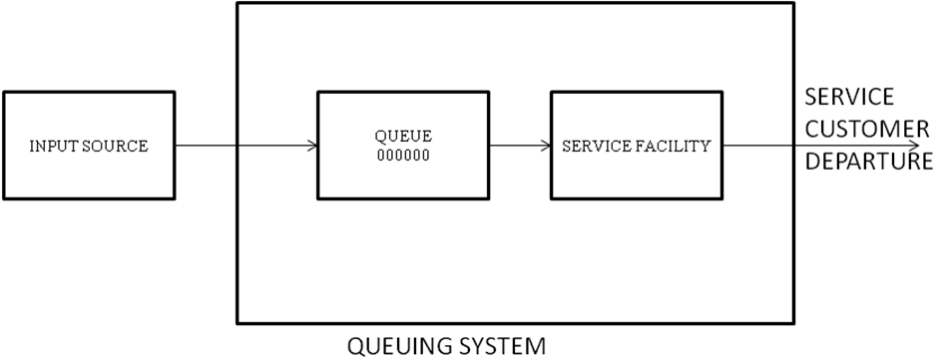
Source: Design by the researcher, 2010

Input and Output Process
Input process is known as the arrival process. Customers/patients are known as arrivals which are generated one time by an input source randomly from finite or infinite population. These Patients/customers enter the queuing system and join a queue to be served. In the hospital setting, the group of individuals from which arrivals come is referred to as the call-in population. Variations occur in this population’s size. Total patient demand requiring services from time to time constitute the size of arrival (Tutunci, 2009). At all times, a member of the patients on the queue is selected for service by some rules known as the queue discipline. The required service is then performed for the customer by the service mechanism, after which the customer leaves the queuing system (Hillier and Lieberman, 2005). The provision of services using certain rule and discharge of patients/customers is referred to as output process. An example of a brief description of input process and output process is shown below

Settings | Input Process | Output Process
Hospital | Arrival of the patient at the registration counter | Assessment, triage, provision of services, discharge
Emergency Department  Intensive Care Unit | Ambulance arrival | Assessment, triage to the inpatient setting or discharge of treatment.

An important point to be noted before proceeding with further discussion is that the most sort of health services have the capacity to serve more patients (on the average) than they are called to over the long term, so that customer waiting lines is a short term phenomenon and the employees (servers) who serve customers may be frequently inactive while they wait for the customer to arrive (Ozcan, 2006). Another fact worth mentioning here is that the key word in queuing models is “average”. It takes the average of the random numbers of patients arriving, the service time arrival intervals, et cetera. (Singh 2007).

2.2.2 Queuing System Characteristics
According to Adedayo et al (2006) and Medhi (2003), queuing phenomenon comprises of the following basic characteristics: (1) arrival characteristics; (2) the queue or the physical line itself; (3) the number of servers or service channels; (4) queue discipline; (5) service mechanism; (6) The capacity of the system; (7) departure.

Arrival Characteristics
Arrival pattern describes the behaviour of way customers’ arrivals. It is specified by the inter-arrival time between any two consecutive arrivals (Medhi, 2003). The inter-arrival time may be deterministic or stochastic in nature. Arrival can occur from unlimited population (infinite) or limited (finite or restricted population) (Adedayo et al, 2006). There are four main descriptor of arrivals as put forth by Davis et al, (2003) as shown in figure 2.2: the pattern of arrivals (whether arrivals are controllable or uncontrollable); the size of arrival units (whether the arrive occurs one at a time or in batches/bulk); the distribution pattern (whether the time between arrivals is constant or follow statistical distribution such a poisson, exponential, etc.); and the degree of patience (whether the arrival stays in line or leave).

Waiting Line or Queue
A waiting line or queue occurs when customers wait before being served because the service facility is temporarily engaged. A queue is characterized by the maximum permissible number of customers that it can contain. Queues are called infinite or finite, according to whether this number is infinite or finite (Hillier and Lieberman 2001). An infinite queue is one in which for all practical purposes, an unlimited number of customers can be held there. When the capacity is small enough that it needs to be taken into account, then the queue is called a finite queue (Hillier and Hillier, 2003). Unless specified otherwise, the adopted queuing network model in this study assumes that the queue is an infinite queue.

Figure 2.2: Arrival Characteristics in Queue
Controllable
Pattern
Uncontrollable

Size of arrival
Single
Batch/Bulk

Distribution
Constant
Exponential or Poisson
Erlang
Other

Degree of Patience
Patient (in line and stay)
Impatient
Arrive, wait and leave

Arrive, wait a while, then leave

Source: Davis et al., (2003).
Queue Discipline
The queue discipline refers to the order in which members of the queue are selected for service (Hillier and Lieberman, 2001). Winston and Albright (1997) posit that the usual queue discipline is first come, first served (FCFS or FIFO), where customers are served in order of arrival. In this study the case hospitals use FCFS queuing discipline. Although, sometimes there are other service disciplines: last come, first served (which happens sometime in case of emergencies), or service-in-random order and priority rule. Davis et al, (2003) assert that reservations first, emergencies first, highest profit customer first, largest orders first, best customers first, longest waiting time in line, and soonest promised date are other examples of queue discipline. Unless otherwise stated, the queuing model adopted in this study assumes arrival from infinite source with infinite queue and with first in first served (FCFS) queue discipline.

Service Mechanism
According to Mosek and Wilson (2001), service mechanism describes how the customer is served. In a single server system each customer is served by exactly one server, even though there may be multiple servers. In most cases, service times are random and they may vary greatly. Sometimes the service time may be similar for each job or constant. The service mechanism also describes the number of servers. A queuing system may operate with a single server or a number of parallel servers. An arrival who finds more than one free server may choose at random any one of them for receiving service. If he finds all the servers busy, he joins a queue common to all servers. The first customer from the common queue goes to the server who becomes free first (Medhi, 2003).

Capacity of the System
A system may have an infinite capacity-that is, the queue in front of the server(s) may grow to any length. Furthermore, there may be limitation of space and so when the space is filled to capacity, an arrival will not be able to join the system and will be lost to the system. The system is called a delay system or a loss system, according to whether the capacity is infinite or finite respectively (Medhi, 2003).

Departure
Once customers are served, they depart and may not likely re-enter the system to queue again. It is usually assumed that departing customers do not return into the system immediately (Adedayo, et al., 2006). Chase et al.,(2004) is of the opinion that once a customer is served, two exit fates are possible as shown in figure 2.3.
1. The customer may return to the source population and immediately become a competing candidate for service again.
2. There may be a low probability of re-service. In hospitals, departure means home discharge, admission or death (Smith and Mayhew, 2008).

Figure 2.3: Departure

Low probability of reservice

Exit

Return to source population
Source: Davis et al., (2005)

2.3.1 Types of Queuing System
There are four major types of queuing system and different combinations of the same can be adopted for complex networks. Lapin (1981) broadly categorized queuing system structures into the following.

1. Single-server, Single-phase system:
This is a situation in which single queue of customers are to be served by a single service facility (server) one after the other. An example is flu vaccination camp where a nurse practitioner is the server who does all the work (i.e. .paper work and vaccination (Singh, 2007). Dragramatically it is depicted in figure 2.4.

Figure 2.4: Single-server, Single phase System.
Arrivals Queue service facility Departures

2. Single-server, Multiple-phases System:
In this situation, there’s still a single queue but customers/patients receive more than one kind of service before departing the queuing system as shown in figure 2.5. For example, at outpatient department, patient first arrive at the registration desk, get the registration done and then wait in a queue to see a nurse for ancillary services before being seen by the consultant (physician). Patients have to join queue at each phase of the system.

Figure 2.5: Single-server, Multiple phases System

3. Multiple-servers, Single-phase System:
This is a queuing system characterized by a situation whereby there is a more than one service facility (servers) providing identical service but drawn on a single waiting line (Obamiro, 2005). An example is patient waiting to see consultants (physicians) at general outpatient department of teaching hospitals as illustrated by figure 2. 6.

Figure 2.6: Multiple-servers, Single phase System

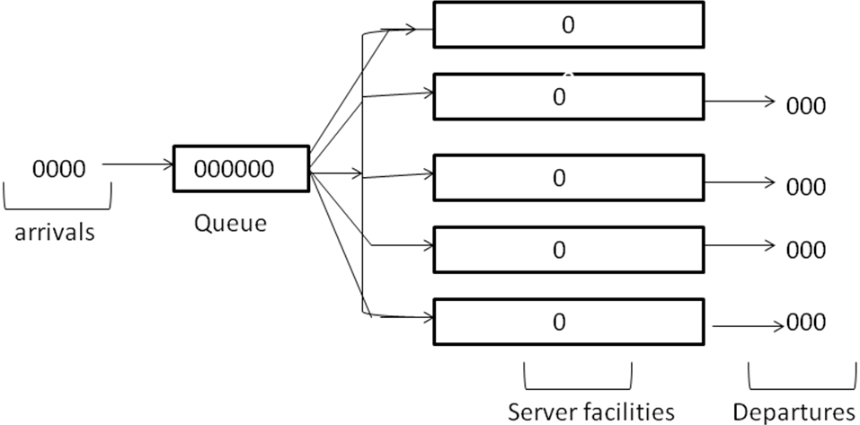

4 Multiple servers, Multiple-phases System:
According to Singh (2007), this type of system has numerous queues and a complex network of multiple phases of services involved as can be seen in figure 2.7. This is the type of queuing system adopted in this study. This type of service is typically seen in a hospital setting, multi-specialty outpatient clinics, patient first form the queue for registration, then he/she is triage for assessment, then for diagnostics, review, treatment, intervention or prescription and finally exits from the system or triage to different provider.

Figure 2.7: Multiple-servers, Multiple-phase System
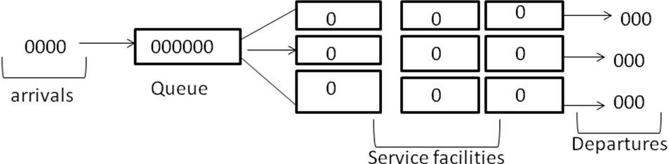

2.3.2 Queuing System Terminology and Notations
Queuing theory is a mathematical theory with its own standard terminologies and notations. Few of the basic terminology and notations used in queuing model that are relevant in this study are enumerated below;
=Average (mean) arrival rate i.e. the rate of arrivals of patients/customers at a system
=Average (mean) service rate i.e. the rate at which customers/patient could be served
Expected inter arrival time.
= Expected service time.
= system utilization factor, where s is the number of servers. The formula is usually denoted by e or rho. e or rho represents the fraction of the system’s service capacity (s) that is being utilized in the average by arriving customers/patients () (Hiller and Lieberman, 2001).
Lq = Average number of customers waiting for service = 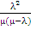 =
Wq = Average number of customers in the system (those waiting and receiving service). = or
Lq=Average time customers spent in the queue = λ
µ-λ
Ws = Average time customers spent in the system = or 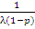
P_{O =} probability of zero customers in the system
P_{o =} 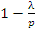 or 1
P_{n =} probability of exactly n units or customers in the system.
P(x=n) = 1(² = (1^{n}
Probability of more than n units in the system = p^{n}

2.3.3. Summary of Queuing Model Assumptions
Hiller and Hiller (2003) summarize the assumption generally made by queuing models of a basic queuing system. Each of these assumptions should not be taken for granted unless a model explicitly states otherwise.
1. Inter-arrival times are independent and identically distributed according to a specified
probability distribution.
2. All arriving customers enter the queuing system and remain there until service has been completed.
3. The queuing system has a single infinite queue, so that the queue will hold an unlimited number of customers.
4. The queue discipline is first- come, first-served.
5. The queuing system has a specified number of servers
6. Each customer is served individually by any one of the servers.
7. Services times are independent and identically distributed according to a specified probability.

2.3.4.0 Types of Queuing Models
There are at least, 40 (queuing) models based on different queue management goals and service conditions… and that it is easy to apply the wrong model, ostensibly, for lack of appropriate theoretical background (Weber, 2006). Kolker (2009) asserts that development of tractable analytic formulas is possible only if a flow of event in the system is a steady-state poisson process where the average inter-arrival time assumes a poisson distribution and service time is assumed to follow an exponential distribution. Based on the steady-state behavior and performance notations, researchers have developed many different queuing models for different cases. Few among the queuing models used most often are:

2.3.4.1 The Simple M/M/S Queue with Poisson Input and Exponential Service
In this queuing system, the arrivals occur from source in accordance with a Poisson process with perimeter λ – that is, the inter-arrival times are independent and exponential with mean 1/λ; the service times are independent and exponential with parameter μ and when the system has just a single server (S=1). The queue discipline is FCFS; the utilization factor is p_{n}= = a; λ and μ being the arrival and service rates, respectively (Medhi, 2006).

Result for the single – Server case (M/M/1)
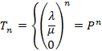 For n = 0, 1, 2……, k
For n >k
Therefore, for p≠1,1
Consequently λ<μ (i.e., that p<1) if P= <1, then
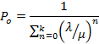
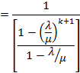
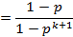
So that
f or n=0, 1, 2, …, k
Hence
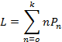
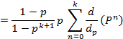
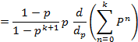
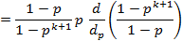
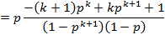
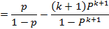
As usual (when s = 1)
Lq = L – (1-P₀)
W =

Constructing the balance equations for all the states in terms of the unknown pn probabilities, we can find probabilities for given levels by solving the equation
as shown in Table 2.1.

Table 2.1: Population Balance Equation for the birth-and-death process
State | Rate In = Rate Out
0  1  2  3  .  .  .  n-1  n  .  .  . | .  .  .  .  .  .
Source: Hillier and Lieberman, 2005; Tutuncu and Newlands, 2009

To simplify the notation, given that
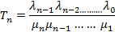
Where = 1 and n = 0
Hence, probability to achieve a given steady-state are expressed as
for n = 0, 1, 2, ……
The requirement that
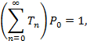
So that
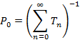
Once is calculated, , , and can be obtained from the following set of equations:
These steady-state results require the assumptions that have realistic steady-state values. This assumption is valid if for some value of n greater than the initial state. Hence, only finite numbers of states are possible. The results are valid if λ and μ are defined by expression 2 and p =
The model does not valid if

For the multiple-serve case (S>1), we have for n = 0, 1, 2… ..
n for n = 1, 2, …. S
s for n = S, S + 1
The rate diagram for the birth-and-death process for the multiple-server case is illustrated in figure 8
Where

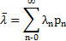

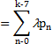

(Medhi, 2003; Hillier and Hieberman, 2005; Carter and Price, 2001.)

2.3.4.2 Multiple-Server Model with Poisson Input and Exponential Service M/M/S (S>1)
In this queuing model, arrival times are exponentially distributed with parameter , while service times are exponentially distributed with parameter . The queue discipline is FCFS, the utilization factor is p = and number of services is two and above (i.e. S>1).

Result for the Multiple-Server Case, When S>1, the factor becomes:

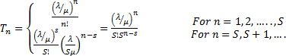
Consequently, if
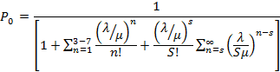
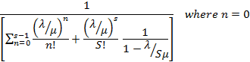
Gives the value 1 since n! = 1 when n = 0.
Using these factors, we have,
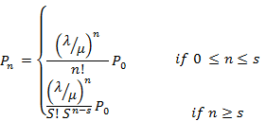
Furthermore,
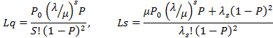
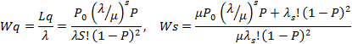
(Medhi, 2003; Hillier and Lieberman, 2005; Tutuncu, Y. and Newlands, D. 2009).

This study proposes an M/M/S within the distribution framework of poisson arrival and exponential service because it suitable for a system where priority requirement is ignored (Cheng-Hua, et al, 2006).

2.3.4.3 M/M/S/K Model (S=1): System with Finite Waiting Space
This model assumes that the system is not permitted to exceed some certain number of customers (denoted by k) – including the one being served. Any arriving customer that arrives joins the system when the queue is less than k, or refuses entry when the system is full and is lost to the system. A queue with limited waiting space is known as queue with finite buffer (Medhi, 2003; Hillier and Lieberman, 2005; Taha, 2005).
At the point of loss to the system, the mean arrival rate becomes zero. Therefore the only one adjustment in the M/M/S model to introduce a finite queue is to change parameter to
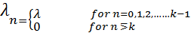

Since for some values of n, a queuing system that fit this model always will eventually reach a steady-state condition, even when , literally, this model implies arriving patients or customers will not join the system and “take their business elsewhere” whenever the queue is full.

Result for the M/M/I/K
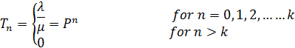

Consequently, if
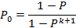
So that
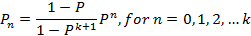
Therefore, after derivation;
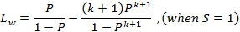
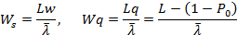
Where,
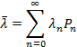
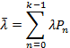

Result for M/M/S/K (S1)
This model does not allow more than k customers in the system. Therefore, k is the maximum number of servers that is allowed. Since S1, becomes
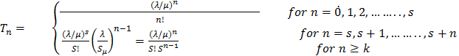
Hence,
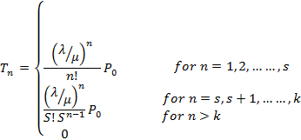
Where
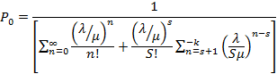
Using the derivation of Lq for the M/M/S model to this case yields
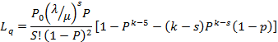
Where
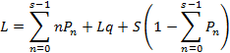 (Hilher and Liberman, 2005; Medhi, 2003; Winston and Albright, 1997).

2.3.4.4 Finite Source Model of the M/M/S Model
In this queuing model, it is assumed that the input source (calling population) is limited or finite. This is against the general assumption of most models that the arrival rate to the system is infinite or unlimited. For this case, let N denote the size of the calling population. Thus, when the number of customers in the queuing system is n (n=0, 1, 2…, N), there are only N-n potential customers remaining in the input source. This model is mostly found applicable in machine repair problem (i.e. it is called machine repair model). It is a birth-death model with:
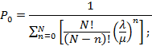
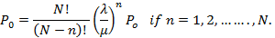
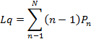
This can be reduced to
,
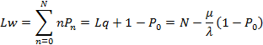
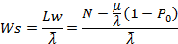
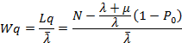
Where

Steady-State Results for Multiple-Server Case (S>1).
For
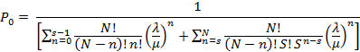
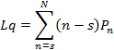
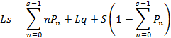
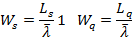

2.3.4.5 M/M/∞ Model: Exponential Model with an Infinite Number of Servers.
This exponential model has an infinite number of servers. This type of model is commonly found in a service facility with provision of self-service. Such model can also be proposed for service centres where any loss to the system can result to death of the customer. A refusal of patient to emergency departments and intensive care unit of a hospital can lead to the death of patient due to the peculiarity of the resources (Beds, personnel) that are not available in other departments. Therefore, proposing exponential model with an infinite number of services M/M/∞ is the better for such system. Based on this premise, the study proposed M/M/∞ as one of the models to measure the impact of fluctuation in patient arrival rate and variation of length of stay over bed allocation (optimization). The available steady-state results are given below:
The situation is given by
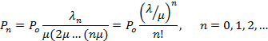
With the resulting derivation, 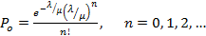

Expected response time = . This result holds irrespective of the magnitude of . (Medhi, 2003). Newell (1982) and Medhi (2003) discuss advanced aspect of this model.

2.3.4.6 M/M/S/C System: Erlang Loss Model.
Erlang Loss Model assumes Poisson arrival process, that is, exponentially distributed inter-arrival times and exponential service time requirement. It is a multiple-server model (S-server) with c-channels. Customer who arrives when c-channels are busy leaves the system without waiting for service. The reason for the term loss is that there is no waiting room at all. The model was called Erlang Loss Model; it was first investigated by Erlang (Medhi, 2003; Hillier and Lieberman, 2005). The summary of the results for Erlang loss model are:
After derivation
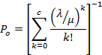
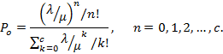
The stated formula is known as Erlang’s first formula. An arriving customer is lost to the system when he finds on arrival that all the channels are busy. The probability of this event is
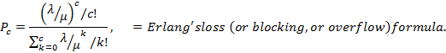

A system in which customers have to leave when the space is full because of limited waiting space is called a loss system, whereas a system where all the arriving customers can wait (because of unlimited waiting space) is called a delay system. In a loss system, blocked customers or patients (who arrive when the space is full) are said to be turned away, rejected, or cleared (Medhi, 2003). Based on these features which are similar to what happen in emergency departments and intensive care units, this model (delay system) is proposed in this study to model patient flow in the selected clinics.

As asserted by literature, there are several queuing models (at least 40 models) (Kolker, 2009), but this study focuses on those models that are relevant to the queuing problems in Nigeria’s Public teaching Hospitals. Few among other queuing models are M/G/I, M/D/S, priority models (non pre-emptive and pre-emptive priorities), etc.

2.3.5 Performance Measures (parameters) of a Queuing System
Stafford (2004), Hillier and Lieberman (2005), Carter and Price (2001), etc., put forth the following performance parameters in a queuing system:
- λ _{n} = mean arrival rate ( expected number of arrivals per unit time) of new customer when n customers are in the system
- μ_{n} = mean service rate for overall system (expected number of customers completing
service per unit time) when n customers are in system.
- s = represents number of servers
- System Utilization: System Utilization is the ratio of system capacity used to available
capacity. It measures the average time the system is busy.
- Mean Number in the system (Ls or N(t)): Mean number in the system is the average number of system users (entities) in the system; it includes those in the queue and those being served by the server(s).
- Mean Number in Queue (Lq): Mean number in the queue is the average or expected number of system users (patients) in the queue (waiting line), waiting for their turn to be served.
- Mean Time in System (Ws): Mean time in the system is the expected value or average waiting time an entity (patients) will spend in the queuing system. It includes the average time waiting for service to begin and the average service time.
- Mean Time in Queue (Wq): Mean time in the queue is the expected value or average time an entity will spend in the queue, waiting for service to begin.
- Probability of n in the system (P^{n}): This is the probability that there are exactly n entities in the system (queue and serving mechanism together) at a point in time.
- Probability of waiting (pw): This is the probability that an arrival will have to wait for its service to begin.

From the above complete description of queuing performance parameters, the problems studied in queuing theory may be grouped as (Medhi, 2003):
1. Stochastic behaviour of various random variables, or stochastic processes that arise, and evaluation of the related performance measures;
2. Method of solution: exact, transform, algorithmic, asymptotic, numerical, approximations, etc.
3. Nature of solution: time dependent, limiting form, etc.,
4. Control and design of queues: comparison of behaviour and performance under various situations, as well as queue disciplines, service rules, strategies, etc., and
5. Optimization of specific objective functions involving performance measures, associated cost functions, etc.
2.3.6 Birth-and-Death Processes
In the context of queuing theory (Hillier and Lieberman, 2005; Carter and Price, 2001; etc.), the term birth refers to the arrival of a new customer into the queuing system, and death refers to the departure of a served customer. Only one birth or death may occur at a time: therefore, transitions always occur to the “next higher” or “next lower” state. The rates at which births and deaths occur are prescribed precisely by the parameters of the exponential distributions that describe the arrival and service patterns. All the possible transitions can be illustrated in the rate diagram in figure 2.8. The state of the system at time t (t≥0), denoted by N(t), is the number of customers in the queuing system at time t. The birth-and-death process describes probabilistically how N(t) changes as t increases. More precisely, the assumptions of the birth-and-death process are the followings:
Assumption 1. Given N(t) = n, the current probability distribution of the remaining time until next birth (arrival) is exponential with parameter λ _{n} (n = 0, 1, 2,…).
Assumption 2. Given N(t) = n, the current probability distribution of the remaining time until the next death (service completion) is exponential with parameter (n = 1, 2, …).
Assumption 3. The random variable of assumption 1 (the remaining time until the next birth) and random variable of assumption 2 (the remaining time until the next death) are mutually dependent. Furthermore, an arrival causes a transition from state n into sate n+1, and the completion of a service changes the system’s state from n to n-1. No other transitions are considered possible. This birth-and-death process illustration as shown in the figure 2.8 leads directly to the formulae that measure the performance of this queuing system.

Figure 2.8: Rate Diagram for the Birth-and-Death Process
₀
₁
_{n-1}
_{n}

₁
₂
_{n}
_{n+1}

0
1
2
n-1
n
n+1
…

Source: Adapted from Taha (2003).

A fundamental flaw in the birth-and-death process structure is a reliance on equilibrium between birth and death rates. This assumes the overall population shall remain constant at long run (Tutuncu and Newlands, 2009). The approach is based on the rate-equality principle (Medhi, 2005) or balanced population model.
Rate-Equality Principle states that the rate at which a process enters a state n (≥0) equals the rate which the process leaves that state n. In other words, the rate of entering and the rate of leaving a particular state are the same for every state.
Rate in = rate out principle (Medhi, 2005). This principle implies that for any state of the system can be expressed by an equation which is called the balance equation for state n (n = 0, 1, 2…), and mean entering rate = mean leaving rate

Transient and Steady-State Behaviour
The development of the generalised model on queuing system is based on the long-run or steady-state condition of the queuing situation, which is achieved after the system has been in operation for a sufficiently long time (Taha, 2005). When a queuing system has recently begun operation, the state of the system (number of customers in the system) will be greatly affected by the initial state and by the time that has since elapsed, the system is said to be in a transient condition. Transient condition occurs during the early operation of the system. However, after sufficient time has elapsed, the state of the system becomes essentially independent of the initial state and the elapsed time. The system has now essentially reached a steady-state condition, where the probability distribution of the state of the system remains the same over time (Hillier and Lieberman, 2005).

Due to the mathematical difficulty of analysing transient condition or short-run behaviour (Winston and Albright, 1997), the study focuses on steady-state condition of the emergency departments and intensive care units of the selected Hospitals. One requirement for any steady-state analysis is that parameters of the system remain constant for the entire time period. In particular, the arrival rate must remain constant. Another requirement for steady-state analysis is that the system must be stable. Basically, this means that the servers must serve fast enough to keep up with arrivals; otherwise, the queue could theoretically grow without limit (Winston and Albright, 1997).
The idea of modeling the health care system as queuing system is, of course, by no means new (Fiems et al., 1976; Cochran, 2004, Au-Yeung et al, 2006). A number of studies have been done on patient flow in hospitals in general (Davis and Davis, 1994; Cote and Stein, 2000) and Emergency departments (Coats and Michalis, 2001; Mayhew and Carney-Jones, 2003; Yoon et al, 2003; Delia, 2007; Creemers and Lambrecht, 2007) and Intensive care unit in particular (Seema et al, 2000; McManus, et al, 2004; Litvak, Rijsbergen, Boucherie and Houdenhoven, 2006). But there are limited studies on modeling patient flow and resource allocation in emergency department and intensive care unit using queuing network model under two different models; (i) M/M/∞ and (ii) M/M/C/C of Kendall notations. Also, none had been applied to determine the patient flows and resource allocation (optimal beds) in Emergency department and intensive care unit in Nigerian public teaching hospitals.

2. 4.1 Queuing Network Model
Most real life queuing systems have more than one service facility (Shaler, 2002).The output of one facility may proceed to another facility for further processing, or return to facility already visited for rework or additional work of a different type. Applications abound in diverse areas, such as hospital-care centres, assembly lines flow shops, and job shops in manufacturing, traffic flow in a network of highways, client server computer systems, telecommunication system, and airport terminals. Therefore a queuing model which composes of a set of linked queues called stations (i.e. multiple stations) is called a queuing network model. Queuing network is a version of queuing model that deals with analysis of patients or customers that require more than one service from different service facilities one after the other, and they have to queue up for service before each of the servers.

Cochran and Bharti (2006) were of the opinion that a queuing network analysis is a branch of applied probability and operational research that studies networks where there are a number of service nodes for entities. The service nodes include waiting in a ‘queue’ whenever the server is busy. Entities advance from one queue to another on the basis of routing probabilities. Networks in which entities enter the system from outside and subsequently exit the system are known as open Jackson networks. Queuing theory provides exact or approximate estimation of performance measures for such systems based upon specific probability assumptions. If arrivals to the queues in the network follow a poisson process, the service times are exponentially distributed, flow is always forward (no feedback), and behaviour is homogenous (does not depend on time), then solutions are exact. In an hospital there assumptions rarely hold, and so results are approximate (Cochran and Bharti ,2006). See example of a queuing network in figure 2.9. A variety of queuing network frameworks have been developed to represent various system mechanisms .The system in a network model is characterized by:
a. An open or a closed system, and
b. Linkage of station (tandem, arbitrarily linked with or without feedback flow) (Koizumi, 2002). As in a single server station model, each station in network system owns characteristics including, (i) inter-arrival times, (ii) service times, (iii) the number of servers (iv) the maximum capacity of station, and, (v) queue discipline. In a queuing network model, waiting spaces between stations (i.e. part of each station’s “capacity”) are expressed as “buffer”.

Figure 2.9: Examples of a Network of Queues
C D

A B E

2.4.2 Closed Network Model versus Open Network Model
In a closed queuing network, a fixed number of entities (i.e. customers, patients, and jobs) circulate in the network indefinitely, there is no external input or departure from the network (Gordon and Newell, 1967).They considered a closed network of Markovian queues, in which a fixed and finite number of customers—K circulate through the network, there being no external input or departure from the network (Medhi,2003). In other words, a closed network system is always full, that is, a discharge from the system is immediately replaced by an admission. Such condition is reasonable for hospital departments that usually run at full occupancy level (Xie et al, 2007).

In an open network model, customers or patients join the network from outside or arrivals arise from an infinite population, receive service at one or more stations, and eventually leave the network. Thus, there may be a randomly change in the population of open network model with different levels of inflows and outflows from the system at different points in time. The decision to use either an open or closed network model depends on whether the congestion levels at a possible location of the entities or patients are controllable by management, policy makers or researchers focus. If the congestion of any particular station is beyond control by management, policymakers or is not the researcher’s focus, the predicted congestion level and the associated information regarding the station would be of little value. Thus, those stations are normally treated as external stations to prevent the model from becoming unnecessarily complex (Koizumi, 2002).The patients flow to these stations represent those departures from the system, assuring an open model as opposed to a closed model.

In “queues in tandem”, the input for each queue except the first is the output of the previous queue (William, 2000), that is, input always flows in a single direction from one station to the next. Entities also enter the system through the most “downstream” station (Koizumi, 2002). Figure 2.10 shows a simple tandem queuing model.

Figure 2. 10: Simple Tandem Queuing Model
λ λ λ

Station 4

Station 1
Station 1

Station 2
µµµµµµµi
Λstati Station 3

In a “queuing network model”, there may be multiple entries and exit points, and entities can optionally skip servers. A queuing network model can further be categorized into two groups depending on whether or not the system has feedback flow. Figure 2.11A and figure 2-11B show the example of an open network model with different flow configurations.

Figure 2.11A: An open Queuing Network Model with Feed- Forward Flows
Server 1
Server3
Server 2

Figure 2.11B: An open Queuing Network Model with Feed- Backward Flows
Server 2
Server 1
Server 3

Modeling complex systems using queuing network model allows us to better understand their behaviours, to estimate and ultimately to improve their performances (Osorio and Bierlaire, 2006). Considering a network of hospitals with different units, each unit is modeled as a specific queue and where it is the patient flow that is the main focus. For such a network, understanding the correlation between the occupation of the different units (e, g. surgical intensive care, and surgical intermediate care) can help avoid bed blocking and improve a patient recovery procedure (Osorio and Bierlaire, 2006).

2.5.1 Jackson Networks
Jackson (1957, 1963), Koenigsberg (1958), made early and notable contributions and application of queuing network models. A Jackson model is probably the most researched and widely applied network model in various fields, including the healthcare field (Koizumi, 2002). Jackson’s major contribution was to find a ‘product-form’ steady state solution for open and closed models with a tandem or a feed-forward flow configuration (Koizumi, 2002).
The characteristics of a Jackson network are the same assumed for a system of infinite capacity for all queues in series, except now, the customers visit the facilities in different order (and may not visit them all) (Hiller and Lieberman, 2001). For each facility, its arriving customers come from both outside the system (according to a Poisson process) and the other facilities (inside). These characteristics are summarized below:
A Jackson network is a system of m service facilities where facility i (i =1, 2… m) have the following characteristics:
- An infinite queue capacity. But Osorio and Bielaire (2007) assert that for real systems this infinite capacity assumption does not hold but is often maintained due to the difficulty of grasping the between-queue correlation of finite capacity networks.
- Customers arriving from outside the system according to a Poisson input process with parameter a_{i}
- S_{i} servers with an exponential service-time distribution with parameter µ
A customer leaving facility i is routed next to facility j (j = 1, 2, 3, 4… m) with joint probability pij or departs the system with probability
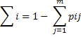
According to Koizumi (2002), in a network model, various numbers of entities can exist at multiple stations and the state of the system is described by the Joint probability for the number of entities at each station. Symbolically, this is denoted as pr (N₁= n₁, N₂= n₂… N_{k}=n_{k}) = pn₁, pn₂ ….pn_{k}, where the number of entities at station i is denoted as n_{i} and the system consists of k stations in total. Jackson showed that the following relationship must hold for a single-server model under certain assumptions:
Pn₁, pn2… pnk = nk

In the equation, p_{i} is the ratio of arrival to service rates from station i and is known as the “Traffic Intensity” in queuing theory.(1- p)_{j}^{n} is the solution of a single- server single-station model and is equal to the probability of n_{i} patients being at station i. Thus, the joint probability that is expressed using the product-form indicates that the states of the systems act as if they are mutually independent. For this reason, the open Jackson network model allows us to analyse individual service facilities within the system separately i.e. independently from the others. Therefore, analysis of the ICU servers (beds) within the emergency department and within the hospital system is justified.
Jackson network model has the following key properties:
- inter-arrival times to the system are independently and identically distributed (IID) random variables following an exponential distribution.
- Service times at each station are IID random variables that follow an exponential distribution.
- The probability of a patient moving from one station to another is fixed (routing probability).
- No limitation in the number of patients/customers allowed in the queue between service facilities.
- Under steady-state conditions, the mean arrival rate is smaller than the mean service rate at each server (equivalently, pi < 1).
It is important to note that the internal arrival pattern in the Jackson model is fundamentally related to Equivalence property propounded by Burke (1956) which assumes that a service facility with s servers and an infinite queue has a Poisson input with parameter λ and the same exponential service-time distribution with parameter µ for each server (M/M/S model), where sµ > λ. Then the steady-state output of this service facility is also a Poisson process with parameter λ (Hiller and Lieberman, 2001). Put differently by Koizumi (2002), Burke demonstrated that the output distribution from a station is identical to the input distribution, as long as (a) the input rate to the station is possion (b) service time at the station is exponential; and (c) there is no restriction on exiting station.

2.5.2 Queuing Theory with Blocking
Theoretically, ‘blocking’ occurs when waiting spaces between stations are finite (i.e. finite buffers) (Koizumi et al, 2005). Queuing networks with finite buffers have received much attention in the past few years (Dallery and Frein, 1991). The study of a finite buffer between two stations was done by G. C Hunt (1956). He investigated a network of single server queues based on Markov Chains with possion arrival rates and exponential service times. His model developed exact solutions and thus the probabilities of all possible states at the two stations are obtained. It is worth knowing that the exact analyses of finite queuing network (FCON) models are limited to very small network. But, for a large and complex network, i.e. if the networks of interest have many stations and / or many servers, their analysis is done by approximation methods. One of the most well known approximation method decomposes the network into smaller subsystems, analyse each subsystem in isolation, and uses subsystem results to analysis the overall network (Koizumi et al 2005).

The most commonly used decomposition method is single station decomposition, which date back to the work of Hillier and Boling (1967), who considered tandem single server networks (Osorio and Bierlaira 2007). Other categories of developing approximation to evaluate performance measures are:
- Diffusion approximation, (ii) Mean value analysis, (iii) Operational analysis
Bitran and Tirupati (1988) assert that the lack of success in obtaining exact solution for general networks has motivated researchers to develop approximations to evaluate performance measure (Takahashi et al, 1990; Korporaal et al, 2000; Koizumi, 2002; Koizumi et al, 2005).

There is an abundance of evidence on healthcare studies that apply queuing theory with blocking. Few among them are; El-Darzi et al, (1998), koizumi et al (2005), Cochran and Bharti (2006). Arnoud et al, (2006) focus on the analysis of the congestion in geriatric patient flows in a hospital system in UK. Koizumi et al (2005) analyzed the congested patient flows in mental health systems while Cochran and Bharti (2006) analysed hospital bed planning under peak loading. Furthermore, Arnoud et al (2006) modelled the emergency cardiac in-patient flow and determine the optimal bed. The model framework uses Erlang loss model or M/M/C.K in Kendall’s notation which is similar to what is to be used in this study. In this study, queuing Network Analysis (QNA) similar to the work of Cochran and Bharti (2006) shall be included.

2.5.3 Blocking Types
Different blocking types have been defined by researchers to represent different system behaviours. According to Haghighi and Mishall (2006); Balsamo et al, (2002), the three types of the most commonly used blocking types are;
- Blocking After Service (BAS);(Type- 1 blocking),
- Blocking Before service (BBS);(Type- 2 blocking)
- Repetitive- service blocking (Type – 3 blocking).
Blocking after Service (BAS): Blocking after service occurs when a patient wants to go from station i to station j and station j is full, then station i will be blocked. As a result of this, the service in that station may stop until a space becomes available for the task to move on to station j.
Blocking Before Service (BBS); This occurs when a patient i declares its destination say station j, prior to starting service and station j becomes blocked and service stop until a space becomes available in station j (Highighi and Michell, 2006).
Repetitive Service blocking (RS): A job upon completion of its service at queue i attempts to enter destination queue j. if node j is full, the job is looped back into the sending queue i, where it receives a new independent service according to the service discipline (Balsamo et al 2002).
Literatures have shown that several studies have been done in these types of blocking. Perrov (1989) discusses the comparison of the types of blocking. Balsamo and Bernado (2002) experience the three types of blocking in their study of heterogeneous queuing network with blocking. Most of the studies in blocking models in the literature are of the blocking-after-service type. This current study will make use of blocking-after-service to model the intensive care unit resources (i.e. optimal beds allocation).

2.5.4 Limitations of Queuing Theory
Queuing models have several limitations and are used in conjunction with the other decision analysis tools such as Simulation, Regression, Markov Chains, etc (Singh, 2007). Some of the limitations are the basic assumptions for the application of queuing models and according to Singh, (2007) they include, inter alia, the following:
- Takes average of all variables rather than the real numbers
- Assumes steady state situation in most cases of queuing system
- Based on assumption that service time is known
- Service rate is greater than arrival rate
- Service times are described by the negative exponential probability distribution.

2. 6.0 Conceptual Framework
2.6.1 Hospital Patient Flow
One of the major elements in improving efficiency in the delivery of health care services is patient flow (Murray, 2000). The movement of the patients through different hospital wards and sections is called patient flow. Patient flow is one of the most important parameters that directly affect the capacity analysis of critical hospital resources. In classical terms, patient flow analysis is used for planning health services (Davies and Davies, 1994). Patient flow represents the ability of the health care system to serve patients quickly and efficiently as they move through stages of care. When the system works well, patient flows, is seamless, meaning that each stage is completed with minimal delay. When the system is broken, patients accumulate like a reservoir, as in the chronic delays experienced in many cities emergency departments. Good patient flow means that patient queuing is minimized; poor patient flow means that patients suffer considerable queuing delays (Hall, 2006). In other words, patient flow represents the progression of a patient’s health status. As such, an understanding of patient flow can offer education and insight to health care providers, administrators and patients about the health care needs associated with medical concerns like disease progression or recovery status (Murray, 2000).

From an operational perspective, patient flow can be thought of as the movement of patients through a set of locations in a health care facility. Then, effective resource allocation and capacity planning are contingent upon patient flow because in aggregate, it is equivalent to the demand for health care services (Murray, 2000). Patient flow in health care system is a complex queuing network as earlier mentioned, in which delays can be managed or reduced through;
- Synchronization of work among service centre (e.g. co-ordination of patient registration, examining, tests, treatment, and discharge procedures).
- Scheduling of personnel (such as doctors and nurses) and other resources (i.e. beds, scanning machine, etc)
- Constant system monitoring (e.g. tracking number of patients waiting by location, diagnostic grouping etc) linked to urgent actions.

2. 6.2 Attributes of Patient Flow
According to Murray (2000), patient flow can be described by one of two complementary approaches: clinical or operational. Regardless of approach, all patient flows share four common characteristics: (1) an entrance, (2) an exit, (3) a path connecting the entrance to the exit, and (4) the random nature of the health care elements. Obviously, patient flow begins at that point when a patient is first diagnosed with a particular medical condition, or where the patient first enters or is admitted to a health care facility. Between these two points is set of conditions, activities, services, or location that the patient may encounter. Within these points, the patient requires a variety of health care resources (e.g, beds, examining rooms, physicians, nurses, or medical procedures). This implies that patient flow can be depicted as a complex queuing network as shown in figure 2.12.

Figure 2.12: A typical Hospital Patient Flow
PATIENT TYPE LEVEL
WAIT/REGISTER
TRACE
ED PATIENTS
DISCHARGED?
EXIT
YES
ADMITTED
BED ASSIGNM
ED BED WAITING
BED TRANSFER
ADMITTED
OPERATING ROOM
MED-SURG-ONCO-ORTHO
STEP
DOWN
WOMEN/
CHILD
INTENSIVE
CARE UNIT

PACU
EXIT

DIAGNOSIS
ARRIVAL
ARRIVAL
MAIN
HOSPITAL
ENTRACE
PATIENTS
CONSULTATION
PATIENT TYPE

Source: Adapted from Murray, 2000.

Given the large scale and complexity of LUTH and OOUTH, a similar patient flow diagram of the whole type was presented in figure 2.12 requires experts’ input and data from medical record.

2.6.3 Capacity Management of Emergency Department and Intensive Care Unit
Capacity management means the planning and controlling of the critical hospital resource(s). Critical hospital resources refer to both simple and complex resources such as beds, experienced trauma leaders, surgeons, emergency physicians, etc., that are limited resources to hospital operation (Geranmayeh and Iyer, 2009). Planning capacity levels in a health care organization requires balancing two conflicting goals: low capacity costs and high service levels. High capacity level help reduce patient waiting time, doctor and staff workloads, and congestion in the facility, but usually result in high capacity costs. Operating with less capacity reduces costs, but increases patient waiting time and the workload of doctor and other staff. The problem is further complicated by the stochastic nature of health care systems. In particular, there is uncertainty in how long it takes to provide service to a patient and the fact that patients may arrive late, or not at all (Bretthauer and Cote, 1998).

To satisfy patients’ needs and organize departments, hospital managers periodically review tactical and strategic plans for anticipated bed capacity. The objective is to define requirements for months and years ahead. In most of the cases, patients’ arrival times appear to vary randomly and their length of stay are a function of various internal and external influences and constraints (Yoon, et al, 2003; Tutuncu and Newlands, 2009). Hence, the factors that influence bed capacity planning can be modeled stochastically. A stochastic variable construction of the health care process increases the model complexity. Estimating ranges, probabilities and limiting values are required. This in turn makes the determination of the optimum bed capacity, measured via utilization for a time period, more problematic. In order to overcome these difficulties some hospitals keep their bed capacity sufficiently large to cater for the periodic fluctuations. This approach reduces inbound registration delays, turning away walk-in patients, and transfers to other health care sites are kept minimal. Typically, the occupancy level decreases as the bed capacity increases. Keeping more beds and staff active on a just-in-case basis (uncontrolled bed capacity) incurs extra hospital costs as a result of constantly available additional service provision required only for emergency situations. Governments, Policy makers, hospital administrators will perceive that the cost to benefit ratio is unjustified and provision should be made to meet reliable and forecastable demand estimates. Hence, hospital management perceives it as vital to estimate the optimum bed capacity for any period through the year (Tutuncu and Newlands, 2009). Since the focus of the study is on the emergency department and intensive care unit, therefore the capacity management will not be that of entire university but on the focus clinics.

2.6.4 Emergency Department
Emergency department (ED) utilization has been growing rapidly in the United States and other parts of world (Yoon, et al. 2003; McCaig and Burt, 2004). Much of this growth associated with ED visits for conditions that are either non-emergent or treatable in primary settings (Cunningham and May, 2003). This trend has implications beyond the ED as it signals problems or dissatisfaction with the performance and accessibility of local primary care delivery systems (Billings et al., 2000).

Institute of Medicine (2006) reports serious problems confronting hospital ED’s across the nation as overcrowding (Delia, 2007). According to the Crowding Resources Task Force (2002), Emergency department crowding refers to:
“A situation in which the identified need for emergency services outstrips available resources in the ED. This situation occurs in hospital EDs when there are more patients than staffed ED treatment beds and wait times exceed a reasonable period. Crowding typically involves patients being monitored in nontreatment areas (e.g. hallways) and awaiting ED treatment beds or inpatient beds”.
Overcrowded emergency departments, prolonged waiting times, patient care delays and scarce resources are common themes in current teaching hospitals (Yoon, et al., 2003). Overcrowded ED has become a major barrier to receiving timely emergency care. Patients who present to EDs often face long waiting times to be treated and, for those who require admission, even longer wait for an inpatient hospital bed (Asplin, et al., 2003). The reasons of overcrowding are; “boarding” in the ED until an inpatient bed becomes available (Henry, 2001; Delia, 2007) and excessive wait times for medical care. These keep patients in ED beds, on stretchers placed in hallways, or in ‘observation’ areas with little if any regard for privacy, dignity or personal hygiene for hours and several days. These patients, while waiting to be transferred to the hospital, occupy the spaces for other patients who need “emergent evaluation of treatment” (Henry, 2001). The regular occurrence of ED overcrowding raises concern about the hospital sector’s ability to respond to a mass casualty event such as an oil disaster, plane crash, ethic war victims and fatal accidents involving vehicles (Delia, 2007). Overcrowded ED’s also create an environment where medical errors are more likely and overall quality of care is below its potential (ICAHO, 2004). In foreign hospitals, to prevent further congestion, the ED often declares diversion, and asks ambulances to find alternate treatment facilities for their patient. As a result, “the ability of the hospital to provide emergency care to its community and serve its role in the emergency medical services (EMS) is lost” (Caglar, 2003). The overcrowding situation is more prevalent in Nigerian Teaching Hospitals because there is no provision for ambulance diversion. That is, in the event of natural disaster like ethnic war and oil vandals, patients are admitted on the floor or any available open space and some patients are rejected or send to primary health care centres of private hospitals that lack the required equipment and personnel.

In response to potential problems facing EDs in Nigerian Teaching Hospitals, this research was undertaken to address the problem of bed capacity and model patient flow within the emergency department and intensive care unit. To solve the problem of mismatches of larger supply and demand that result to overcrowded ED, we proposed a conceptual model of ED (similar to Asplin, et al., 2003 and Delia’s, 2007, studies) that will be helpful to researchers, hospital administrators, policy makers to understand the cause, effect and proffer solution to ED overcrowding.

2.6.5 Emergency Department Input, Throughput, Output Model
ED input compound consists of any “condition, event, or system characteristic that contributes to demand for ED’s services.” Input includes demand for emergency care, urgent care, and safety net care (Delia, 2007). Recently, hospital ED’s across the nation have seen an increase in the demand for emergency services. Much of this demand occurs in rapidly growing cities such as Lagos, Sagamu, Abeokuta, Ibadan, Abuja, Zaria, Kaduna, etc. As asserted in the literature, the use of the ED for non-urgent care contributes greatly to the growth of ED. Another contributor comes from the doctors who refer patients to the ED in ambiguous cases to avoid liability risks, or when they do not have the ability to perform recommended tests in their offices (Berenson et al., 2003; Studdert et al., 2005).

ED throughput section of the model identifies patient length of stay in the ED as a potential contributing factor to ED overcrowding. This part of the model highlights the need to look internally at ED care processes and modify them as needed to improve their efficiency and effectiveness, especially those that have the largest effect on length of stay and resource use in the ED (Asplin et al.203).
Output component refers to the discharge of patients from the ED to the next phase of care as appropriate. Depending on the medical circumstances, the discharge may be to other wards, ICU, home with follow-up care, et cetera. The inefficient disposition of ED patients contributes to crowding for admitted and discharged patients (Asplin et al., 2003). This manifests itself in the form of bottlenecks in the ED and ultimately ED overcrowding (Delia, 2003). One of the most commonly cited output bottlenecks facing the ED is the lack of available inpatient beds, especially intensive care unit beds (Derlet and Richard, 2000; Lewin Group, 2002). This is one of the motivating factors for this study.

Figure 2.13 In-patient Flow Throughout Emergency Department

Figure 2.13: In-patient Flow Throughout Emergency Department

Patient arrives at ED
Diagnostic evaluation and ED treatment
ED boarding of inpatients
Leaves without treatment complete
Patient disposition
Lack of available staffed inpatient beds
Ambulatory care system
Transfer to other facility (eg, skilled nursing, referral hospital)
Admit to hospital
Lack of access to follow-up care
Input
Throughput
Output
Triage and room placement
Emergence care

* Seriously ill and injured patients from the community
*Referral of patients with emergency conditions
Ambulance
Diversion
Demand for ED care
Unscheduled urgent care

* Lack of capacity for unscheduled care in the ambulatory care system
* Desire for immediate care (eg, convenience, conflicts with job, family duties)
ACUTE CARE SYSTEM

2.6.6 Intensive Care Unit
An Intensive Care Unit (ICU) is a specific part of a hospital that provides one-to-one nursing
care patients requiring special attention (Vohra et al., 2000), or care of the sickest and most unstable patients in a given hospital (Chan et al, 2009). Litvak et al. (2006) assert that ICU is a clinic in the hospital that provides specific medical treatment and nursing to severely ill patients who require very close monitoring, mostly elaborate treatment and in many cases support with artificial ventilation. The idea of ICU originated during the poliomyelitis epidemics in the 1950s, when polio patients were managed in a specific part of the hospital and received one-to-one nursing care. From then on, there was a gradual development in this concept, until the ICU was a recognizable component of most general hospitals. Currently, new ICUs are special nursing units designed, equipped and staffed with especially skilled personnel for treating critically ill patients or those requiring specialized care and equipment (Vohra et al., 2000 Chan et al, 2009). With the advancement in medical care and the availability of facilities for highly specialized treatments, separate sophisticated ICUs are available for admitting patients according to their age, surgical procedures, diagnosis (Vohra et al. 2000).

As indicated in the literature, the common clinics in intensive care unit are; Pediatric Intensive Care Unit (PICU), where neonates and children cases are treated, Coronary Intensive Care Unit (CICU) handles patients with acute cardiac conditions. Emergency patients suffering coma, shock, convulsion and other related diseases are treated in Medical Intensive Care Unit (MICU), while Surgical Intensive Care Unit (SICU) and Neuro-Intensive Care Unit (NICU) care for post-surgical patients and patients with epilepsy, head injury and paralysis. The admission and discharge of a patient in the ICU is subject to certain rules. There are, however, no unambiguous agreements on how to deal with an arriving patient when no operational ICU bed is available (Litvak et al., 2006).

Capacity management in an ICU involves optimal utilization of available resources (beds, doctors, nursing staff, equipment and operating theatre) (Vohra et al. 2000). The bed of an ICU is a scarce and non-interchangeable expensive resource that needs serious attention considering the limited budgets. Of course, not all decisions affecting ICU patients are made within the unit itself. Demand for ICU beds comes from internal and external emergency, add-on and planned (so-called elective) procedures and from the wards. Emergency and add-on procedures are random and cannot be scheduled in advance. Although planned procedures are scheduled ahead of time, they are often scheduled for the daily block-time driven mostly by physicians’ priorities. Usually, elective surgery scheduling does not take into account the competing demand for ICU beds from ED and add-on cases. This leads invariably to a typical example of a system bottleneck caused by the interdependency and competing demands between patient flows from different subsystems in a complex system: the upstream problem (ED closure, diversion or queuing) is created by the downstream problem (no ICU beds). Needless to say, medical errors and reduction of quality of care may result (Troy et al., 2008). In the opinion of Litvak et al. (2006), typical solutions in case of bed shortage include transferring a patient to another hospital; postponing a planned operation; and releasing another patient earlier. These solutions have serious drawbacks, and they also depend on the patients’ class. Patients arriving at an ICU are of three classes, which mainly differ in the decision for admittance to the ICU. An elective patient requires an ICU bed following a planned operation. A planned operation can start only when an ICU bed is available. When all ICU beds are occupied, the so-called over-bed is created. An over-bed is an originally non-staffed bed which is forcefully brought into operation thus loading the staff with an extra patient. This results in a decreased level of care at the ICU. A trauma patient as a result of accident is accepted only when an ICU bed is available. Otherwise the patient is not admitted and sent to another ICU. The challenge of the over-bed is that physicians and nurses have to work harder as they have an extra patient to take care of, which requires flexible staffing and often negatively affects the quality of care (Litvak et al., 2006).

The estimation and forecasting of the number of beds required in an ICU is an important issue for new planners and for those who want to expand existing unit beds (Troy et al., 2008). McManus, et al., (2004) determine the proper number of ICU beds necessary to serve a given demand while Cooper and Corcoran (1974) used queuing model to estimate the required beds in a hospital that was planning to increase acute Coronary Care Unit (CCU) beds and also establish a new intermediate CCU. Another important issue is the efficient utilization of available ICU beds. This has an impact on a patient’s welfare in terms of quality of care provided, and on the hospital’s cost effectiveness (Troy et al., 2008). Kim et al. (2000) modelled the admission-and-discharge data of a specific ICU using queuing theory and computer simulation model. According to Troy et al. (2008), other important factors included the optimum staffing level of nursing staff, nursing staffing policy costs, availabilities, and a table of past patient activity points per shift, total overstaffing, understaffing, and cost per year for full-time nursing equivalents for direct patient care. Also another important issue is the prediction of the risk associated with the transfer of a patient from ICU to a ward because the ICU is full. When ICU becomes full, an existing patient is transferred into a ward in order to make room for the next arrival. Although, these last two points are critical for the optimum service delivery in ICU care unit, they are outside the focus of the study. A typical ICU patient flow in the selected hospitals is presented in figure 2.14. Evidence from the literature indicated that most studies on ED and ICU were done separately in advanced countries. To the best of our knowledge, there are no available studies that model both ED and ICU of the same hospital. Moreover, in the Nigerian context, practically no research work has been carried out in these areas.

Emergency Department
ICU Beds
Hospital Beds
Primary/Internal Arrival
Secondary/External Arrival
Discharge
Expire
Figure 2.14: Patient Flow in Intensive Care Unit.

2. 7.0 Modeling the Healthcare System as a Queuing Model
Parametric Decomposition
Queuing models of the proposed hospitals are developed using parametric decomposition approach. The most popular approach to evaluate the performance of both infinite, (Jackson (1957; 1963)), and finite capacity queuing networks is the use of decomposition models. The parametric decomposition approach was first researched by Jackson (Jackson (1957 and 1963)) which assumes infinite capacity for all stations but further refined and applied in infinite capacity queuing models by authors such as Bitran and Tirupati(1988); Vandale et al, (2002); and Osorio and Bierlaire, (2007a and 2007b); Xie et al, (2007).

Evidence from the literature indicates that queuing theory provides exact or approximate estimation of performance measures of systems based upon specific probability assumptions. The study adopts the analytic approximation methods because it allows for a successful decomposition of complex systems of entire hospitals such as LUTH and OOUTH into sub-units (sub-multi-servers), where each unit has specific characteristics. Another reason is that analytic approximation methods reduce the dimensionality of the system under consideration. Decomposition methods achieve this by disaggragating the network into subnetworks and analyzing each subnetwork in isolation (Osorio and Bierlaire, 2007b). The structural (also called behavioural) parameters of each subnetwork (e.g. average arrival and service rates) depend on the state of other subnetworks and thus acknowledge the correlation with other subnetworks (Osorio and Bierlaire, 2007b). Existing decomposition methods have analsed simple subnetworks consisting of single stations, pairs of stations and triplets. If not stated otherwise, the methods concern open finite capacity networks with exponentially distributed service times. The most commonly used decomposition method is single station decomposition, which dates back to the work of Hillier and Boling (1967), who considered tandem single server networks (Osorio and Bierlaire, 2007b). The most common approach concerns single server feed-tandem single networks where each station is modeled as an M\M\1 station (Takahashi et al., 1980) but Koizumi et al. (2005) extended the approach to M/M/c stations. Here, each station is modeled as M\M\c queue for which closed form expressions of the performance measure exit separately. In Korporaal et al’s. (2000) study, the individual stations are modeled as M/M/c/K stations for which closed performance measures are used.
Recent studies, such as Bretthauer and Cote, 1998; Korporaa et al., 2000; Koizumi et al., 2005; Cochran and Bharti, 2006; Osorio and Bierlaire, 2007a; Osorio and Bierlaire, 2007b; Xie et al., 2007 have refined and extended the use of decomposition methods to multiple server networks involving finite capacity property. All of these studies were conducted in advanced countries and there are few or no researchers using decomposition methods to multiple server networks involving both infinite and infinite queue capacity on healthcare issues in Nigeria. Though, in practice, the assumption of infinite capacity does not hold, it is often maintained due to the difficulty of grasping the between-station correlation structure present in finite capacity networks (Osorio and Bierlaire, 2007a).

2.8.1 Simulation Model
Queuing theory provides exact or approximate estimation of performance measures for such systems based upon specific probability assumptions. If arrivals to the queues in the network follow a poisson process, the service times are exponentially distributed, flow is always forward (no feedback), and behaviour is homogenous (does not depend on time), then solutions are exact. In a hospital, these assumptions rarely hold, and so results are approximated (Cochran and Bharti 2006). On the other hand, for peak busy periods and random arrivals to the Emergency Department (ED) and Intensive Care Unit in particular, queuing network analysis (QNA) results do indicate good bed allocation over bad bed allocation (Cochran and Bharti, 2006). In the opinion of Harrell et al, (2004), queuing theory allows us to compute the exact values of operating parameters of a queuing system. Since the queuing theory can provide the exact answers, why are we using simulation to estimate the expected values? There are two parts to the answer. First, it gives us an opportunity to measure the accuracy of simulation by comparing the simulation output with the exact results produced using queuing theory. Second, most systems of interest are too complex to be modeled with the mathematical equations of queuing theory. In those cases, good estimates from simulation are valuable commodities when faced with expensive decisions. The simulation approach basically takes three steps: (i) Building a model, (ii) Specifying the model, (iii) Executing the model (Koizumi, 2002)
The first step builds the model structure. The second step specifies the circumstances of the system such as average arrival rates, average service times and the related distributions. The final step executes the simulation.

The type of simulation employs in this kind research study is
called “discrete event simulation”. The method is used to model event behavior that causes a change from one state to another discrete point in time (Kuno et al, 2004). In the case of intensive care unit under study, an event is associated with an individual patient e.g. an admission of a patient to the system and discharge from the system. Thus, a core undertaking of discrete event simulation is to track arrival and departure events of clients to and from each system component (Kuno et al, 2004).
Simulation models have been frequently used to describe the intensive care unit (Cahill and Render, 1984; Ridge et al, 1986; Kim et al, 1999; Shmueli et al 1988; Elbeyi and Krishnan, 2000). Simulation is a powerful tool in enhancing a dynamic and complex system. The major importance of using simulation is in four-fold: (i) The graphic interface, (ii) Ease of comprehension by doctors and managers, (iii) Capacity to analyze the impact of time varying arrival rates better, (iv) Lastly, simulation model can be valuable when LOS data does not fit any description (Arnoud et al, 2006). However, analytical queuing approach was preferred for this study and the decision is similar to what happened in Green and Nguyen (2001), Green (2002) and Arnoud et al, (2006)’s studies.

2.8.2 Verification and Validation of the Simulation Model
Model Verification
Verification is the process of determining whether the model performs as planned. It may not mean that the model is valid, only that it runs correctly. According to Bank, et al. (2000) as cited in Harrell et al, (2004), “Verification is concerned with building the model right. It is utilized in the comparison of the conceptual model to the computer representation that implements that conception” Model verification helps to detect unintended errors (such as syntax and semantic errors) in the model data and logic.

Model Validation
According to Hoover and Perry (1990), validation is the process of determining whether the model is a meaningful and accurate representation of the real system. Where verification is concerned with building the model right, validation is concerned with building the right model (Harrell et al., 2004). For this reason, experts, system managers or administrators and policy makers should be fully involved in the validation. It is worth mentioning that our interest is to achieve functional validity not absolute validity. From a functional standpoint, model validation is viewed as the process of establishing “that the model’s output behaviour has sufficient accuracy for the model’s intended purpose over the domain of the model’s intended applicability” (Sargent, 1998 as cited in Harrell et al., 2004) .
In this research study, the patient flow of computer animation and behaviour will be discussed with experts and the hospital unit administrators. After the simulation runs, the performance measures will be compared with the outcome of mathematical model. Histogram for historical data and simulation model would be drawn and compared to show the similarity in shapes.

CHAPTER THREE
RESEARCH METHODOLOGY

3.1 Introduction
In order to present a coherent body of knowledge, a study needs to be systematic in nature. This chapter is concerned with the systematic method used in carrying out the study. It includes the problem description of research methodology, research design, population of the study, sample size determination, sampling technique, sources of data, collection, research instruments, model specification and methods of data analysis. In research, there are many methods which can be used in collecting and analyzing data. No one method can be said to be the best which explains why sometimes, a combination of data collection methods may be suited for different types of research. The key factors in the operations of any research work are the appropriateness and the suitability of a research design to the purpose of the main work (Olawepo 1996).

3.2 The Case Hospitals and Problem Description
This is a case study targeted at two Teaching Hospitals viz: University of Lagos Teaching Hospital (LUTH) and Olabisi Onabanjo Teaching Hospital, Sagamu (OOUTH). The Lagos University Teaching Hospital and the Medical School grew out of a decision of of the government of the Nigerian Federation, April, 1961 . It was established with the objectives of excellent services of international standard in patient care, training and research. Admission of patients started in1962 in what was the nucleus of the then 330-bed Mainland Hospital. Initially, it was decided that the Teaching Hospital and Medical School should run on the principle of integrating, as much as possible, pre-clinical and clinical teaching. Apart from the obvious advantage of utilization of common equipment, scarce financial resources and training facilities, the idea was to employ the latest developments in medical education the world over in both education, training of medical doctors and health care system.

Despite numerous financial difficulties, aging equipment, irregular or non-continuity in service due to regular national strike actions by various National Health Professionals, etc., Lagos University Teaching Hospital is one of the best Teaching/Specialist Hospitals in the country with a high concentration of skilled medical and paramedical staff in different areas of medicine. The hospital is designated as a center of excellence in specialized areas of Medicine such as; Neuro-Surgery, Haemo-dialysis, Cancer treatment, Eye treatment, Urology, Pediatric Surgery, Maternal Health, etc. Most of the infrastructures in LUTH are still very solid while areas that need refurbishment and rehabilitation are being taken care of continually in order to return the hospital to glories of its founding years.

LUTH is situated in a prime location of Lagos in western Nigeria. This hospital is considered as one of the largest Teaching Hospitals in Nigeria. The hospital was chosen for this study for its location in a populous and competitive environment and its successful transition through major changes in healthcare environment in Nigeria. LUTH was established in 1961/1962 with a bed capacity of 330 at inception. Thereafter, the bed strength was increased to 761.

In terms of patient flow, the Hospital could be viewed from several perspectives. At the highest level, the hospital includes three general subdivisions: Outpatient, Inpatient and Emergency (Georgievskiy et al., 2007). The focus of this study is on the last subdivision. Research on the hospital and its different activities gave us opportunity to discuss some problem areas effecting physicians, patients and hospital management and seek suitable solutions. The hospital faces a heavy patient load over emergency department (ED) and intensive care unit (ICU) beds as compared to general beds. The hospital management was of the opinion that effective allocation of the most important resource (beds) in these two units would increase the capacity-utilization of the hospital in terms of patient flow although they were not sure about the extent of such an improvement. Among all the services that are provided by the selected hospitals, ED and ICU were chosen because their tasks and operations cover nearly all departments of the institutions.

The ED under study is one of the busiest in the south-western port of Nigeria, serving about 50, 000 patients annually. Like every ED in Nigeria and other countries, it has been working hard towards improving patient flow and reducing waiting time’s in consonance with the National Health Service (NHS) target. In terms of Accident and Emergency (A&E) services, the NHS plan performance ratings were based on eight key parameters, six of which involved patient waiting and treatment times (Yeung et al., 2006). The NHS performance target stated:
“By 2004 no-one should be waiting more than four hours in Accident and Emergency from arrival to admission, transfer or discharge. Average waiting times in accident and emergency will fall as a result to 75 minutes. ... …. … if they (patients) need a hospital bed they should be admitted to one without undue delay” (Smith and Mayhew, 2007). Patient flow in the ED is very intense, as a result, overcrowding and delays are the major problems in the departments.

The Intensive care unit (ICU) is the section of the hospital where critically ill and injured patients that require intense monitoring when they are admitted. ICUs are usually the most expensive units in the hospital due to both the technology utilized and the skilled staff needed (Green, 2002). The cost per-day in an ICU is about three to five times as much as in a regular inpatient unit (Groeger et al, 1992). The focus ICUs are very busy because they are situated in Lagos and its environment, ostensibly the most populous areas of the country. These intensive care units attended to over 500 patients in 18 months of study. To be more specific, LUTH ICU with 6 operational beds treated 434 patients in 18 months of study with varied and long average length of stay. OOUTH ICU with 2 beds accounted for 79 patients also for the corresponding period of 18 months. It is worth mentioning that the records at the units of the two hospitals have some incomplete patients’ data. In some cases patients discharge times were not indicated. Therefore, we could not determine the average length of stay of those patients. To avoid complexity, those patients were excluded from this research. Thus, the exclusion has some implication on the average length of stay in the two units.

3.3 Research Method
In the field of management and social sciences, there are four common types of research methods; survey, experimental, observation and Ex Post facto. Generally, the problem to be investigated, the objective and focus of the study determine the type or combination of research methods to be adopted. To confirm this assertion, Otokiti (2005) posited that the objective of research and associated problems of research necessitate the use of one or a mixture of two or more methodologies, called Triangulation method of research. This study adopted a combination of three research methods: (i) Survey method was considered to obtain first hand information from the concerned medical personnel to examine the extent of overcrowding, likely solutions from individual perspective and to also validate the required historical data. The adoption of the method is justified by the opinion of Denga and Ali, (1998) who asserted that survey method is used when a researcher aimed at gathering large and small samples from given population in order to examine the description, incidence and interaction of relevant variable pertaining to a research phenomenon. Also, it is a commonly used method on modeling patient flow (DeLia, 2007). (ii) Observation method was adopted to have opportunity for observing the samples’ subjects and variables without making any attempt to control or manipulate them. The needs to assess patient routings within the case units and hospitals and overall patient activities necessitated this method. (iii) Ipso Facto method was used to obtain historical data on patients’ activities because analyzing patient flow to establish the optimal beds to achieve a certain delay objective involves the use of Secondary data (patient record) over a period of time.

3.4 Research Design
The study adopts a descriptive, observation and Ex post Facto case study approach. In this approach, a specific phenomenon is being studied in order to gain understanding of issues that affects a relatively complete organizational unit. Owojori (2002) asserts that case study method is used when a research focuses on a set of issues in a single organization, and how to identify the factors involved in an in-depth study of the organization. The data in a case study approach are obtained largely through a review of written records and by means of interview and questionnaire techniques, and in this sense, the case study resembles the archival method; where it differs direct observation techniques and stakeholders analysis are applied (Buroyne, 1994). The data used in this study satisfied the following conditions. First, historical data of patients in ED and ICU were used to model patient average arrival and length of stay. Second, some concerned persons in the case units were interviewed to gather some relevant information in validating the historical data. Finally, Questionnaires were distributed to key persons in the selected units and hospitals and the responses were analysed using content analysis method.

According to Yin (1994), the greatest advantage of case study over other methods is that it attempts to be comprehensive in describing and analyzing a variety of events and issues in the organization(s) or department(s) in question while the difficulty of this method is the need to lay your design open to the influence and interruptions of day-to-day events.

3.5 Population of the Study
A population is made up of all considered elements or subjects or observations relating to a phenomenon of interest to the researcher (Asika, 2000). They may be observed or physically counted. Population of health care system is partly made up of individual patients that visit the hospitals for different medical services. The survey population of this research consists of the entire patients of Lagos University Teaching Hospitals, Olabisi Onabanjo University Teaching Hospital during the period of this study (January 2008 to June 2009).

3.6 Sample Size Determination
A sample is a representation of the population of study (Otokiti, 2005). The focus of the study is on two teaching hospitals in Lagos and Ogun states, and it is not feasible to cover the entire departments of the two hospitals because of the size of the departments, number and resources of the hospitals. Therefore, University of Lagos Teaching Hospital (LUTH) and Olabisi Onabanjo University Teaching Hospital (OOUTH) emergency department (ED) and intensive care unit (ICU) were considered as the sample size. The sample size was determined with reference to past studies (McManus, et al., 2004; Arnoud, et al, 2004).

3.7 Sampling Technique
According to Abosede (2000), sampling techniques are approaches used in selecting samples from a study population. Given the large scale and complexity of LUTH and OOUTH, the judgmental sampling procedure, a non-random sampling technique was used to select the emergency departments (ED) and intensive care units (ICU) of these public teaching hospitals. The ED and ICU were selected because it can easily be decomposed or disaggregated from other units or clinics in the hospitals. Also, the units or clinics do not share resources with other units or clinics in the hospitals, that is, the unit or clinic has unique health care resources.
3.8 Research Instrument
The research instruments adopted in the research are; (i) Observation: We observed the patient routings and obtained the data of patients that visited the emergency departments and intensive care unit of the selected teaching hospitals. These data were obtained from several administrative data files of the selected department and from Medical Records section. Also, the patients’ movement within the emergency departments, intensive care unit and throughout the entire hospitals was observed. (ii) In-depth interview of the concerned medical officers and patients was conducted to validate the secondary data and to gather first hand information required to construct the structural model of the routings in and out of emergency department and intensive care unit. (iii) Structured questionnaire was used to obtain primary information concerning overcrowding, its effect and actions taken to manage such situation. The questionnaire contains questions that relate to patients’ routings in ED and ICU. The rationale behind collecting primary data is to gather first hand information about patient flow and to harvest suggestions and way forward from medical experts that are directly involved. It is imperative to know that research survey is only as good as the question it asks. Therefore, Questionnaire design is one of the most critical stages in the research process (Zikmund, 2000). A copy of the questionnaire can be seen in Appendix A

3.9 Sources of Data Collection
For the purpose of obtaining the required data for this study, both primary and secondary data sources were utilized.
Primary Data: Primary data were collected by (i) obtaining raw data from the hospitals’ database, (ii) observing the patient flow at emergency department and intensive care unit and the entire hospital (iii) interviewing concerned participants from different units of the hospital to capture comprehensive information needed to construct patient flow, (iv) structured questionnaire was equally used to obtain data on factors which affect ED and ICU efficiency in terms of patient flow. This method of data collection is considered important to validate the historical data and highlight the other factors affecting the efficiency of ED and ICU. The semi-closed ended questionnaire was designed to obtain the opinions of health professionals and administrators about suitability of queuing model to address problems confronting the case units. These concerned individuals include; (a) Medical record officers, (b)Head of intensive care unit and other administrative staff, (c) Nursing director of intensive care unit and other nurses, (c) Computer/System engineers and others. These individuals were consulted because of the complexity of a hospital and the selected clinics, as well as the domain expertise required to define the model.

Secondary Data: Patient data were collected from the database of the two hospitals, emergency departments and intensive care unitsi.e LUTH and OOUTH. At the emergency departments and intensive care units, several administrative data files were consulted to obtain data on dates and sources of referrals, dates of admission or diversion and discharge. Also, important data such as the numbers of beds in emergency department and intensive care unit were collected and subsequently validated by interviewing the departmental staff. The patient flow was quantified using this data. Existing data were also obtained from the medical records office reports. The average number of admission per day was computed from the secondary data.

Greater involvement of relevant persons helped not only in defining the system but also in the understanding of the model, results and implementation. The main object of the study was identified as the building of bed allocation (capacity) model for ED and ICU, which would provide detailed insight for hospital management for better bed allocation particularly at peak periods. Also, analysis of data collected and identification of data needs and data sources for such modeling, rate and pattern of arrival, length of stay distribution and recognition of various constraints in bed allocation were taken into consideration.

Special Note
This study received ethics approval from LUTH Review and Ethical Committee as well as OOUTH Scientific and Ethics Review Committee before obtaining necessary data (see appendix 2). The raw data were obtained both manually from ED and ICU administrative files of patients’ information and electronic database of medical records office from the case hospitals. The manual records were reviewed for all patients who visited the ED and ICU between midnight January 1, 2008, and midnight June 30, 2009. Time of arrivals, mode of arrival, age, sex, length of stay, time and reasons for discharge and number of available beds were also reviewed.

3.10.0 Model Specification
3.10.1 Model Framework of the System
The systems in this research consist of emergency departments and intensive care units of Lagos University Teaching Hospital (LUTH) and Olabisi Onabanjo Teaching Hospital (OOUTH). The units (stations) serve both the need of the hospitals and surrounding hospitals by admitting patients with serious emergency cases from lower level hospitals and such cases that are directly brought to them.

Figure 3.1: Structural model of Patient Flow through ED and ICU
Arrivals
Alternative
Arrangement
Admissions
ED/ICU beds
Discharge

Occupied?
Yes
No

Source: Design by the researcher, 2010

Structural model or flow chart in figure 3.1 represents the patient’s in-flows and out-flows within emergency department and intensive care unit. The model describes the different patient routings in a qualitative manner and defines the relations between different hospital units especially in the emergency department which house the intensive care intensive care. Upon obtaining necessary data from concerned individuals, two different patient flows identified include the following:
(i) The internal/primary patient flow - The internal patient flow enters the system (emergency department and intensive care unit) from the same hospital.
(ii) The external/secondary patient flow originates from other systems (i.e. surrounding hospitals). Here, patients enter the emergency department and intensive care unit and returns to those external hospitals after treatment. The model is similar to Arnoud et al (2006) structural model with the exception that their system was limited to emergency department. Health care activities are complex and characterized by a great uncertainty. A detailed investigation of the different flows throughout the hospital will produce the flow chart for the entire patient flows in the hospital. Structural model or flow chart is a summary of the routings in and out of Emergency department and intensive care unit, but not striving for completeness. Nevertheless, it reduces the complexity without losing integrity by focusing on the most critical patient flow. In this research both the internal/ primary and external/secondary flows (arrivals) were taken into consideration as one.

The focus of this research is to model patient flow and determine optimum number of beds for emergency department and intensive care unit of LUTH and OOUTH under the assumptions of:
- Infinite capacity: system has unlimited number of beds (i.e. no waiting line or queue).
- Finite capacity (i.e. system has fixed number of beds).
Refusal of admission for referrals at the emergency department and intensive care unit occurs when the available beds are engaged. Delay and blocking occur when the patient out flow from other stations is prevented from admission due to full occupancy of emergency department and intensive care unit beds. Although the case hospitals confirmed that they admit patients into alternative spaces or clinical wards instead of rejecting or turn-away patients, the reason being that teaching hospital is the highest public hospital in Nigeria. The effect of blocking is twofold:
- Patients at station i remain there, and
- By remaining at station i even after necessary treatment, the patients potentially block incoming patient entering station i. This occurs if the beds at station i are fully engaged when referred patients arrive. This thesis defines blocking as the situation that occurs when there is refusal of admission at emergency department and intensive care unit which causes diversion of patients to other hospitals or forces patients to remain in the current station.

3.10.2 Model Description of the System
This section specifies the five basic characteristics or features that determine the models used to analyze the steady-state of the systems. The specification of these characteristics is presented using a queuing shorthand notation VWXYZ. Where V represents patients’ arrival process, W represents service process, X represents number of beds at the ICU, Y represents the capacity of the clinic, which is equal to the number of beds plus the waiting space to enter the clinic, and Z represents the queuing discipline. The models take the form of M/M/∞ and in Kendall’s notation M/M/C/C/FCFS. The first and the second M indicate a Markovian arrival and service times respectively. This means that arrival and service rates are random and exponentially distributed respectively. The first C indicates multiple servers (C>1), which implies that the capacity of the system is limited to the number of servers. The second C measures the capacity of the system in terms limited number of resources (beds and waiting space) . Often, under birth-and-death queuing processes: experimental models M/M/C/C/FCFS is shortened as M/M/C/C. The ED/ICU was modeled as a multi-servers single-stage system of identical parallel servers that process randomly patterned arrivals according to exponentially distributed service times. Each ED/ICU bed was treated as one service facility (one server).
The specifications of the five model characteristics are examined individually in the following subsections.

3.10.2.1 The Arrival Pattern
This subsection addresses the patient arrival behaviour to the system under the following sub- heading:
3.10.2.1.1 Arrival time Definition:
Patient arrival at the clinics (ED and ICU) is recorded when a patient is referred to the clinics by a doctor. In a model with blocking, this patient recording method means that the patient conceptually “arrives” and becomes a part of system at the time of referral, even though the patients would physically remain at present station if the clinic is full at the time of referral. In a model without blocking, the patient physically and conceptually leaves current station to join a queue at the ED/ICU even when the beds are fully engaged because of infinite waiting space. But it is worth knowing that no waiting line is possible for these critically ill-patients and therefore, the probability of waiting equals the probability of rejection (blocking).

In an attempt to differentiate between physical arrivals and conceptual arrivals, this research study will define “effective arrivals as physical arrivals”. Also, as mentioned earlier, arrivals are classified into two groups; the secondary (external) and the primary (internal) arrivals. Secondary and primary arrivals originate respectively from surrounding hospitals and internal stations (sub systems) within the system. This study takes all arrivals as effective arrivals since there were no records to show rejected patients. The average arrival rate parameter is represented in general queuing theory as λ

The time of patient arrival rate was obtained from the medical records and ED and ICU data base. The average arrival rate was determined by dividing the number of actual cases in a month or year by numbers of days in a month or days in a year multiply by 24 hours in order to reduce the time unit to one hour.
λ = Monthly number of actual cases
Number of days in a month X 24hrs
OR
= Yearly number of actual cases
Number of days in a year X 24hrs

Characteristics of Poisson Arrival Process
There are four major characteristics of a Poisson arrival process which include:
- Exponentially distributed inter-arrival time gaps
- Lack of-memory (memory loss property) - This implies that the probability distribution of the next arrival occurs always is the same regardless of whether the last arrival occurred just now or a long time ago (Hiller and Hiller, 2003).
- Independent- increments property- This states that number of arrivals in non-overlapping time intervals are independent random variables
- Stationary-increment property- This implies that the number of arrivals in a time interval, (t,t+ t), depends only on the length of the increment, t, and not the starting point (Koizum, 2002).

3.10.2.2 Service Pattern
Service Time Definition
The service time denotes duration of stay of patient at ED and ICU. The recording of duration of stay that a patient physically spends at ED and ICU starts at the time of physical presence to time of discharged. That is, duration of stay will be calculated as discharge-admission date. In application of queuing theory in hospitals, service time is often referred to as length of stay (LOS), which is characterized by a relatively high variability. It is worth mentioning that the measured real length of stay is generally not equal to the length of stay indicated by ED and ICU professionals. Both medical and logistic reasons determine the length of stay (Arnoud et al, 2006). The difference between the two, the addition to LOS is often caused by congestion or blocking (Koizumi, et al, 2005). Blocking or congestion occurs when a patient’s condition has improved enough to be transferred to another unit where no beds are available; the patient will remain at the current station until availability of free bed. This type of congestion also occurs between hospitals and other health care institutions such as nursing homes (Arnoud et al, 2006).

In this research study, the real LOS plus the additional time were taken into consideration which was determined from hospital database. In the existing theory of queuing with blocking, mathematically, ALOS without blocking is referred to as 1/µ while ALOS with blocking (additional time) is referred to as 1/^{w}µ. The relationship between the two formulas is expressed in the following equation
1 = 1 + 1
^{w}µ_{i} µ_{i} b_{i}

Where 1 : ALOS with blocking (called average effective service time) ^{w}µ_{i}

1 : ALOS (treatment time)
µ_{i}
1 : Average additional time (blocked time)
b_{i}

3.10.2.3 Number of Beds/Severs
The study assumes two different queuing models to determine optimum number of beds for intensive care unit. Firstly, M/M/∞ model assumes infinite number of beds at ED and ICU, reflecting the fact that all patients are accommodated or served because of the availability of unlimited beds. That is, no patient is rejected or delayed (blocked) when entering the clinic or at referral. Secondly, M/M/C/C model assumes finite number of beds at ED and ICU, implying that there is afixed number of beds. This means that patient delay, bottleneck or diversion (i.e. blocking) or admission turn-away occurs when the servers (beds) are fully occupied.

3.10.2.4 System Capacity
The capacity of the systems (ED and ICU) is determined as the sum of the number of beds at the unit and the maximum number of patients allowed waiting or queuing at the unit. As mentioned earlier, M/M/∞ has infinite servers (beds), implying that all referrals are admitted (i.e. no patients waiting on the line to be served). But in reality there are limited servers (beds), which imply that a queue will be experienced but because of the nature or seriousness of the disease and urgency of treatment, patients are diverted to temporary beds outside ICU or surrounding hospitals. This necessitates our second model – M/M/C/C. Therefore, in this study, capacity of the system is the number of beds (servers) at ED/ ICU.

3.10.2.5 Queuing Discipline
First-come, first-served queuing discipline for incoming patients was adopted in this study. The treatment decision at ED and ICU and the entire LUTH and OOUTH is based on a FCFS principle, except that the patients referred internally, occasionally receive priority over external patients (i.e. patients from outside the system). In summary, the study adopts a queuing system where the arrivals occur from an infinite source in accordance with a Poisson distribution and service times are independently and exponentially distributed. The queue discipline is FCFS, with and without restriction as to the number of servers. In a nutshell, the model is based on the basic birth-death process.
3. 11.0 Method of Data Analysis
The data collected were analysed by mathematical / analytic queuing formulas and TORA Optimization Software.

3.11.1 Mathematical/ Analytic Queuing Analysis
The queuing analysis is dependent on accurate measurement of three variables: arrival rate, service time, and the number of servers in the system (McManus et al, 2004). Data that contains the date of referral, date of admission and date of discharge were used to obtain the parameter values that described the arrival and length of stay (service time). Mathematically, as mentioned earlier, the parameters are represented by the following notations:
λ = Average arrival rate (referral or admission time) of patient per time
µ= Length of stay (LOS) of patients at intensive care unit
C= Number of intensive care unit beds. These three major parameters are paramount to the determination of other useful queuing model performance parameters in the analysis.

3.11.2 Impact of Fluctuation in Arrival and Variation in Length of Stay on Capacity Requirements
In this section, queuing model parameters (arrival rate, service times and infinite numbers of bed) were used to quantify the impact of fluctuations in arrivals and variation in length of stay on bed requirements. To determine the effect we assume Markovian arrival and service (i.e., Poisson arrivals, and exponential service times) and an infinite number of beds (servers). The expected result is number of beds needed to accommodate all arrivals. This is very relevant because one of the main goals of the hospital is providing an admission guarantee for all arriving patients (Arnoud et al, 2006). But in a real life emergency department and intensive care unit system, there is no infinite number of beds and consequently, patients are usually diverted or turned away. An example of where infinite server model can be appropriate is a service facility with a provision of self service (Medhi, 2003). The situation is called finite capacity queuing model.

M/M/∞ in Kendall notations (Tijms, 2003) refers to the queuing system where patient arrivals and service follow poisson and exponential distribution respectively. ∞ represents infinite system capacity. Poisson arrival would be used to describe unscheduled hospital admissions (Young, 1965) and for simplicity we assume exponential service times (Arnoud et al, 2006). This study assumes steady state behaviour for both emergency department and intensive care unit.
The following describe the M/M/∞ queuing system:
λ =average arrival rate = (Effective arrival)
µ=average length of stay or service time.
A(t) =number of patients in system at a time (t) or number of beds occupied at a time (t) (since there are infinite beds, all arrivals are effective arrivals (not lost arrivals) because there are always beds for accommodation.
This study examined Little’s formula which rigorously proved in 1961 to establish the relationship between expected or average number of patients in the system, A(t), the average length of stay (N).
ΣA (t) = λµ …………….. 3.1
Probability that n beds are occupied is just the function of the expected number of patients in the system (λµ). i.e.

P^{n} =e^{-λµ}(λµ)^{n} …………..3.2
n!
The probability that more than n beds are occupied is
P (›n) = Σ P^{n ………………………}3.3 (Medhi, 2003, Arnoud et al, 2006)

3.11.3 Modeling the Emergency Department and Intensive Care Unit
This study adopts of M\M\C/C model to analyse the queuing system of ED and ICU. The model has Poisson arrival, exponential service times, multiple but finite number of servers-limited beds (limited capacity). This is a two-dimensional model called delay model or lost model, where all the patients that arrive while the station is full are delayed or considered to be lost. First, in section 3.10.2.4, the phenomenon of blocking (refused admissions or turn away patients) was introduced. Blocking is a crucial feature of health care system and is directly related to the quality of health care delivery. Ridge et al (1995) described non-linear relationship between number of beds, mean occupancy level and the number of patients that have been transferred through lack of bed space. Section 4.3 o describes the application delay objective standard in capturing the effect of fluctuation in arrival time and variation in length of stay on bed utilization.

3.11.4 Queuing with Admission Delay, Diversion or Bed Blocking
M/M/C/C in Kendall’s notation or Erlang loss model was used to analyse patient flow where arrival follows Poisson process (λ) including refused admission. This C- server model with poisson input and exponential service time such that when all the C-channels are busy, an arrival waits in the system for service. This is called a delay system (C-channel) and was first investigated by Erlang (Medhi, 2003) and recently by Green and Nguyen (2001) and Green (2002). Put differently, the length of stay (LOS) of patients is independently and exponentially distributed (µ). The number of beds is fixed (finite) and equal to C. Since there is limited capacity, no queue is possible (i.e. no waiting space), which implies that an arriving patient must be admitted in alternative clinical wards or spaces. This is a real–life operation of emergency department and intensive care unit in the case hospitals. The policy of the Nigerian teaching hospitals management is to accommodate all patients because teaching hospitals constitute the highest healthcare centres. So other lower public and private hospitals refer their complex cases to them. But ordinarily the consequence of blocking could be refused admission or diversion to surrounding hospitals. Admission refusal or bed blocking may occur for instance when a recovered intensive care patient cannot find a bed at intermediate/normal care facility, due to occupied beds. Studies have shown that bed unavailability renders the emergency and surgical admissions procedure less flexible and less responsive (Mackay, 2001). Modeling bed blocking and estimating its effect would bring about both patient care and budgetary improvements (Cochran and Bhartic, 2006, Koizumi et al, 2005). Thus, this is the essence of modeling the admission delay, diversion or turn-away or bed blocking in emergency department and intensive care unit in particular. Erlang delay model (Green, 2002) would be used to determine optimal beds that will minimize or eliminate patients waiting time and improve service delivery in emergency department and intensive care unit.

In developed countries, many hospitals use the same target occupancy rate for all hospital units irrespective of the size of the units. The target occupancy rate is typically set at 85% and has developed into a golden standard (Green, 2002). But this golden standard is mainly applicable to profit making hospitals with large units and high patient demands (Green 2002). In the case of nonprofit hospitals such as LUTH and OOUTH, the current average occupancy rate is about 63% (AHA, 1996). Past studies from queuing theory support the fact that larger clinical units can achieve higher utilization levels than smaller ones in trying to achieve a given patient delay objective (Whitt, 1999; Lynk, 1995; Green and Nguyen, 2001).

CHAPTER FOUR
DATA PRESENTATION, ANALYSIS AND INTERPRETATION
4.1 Introduction
This study used queuing network model to analyse patient flow and resource allocation in public hospitals. This chapter presents the results of statistical analysis of survey data and analysis of the emergency department and intensive care unit queuing model. Also, questions designed to elicit qualitative responses from ED, ICU and medical record officers on factors relating to patient flow and capacity utilization were discussed.
Therefore, data and information on which the study is based are both qualitative and quantitative. In the first phase of the analysis, the study provides updated analysis of patient admission, ED utilization, ICU utilization and other capacity utilization in the selected hospitals. The annual trends in hospital utilization, occupancy, and potentially ED and ICU use were also analysed. Then daily variation in hospital occupancy rates and ED and ICU capacity was analysed. Data presentation starts with descriptive statistics of the quantity of health care inputs resources and output used in the study. In the second phase, analytical queuing model was solved numerically to find the system performance parameters such as average patient arrival and service per hour, system utilization, average number of patient in the system and queue, average time sent by patient in the system and queue, and probability that certain number of patients is in the system(If scenario). In the third phase of the analysis, the delay objective standard (Green and Nguyen, 2001; Green, 2002) was used to estimate optimal bed for each unit. Lastly, a qualitative or content analysis of respondents’ views concerning the ED and ICU waw discussed. This was done to validate or confirm the reliability of the obtained secondary data.

4.2 Descriptive Statistics of Patient Activities in OOUTH
4.2.1 Annual Hospital Out-patient activities, 1995 to 2008
As described in literature, out-patient refers to patient that visits the hospital and leave immediately after treatment. In figure 4.1, out-patient visits was high in 1995 (33,955), fell drastically in 1996 (26,550) because of series of strike actions witnessed by the hospital for period of 91 days out of 365 days in the year. The patronages rebounded to 37 745 and 40, 255 in 1997 and 1998 respectively. In 1999 the out-patient visits were hit again because many days were lost to strike. The total out-patient visits fell to 19,834 representing the worst episode of visits in the period under review because 109 days were lost to strike actions.
As civilian government came into power, out-patient visits rose steadily from 2000 to 2003 (figure 4.1) because of the renovation of existing facilities and provision of modern ones. Total out-patient visits were almost equal on annual basis from 2004 to 2007. These visits rebounded to 52,808 in 2008 representing the highest annual volume of out-patient visits during the study period.
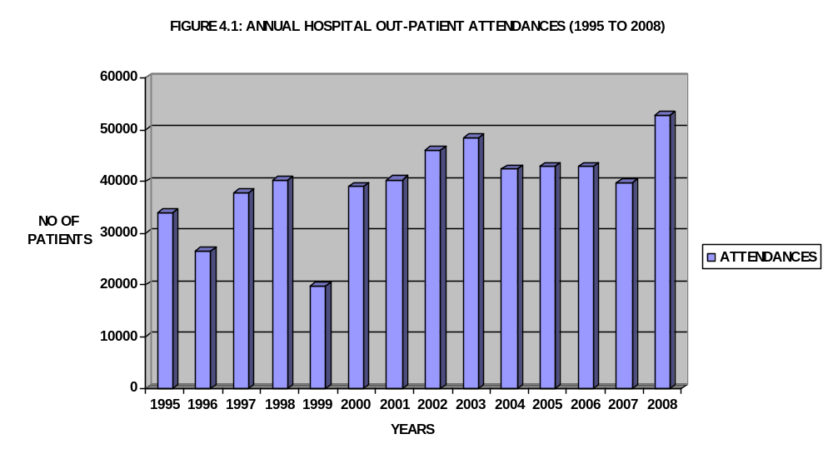4.2.2 Annual Hospital In-patient activities, 1995 to 2008
In-patient trends represent the activities of patients who were admitted in different wards of the hospital for different illnesses or diseases from 1995 to 2008 as presented in table 4.2. As mentioned earlier, the focus of this study is on in-patient activities of the case hospitals, especially that of ED and ICU. In-patient activity patterns are driven or affected partly by strike actions just as witnesses in the out-patient visits.
In 1995, 1997 and 1998, the numbers of admitted patients were high compared to patients admitted in 1996 and 1999. This is as a result of long days of strike actions i.e. 99 and 109 days respectively. These admissions rose steadily from 2000 to 2003 but the hospital experienced progressive decreases from 2004 to 2007.
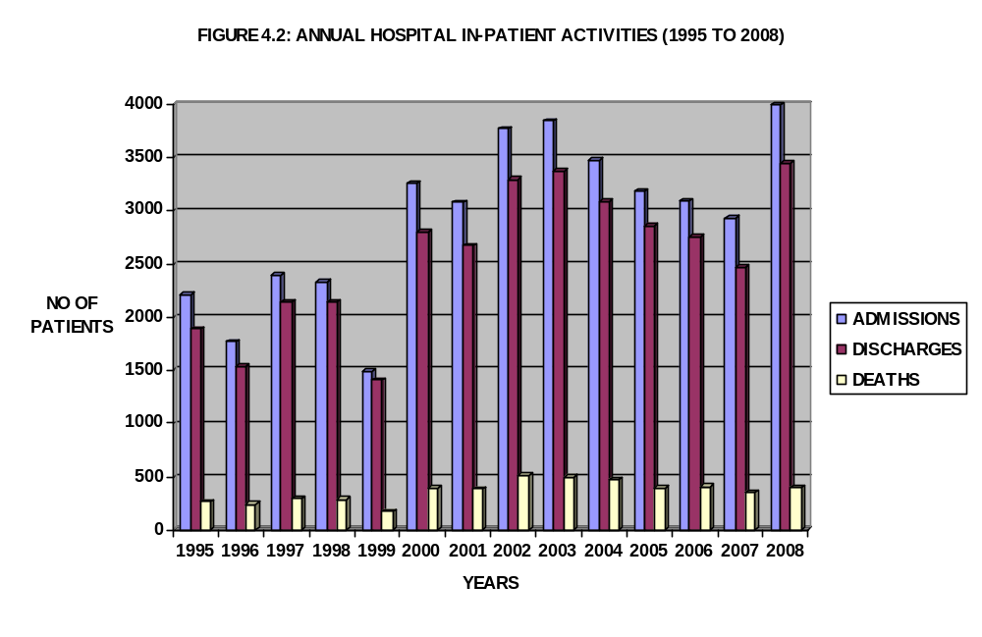

As experienced in out-patient visits, we equally have the highest number of admitted patients in 2008. This implies that the focus of January to December, 2008 for this study is justifiable and meaningful because 2008 records did correlate to predict activities of 2009. In fact, according to the data obtained from the medical records of the case hospital, its analysis showed that 2008 patient activities were similar to 2009’.

4.2.3 Annual Percentage Changes in Out-patient Activities, 2000-2009
Figure 4.3 shows the changes in out-patient visits on a monthly basis from year 2000-2009. Patient activities were low in some months of 2001, 2002 and 2003 compared to subsequent years. This is evident by the continuous increase in patient visits in 2008 and 2009. Also, we can say that the drastic patronage is necessitated by the renovation and modernization of the hospital clinics and equipment by the incumbent administration. This high patient visit caused serious overcrowding in all departments of the hospital which invariably put pressure on the limited resources.

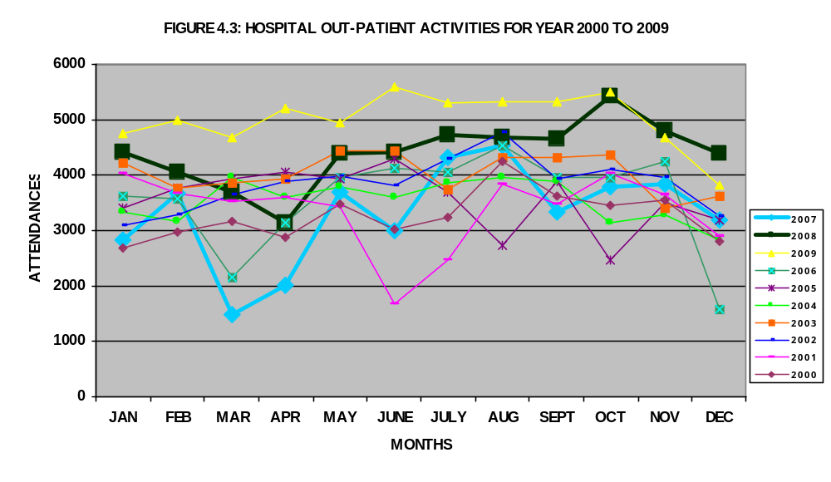

4.2.4 Percentage Changes in in-Patient Activities, 2000-2009
As revealed by figure 4.4, the monthly trends of admitted patients in different hospital wards of OOUTH for year 2000, 2005 and 2007 were very low in some months especially in march, June, July, August, October and December. Average inpatient activities were witnessed in 2003 and 2004. In 2008 and 2009, the inpatient trends rose to the highest with 2009 having highest patronage in January to May while 2008 had for September to December. This implies that averagely, the 2008 and 2009 experienced the highest inpatients activities.
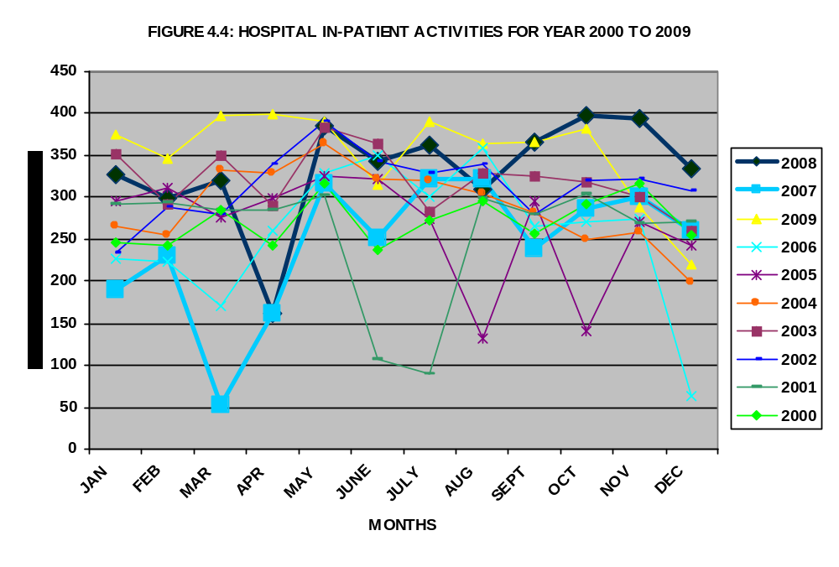
4.2.5 Out-patient Activities, January to December, 2008
Figure 4.5 shows a graphical picture of treated and discharged patients per month for 2008. This section is considered necessary to reveal the out-patient activities for study periods and this shows how busy the hospital was in 2008 compared to previous years.
The first four months (January to April) shows a slight decrease in out-patient activities. This implies that General Out-patient Department (GOPD) utilization appears fairly low in these months compared to other months. From May to September, 2008, the total out-patient visits grew tremendously and got to the climax in October but fell slightly in November and December, 2008. Graphically, we can visualize the utilization of the GOPD in 2008. This means that the department was highly utilized and crowded throughout the year.

FIGURE 4.5: OUT-PATIENT ACTIVITIES, JANUARY TO DECEMBER, 2008
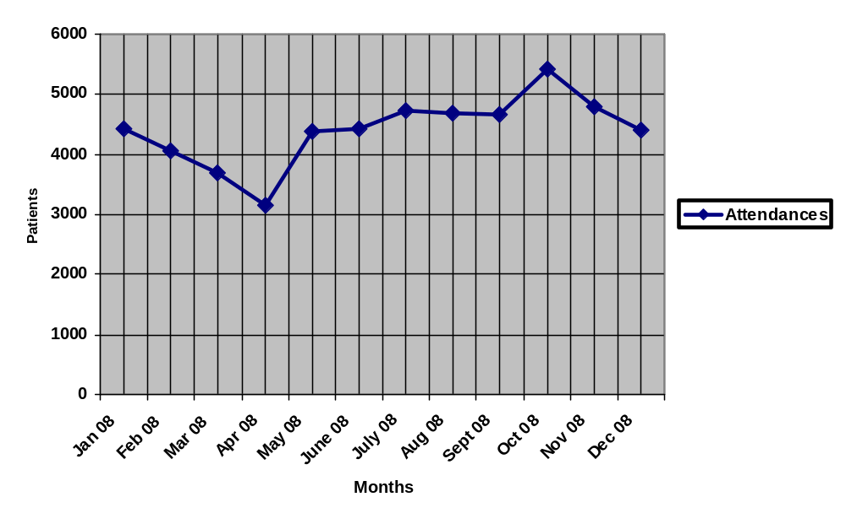4.2.6 Annual Road Traffic Accident Trends
Presenting the distribution of road accident victims became necessary because of the proximity of OOUTH to Lagos-Ibadan expressway where different road accidents occur every day. Figure 4.6 shows the distribution of road accident victims according to gender. The annual trend of victims is almost the same for male and female during the period except for year 2008, which rose dramatically. The reported accident cases for January to July 2008 were as high as the summation of cases for other periods.

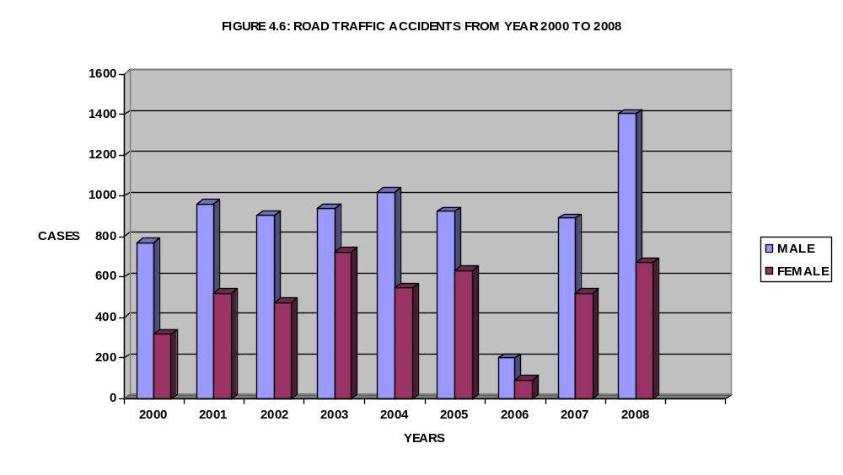
4.2.7 In-patient Activities, January to December, 2008
The rate of admissions, discharges alive and deaths (in-patient trends) on a monthly basis is illustrated in figure 4.7. The monthly in-patient trend is similar to that of out-patient activities. The total visits of patients reduced slightly from January to April, 2008. The hospital received the least visits in April 2008 which implies that the hospital wards were less crowded in April, 2008. In contrast to other months, the volume of patients treated and discharged alive from May to December was high. The highest patronage was witnessed in May, October and November. It is worth mentioning that the total in-patient activities represent the total volume of patients admitted, treated and discharged either alive or death in various hospital wards including the focus clinics; emergency department and intensive care unit.
The monthly percentage change of in-patient activities is illustrated in figure 4.7. A growing number of in-patient admissions are potentially avoidable if patients consult qualified medical personnel as illness is noticed and stop doing self-medication. Also, having access to timely and effective primary care can reduce minor illness aggravating to serious diseases, hence, patient admission.
FIGURE 4.7: IN-PATIENT ACTIVITIES, JANUARY TO DECEMBER, 2008
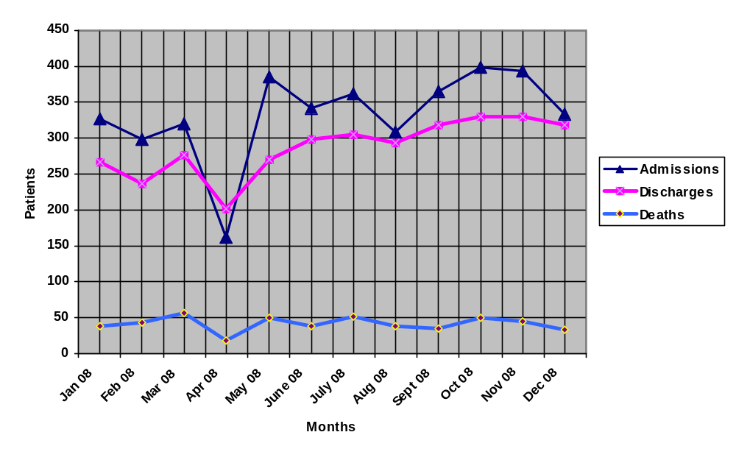
4.2.8 Percentage of Hospital Bed Occupancy Ratio
Hospital occupancy ratio is related to the real demand and length of stay which is defined as the average numbers of beds occupied/number of beds available multiplied by100. Maintained bed occupancy rates generally rose from January to March and May to September, 2008 (see figure 4.8). This represents the longer term among hospital wards. Nevertheless, the hospital did not experience an annual occupancy rate above 65%. As described earlier, occupancy rate of 65% is well below the golden target but it is acceptable for non-profit making hospitals (Green, 2001; Green and Nyugen, 2002) like OOUTH and LUTH.
The percentage movement of monthly beds occupancy ratio is clearly illustrated in figure 4.9. Most hospital managements use occupancy rate as a basis for budget preparation and resource allocation, a practice that is questionable (Green, 2001; Green and Nyugen, 2002; Arnoud et al, 2006), because it ignores the fluctuations in demand (patient arrivals) and variability in length of stay (service times) which have greater impact on resource allocation (bed capacity). Also, the overall percentage of bed occupancy ratio for 2000-2009 was presented in figure 4.9. This provides a better picture of bed utilization.
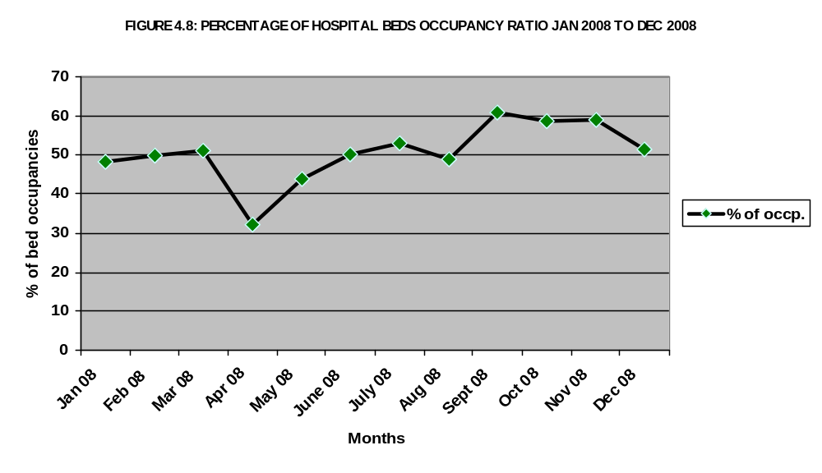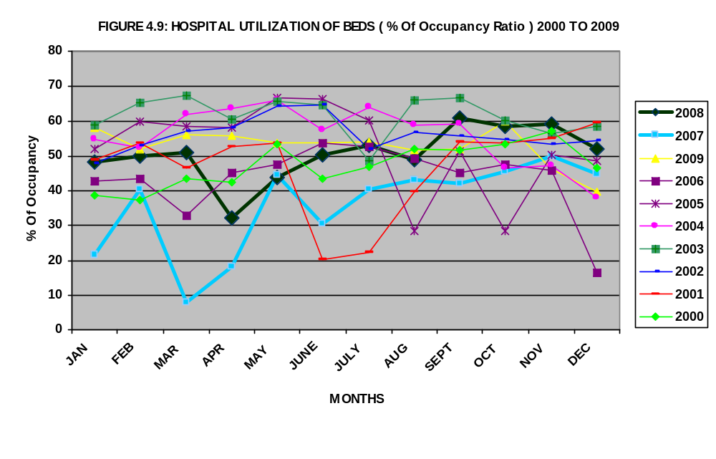

4.2. 9 Comparison of In-patient Activities (June-Sep., 2008 and June- September, 2009)
This section attempts to compare in-patient activities of 2008 with that of 2009. This will reveal whether there are similarities and differences in in-patient activities trends between the two periods. The implication of this is that if similarity occurs in the trends, there is high probability that the future trends will follow the same patterns. That is, the future trends will reflect the most current trends. Therefore, most current in-patient distribution for study period can be used to predict or forecast for the future period. In terms resource allocation the current data can be used to budget (in terms of resource allocation i.e. staff, beds, expenditure, and others) for future.
Considering the data distribution of June-September, 2008 and June-September, 2009, the in-patient trends were almost the same. 1384 patients were admitted between June and September, 2008 and 1387 patients were admitted in the corresponding period in 2009. The data distribution were similar in discharged alive and deaths. The slight difference was clearly illustrated in figure 4.10.
FIGURE 4.10: COMPARISON OF IN-PATIENT ACTIVITIES (JUNE-SEPTEMBER, 2008 AND JUNE- SEPTEMBER, 2009).
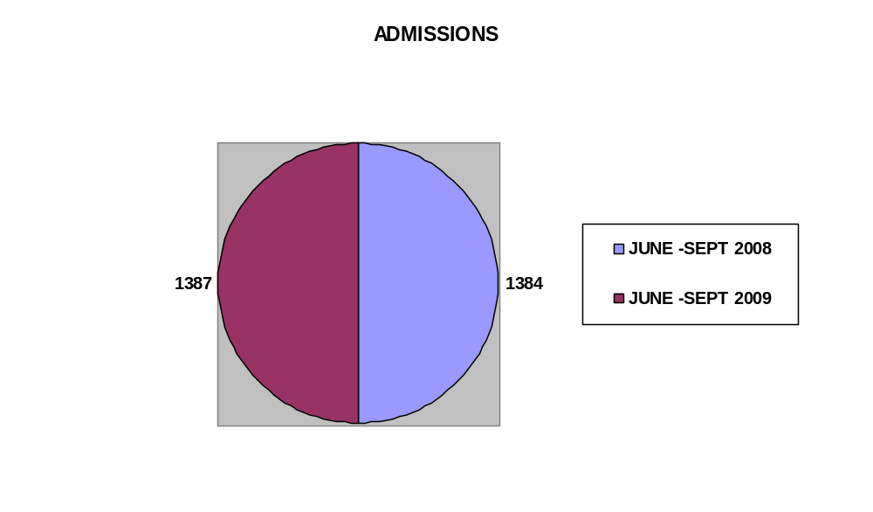
4.2.10 Emergency Cases in OOUTH (2000-2008)
Out of the various departments that constitute OOUTH, emergency department and intensive care unit were fashioned out for analysis because they are the focus of the study. Figure 4.12 shows that an average of 3500 emergency cases were treated in 2000 and 2001, but the visits rose to the highest level in 2002 (i.e. over 4500 patients were treated). The total emergency visits slightly decreased from 2003 to 2007 before rising drastically in 2008. During the last 7 years of handling emergency cases, the total visit of 2008 was the highest. This was further reflected in the total visit in 2008 (table 4.11).
FIGURE 4.11: ACCIDENT AND EMERGENCY DATA FOR YEAR 2008, OOUTH
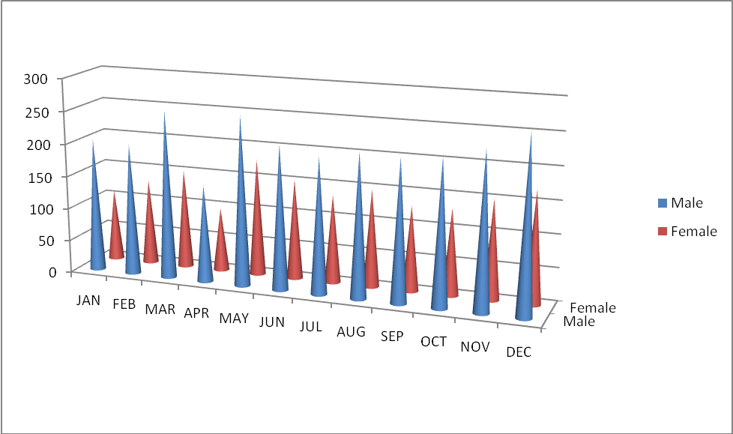

FIGURE 4. 12. ACCIDENT AND EMERGENCY DATA FOR YEAR 2009, OOUTH
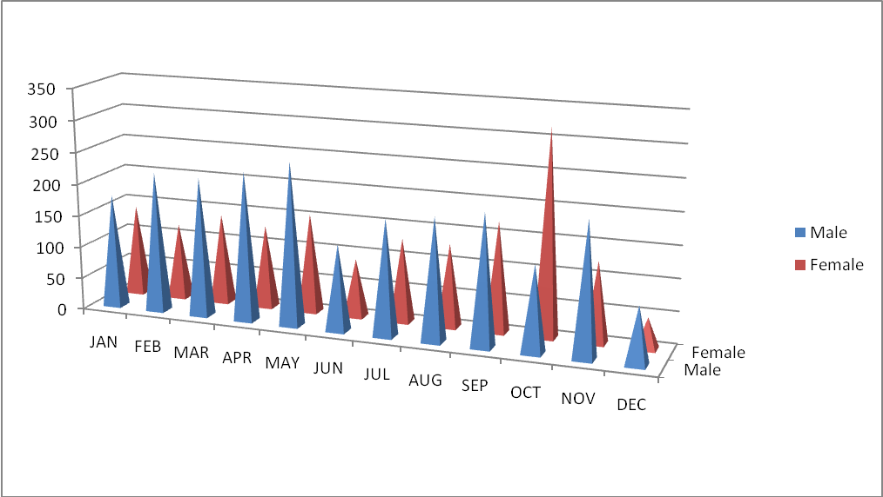
4.2.11 Intensive Care Unit Cases Treated for 2000-2009
Intensive care unit treats critically ill patients. During the field survey, one of the ICU experts said, our patients cannot talk; they hardly know themselves when brought to the unit. Figure 4.13 presents the serious cases treated in ICU for year 2000 to 2009. In 2004, the unit received the highest number of visits: it may be as result of major disasters in some parts of Ogun State or frequent fatal accidents on Lagos-Ibadan expressway. The visits reduced gradually from 2005 to 2008 and rose slightly in 2009. Irrespective of the level of demand and the existing bed capacity (2 operational beds) of OOUTH, the clinic experiences overcrowding at irregular times as described by the ICU staff.

FIGURE 4.13: INTENSIVE CARE UNIT CASES TREATED FOR 2000-2009
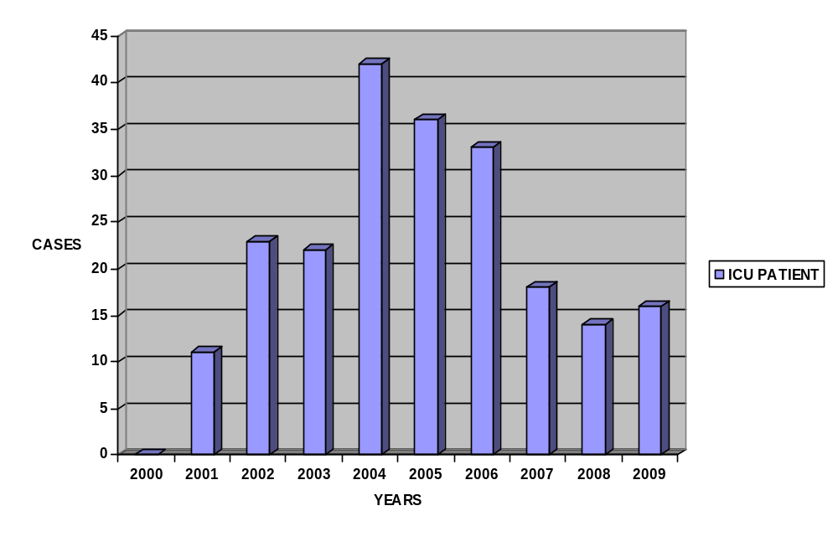 4.3.0 Descriptive Statistics of Patient Activities in LUTH
4.3.1 Annual Hospital out-patient activities, 1995-2008
According to the data supplied by LUTH medical records office, the total yearly male visits in the outpatient department rose gradually from 1995 (35,338 patients) to the total of 42,825 patients in 1998.(see figure 4.14). 2004 and 2008 received the lowest and highest patronage of male patients. The yearly female visit in out-patient department was higher than male visits, although, the male and female activities follow the same pattern. The female visits increased slightly from 85,704 to 106, 533 patients in 1995 and 1999 respectively. As noted in male visit distribution, the lowest and highest male visit was recorded in 2004 and 2008. The situation in 2004 occurred because of series of strike actions which the hospital experienced that year. The total out-patient visit of 2008 is of importance because it is included in the study period. It is worth mentioning that the available data for 2009 (January to June) is similar to the 2008. Therefore, this supports the basis for using 2008 and January to June, 2009 patient data distribution to predict and plan bed capacity utilization that can be used to budget for resource allocation for subsequent years.
FIGURE 4:14: OUT PATIENT ATTENDANCES 1995 – 2008, LUTH
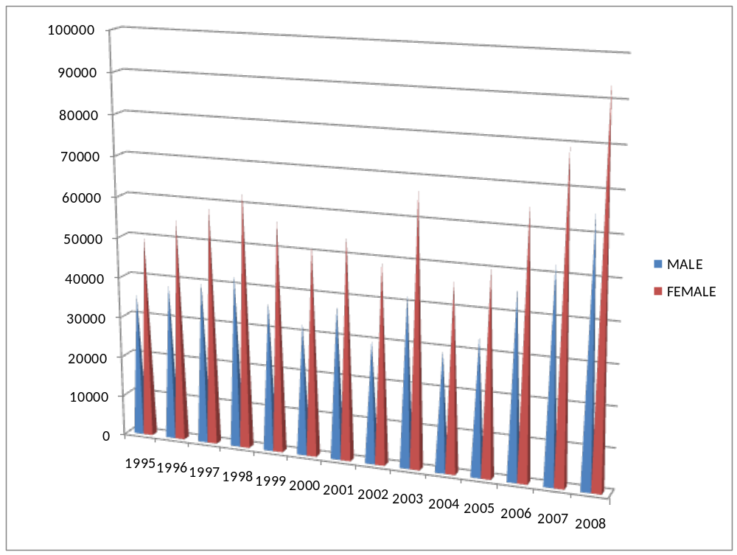
4.3.2 Annual in-patient distribution, 1997 to 2008 and January to December, 2008
As mentioned earlier, the study focused on the inpatient data distribution of the case hospitals, therefore, it is considered necessary to analyse both the annual inpatient and January to December, 2008 patient activities. In figure 4.15, from 1997 to 2005, LUTH attended to almost constant number of patients except in 2003, and 2004 and 2005 that experienced the highest and lowest among these periods respectively. This constant trend is noticeable in terms of number of patient admitted, discharges alive and death. Also, the highest visit occurred in 2007 and 2008 where total number of patient admitted, discharged alive and death were 10528, 8576, 1145 and 10611, 9067, 1256 respectively. This rapid increase was witnessed due to some factors. Few among these factors are; (i) recent renovation and modernization of teaching hospitals (including LUTH). (ii) Persistent increase in Lagos population, (iii) increase in referral of patients from private hospitals because of the status and the existing modern facilities and qualified medical manpower.
Figure 4.16 shows an evenly distributed in-patient attendances throughout the year except for February and October that received the lowest number of in-patients. In the actual sense, we would say that the sum discharged alive and deaths should be equal to admissions for every month throughout the year. But it is not always so because there is always an overflow of patients from previous month as a result of patients who stayed longer than a month.

FIGURE 4:15: ANNUAL HOSPITAL IN PATIENT ACTIVITIES
(YEARLY BASES, 1997 – 2008), LUTH

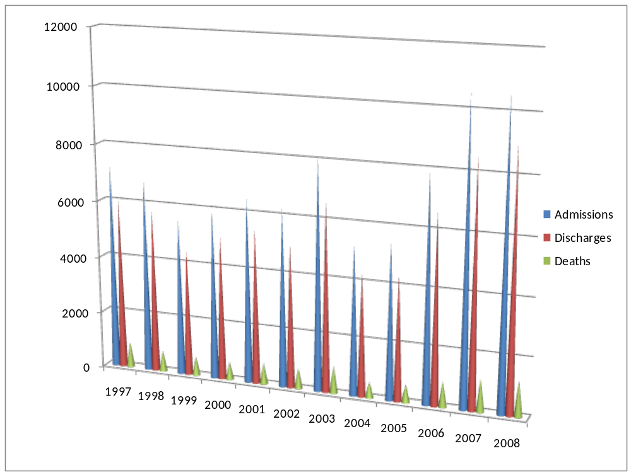

FIGURE 4:16: ANNUAL HOSPITAL IN-PATIENT ACTIVITIES, (JAN – DEC, 2008), LUTH
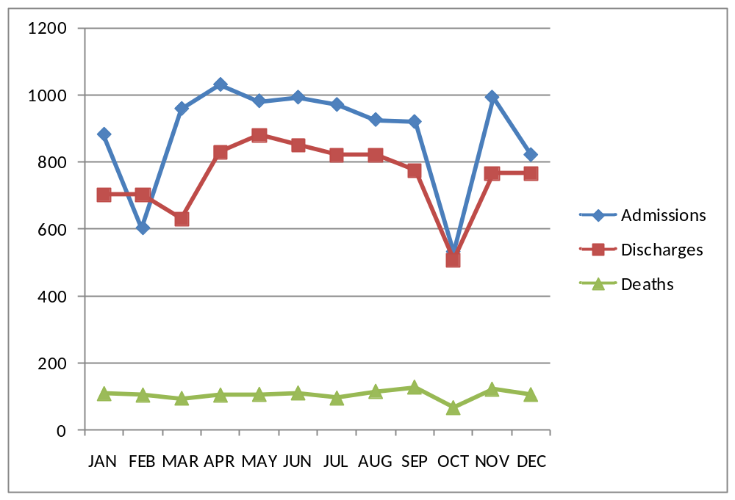
4.3.3 Comparison of Hospital In-patient Activities (January to June of 2008 and 2009)
Although in the case of OOUTH, June to September of 2008 and 2009 were compared, albeit based on the available data from LUTH, we compared January to June of 2008 and 2009. The inpatient trends in terms of admissions, discharged alive and deaths 4for these periods were very similar except that admitted patients in February was higher in 2009 (905) (see table 4.17) than 2008 (602). There were little variations in the inpatient activities in other months of the two periods. The researcher considered this comparison necessary to show the similarities and differences in inpatient trends between 2008 and 2009, since 2008 is the study period. This shows that 2008 patient activities can be used to predict patient trends in 2009 and subsequently. The implication of this for hospital management is that the outcome of the analysis can be used for budgeting and resource allocation (capacity management) for future years.

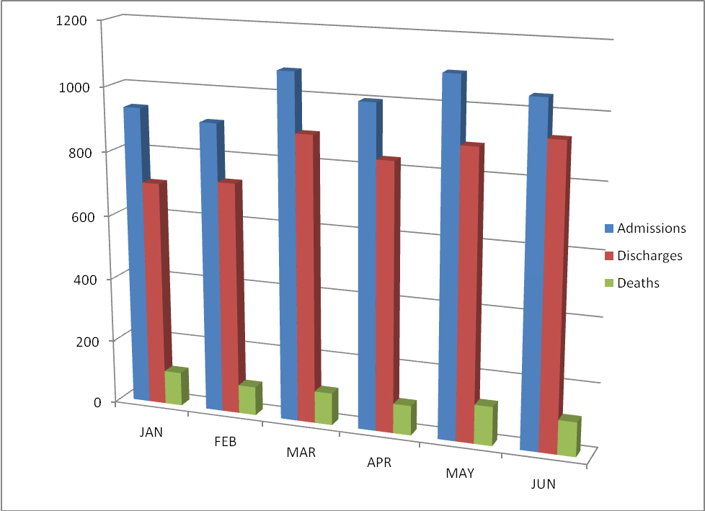
FIGURE 4.17: ANNUAL HOSPITAL IN-PATIENT ACTIVITIES, 2009, (JAN – JUNE, 2009) LUTH

4.3.4 Occupancy Ratio (January to December, 2008)
Based on the data obtained, we analysed the 2008 monthly occupancy rate as illustrated in figure 4.18. The LUTH occupancy ratio (which is a function of occupied beds divided by available beds multiplied 100) is above 50%. In some cases, we have occupancy rate of 70% and above. But, the average occupancy rate for the months is 60.58%. This occupancy rate is higher than OOUTH’s but less than the golden target rule (85%) obtainable in developed countries. However, 60% occupancy rate is acceptable for public funded hospitals

FIGURE 4.18: OCCUPANCY RATIO (MONTHLY BASIS), 2008, LUTH
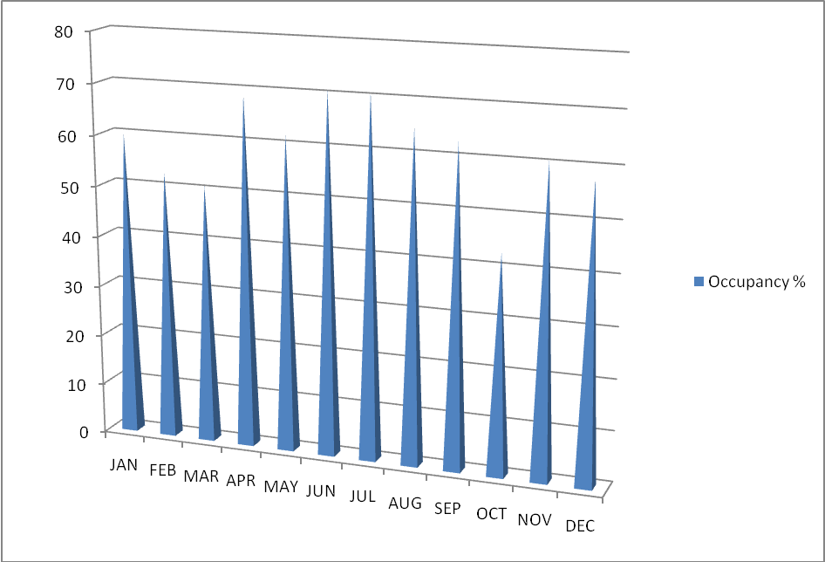
4.3.4 Emergency Department Patient Activities in LUTH
We singled out the analysis of ED activities from the hospital inpatient activities because it is one of the case units in this study. ED patient activities were higher in 1997 than other years (see figure 4.19). This could be as a result of some disasters in Lagos and its environs. After this year (1997), patient activities decreased gradually except in 2001 and 2003. The total visits rose slightly in 2006. Some of the reasons behind this fluctuation is non-availability of operational beds and unavoidable strike actions by medical personnel. Considering the monthly patient trend in ED for 2008, the total patient visits decreased slightly from January to March. The highest number of patients’ visits was recorded in April, June and July and least patient patronage was recorded in October, 2008. Irrespective of the visits recorded in these months and the available ED beds overcrowding is inevitable.

FIGURE 4.19: EMERGENCY DEPARTMENT (1997 – 2008), LUTH
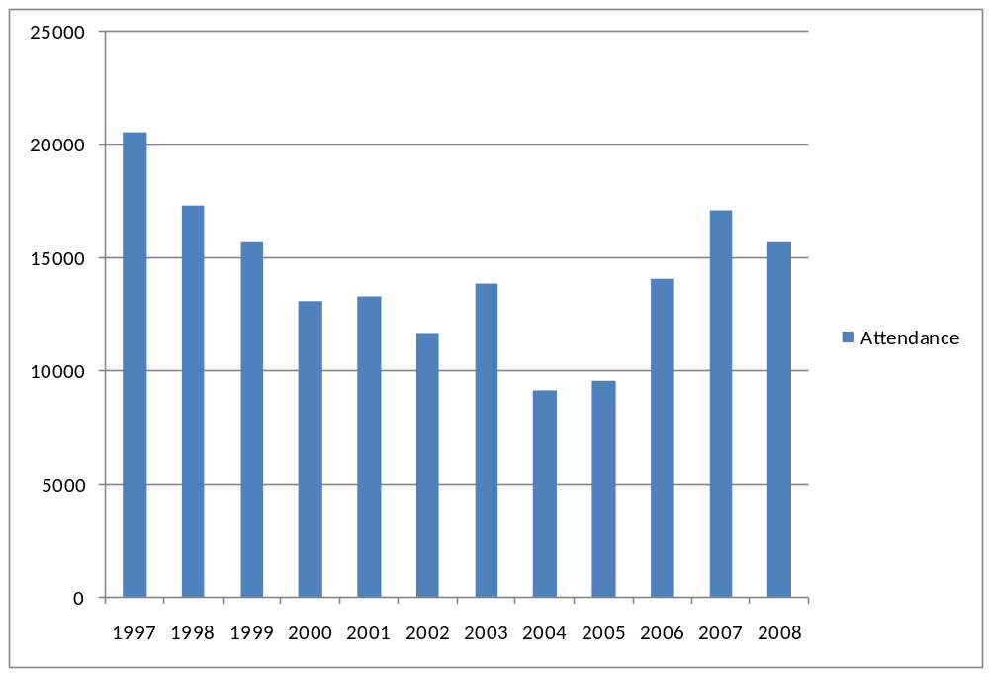
4.4 Queuing Analysis of the Case Hospitals
The patients’ data obtained from the hospital records departments and admissions at the EDs and ICUs were used to analyse the arrival pattern of patients and average arrival per day. Also, patients’ activities were used to quantify patient flow in which the patient routings, length of stay (LOS) and occupancy ratio of ED and ICU have been determined. These units were selected because of the following reasons:
(i) the majority of patients’ visits to these facilities are “unscheduled”, “urgent” or “emergent”, (ii) these patients can only be admitted into these units because of the uniqueness in operational beds and other resources. These points among others make it possible to decompose and analyze these units separately.

4.4.1 Arrivals
The queuing model adopted assumes that daily admission rates (average arrivals) follow a Poisson distribution (coefficient of variation=1) in consonance with some studies which have found that the arrival rate of patients to EDs/ICUs follows a poisson distribution (McManus et al, 2004: Green, 2002; Arnoud, et al, 2007). From the flow of the structural models (figure 3.1), patient arrives to the system and he/she is admitted if there is a vacant bed. If all beds are occupied, an arriving patient is admitted to alternative ward or refused and leaves the system. Although the case hospitals confirmed that they experience overcrowding most times and in such situations some inpatients that have recovered or stabilized are timely discharged to create vacant beds for new patients or they are admitted to alternative clinical ward or spaces instead turn-away because teaching hospital is a tertiary public hospital in Nigeria. This research considers patients admitted in alternative wards instead of proper clinics (ED and ICU) as refused patients.
Available data shows that the total number of arrival for 18 months fluctuate around 24,263 and 434 for ED and ICU of LUTH and 6364 and 79 for ED and ICU of OOUTH. For LUTH, the average number of patients arriving per day is therefore 44.37 for ED and .79 for ICU. For OOUTH, the average number of patients per day is 11.61 for ED and .14 for ICU. The units are characterized by random arrival during the day. The arrival data were considered over period of 24 hours based on the medical personnel shift (3 shifts) as it is in developed countries. Although, the arrivals at night shift were very low but they were included in the study. Among the reasons that contribute to low patronage at night is our peculiar situations of less human activities at night because of our working hours, insecurity and lack of adequate social amenities such as electricity and ambulance, etc.

4.4.2 Length of Stay Distribution
Length of stay (LOS) describes the number of days spent by patient in hospital. LOS is determined by the time of discharge minus time of admission. Average length of stay (ALOS) distribution in relation to health care service is characterized by a relatively high variability. In probability theory the coefficient of variation (CV) is a measure of dispersion of a probability distribution. It is defined as the ratio of standard deviation (α) to the mean (µ): 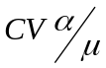(Bruin, etal, 2007, Bruin, etal, 2009). The coefficient of variation (CV) for each clinic is greater than 1. This implies that the LOS at ED and ICU is highly variable. This conforms with the findings of Green and Nguyen (2001) and Bruin, et al, 2009. As described earlier, the actual (measured) LOS is generally not equal to LOS opinionated by hospital experts. The difference between the two, the additional LOS is often caused by congestion or delay or blocking that occurs when the system is filled. The LOS at focus required estimation. The data from the two units revealed that some patients had not exited from the clinics, thereby creating truncated LOA data. The reasons for this appear to be that medical officers in charge of documentation may be engaged at time of discharged of some patients. So the estimated LOS of patient in LUTH ED and ICU are 1.5 day and 2.76 day respectively. Also, the estimated LOS for OOUTH ED and ICU are 1.75 day and 0.56 day. Furthermore, the LUTH ED and ICU system capacities are is 61 and 6 beds respectively, while OOUTH ED and ICU system operates with 14 and 2 beds respectively. At this juncture, it is important to understand that 61 and 6 beds of LUTH are census figures which may be different from operational beds and this applies to OOUTH.

4.4.3 Impact of Fluctuation in Arrival and Variation in Length of Stay on Capacity Management
In this section, the study adopts an M/M/∞ in kendall’s notation (Young, 1965) to analyse the impact of fluctuations in arrivals and variation in LOS on bed requirement at ED and ICU. The queuing model assumes poisson arrivals, exponential length of stay and unlimited or infinite number of beds. The aim of this section or model is to determine the number of beds required to accommodate all arrivals. This is highly necessary because the main goal of the hospital management is providing an admission guarantee for all arriving patients. However, in reality, hospitals operate with fixed number of beds and its effects are overcrowding, bed blocking, patient turn-away and/or admitted into alternative spaces or wards. This issue of limited capacity (beds) and delay objective is discussed in next section 4.3.3. A computer analysis of queuing system of ED and ICU flow was constructed using TORA Optimization software (Taha, 2003). The TORA Optimization System is Windows-based software application for solving practical operations research problems. It combines several operations research techniques such as queuing theory, linear programming model, transportation model, etc., into an integrated environment.
As stated earlier, poisson arrivals and exponential distribution were used to describe the hospital admissions and service times (length of stay) respectively. The steady state analysis of ED and ICU of the case hospitals using the M/M/∞ to model is presented in table 4.1—4.4 This implies that over time the fluctuations in arrival rate are overlooked or neglected to assume a steady state. This model helps to determine the efficiency and effectiveness of the selected units.
Queuing Output Analysis

Table 4.1: LUTH Emergency Department Analysis
Scenario 1—(M/M/9999) (GD/infinity/infinity)
Lambda = 44.27000 Mu = 1.50000
Lambda eff = 44.27000 Rho/c = 0.00295

Ls = 29.51333 Lq = 0.00000
Ws = 0.66667 Wq = 0.00000

N | Probability, pn | Cumulative, Pn |  | n | Probability, pn | Cumulative, Pn
0 | 0.00000 | 0.00000 |  | 28 | 0.07226 | 0.43777
1 | 0.00000 | 0.00000 |  | 29 | 0.07354 | 0.51131
2 | 0.00000 | 0.00000 |  | 30 | 0.07235 | 0.58365
3 | 0.00000 | 0.00000 |  | 31 | 0.06888 | 0.65253
4 | 0.00000 | 0.00000 |  | 32 | 0.06352 | 0.71605
5 | 0.00000 | 0.00000 |  | 33 | 0.05681 | 0.77286
6 | 0.00000 | 0.00000 |  | 34 | 0.04931 | 0.82218
7 | 0.00000 | 0.00000 |  | 35 | 0.04158 | 0.86376
8 | 0.00000 | 0.00000 |  | 36 | 0.03409 | 0.89786
9 | 0.00001 | 0.00001 |  | 37 | 0.02719 | 0.92505
10 | 0.00002 | 0.00003 |  | 38 | 0.02112 | 0.94617
11 | 0.00006 | 0.00009 |  | 39 | 0.01598 | 0.96215
12 | 0.00014 | 0.00023 |  | 40 | 0.01179 | 0.97394
13 | 0.00032 | 0.00054 |  | 41 | 0.00849 | 0.98243
14 | 0.00066 | 0.00121 |  | 42 | 0.00597 | 0.98840
15 | 0.00131 | 0.00251 |  | 43 | 0.00409 | 0.99249
16 | 0.00241 | 0.00492 |  | 44 | 0.00275 | 0.99524
17 | 0.00419 | 0.00911 |  | 45 | 0.00180 | 0.99704
18 | 0.00686 | 0.01597 |  | 46 | 0.00116 | 0.99819
19 | 0.01066 | 0.02663 |  | 47 | 0.00073 | 0.99892
20 | 0.01573 | 0.04236 |  | 48 | 0.00045 | 0.99937
21 | 0.02211 | 0.06447 |  | 49 | 0.00027 | 0.99963
22 | 0.02966 | 0.09413 |  | 50 | 0.00016 | 0.99979
23 | 0.03806 | 0.13219 |  | 51 | 0.00009 | 0.99989
24 | 0.04680 | 0.17899 |  | 52 | 0.00005 | 0.99994
25 | 0.05525 | 0.23424 |  | 53 | 0.00003 | 0.99997
26 | 006272 | 0.29696 |  | 54 | 0.00002 | 0.99998
27 | 0.06855 | 0.36551
Source: Survey, 2010
Table 4.2: LUTH ICU Analysis

Scenario 2-- (M/M/9999): (GD/infinity/infinity)

Lambda = 0.79000 Mu = 2.75000
Lambda eff = 0.79000
Ls = 0.28727 Lq = 0.00000
Ws = 0.36364 Wq = 0.00000

N | Probability, pn | Cumulative, Pn |  | n | Probability, pn | Cumulative, Pn
0 | 0.75031 | 0.75031 |  | 3 | 0.00296 | 0.99977
1 | 0.21554 | 0.96585 |  | 4 | 0.00021 | 0.99999
2 | 0.03096 | 0.99681 |  | 5 | 0.00001 | 1.00000
Source: Survey, 2010

Table 4.3: OOUTH Emergency Department Analysis
Scenario 1—(M/M/9999) (GD/infinity/infinity)

Lambda = 11.61000 Mu = 1.75000
Lambda eff = 11.61000
Ls = 6.63429 Lq = 0.00000
Ws = 0.57143 Wq = 0.00000

N | Probability, pn | Cumulative, Pn |  | n | Probability, pn | Cumulative, Pn
0 | 0.00131 | 0.00131 |  | 11 | 0.03609 | 0.96149
1 | 0.00872 | 0.01004 |  | 12 | 0.01995 | 0.98144
2 | 0.02893 | 0.03896 |  | 13 | 0.01018 | 0.99162
3 | 0.06397 | 0.10294 |  | 14 | 0.00482 | 0.99644
4 | 0.10610 | 0.20904 |  | 15 | 0.00213 | 0.99858
5 | 0.14078 | 0.34983 |  | 16 | 0.00088 | 0.99946
6 | 0.15567 | 0.50549 |  | 17 | 0.00035 | 0.99981
7 | 0.14753 | 0.65303 |  | 18 | 0.00013 | 0.99993
8 | 0.12235 | 0.77538 |  | 19 | 0.00004 | 0.99998
9 | 0.09019 | 0.86557 |  | 20 | 0.00001 | 0.99999
10 | 0.05983 | 0.92540
Source: Survey, 2010
Table 4.4: OOUTH ICU Analysis
Scenario 2—(M/M/9999) (GD/infinity/infinity)

Lambda = 0.14000 Mu = 0.56000
Lambda eff = 0.14000
Ls = 0.25000 Lq = 0.00000
Ws = 1.78571 Wq = 0.00000

N | Probability, pn | Cumulative, Pn |  | n | Probability, pn | Cumulative, Pn
0 | 0.77880 | 0.77880 |  | 3 | 0.00203 | 0.99987
1 | 0.19470 | 0.97350 |  | 4 | 0.00013 | 0.99999
2 | 0.02434 | 0.99784
Source: Survey, 2010
In scenario 1 of LUTH emergency department analysis (table 4.1), where the patient arrival per day (lambda effective) = 44.27 patients; average length of stay per day = 1.5 and unlimited beds (infinity servers). As asserted in the model, unlimited number of beds was assumed due to the fact Nigerian teaching hospitals aspire to meet the needs of all arriving patients. The system performance parameters are as follows; Ls= 29.51333 which implies that there are 29.51333 patients in LUTH emergency department at any point in time undergoing treatment. Ws =.6666 day measures the average time delay in the system (LUTH ED) That is, patient spent .67 day to undergo urgent treatment. The time in question covers the time spent before joining the queue, admission period and time spent shortly after being served before departure. The probability of 0-40 patients in the Ed was also determined. As should be expected, Lq =Wq = 0 because of a model involving unlimited beds was considered. This situation (result) can be found in a self-service model.
In scenario 2 (table 4.2) of LUTH ICU, average arrival rate of patient is .79 per day based on the available data supplied by the unit. Average length of stay is 2.75 per day and unlimited capacity. Ws =.36364, meaning the maximum patient waiting time in the system i.e. wq +1/µ. This covers patient being served and those on their way out. Also, the expected waiting time in the queue (wq) and ICU system (Ws) is 0 because there are enough beds (infinity) to serve the patients.
In table 4.3, OOUTH emergency department analysis (scenario 1) reveals that Lambda (λ) = 11.61 per day and mu (µ) = 1.75 per day. This implies that an average of 11.61 patients visited the hospital between January 2008 and June 2009 and average length of stay (ALOS- time of discharge – time of admission) of 1.75. The unit performance parameters are; the System utilization is very low, the number of patients in the system is 6.6 and time spent waiting in the system by a patient is .57. As usual, the average number of patient in the queue (Lq) and system (Wq) is equal to 0 due to the fact that an infinity server model was adopted for analysing the activities at OOUTH emergency department.
Table 4.4 reports the efficiency and effectiveness of OOUTH ICU using M/M/∞ model. Based on data obtained from the unit (ICU) over 18 months, the effective demand (λ) of urgent services is .14 patients per day; average length of stay (µ) is 0.56 day with unlimited beds. It is pertinent at this juncture to say that some incomplete information concerning date of patient arrival and time of discharge affect the estimated patient arrival rate and service duration. Other performance indexes are; Ls =.25000, Ws = 1.78571, Lq and Wq = 0 as such because the model that the unit has available beds for any number of incoming patients. The probability that 0 numbers of patients in the system is equal to 0.77880 and probability of 1-4 patients in the system was determined.

4.4.0 Modeling the Emergency Department and Intensive Care Unit
4.4.1 Emergency Department
In the previous section, we assumed multiple servers model with unlimited number of beds. This section adopts M/M/C queuing model to estimate delays (Gross and Harris, 1985; Green and Nguyen, 2001; Green 2002). This is known as Erlang’s delay probability. The notations respectively represent poisson arrival (λ= patient demands for beds) and exponential service times (µ= length of stay), a fixed number of servers (beds equal to c), an infinite capacity (waiting space), and first come first serve queuing discipline. The number of beds (servers), c, can be varied to determine its effect on patients’ delays for beds. Due to the robustness of its assumptions and its ease of use, this type of model is used extensively for capacity planning in a very broad variety of service industries (Green and Nguyen, 2001). The model reflects the teaching hospital practical situation in Nigeria in which there is a single queue with unlimited capacity that feeds into c identical servers (beds). The rationale for adopting this model is that Nigerian teaching hospital being a tertiary hospital has a policy not to reject or turn-away patient in any unit. In reality, there is no waiting area, which implies that an arrival who finds all beds occupied must be admitted to alternative clinical bed or space. The patient is considered waiting for ED/ ICU bed for the period being admitted to alternative bed. This model is a more realistic representation of emergency inpatient flow. Though in some studies, this situation is called bed blocking or patient turn-away (McManus, et al 2004, Arnoud et al, 2007). In real-life the consequence of blocking could well be a refused admission (Arnoud et al, 2007). This model helps in estimating delay that occurs from the time of the demand for service (i.e. request for a bed) to the time at which service begins (i.e. a bed is available
One advantage of using this model is that given an arrival rate, an average service duration and the number of severs, closed form expressions for performance measure such as the probability of a positive delay or the mean delay can be easily determined (Green, 2002). This delay means the time a patient is put on hold before being assigned a bed.
Determining the efficiency and effectiveness of a service system such as hospitals, banks, restaurants, etc., can be done through many performance measures referred to chapter 2. In emergency systems such as emergency department and intensive care unit, the most common measure of service performance is the probability that an arrival has any delay. This measure is called probability of delay. If we define P_{n} to be the steady-state probability that there are n patients in the system, then probability of delay, P_{D}, is given by 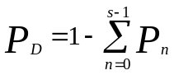……………………………………………………………………..1
Server utilization, denoted by p, is usually considered a measure of system efficiency and is referred to as average occupancy level in the hospital context. It is given as P = λ/sµ. ……………………………………………………………………………..2
Another common performance measure is the expected wait in queue until a server (bed) is available, W_{q}. This is given by W_{q} = P_{D}/((1-p)sµ) (Green, 2002) …………………..3
It is important to note that probability of delay and expected delay, as well as other critical measure of customer performance, increase at an increasing rate with server utilization. This not only implies the intuitive notion that higher hospital occupancy levels result in longer delays for beds but, perhaps nonintuitively, that relatively small increases in occupancy levels can result in very large increases in delays, particularly at “critical” levels. Also, the smaller the hospital (or unit), the lower this critical level will be. Thus, large hospital units can operate at higher occupancy levels than small ones and achieve the same delay levels (Green, 2002).
Though, some studies have used complex queuing models (Green and Nguyen, 2001; McManus, 2005; Arnoud, et al 2007; Bruin, 2005), they should be used to more, to accurately estimate resource allocation (capacity planning) in specific hospital units. But this Erlang delay probability model was adopted for several reasons. One of which is the tractability since the analysis of hundreds of different units requires a model which can be solved quickly and requires only the data which is publicly available. The performance parameter results of the systems using TORA Optimization Windows-based software (Taha, 2003) were used to calculate probability of delay and expected wait in queue until a bed is vacant using equations 1 and 3.
Table 4.7 presents the results of the analysis of LUTH ED using an Erlang’s delay probability- a queuing multiple model with a fixed number of beds and limited space. The emphasis here is not ascertaining the effectiveness and efficiency of the system only but using the performance parameters to determine the proportion or probability of patients that are delayed waiting for beds. As pointed out in the M/M/S mode, we assume markovian arrival and service time (LOS). The number of servers (beds), s, can be varied to determine the impact on patients’ delay for beds. One advantage of using this model is that given an arrival rate, an average duration, and the number of servers, closed form expression for performance measures such as the probability of a positive delay or the expected delay can be easily determined (Green and Nguyen, 200). Probability of delay is a function of two parameters: s and p (Green, 2002). Although the impact on the medical outcome of a patient’s delay for an appropriate bed is difficult to measure and clearly depends upon the specific medical condition, hospitals do recognize the adverse consequences of delays on emergency patients (Green and Nguyen,2001). Emergency patients admitted in ED/ ICU require beds almost immediately and unavailability of beds requires the admission of such patients in less appropriate units, often compromising the quality of care. These patients not admitted immediately into ED/ICU are considered blocked but not lost to the system because of the temporary arrangement.

Using average patient arrival rate of 44.27 and average length of stay (ALOS) of 1.5 days and looking at the effect of unit size (bed available) and occupancy levels on delays, table 4.5 shows probability of delay (p_{D} ) as a function of number of beds for utilization levels ranging from 50% to 70%%. This utilization range is guided by the current average occupancy rate for nonprofit hospitals which is about 63%, (AHA, 1996). Probability of delay was chosen as our main indicator to measure service performance because ED/ICU patients are classified as emergent who require beds immediately. Probability of delay is the standard measure used in service systems where customers have low tolerance for any delays, particularly emergency systems. The analysis reveals that if it is desirable to keep p_{D} below 0.01(1%), it can only be achieved in ED (LUTH) that operate more than 64 beds. Yet some teaching hospitals or smaller public hospitals, often in less populated areas, may have far fewer beds. On the other hand, LUTH which have 61 beds for both adults and pediatrics could increase its occupancy level higher than the current rate. But increasing occupancy rate leads to higher probability of delay, hence, higher waiting time. It is pertinent to note that to the of our knowledge, there exists no operational standard regarding patient delays for ED beds but articles on analyzing the need for emergency beds used a p_{D} target of 10% (Green and Ngugen, 2001) and .01 (Schneider, 1981). So this study adopted 0.01 (1%) because of the size of the hospital and its moderate utilization. Probability of delay (p_{D )} target of 1% can only be used but mostly suitable for large unit with high utilization or, conversely, have to settle for low occupancy levels(Green and Ngugen, 2001). Another important performance measure is the expected delay (eqns. 1 and 2) for those patients who have a positive delay. The findings reveal that at the current occupancy level of LUTH, the expected delay at operating 37 beds was 0.02 days or around 29 minutes. This information is clearly important for hospital decision makers for capacity planning.

For Olabisi Onabajo Teaching Hospital (OOUTH), the average arrival rate equal 11.61 patients per day, average length of stay (ALOS) equal 1.75 days and 14 operational beds. Considering the department current occupancy rate and size, for the ED to operate below (p_{D )} target of 1%, they need 16 and above operational beds. The expected delay at the existing occupancy level and bed capacity is .005 day or around 7.2 minutes (see table 4.6).

Table 4. 5: Probability of Delay with existing Occupancy rate and size at ED of LUTH
Numbers of bed |  | PD
10 | 1 – 0.00003 | 0.999
15 | 1 – 0.00251 | 0.997
20 | 1 – 0.04236 | 0.957
25 | 1 – 0.23424 | 0.765
30 | 1 – 0.58366 | 0.416
35 | 1 – 0.86376 | 0.13
40 | 1 – 0.97374 | 0.02
45 | 1 – 0.99704 | 0.0029
50 | 1 – 0.99979 | 0.00021
55 | 1 – 0.99999 | 0.00005
Source: Survey, 2010

Table 6: Probability of Delay with existing Occupancy rate and size at ED of OOUTH

Numbers of bed |  | PD
2 | 1 – 0.03893 | 0.96107
4 | 1 – 0.20888 | 0.7912
6 | 1 – 0.50510 | 0.4949
8 | 1 – 077477 | 0.2252
10 | 1 – 0.92467 | 0.0753
12 | 1 – 0.98066 | 0.01934
14 | 1 – 0.99084 | 0.00910
16 | 1 – 0.99902 | 0.00098
Source: Survey, 2010

4.4.2 Intensive Care Unit
Recently, teaching hospitals are decreasing the number of inpatient admission by increasing the number of procedures that can be done on an outpatient basis. However, patients who are critically ill still need the facilities of the hospital. In some critical cases, such patients require the need of intensive care unit (ICU) resources (beds). As corroborated in the literature, ICUs are usually the most expensive unit in the hospital system in terms of equipment and staff. Also, these resources are not interchangeable as we have in other units. Generally, around the world, ICUs are small in terms of number of operation processes and only used for patients who need close monitoring. It is interesting to know that the case hospitals claimed to have 6 and 2 operational beds for LUTH and OOUTH respectively. Though, there are 5 and 2 operational beds at LUTH and OOUTH respectively at the time of this study. Adopting the standard of probability of delay of 1% target, patient will have to wait for .003 days in LUTH ICU. Therefore, the unit should use more than 6 and more beds so that the current system utilization or occupancy will be increased (table 4.7). In case of OOUTH ICU, the unit has 2 operational beds with arrival rate of .14 and ALOS of .56 an estimated figure based on the information obtained from the unit patient register. The Ls and Ws are .25 and 1.78571 respectively. For OOUTH ICU to operate at 1% target of probability of delay, it must have around 4 beds (see table 4.8).

Table 4.7, Probability of Delay with existing Occupancy rate and size at ICU of LUTH

Numbers of bed |  | PD
1 | 1 – 0.96585 | 0.03415 = 3.4%
2 | 1 – 0.99681 | 0.00319 =0.319%
3 | 1 – 0.99977 | 0.00023 = 0.023%
4 | 1 – 0.9997 | 0.0003 = 0.03%
5 | 1 – 1 | 0
Source: Survey, 2010

Table 4.8, Probability of Delay with existing Occupancy rate and size at ICU of OOUTH

Numbers of bed |  | PD
0 | 1 – 0.77880 | 0.2212 = 22.12%
1 | 1 - 0.97350 | 0.0265 = 2.65%
2 | 1 - 0.99784 | 0.00216 = 0.216%
3 | 1 – 0.99987 | 0.00013 = 0.013%
4 | 1 – 0.99997 | 0.000011 = 0.001%
Source:Survey,2010
4.5.0 Respondents’ Perspectives of Patient Flow and Suitability of Queuing Model

This section summarizes findings from responses to questionnaire and interview. The goal of the analysis is to understand sources of stress on hospital EDs and ICUs, how hospitals manage patient flow through the ED, ICU and other units, potential barriers to implementing best practices, how hospital coordinate care activities. The case studies consist of personal and telephone interviews and distribution of questionnaires to key informants at LUTH and OOUTH such informants include ED and ICU directors, doctors, nurses, medical records officers, etc. A copy of the questionnaire/ interview protocol is found in the Appendix 4.

4.5.1 Overcrowding and Patient Flow
Interestingly, one of the hospitals reported ED and ICU overcrowding on a regular basis. One informant summarized the issue stating that overcrowding was “always a challenge”. An informant from OOUTH indicated that it ICU was never overcrowded; one said it happened sometimes, and one said it occurred frequently. The classification of one hospital ED and ICU as routinely overcrowded but not on diversion appears to be driven by the policy of the hospital. The policy explicitly discourages rejection, turn-away, diversion and requires more quantifiable criteria for doing so (.e.g., time between decision to admit and actual admission routinely exceeding 30minutes and growing). Although the ED and ICU were still overcrowded, the hospital had been able to cope with the situation without restoring to admission of patients in alternative clinical wards/spaces
There was virtually no overlap in the indicators that hospitals used to define and measure overcrowded conditions. One had specific criteria involving cycle times for beds and laboratory tests. Another informant defines ED/ICU overcrowding as a situation where at least 1 or 2 patients are waiting for admission or at least 3 patients are waiting for care.

The lack of common definitions for ED and ICU overcrowding led to a lack of common thresholds for patients blocking or turn-away. In these hospitals diversion is based on a combination of volume, occupancy, and/or patient activity. Only one of the two hospitals had a specific measure that triggered the diversion (available beds relative to patients waiting for admission).
In case of major disasters in the areas or several areas hospitals brought in life threatening cases (e.g cardiac arrest). When this happens, hospitals must revert to taking all patients and admit them in less appropriate clinical wards. As one informant described it, “We kind of smile when we experience such situation. Patients are coming regardless of the limited beds.” These “rushes” or persistent bulk arrivals are described as a source of substantial frustration for care-givers in the ED/ICU.

All of the hospital informants appeared to agree that better management of patient flow is crucial to avoid ED and ICU overcrowding. Yet they varied substantially in the scale, scope, and success of their efforts. The informants described detailed patient flow management systems that run through the entire hospital system. For example, when the volume in inpatient units or ancillary service area (e.g., laboratories) reaches a certain level, the head of the unit is informed for necessary backup resources. When this occurs, more resources (e.g. nurses) are brought to the area or alternatively, patients are diverted to other areas that can provide the needed service (e.g., a laboratory on another floor). This system is also used by one of the hospitals to determine when patient volume is high enough to justify ambulance diversion, which occurs only rarely at this facility. The other hospital in this set emphasized the measurement of cycle times through various stages of the care process (e.g., the time interval between the request and receipt of laboratory results). In the informant’s words, “we analyze everything that moves in the ED.” These measures allow managers in the ED and other departments to move quickly when cycle times begin to slow down. The informant offered a view of the big picture saying, “We drive the entire hospital through the ED…The ED runs the flow of the facility.”
The hospitals with overcrowded ED and ICU’s have also made attempts to improve patient flow. While some of their attempts were believed to be successful, the procedures that were implemented were generally not as comprehensive or far reaching as the ones used by the hospitals in advanced countries. Some of the approaches that helped reduce, ED and ICU overcrowding include the following:
- Use of hospital experts to expedite the movement of patients into different levels of care
- Creation of a back-up team of on-call nurses to fill in when scheduled nurses call out
- Bed huddles to assess conditions in the ED, ICU and other units on a daily basis.
One informant also described some success with a procedure where inpatients in the ED and ICU are sent up to the units immediately. Having a patient board in the unit hallway creates a visible incentive to speed up the admission process. However, this informant added that the procedure cannot be done if the floors themselves are overwhelmed.
Few informants assert that expansions of capacity (beds) in ED and ICU will not alleviate overcrowding if issue of staff shortage is not addressed. Many interviewers see do not staffing problem as serious as inadequate equipment where most of the available ones are obsolete. Another commented that the expanded capacity may reduce overcrowding and not total elimination because additional capacity will increase volume of patient visits. This is confirmed in Delia (2007)’s that assert that patients heard it was new and they showed up and this view only confirms say’s Law in Economic Theory. Yet, several others stated that a number of difficulties involved getting other departments/sections of the hospital to coordinate their operations with the needs of ED and ICU.

Almost all the respondents discussed difficulties they faced with timely discharge of patients. In many facilities, ED volume increases after 8 .00AM. Ideally, patients ready to end their inpatient stay would be discharged by then, making room for admissions for incoming patients. Though, admissions to the two units can occur at any time of the day, however, physicians who admit some patients are sometimes not available to give their final signoff until later in the day. Instead, these physicians often spend their mornings doing ward round or performing other more urgent clinical activities. As a result, discharge orders are written at different times of the day depending on the physician’s schedule. Timely discharge becomes delayed when patients need to consult with more than one physician before discharge. Some interviewers also described challenges involved with getting family members to pay the necessary bills and pick up discharged patients immediately. This unavailability of family and/or inability to effect payment immediately usually elongate discharge for hours or days.
Respondents mentioned different methods to improve the timeliness of discharges. The hospital with the limited capacity to handle overcrowding emphasizes the need for timely discharge to physicians and patients’ families as part of the formal admission process. This approach would be helpful in improving timely discharge. Another respondent in an overcrowded ED and ICU found the application of the approach (coordination) difficult in their institutions because an attempt was made to ask admitting physicians to expedite their discharges when the ED/ICU became overcrowded via notes in the physicians’ desks since the ED was routinely overcrowded, requests which were very common and ultimately “pressurizing and annoying” to the physicians.
Another informant considered the shortening length of stay or creation of a discharge lounge to hold patients before they are released from the hospital but was condemned by others saying that with declining length of stay, patients are discharged sicker than they used to be and would not be comfortable in a temporary holding area. As a result, this arrangement would be very costly in terms of the health of the patient or patient satisfaction.
The nature of patients seen by hospitals is also a factor in ED/ICU overcrowding. Several informants emphasized strongly the difficulties created by a growing number of psychiatric patients coming to the ED/ICU. Also, respondents said intoxicated patients brought to the ED and who must be held there until they became sober constituted another delayed discharge.

4.5.2 Queuing and Smoothing
Respondents were asked about the knowledge and implementation of queuing theory and whether it can help in allocating resources and managing patient flow in the ED and ICU as proposed in the literature. Some said they had not heard about the model and while some viewed general concepts favourably, they still identified a number of practical barriers to implementing such models. Few informants believed that “too much planning few results”, adding that formal operations research model is often complicated; results need serious interpretation and require training for proper implementation.
Only one informant described efforts to explicitly smooth the emergency surgery schedule as a way of improving patient flow through the ED and ICU and this respondent opined that “Surgeons are beginning to appreciate the problem (of bottlenecks in the ED and ICU).”

4.5.3 Anticipated Response to other Public Hospitals Closure
As part of the interview, hospital respondents were asked how well they would be able to handle increased volume from other hospitals closure especially Lagos State Teaching Hospital and major general hospitals, particularly in the ED and ICU. This situation often occurred due to strike of medical personnel. Some informants expressed strong reservations or outright alarm at this prospect. According to one respondent, the hospital is “at a tipping point right now. If that (nearby closure) were to happen, it would have serious effects in this environment.” Interestingly, this particular respondent had spoken confidently about the hospital’s ability to manage its current patient flow and its avoidance of patient diversion or turn-away. However, this hospital also operates at very high occupancy rate for most of the year, suggesting that it would be difficult to add more volume without new capacity. The informant linked prior closures to a recent influx of ED and ICU patients remarking that, “It makes you wonder if that was the right choice.”
CHAPTER FIVE
5.0 SUMMARY, CONCLUSION AND RECOMMENDATIONS
This chapter is a discussion the summary of the work as well as the highlights of the major findings. It also includes recommendations for policy implementation and the summary of the limitations of the study as well as suggestions for further research.

5.1 Summary of Work Done
The variability in demand for healthcare services and service times means that simplistic rules like mandating specific utilization levels or fixing patient to resource ratios would lead only to congestion and poor quality of service and are unlikely to be successful approaches to contain or reduce healthcare cost (Fomundam and Herrmann, 2007). In Nigeria, inspire of the inadequate renovation and restructuring of teaching hospitals to meet international standard, the patronage at these hospitals continues to increase. In some teaching hospitals, this has produced serious overcrowding, patient rejections or turn-away, particularly in emergency department and intensive care units. This is mainly due to the increase in the demands for the available space capacity at EDs and ICUs. A primary report (Litvak et al. 2006) indicated that almost 10% of the severely ill patients were refused, 4% were admitted even though there was actually no space, and 3% were released earlier to make room for new patients. The most important reason for the refusal of a patient was the lack of operational Ed and ICU beds. This problem of capacity has been recognized and studies have been initiated in advanced countries such as USA, Belgium, Netherland, Britain, etc. But the literature within our reach has not revealed such study in a developing country like Nigeria. This research examined how resource (bed) could be allocated in Nigerian public hospitals with emphasis on two teaching hospitals.

This study described how queuing network model (single tandem decomposition) has been applied in modeling emergency departments and intensive care units in-patient flow of Lagos University Teaching hospital (LUTH) and Olabisi Onabanjo University Teaching Hospital (OOUTH). Historical data of two clinics over the period of 18 months (January, 2008-June, 2009) were used to analyse the arrival rate and length of stay distribution. The assumptions of queuing model for in-patient flow hold for the two clinics of the case hospitals.
In further attempts to achieve the objective of the study and, verification and validation of historical data, we involved greater number of people in defining the system and also in the improvement of the understanding of the model. This was done through personal interview of few medical officers and administering of an open-ended questionnaire to medical record officers and health officers at ED and ICU of the two hospitals. The outcome of thorough content analysis of the participants’ opinions was presented.

5.2 Summary of Mayor Findings
The attention of this section is the discussion of highlights of mayor findings of this study. The summary of theoretical findings and gap in literatures has been presented in chapter two. The empirical findings of this study can be categorized into general and special results. Few among the general results are confirmation of earlier studies while specific results are directly drawn from this study

5.2.1 General Results
The number of arrival and length of stay calculation based on average data could be misleading sometimes because in some cases they do not meet the actual hospital capacity requirement. Since single average arrival and length of stay is assumed for all days throughout a given period of study and operational rate and pattern of arrival differ and there is daily variation in length of stay over same period. Therefore, hospital administrators and policy makers using mainly average arrival and length of stay may result in frequent operational difficulties. The immediate effect is overcrowding, admitting patients in alternative clinical space or floor and/or refused admission.

The high variability in length of stay of the patients in these departments and overcrowding effects influence the average length of stay (ALOS). This must be considered along with the characteristics because EDs and ICUs resources are expensive and limited.

Based on our field trips to both hospitals and discussions with health officers, we realized that the operational data required to accurately model case clinics for the purpose of evaluating capacity decisions and patient delays was not to be routinely captured by the hospitals’ or clinics’ registers and medical record office. In some cases patient arrival time will be recorded but the time of discharge to home or transfer to another ward will be missing. Sometimes, the gender or age could be missing.
The tradition of hospital management or policy maker in setting high occupancy rates based on historical experience and population is unrealistic. Larger hospital units can operate at higher occupancy than smaller ones while attaining the same efficiency.
Based on our interviews and responses from the administered questionnaire, we found that staffing (inadequate medical personnel) is another problem confronting the case units and the hospital as a whole.

5.2.2 Specific results
Overcrowding, congestion and admission of patients in less appropriate clinical wards or spaces are caused in the two clinics by inadequate beds. This has serious implication for patient flow.
The TORA optimization results revealed that LUTH emergency department has effective arrival of 44.27 patients per hour, average length of stay per day equal 1.5. The department performance parameters are: average number of patient in ED is 29.133 which implies that any point in time patients are being served. Patient spent .667 days (16hour) in ED to undergo urgent treatment. The number of patient and time spent in the queue is zero (0). This result is obtained because the study adopted multiple channel models with infinite servers.
LUTH ICU findings show that .79 patient averagely arrived in a day with average length of stay of 2.75 days. This is derived from the information provided by the hospital database. The number of patient in the ICU system is .287 patients and the waiting time in the system is .36364 days. The Lq and Wq are 0 because infinite server (bed) queuing model was proposed. This implies that the unit can serve all patients that visited. Though, it is not practicable but it is the goal of all Nigerian teaching hospitals to serve all visiting patients.

It was discovered that OOUTH emergency department has effective average arrival rate of 11.61 patients per day and ALOS of 1.75 days. The system has 6.64254 patients being served at any time of the study period. Patients waited for .57214 days (13.73 hours) before being served and discharged from the ED. It is pertinent to note that the patients that visit this department need urgent attention. Therefore waiting for hours before being served and transferred to the appropriate unit (ICU, operation room and other specialized clinics) could portend greater implication.

In the case of OOUTH ICU, the average arrival rate per day and length of stay were .14 and .56 respectively. The probability of zero patients in system was .77880, average number of patient in the system was .25 and waiting time of patient before server and discharge or transfer to another unit or ward is 1.78571. Also, the average number patients waiting on the queue and time spent on the queue is zero because there were unlimited resources (beds).
In the second model (M/M/C- with certain number of beds), the emphasis is not to determine the system performance parameters only but to estimate the probability of delay of patient in each system and expected wait in the queue using formulas proposed by Green (2002). For LUTH ED to achieve PD target of 10% and 1%, it needs not below 37 and around 64 operational beds respectively. Using the standard probability of delay (1%) that is suitable for a small unit, patients visiting LUTH ICU will have to wait for 4.3 minutes. Therefore, it is clear that the system needs more than 6 beds.

In the case of OOUTH ED that has 14 beds to operate at probability of delay target of between 10% and 1%, it needs more than 16 operational beds considering the expected delay of 7.2 minutes which may be risky for urgent patients. In OOUTH ICU, with .14 and .56 average arrival rate per day and length of stay respectively (hospital database), it requires around four (4) beds to maintain a probability of delay target of 1%.

The general findings represent common phenomenon that can be found in similar large urban teaching hospitals which provide large percentage of hospital care because most of the findings are the result of structural model of queuing systems. But we believe that the specific empirical results relate to the case hospitals by the virtue of our dependence on the data obtained from the hospitals.

5.3 Conclusion
In the delivery of medical service, individual patient needs, expectations and experiences will undoubtedly vary for several of reasons. Sources of fluctuation and variation are many in healthcare, such as the rate and nature of patient arrivals and patient severity or treatment responses, which are outside the management of control of the hospital management. It is pertinent to know that LUTH ED and ICU do have more modern resources than the corresponding units in OOUTH. Some of the reasons for the variation in resources are: first, LUTH is owned and funded by federal government while OOUTH is funded by Ogun state government. This implies that LUTH is better funded than OOUTH. Second, LUTH is situated in the city of Lagos where most multinational corporations operate. Some of these companies perform social responsibility in terms of provision of some modern facilities for LUTH through Public Private Partnership (PPP). For instance Skye Bank donated a new Accident and Emergency Department to LUTH. This kind of endowment is not seen at OOUTH. Third, the high population density of Lagos easily encourages the spread of some deadly diseases such as malaria, tuberculosis, HIV/AIDS, etc. These attract national, multilateral, international and non-governmental organizations donations of modern facilities to LUTH. Finally, although Nigerian teaching hospitals are non-profit making organizations but they charge some fees to cover some operational costs. Since more patients visit LUTH than OOUTH, it means more financial resource accrue to LUTH than OOUTH.

In terms of medical services, the magnitude of the patient visits over the years in the two hospitals showed a better utilization of medical facilities. Though the current state of medical technology and resource profile of LUTH and OOUTH portray modern hospitals to some extent, heavy investment is required to upgrade them to meet international standards. With respect to medical experts (specialists) and other medical personnel, LUTH is in a better position than OOUTH.

The 18-month experience illustrates that queuing network model may be used to allocate ED and ICU resource (bed) in a unit that operate at or near capacity. This study accurately determines the number of bed suitable for ED and ICU of the selected hospitals.

5.4 Recommendations and Policy Implications
This study attempts to model actual operations of ED and ICU of hospitals to accurately determine the number of bed required to serve the visiting patients in order to reduce waiting times, which invariably should lead to a better patient flow and improve service quality within the departments and entire the hospitals. Generally, improving patient flow, and reducing waiting time for patient can be achieved through the following ways: (1) managing the arrival rate by different appointment methods such as online appointment management system to spread arrivals and call in appointment system; (2) increasing the number of servers; (3) optimizing the service rate. It is worth mentioning that a good patient flow reduces waiting and facilitates bed usage, and optimizes patient length of stay. In the light of these, the following recommendations are made which all things being equal, believe will assist hospital managers and policy makers in performing their function of allocating resource (beds) and improving on the efficiency of ED and ICU operations.

Hospital administrators and policy makers need to understand that clinical and service performance standards (such as, average arrival and length of stay) and not target occupancy levels should be used to determine appropriate bed capacity/requirement in a timely fashion. That is, bed capacity planning should be a function of such performance standards, otherwise, it will be impossible to make any accurate determination of the optimal bed to serve a given population and it may lead to excessive delays for beds.

Also, in order to aid accurate capacity planning and assure quality and service, hospital management should put place a proper record system that will capture all vital information about patients. Information on age, sex, time of admission, time of transfer and, time and reasons for discharge is vital to planning process. This helps to determine service performance parameters such as arrival rate, length of stay, probability of delay, average time spent in the queue and system, number of patient in queue and system and rate of rejection or turn-away.

Since evaluation of bed capacity are related to other units and utilization of hospital resources such as medical equipment, doctors, nurses and other medical staff, hospital management should conduct cost-benefit and tradeoff analyses to identify opportunities for increased efficiency and effectiveness through synergy. Also, shortage or inadequate manpower and modern technology need to be addressed by government for both hospitals. Government and hospital administrators must act urgently to recruit the required medical experts in some specialized areas such as ICU, ED, operating theatres, etc. In the selection process, emphasis should be placed on human capacity and ability to do the job not sentiments. The medical equipment and technology need to be upgraded to meet international standard. Also, very important is the continuous training of the work force in the context of increasing service quality and human relations.

Furthermore, hospital management and health policy makers should address the issue of inadequate bed in the case of clinics to improve service delivery. They should know that relationship between size and quality of service is a vital issue in capacity planning. Also important is quality information concerning cost structures and revenue characteristics and how these affect capacity and resource allocation decisions.

5.5 Research Contribution to Knowledge
As far as it can be determined by literature at our disposal, this is the first study of its kind to be conducted in Nigerian public hospitals, and the first to use queuing network model to analysis patient flow and resource allocation in the emergency department and intensive care unit under two different models; M/M/∞/FCFS and M/M/C/C/FCFS in a Nigerian public hospital system.

The 18-month experience shows that queuing theory based on decomposition approach is a useful technique to accurately model resource allocation by determining the required number of resources in terms of beds, doctors, nurses, etc., to provide quality medical care to a given population. Decomposition based queuing network models yield accurate results and as such hospital decision makers can consider it as a valuable tool to analyse the entire hospital system.

The study provides useful insight for understanding the inefficiencies and finding improvement opportunity for the emergency departments, intensive care units in particular and the hospitals at large which are crucial for making health care policy and budgeting decisions.

Academically, the study is a pathfinder in the history of applicable of operations research models. Therefore, it serves as a reference and guide for the incoming academics to work on some of the limitations already identified in the course of the study. This serves as a basis for further research opportunities by focusing on other aspects of the hospitals which offer themselves for the application of queuing theory.

5.6 Limitations and Suggestions for Further Research
One of the major limitations of this study is that most data were collected manually from handwritten patients’ record, registers and some of the vital information about patients was not found. This deficiency in documentation prevented the accurate capture of data variables about patient care records especially in ED and ICU of the two hospitals. Having a better and modern ED and ICU information systems will help in gathering accurate, reliable and timely data that can aid effective and efficient decision-making. For instance, during our study trip we observed that the sex and dates of discharge of some patients were missing in the units registers. The records of these patients were not included in this study as a result of data of incompleteness or insufficiency.

Another limitation of this study is that the focus is exclusively on two units of the hospitals thereby ignoring the interplay with departments or subsystems outside the case units. ED and ICU patient flow is interdependent but also a function of external influences. Therefore, optimization in one or two areas may not improve the overall patient flow. A meaningful change in terms of patient flow may involve addressing a combination of many factors facing the entire hospitals. This kind of study needs serious funding and time for complete and thorough coverage.

Also, the findings of the study are peculiar to the case units of the selected hospitals but still generalized to hospital units facing similar patient activities and operate at full or near capacity. The findings may not necessarily be applicable to smaller or bigger units or units that operate below capacity. Among factors that account for variations among units and hospitals are: ED/ICU work processes, ED/ICU management structures, Availability of specialized resources and specialty consultation. These factors affect ED and ICU length of stay. Follow up research works could consider some of these variables. In particular, whereas part of this study focused on ICU units with too few beds, other units in the same hospital or other hospitals could have too many. Adopting more sophisticated models to better analyse the resource required by each of the hospital units can improve capacity planning in general and bed allocation in particular.

Furthermore, this study concentrated on determining the actual waiting time of patients in the queue and system but ignored the aspect of effect of perception of waiting on patient satisfaction. A study of this kind can include the effect of perception of waiting on service delivery. Also very important area that was excluded is the aspect of human error factors. Since human plays significant role during design and operation
phases of any system, the human reliability will also affect the overall reliability of the system.

A final concern is that the study adopted standard queuing formulas using TORA optimization software. Computer simulation has been used with considerable success in improving ED operation (Braly 1995) and ICU bed allocation (McManus et al, 2004) and this advanced model could be exploited in the future for modeling both ED and ICU efficiency and patient flow in Nigerian teaching Hospitals. Simulation model has been found suitable for analyzing very complex situations and therefore, the work can be extended in this direction for better analysis of ED/ICU processes and outcomes in Teaching Hospitals in Nigeria.

REFERENCES

Adedayo, A.O., Ojo, O. and Obamiro J.K. (2006) Operations Research in Decision Analysis and Production Management, Lagos: Pumark Nigeria Limited.
Adele, M and Barry, S., (2005) “Modeling Patient Flow in Hospital Using Queuing Theory”, Unpublished Manuscript.
Adeleke, A. R., Adebiyi, C.E. and Akinyemi, O.(2005) “Application of Queuing Theory to Omega Bank Plc, Ado Ekiti”, International Journal of Numerical Mathematics 1(122):129.
Armeo, C., Abellan, J. .J., Conesa, D., Perez-Panades, J., Zurriage, O., Martinez-Beneito, M. A., Vanaclocha, H. and Garcia-Blasco, M. J. (2003) “Waiting for a Kidney in the Pais Valencia (Spain), Technical Report TR05”, Departament d'Estadística iInvestigació Operativa, Universitat de València.
Arnoud, M. d, Rossum, A.C., Visser, M.C, and Koole, G.M. (2006) “Modeling the Emergency Cardiac In-patient Flow: An Application of Queuing Theory”, Revised Manuscript.
Arnoud, M. d, Rossum, A.C., Visser, M.C. and Koole, G.M. (2006) “Bottleneck Analysis of Emergency Cardiac In-patient Flow in a University: An Application of Queuing Theory” Invest Med, 28, (6): 316-317
Arnoud, M. de Bruin (2004) “Patient Flow and Resource Allocation in Hospitals: A Quantitative Approach”, Outline of PhD-Thesis.
Asika, N. (2000) Research Methodology in the Behavioural Sciences, Lagos: Longman Nigeria Ltd.
Asplin, R. B., Magid, J. D., Rhodes, V. K., Solberg, I. L., Lurie, N. And Camargo, A. C. (2003) “A Conceptual Model of Emergency Department Crowding” Annals of emergency Medicare 42 (2): 173-180.
Au-Yeung SWM, Harder U, McCoy EJ, (2009) “ Predicting patient arrivals to an accident and emergency department”. Emerg Med J ;26:241–4.

Av-yeung, M. W. S., Herrison, P. G., and Knottenbelt, W. J. (2006) “ A Queuing Network Modal of Patient Flow in an Accident and Emergency Department” Unpublished Paper.
Bagust, A, Place, M. and Posnett, J.W., (1999) “Dynamics of Bed use in Accommodating Emergency Admissions: Stochastic Simulation Model” BMJ, 329: 155-163.
Bailey N.T.J. (1952) “A study of Queues and Application Systems in Hospital Out-patient department with special reference to waiting time”, Journal of the Royal Statistical Society, Series B (14):85:197.
Balsamo, S. (1994) “Properties and Analysis of Queuing Network Models with finite capacities in Performance Evaluation of Computer and Communication Systems”, Notes in Computer Science, Springer, Berlin, Pp. 729.
Balsamo, S. and Bernado, M. (2002) “Heterogeneous Queuing Network with Blocking: An Architectural in SPA” Research Report CS-2002-4.Dipartmentob, informatica, unversita ca foscar de uenezia.
Balsemo, S., De Mitto Persone, V and Inveradi, P. (2003),“A Review on Queuing Network Models with Finite Capacity Queues for Software Architectures Performance prediction”, An International Journal of Performance Evaluation, 1: 269-288.
Banks, J., Carson, J. S. and Nelson, B. L. (2000) Discrete Event System Simulation, Upper Saddle River: Prentice-hall, 3rd Edition.
Behen, J., Demevlemeester, E., and Cardoen, B (2006) “Visualizing the Demand of Various Resources as a Function of the Master Surgery Schedule. A case study” unpublished paper.
Belson D. (2006) Managing a Patient Flow Improvement Project, Springer Science, New York, pp. 151 – 187.
Bitren, G., and Tirupat, D. (1988) “Multi-product Queuing Networks with Deterministic Routing: Decomposition Approach and the Notion of Interference”, Management Science, Volume 34, pp 75 – 100.
Black D and Pearson, M. (2002) “Average Length of Stay, Delayed Discharge, and Hospital Congestions”, British Medical Journal” 325: 610-611
Bretthauer, K. (2004), “Service Management” Decision Sciences, Volume 35, pp. 325 – 332.
Bretthener, M. K. And Cote, J. M. (1998) “Model for Planning Resources Requirement in Health care organization”, Decision Sciences, Winter 29, (1), ABI/Inform Global pp. 243 – 269.
Bruin, A. M., Rossum, A. C., Visser, M. C. and Koole, G. M. (2007) “Modeling the Emergency Cardiac In-patient Flow: An Application of Queuing Theory”, Health Care Management Science, 10, 125-137.
Buhang, H. (2002) “Long Waiting Lists in Hospital” BMJ, U. 324 (7332) 252-253.
Burke, P.J (1956) “The Output of a Queuing System”, Operations Research, 4: 699-704.
Caglar, T. (2003) “A Queuing Theoretic Approach to Gridlock prediction in Emergency Department”. An M.Sc. Project Submitted to the Department of Industrial and Systems Engineering.
Cahill, W and Render, M (1999) “Dynamic Simulation Modeling of ICU Bed Availability”, Proceeding of the 1999 Winter Simulation Conference, pp.1573-1570.
Cerda, E., de Pablo, L. & Rodrigolz, M. (2006) ”Waiting Lists for Surgery”, Springer Science, New York pp: 151 – 187 in R. W. Hall: Patient Flow: Reducing Delay in Healthcare Delivery.
Cochran, K. J. and Bharti, A.( 2006) “ A Multi-stage Stochastic Methodology for whole Hospital Bed Planning Under Peak Loading” International Journal of Industrial and Systems Engineering, 1(1/2) : 8-35
Cooper, J. K., and Corcoren, T. M., (1974) “Estimating Bed Needs by Means of Queuing Theory”, New England Journal of Medicare, 344: 404 – 405.
Cooper, R.B. (1981) Introduction to Queuing Theory, New York: Macmillan.
Costa, A.X., Riddely, S.A., Shahani, A.K., Harper, P. R., De Senna, V, and Nielsen, M.S.,(2003)” Mathematical Modeling and Simulation for Planning Critical Care Capacity”, Anaesthesia, 58, (1),320-329.
Creemers, S. And Lambrecht, M.R. (2007) Modelling a Healthcare System as a Queuing Network: The Case of Belzian Hospital”. A Paper Submitted to Department of Decision Sciences and Information Management, Research Centre for Operations and Management, Katholieke University Leuven.
Davies, R. & Davies, H. T. O.(2005), “Modelling Patient Flows and Resource Provision in Health Systems”, Omega – Oxford Pergamon Press, 22: p 123.
Davis, M. M., Aquilano, J. N. and Chase, B. R. (2003) Fundamentals of Operations Management, Boston: McGraw-Hill Irwin.
Delia, D. (2007) “Hospital Capacity, Patient Flow and Emergency Department Use in New Jersey”, A Report to the New Jersey Department of Health and Senior Services.
Denga, D. I. and Ali, A. (1998) An Introduction to Research Methods and Statistics in Education and Social Sciences, Calabar: Rapid Education.
Derlet, R. & Richards. J. (2000) “Overcrowding in the Nation’s Emergency Departments: Complex Causes and Distributing Effects”, Annual of Emergency Medicare, 35(1): 63-68.
Dshalalow, J. H. (1997) “Queuing Systems with State Dependent Parameters in Frontiers in Queuing “, CRC Press, Boca Raton, pp 61-116.
Duckworth, W.E., (1962) Operational Research Techniques, London: Methinen & co.
Elbeyi, S. and Krishnan P., (2000) “In-patient Flow Analysis Using ProModel TM Simulation Package”, Food and Resource Economic Research Reports.
El-Darzi, E, Vasilakis, C., Chaussalet, T. and Millard, P.H (1998) “A Simulation Modeling Approach to Evaluating Length of Stay, Occupancy, Emptiness and Bed Blocking in a Hospital’s Generic Department”, Health care Management Science, 1: 143-152
Fernandes, C. M., Price, A., Christenson, J.M.(1995) “Use of Continuous Quality Improvement to Facilitate Patient Flow Through The Triage and Fast-Track Areas of an Emergency Department”, Journal of Emergency Medicine, 13:847-855.
Fernandes, C. M., Price, A., Christenson, J.M.(1997) “Does Reduced Length of Stay Decrease the Number of Emergency Department Patients who Leave Without Seeing a Physician”, Journal Emergency Medical, 15:397-9.
Fiems, D. Koole, G., and Nain, P. (2007) “Waiting Times of Scheduled Patients in the Presence of Emergency Requests”, Unpublished Paper.
Fomundam, S. and Hermann, J. (2007) “A Survey of Queuing Theory Applications in Healthcare” ISR Technical Report Submitted to A James Clark School of Engineering.
Frankel, S. and West, R., (Eds) (1993) “Rationing and Rationality in the National Health Service, the persistence of waiting lists”, Basingstoke: Macmillan.
Gauld, R, (2000) “Solving the Surgical Waiting List Problem” New Zealand’s Booking System” Int. Journal of Health Planning Management , 15,(4): 257-272.
Geranmayeh, S., and Iyer, A. S. (2008) “Capacity Analysis of Critical Hospital Resources Using System Dynamics Approach”, Unpublished Manuscript.
Ginter, P. M., Swayre, L. M. And Duncan, W. J. (1998) Strategic Management of Health care Organizations, Cambridge Blackwell Business.
Goddard, J.A., Malek, M. and Tauakolu, M.,(1995) “An Economic Model of the Market for Hospital Treatment for Non-Urgent Conditions”, Health Economics, 4, (1): 4.
Gordon, W.J and Newell, G.P., (1967) “Closed Queuing Systems with Experimental Servers”, Operations Research, 5,(1): 254-265.
Gorunescu, F. Mcleen S.I, Millard, P. H. (2002) “Using a Queuing Model to Help Plan Bed Allocation in a Department of Geriatric Medicine”, Health care Management Science (5): 307 – 312.
Green, L.V., (2002) “How many Hospital Beds?” Inquiry, 37 (4), 400-412.
Green, V.L., Soares, J., Giulio, J. and Green, R.(2006) “Using Queuing Theory to Increase the Effectiveness of Emergency Department Provides Staffing” Academic Emergency Medicine, 13, (1): 61-68.
Georgievskiy, I., Georgievskiy, Z. and Pinney, W. (2007) “Using Computer Simulation Modeling to Reduce Waiting Times in Emergency Departments” Springer; 1 edition, February, pp 1-18.
Gross, D. and Harris, .C.M (1998) Fundamentals of Queuing Theory, New York: Wiley, 3rd Edition.
Haghighi, M.A and Mishell, P.D (2006) “A Tandem Queuing System with Task-Splitting, Feedback, and Blocking”, Department of Mathematics Technical Report,
Haghighi, M.A. and Michell P.D. (2006) “A Tandem Queuing System with Task-Splitting, Feedback, and Blocking” Department of Mathematics Technical Report.
Hall, R., Benson, D., Mural, P. and Dessouky, M., (2001) “Modeling Patent Flows through the Healthcare System”, Revised Manuscript.
Hall, W.R. (2006) “Patient Flow: The New Queuing Theory for Healthcare,” OR/MS, Today.
Harrell, C., Ghosh, K. B. and Bowden, O. R.( 2004) Simulation Using ProModel, Boston: McGraw Hill, Second Edition.
Henry, M. C. (2001) “Overcrowding in America’s Emergency Department Inpatient Wards Replace Emergency Care”, Academic Emergency Medicine, 8 (2): 151 – 155.
Hiller, F.S. and Boling, R.W. (1967) “Finite Queues in Series with Exponential or Erlang Service Times- A numerical Approach”, Operations Research, 15: 286-303
Hiller, S.F and Lieberman, J.G. (2001) Introduction to Operations Research, Boston: McGraw Hill, Seventh Edition
Hiller, S.F and Lieberman, J.G. (2005) Introduction to Operations Research, Boston: McGraw Hill, Eight Edition.
Hillier, S.F and Hillier, S.M. (2003) Introduction to Management Science; A Model and Case Studies Approach with Spreadsheets, Boston: McGraw-Hill Irwin, Second Edition.
Hoover, S. and Ronald, P.( 1990) Simulation: A Problem Solving Approach, Reading, MA: Addison-Wesley.
Hunt, G.C (1956) “Sequential Arrays of Waiting lines” Operations Research, 4: 343-370
ICAHO Joint Commission Resources (2004) “Managing Patient Flow: Strategies and solutions for Addressing Hospital Overcrowding”, Oakbrook Terrace, IL: Joint Commission on Accreditation of Healthcare Organizations.
Institute of Medicine (IOM) (2006) “Hospital-Based Emergency Care: At the Breaking Point”, National Academy of Sciences: Washington DC.
Ivahs, S. and Millard, P. (2003) “Health Care Modeling Operating the Black Box”. British Journal of Health Care Management, 8, (7): 251-255
Jackson R. R. P., Welch, J. D., and Fry, J. (1964) “Appointment Systems in Hospitals and General Practice”, Operational Research Quarterly (15): 219 – 237.
Jackson, J.K (1957) “Networks of Waiting Lines”, Operations Research, 5: 518-522
Jackson, J.K (1963) “Jobshop like Queuing Systems”, Management Science, 10: 131-142.
James, E.P (2001) “Estimation of a Simple Queuing System with Limits-in-Science and Complete Data”, Summary of University of California PhD Dissertation.
Kao, E.P.C., and Tung .G.G., (1981) “Bed Allocation in a Public Health Care Delivery System”, Management Science, 27, (1): 507-520.
Kendall, D. G. (1951) “Some Problems in the Theory of Queues”, J.R.S.S.B. 13 :151-185
Kendall, D. G. (1953) “Stochastic Processes Occurring in the Theory of Queues and their Analysis by the Method of Imbedded Markov Chains”, Ann. Math. Statist, 24, 338-354
Kim, S. Horowitz, I, Young, K and Buckly, T. (2000)“A Flexible Bed Allocation and Performance in the Intensive Care Unit”, Journal of Operations Management 18: 427 – 443.
Kim, S., Horowitz,I, Young, K. and Buckly, T (1999) “Analysis of Capacity Management of the Intensive Care Unit in a Hospital”, European Journal of Operational Research, 105:346- 355.
Koenigsberg, E. (1958) “Cyclic Queues”, Operations Research Quarterly, 9: 22-35
Koizumi, N. (2002) “A Queuing Analysis with Blocking: Analysis of Congested Patients flows in Mental Health Systems”, Regional Science, University of Pennsylvania,
Koizumi, N., Kuno E and Smith, E.T (2005) “A Queuing Network model with blocking: Analysis of Congested Patient Flow in Mental Health Systems”, Health Care Management Science, 8(1):49-60
Korporaal, R., Ridder, A., Kloprogge, P. and Dekker, R. (2000) “An Analysis Model for Capacity Planning of Prisons in the Netherlands”, Journals of Operations Research Society, 51(11): 1228-1237
Krajewski, L. J and Ritzman, L. (1998) Operations Management: Strategy and Analysis, New York: Addison- Wesley Longman Publishers, 5th Edition
Kuno E., Koizum, N., Rothberd, B.A, and Greenward, J. (2007) “A Secure System Planning Model for Individual with Serious Mental Illness”, Unpublished Paper.
Lapin, L. L. (1981), Quantitative Methods for Business Decision, Harcourt: B. Jouanaurch, 2nd Edition
LewinGroup (2004) “Hospital Capacity and Emergency Department Diversion: Four Community Case Studies”, American health Association
Liturk, N., Rijsbergen, V. M., Boucherner, J. R., and Houdenhouen, V. M. (2006) “Managing the Overflow of Intensive Care Patient”, Unpublished Manuscript.
Lynk, W. J. (1995) “The Creation of Economic Efficiencies in Hospital Mergers”, Journal of Health Economics, 14: 507-530
Mackay, M. (2001) “Practical Experience with Bed Occupancy Management and Planning System: An Australian view”, Health Care Management, 4: 47-56
McCaig L. And Nawar, E. (2006) “National Hospital Ambulatory Medical Care Survey: 2004 Emergency Department Summary Washington, DC: US Department of Health & Human Services Centre for Disease Control and Prevention”, National Centre for Health Statistics, No. 372.
McManus, M.C, Long, M.C, Cooper A.B and Litvak, E(2004) “Queuing Theory Accurately Models the Need for Critical Care Resources”, Anesthesiology, Vol. 100, No.5, pp. 1271-1276.
Medhi, J.(2003) Stochastic Models in Queuing Theory, Amsterdam: Academic Press, Second Edition.
Meticafe, M.A, Slogget, A., and Mcpherson K. (1997) “Mortality Among Appropriately Referred Patients Refused Admission to Intensive Care Units”, Lancet, 350: 7-11.
Milliken, R.A., Rosenberg, L., and Milliken, G.M., (1972), “A Queuing Theory Model for the Prediction of Delivery Room Utilization”, Amsterdam Journal of Obstel. Gyneco., 114: (1): 691-699.
Mulligen, J.G and Hoffmen, S.D. (1998) “Daycare Quality and Regulation: A Queuing Theoretic Approach”, Economics of Education Review, 17, (1): 1-13.
Murray, S. C. (2000) “Understanding Patient flow”, Decision Line (March), pp: 8 – 10.
Nelson, M., Waldrop, R.D., Jones, J., and Randall, .Z. (1998), “Critical Care Provided in an Urban Emergency Department”, Amsterdam Journal of Emergency Med, 16: 56-75.
Newell, G. F. (1982), Application of Queuing Theory, London, Chapman & Hill, 2nd Edition.
Obamiro, J.K.,(2003) “Application of Queuing Model in Determining the Optimum Number of Service Facilities in Nigerian Hospitals”, M. Sc. Project Submitted to Department Business Administration, University of Ilorin
Onvural, R.O., and Perros, H.G., (1986),“An Equivalences of Blocking”, Operations Research, 5: 293-297
Osorio and Bielaire (2007, a) “An Analytical Finite capacity Queuing Network Capturing Congestion and Spillbacks”, Unpublished Paper
Osorio and Bielaire (2007, b) “Describing Network Congestion with an Analytic Queuing to Network Model”, Swiss Transport Research Conference
Otokiti, S. A. (2004) Methodologies and Mechanics of Computational Systems, New Delhi: Sultan Ghand and Sons Publishers Limited.
Owojori, A.A., (2002) Managerial Research, Ado-Ekiti : Kaycee Publishers.
Ozcan, Y.A., (2006), Quantitative methods in Health Care Management; Techniques and Applications, Jossey -Bass Publications.
Peinus, W.R., Enyan, A., Flanegen, P., Pim, B., Sallee, S. and Segrist, J. (2000) “A Proposed Scheduling Model to Improved use of Computed Topography” Journal of Medical Systems, 24, (1):69-71.
Persson, M. (2007) “Modeling and Analyzing Hospital Surgery Operations”, Publication of Blekinge Institute of Technology.
Perros, N. (1994) Queuing Networks with Blocking: Exact and Approximate Solutions, Oxford: Oxford press.
Pierskalla, W. P., & Wilson, D. (1989) “Review of Operations Research Improvements in Patient Care Delivery Systems”, Working Paper, University of Pennsylvania.
Prabhu, N. U. (1987) “A Bibliography of Books and Suvery Papers on Queuing Systems: Theory and Applications”, Queuing Systems, 2, 393-398.
Ridge, J., Jones, S Nielsen,M. and Shahani, A.,(1998) “Capacity Planning for Intensive Care Units”, European Journal of Operational Research, 105:346-355
Shmueli, a., Springe, C. and Kaplan, E.,(2003) “Optimizing Admissions to an Intensive Care Unit”, Health Care Management Science, 6:113-136
Singh, V., (2007) “Use of Queuing Models in Health Care”, Department of Health Policy and Management, University of Arkansas for Medicals Sciences.
Smith, D., and Mayhew, L., (2008) Using Queuing Theory to Analyse Governments 4 –h Completion Time Target in Accident and Emergency Departments, “Health Care Management Science, 11: 11 -21.
Stidham, S. (2002) “Analysis, Design and Control of Queuing Systems”, Operations Research, 50, (1):197-216.
Stock, L. M, Bradley, G. E, Lewis, R. J, Baker, D. W, Sipsey, J, and Stevens, C. D. (1994) “Patients who Leave Emergency Departments Without Being Seen by a Physician: Magnitude of the Problem in Los Angels Country”, Annual Emergency, 23:294-298
Taha A.H. (2002) Operations Research: An Introduction, Delhi: Pearson Prentice Hall, Seventh Edition.
Takagi, H (1991) “Queuing Analysis, A Foundation of Performance Evaluation”, Vacation and Priority Systems, 1, 10-19.
Takagi, H and Boguslavsky, L. B. (1991) “A Supplementary Bibliography on Queuing Analysis and Performance Evaluation”, Queuing Systems, 8, 313-322.
Takahashi, Y., Miyahara, H. and Hasegewa, T., (1980) “An Approximation Method for Open Restricted Queuing Networks”, Operations Research, 28(3): 594-602.
Tijms, H. C.(2003) A First Course in Stochastic Models “algorithmic analysis of Queues”, Wiley: Chichester.
Troy, P., and Rosemberg, L. (2008) “Using Simulation to Determine the Need for ICU Beds for Surgery Patients”, Unpublished Manuscript.
Tucker, J.B., Barone, J,E., Cerere, J., Blabbey, R.G. and Rha, C. (1999) “Using Queuing Theory to Determine Operating Staffing Needs” The journal of Trauma injury, Infection and Critical care, 46, No. (1): 10-16
Tutunic, Y. And Newlands, D (2009) “Hospital Bed Capacity and Mix Problem for State Supported Public and Fee Paying Private Wards”, Economic and Management, IESEG, School of Management, CNRS-LEM (UMR 8129).
Vandale, N., De Boeck, L. & Callewier, D. (2002) “An Open Queuing Network for Lead Time Analysis”, IIE Transaction, 34, pp 1- 9.
Vasanawala, S.S. and Desser, T.S. (2005) “Accommodation of Requests for Emergency US and CT: Application of Queuing Theory to Scheduling of Urgent Studies”, Radiology, 238, (1): 244-249.
Volira, S., Dulta, G., and Ghosh, D. K. (2008) “Capacity Management of Intensive Care Units in a Multi-specialty Hospital in India”, Indian Institute of Management Ahmedabad, Research and Publication Department Series IIMA Working Papers , number WP2006-07-04.
Whitt, W. (1992) “Understanding the Efficiency of Multi-Server Service Systems”, Management Sciences, 38(5):708-23
William, S. (2000) Queuing Analysis, Williamstallings.com/studentsupport.html.
Worthington D. (1991) Hospital Waiting List Management Models”, Journal of the Operational Research, (42): 883 – 843.
Wu, L.,(1998) “Application of Queuing Theory With Monte Carlo Simulation to the Study of the Intake and Adverse Effects of Ethanol”, Alcohol and Alcoholism, 33, (5): 519-527
Xie, H., Chaussalet, T. And Pees, M. (2007) “A Semi-open Queuing Network Approach to the Analysis of Patient Flow in Healthcare Sstem” Twentieth IEEE International Symposium on Computer Based Medical Systems, 0-7695-2905-4/07.
Yin, R. K. (1994) “Case Study Research: Design and Methods” Thousands Oaks: Sage Publications.
Yin, R. K. (1994) Case study Research: Design and Methods, Newbury: Sage Publications
Yoon, P., Sterner, I., And Pernhardt, G. (2003) “Analysis of Factors Influencing Length of Stay in the Emergency Department”, Journal Emergency Medicine, 5 (3): 155 – 161.
Young, P.J. (1965) “Stabilization of Inpatient Bed Occupancy through Control of Admissions” Journal of the American Hospital Association, 39: 41-48.
Zhu, Z., Sivakumar, K. and Parasuraman, A (2004) “A Mathematical Model of service Failure Recovery Strategies” Decision Sciences, 35, pp 493-525.
Zikmund, W. G. (2006), Business Research Methods, Thomson, 7 th. Edition.


Appendix A

Covenant University
CANAAN LAND, KM 10, IDIROKO ROAD, P.M.B. 1023 OTA, OGUN STATE, NIGERIA (01-7900724, 7901081, 7913282, 7913283 E-mail: contact@covenantuniveraity.com
Letter from the Supervisor
August 3rd, 2009

The Chief Medical Director,

Dear Sir/Ma,

I write to to introduce Mr Obamiro, John Kolade who is under my supervision for his PhD degree in Business Administration at the department of Business Studies, Covenant University, Ota, Ogun State, Nigeria

His study focuses on Queuing analysis of patient flow and resource allocation in Nigerian public hospitals. This is a very important study in the light of optimal allocation of limited resources by hospital management to reduce the serious challenge of patient congestion, long waiting list and admission diversion. This research is basically academic in nature with a view of studying and maintaining close contact with sectors of the economy

However, it is critically important that he obtain your cooperation in respect of his data needs if he is to get a good result and make meaningful contributions. It is in respect of this that I now solicit your support and cooperation by way of furnishing him with the required data and information. I must, however, emphasize that the data and survey result will remain strictly confidential and are in no way harmful to your operations. The required data and information may kindly be pulled out from your internal records.

I would be grateful if my request is granted

Thanking you in anticipation

Yours faithfully

Prof. J. F Akingbade
Supervisor

Appendix B

Department of Business Studies,
Covenant University, Ota
Ogun State, Nigeria.
18th of November, 2009.

Dear Respondent,
I am conducting a doctoral Research focusing on Queuing Network Analysis of Patient flow and Resource Allocation: A Case Study of Lagos and Ogun States. Your hospital and you have been selected to participate in the study. Your cooperation in participating in the study is highly appreciated. The exercise is expected to take approximately 30 minutes to conclude.

The questions are not difficult to answer and it will be appreciated if you could answer the questions in the ways things are and not the ways things ought to be.
The researcher is aware that some of the information required is confidential; it is promised that the information provided on your activities and you hospital will be treated in confidence

Thanks for your anticipated cooperation

Obamiro, John Kolade
Doctoral Student

Questions for Participants
Thank you for agreeing to participate in this study. This interview is expected to take approximately 30 minutes to complete.
1. What is your current position/title and what are your current responsibilities
a……………………………….., (b)…………………………………..
2. Do your Ed and ICU experience overcrowding on regular basis?....................................
a. How do you measure overcrowding?...........................................................................
……………………………………………………………………………………….
b. How Often have the ED and ICU been overcrowded in the past 3 months?....................
…………………………………………….
- Do you experience admission diversion or turn-away? Yes/no
- How often has ED/ICU diverted or turndown admission because overcrowding in the past 3 months?
- Can you identify predictable periods of peak and off-peak demand for various services in the ED and ICU? ……………………………………………………………………..
a. Did you forecast demand and use the results for planning?.....................................
6. What do you see as the greatest challenges to meeting the ongoing demand for ED and ICU care? Is it bed capacity, staffing, equipment, etc.?
7. What are the major barriers to efficient patient flow through ED and ICU? Is it available beds, staffing, on-call specialists, coordination across hospital units?....................................
………………………………………………………………………………………….
8. If a nearby hospital (such as LASUTH, General hospital) closed, hoe difficult would it be to serve patients from the closed facility, particularly in the ED and ICU? ………………… ……………………………………………………………………………………………….
9. Are there any approaches to alleviate ED and ICU overcrowding that you have tried and found particularly successful or unsuccessful? Probe: redesigning elective surgery schedule, patient flow procedure in other units? ………………………………………………………..
10. What percentage of patients coming to the ED come for primary care or conditions that primary care may have prevented? ………………………………………………………
a. How does it affect ED operations whan patients use the Ed for primary care?
Probe: impact on patient flow …………………………………………………………
………………………………………………………………………………
………………………………………………………………………………
11. Do you have a “fast track” to see patients that are more appropriate for primary care than ED care ? ………………………………………………………………………………………
a. Is there different staffing for “fast track” (not ED trained)? …………………………….
……………………………………………………………………………………………..
12. Do private physicians send patients to ED/ICU for evaluation rather than seeing the patients themselves …………………………………………………………………………
……………………………………………………………………………………………….
13. Do you have a large number of repeat ED/ICU users? ……………………………….
a. Do they create special challenges? ………………………………………………….
b. Do you have specific procedures to identify and direct the care of these patients?
……………………………………………………………………………………………..
14. Do you have arrangements with primary care centres (hospitals) to provide follow-up care after ED/ICU? ……………………………….. Probe: shared clinical date, shared appointment system.
15. Do you have physician training programmes?..................................................................
a. Do these programmes improve or impede ED/ICU efficiency? ……………………..
……………………………………………………………………………………………
16. In the event of a major disaster, what kinds of immediate actions would be most important to make significant to surge capacity? A. Cancel surgeries, b. early discharge/tramsfer, c. use of non-clinical space for overflow …………………………….. ?
17. Have you found it necessary to take any of these or similar actions? …………………..
…………………………………………………………………………………………………
18. In the case of a disaster, is there a specific role that could be played by primary care centres (hospitals) to support your hospital’s emergency response? Probe: Screening/triage, shared staff, receive patient overflow, create temporary impatient unit, ……………………
19. Do you find that most disaster planning activities enhance or detract from other non-disaster related care activities?...............................................................................................
………………………………………………………………………………………………
20. What sorts of public policy initiatives would you consider most important to support or improve hospital emergency care? ……………………………………………………………
………………………………………………………………………………………………….
…………………………………………………………………………………………………
…………………………………………………………………………………………………
Thank you again for you participation.

Appendix C

Appendix D

